Supplementary Information for
A radical polymer for highly efficient solar evaporation and gas separation
Wei Liu^{1,2,+}, Ming Yang^{3,+}, Jing Liu,^{4,+} Meijia Yang,⁵ Jing Li,⁶ Yanqiu Lu,¹ Susilo Japip,¹ Zhongxin Chen,⁶ Ji Wu,¹ Feng Li,¹ Sui Zhang^{1,*}
¹ Department of Chemical and Biomolecular Engineering, National University of Singapore, 4 Engineering Drive 4, Singapore 117585, Singapore
²School of Physics, Southeast University, Nanjing, 211189, China
³Department of Applied Physics, The Hong Kong Polytechnic University, Hung Hom, Hong Kong SAR, China
⁴School of Materials Science and Engineering, Guilin University of Electronic Technology, Guang Xi, China
⁵Key Laboratory for Polymeric Composite and Functional Materials of Ministry of Education, School of Chemistry, Sun Yat–sen University, Guangzhou 510275, China
⁶Department of Chemistry, National University of Singapore, 3 Science Drive 3, Singapore 117543, Singapore
⁺: These authors contributed equally to this work.
Correspondence should be addressed to: chezhangsui@nus.edu.sg;

Methods and instruments
Scanning electronic microscopy (SEM) images were obtained using a Jeol JSM-6701F instrument. For X-ray photoelectron spectroscopy (XPS) investigations, samples were dispersed on Au-coated Si wafers. The XPS spectra were collected with the Phobios 100 electron analyzer equipped with 5 channeltrons, using an unmonochromated Al Ka X-ray source (1486.6 eV). Fourier-transform infrared spectroscopy (FTIR) measurements were performed at room temperature in a continuous vacuum environment. The FTIR samples were prepared by compressing samples with KBr into a disc. Solid ¹³C NMR spectra were recorded with Bruker 400 MHz NMR. UV-VIS-NIR adsorption spectra were collected with Shimadzu UV-3600. Thermal gravimetric analysis (TGA) was performed at a heating rate of 10 ºC /min in nitrogen atmosphere. The free volume size, fraction and distribution of RP as a function of temperature were characterized by positron annihilation lifetime spectroscopy (PALS) using a conventional fast-fast coincidence spectroscope. Two Kapton® films were used to sandwich a radioactive source of ²²Na as the source of positrons. The samples were vacuumed for at least 12 h prior to testing and five million counts were collected for each spectrum. The data were resolved into three lifetimes using the PATFIT program, which assumes a Gaussian distribution of the logarithm of the lifetime for each component. The free volume distribution was analysed based on the MELT program.

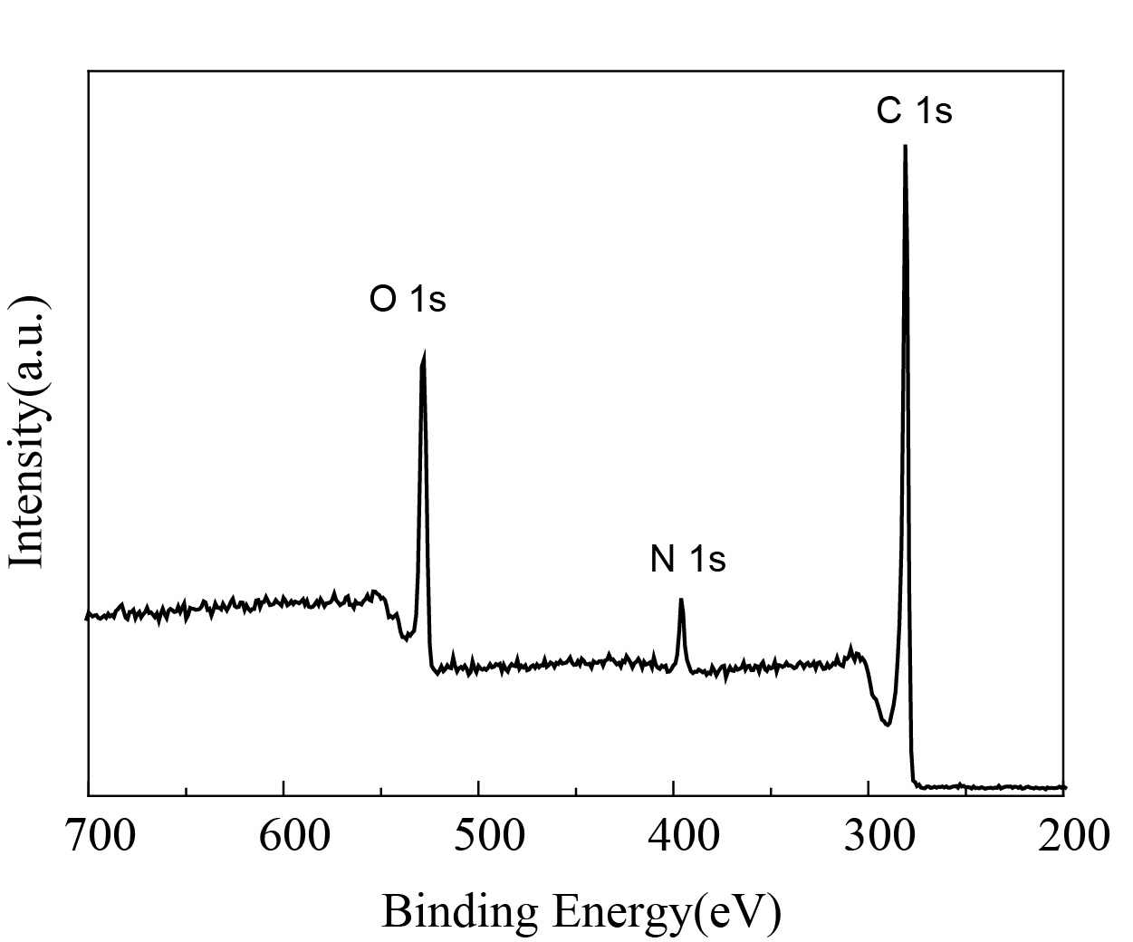
Supplementary figure 1｜X-ray photoelectron spectroscopy spectrum of RP-CN.
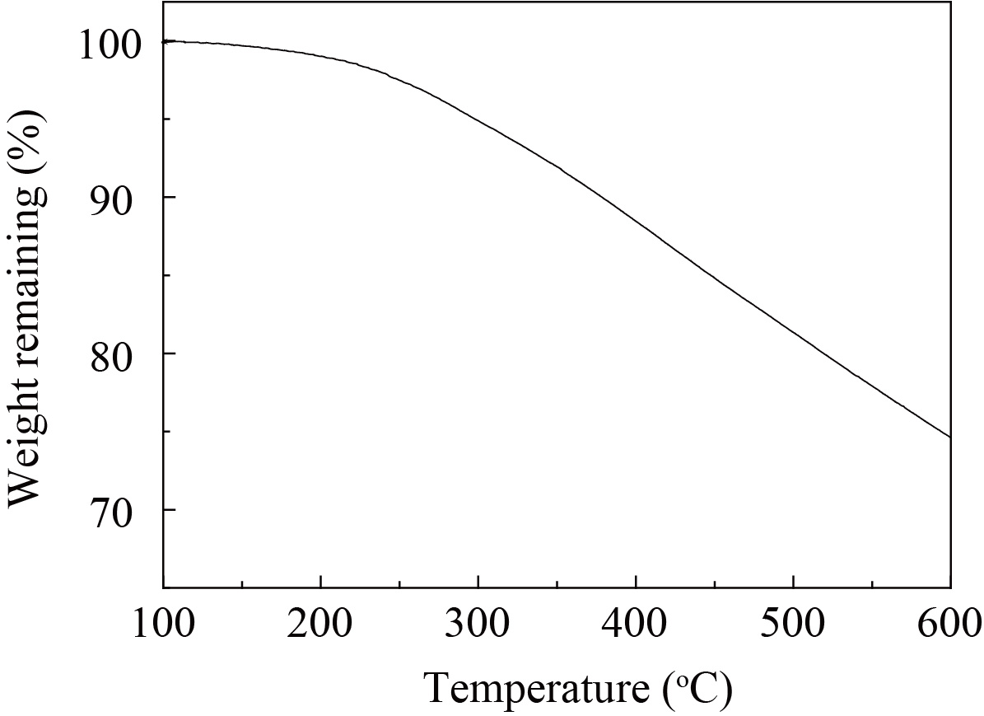
Supplementary figure 2｜Thermal gravimetric analysis curve of RP-CN.

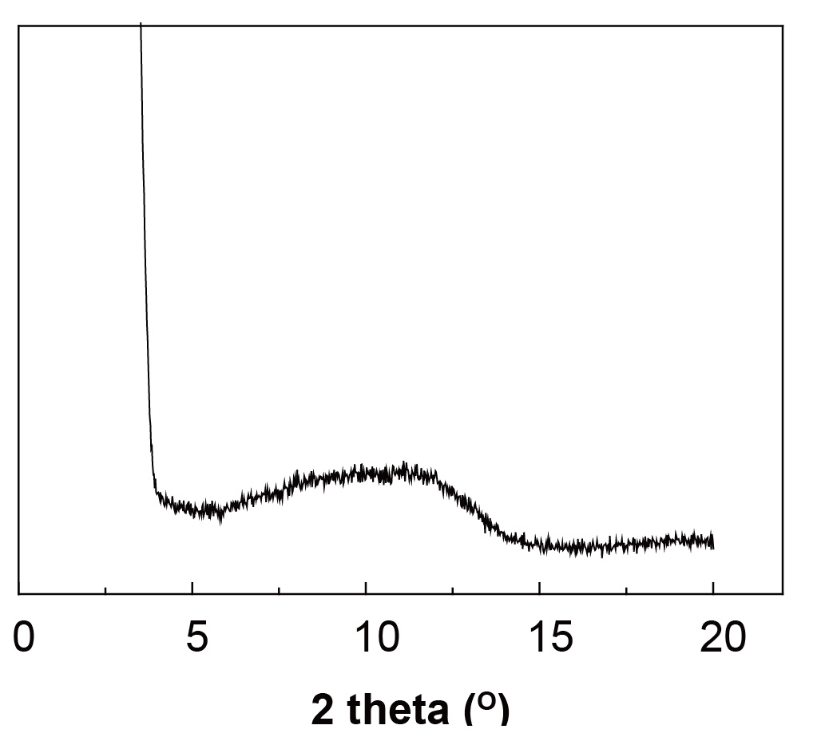
Supplementary figure 3｜XRD profile of RP-CN. No obvious peak observed, indicating the amorphous of the cross-linked radical polymer.

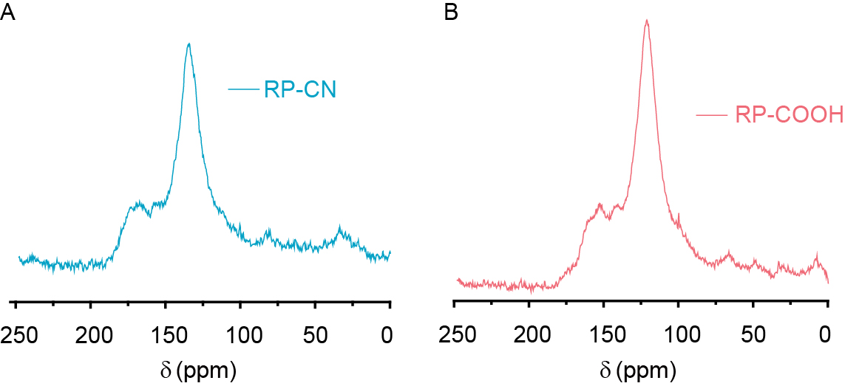
Supplementary figure 4｜Solid state ¹³C NMR spectra of RP-CN and RP-COOH

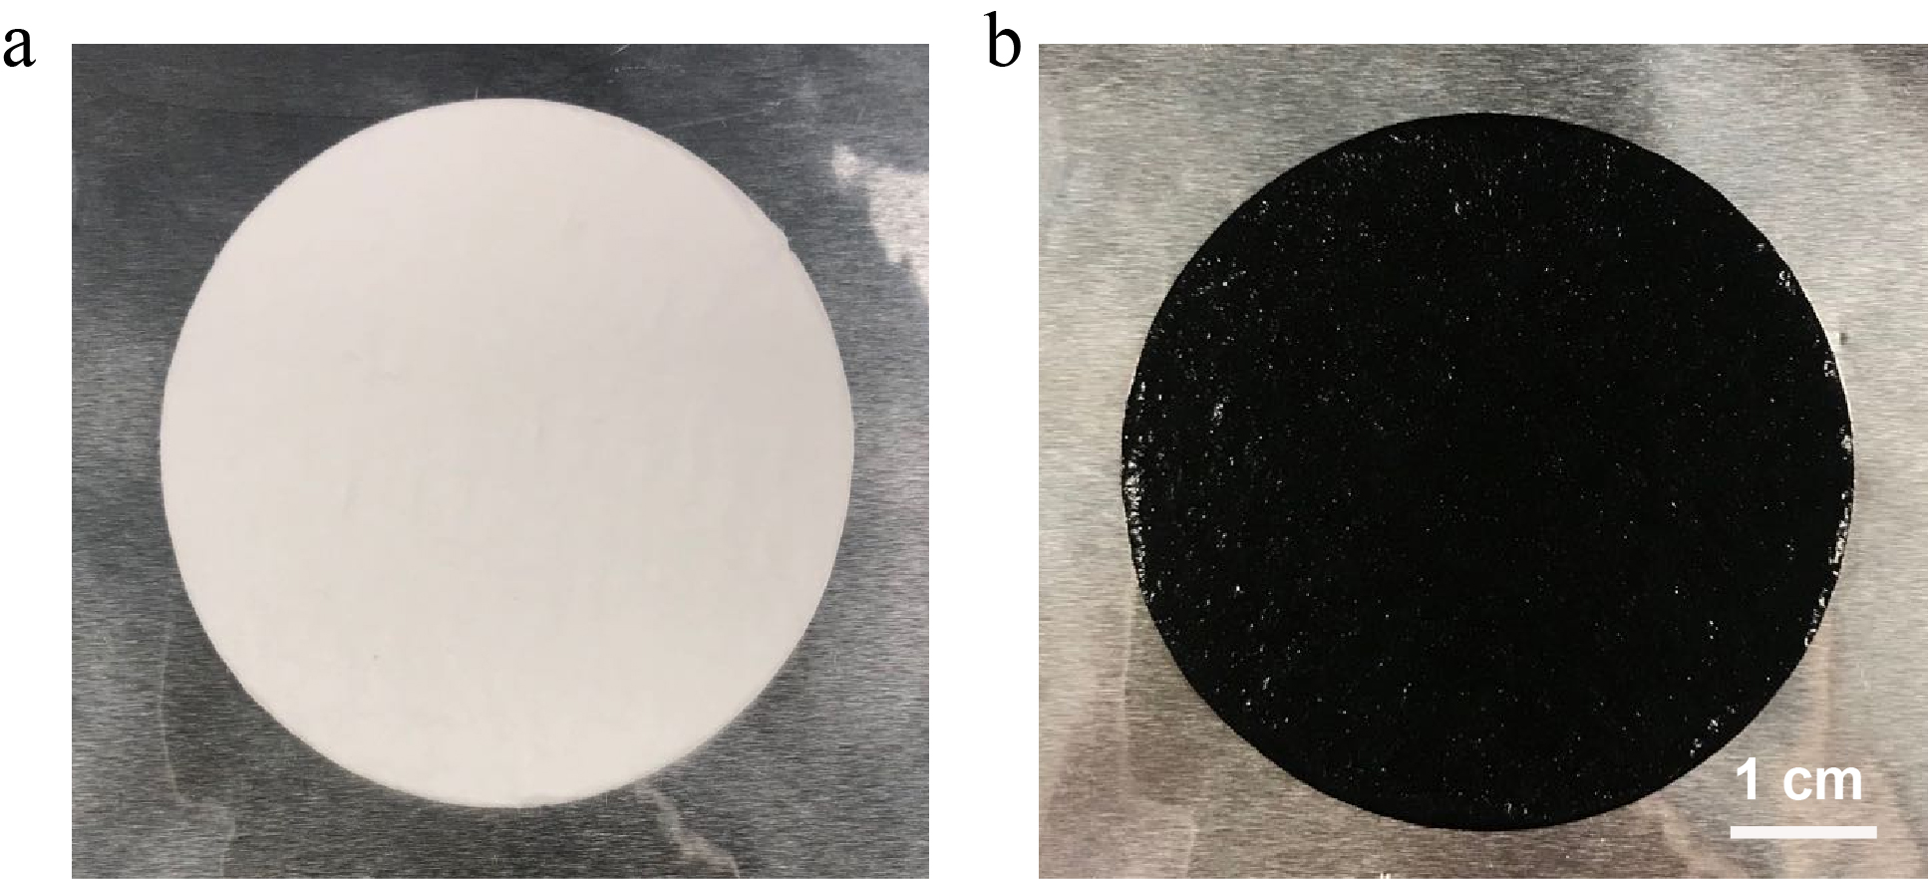
Supplementary figure 5｜Optical images of RP-water/GF composite membrane.

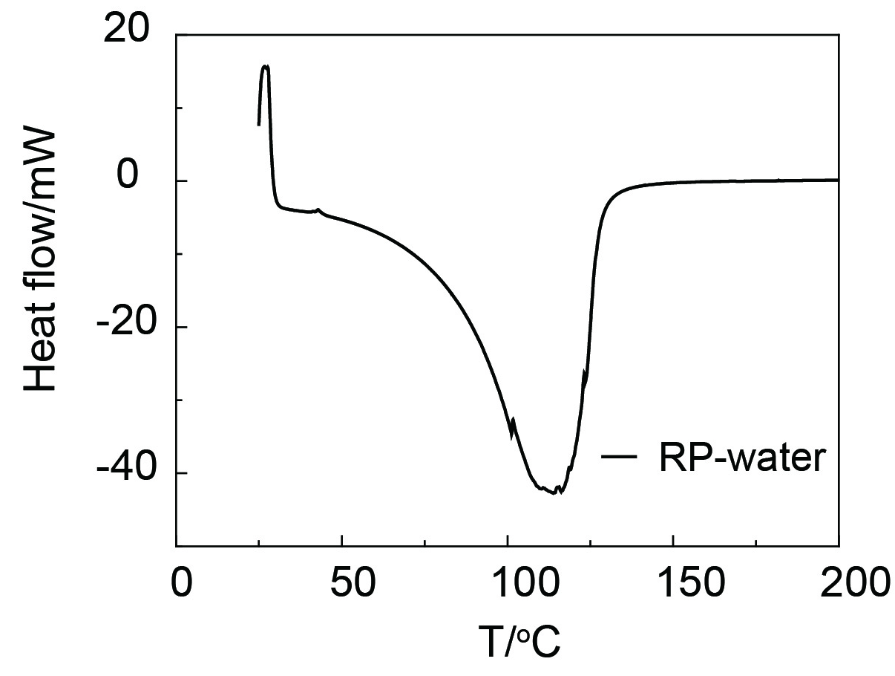
Supplementary figure 6｜Differential scanning calorimetric (DSC) curve of RP-water. The calculated vaporization enthalpy of water is 1972 J g⁻¹. Samples were placed in open Al crucibles and heated in the temperature range from 30 to 200 ºC at a heating rate of 5 ºC/min under a nitrogen flow flux f 20 ml/min. Before measuring the RP-water sample, sapphire is used as the reference to calibrate the DCS. The effective heat capacity of RP-water can be calculated by comparing the measured heat flow with that of the standard sapphire sample.

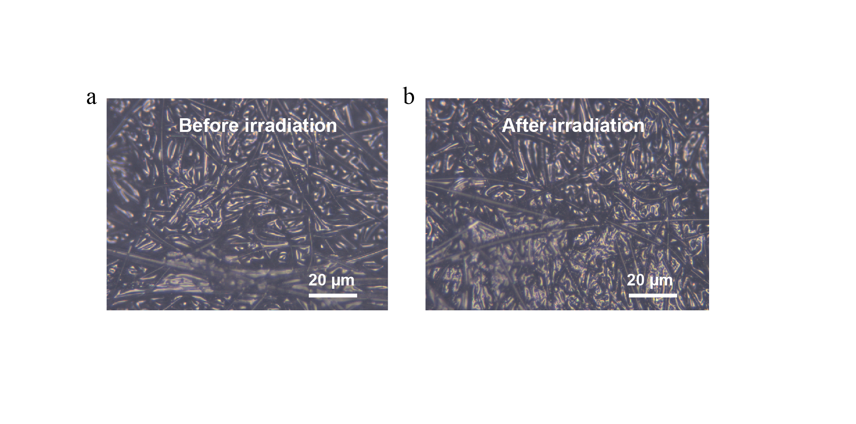
Supplementary figure 7｜Optical images showing the morphologies of RP-water/GF hydrogel membrane before (a) and after (b) 1-sun irradiation.

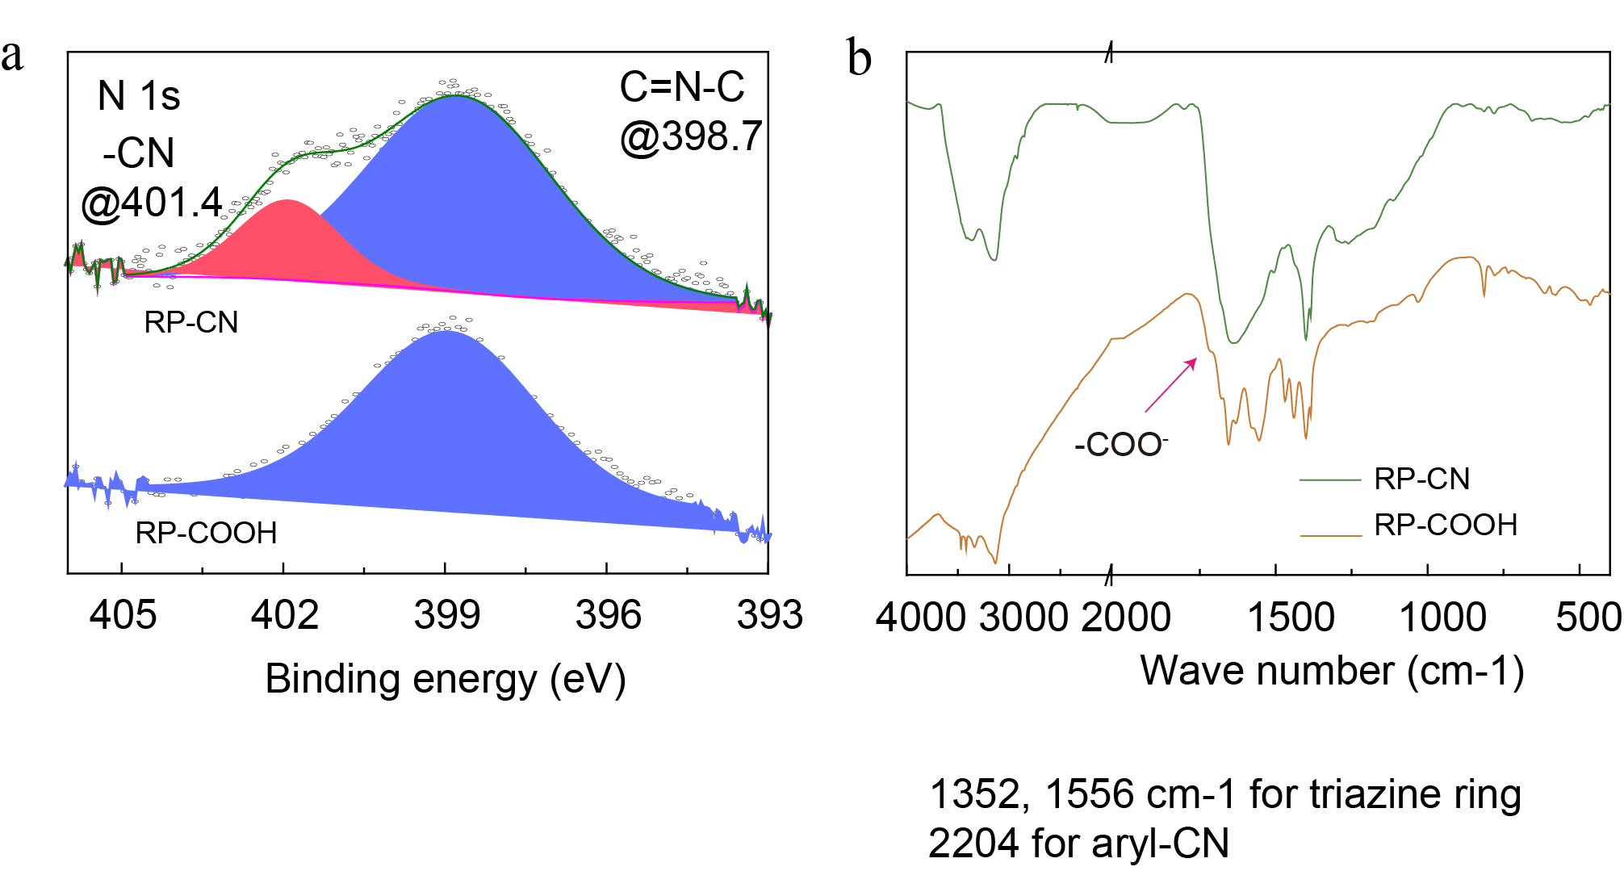
Supplementary figure 8｜X-ray photoelectron spectroscopy (XPS) spectra and FTIR spectra of RP-CN and RP-COOH. a, N1s spectra of RP-CN and RP-COOH. RP-CN has two distinct peaks at ~398.7 eV and ~401.4 eV, while the second peak disappeared in RP-COOH. The first peak can be assigned to the –C=N-C- of formed triazine rings. The second peak is associated with unreacted nitrile group, which accounts for 20.5% of whole N content. b, FTIR spectra of RP-CN and RP-COOH. RP-COOH shows an additional peak at ~1722 cm⁻¹ associated with –COO⁻ group.

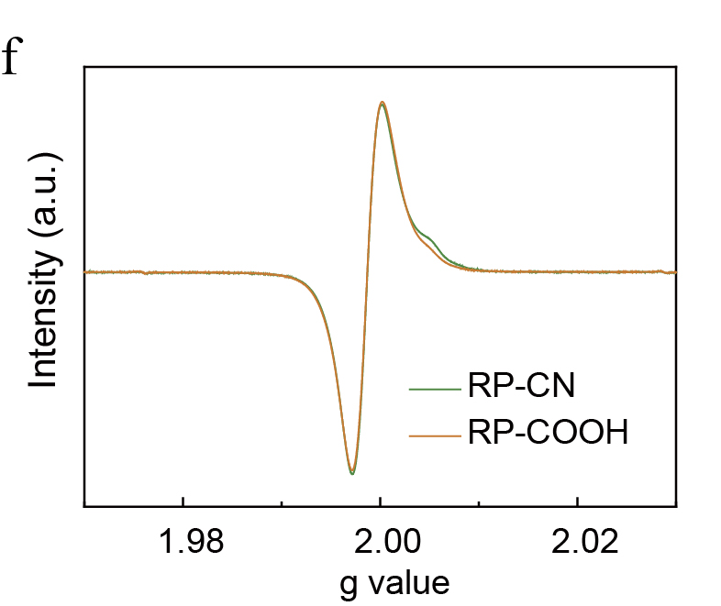
Supplementary figure 9｜EPR spectra of RP-CN and RP-COOH

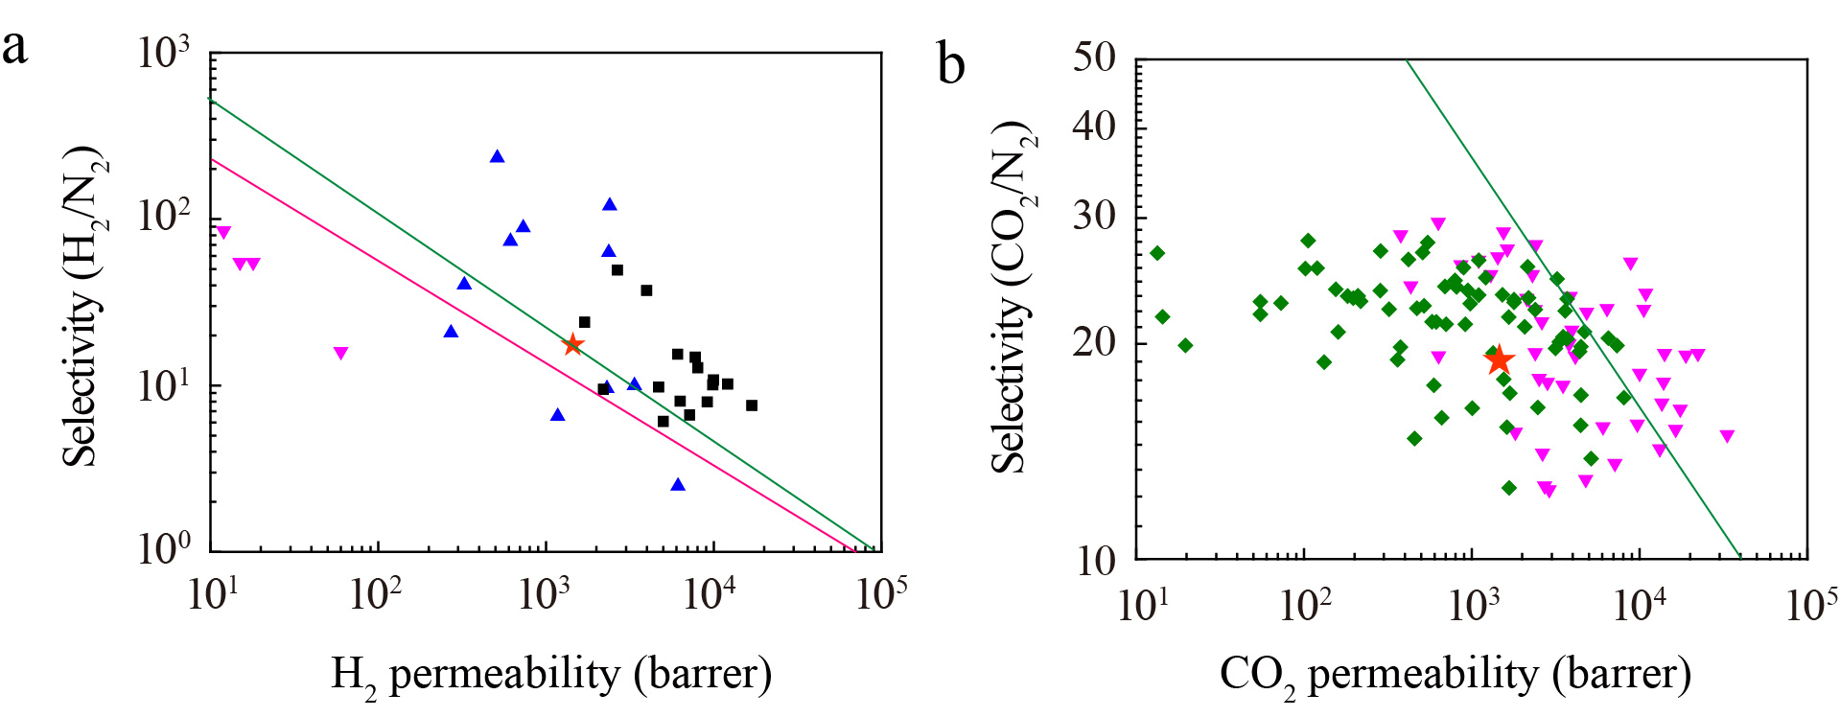
Supplementary figure 10｜a, Robeson plot for H₂/ N₂ gas pairs with the 1991 upper bounds indicated by a pink line and 2008 upper bounds by a green line. The single-gas permeation data of RP-CN membrane (red star) were compared with accumulated literature data for state-of-the-art ultrapermeable PIMs (black squares), microporous solids (zeolites, MOFs, POPs and inorganic 2D materials, blue triangles) and commercial polymer membranes (purple triangles). b, Robeson plot for CO₂/N₂ gas pairs with the 2008 upper bounds by a green line. The single-gas permeation data of RP-COOH membrane (red star) was compared with accumulated literature data of PIM-PIs (green diamond) and ladder PIMs (purple triangles).

Supplementary figure 11｜The calculated DOSs of f-RP with one radical state, in which the top figure is the DOS without spin-polarization, and the bottom figure is the DOS with spin-polarization. The SOMO state in the DOS is denoted by the black arrow. The f-RP with one radical state is energetically more favourable with spin-polarization.

