Appendix 1
Table A1. Variables, description, available and source for each country
Countrie | Variables | Description | Sourse
Mexico | Water | Binary variable: 1 if the villa has piped water, 0 if it does not have piped water. | ENSANUT (2018)
Mexico | Sewage | Binary variable, where 1 represents that the house's drainage is connected to the public network, septic tank or septic tank (biodigestor) and 0 for a pipe that leads to a ravine or a storm drain, a pipe that leads to a river, lake or sea and no drainage | ENSANUT (2018)
Mexico | Garbage | Binary variable, where 1 represents that in the house the basura collects a truck or a cart, the lever in the public basure or the lever in a container or deposit, and 0 for the options of those who man the basura, enters the basura , the tyrant on the street, on a ravine or the tyrant on a river or the sea. | ENSANUT (2018)
Mexico | Education | Ordinal variable with the following categories: "No education", "Complete primary", "Complete secondary", "Higher". "Complete secondary" includes secondary education and bachelor's degree, "Higher" includes bachelor's degree and postgraduate degrees. | ENSANUT (2018)
Mexico | Occupation | Variable with categories: Formal employee, Casual employee, Unemployed, Retired. Formal employee is obtained by combining the question about whether you have worked in the last week and whether you have received medical insurance for that job. | ENSANUT (2018)
Mexico | Gender | Question with the categories about whether the person was a man or woman. | ENSANUT (2018)
Mexico | Age | Age in completed years | ENSANUT (2018)
Mexico | Race/Ethnicity | Variable with the following categories: "miracle" and "Indigenous". For indigenous people, we take into account the question about whether the person speaks some indigenous language. | ENSANUT (2018)
Mexico | Urban/Rural | Binary variable where 0 represents that the house is located in a rural location (<2,500 inhabitants) and 1 for urban (2500-99,999 inhabitants) or metropolitan (>100,000 inhabitants) | ENSANUT (2018)
Ecuador | Water | binary variable; 1 if the villa is supplied with piped water from the public network, 0 for other sources such as a distribution car/tricycle, by the river/ shed/ acequia. | ENSANUT (2018)
Ecuador | Sewage | Binary variable, where 1 represents that the house's exhaust and water supply is connected to the public network, 0 for the options of: septic well, underground well, streetlight and the alcantarillado is not excluded. | ENSANUT (2018)
Ecuador | Garbage | Binary variable, where 1 represents that in the house the basura is eliminated through the municipal service, 0 for the other options such as the botan on the street/brake/river, the man, the interior or contract the service. | ENSANUT (2018)
Ecuador | Education | Ordinal variable with the following categories: "No education", "Complete primary", "Complete secondary", "Higher". "Complete secondary" includes secondary education and bachelor's degree, "Higher" includes bachelor's degree and postgraduate degrees. | ENSANUT (2018)
Ecuador | Occupation | Variable with categories: Formal employee, Casual employee, Unemployed, Retired. | ENSANUT (2018)
Ecuador | Gender | Question with the categories about whether the person was a man or woman. | ENSANUT (2018)
Ecuador | Age | Age in completed years | ENSANUT (2018)
Ecuador | Race/Ethnicity | Variable auto identification category: "Mestizo", "Indigenous", "Others", "Black". For the "other" category contains the mulato/montuvio and white categories. For the Black category, the "Afro-Ecuadorian/Afro-descendant" category was considered. | ENSANUT (2018)
Ecuador | Urban/Rural | Binary variable where 0 represents that the house is located in a rural location (<2,500 inhabitants) and 1 for urban (>2500 inhabitants) | ENSANUT (2018)
Brasil | Water | Binary variable; 1 if the villa has piped water from the public network, 0 if it does not have piped water | PNS (2019)
Brasil | Sewage | Binary variable, where 1 represents that the house from which drains the bathrooms and inodors through a general drainage system or storm drain, septic tank or rudimentary black well and 0 for Zanja  Direct to the river, lake or sea, Otro. | PNS (2019)
Brasil | Garbage | Binary variable, where 1 represents that in the house the base is collected directly by the cleaning service or collected in the cleaning service cube. For 0 it represents the villa where the base is built, dug in, taken out on a vacant lot or taken into a river, lake or sea. | PNS (2019)
Brasil | Education | Ordinal variable with the following categories: "No education", "Complete primary", "Complete secondary", "Higher". "Complete secondary" includes secondary education and bachelor's degree, "Higher" includes bachelor's degree and postgraduate degrees. | PNS (2019)
Brasil | Occupation | Variable with categories: Formal employee, Casual employee, Unemployed, Retired. | PNS (2019)
Brasil | Gender | Question with the categories about whether the person was a man or woman. | PNS (2019)
Brasil | Age | Age in completed years | PNS (2019)
Brasil | Race/Ethnicity | Variable auto identification category: "Mestizo", "Indigenous", "Others", "Black". For the "other" category contains the categories White, Yellow. . For the Black category, the "Black" category is taken into account. For mestizos, I consider the "Brown" category. | PNS (2019)
Brasil | Urban/Rural | Binary variable where 0 represents that the house is located in a rural location (<2,500 inhabitants) and 1 for urban (>2500 inhabitants) | PNS (2019)

Figure A1. Age distribution of total population and random sample
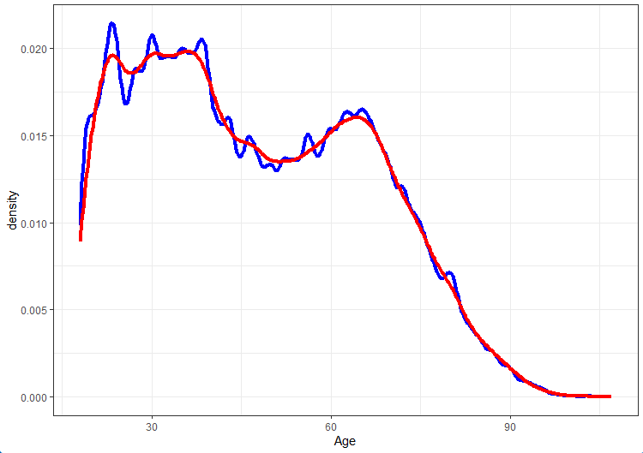
Note: The distribution of the entire population is represented in blue while the sample is represented in red. The difference of distributions test had a p-value = .83
Figure A2. Percentage of population with self-reported diagnosis of at least one chronic disease, population vs. random sample
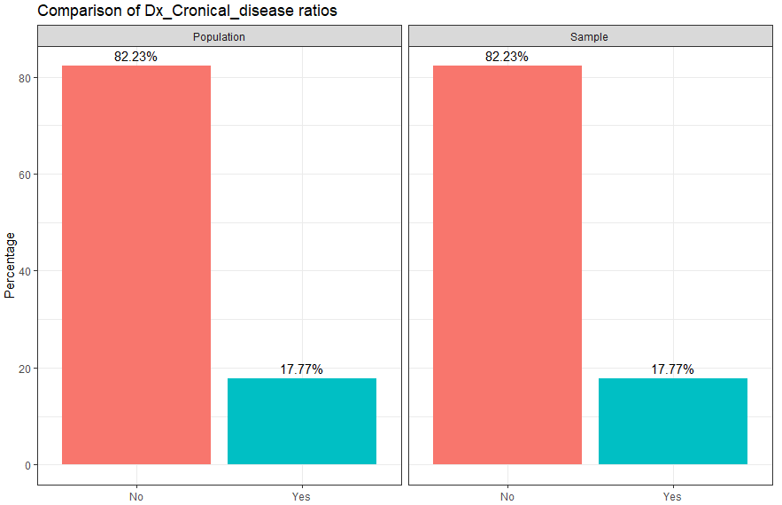
Note: The difference test had a p-value = .99

Figure A3. Gender percentage in population vs random sample
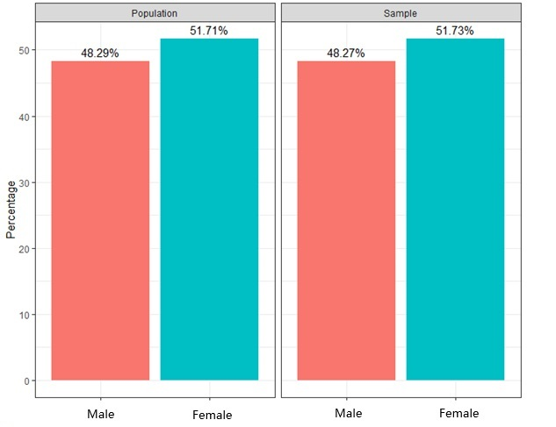
Note: The difference test had a p-value = .92
Figure A4. Percentage of population in rural locality in population vs random sample
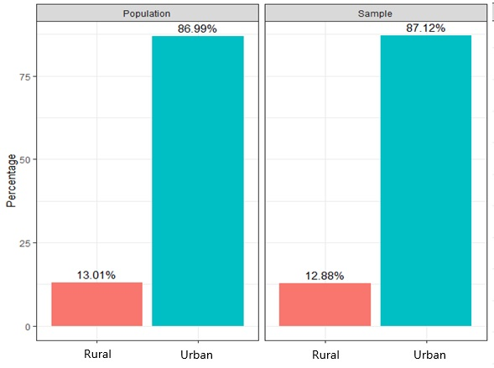
Note: The difference test had a p-value = .26

Figure A5. Percentage of water in population vs random sample
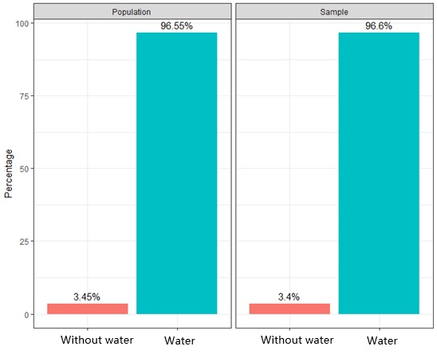
Note: The difference test had a p-value = .47

Figure A6. Percentage of sewage in population vs random sample
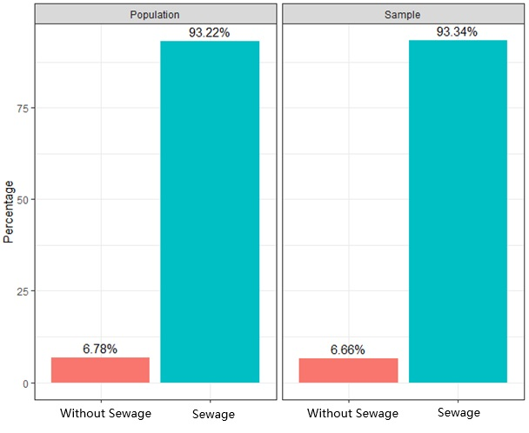

Note: The difference test had a p-value = .15

Figure A7. Percentage of garbage in population vs random sample
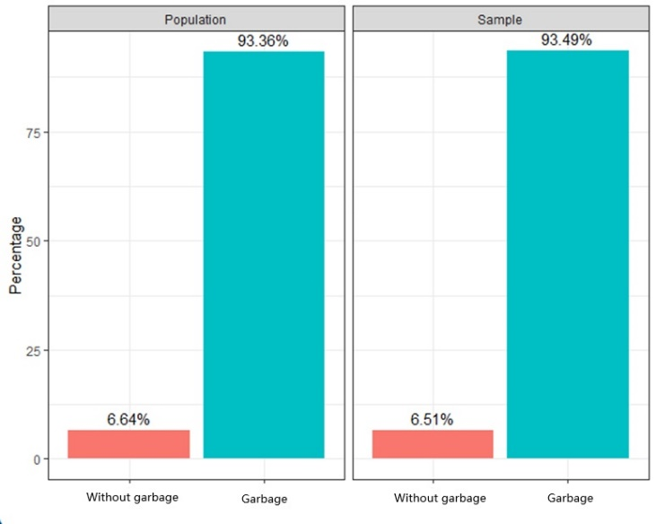
Note: The difference test had a p-value = .13

Figure A8. Percentage of occupation in population vs random sample
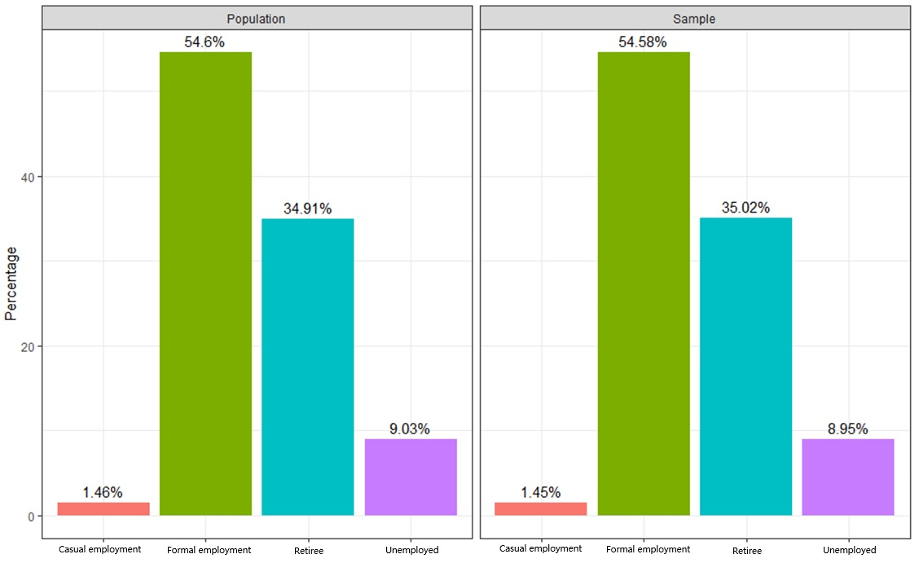
Note: The difference test had a p-value = .99

Figure A9. Percentage of etnicity in population vs random sample
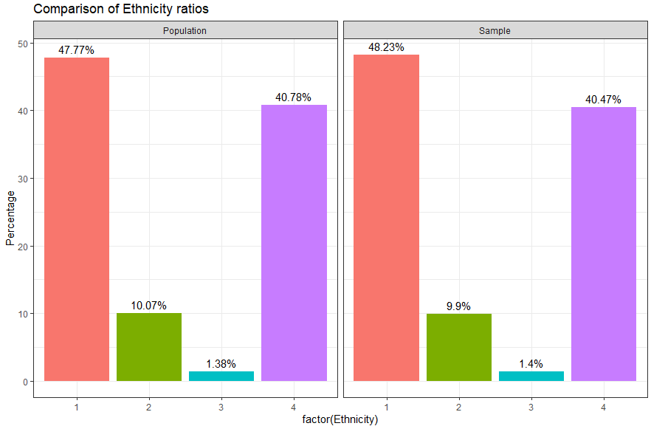
Note: The difference test had a p-value = .99

Figure A10 shows the importance of the variables by gender and ethnicity for the case of Mexico. For indigenous women the piper water and education variables were the most important in predicting the diagnosis of chronic diseases. For women of mixed ethnicity, the most important was education. For men, education was the most important variable to predict the diagnosis of chronic diseases.
Figure A10. Importance of variables to predict the diagnosis of chronic diseases by gender and ethnic in Mexico
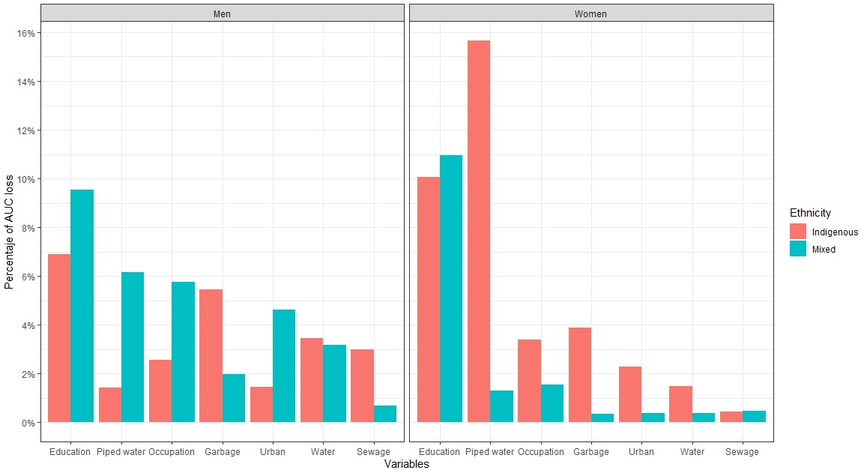

Figure A11 shows the difference in the importance of the variables between genders. For the indigenous population, piper water was the variable that differed the most between men and women, being much more important for women. For its part, for the mixed-race population, the piper water variable was also the most important, being more important for men.

Figure A11. Difference in AUC lost between genders for each ethnicity group in Mexico.

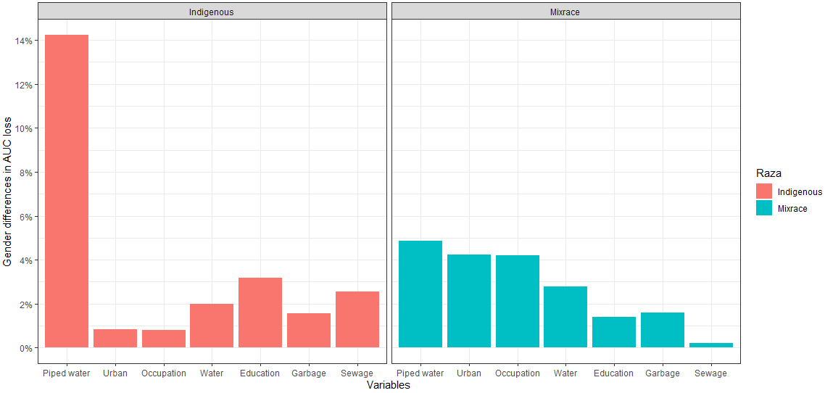

Figure A12 shows the importance of the variables to predict the diagnosis of chronic diseases in the Brazilian population. In the case of women, occupation was the most important variable in almost all ethnic groups (except for the black population). For its part, for men, the occupation was also the most important for all ethnic groups.
A12. Importance of variables to predict the diagnosis of chronic diseases by gender and ethnic in Brazil.
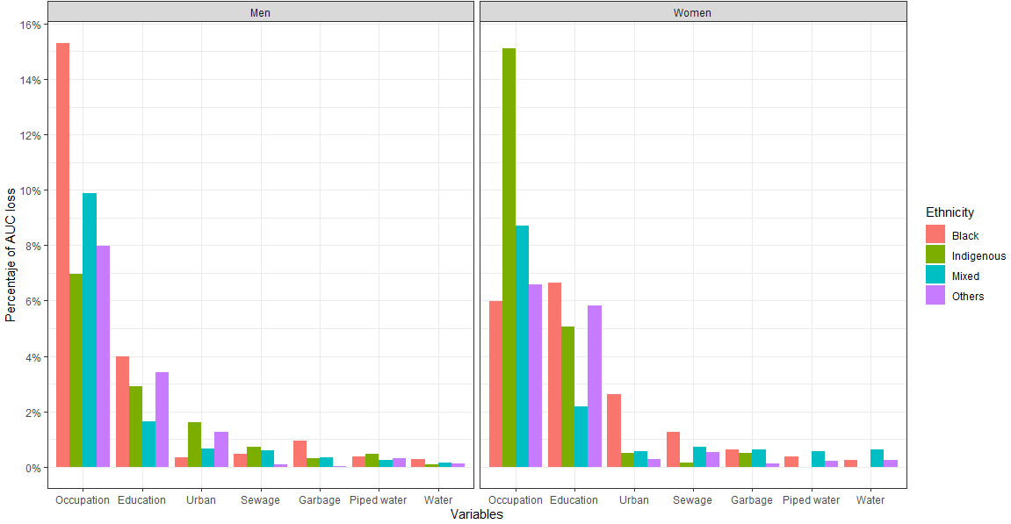
Figure A13 shows the difference in missing AUC between genera for each ethnia. For the black population, the most important difference between genders was for occupation, as it was much more important for men than for women. In the same way, for the indigenous population, occupation was the most important, but it was more important for women. For the mixed race, the differences between genders were minimal, with occupation being the largest. For the other group, education was the variable that presented the greatest differences, being more important for women than for men.

Figure A13. Difference in AUC lost between genders for each ethnicity group in Brazil.
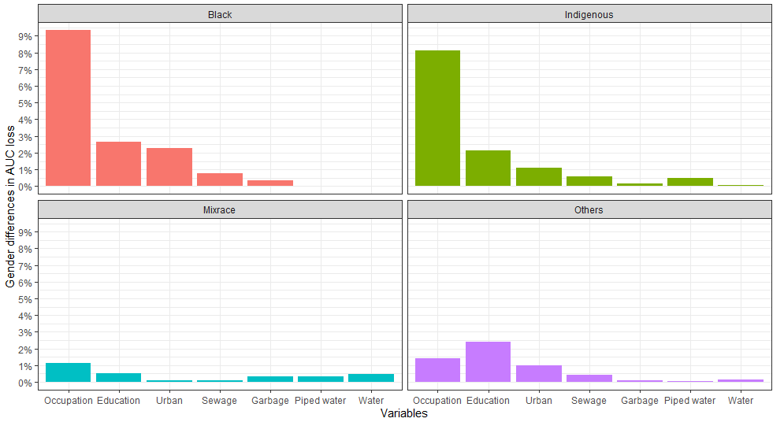
Figure A14 shows the importance of the variables to predict the diagnosis of chronic diseases in the population of Ecuador. In the case of women, education was the most important variable. For their part, for men, education was also the most important for all ethnic groups.
Figure A14. Importance of variables to predict the diagnosis of chronic diseases by gender and ethnic in Ecuador.
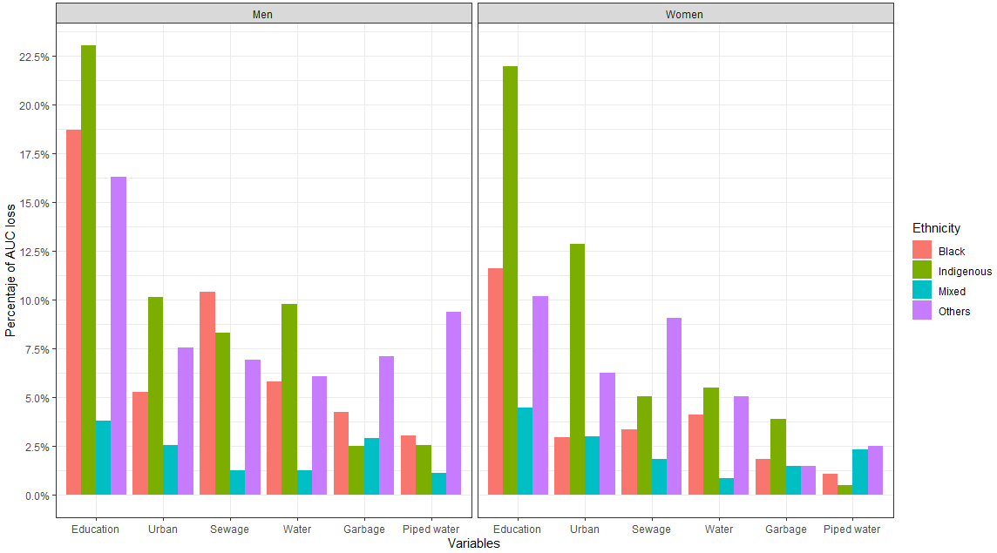
Figure A15 shows the difference in missing AUC between gender for each ethnicity in Ecuador. For the black population, the most important difference between genders was for education, closely followed by sewage, both being much more important for men than for women. For the indigenous population, water was the most important, being more important for men. For the mixed race the differences between genders were smaller, with garbage being the largest. For the entia others, piper water was the variable that presented the greatest differences, being more important for men than for women.
Figure A15. Difference in AUC lost between genders for each ethnicity group in Ecuador.

