Magnetic sodium aluminate 60 wt.% as an efficient and recyclable catalyst for the Rap–Stoermer reaction
Ali Akbari^{a,} ∗
ª Department of Chemistry, Faculty of Science, University of Jiroft, Jiroft, P. O. Box 8767161167, Iran.
Abstract
Synthesis of 2-aroylbenzofuran derivatives through Rap–Stoermer reaction with condensation of salicylaldehydes and substituted phenacyl bromides in the presence of magnetic sodium aluminate 60 wt.% (MNPs-60). The catalyst can be easily recovered from the reaction mixture by applying an external magnetic field. This catalyst is stable and can be reused multiple times without losing its catalytic properties. High yields of product in a short experimental time and easy workup are other advantages of the present method.
Keywords: Heterocyclic compounds; Rap–Stoermer reaction; Magnetic catalyst: Synthesis.

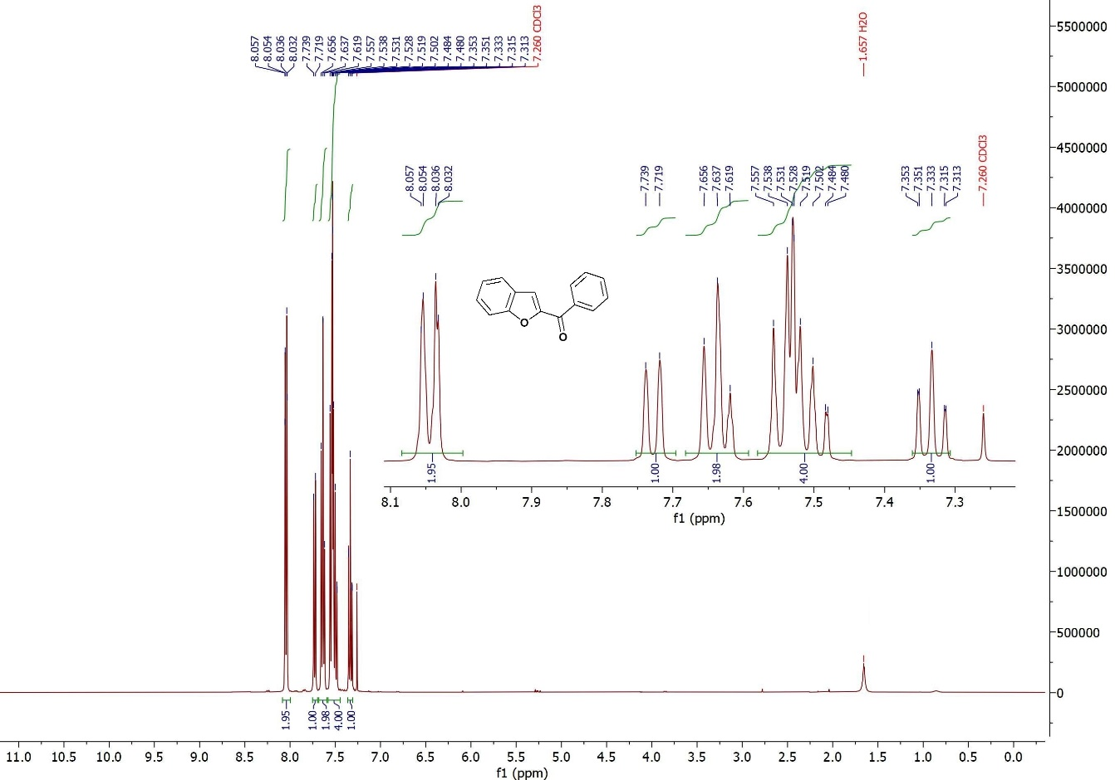
¹H NMR (400 MHz, CDCl₃): Benzofuran-2-yl(phenyl)methanone
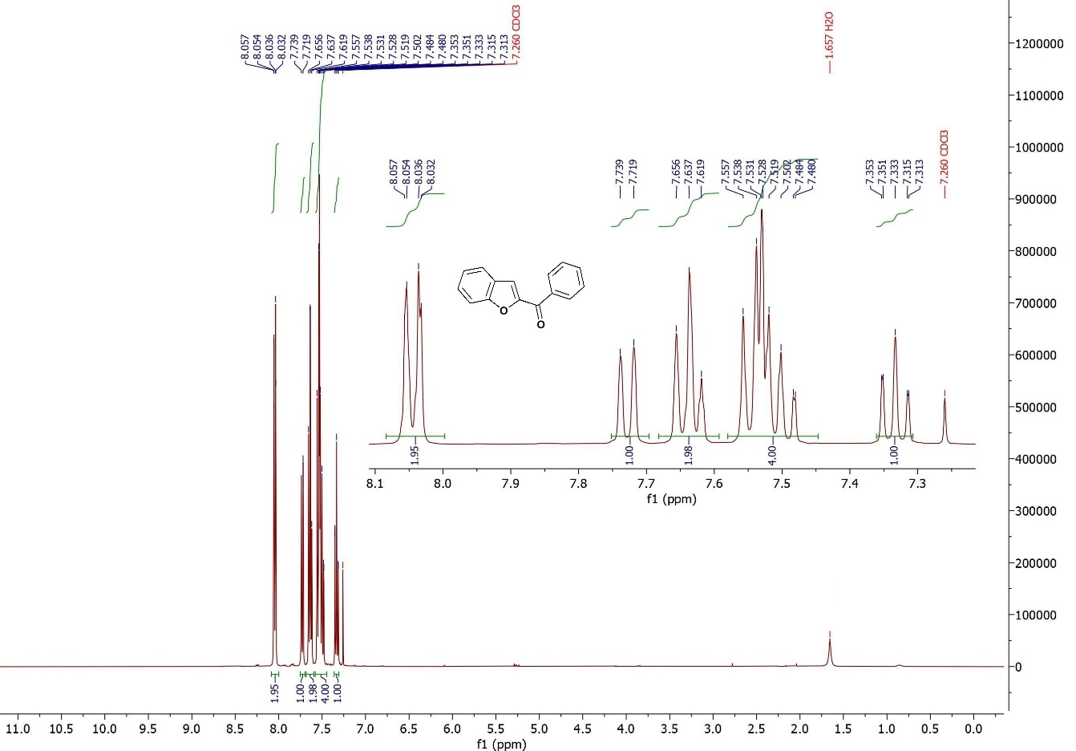
¹³C-NMR (100 MHz, CDCl₃): Benzofuran-2-yl(phenyl)methanone
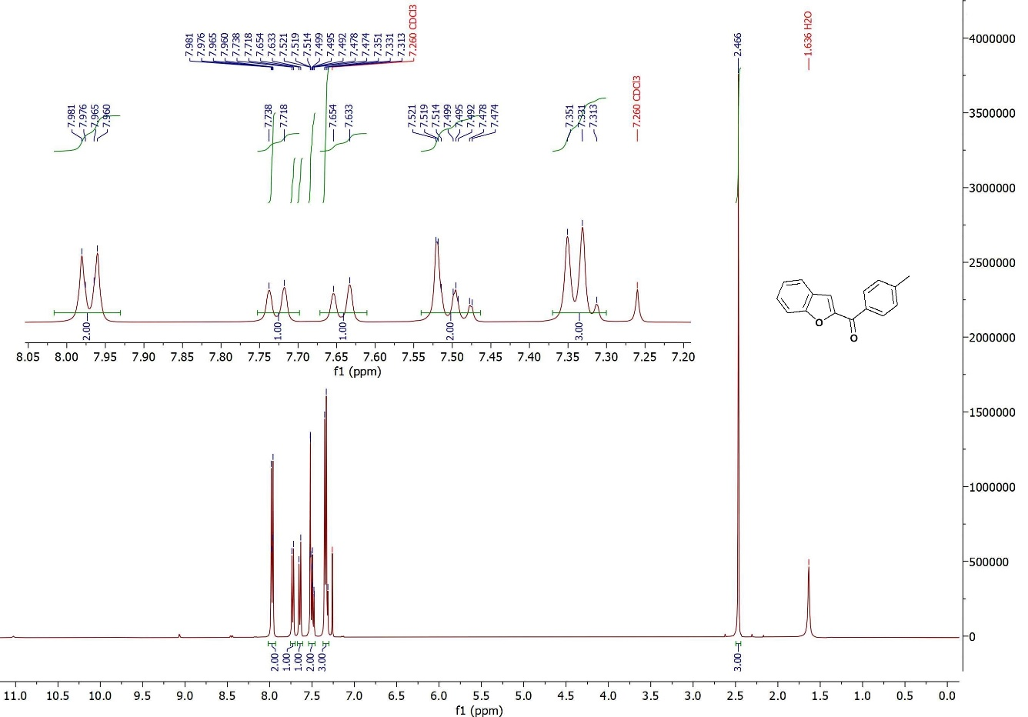
¹H NMR (400 MHz, CDCl₃): Benzofuran-2-yl(p-tolyl)methanone
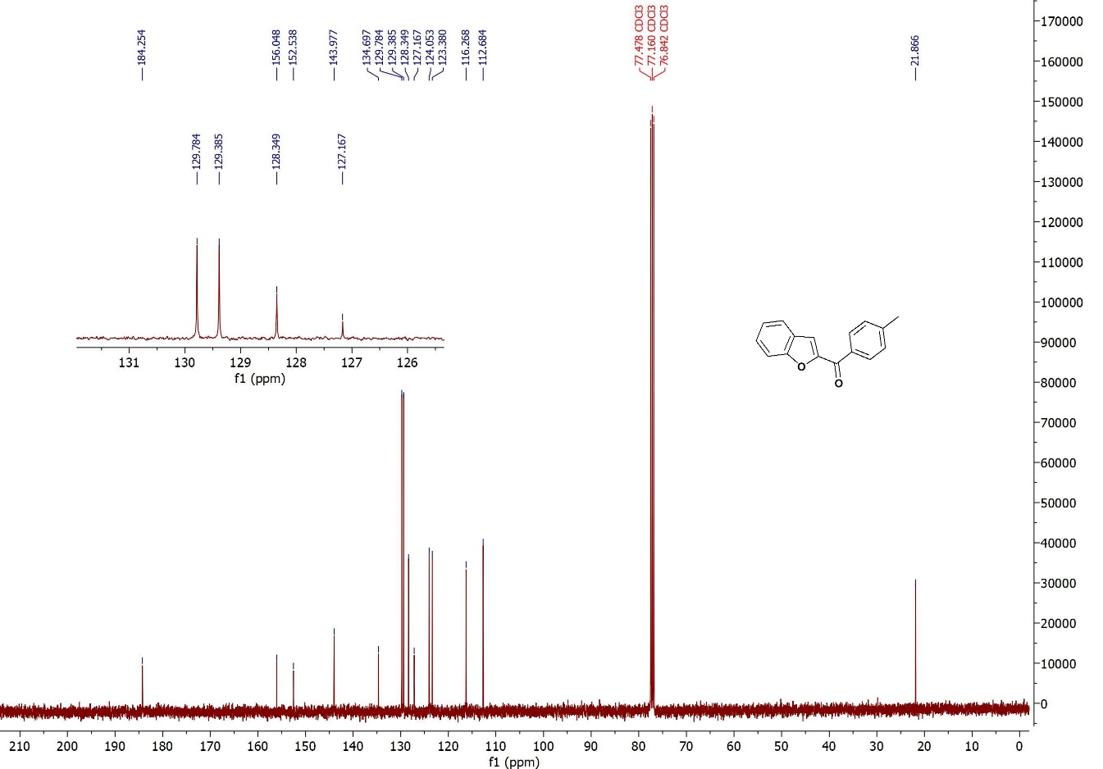
¹³C-NMR (100 MHz, CDCl₃): Benzofuran-2-yl(p-tolyl)methanone
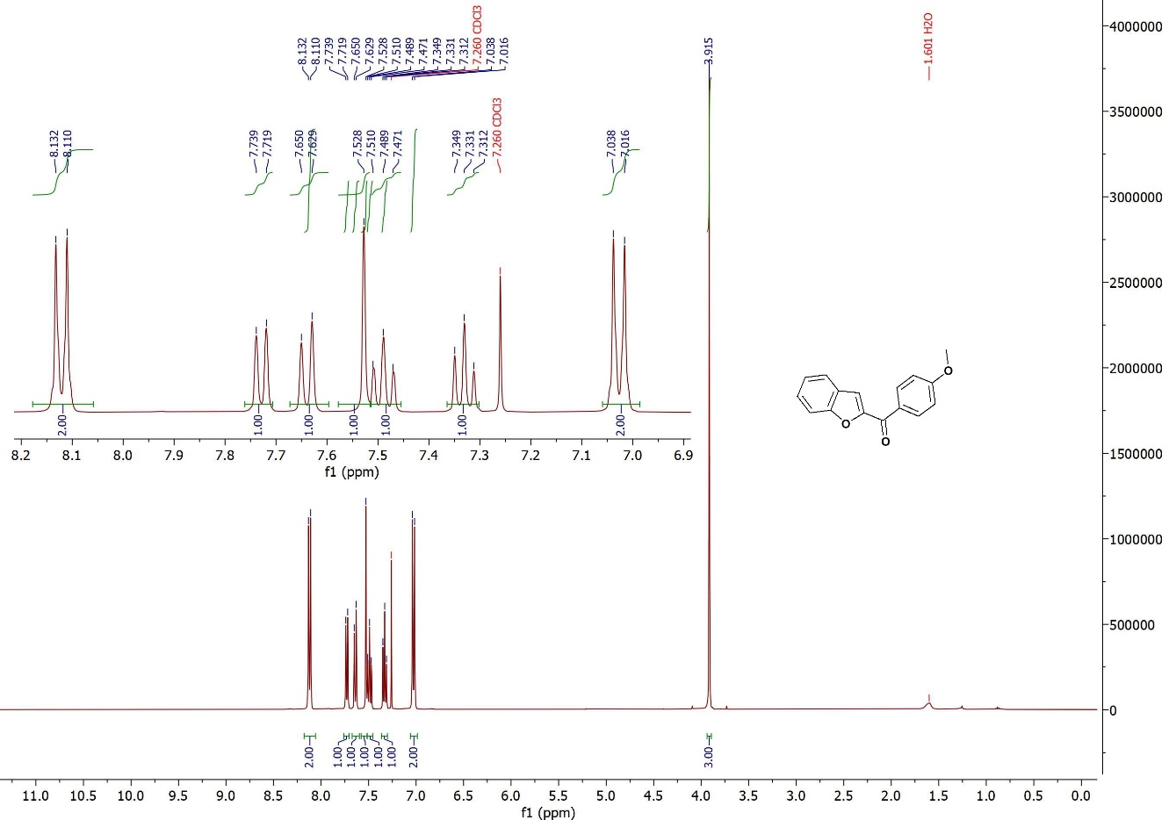
¹H NMR (400 MHz, CDCl₃): Benzofuran-2-yl(4-methoxyphenyl)methanone
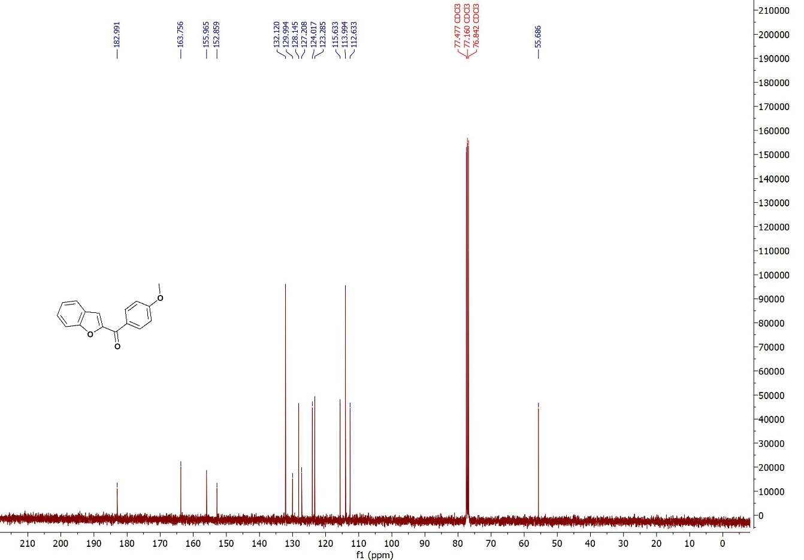
¹³C-NMR (100 MHz, CDCl₃): Benzofuran-2-yl(4-methoxyphenyl)methanone
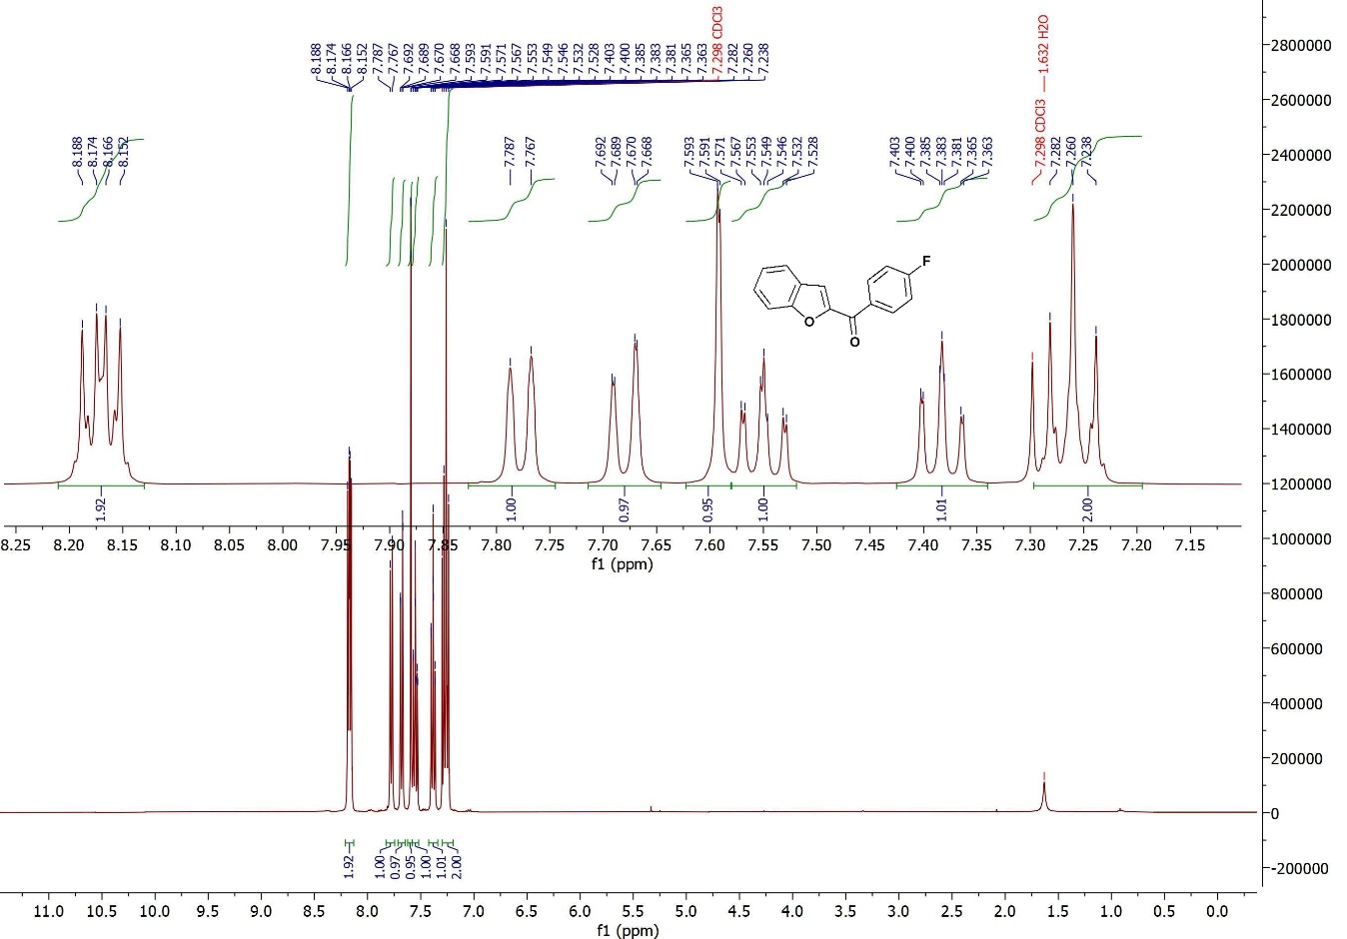
¹H NMR (400 MHz, CDCl₃): Benzofuran-2-yl(4-fluorophenyl)methanone
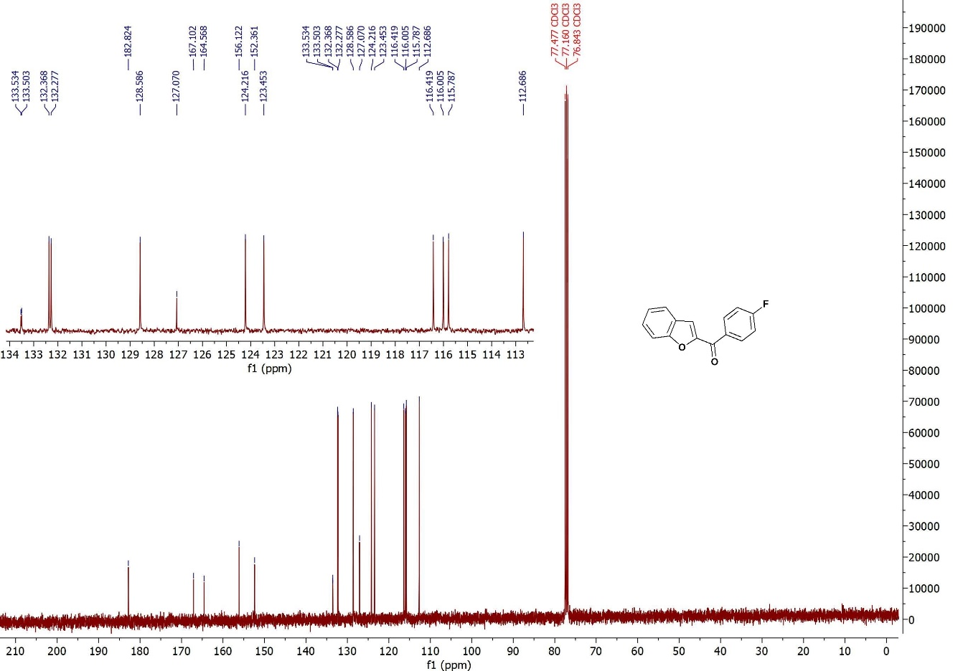
¹³C-NMR (100 MHz, CDCl₃): Benzofuran-2-yl(4-fluorophenyl)methanone
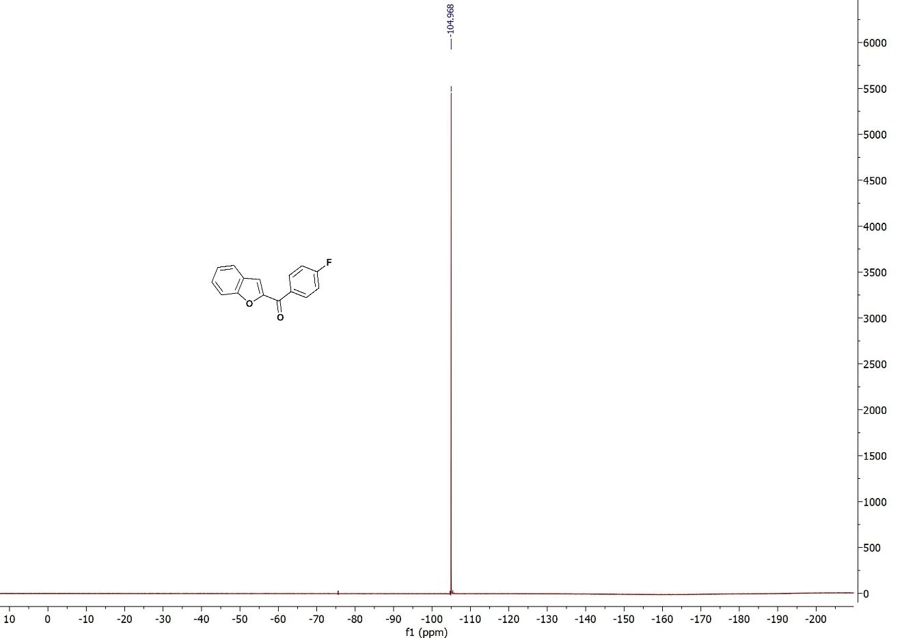
¹⁹F-NMR (376 MHz, CDCl₃) : Benzofuran-2-yl(4-fluorophenyl)methanone
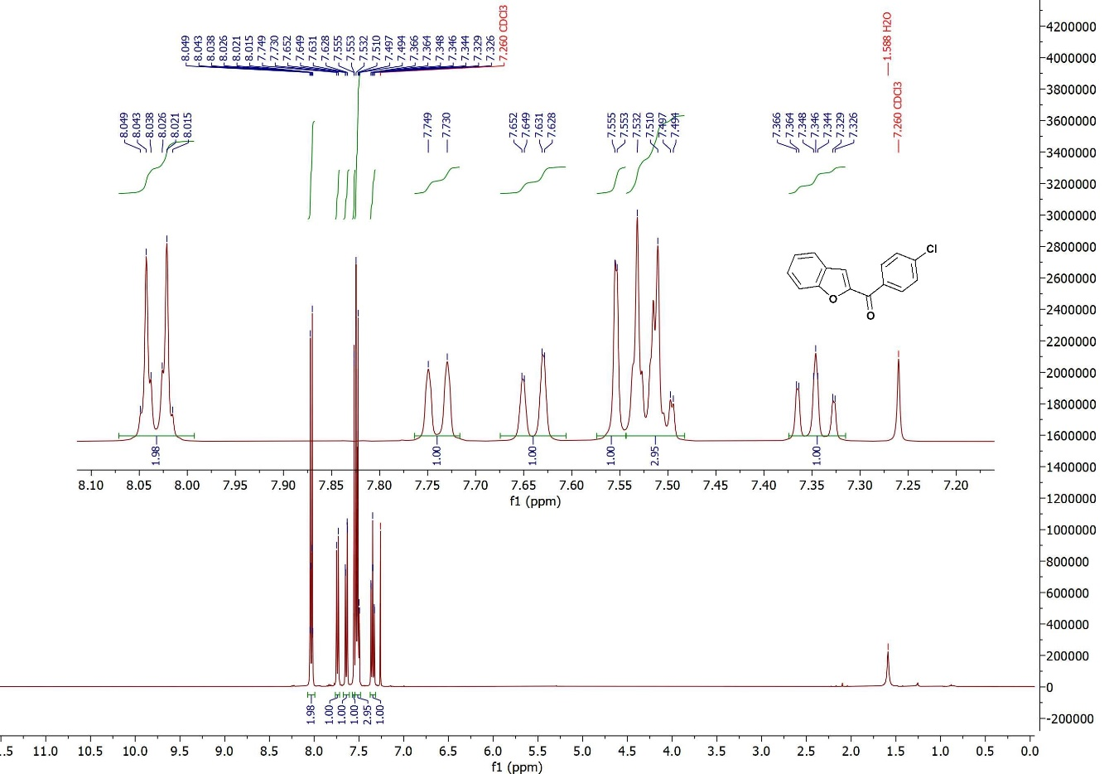
¹H NMR (400 MHz, CDCl₃): Benzofuran-2-yl(4-chlorophenyl)methanone
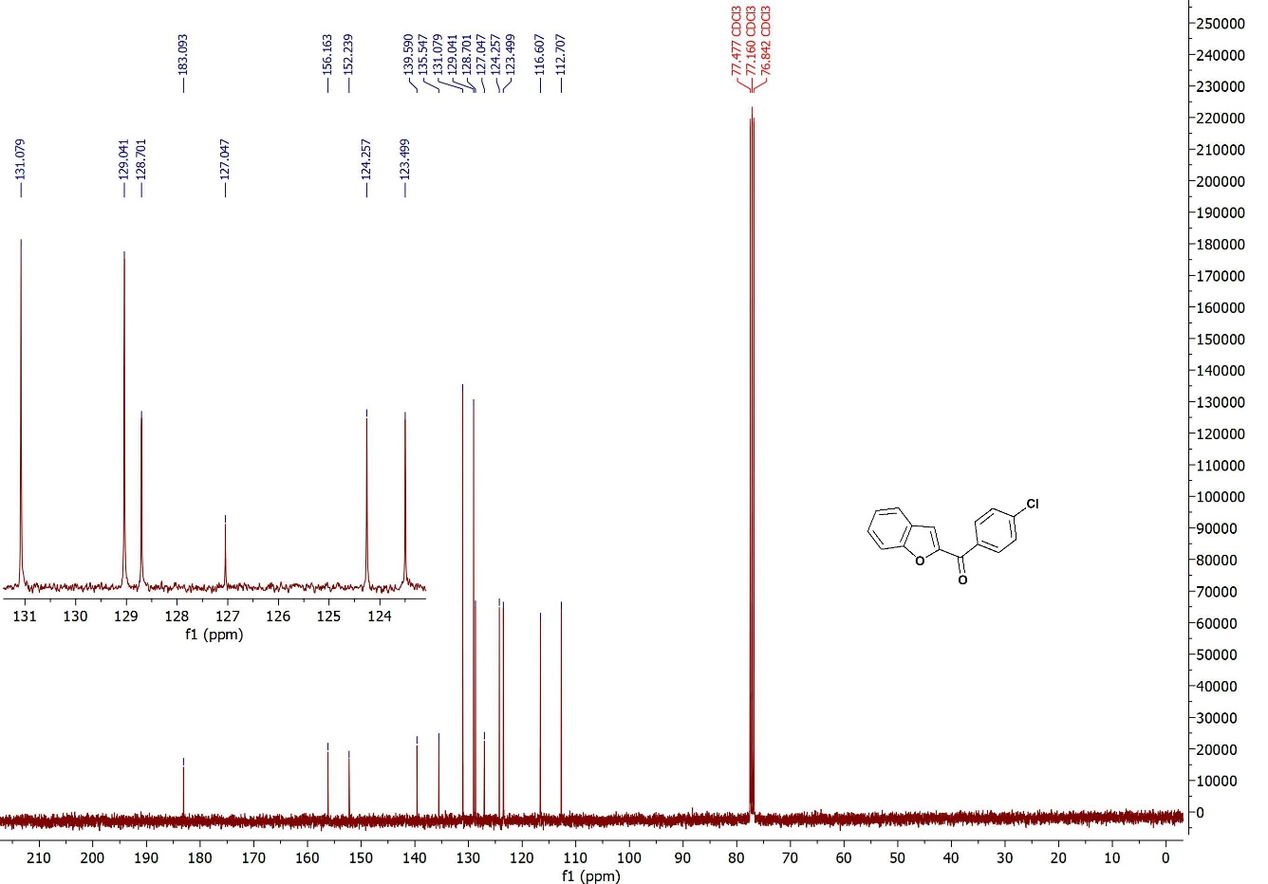
¹³C-NMR (100 MHz, CDCl₃): Benzofuran-2-yl(4-chlorophenyl)methanone
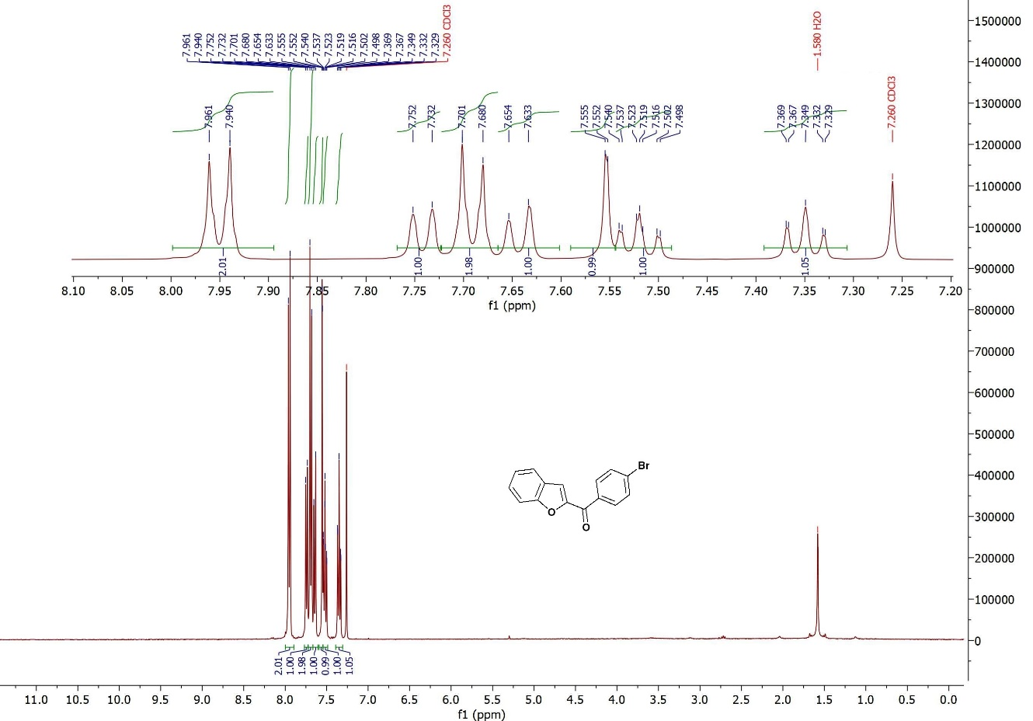
¹H NMR (400 MHz, CDCl₃): Benzofuran-2-yl(4-bromophenyl)methanone
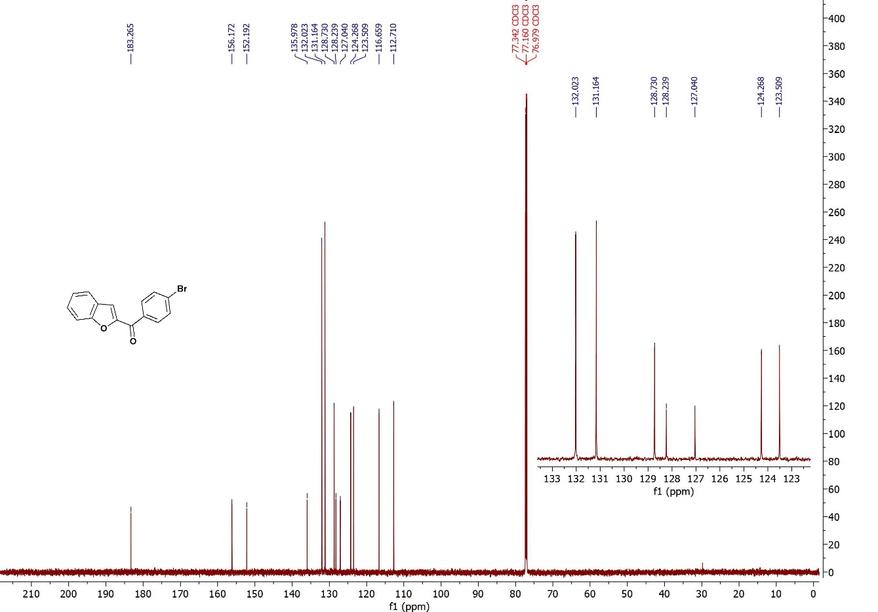
¹³C-NMR (100 MHz, CDCl₃): Benzofuran-2-yl(4-bromophenyl)methanone
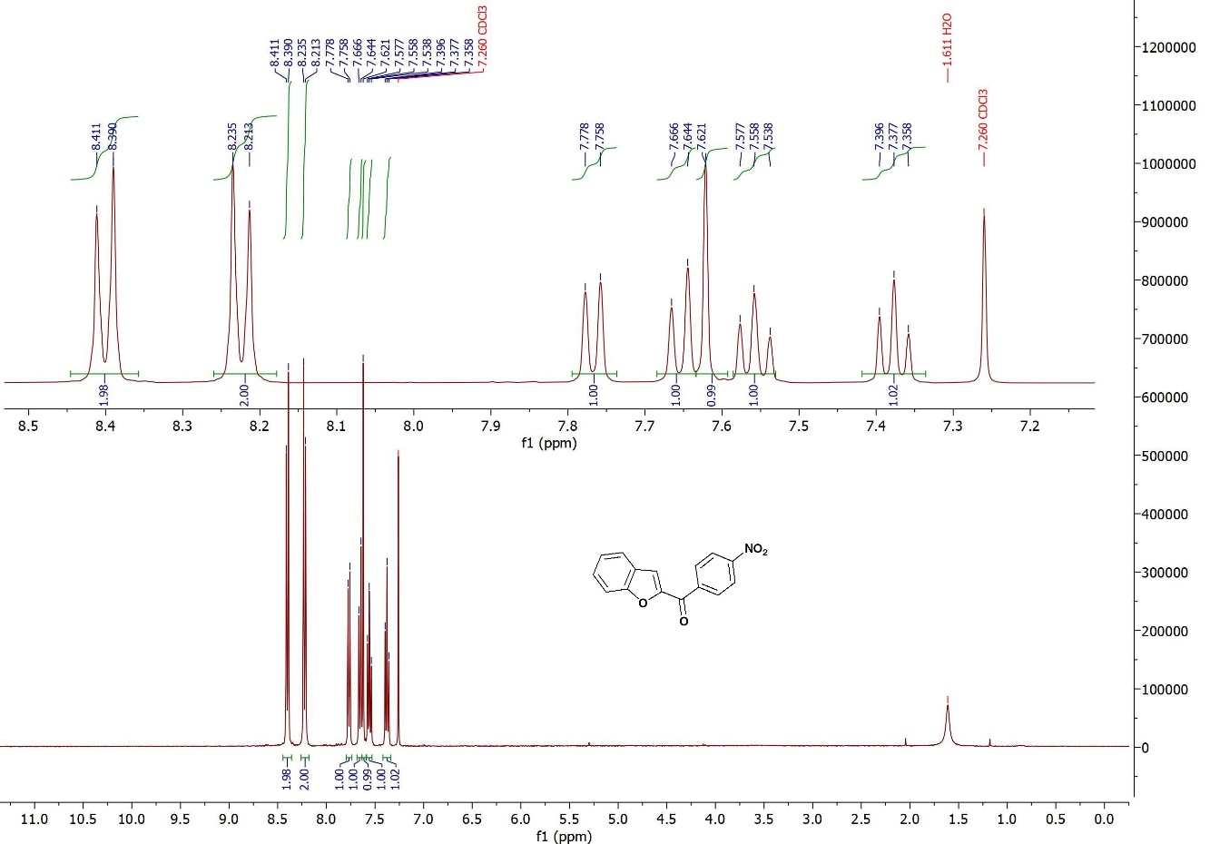
¹H NMR (400 MHz, CDCl₃): Benzofuran-2-yl(4-nitrophenyl)methanone
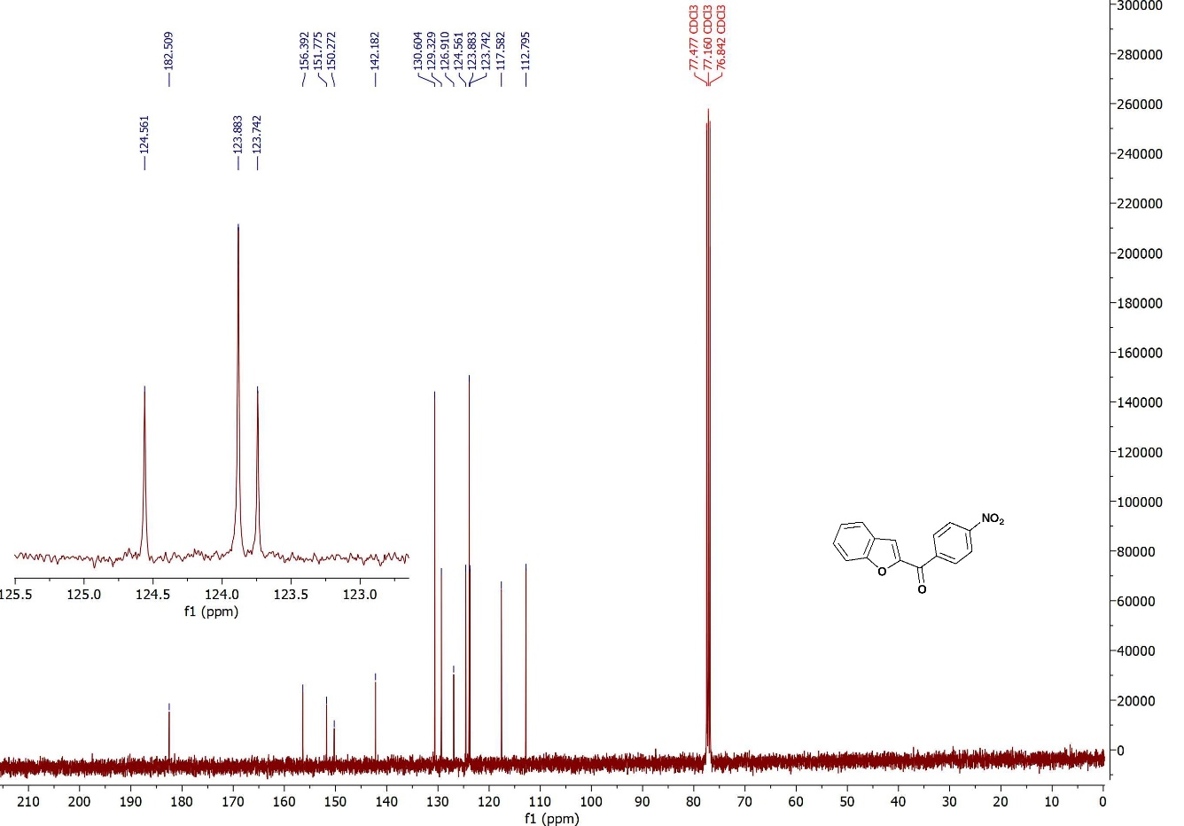
¹³C-NMR (100 MHz, CDCl₃): Benzofuran-2-yl(4-nitrophenyl)methanone
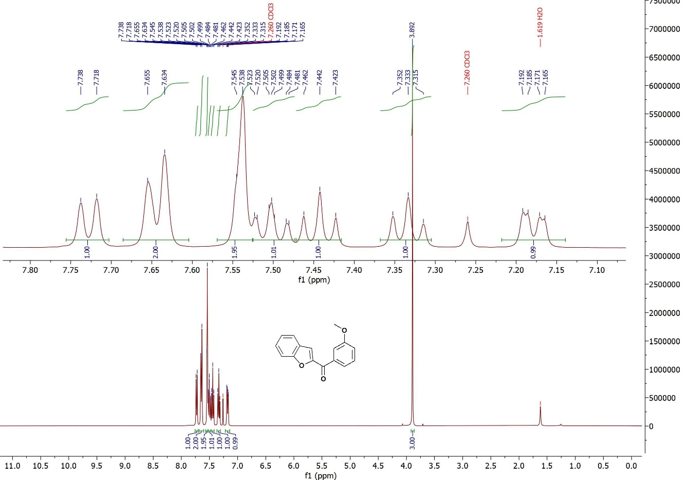
¹H NMR (400 MHz, CDCl₃): Benzofuran-2-yl(3-methoxyphenyl)methanone
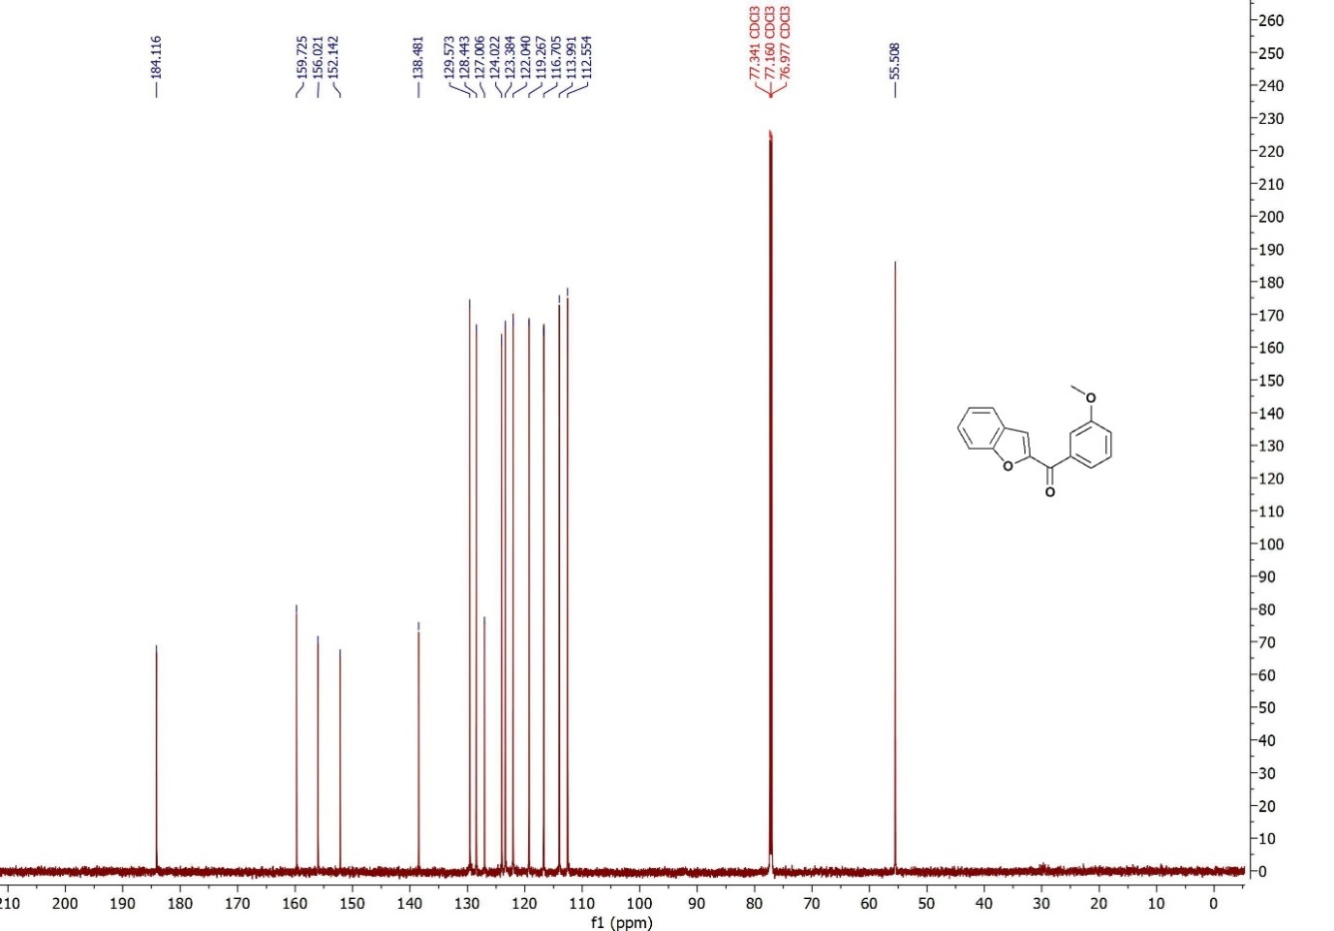
¹³C-NMR (100 MHz, CDCl₃): Benzofuran-2-yl(3-methoxyphenyl)methanone
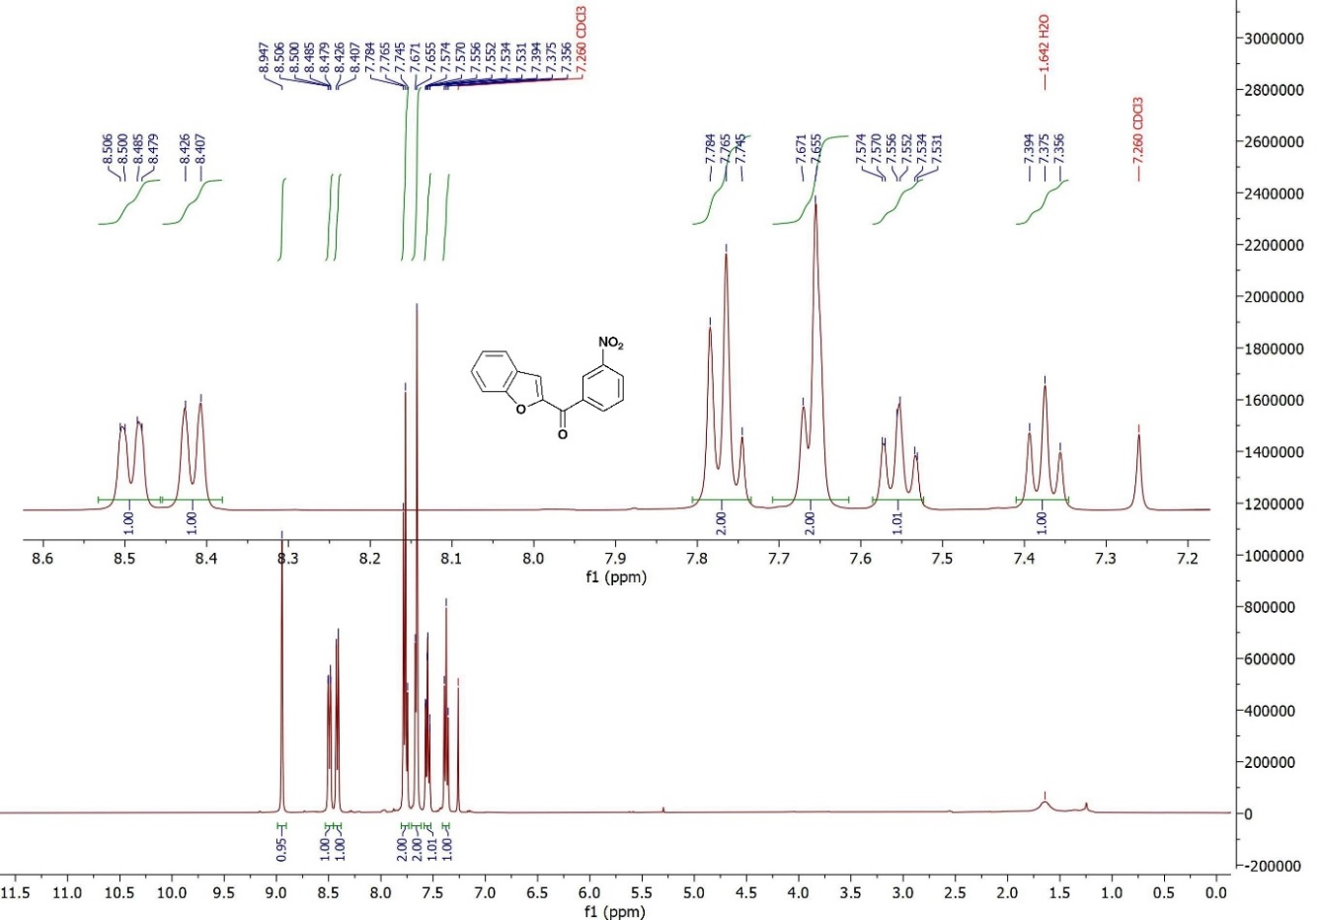
¹H NMR (400 MHz, CDCl₃): Benzofuran-2-yl(3-nitrophenyl)methanone
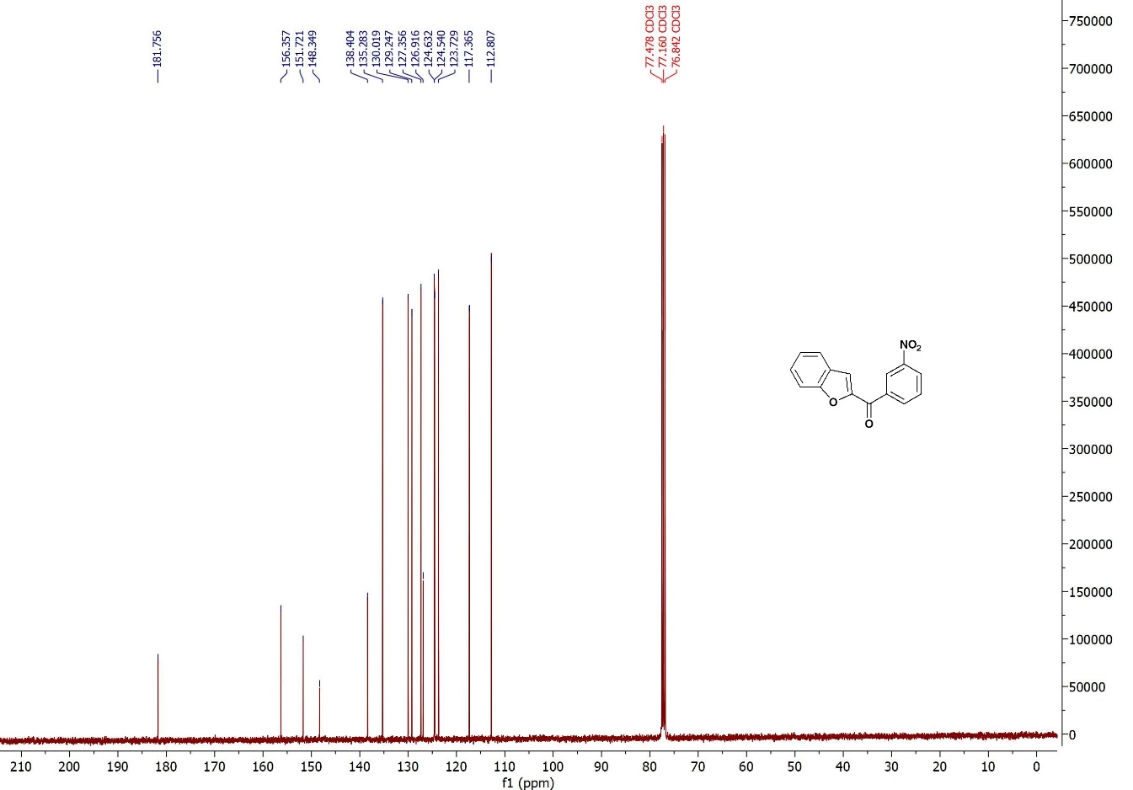
¹³C-NMR (100 MHz, CDCl₃): Benzofuran-2-yl(3-nitrophenyl)methanone
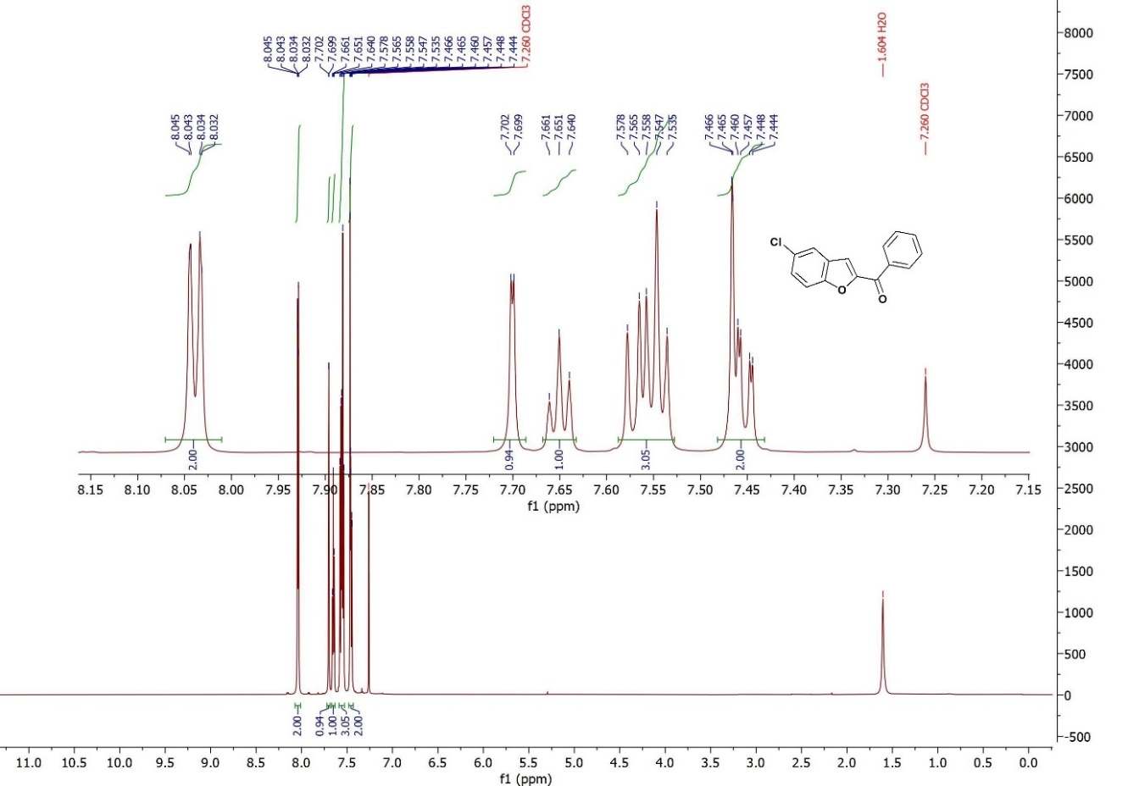
¹H NMR (400 MHz, CDCl₃): (5-Chlorobenzofuran-2-yl)(phenyl)methanone
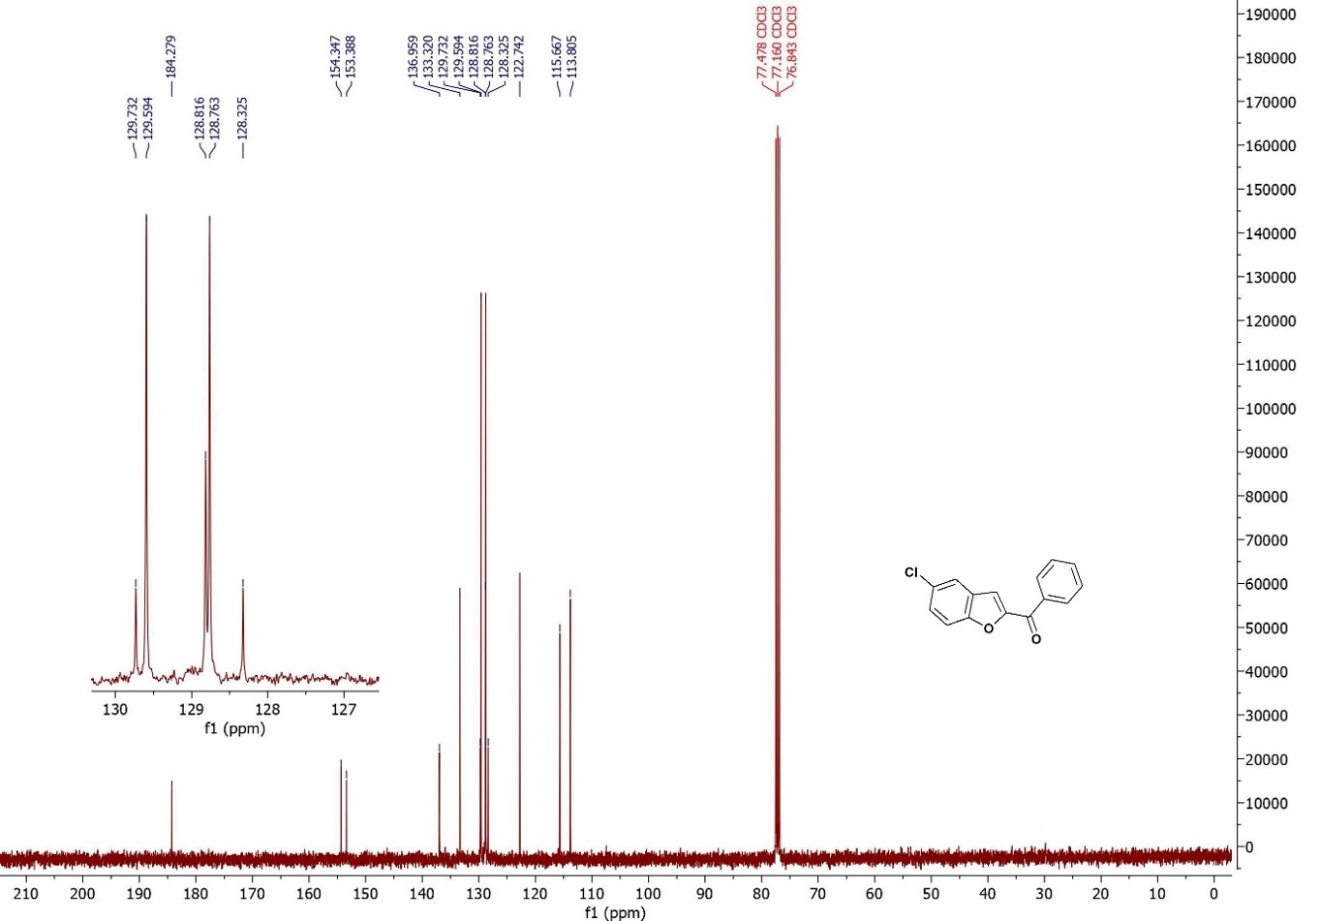
¹³C-NMR (100 MHz, CDCl₃): (5-Chlorobenzofuran-2-yl)(phenyl)methanone
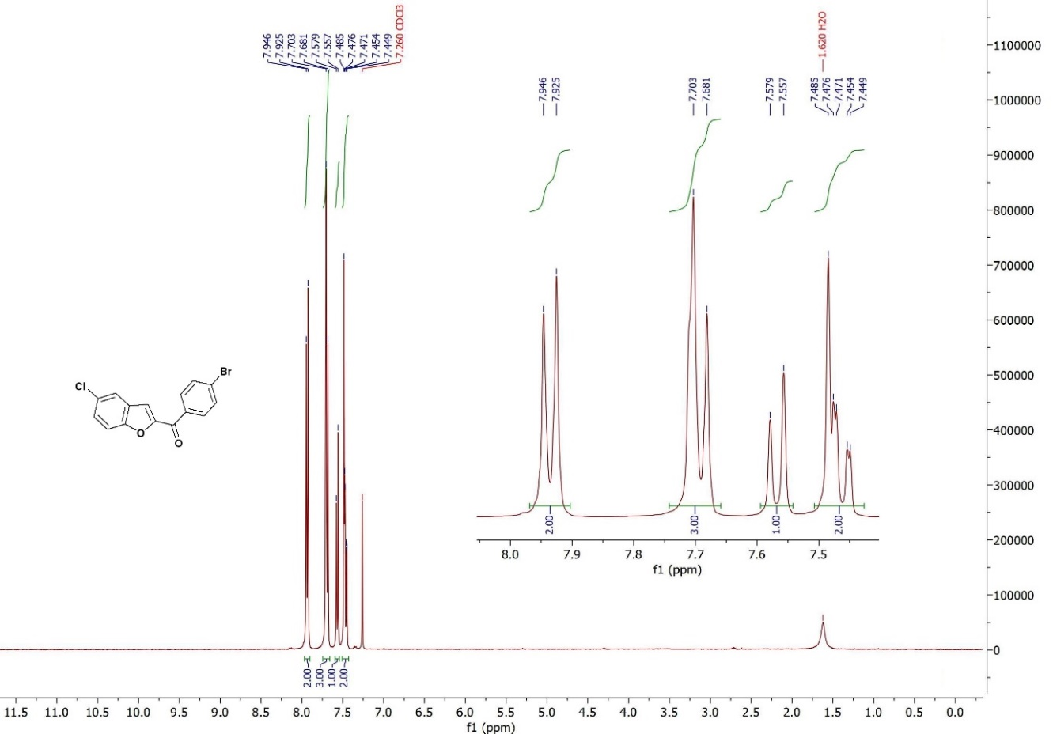
¹H NMR (400 MHz, CDCl₃): (4-Bromophenyl)(5-chlorobenzofuran-2-yl)methanone
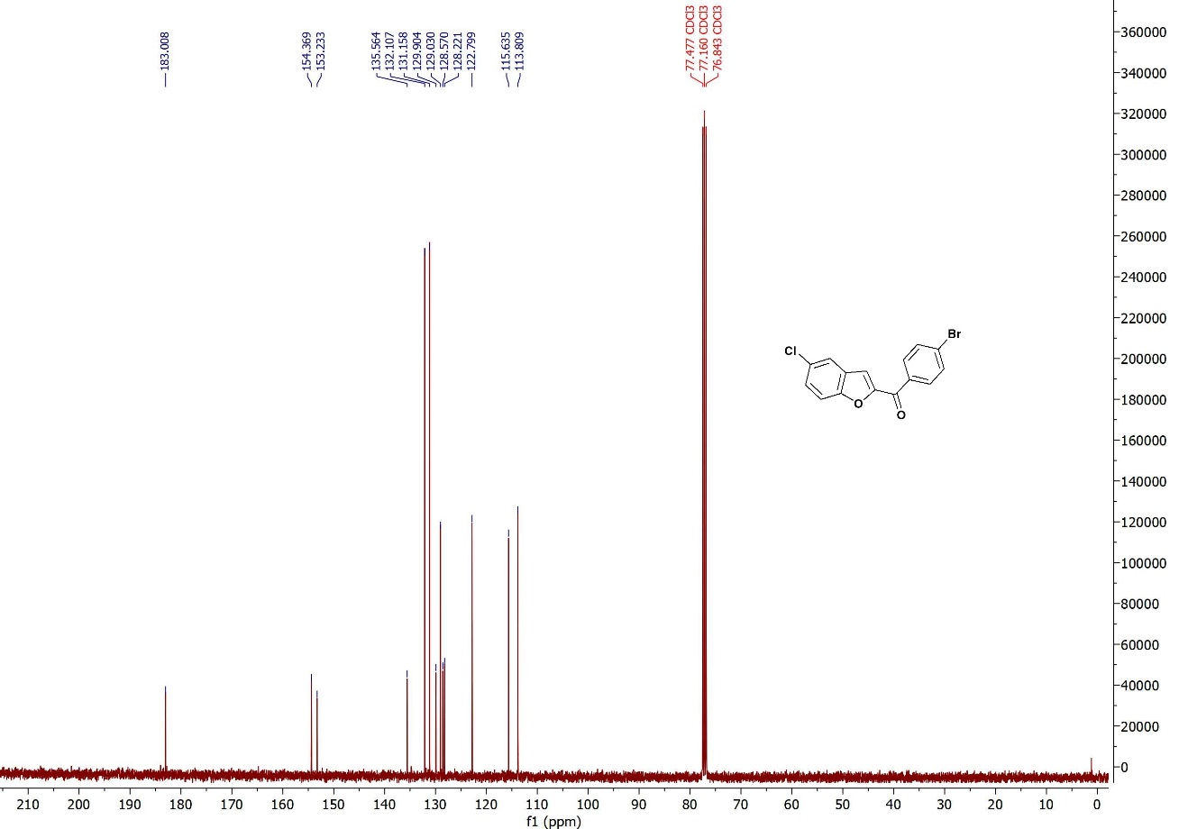
¹³C-NMR (100 MHz, CDCl₃): (4-Bromophenyl)(5-chlorobenzofuran-2-yl)methanone
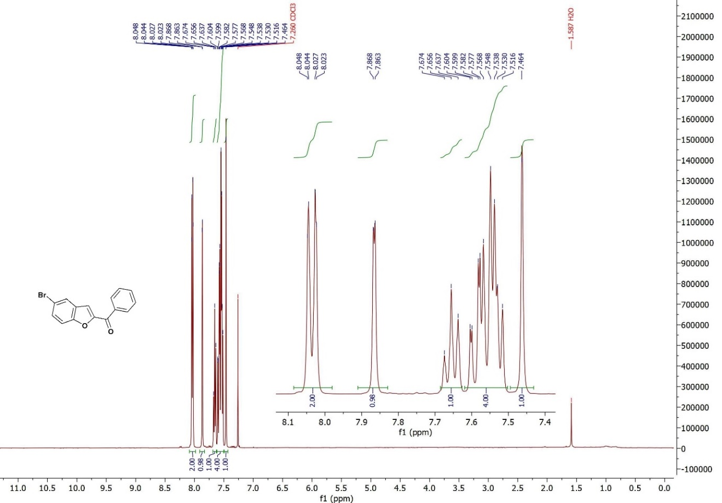
¹H NMR (400 MHz, CDCl₃): (5-Bromobenzofuran-2-yl)(phenyl)methanone
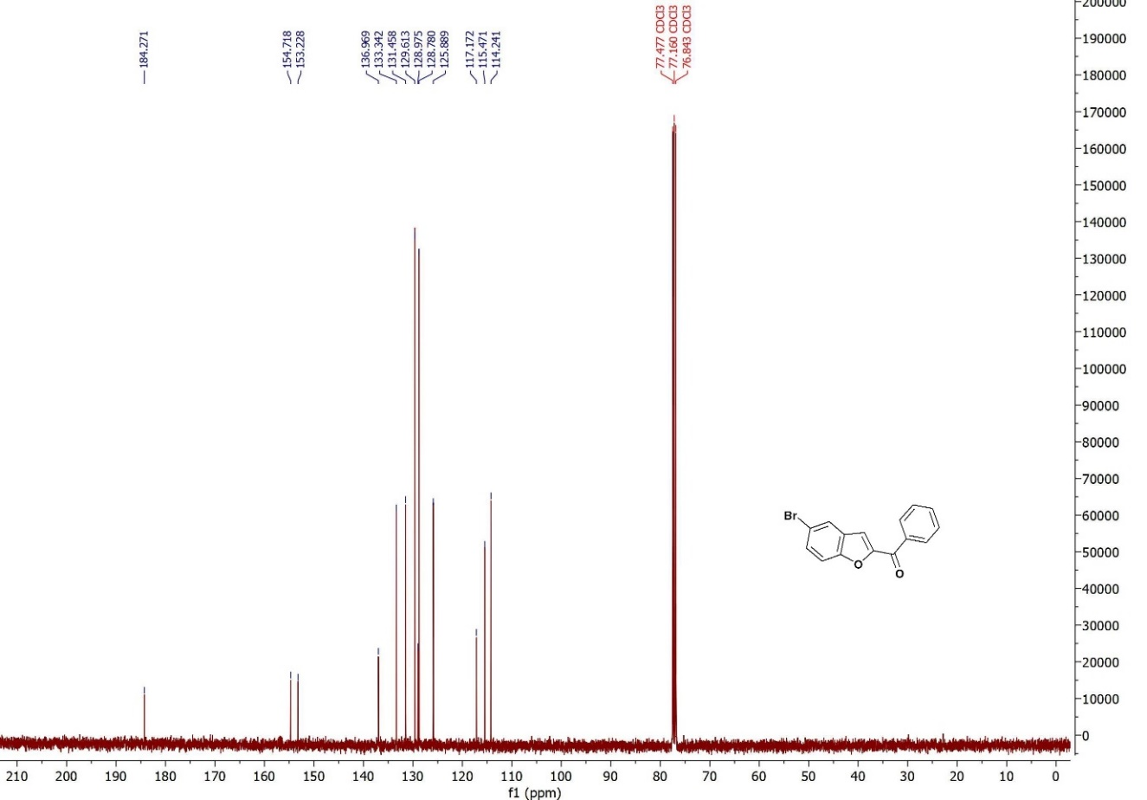
¹³C-NMR (100 MHz, CDCl₃): (5-Bromobenzofuran-2-yl)(phenyl)methanone
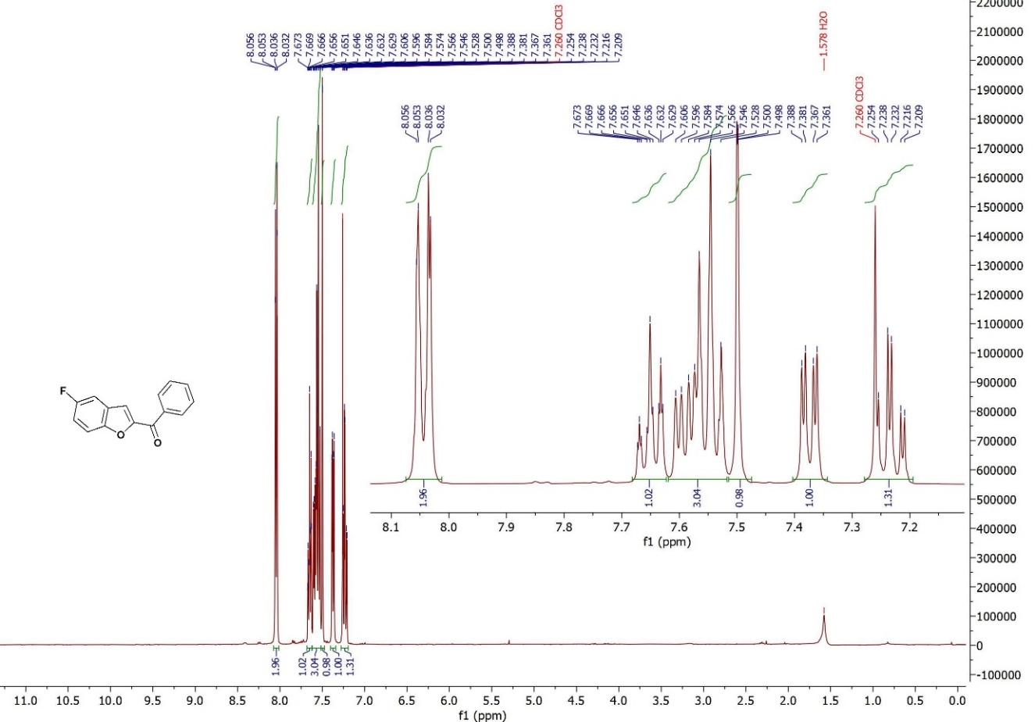
¹H NMR (400 MHz, CDCl₃): (5-Fluorobenzofuran-2-yl)(phenyl)methanone
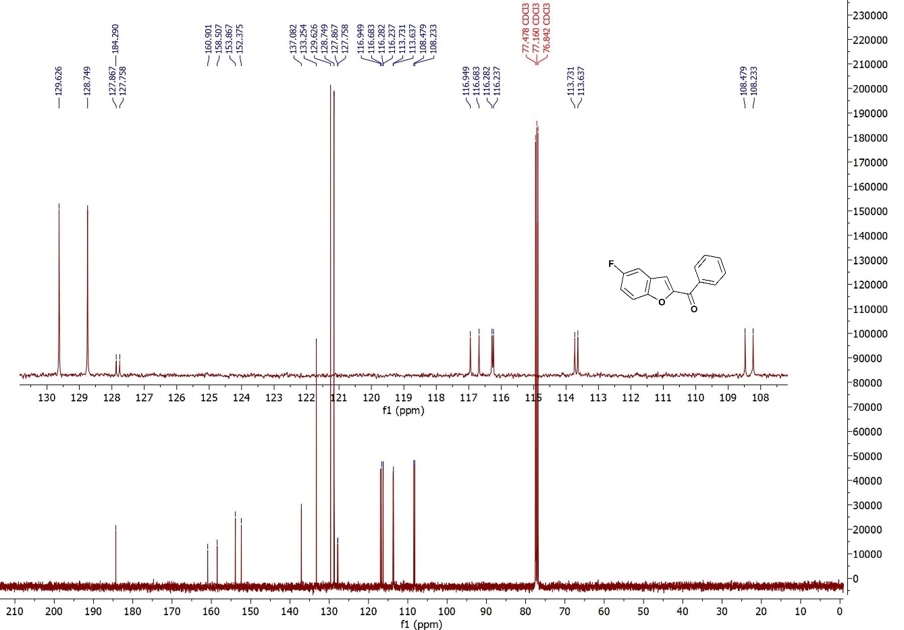
¹³C-NMR (100 MHz, CDCl₃): (5-Fluorobenzofuran-2-yl)(phenyl)methanone
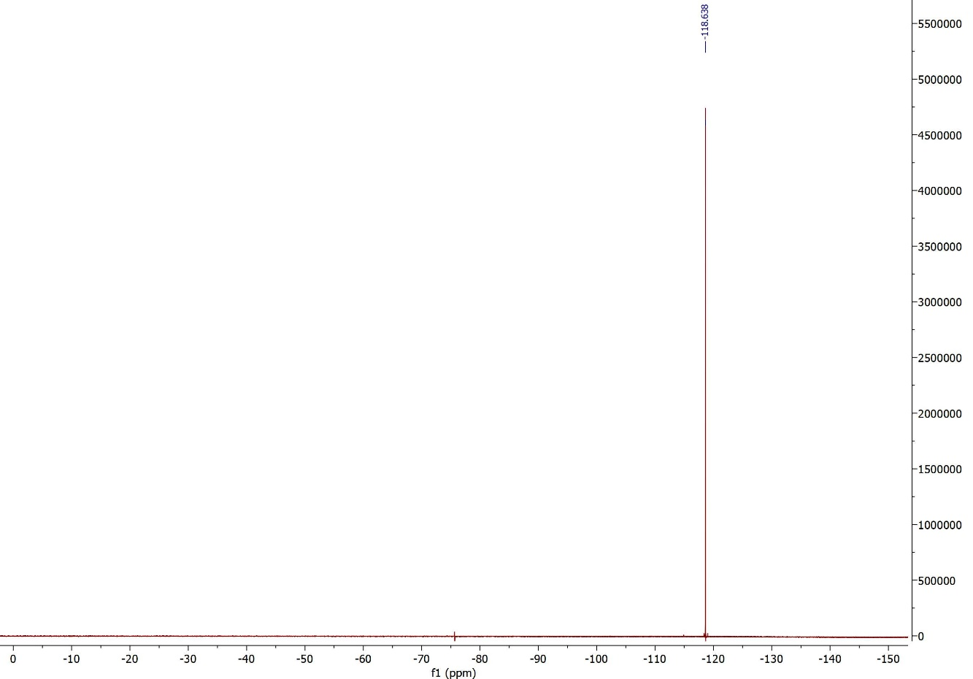
¹⁹F-NMR (376 MHz, CDCl₃) : (5-Fluorobenzofuran-2-yl)(phenyl)methanone
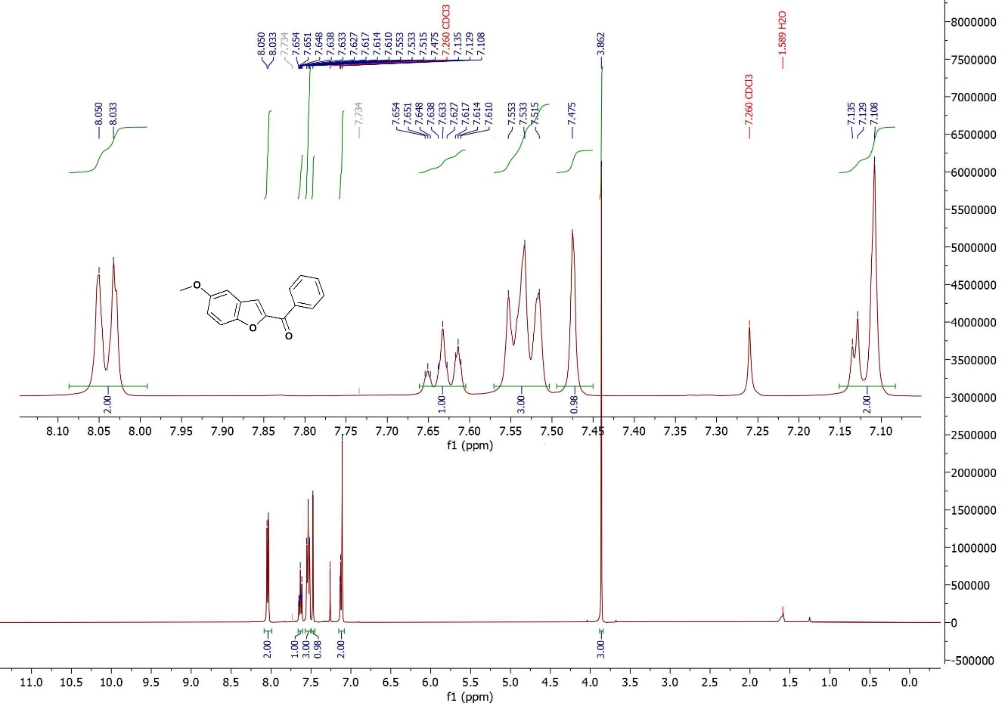
¹H NMR (400 MHz, CDCl₃): (5-Methoxybenzofuran-2-yl)(phenyl)methanone
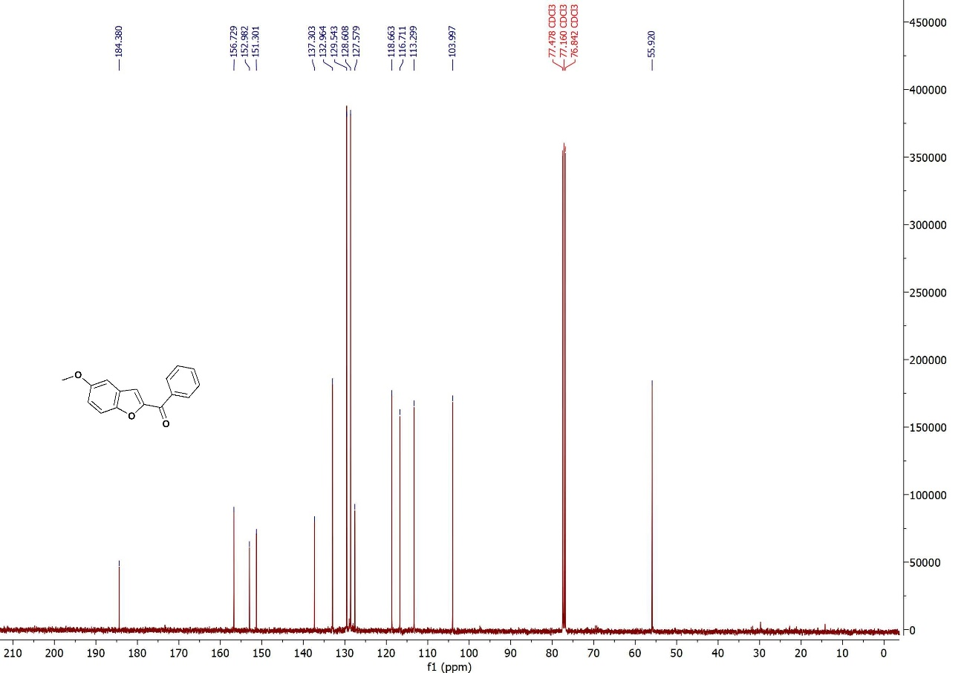
¹³C-NMR (100 MHz, CDCl₃): (5-Methoxybenzofuran-2-yl)(phenyl)methanone
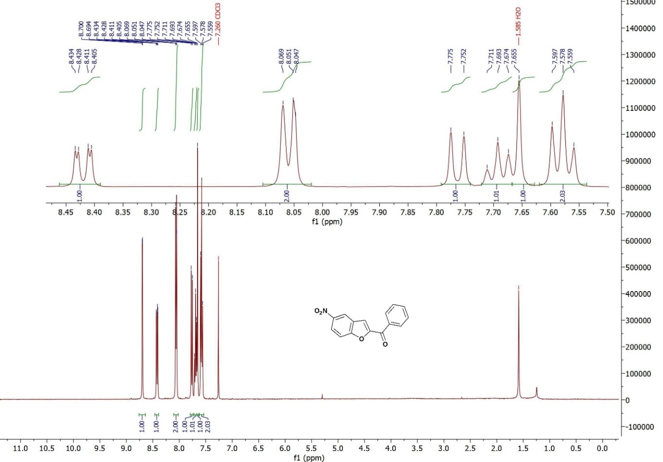
¹H NMR (400 MHz, CDCl₃): (5-Nitrobenzofuran-2-yl)(phenyl)methanone
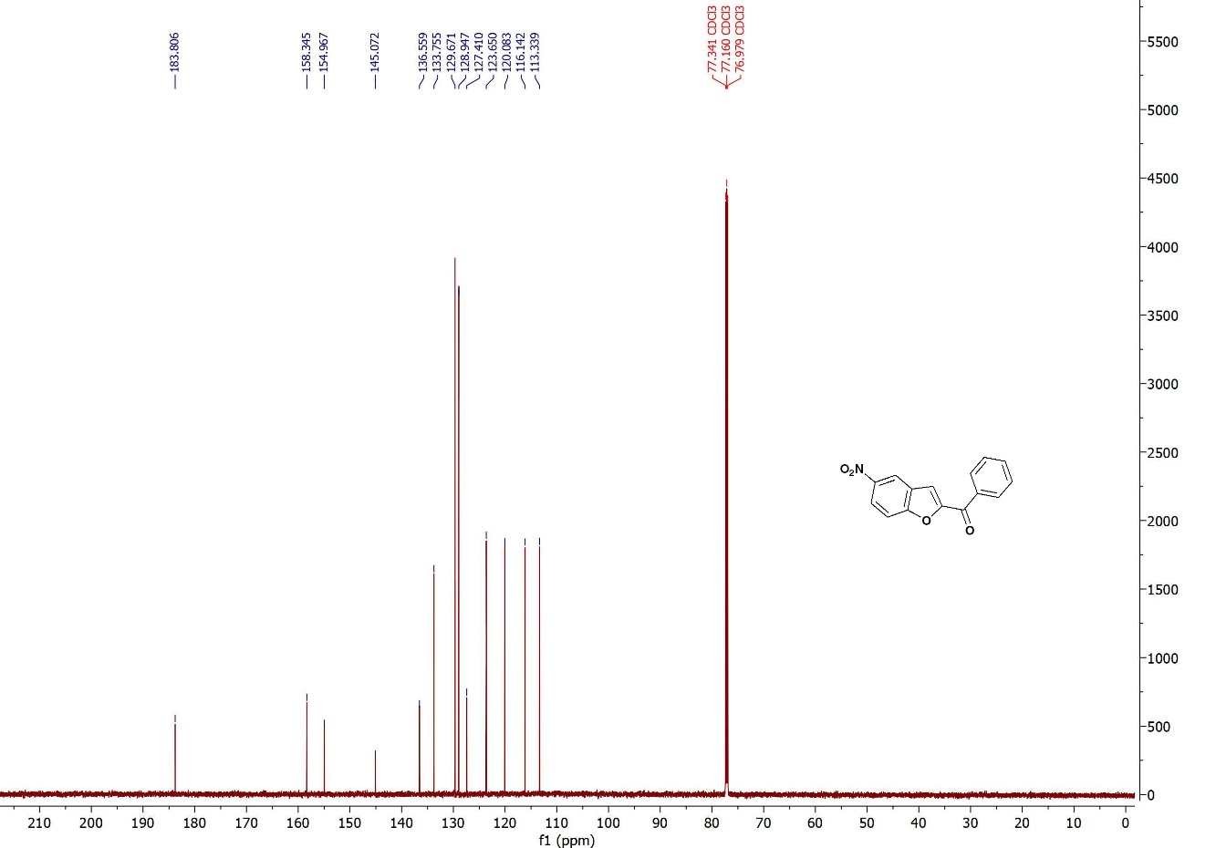
¹³C-NMR (100 MHz, CDCl₃): (5-Nitrobenzofuran-2-yl)(phenyl)methanone
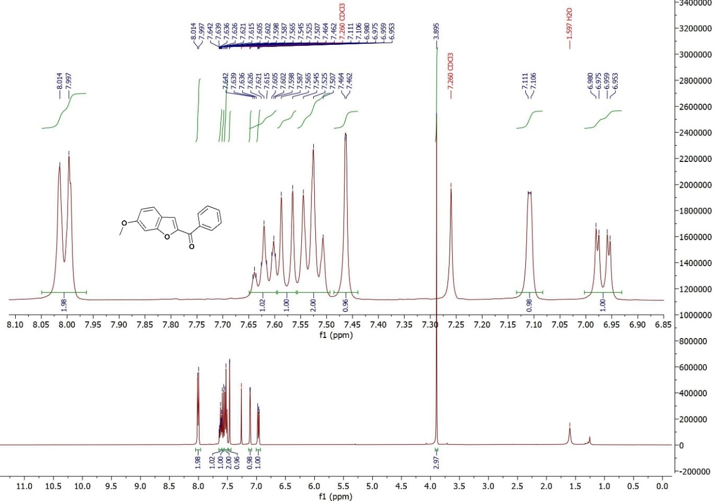
¹H NMR (400 MHz, CDCl₃): (6-Methoxybenzofuran-2-yl)(phenyl)methanone
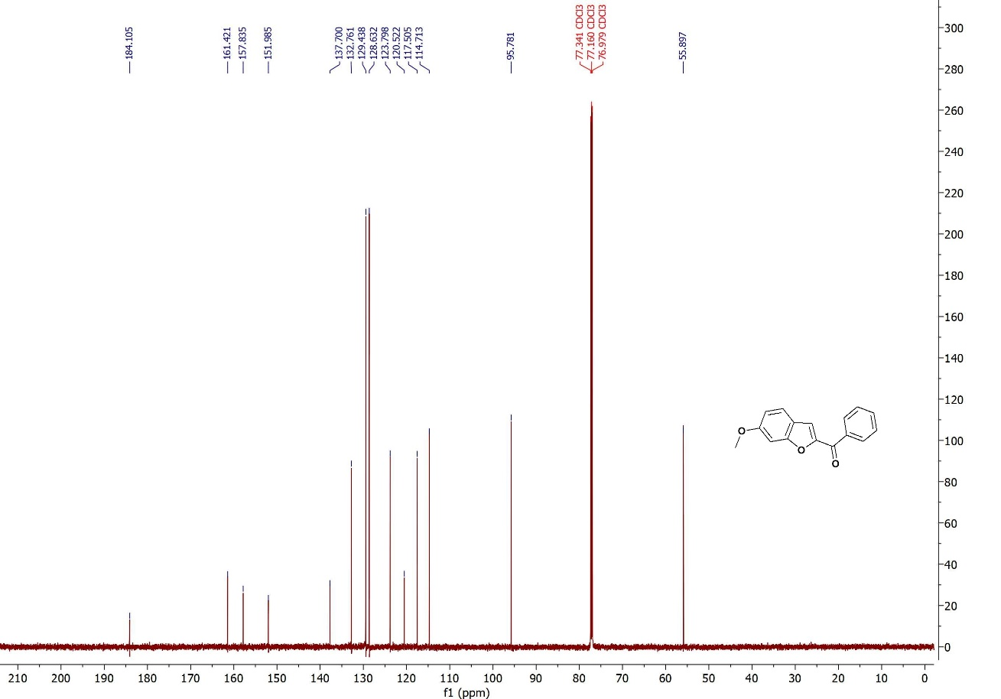
¹³C-NMR (100 MHz, CDCl₃): (6-Methoxybenzofuran-2-yl)(phenyl)methanone

∗ Corresponding author. Tel.: +98-344-334-7061; fax: +98-344-334-7065; e-mail: a.akbari@ujiroft.ac.ir

