Supporting Information for

Bioelectrochemical Intercalation for Scalable Lithium Recovery
Kohei Shimokawa,^{1,2,3†*} Duyen Minh Pham,^{†3,4} Heng Yi Teah,⁵ Xizi Long,³ Yasunori Kikuchi,^{5,6,7*} and Akihiro Okamoto^{3,4,8,9*}
¹Frontier Research Institute for Interdisciplinary Sciences, Tohoku University, 6-3 Aramaki Aza Aoba, Aoba-ku, Sendai, 980-8578, Japan.
²Institute for Materials Research, Tohoku University, 2-1-1 Katahira, Aoba-ku, Sendai, 980-8577, Japan.
³International Center for Materials Nanoarchitectonics (WPI-MANA), National Institute for Materials Science, 1-1 Namiki, Tsukuba, 305-0044, Japan.
⁴Research Center for Macromolecules and Biomaterials, National Institute for Materials Science, 1-1 Namiki, Tsukuba, 305-0044, Japan.
⁵Presidential Endowed Chair for “Platinum Society”, the University of Tokyo, 7-3-1 Hongo, Bunkyo-ku, Tokyo 113-8656, Japan.
⁶Department of Chemical System Engineering, the University of Tokyo, 7-3-1 Hongo, Bunkyo-ku, Tokyo 113-8656, Japan.
⁷Institute for Future Initiatives, the University of Tokyo, 7-3-1 Hongo Bunkyo-ku, Tokyo 113-8654, Japan.
⁸Graduate School of Chemical Sciences and Engineering, Hokkaido University, North 13 West 8, Kita-ku, Sapporo, 060-8628, Japan.
⁹Graduate School of Science and Technology, University of Tsukuba, 1-1-1 Tennodai, Tsukuba, 305-8577, Japan.
†These authors contributed equally to the work.
*Email: kohei.shimokawa.b7@tohoku.ac.jp; ykikuchi@ifi.u-tokyo.ac.jp; okamoto.akihiro@nims.go.jp

Table 1 | Previously reported Li recovery methods.
method | material | Li source (concentration)¹ | process time | reference²
lime-soda evaporation process | - | Li-rich brine (30–550 mM) | 1–2 years | [9]
electrochemical intercalation | λ-MnO₂ | LiCl solution (0.05–200 mM) | several hours | [5]
electrical ion pump (membrane type) | Li ionic superconductor | seawater (~0.030 mM) | 100 hours/5 cycles | [22]
electrochemical intercalation | TiO₂ coated LiFePO₄ | seawater (~0.026 mM) | several hours (Li/Na 1/1) | [11]
electrochemical ion pump (battery type) | λ-MnO₂ | artificial brine (30 mM) | 1 hour | [13]
ion exchange (adsorption) | H₂TiO₃ | brine (~230 mM) | 24 hours | [19]
electrochemical ion pump (battery type) | λ-MnO₂ | artificial brine (100 mM) | 11 hours | [12]
electrochemical intercalation | λ-MnO₂ film on Pt | artificial brine (30 mM) | 2 hours | [14]
ion exchange (adsorption) | granulated λ-MnO₂ | Li-spiked seawater (~4 mM) | several days | [18]
electrochemical intercalation | LiFePO₄ | LiCl solution (5 mM) | several hours | [15]
electrochemical intercalation | LiNi_{1/3}Co_{1/3}Mn_{1/3}O₂ | LiCl solution (30 mM) | 20 min/step | [16]
electrochemical intercalation | LiNi_{0.5}Mn_{1.5}O₄ | LiCl solution (30 mM) | 20 min/step | [17]
ion exchange (adsorption) | H_{1.6}Mn_{1.6}O₄ | seawater (~0.024 mM) | 2 days (61% recovery) | [20]
ion exchange (adsorption) | H_{1.6}Mn_{1.6}O₄ | brine (~230 mM) | 8 hours | [21]
¹Concentration of Li provided in each paper is converted into a value in the unit of mM.
²The reference numbers are corresponding to those in the main article.

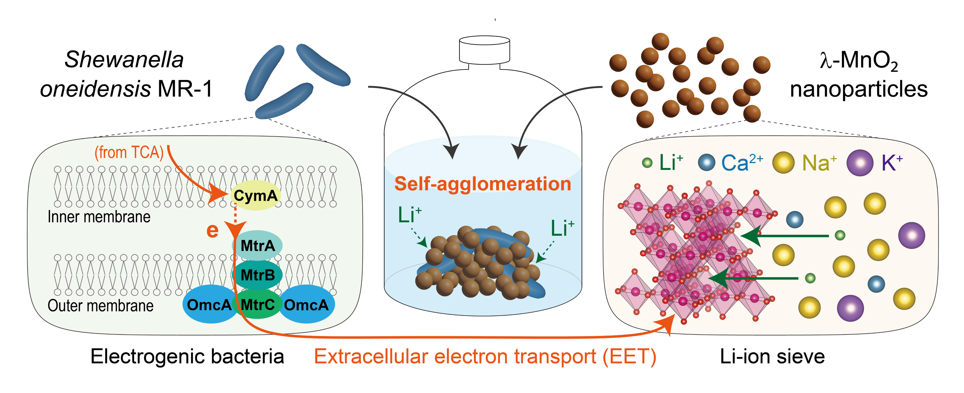
Fig. 1 | Concept of bioelectrochemical intercalation. Shewanella oneidensis MR-1, electrogenic bacteria, provides electrons outside the cell by extracellular electron transport (EET). On the other hand, λ-MnO₂ with a spinel structure is a Li-ion sieve that prevents the intercalation of larger ions (e.g., Na⁺, K⁺, Ca²⁺). In this method, agglomerates composed of MR-1 and λ-MnO₂ spontaneously form on the bottom of the reactor, and Li⁺ in the solution intercalate into λ-MnO₂ due to the charge compensation for electrons supplied by MR-1.

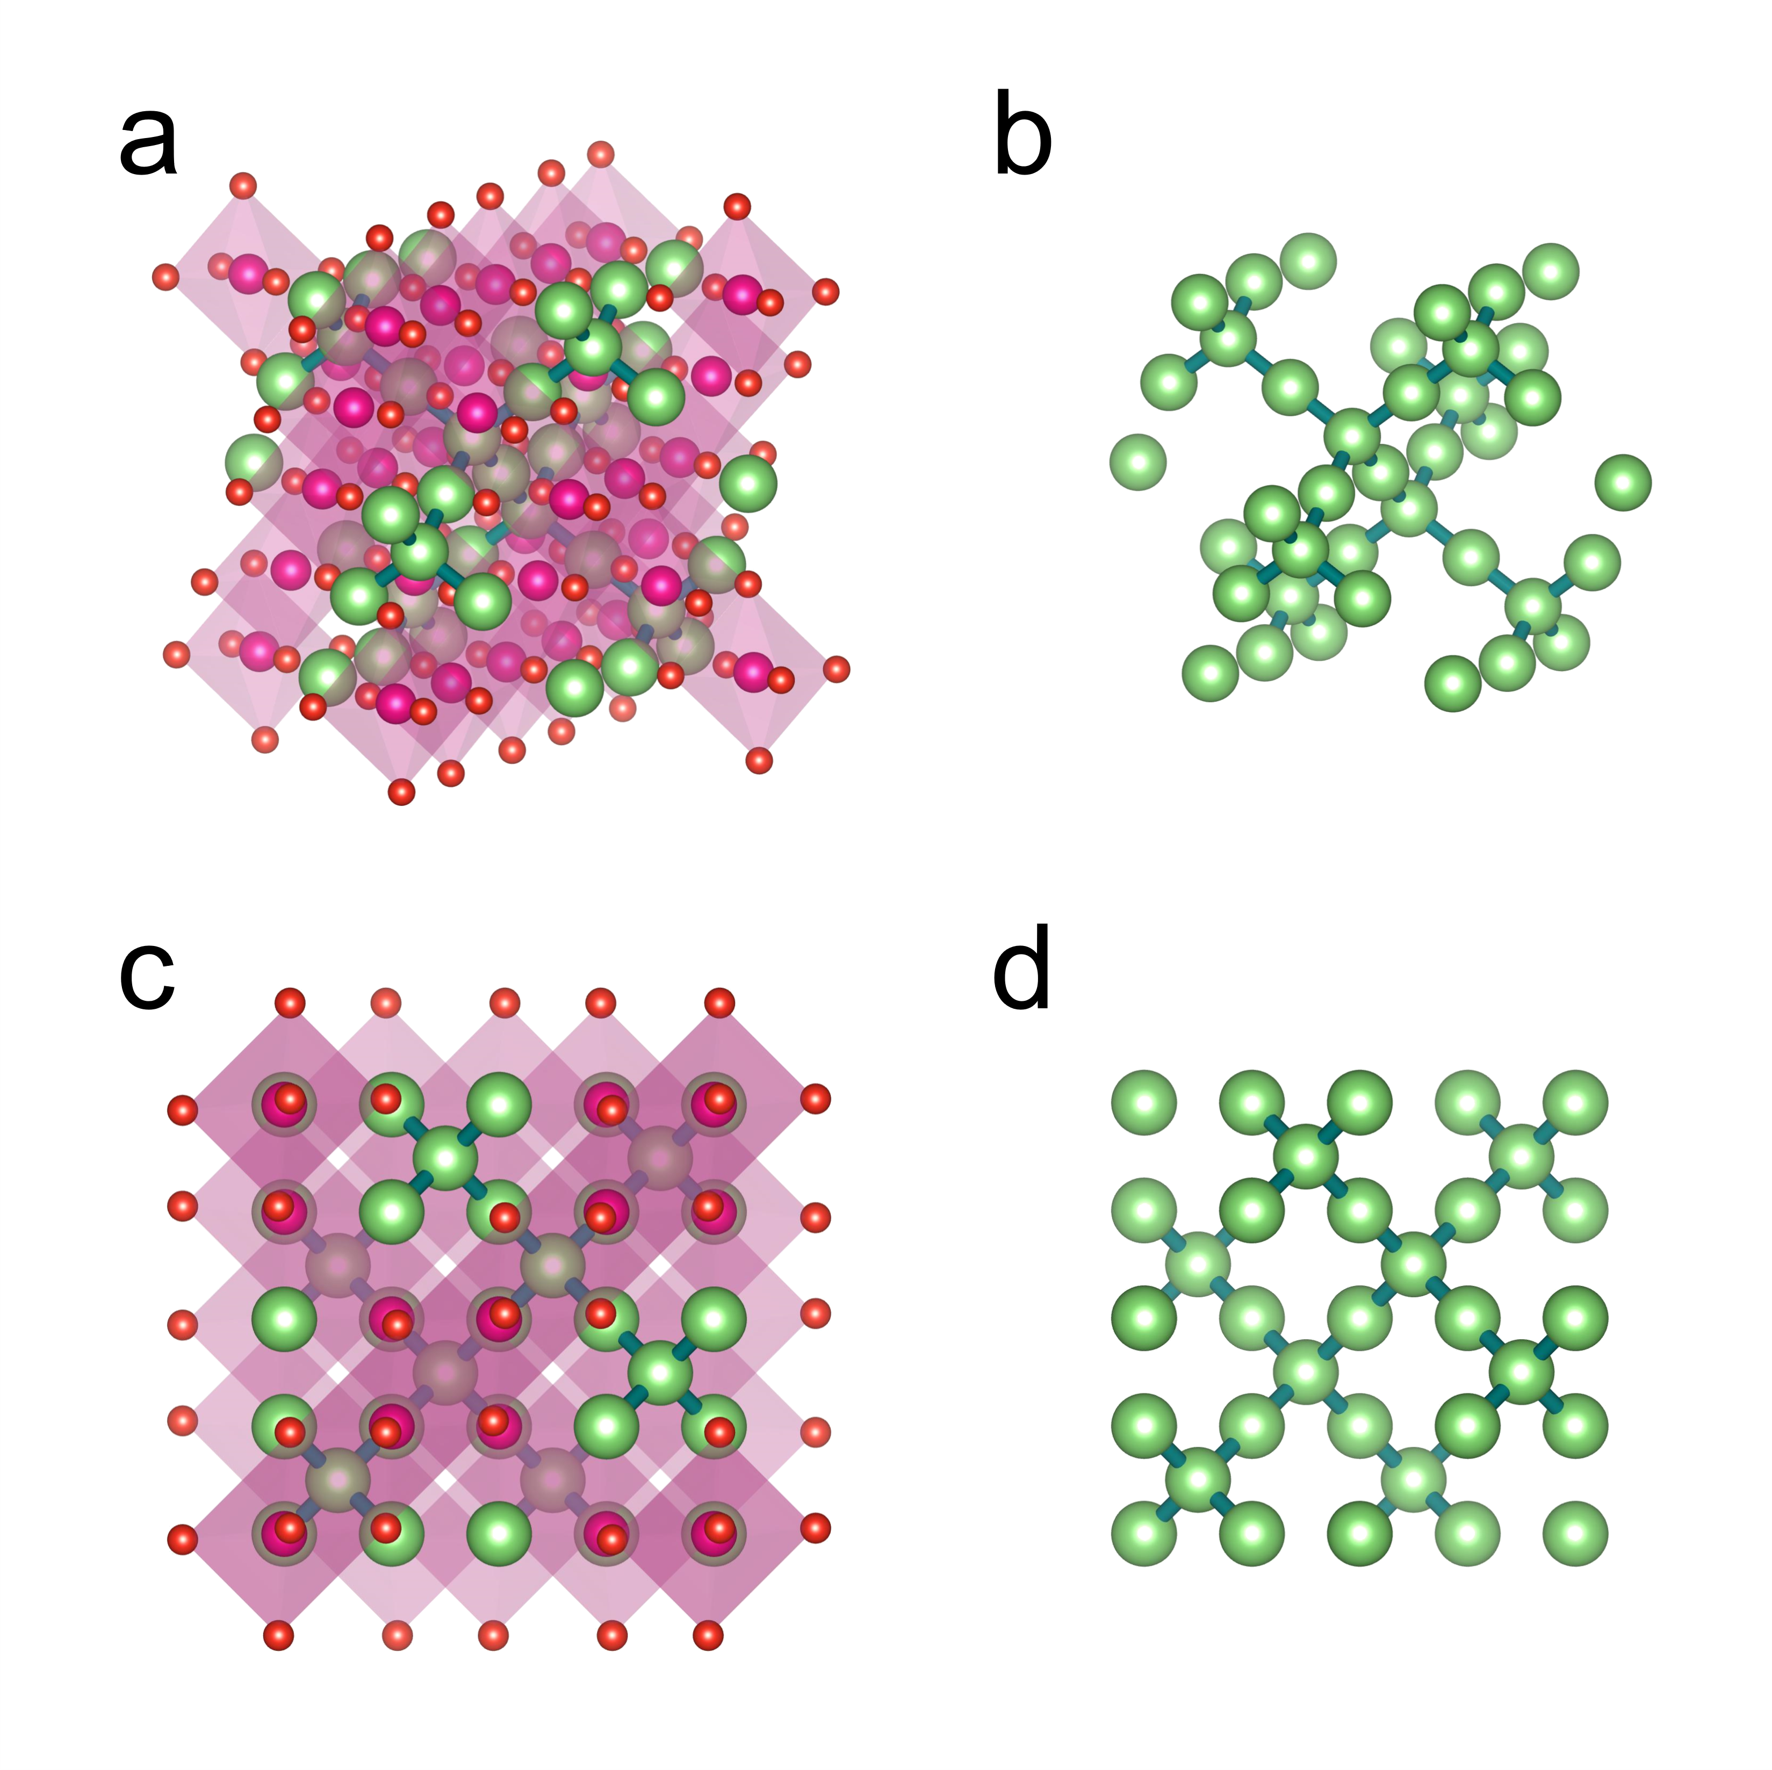
Fig. 2 | Diffusion paths of Li ions in λ-MnO₂. (a) Crystal structure of λ-MnO₂ with (b) the three-dimensional diffusion paths of Li ions in the spinel lattice. The pictures viewed directly above are shown in (c) and (d). There are two sites for cations to sit in the spinel lattice, 8a and 16c in the space group $Fd\overline{3}m$, and they form the three-dimensional network for diffusion. Visualization was carried out by using VESTA^{[S1]}.

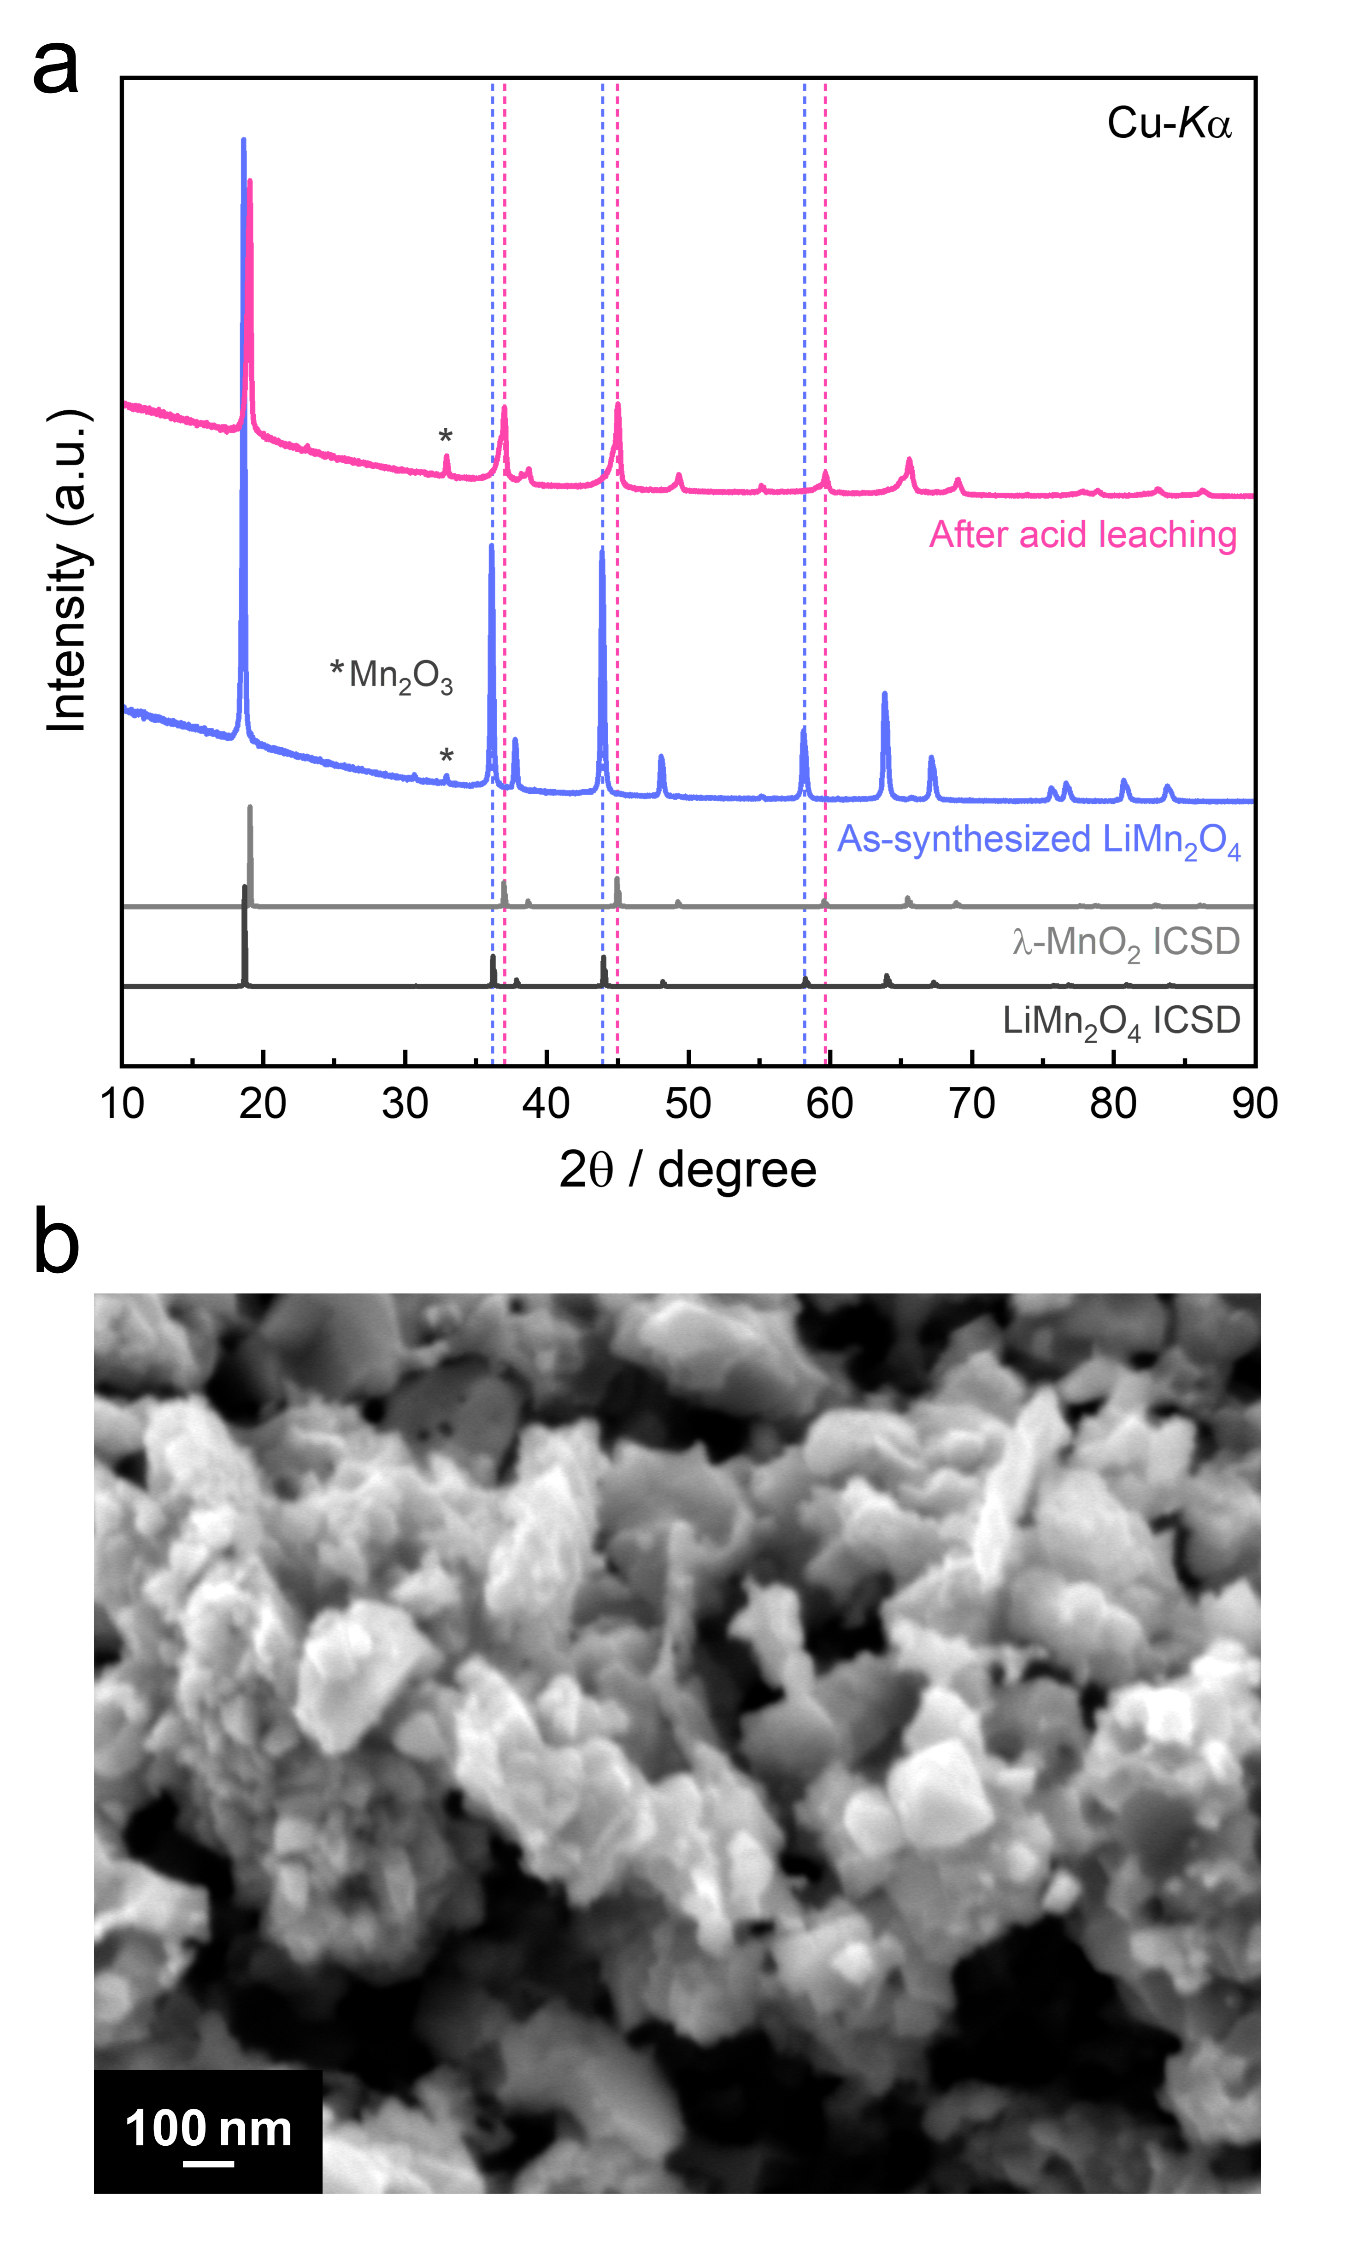
Fig. 3 | Synthesis of λ-MnO₂ nanoparticles. (a) XRD profiles for the materials before and after the acid leaching process for LiMn₂O₄. Rietveld analysis using the program RIETAN-FP^{[S2]} revealed that the lattice constant was reduced to ~8.037 Å, in good agreement with that of reported λ-MnO₂.^{[S3,S4]} (b) SEM image of the prepared λ-MnO₂ nanoparticles.

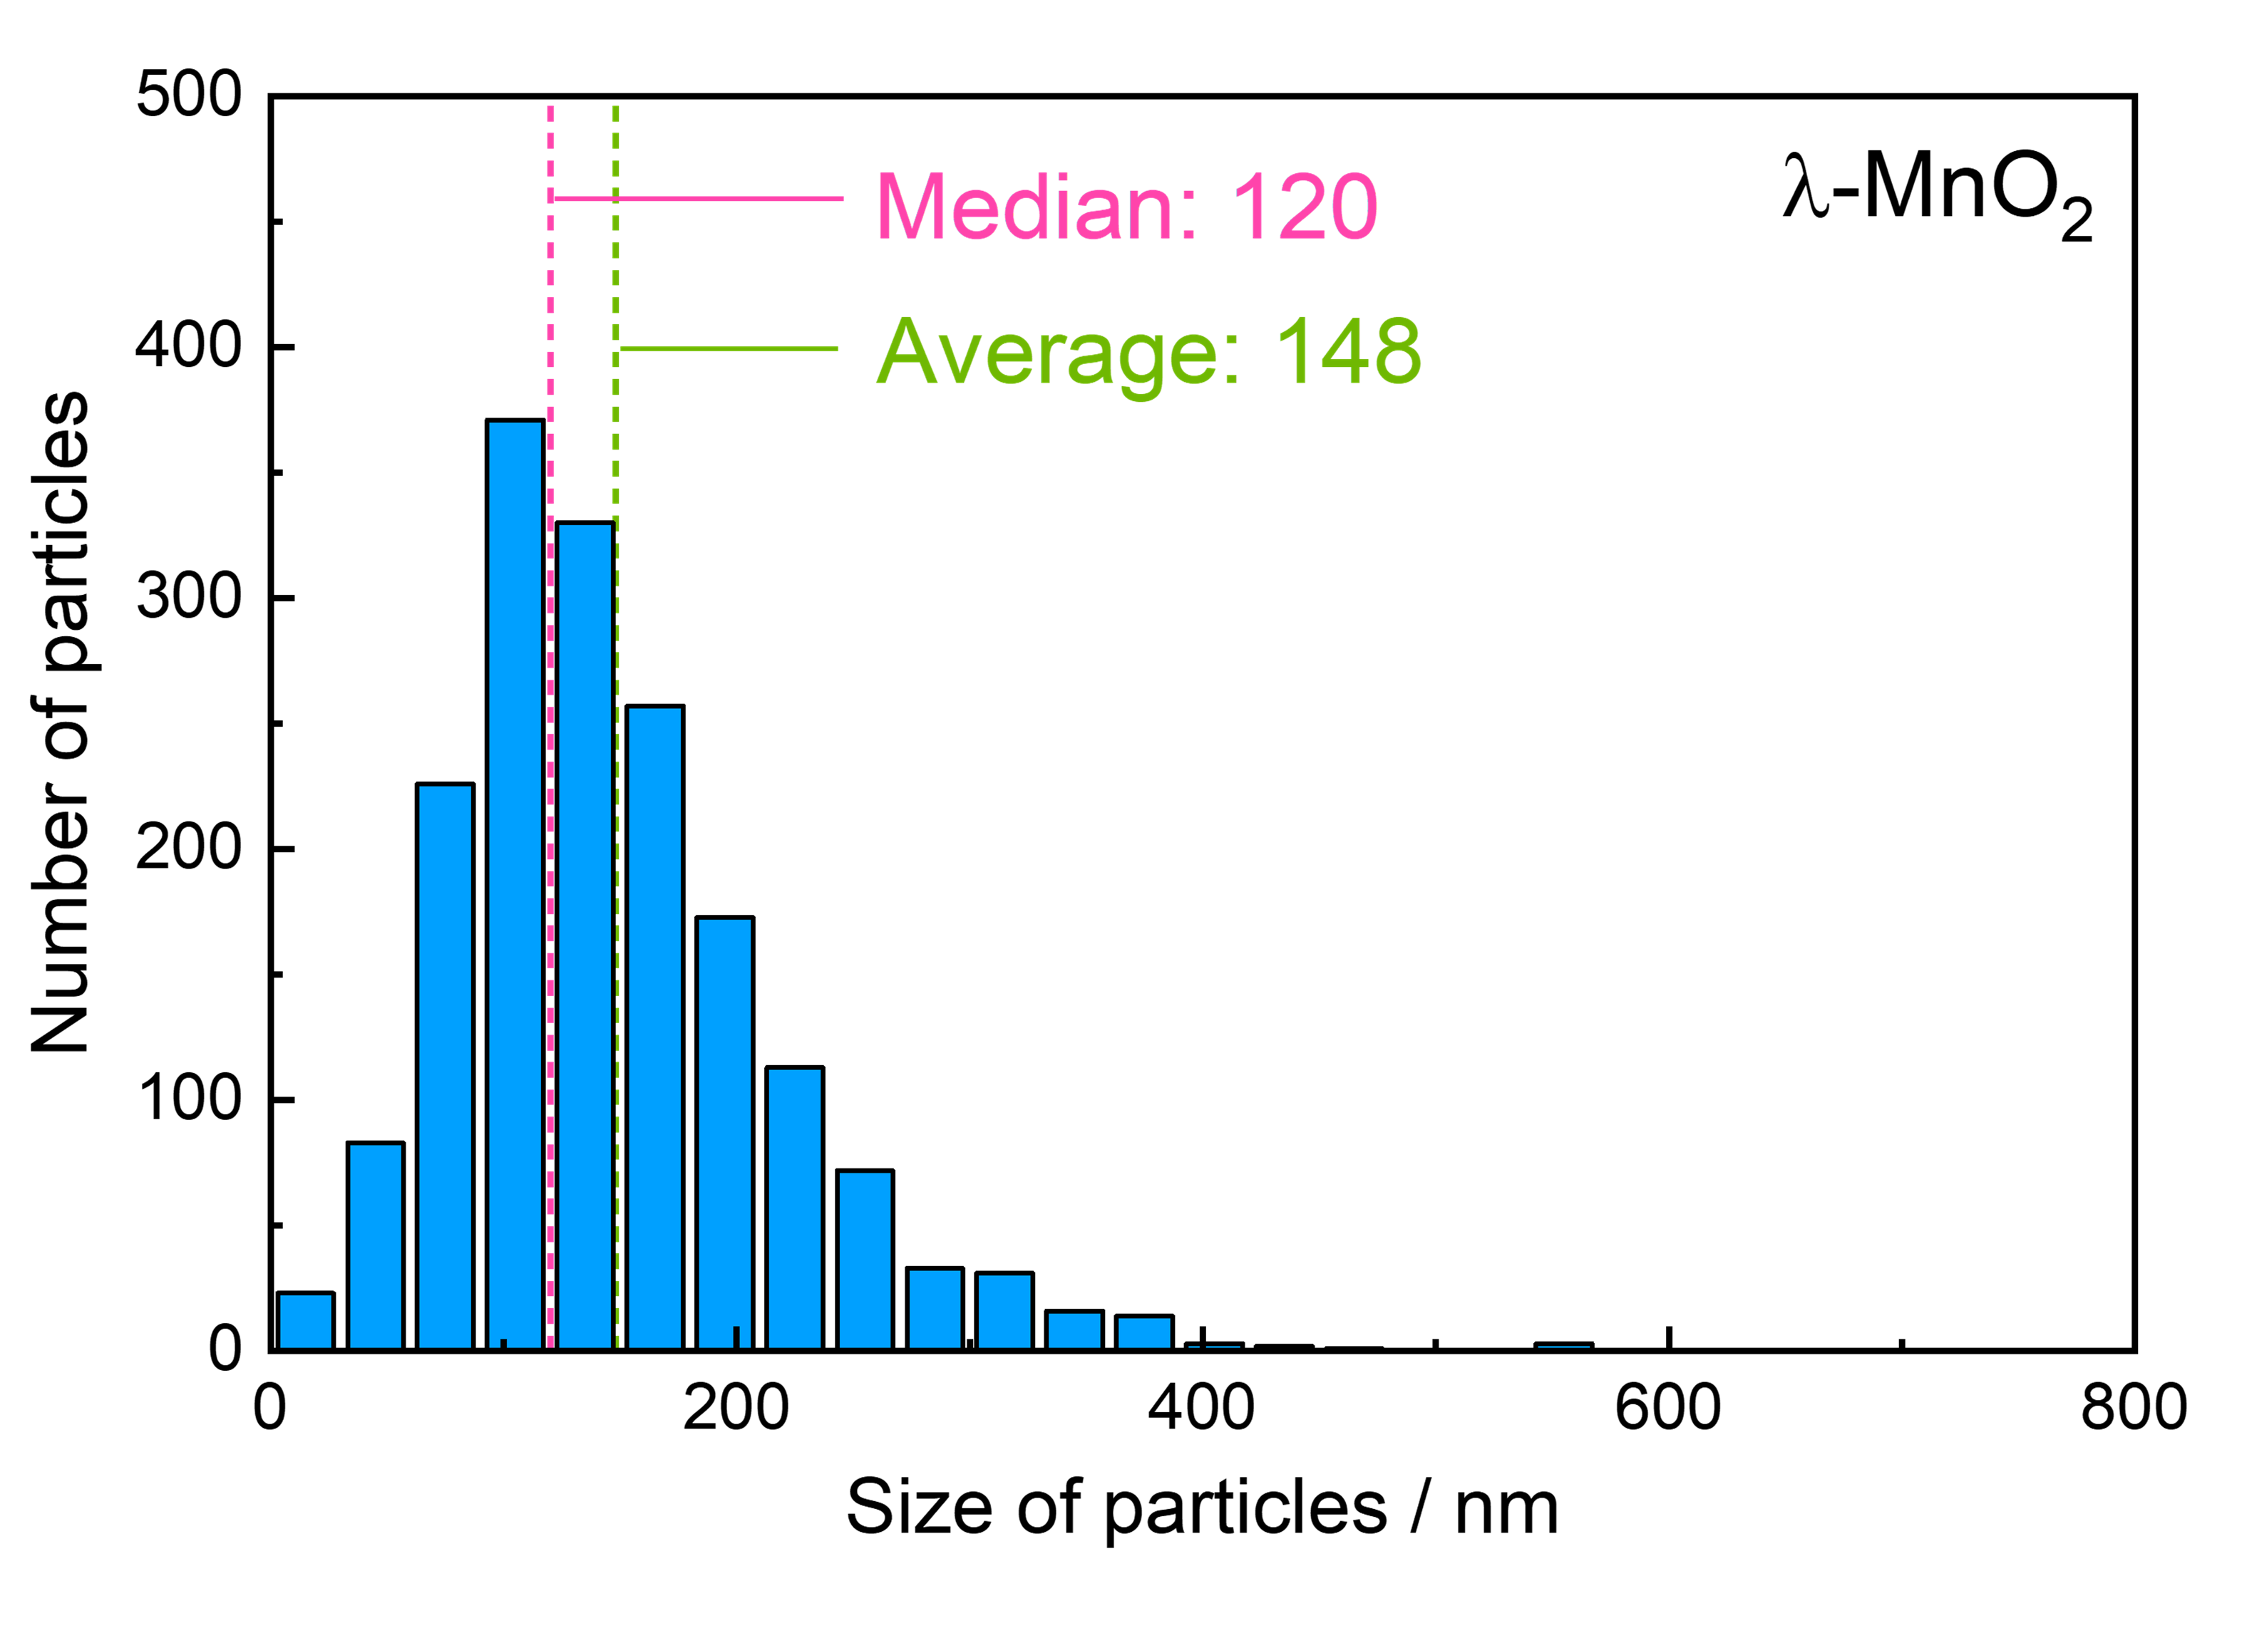
Fig. 4 | Size of dispersed λ-MnO₂. Size distribution of the prepared λ-MnO₂ nanoparticles dispersed in water determined by using a nanoparticle tracking analyzer. The average and median values were smaller than those of LiMn₂O₄ synthesized via the same route,^{[S5]} suggesting that the particle size downscaled during the acid leaching process.

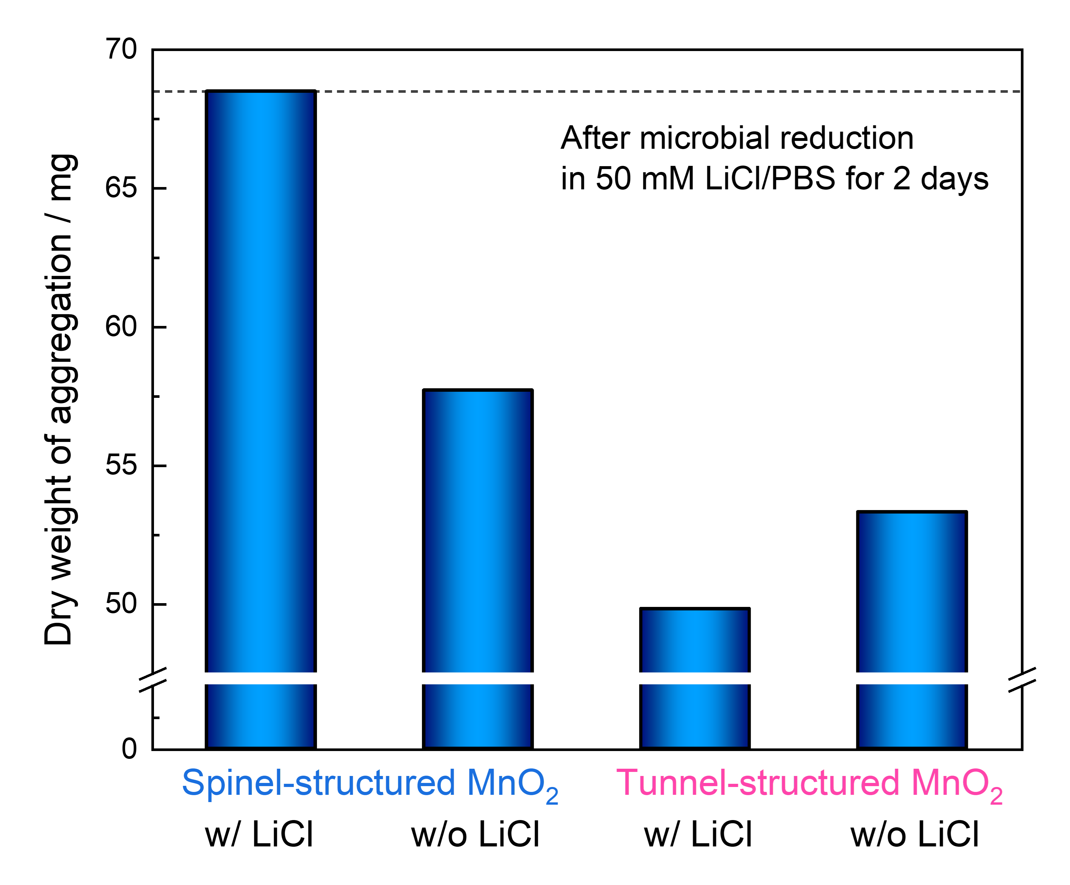
Fig. 5 | Dry weight after microbial reduction. Comparison of the dry weight after microbial reduction for 2 days between spinel- and tunnel-structured MnO₂. The dry weight of the mixture of materials/microbes was 68 mg when we used λ-MnO₂ in LiCl/PBS, while it remarkably decreased for other conditions especially for tunnel-structured MnO₂, suggesting dissolution by the microbial reduction.

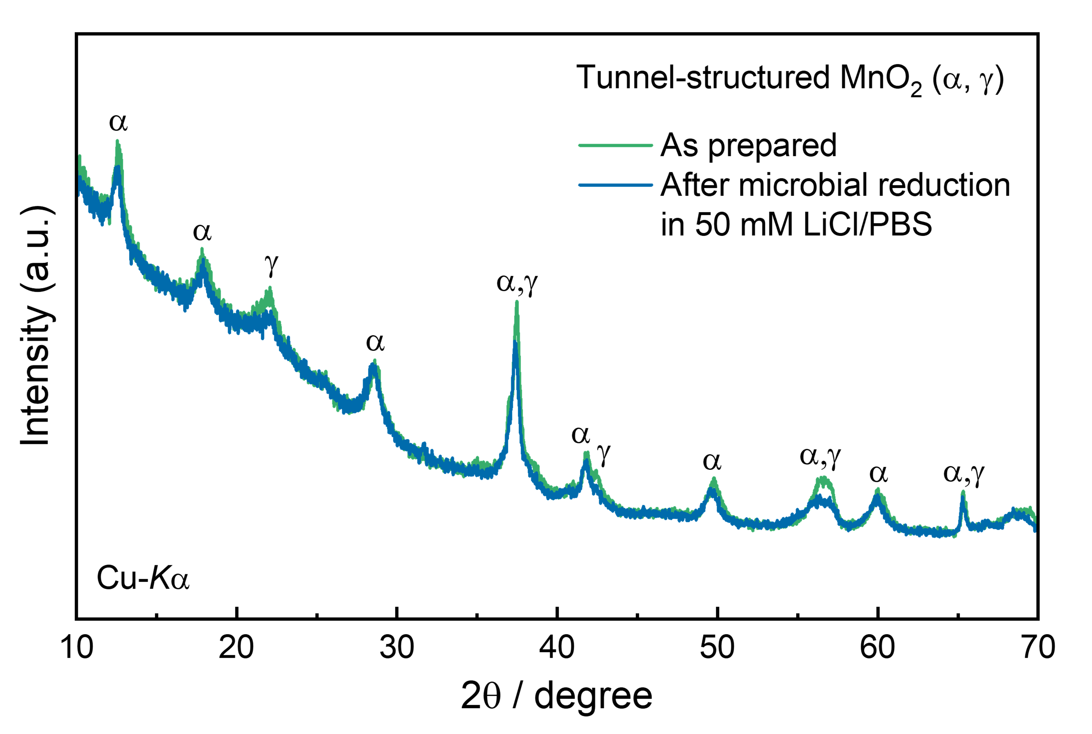
Fig. 6 | Crystal structures of tunnel-structured MnO₂. XRD profiles of the tunnel-structured MnO₂ (α, γ) before and after microbial reduction in 50 mM LiCl/PBS. Little change in the crystal structure was indicated while the intensity of diffraction peaks decreased, indicating that dissolution is preferential to the Li intercalation reaction.

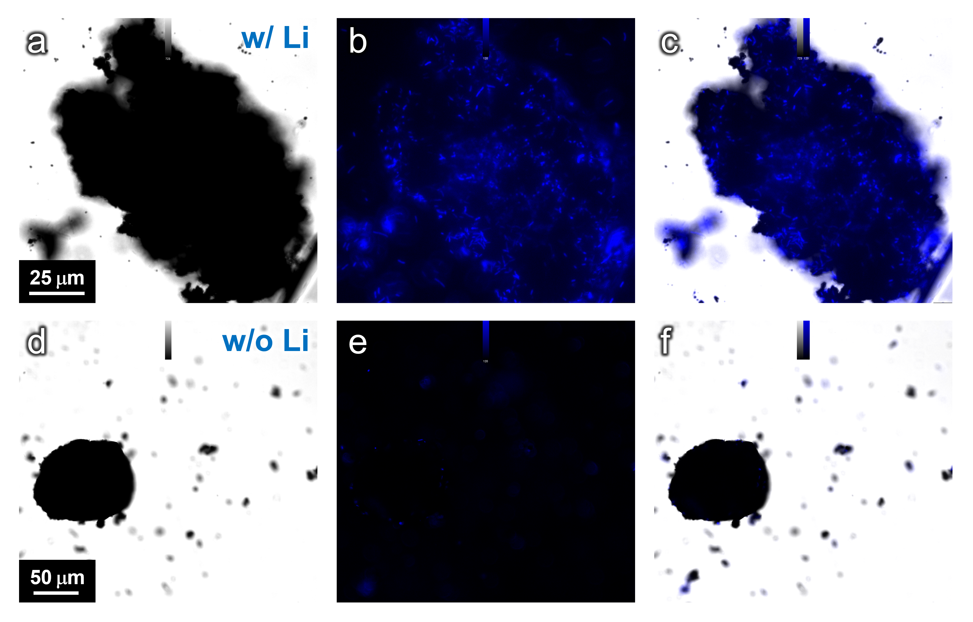
Fig. 7 | DAPI-staining image. Bright-field and fluorescence microscopy for resuspended precipitation prepared in (a–c) 10 mM LiCl/PBS solution and (d–f) PBS without LiCl. DNA-stained MR-1 cells were indicated in the agglomerates formed in LiCl/PBS. In contrast, there were few agglomerates in the absence of LiCl. Although we found one big particle, microbes were not involved.

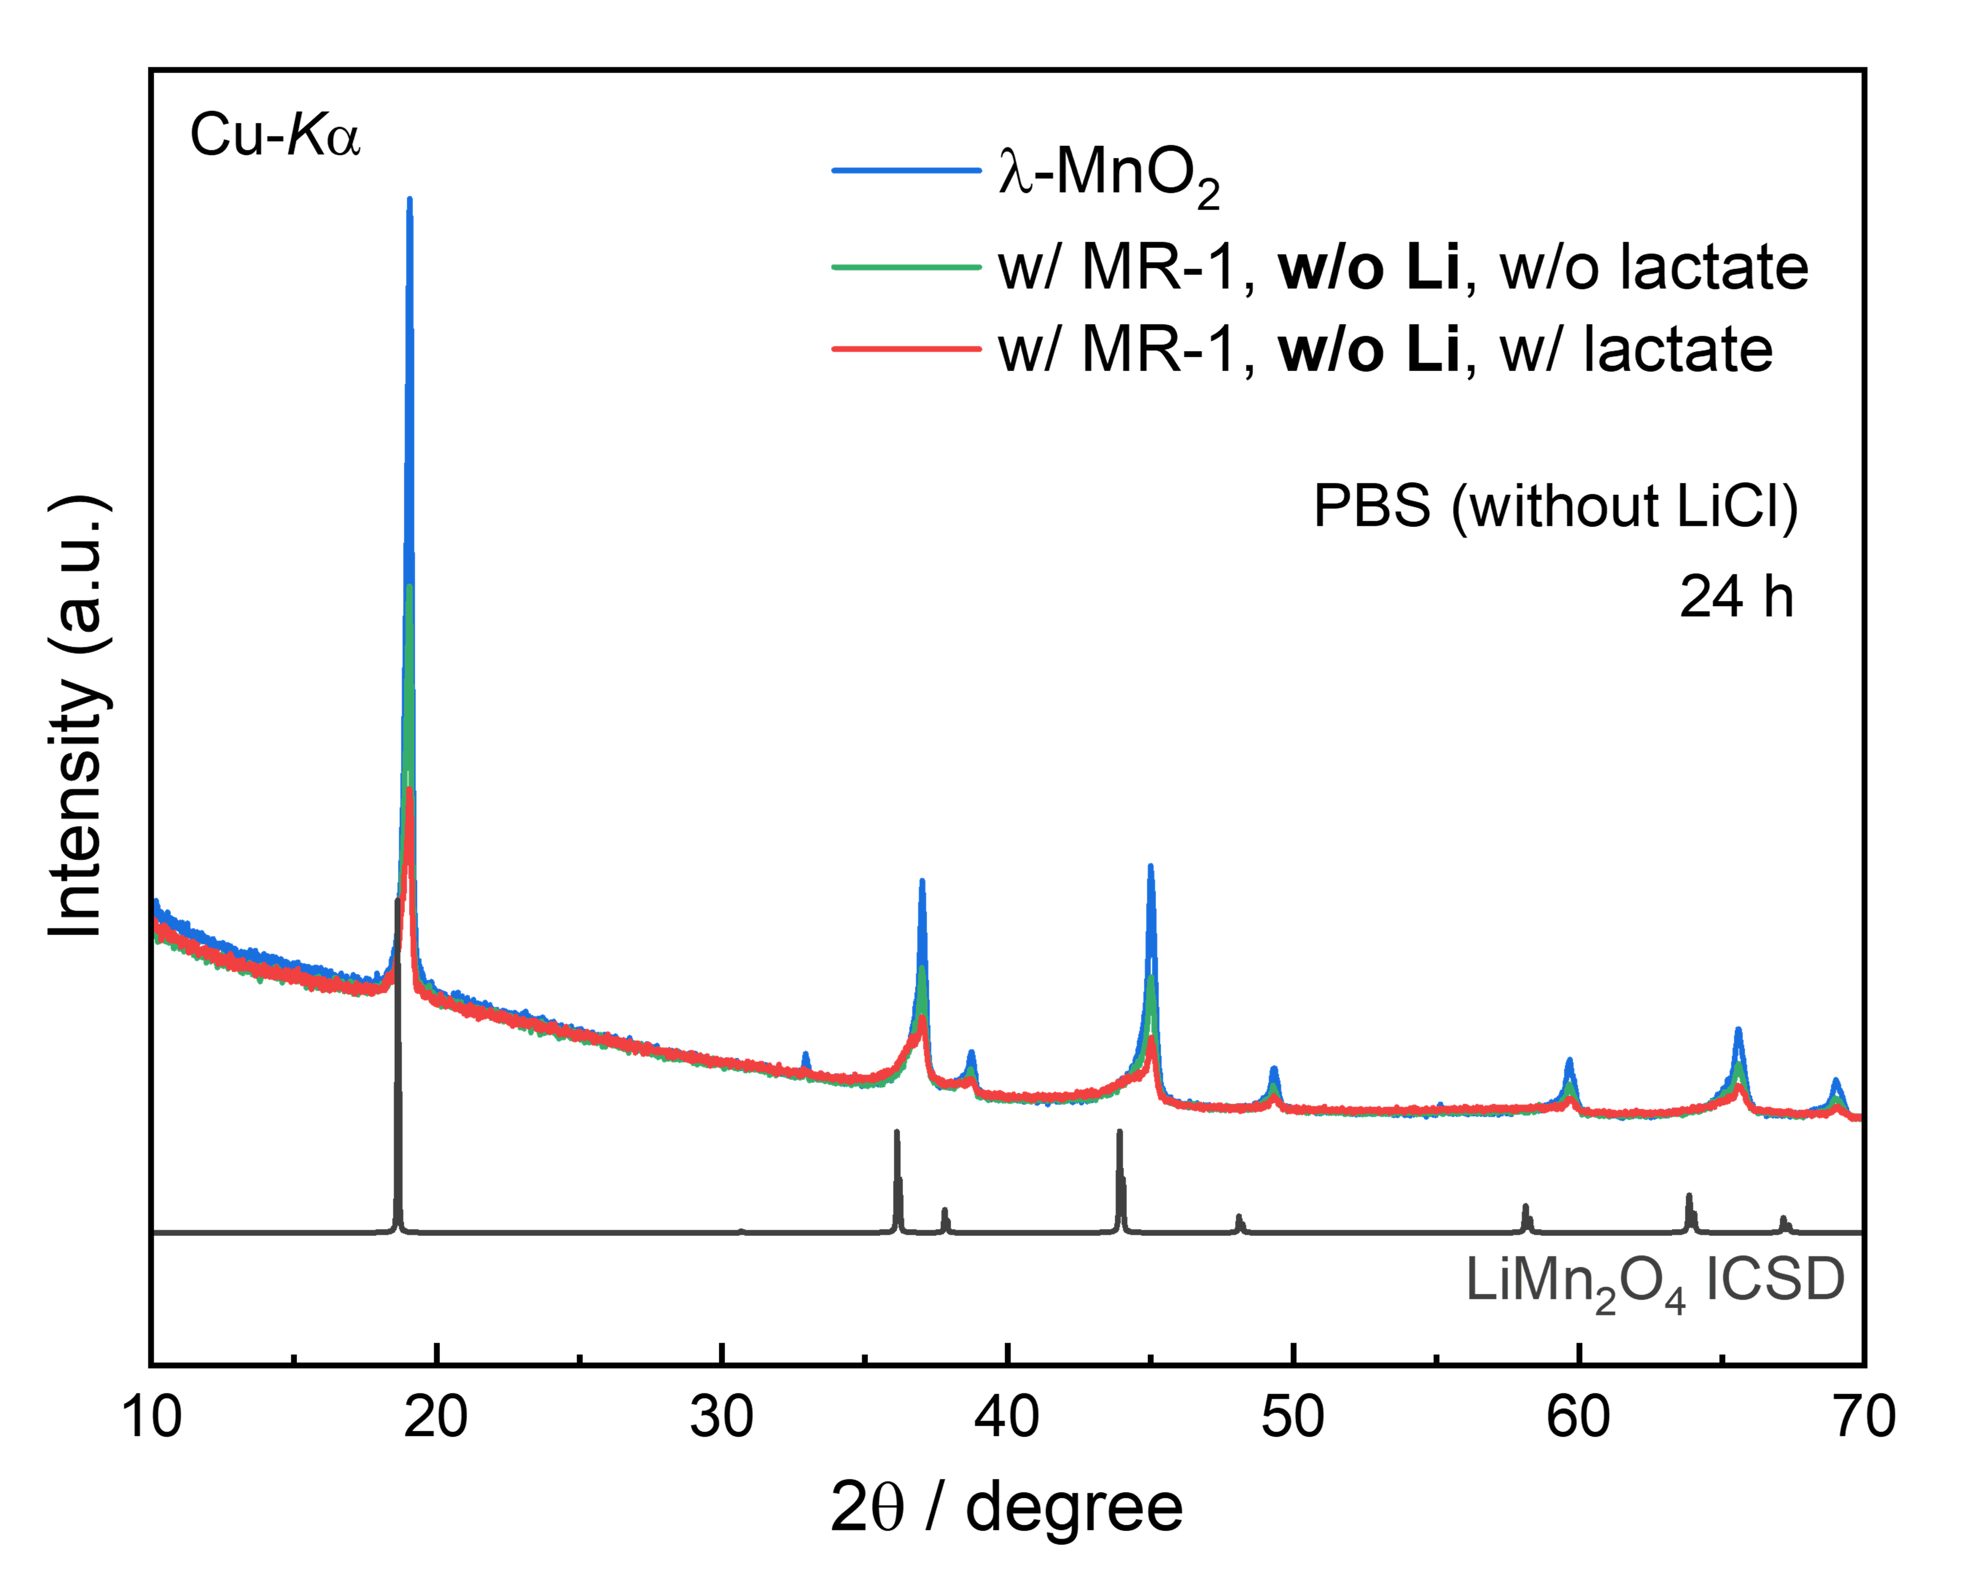
Fig. 8 | Microbial reduction of λ-MnO₂ in PBS without LiCl. XRD profiles of the materials after microbial reduction of λ-MnO₂ nanoparticles in PBS without LiCl, together with that of as-synthesized λ-MnO₂ for comparison. Peak shift was not observed while the intensity significantly decreased, suggesting dissolution of the material due to the lack of Li in the solution.

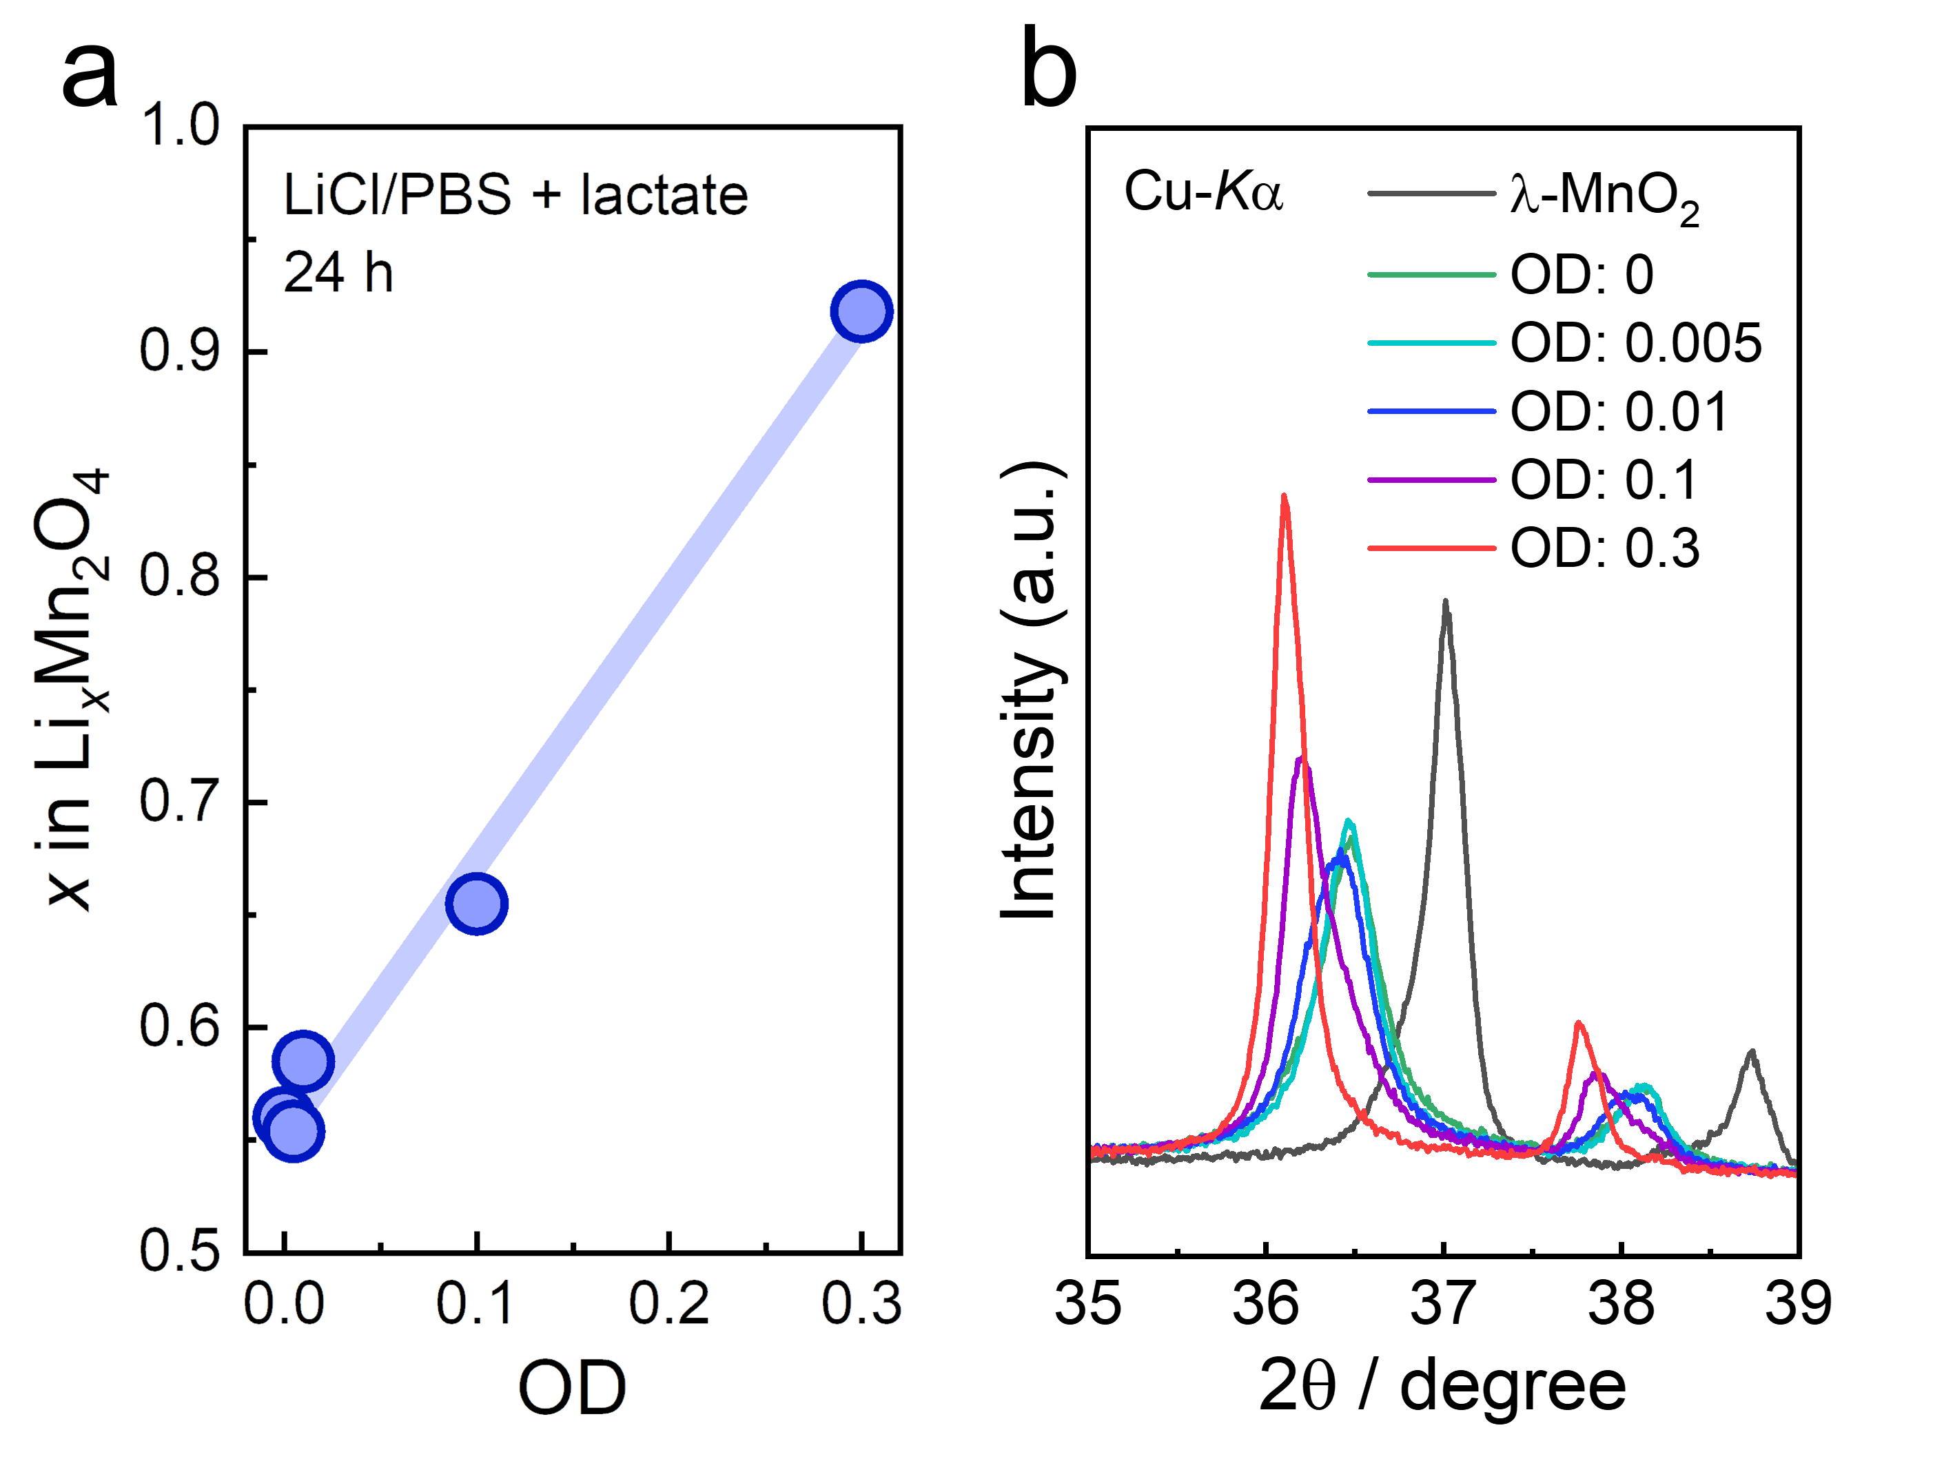
Fig. 9 | Bioelectrochemical Li recovery with different OD values. (a) Composition determined by ICP-OES and (b) XRD profiles of the materials before and after bioelectrochemical Li recovery from LiCl/PBS solution with different OD values of MR-1 (0, 0.005, 0.01, 0.1, and 0.3), where the concentration of Li and reaction time were 10 mM and 24 h, respectively. Composition and crystal structure become closer to those of LiMn₂O₄ with the increase in OD values, indicating that MR-1 accelerates Li intercalation into λ-MnO₂.

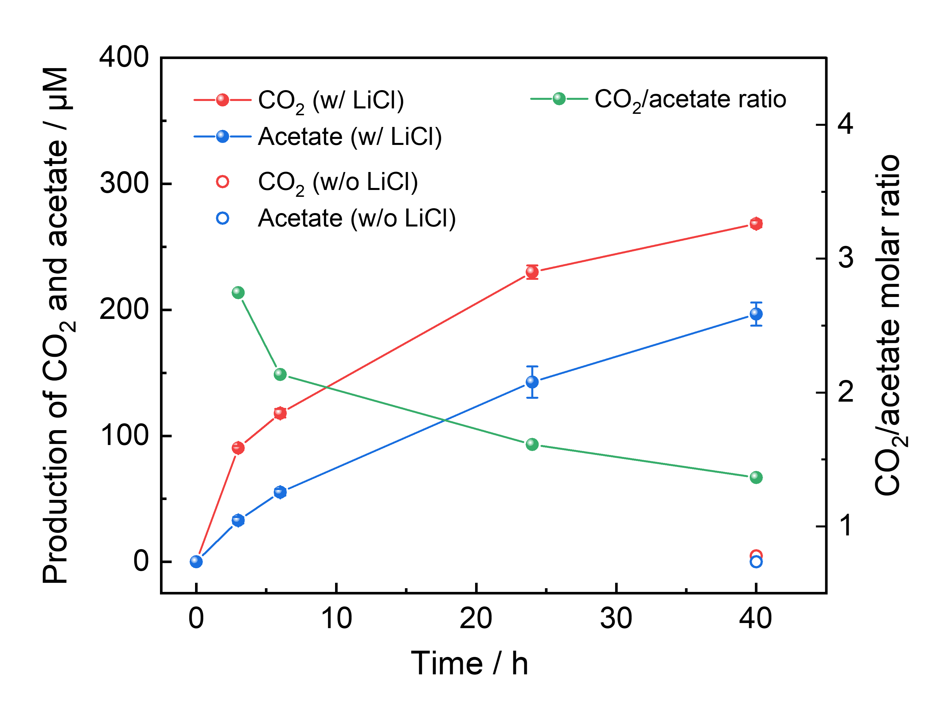
Fig. 10 | Metabolic pathway of microbial lactate consumption. Production of CO₂ and acetate was measured in the culture bottle containing PBS (50 mL), MnO₂ (500 mg), lactate (50 mM), LiCl (70 mM), and MR-1 (OD 0.3). Without LiCl, there was little CO₂ and no acetate production, indicating that all lactate was consumed for Li intercalation. Each condition was replicated three times and each timepoint was conducted independently by different sets of the culture bottles with the same starting components. CO₂ and acetate production during the bioelectrochemical Li intercalation suggests an NADH-dependent metabolic pathway for microbial electron generation.

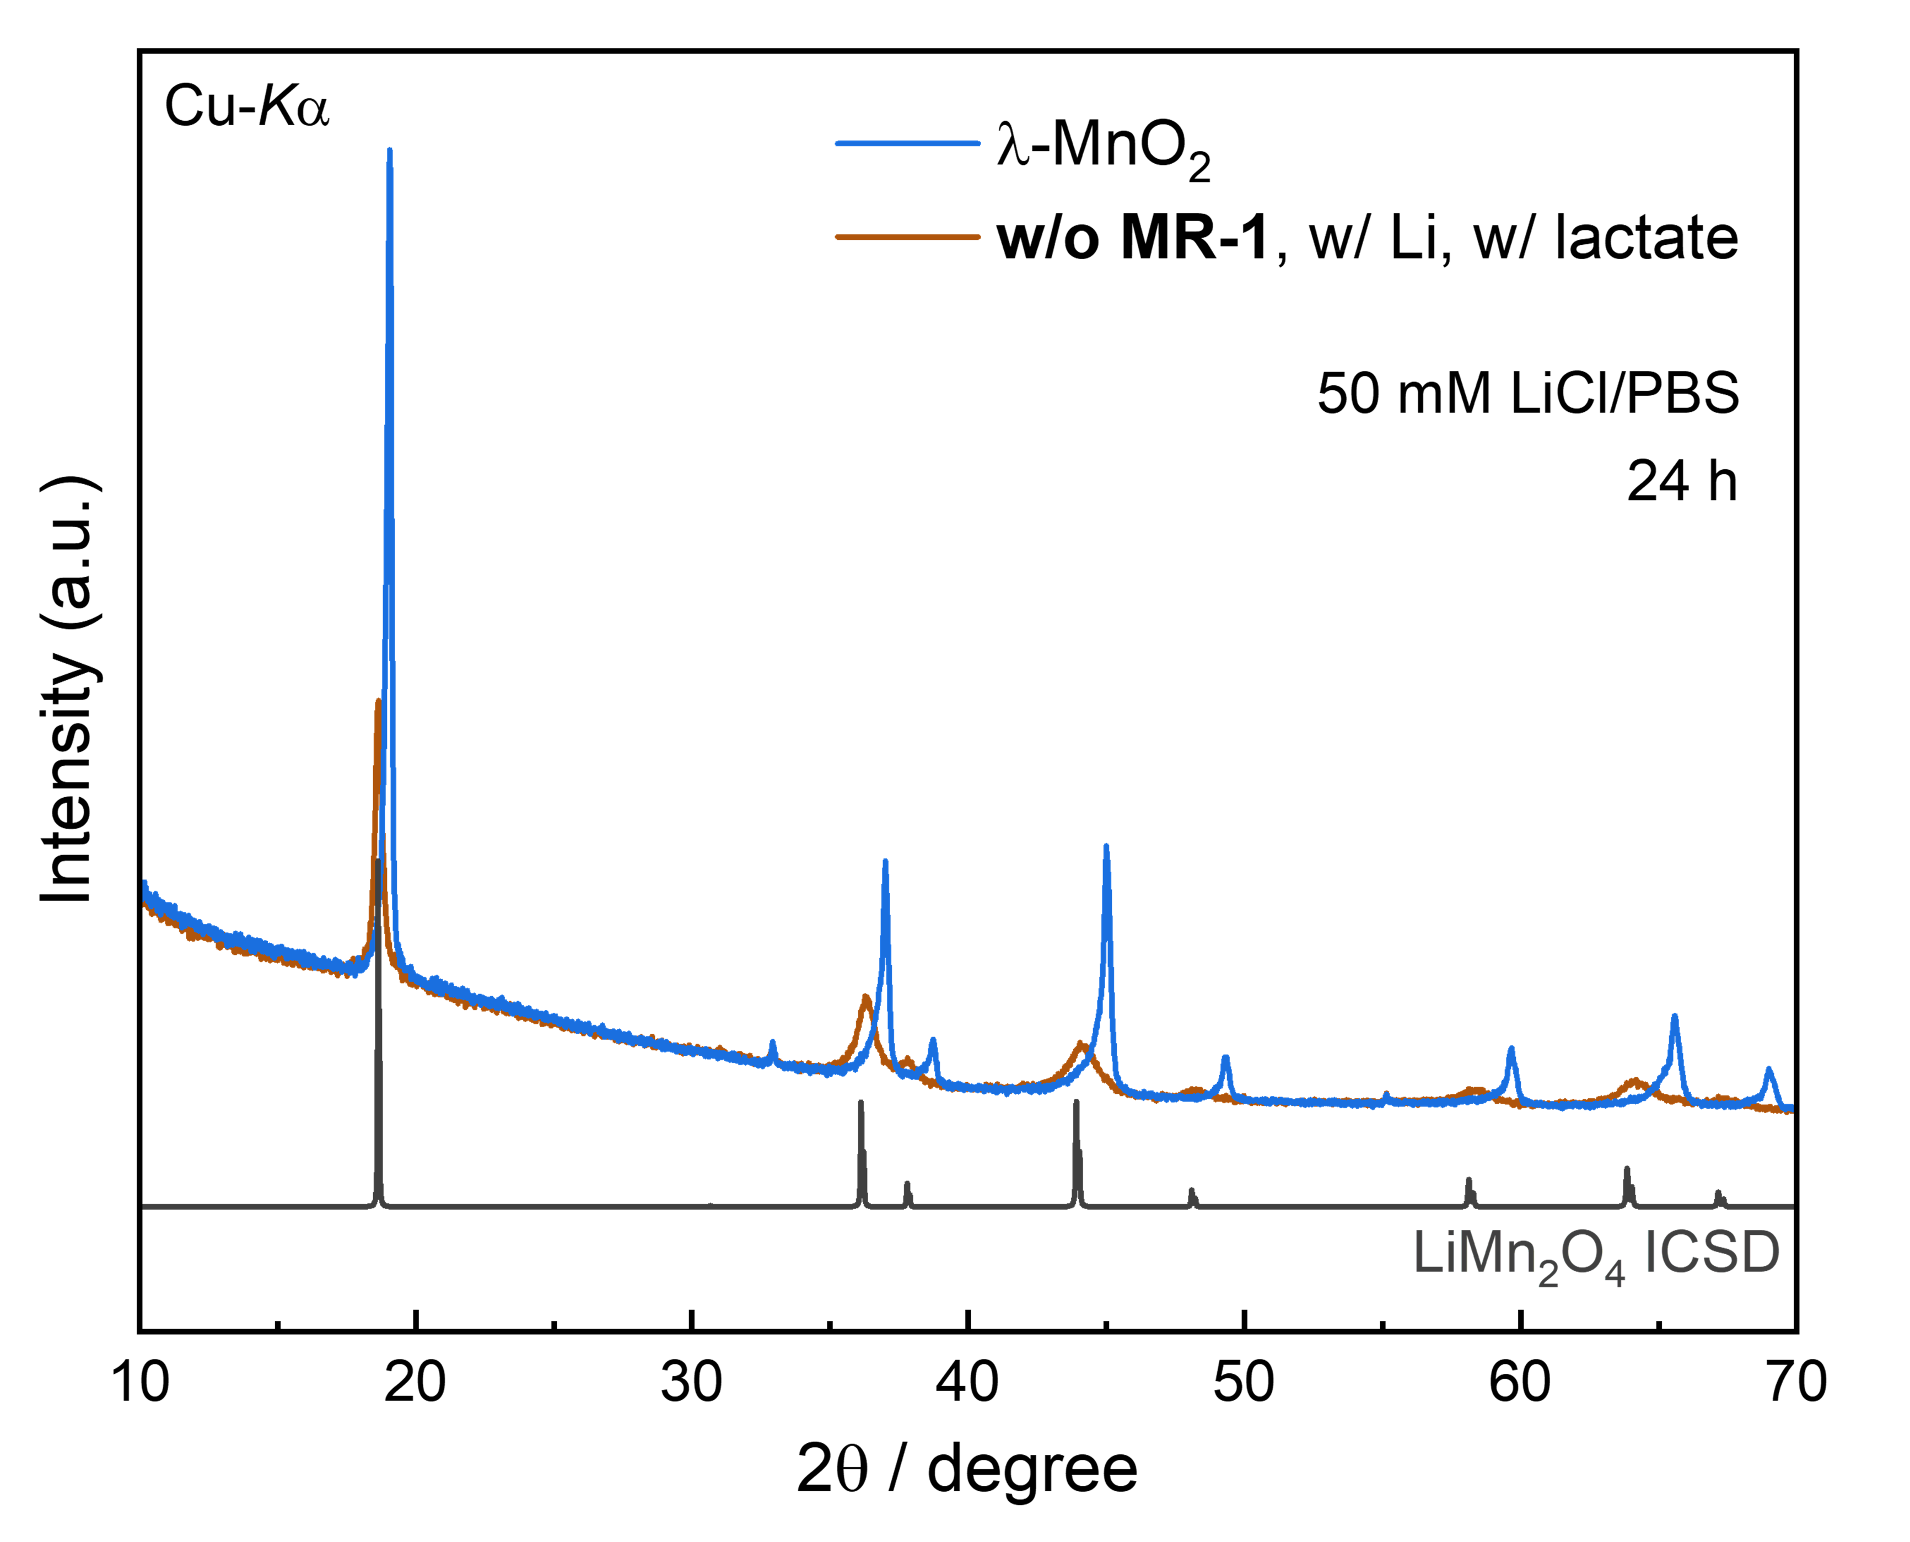
Fig. 11 | Chemical reduction by lactate without MR-1. XRD profiles of the materials before and after the abiotic chemical reduction by lactate in 50 mM LiCl/PBS solution. The lattice constant of the obtained material was determined by Rietveld analysis^{[S2]} to be ~8.21 Å, which is smaller than that of LiMn₂O₄ (~8.24 Å).^{[S3,S4]} In addition, the peak intensity significantly decreased, indicating the loss of crystallinity during the reaction.

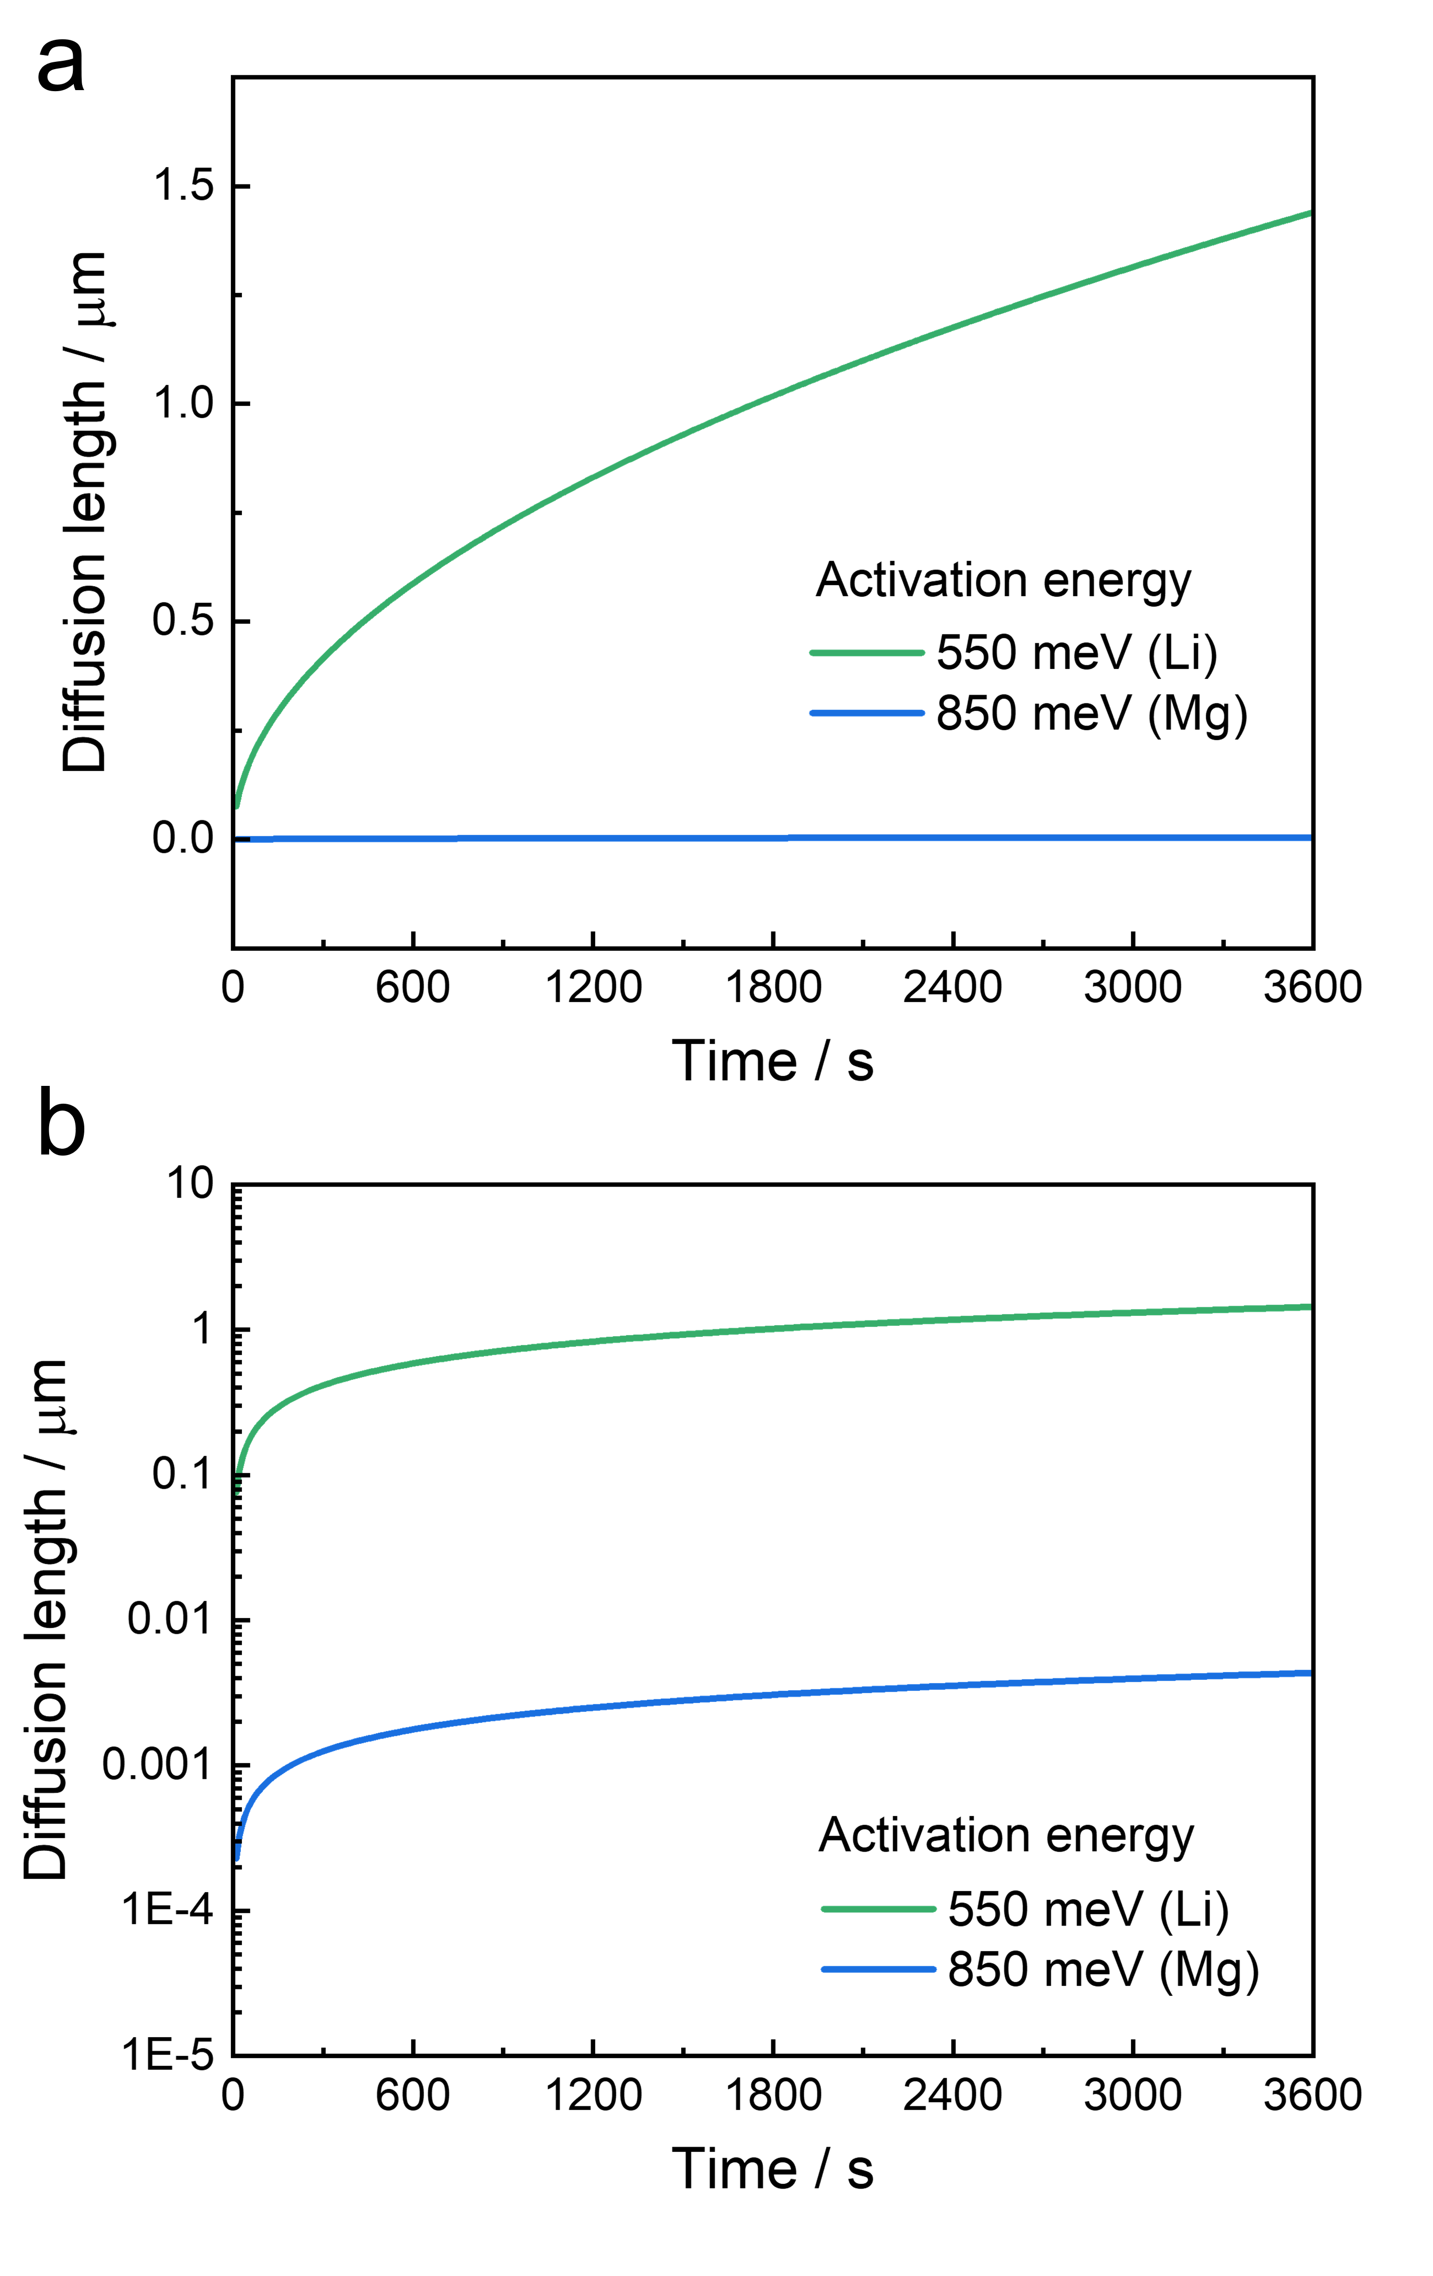
Fig. 12 | Difference in diffusion length for Li and Mg ions in λ-MnO₂. Roughly estimated diffusion length for Li and Mg in the spinel lattice at room temperature displayed in (a) linear and (b) logarithmic graphs. The activation energies of Li and Mg were assumed to be 550 and 850 meV, respectively, according to a previous computational study^{[S6]}. Diffusion coefficient, D, was estimated by the following equation: D = νa²exp(-E/kT), where ν, a, E, k, and T are attempt frequency, jump path distance, activation energy for migration, the Boltzmann constant, and temperature, respectively. ν and a were assumed to be 10¹⁴ s⁻¹ and 1 Å, respectively, just to compare the order of diffusion length for Li and Mg. The diffusion length shown in the graphs was calculated by $\sqrt{Dt}$, where t is time. The difference in the order of diffusion length between them is 100–1000, which is consistent with the selectivity of Li/Mg in our experiments.

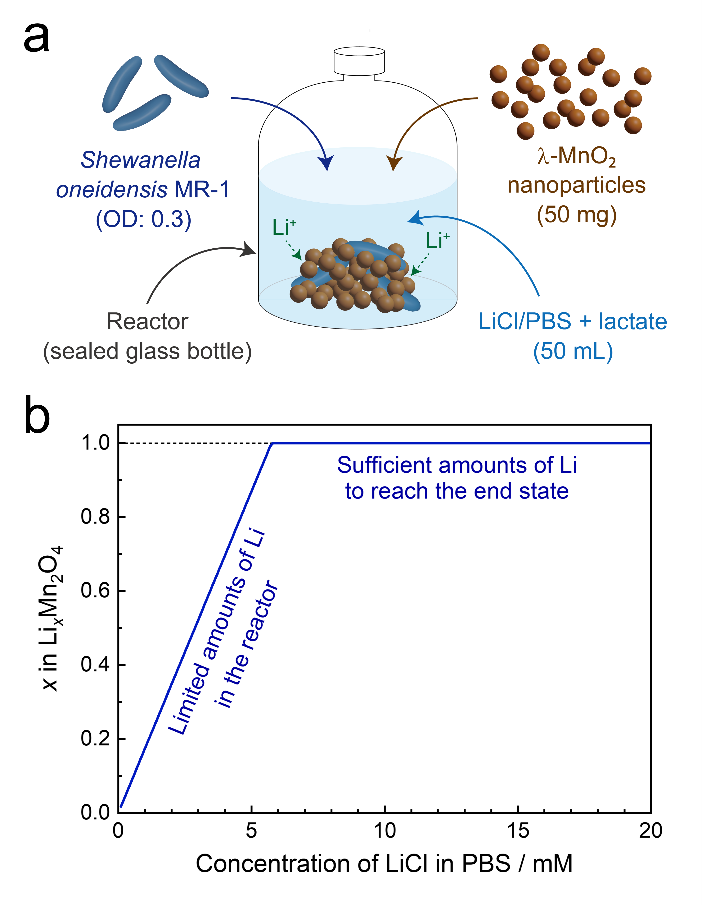
Fig. 13 | Experimental setup for making intermediate states. (a) Details of the experimental setup with limited amounts of Li to prepare materials with intermediate states used for XRD and XANES analyses, where MR-1 (OD: 0.3) and 50 mg of λ-MnO₂ are put into a glass bottle filled with 50 mL of LiCl/PBS solution. (b) Theoretical composition after Li recovery depending on the concentration of LiCl in PBS. The amounts of Li in the reactor are insufficient to reach the end state if the concentration is below approximately 5 mM. Note that the remained Li in the initial state of λ-MnO₂ after acid leaching was not considered in this estimation.

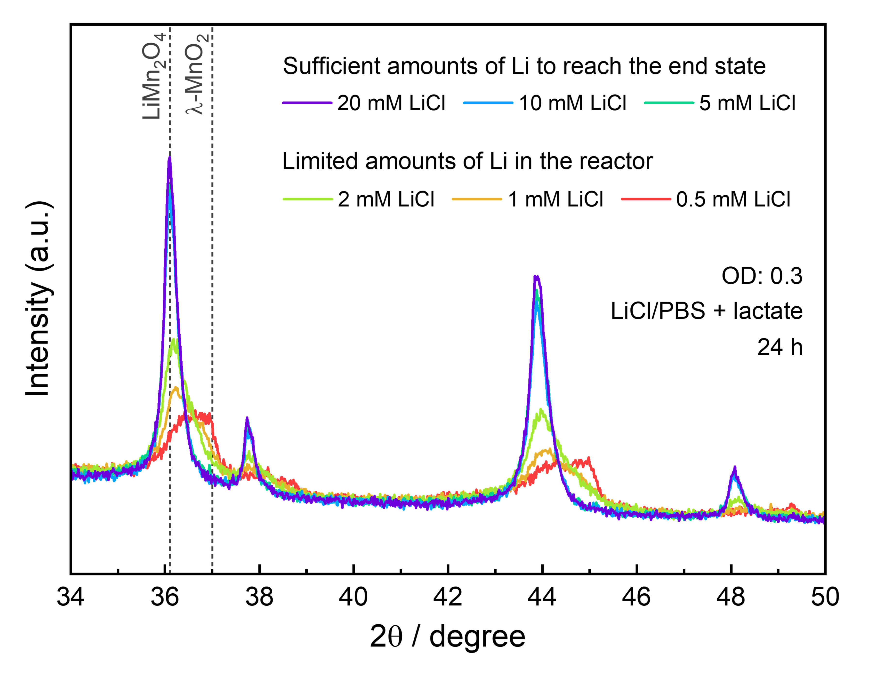
Fig. 14 | Crystal structures of the materials with intermediate states. XRD profiles for the materials after bioelectrochemical Li recovery with different amounts of Li in the reactor (see Supplementary Fig. 13). Intermediate states between λ-MnO₂ and LiMn₂O₄ were obtained in the Li-limited conditions as we predicted, and the phase change behavior indicating a two-phase existence in the initial stage of Li intercalation is consistent with a previous report^{[S7]}.

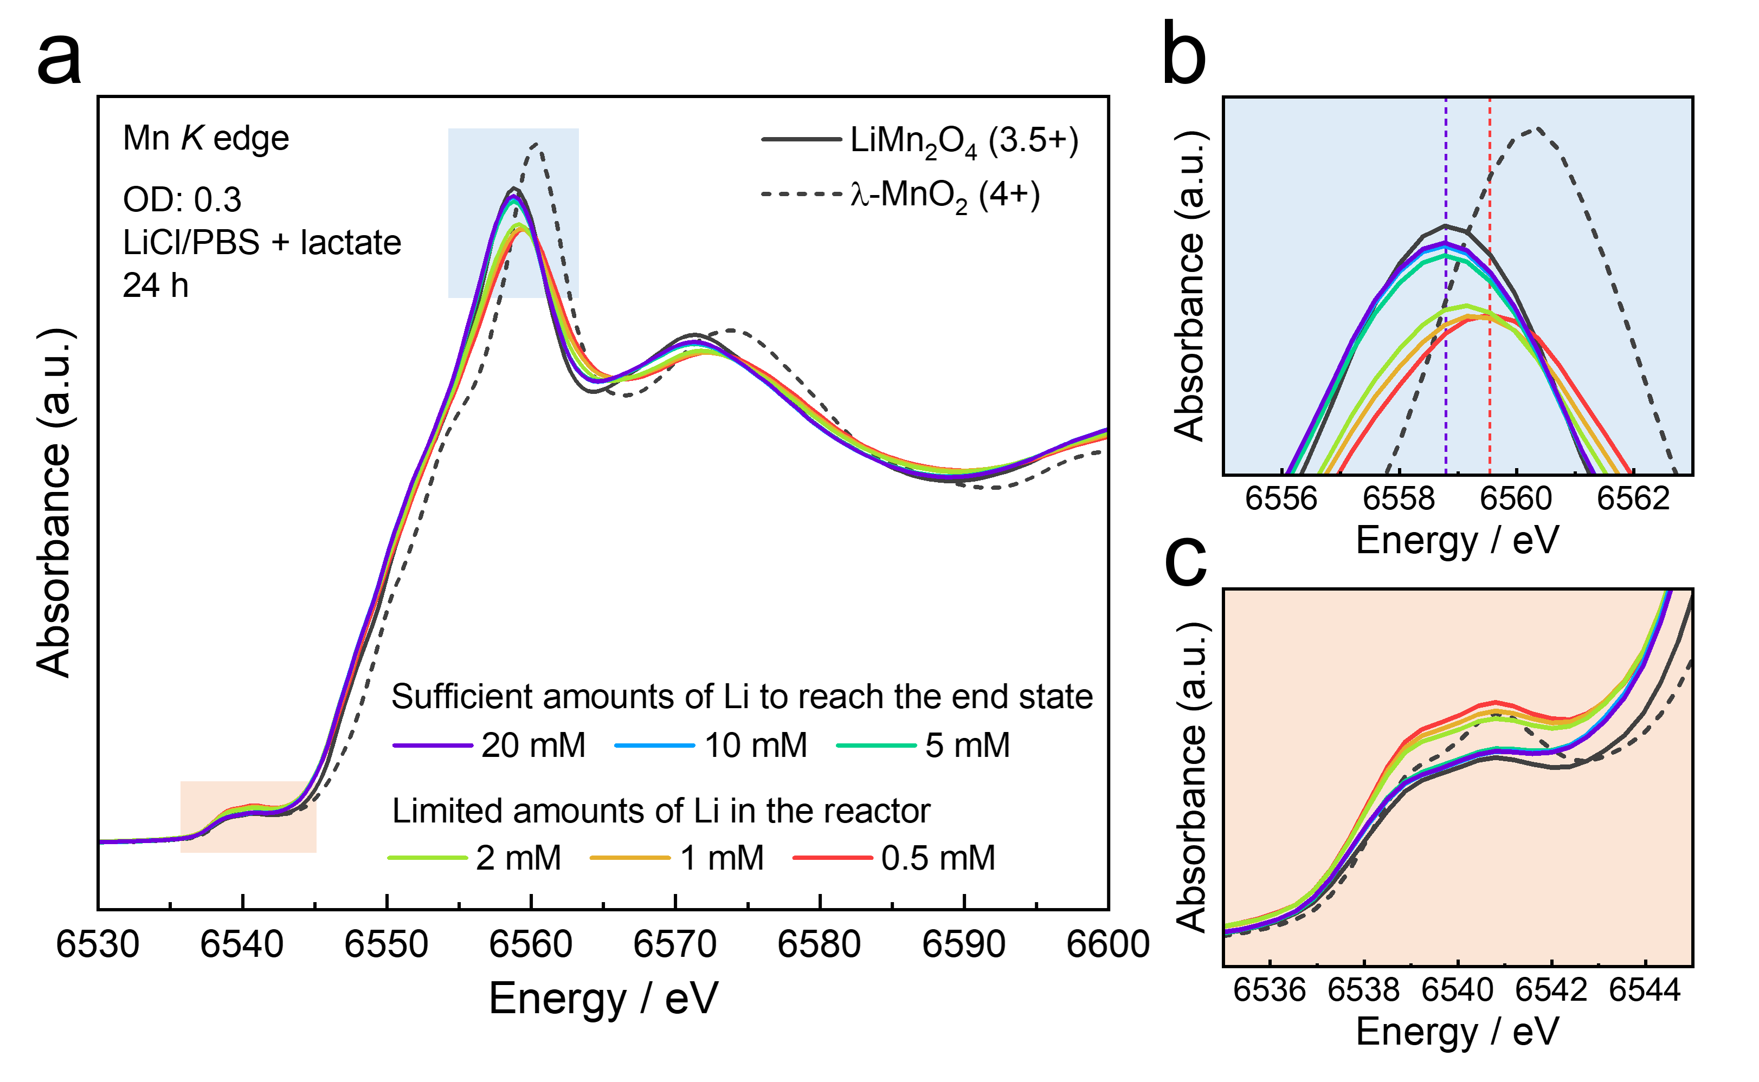
Fig. 15 | Electronic structures of the materials with intermediate states. (a) XANES spectra for the materials after bioelectrochemical Li recovery with different amounts of Li in the reactor (see Supplementary Fig. 13) and (b,c) their enlarged views. The materials with sufficient amounts of Li showed almost the same profiles as that of LiMn₂O₄ in both the white line and pre-edges. In contract, those with limited amounts of Li were intermediate states between λ-MnO₂ and LiMn₂O₄, which is consistent with a previous report^{[S8]}.

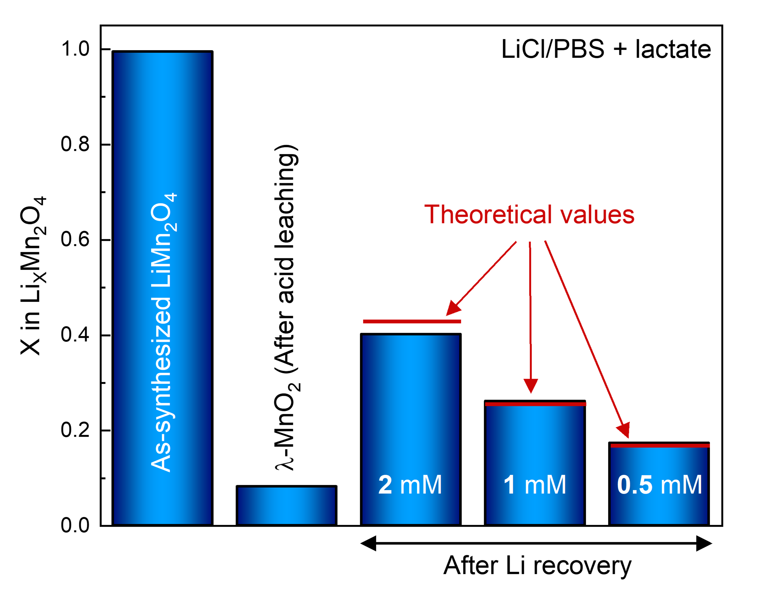
Fig. 16 | Composition of the materials prepared in Li-limited conditions. ICP results for the materials after bioelectrochemical Li recovery in the PBS solutions with limited amounts of Li in the reactor (see Supplementary Fig. 13), together with those of as-synthesized LiMn₂O₄ and λ-MnO₂. The compositions of Li in the materials after bioelectrochemical Li recovery were in excellent agreement with the theoretical values indicated by red bars, which are the sum of initial Li in as-prepared λ-MnO₂ and dissolved Li in the solution, suggesting that almost all Li ions were collected into λ-MnO₂ even from lower concentrated solutions.

Fig. 17 | Distribution of elements in MR-1/nanoparticles composite. STEM–EDS mapping images for the dispersed agglomerates after bioelectrochemical Li recovery. Mn was detected only outside the cell along with O mainly keeping the morphology of nanoparticles, supporting our concept of bioelectrochemical intercalation driven by EET.

Fig. 18 | Nanosheets observed around microbes. (a) Cross-sectional TEM image for a dispersed composite of MR-1 and nanoparticles after bioelectrochemical Li recovery. Although the morphology of nanoparticles was mostly kept after Li recovery experiments, nanosheets were also found near microbes. This morphology is similar to that of a reported hydrated Mn phosphate^{[S9]}. (b) STEM and (b) EELS mapping images for the nanosheets along with nanoparticles. EELS analysis revealed that the nanosheets consist of Mn²⁺, which is consistent with the valence state of the hydrated Mn phosphate (i.e., Mn₃(PO₄)₂·3H₂O).

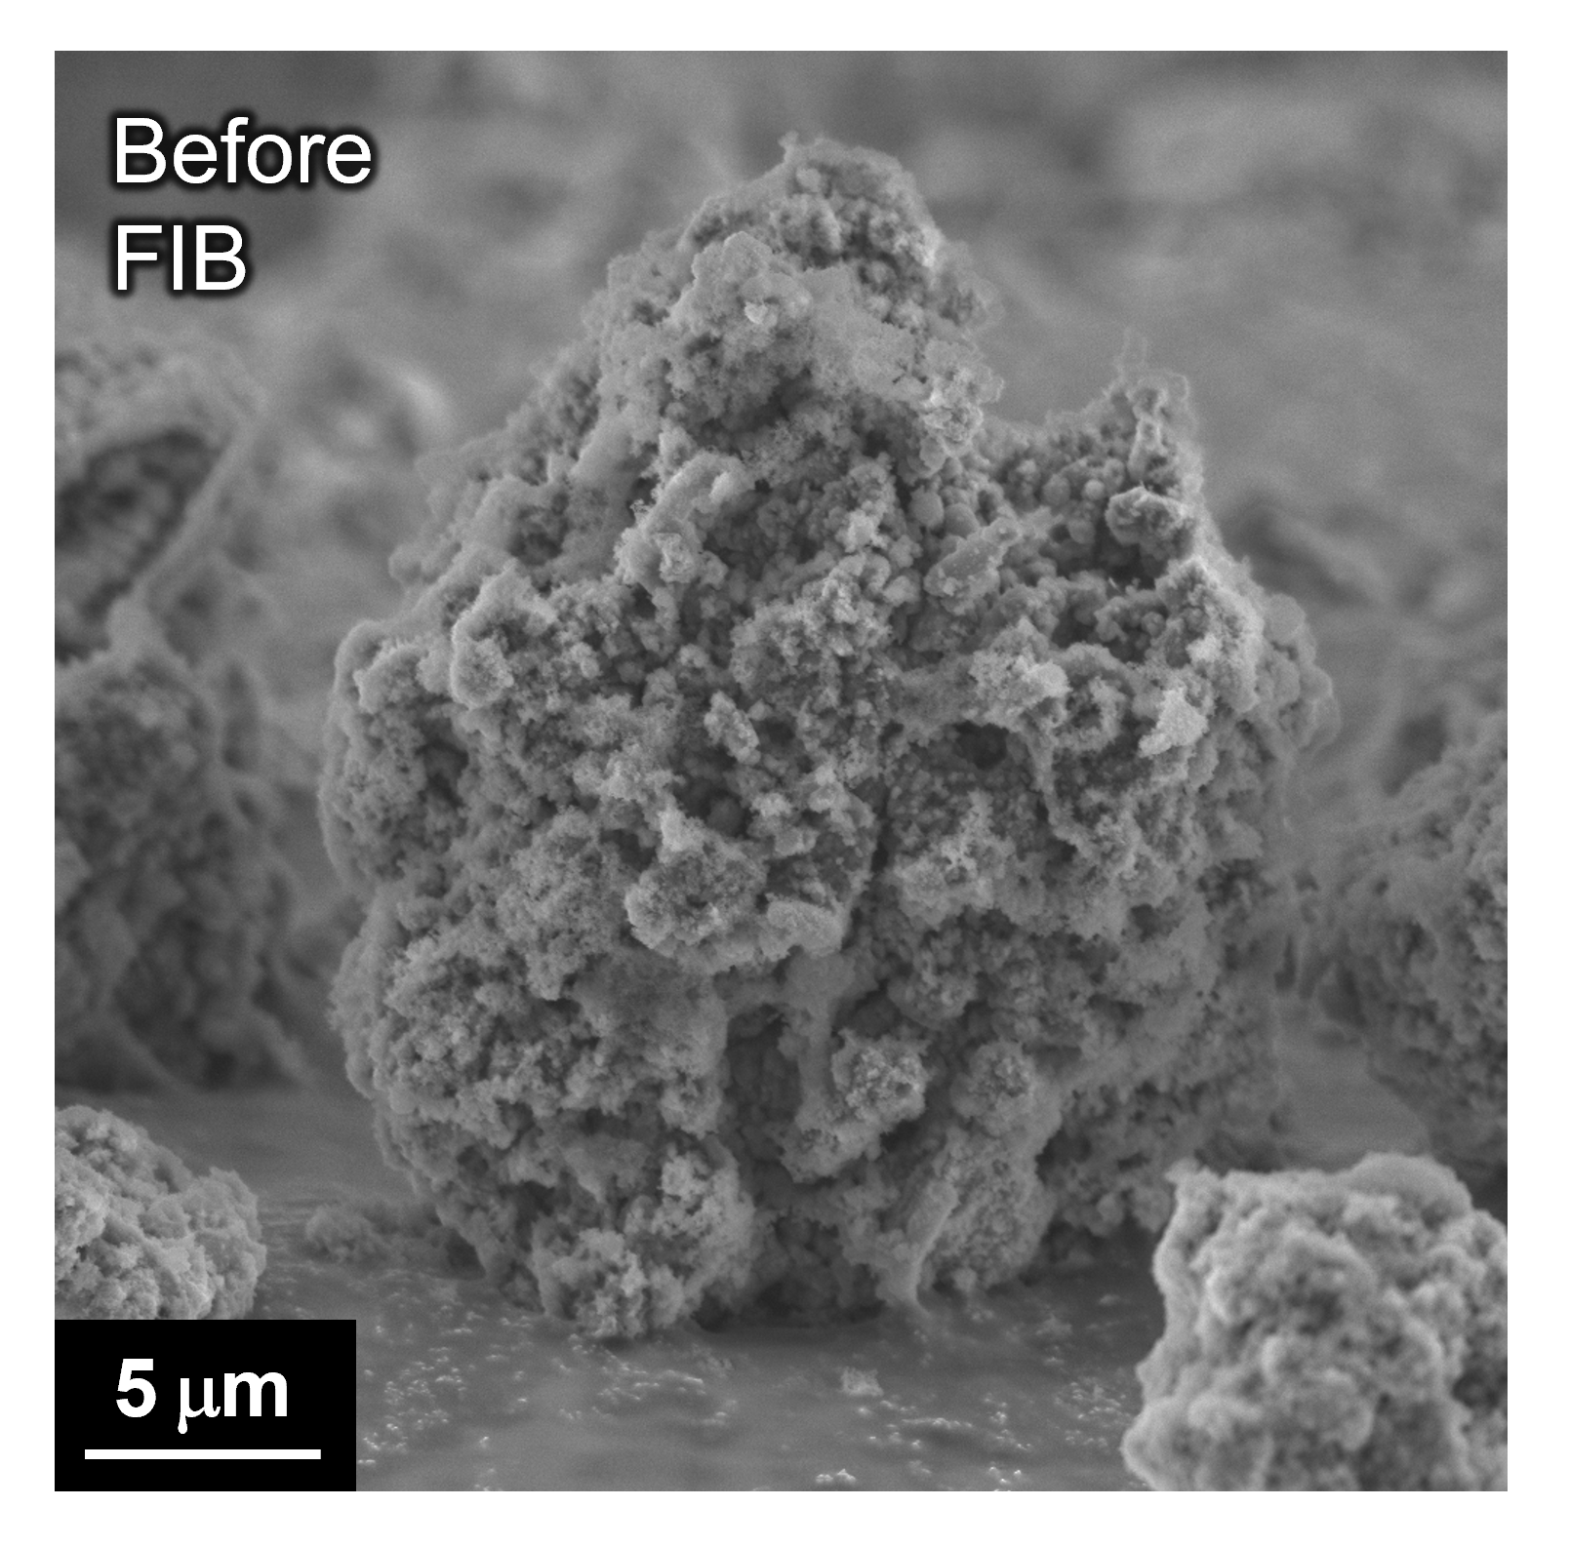
Fig. 19 | Agglomerate used for FIB–SEM–EDS analysis. SEM image for the agglomerate before FIB milling. We selected a relatively small agglomerate because it is suitable for processing and preparing a cross-section. Microbes were found on the surface of the agglomerate in addition to those inside.

Fig. 20 | Distribution of elements on the cross-section of agglomerate. (a) EDS mapping for the agglomerate after FIB milling and (b) corresponding SEM image. In addition to Mn and O from oxide particles, Os indicating stained OM c-Cyts was detected even inside the agglomerate, suggesting that secretions from microbes were distributed across the particles and secure electronic conductivity.

Fig. 21 | Potential change during Li insertion into MnO₂ polymorphs. Based on data provided in a previous computational study^{[S10]}, we prepared a diagram showing the predicted potential change in Li intercalation into MnO₂ polymorphs. λ-MnO₂ has the highest potential for accommodating Li ions up to the composition of LiMn₂O₄, and the two-phase reaction of LiMn₂O₄/Li₂Mn₂O₄ undergoes at a lower potential. In contrast, tunnel-structured MnO₂ (e.g., α, β, γ) showed much lower potentials compared to λ-MnO₂ at the beginning of Li intercalation. The above results are consistent with the fact that λ-MnO₂ is synthesized via LiMn₂O₄;^{[S4]} namely, it is stabilized by Li.

Fig. 22 | Reaction pathways during bioelectrochemical Li recovery. Schematic diagram for discussing the reaction mechanism during the reduction of (a,b) tunnel-structured and (c,d) spinel-structured MnO₂ in the environments of LIBs and seawater. Li intercalation into tunnel-structured MnO₂ proceeds in LIBs as 3–3.5 V class cathode materials (i.e., approximately 0–0.5 V vs SHE) according to Supplementary Fig. 22 and previous experimental reports^{[S11–S13]}. However, in dilute Li aqueous solution such as seawater, the potential for Li intercalation becomes lower than that for dissolution of MnO₂, which is approximately 0.4 V vs SHE at neutral pH.^{[S14]} In the case of spinel-structured MnO₂ (i.e., λ-MnO₂), the potential for Li intercalation is higher than that of the dissolution of MnO₂. In addition, the reductive potential of MR-1 (i.e., approximately -0.2 V vs SHE) is suitable for obtaining a large driving force of Li intercalation into λ-MnO₂ while preventing the over-lithiation to form Li₂Mn₂O₄. (e) Summary of the reaction pathways of λ-MnO₂ during bioelectrochemical Li recovery from seawater.

Fig. 23 | Lactate consumption during Li recovery from seawater. Concentration of lactate measured by ion chromatography during Li recovery from seawater with MR-1. Lactate was gradually consumed for 9 h and then the concentration became constant. The concentration of Li (see Fig. 4b in the main article) was not largely changed after the activity of microbes was settling down, suggesting that Li was stably stored in the material even without microbial activity once it was inserted electrochemically.

Table 2 | Mass% of each element measured by ICP-OES.
 | Li | Mg | Na | K | Ca
As-prepared λ-MnO₂ (sample 1) | 0.29 | 0.007 | 0.01 | <0.005 | <0.005
As-prepared λ-MnO₂ (sample 2) | 0.29 | 0.007 | 0.01 | <0.005 | <0.005
As-prepared λ-MnO₂ (sample 3) | 0.29 | 0.007 | 0.02 | <0.005 | <0.005
After being soaked in seawater (sample 4) ¹ | 0.33 | 0.03 | 0.05 | 0.01 | 0.06
After being soaked in seawater (sample 5) ¹ | 0.33 | 0.03 | 0.05 | 0.01 | 0.06
After being soaked in seawater (sample 6) ¹ | 0.33 | 0.03 | 0.06 | 0.01 | 0.07
After microbial Li recovery from seawater (sample 7) ² | 0.79 | 0.04 | 0.06 | 0.01 | 0.07
After microbial Li recovery from seawater (sample 8) ² | 0.85 | 0.04 | 0.07 | 0.01 | 0.07
After microbial Li recovery from seawater (sample 9) ² | 0.81 | 0.04 | 0.05 | 0.01 | 0.07
¹ 30 mg λ-MnO₂ was just soaked in 500 mL seawater for 24 h.
² 500 mL seawater was bioelectrochemically treated with 30 mg λ-MnO₂ and MR-1 for 24 h.

Table 3 | Molar ratio of Li/M (M = Mg, Na, K, Ca) bioelectrochemically intercalated into the material.
 | Mg | Na | K | Ca
Calculated from the averaged values of samples 4–6 and 7–9 | 170 | 242 | - | 422

Fig. 24 | Li recovery from seawater with riboflavin. Concentration of Li before and after bioelectrochemical Li recovery from seawater with and without 2 μM riboflavin. The Li recovery kinetics was substantially increased by spiking a tiny amount of riboflavin, suggesting the enhanced current generation of MR-1 as also observed in the LiCl/PBS system. Error bars present the standard error of means (n = 3).

Fig. 25 | Regeneration of λ-MnO₂ by Na₂S₂O₈. XRD profiles showing the reversibility of bioelectrochemical Li intercalation and following chemical Li leaching by using an oxidant, Na₂S₂O₈^{[S15]}. The peak positions clearly shifted to higher angles and became almost the same as those of original λ-MnO₂ after the oxidation process, indicating high reversibility in the structure change.

Fig. 26 | Mn loss in the Li-reaching unit and efficiency of the Mn-removal unit. The concentrations of Mn after the Li-reaching and Mn-removal processes. The amount of Mn loss (0.0012%) was calculated from the concentration of soluble Mn (0.46 mg/L) in the effluent of the Li-leaching unit (40 mL) and the starting amount of LiMn₂O₄ (5 g). Based on this result, it was assumed that 99.9% of λ-MnO₂ could be recycled in our Li₂CO₃ production process. After increasing the pH to 11, all soluble Mn was precipitated and removed by filtration, resulting in an effluent Mn concentration below the detection limit (<0.005 mg/L).

Fig. 27 | Material obtained by the Li₂CO₃-precipitation process. (a) XRD and (b) ICP results for the material obtained through our bioelectrochemical Li recovery and Li₂CO₃-precipitation processes, roughly explained as follows. Li_{1-x}Mn₂O₄ was collected after bioelectrochemical Li recovery from LiCl/PBS and then it was washed with water (water/Li_{1-x}Mn₂O₄ = 10 w/w). A calculated amount of water and Na₂S₂O₈ were added and heated in the Li-leaching step. Subsequently, pH was adjusted and Na₂CO₃ was added to the solution in the Mn-removal and Li₂CO₃-precipitation steps, respectively. Hot water wash was carried out before drying the obtained material. The XRD profiles indicate crystalline Li₂CO₃, whose purity was ~98% based on ICP for two different batches. These results suggest that a small amount of water is enough to wash the material and the organic contamination is not a serious issue in our method.

Table 4 | Industrial Li₂CO₃ market price. As of 2024.
 | Price  (USD/kg Li₂CO₃) | References
98% Li₂CO₃ | 7.4 | https://www.intratec.us/chemical-markets/lithium-carbonate-price
99.2% Li₂CO₃ | 9.9 | https://www.metal.com/Lithium/201905160001
99% Li₂CO₃ | 8.9–16.9 | https://yujianghuagong.en.made-in-china.com/product/MnCpSPUYnBkj/China-Hot-Sale-CAS-554-13-2-99-Purity-Industrial-Grade-Lithium-Carbonate.html

Fig. 28 | Breakdown of the production cost of Li₂CO₃. The calculated production cost of Li₂CO₃ in our bioelectrochemical Li recovery method. The raw materials, which contributed significantly to the total cost, include λ-MnO₂, lactate, soybean meal, Na₂S₂O₈, NaOH/HCl, and Na₂CO₃. The cost for Na₂S₂O₈ accounted for approximately 60% of the total raw material cost.

Fig. 29 | Cation-exchange membrane cell. (a) Setup of our prototype system with a cation-exchange membrane. LiCl was not included in the bottle but dissolved in the solution filling the beaker. (b) The change in color before and after the Li recovery process, where the concentration of LiCl and processing time were 10 mM and 24 h, respectively. The disappearance of a characteristic red color suggests Li intercalation into λ-MnO₂. Note that the precipitates formed during the Li recovery process were firmly dispersed to show the color of particles. (c) XRD profiles before and after the experiments. The peak positions clearly shifted to be almost the same as those of LiMn₂O₄, indicating Li recovery via the membrane filter.

Fig. 30 | A cradle-to-gate life cycle system boundary of the modelled system. The Li intercalation (in blue) and the Li₂CO₃ precipitation (in green) are based on the experiments in this study. Recycling paths for the λ-MnO₂ and water are included for a practical design. This prospective system is used as the basis for the environmental LCA and TEA.

Table 5 | The efficiency of Li intercalation and Li₂CO₃ precipitation. We developed two cases in this study: SIMULATION (industrial scale) and LAB (laboratory scale).

Process | SIMULATION | LAB
Li intercalation | 90% | 80%
Li₂CO₃ precipitation  (= leaching × precipitation) | 58.5%  = (90 × 65)% | 48%  = (80 × 60)%

Table 6 | Life cycle inventory data of Li intercalation for 1 kg Li₂CO₃ production. The SIMULATION is presented in the main text. The LAB is based on lab experiment procedure.

 | Unit | SIMULATION | LAB
Input
Brine, 0.15 wt.% Li | kg | 237.887 | 326.165
λ-MnO₂ | kg | 0.080 | 1.961
Sodium lactate | kg | 0.432 | 1.580
Soybean meal | kg | 0.300 | 0.300
Water | kg | 21 | 30587
Electricity, pumping brine | kWh | 0.0974 | 0.1335
Electricity, pumping groundwater | kWh | 0.0068 | 2.5042
Electricity, heating (30 °C) | kWh | 1.4584 | 1.4584
Electricity, dewatering | kWh | 0.0024 | 0.0024
Output
LiMn₂O₄, in slurry | kg | 8.366 | 10.196
Brine effluent, for potassium extraction | kg | 292.264 | 397
Wastewater | kg | 0 | 30348

Table 7 | Life cycle inventory data of Li₂CO₃ precipitation for 1 kg Li₂CO₃ production. The LiMn₂O₄, in slurry is the output from Table 5.

 | Unit | SIMULATION | LAB
Input
LiMn₂O₄, in slurry | kg | 8.366 | 10.196
Na₂S₂O₈ | kg | 5.507 | 6.711
NaOH | kg | 0.06 | 0.06
Na₂CO₃ | kg | 1.434 | 1.434
HCl | kg | 0.04 | 0.04
water | kg | 20.914 | 20.914
electricity, pumping | kWh | 0.0017 | 0.0017
electricity, stirring | kWh | 0.0001 | 0.0001
electricity, heating (90 °C) | kWh | 3.6461 | 3.6461
Output
Li₂CO₃, battery grade | kg | 1 | 1
waste Mn(OH)₂ | kg | 0.082 | 2.006
wastewater | kg | 20.914 | 20.914

Table 8 | List of the reference life cycle inventory. From ecoinvent 3.10 database for LCA.

 | Activity name in ecoinvent 3.10
Electricity | market for electricity, medium voltage | electricity, medium voltage | APOS, U - CL
Hydrochloric acid | market for hydrochloric acid, without water, in 30% solution state | hydrochloric acid, without water, in 30% solution state |APOS, U - RoW
Manganese oxide | market for manganese dioxide | manganese dioxide | APOS, U - GLO
Sodium carbonate | market for soda ash, light | soda ash, light | APOS, U - RoW
Sodium hydroxide | market for sodium hydroxide, without water, in 50% solution state | sodium hydroxide, without water, in 50% solution state | APOS, U - RoW
Sodium persulfate | market for sodium persulfate | sodium persulfate | APOS, U - GLO
Solid waste treatment | treatment of waste zeolite, inert material landfill | waste zeolite | APOS, U - RoW
Soybean meal | market for soybean meal | soybean meal | APOS, U - BR
Wastewater treatment | treatment of wastewater, average, wastewater treatment | wastewater, average | APOS, U - RoW

Table 9 | Result of water consumption for 1 kg Li₂CO₃ production. Unit in m³.

 | In-situ water | Ex-situ water | Brine’s water
This study | 0.084 | 0.295 | 0.006
Atacama | 0.041 | 0.045 | 0.215
Olaroz | 0.217 | 0.032 | 0.450

Table 10 | Result of climate change impact for 1 kg Li₂CO₃ production. Unit in kg CO₂-equivalent.

 | Li intercalation/concentration | Li₂CO₃ precipitation
This study | 3.71 | 13.09
Atacama | 1.85 | 1.52
Olaroz | 5.28 | 2.11

Table 11 | Additional results of water consumption in background system of this study, ex-situ water. Unit in m³/kg Li₂CO₃.

 |  | SIMULATION | LAB
Li intercalation | Sodium lactate | 0.019 | 0.068
Li intercalation | Manganese oxide | 0.005 | 0.117
Li intercalation | Soybean meal | 0.001 | 0.001
Li intercalation | Electricity | 0.002 | 0.004
Li intercalation | Brine pumping | 0.000 | 0.000
Li intercalation | Groundwater pumping | 0.000 | 0.002
Li₂CO₃ precipitation | Sodium persulfate | 0.239 | 0.291
Li₂CO₃ precipitation | Sodium carbonate | 0.025 | 0.025
Li₂CO₃ precipitation | Electricity | 0.004 | 0.004
Li₂CO₃ precipitation | Sodium hydroxide | 0.001 | 0.001
Li₂CO₃ precipitation | Hydrochloric acid | 0.000 | 0.000
Li₂CO₃ precipitation | Wastewater treatment | 0.000 | 0.000
Li₂CO₃ precipitation | Solid waste treatment | 0.000 | 0.000
Total |  | 0.295 | 0.513

Table 12 | Additional results of climate change impact of this study. Unit in kg CO₂-equivalent/kg Li₂CO₃.

 |  | SIMULATION | LAB
Li intercalation | Sodium lactate | 2.086 | 7.629
Li intercalation | Manganese oxide | 0.274 | 6.726
Li intercalation | Soybean meal | 0.396 | 0.396
Li intercalation | Electricity | 0.890 | 2.331
Li intercalation | Brine pumping | 0.055 | 0.076
Li intercalation | Groundwater pumping | 0.004 | 1.391
Li₂CO₃ precipitation | Sodium persulfate | 10.217 | 12.448
Li₂CO₃ precipitation | Electricity | 0.660 | 0.660
Li₂CO₃ precipitation | Sodium carbonate | 2.074 | 2.074
Li₂CO₃ precipitation | Sodium hydroxide | 0.091 | 0.091
Li₂CO₃ precipitation | Hydrochloric acid | 0.040 | 0.040
Li₂CO₃ precipitation | Wastewater treatment | 0.011 | 0.011
Li₂CO₃ precipitation | Solid waste treatment | 0.001 | 0.013
Total |  | 16.799 | 33.887

Table 13 | All environmental Impacts of 1 kg Li₂CO₃ production. Based on ReCiPe 2016 methods.

 |  | SIMULATION | LAB
Acidification: terrestrial | kg SO₂-Eq | 0.0897 | 0.1586
Climate change | kg CO₂-Eq | 16.7991 | 33.8872
Ecotoxicity: freshwater | kg 1,4-DCB-Eq | 2.0249 | 3.1993
Ecotoxicity: marine | kg 1,4-DCB-Eq | 2.5554 | 4.1818
Ecotoxicity: terrestrial | kg 1,4-DCB-Eq | 179.2851 | 324.5271
Energy resources: non-renewable, fossil | kg oil-Eq | 4.5567 | 9.2149
Eutrophication: freshwater | kg P-Eq | 0.0072 | 0.0136
Eutrophication: marine | kg N-Eq | 0.0018 | 0.0030
Human toxicity: carcinogenic | kg 1,4-DCB-Eq | 4.1352 | 7.1518
Human toxicity: non-carcinogenic | kg 1,4-DCB-Eq | 38.5904 | 64.3499
Ionising radiation | kBq Co-60-Eq | 0.8044 | 1.7145
Land use | m²*a crop-Eq | 0.5918 | 0.9377
Material resources: metals/minerals | kg Cu-Eq | 0.2196 | 0.5435
Ozone depletion | kg CFC-11-Eq | 0.0000 | 0.0000
Particulate matter formation | kg PM2.5-Eq | 0.0668 | 0.1249
Photochemical oxidant formation: human health | kg NOx-Eq | 0.0417 | 0.0833
Photochemical oxidant formation: terrestrial ecosystems | kg NOx-Eq | 0.0438 | 0.0878
Water use | m³ | 0.2945 | 0.5130

Table 14 | List of the reference prices of raw material and electricity for the techno-economic assessment. Unit in USD/kg material or USD/kWh electricity.

 | Base | Best case | Worst case | References
Manganese oxide | 0.40 | 0.20 | 0.80 | https://xtmkcom.en.made-in-china.com/product/IyeJLhWdLoki/China-Batter-Materials-Electrolytic-Manganese-Dioxide-Emd-Powder.html
Sodium lactate | 3.15 | 2.80 | 3.50 | https://zm-biotech.en.made-in-china.com/product/MJSYWZPykqVe/China-Zhuangmei-Biotech-Produce-Sodium-Lactate-Powder-96-at-Competitive-Price.html
Soybean meal | 0.60 | 0.56 | 0.65 | https://humicchina.en.made-in-china.com/product/vOnGRTmdvPAi/China-75-Amino-Acid-Powder-Soybean-or-Soybean-Meal-Organic-Nitrogen-Inorganic-Nitrogen.html?pv_id=1i1ojqm22150&faw_id=1i1ojqvcfb41
Sodium persulfate | 0.63 | 0.55 | 0.70 | https://hongbangjinhua.en.made-in-china.com/product/gnSpTbwvhtYX/China-Best-Price-99-Purity-Potassium-Sodium-Persulfate-for-Triggering-Agent.html
Sodium carbonate | 0.25 | 0.24 | 0.26 | https://wffondland.en.made-in-china.com/product/POxAvNpEbzhC/China-99-2-Industrial-Grade-Dense-Light-Soda-Ash-Sodium-Carbonate-for-Glass-Paper-Making.html?pv_id=1hrod1qnp269&faw_id=1hrod3bjb7cc
Sodium hydroxide | 0.48 | 0.47 | 0.48 | https://zf-sodiumhydroxide.en.made-in-china.com/product/EwmaMJtduHfU/China-Hot-Sale-Chemical-Sodium-Hydroxide-CAS-1310-73-2-From-Supplier.html?pv_id=1hrocp0ll10c&faw_id=1hrocubvs673
Hydrochloric acid | 0.18 | 0.15 | 0.21 | https://sincerechemical01.en.made-in-china.com/product/vOcfVoKZGeRq/China-Hydrochloric-Acid-31-33-34-35-36-37-HCl-Muriatic-Acid.html?pv_id=1hrodehh551f&faw_id=1hrodf9p87b5
Waste treatment | 0.08 | 0.08 | 0.08 | Huang et al. 2021 https://doi.org/10.1021/acssuschemeng.0c08733
Electricity | 0.10 | 0.08 | 0.12 | https://www.statista.com/statistics/1029737/chile-electricity-average-market-price/

Table 15 | Details of production cost for 1 kg Li₂CO₃ production. The operational expenditure per year includes capital expenditure, represented under asset depreciation (20 years facility lifetime). The unit cost calculation is based on a 70,000-ton of annual production of Li₂CO₃ production.

 | Unit | SIMULATION | LAB
Raw materials | USD/year | 378,450,555 | 853,905,824
Utilities | USD/year | 36,951,359 | 76,305,611
Operation and maintenance | USD/year | 1,545,000 | 1,854,000
Overhead, tax and insurance, general expenses | USD/year | 466,667 | 560,000
Asset depreciation | USD/year | 394,967 | 473,960
Total annual production cost | USD/year | 417,808,548 | 933,099,395
Unit cost per kg Li₂CO₃ | USD | 5.97 | 13.33

References
[S1] Momma, K., Izumi, F.: VESTA 3 for three-dimensional visualization of crystal, volumetric and morphology data. Journal of Applied Crystallography 44(6), 1272–1276 (2011)
[S2] Izumi, F., Momma, K.: Three-dimensional visualization in powder diffraction. Solid State Phenomena 130, 15–20 (2007)
[S3] Knight, J.C., Therese, S., Manthiram, A.: Delithiation mechanisms in acid of spinel LiMn_{2−x}M_{x}O₄ (M = Cr, Fe, Co, and Ni) cathodes. Journal of The Electrochemical Society 162(3), 426 (2014)
[S4] Hunter, J.C.: Preparation of a new crystal form of manganese dioxide: λ-MnO₂. Journal of Solid State Chemistry 39(2), 142–147 (1981)
[S5] Shimokawa, K., Matsubara, S., Okamoto, A., Ichitsubo, T.: Light-induced Li extraction from LiMn₂O₄/TiO₂ in a water-in-salt electrolyte for photo-rechargeable batteries. Chemical Communications 58(69), 9634–9637 (2022)
[S6] Liu, M., Rong, Z., Malik, R., Canepa, P., Jain, A., Ceder, G., Persson, K.A.: Spinel compounds as multivalent battery cathodes: a systematic evaluation based on ab initio calculations. Energy & Environmental Science 8(3), 964–974 (2015)
[S7] Kanamura, K., Naito, H., Yao, T., Takehara, Z.: Structural change of the LiMn₂O₄ spinel structure induced by extraction of lithium. Journal of Materials Chemistry 6(1), 33–36 (1996)
[S8] Kim, S., Kang, J.S., Joo, H., Sung, Y.-E., Yoon, J.: Understanding the behaviors of λ-MnO₂ in electrochemical lithium recovery: key limiting factors and a route to the enhanced performance. Environmental Science & Technology 54(14), 9044–9051 (2020)
[S9] Jin, K., Park, J., Lee, J., Yang, K.D., Pradhan, G.K., Sim, U., Jeong, D., Jang, H.L., Park, S., Kim, D., et al.: Hydrated manganese(II) phosphate (Mn₃(PO₄)₂·3H₂O) as a water oxidation catalyst. Journal of the American Chemical Society 136(20), 7435–7443 (2014)
[S10] Kitchaev, D.A., Dacek, S.T., Sun, W., Ceder, G.: Thermodynamics of phase selection in MnO₂ framework structures through alkali intercalation and hydration. Journal of the American Chemical Society 139(7), 2672–2681 (2017)
[S11] Lee, S.-Y., Wu, L., Poyraz, A.S., Huang, J., Marschilok, A.C., Takeuchi, K.J., Takeuchi, E.S., Kim, M., Zhu, Y.: Lithiation mechanism of tunnel-structured MnO₂ electrode investigated by in situ transmission electron microscopy. Advanced Materials 29(43), 1703186 (2017)
[S12] Jiao, F., Bruce, P.G.: Mesoporous crystalline β-MnO₂—a reversible positive electrode for rechargeable lithium batteries. Advanced Materials 19(5), 657–660 (2007)
[S13] Sarciaux, S., La Salle, A.L.G., Verbaere, A., Piffard, Y., Guyomard, D.: γ-MnO₂ for Li batteries: Part II. some aspects of the lithium insertion process into γ-MnO₂ and electrochemically lithiated γ-Li_{x}MnO₂ compounds. Journal of Power Sources 81, 661–665 (1999)
[S14] Sun, W., Kitchaev, D.A., Kramer, D., Ceder, G.: Non-equilibrium crystallization pathways of manganese oxides in aqueous solution. Nature Communications 10(1), 1–9 (2019)
[S15] Zhou, Z., Liu, Y., Tang, Z., Xia, J., Jin, H., Zhang, J., Chen, Y., Wang, C.: Facile and efficient recycling of cathode materials of spent lithium manganate batteries. Chemical Communications 59(26), 3906–3909 (2023)

