Table 1
Molecular Docking and rescoring results.
Compound No. | Name | Structure | Vinardo score (kcal/mol) | Rf-score (pK)
Reference | Z3N | 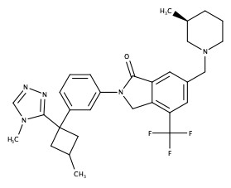 | -12.10 | 6.338
1 | Z3396339411 |  | -9.12 | 6.434
2 | Z1102107341 |  | -9.22 | 6.432
3 | Z3396345178 |  | -9.72 | 6.431
4 | Z2077032497 |  | -10.06 | 6.430
5 | Z3396341038 |  | -9.60 | 6.428
6 | Z5011956847 |  | -8.86 | 6.428

