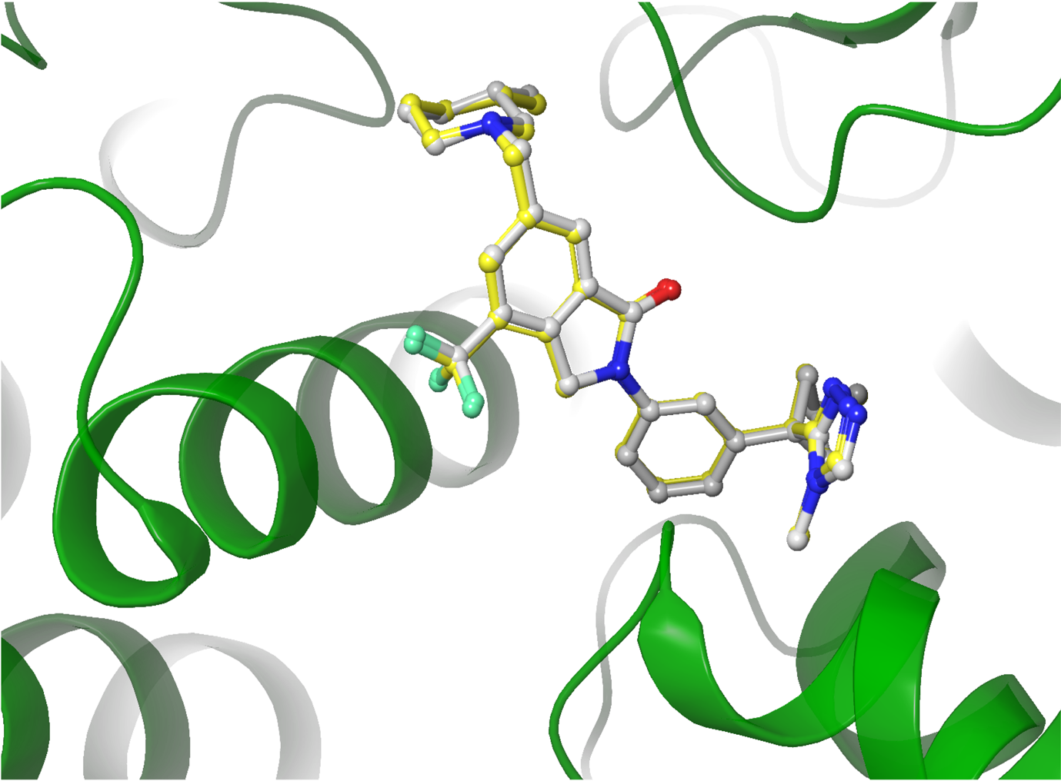

Supplementary Fig. 1 Alignment between the co-crystallized (white) and redocked (yellow) ligand. RMSD value was 0.17 Å.

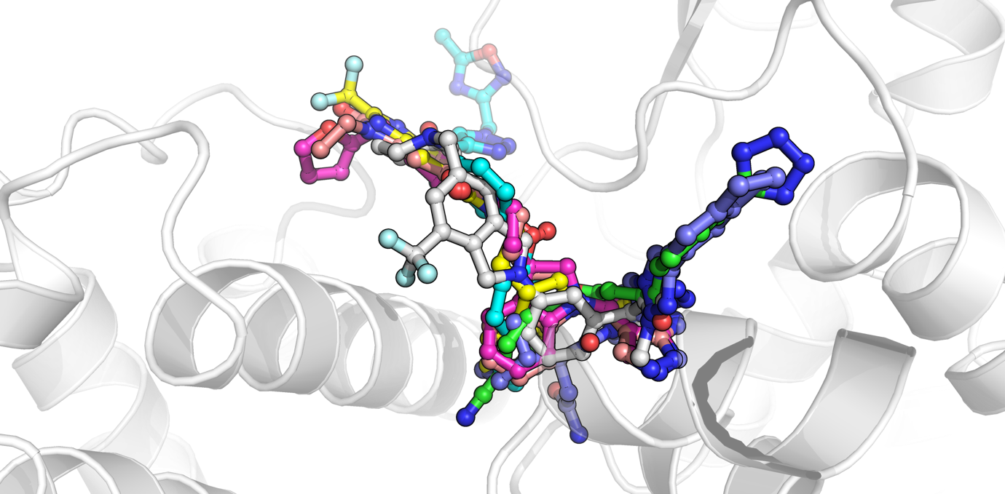

Supplementary Fig. 2 Superimposition of the lead compounds’ binding poses in comparison with the bound inhibitor (yellow).

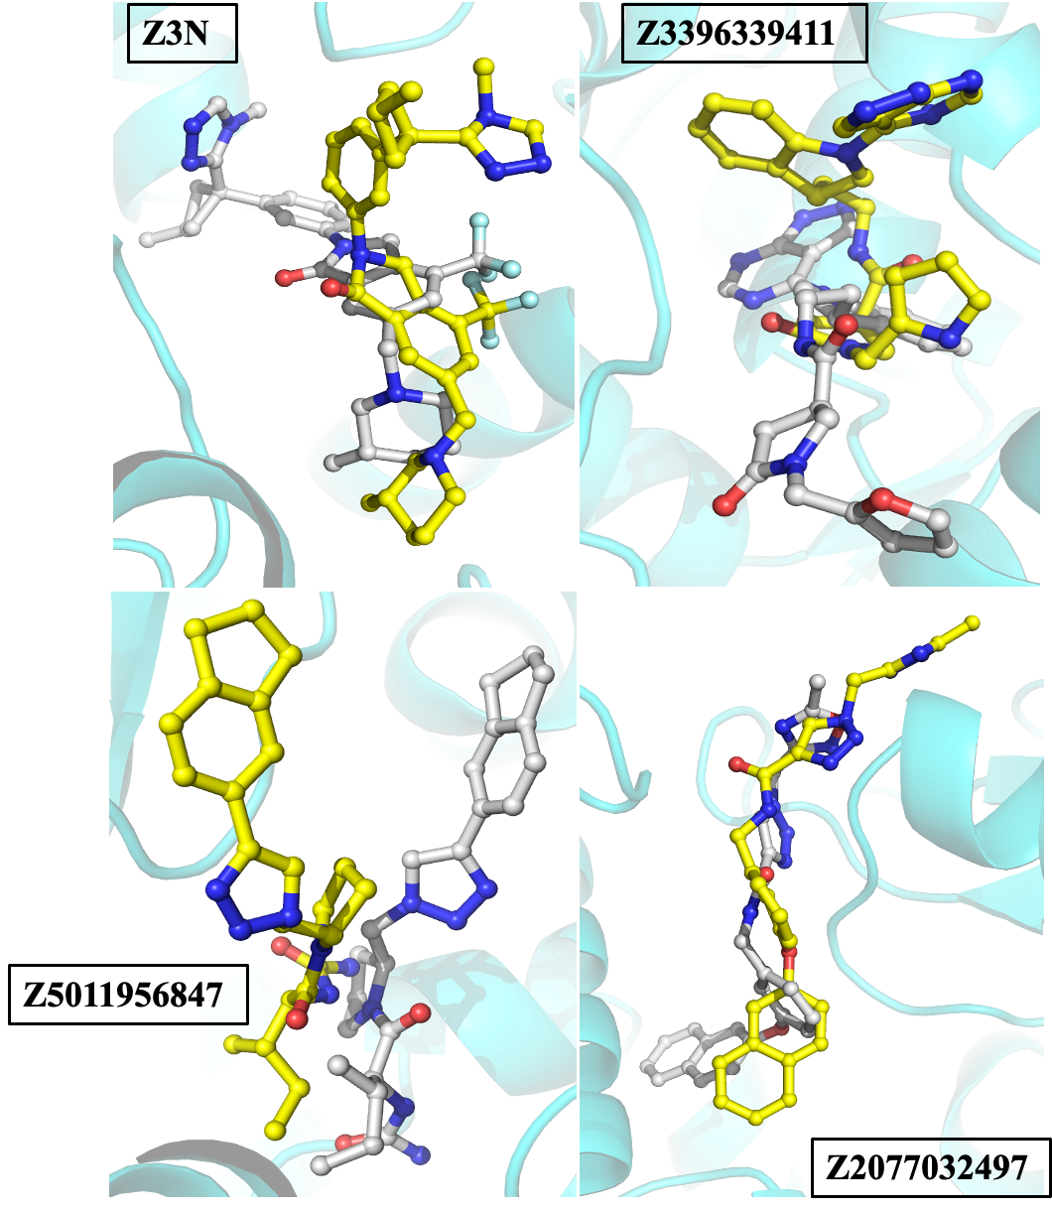
Supplementary Fig. 3 Alignment between the initial (white) and final (yellow) poses of the potential inhibitors from the 100 ns MD simulation run.

Supplementary Table 1 Protein-Ligand interaction analysis.
Compound | H-bonds (Distance Å) | Hydrophobic interactions | Salt bridges | π-stacking
Z3N | Y224 (3.58), F227 (3.04), Y312 (3.97) | T108, L112, T183, L186, F227, T229 | E232 | Y12
Z3396339411 | T183 (2.98), T229 (4.05), Y312 (3.18) | T108, K109, L112, F227
Z1102107341 | V219 (2.80), H221 (3.48), Y224 (3.66,3.66), Y312 (3.91) | Y224, A226, F227, Y312, M315
Z3396345178 | P35 (2.71), T183 (3.30), Y224 (3.87), F227 (3.95), Y312 (2.96) | K109, L112, F227
Z2077032497 | T229 (3.80), Y230 (3.71), R250 (2.86), S252(3.85), C253 (2.86) | K109, L112, F227
Z3396341038 | P35 (2.81), Y224 (2.66), Y312 (2.50,2.50) | T108, K109, L112, F227
Z5011956847 | S182 (3.68), D185 (2.82), Y312 (4.00) | L112, I113, L186, Y224, L311, Y312, M315 |  | Y12

Supplementary Table 2 ADMET properties of top hits and reference compound.
Compound | QED | Lipinski Rule | Pfizer Rule | GSK Rule | Caco-2 Permeability | HIA | Pgp inhibitor | Pgp substrate | BBB Penetration | CL | T_{1/2}
Z3N | 0.52 | Accepted | Rejected | Rejected |  | 0.126 | 0.989 | 0.558 | 0.774 | 4.391 | 0.405
  -5.469
Z3396339411 | 0.425 | Accepted | Accepted | Rejected | -5.319 | 0.122 | 0.708 | 0.999 | 0.497 | 6.108 | 0.42
Z1102107341 | 0.542 | Accepted | Accepted | Accepted | -5.191 | 0.266 | 0.838 | 0.382 | 0.038 | 3.532 | 0.494
Z3396345178 | 0.352 | Accepted | Accepted | Rejected | -5.067 | 0.011 | 0.965 | 1.0 | 0.236 | 5.484 | 5.484
Z2077032497 | 0.409 | Accepted | Accepted | Rejected | -4.744 | 0.005 | 0.003 | 0.001 | 0.359 | 6.504 | 6.504
Z3396341038 | 0.339 | Accepted | Accepted | Rejected | -5.215 | 0.012 | 0.825 | 0.999 | 0.112 | 4.977 | 0.285
Z5011956847 | 0.712 | Accepted | Accepted | Rejected | -5.046 | 0.006 | 0.081 | 0.216 | 0.434 | 7.689 | 7.689
Compound | CYP1A2-inh | CYP2C19-inh | CYP2C9-inh | CYP2D6-inh | CYP3A4-inh | hERG  blocker | H-HT | DILI | Ames | Carcino-genicity | Respiratory
Z3N | 0.048 | 0.312 | 0.079 | 0.974 | 0.848 | 0.753 | 0.471 | 0.054 | 0.371 | 0.412 | 0.968
Z3396339411 | 0.08 | 0.557 | 0.849 | 0.09 | 0.941 | 0.864 | 0.933 | 0.986 | 0.071 | 0.131 | 0.955
Z1102107341 | 0.697 | 0.766 | 0.787 | 0.787 | 0.672 | 0.937 | 0.937 | 0.972 | 0.901 | 0.368 | 0.675
Z3396345178 | 0.703 | 0.365 | 0.809 | 0.384 | 0.917 | 0.790 | 0.924 | 0.994 | 0.429 | 0.514 | 0.946
Z2077032497 | 0.777 | 0.957 | 0.936 | 0.936 | 0.802 | 0.829 | 0.954 | 0.985 | 0.671 | 0.937 | 0.282
Z3396341038 | 0.927 | 0.767 | 0.895 | 0.736 | 0.939 | 0.965 | 0.965 | 0.994 | 0.514 | 0.392 | 0.976
Z5011956847 | 0.236 | 0.495 | 0.495 | 0.421 | 0.587 | 0.049 | 0.944 | 0.952 | 0.254 | 0.964 | 0.085

