Extended Data 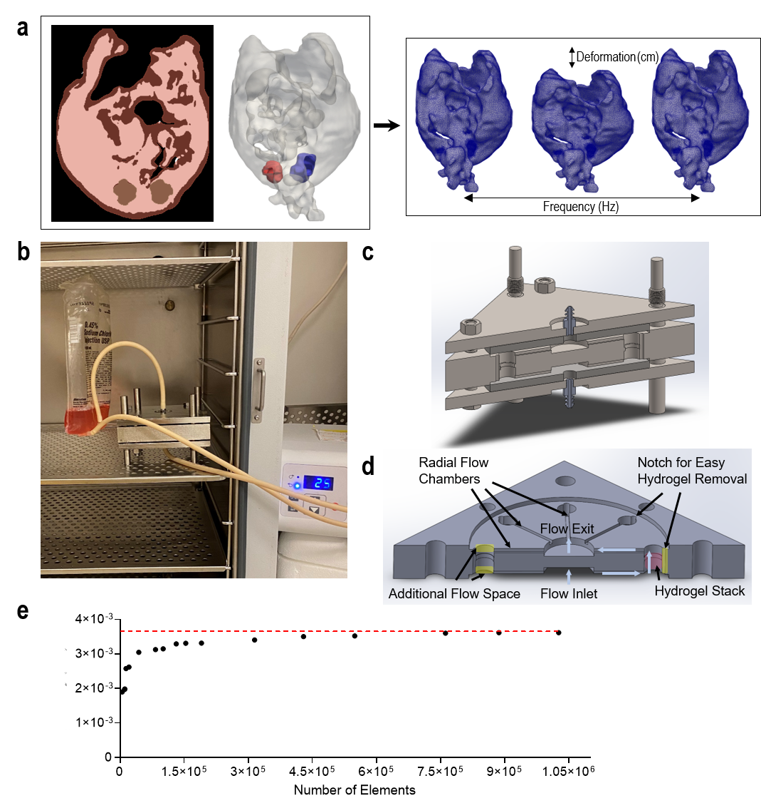
Extended Data Fig. 1| In silico and in vitro modeling of ascitic FSS in ovarian cancer. a, Segmentation of ascites fluid mask provided by University of Michigan’s Radiology Department and final model generation (left). The surface of the ovaries are highlighted in blue (right ovary) and red (left ovary) (right). Tetrahedral volume meshing of the model and definition of isovolumetric deformation for boundary driven CFD problem. b, FSS bioreactor in operation within a CO₂ incubator. Fluid flow is produced by a peristaltic pump. c, Rendered cross-section of the assembled FSS bioreactor. d, FSS bioreactor cross-section showing the locations of radial flow chambers and hydrogel stacks that allow the perfusion flow. Hydrogel stack regions contain a notch to assist in hydrogel stack removal. e, Mesh convergence analysis on the output of fluid velocity within the FSS bioreactor.
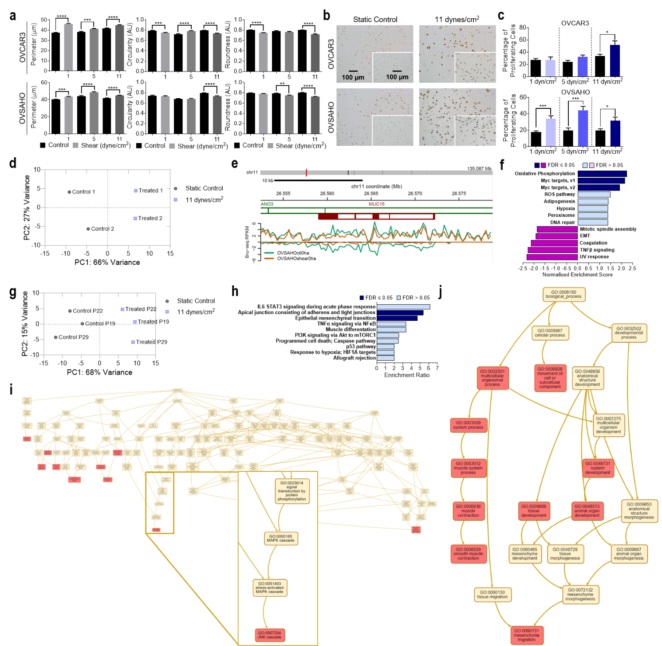
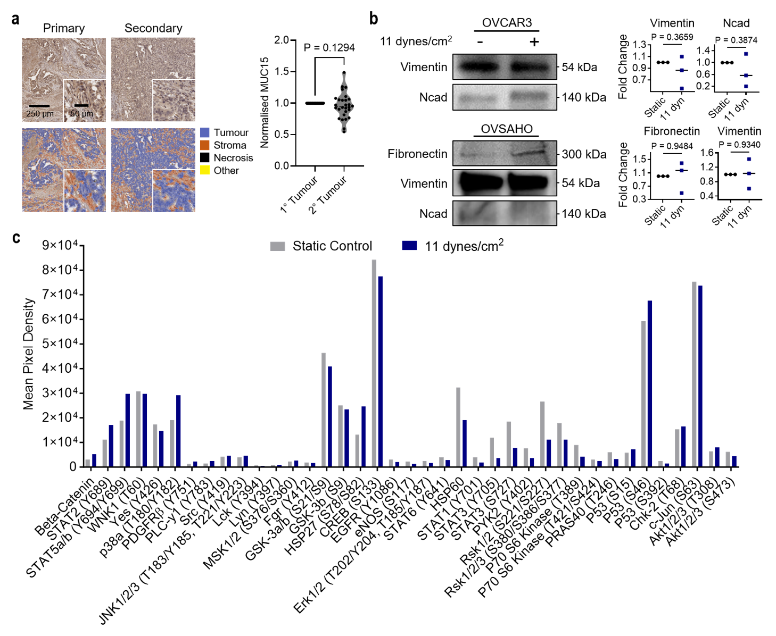
Extended Data Fig. 2 | Phenotypic alterations in FSS-exposed ovarian cancer cells. a, Cell perimeter, circularity, and roundness of OVCAR3 (top) and OVSAHO (bottom) cells exposed to static or increasing FSS conditions (1 dynes/cm², 5 dynes/cm², 11 dynes/cm² ; 24 hr; n = 3). b,c, Ki67 stains (b) of static and sheared OVCAR3 (top) and OHSAHO (bottom) cells (1 dynes/cm², 5 dynes/cm², 11 dynes/cm²; 24 hr) and the associated quantification of the number of Ki67⁺ cells (c; n = 3). Significance evaluated by Student t-test. d, Bru-seq PCA of sheared OVSAHO cells (11 dynes/cm², 1 hr). e, Nascent MUC15 RNA signal from Bru-seq libraries is represented as reads per kilobase per million (RPKM) and is shown for the static control (green) and shear condition (yellow). f, GSEA of Bru-seq data showing gene sets upregulated and downregulated in OVSAHO following a 1 hr exposure to shear. Gene sets in the Hallmark pathways are shown and the data is expressed as NES. g, RNA-seq PCA of sheared OVCAR3 cells (11 dynes/cm², 24 hr). h, ORA of RNA-seq data showing gene sets upregulated in OVCAR3 following 24 hr exposure to shear. Gene sets in the Hallmark pathways are shown and the data is expressed as enrichment ratio. i,j, NTA of RNA-seq representation of uniquely upregulated genes in sheared OVCAR3 when compared to sheared FTE237, gene sets in TCGA RNAseq TGCT (i) and ACC (j) datasets are shown. Significance evaluated by Student’s t-test, *P ≤ 0.05, **P ≤ 0.01, ***P ≤ 0.001, ****P ≤ 0.0001.

Extended Data Fig. 3 | FSS-activated signal transducers in ovarian cancer cells. OVCAR3 and OVSAHO cell lines were exposed to static conditions or 11 dynes/cm² FSS for 24 hr. a, MUC15 immunohistochemistry and quantification of MUC15 fold change between paired tumour sections from primary and metastatic sites of HGSC patients (stages III and IV). b, Protein expression and quantification of EMT markers in static and sheared OVCAR3 and OVSAHO cells (11 dynes/cm², 24 hr). c, Phospho-kinase array quantification of suspected FSS signal transducers. d, Phospho-kinase array legend. Significance evaluated by Student’s t-test.
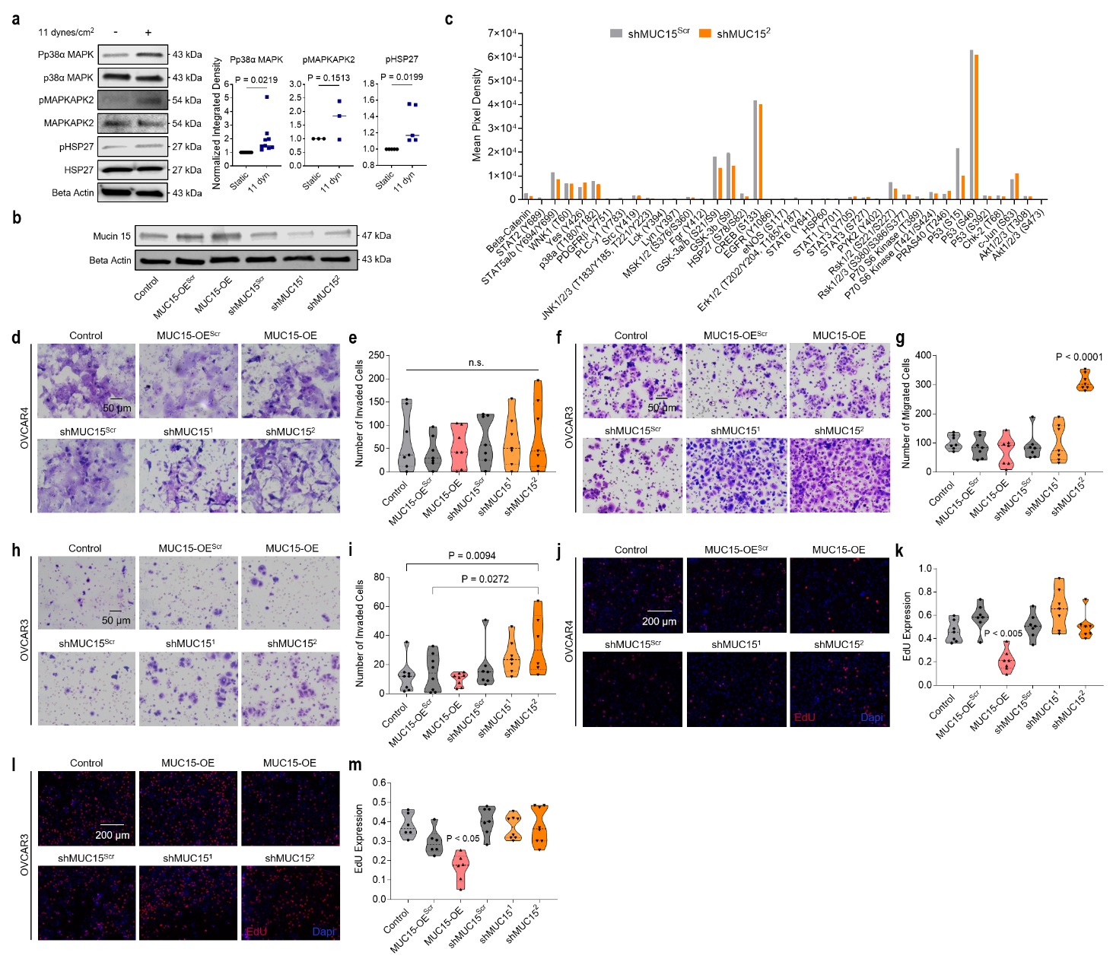
Extended Data Fig. 4 | p38α MAPK signaling and MUC15 in ovarian cancer cell FSS-associated behaviors. a, Protein expression and quantification of p38α MAPK-associated signaling molecules in static and sheared OVSAHO cells (11 dynes/cm², 24 hr). Significance evaluated by Student’s t-test. b, MUC15 protein expression of the OVCAR3 parental line and MUC15-transduced overexpressing, knockdown, and scramble control lines. c, Phopsho-kinase array and quantification of suspected FSS signal transducers in MUC15 knockdown and scrambled shRNA control OVCAR4. d,e, MUC15-transduced OVCAR4 Boyden chamber Matrigel invasion assays (d) and quantification (e) of the number of invaded cells per FOV. Significance evaluated by one-way ANOVA, multiple comparisons. No significance, n.s. f,g, MUC15-transduced OVCAR3 Boyden chamber migration assays (f) and quantification (g) of the number of migrated cells per FOV. Significance evaluated by one-way ANOVA, multiple comparisons. h,i, MUC15-transduced OVCAR3 Boyden chamber Matrigel invasion assays (h) and quantification (i) of the number of invaded cells per FOV. Significance evaluated by one-way ANOVA, multiple comparisons. j,k, MUC15-transduced OVCAR4 EdU proliferation assays (j) and quantification (k) of the number of EdU⁺ cells per FOV. Significance evaluated by one-way ANOVA, multiple comparisons. l,m, MUC15-transduced OVCAR4 EdU proliferation assays (l) and quantification (m) of the number of EdU⁺ cells per FOV. Significance evaluated by one-way ANOVA, multiple comparisons.

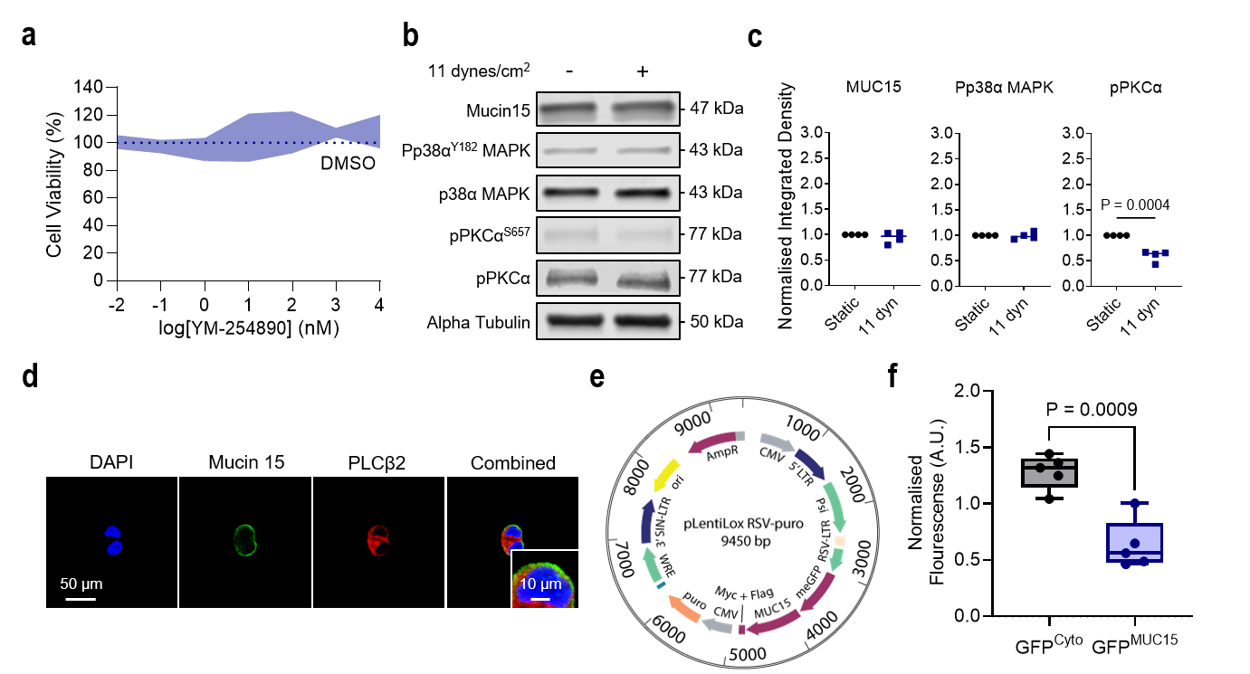
Extended Data Fig. 5 | GPCRs and MUC15 FSS mechanotransduction. a, Cell viability of OVCAR3 cells exposed to increasing concentrations of YM-254890 (SD; n = 3). Dotted line represents the viability of cells treated with DMSO (vehicle). b,c, Protein expression of MUC15 and p38α MAPK-associated signaling molecules in FTE237 (11 dynes/cm², 24 hr) (b) and quantification (c). Significance evaluated by Student’s t-test. d, MUC15 and PLCβ2 immunofluorescence in OVCAR3. e, Vector sequence used to create the GFP^{MUC15} OVCAR3 cell line. f, Fluorescent intensity of static and sheared cell-laden hydrogels containing GFP^{Cyto} and GFP^{MUC15} (11dynes/cm², 24 hr). Significance evaluated by Welch’s t-test.

Supplementary Information
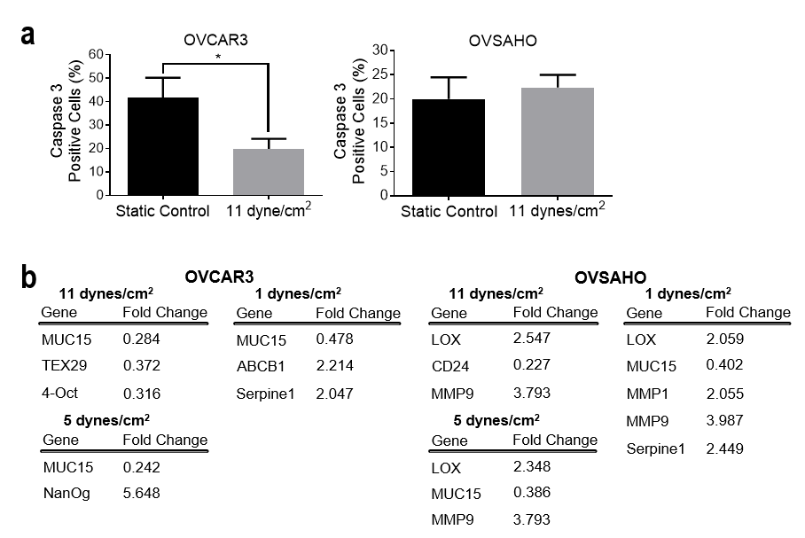
Supplementary Fig. S1 | a, Apoptotic activity in static and sheared OVCAR3 (left) and OVSAHO (right) cell (11 dynes/cm², 24 hr) evaluated by caspase-3 expression (n = 3). b, Quantitative PCR on genes of interest for OVCAR3 (left) and OVSAHO (right). Significance evaluated by Student’s t-test, *P ≤ 0.05.
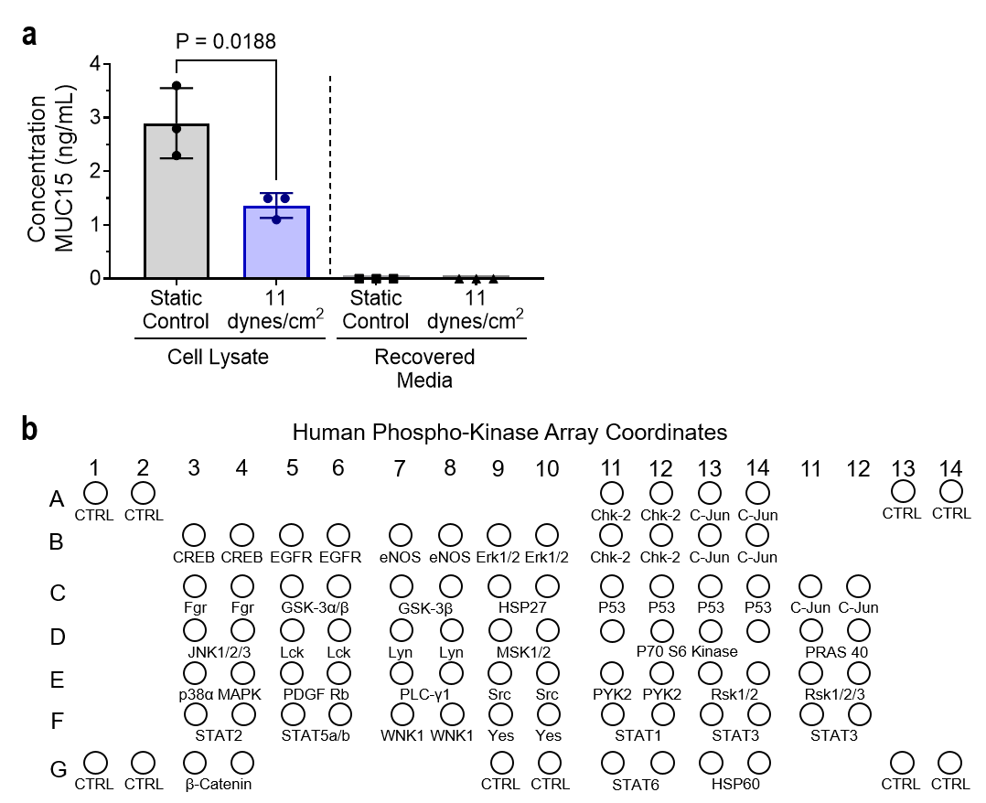

Supplementary Fig. S2 | a, MUC15 ELISA of OVCAR3 cell lysate and conditioned media. b, Phospho-kinase array legend. Significance evaluated by Student’s t-test.
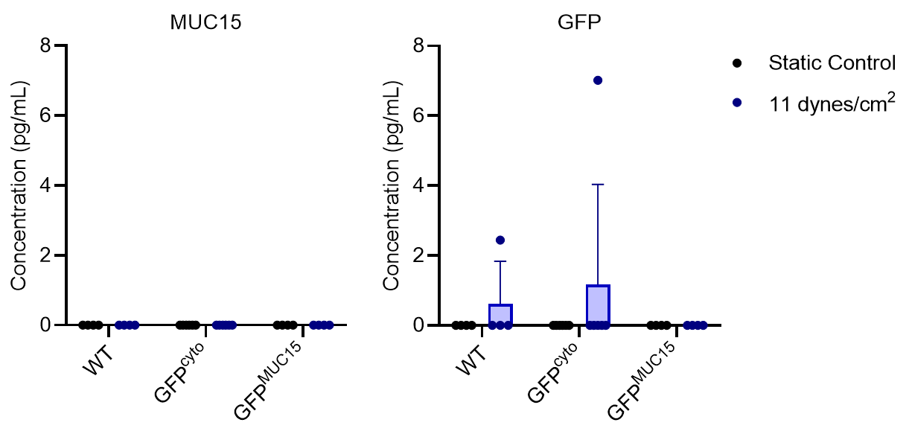
Supplementary Fig. S3 | MUC15 (left) and GFP (right) ELISA of OVCAR3 conditioned media exposed to 11 dynes/cm² or static conditions for 24 hr. Significance evaluated by Multiple paired t-tests.

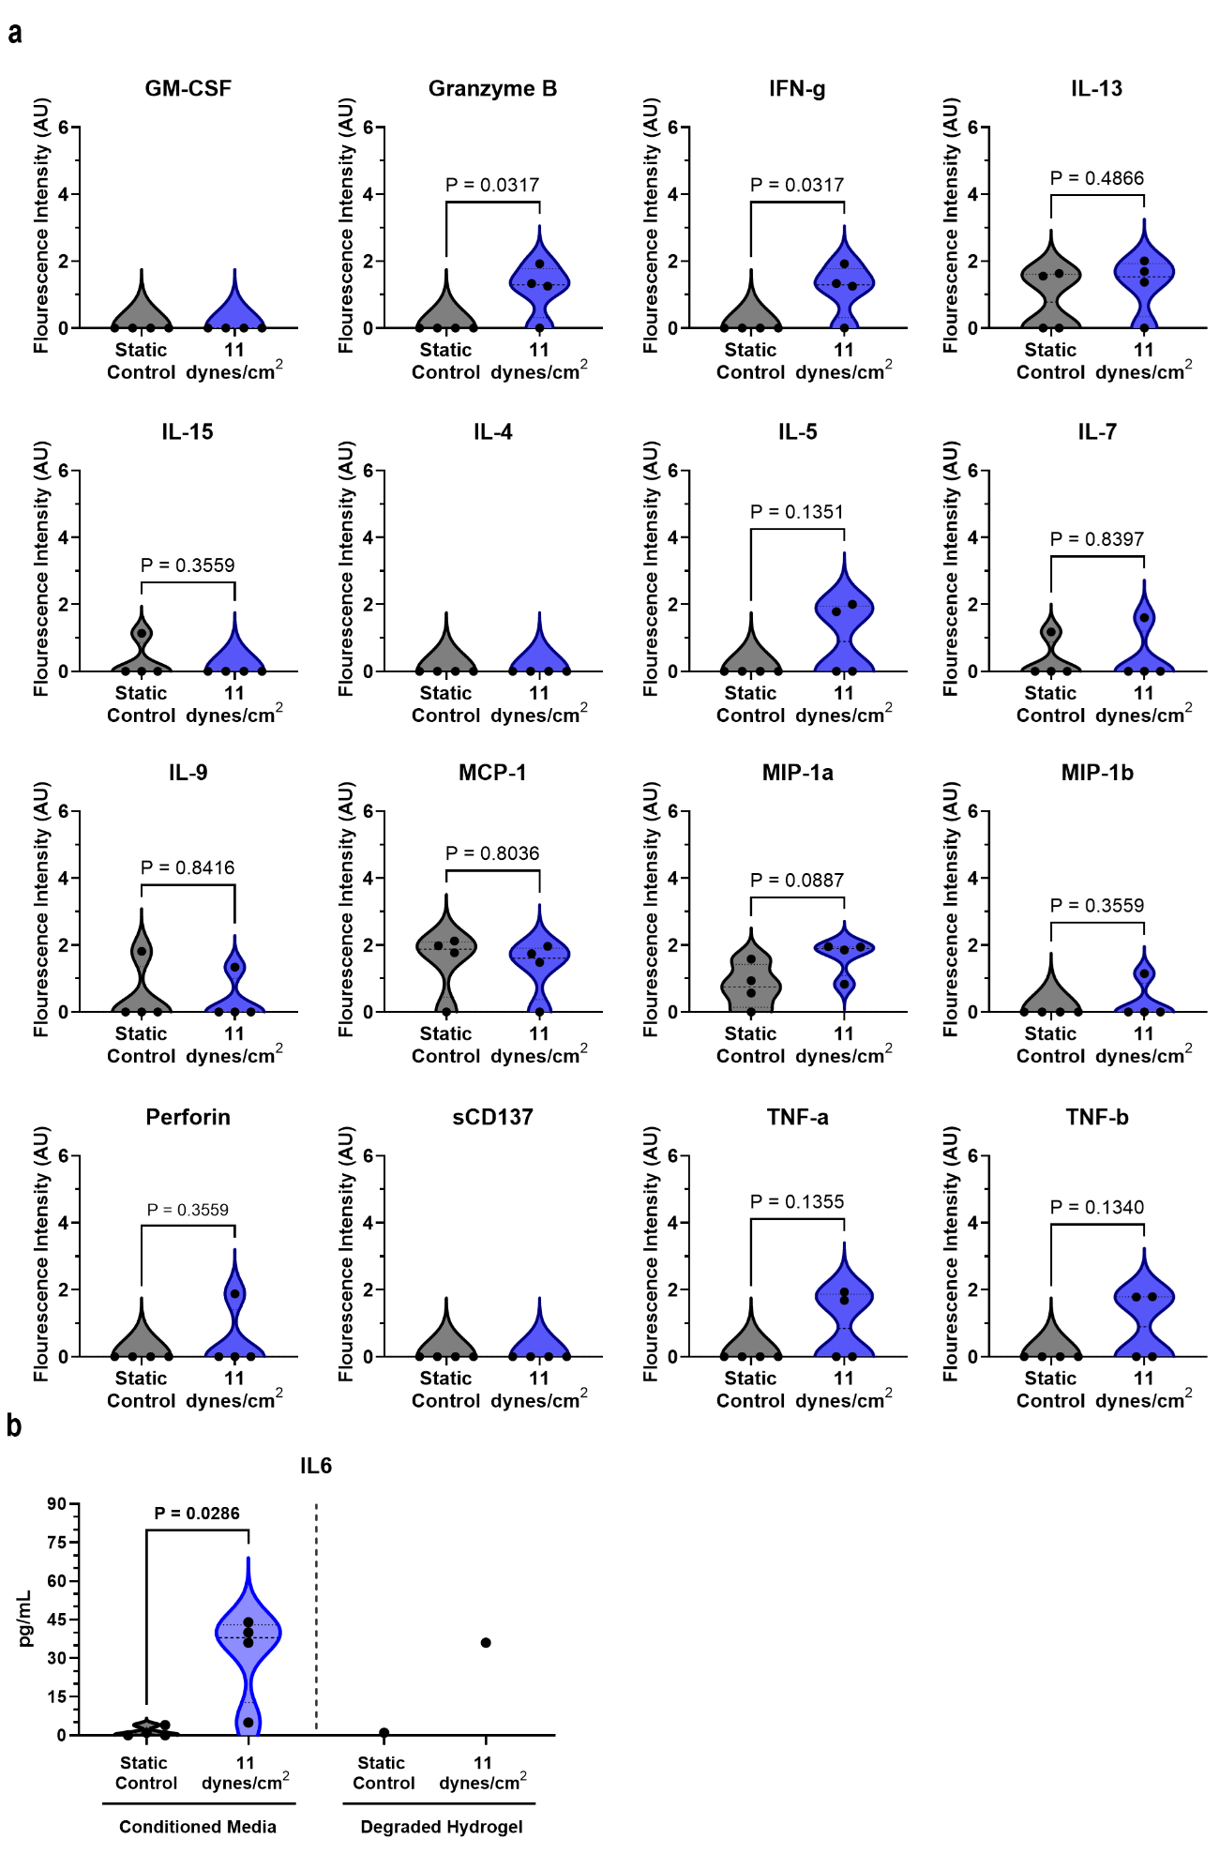
Supplementary Fig. S4 | Secretome in FSS-stimulated ovarian cancer cells. a, Fluorescent intensity of cytokines secreted by static and sheared OVCAR3 (11 dynes/cm², 24 hr) measured by multiplex cytokine array. b, IL-6 ELISA of conditioned media and the degraded hydrogel of sheared OVCAR3 (11 dynes/cm², 24 hr). Significance evaluated by Student’s t-test.

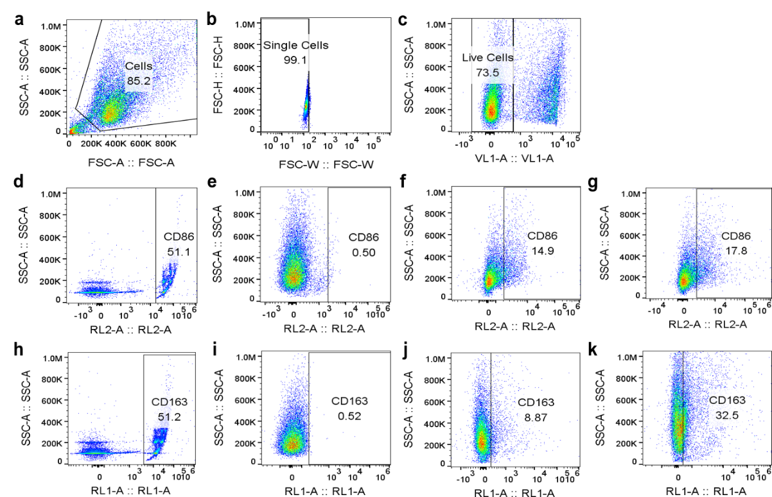
Supplementary Fig. 5 | Representative flow plots for gating. Flow cytometry of U937-derived M0 macrophages following 24 hr treatment with conditioned media from sheared and static OVCAR3 (11 dynes/cm², 24 hr). a, Unlabeled sample. b, Doublet discrimination. c, Identification of live cell population using a DAPI stain. d, Gating for CD86 using UltraComp eBeads Plus Compensation Beads (Thermo Fisher Scientific). e, Gating of isotype control for CD86. f, Representative plot for CD86 expression in static CM sample. g, Representative plot for CD86 expression in shear CM sample. h, Gating for CD163 using UltraComp eBeads Plus Compensation Beads (Thermo Fisher Scientific). i, Gating of isotype control for CD163. j. Representative plot for CD163 expression in static CM sample. k, Representative plot for CD163 expression in shear CM sample.

Supplementary Table 1 | FSS-Mechanosensor RT-qPCR Primer Sequences
RT-qPCR Gene | Forward Primer | Reverse Primer
TBP | 5’- GAGCCAAGAGTGAAGAACAGTC -3’ | 5’- GCTCCCCACCATATTCTGAATCT -3’
HPRT1 | 5'- GAAAAGGACCCCACGAAGTG -3' | 5'- GTCAAGGGCATATCCTACAAC -3'
RPL27 | 5'- GGCTGGAATTGACCGCTAC -3' | 5'- CCTTGTGGGCATTAGGTGATTG -3'
CD177 | 5'- CGGCAATGGACCCCTAAGAAC -3' | 5'- CGAGGTTGTTGCAGAAGTC -3'
TAGLN | 5'- GTGCAGTCCAAAATCGAGAAG -3' | 5'- CTTGCTCAGAATCACGCCA -3'
MUC15 | 5'- CTCAAATCTCAAGGCGAGTC -3' | 5'- CAGGTGTAGCATTGGGATG -3'
STIM1 | 5'- GGTGAGGATAAGCTCATCAGC -3' | 5'- CAGCACAGTCCCTGTCATGG -3'
GNA15 | 5'- CCAGGACCCCTATAAAGTGACC -3' | 5'- GCTGAATCGAGCAGGTGG -3'
GNAQ | 5'- GGGTCAGGATACTCTGATGAAG -3' | 5'- GTGCATGAGCCTTATTGTGC -3'
GNA11 | 5'- GGCTTCACCAAGCTCGTCTAC -3' | 5'- CACTGACGTACTGATGCTCG -3'
GNA12 | 5'- GGAGGGATTCTGGCATCAGG -3' | 5'- CCGATCCGGTCCAAGTTGTC -3'
GNA13 | 5'- CAGCAACGCAAGTCCAAGG -3' | 5'- CCAGCACCCTCATACCTTTG -3'
GPR68 | 5'- GTACCATCGACCATACCATCC -3' | 5'- GGTAGCCGAAGTAGAGGGAC -3'
PTGER1 | 5'- GCTTGTCGGTATCATGGTGG -3' | 5'- GAGGCGAAGCAGTTGGC -3'
PTGER2 | 5'- CGATGCTCATGCTCTTCGC -3' | 5'- GGGAGACTGCATAGATGACAGG -3'
PTGER3 | 5'- CGCCTCAACCACTCCTACAC -3' | 5'- GACACCGATCCGCAATCCTC -3'
MRGPRX1 | 5'- CACCAATCAACGGAACTGAGG -3' | 5'- GCGTTTCCTGTCAGCCC -3'
MRGPRX2 | 5'- CGTGGGCTCTTTTAGGAAGC -3' | 5'- CCTGACGGAAGCATCCTTCAC -3'
MRGPRX3 | 5'- CCCAGTCTTGGGTACAGAAC -3' | 5'- GGCCGCTAAGGAAGAGG -3'
PLCB1 | 5'- GGAAGCGGCAAAAAGAAGCTC -3' | 5'- CGTCGTCGTCACTTTCCG -3'
PLCB2 | 5'- CCGGGATACTCGCTTTGG -3' | 5'- CACCACCGTGAGTGTCTTCAG -3'
PTGS2 | 5'- GTGCGATTGTACCCGGAC -3' | 5'- GTAGCCATAGTCAGCATTG -3'
TRPC3 | 5'- CCCTGAGACGCATGACAGTG -3' | 5'- CACGCAGTTGACGTTCAGC -3'
CLIC2 | 5'- CTGTCCCTTTTGCCAACGC -3' | 5'- GGGGCTAAGTCCTTTAGTTCTTC -3'
CLIC3 | 5'- CCTCAAGGGCGTACCTTTCAC -3' | 5'- GTCGCTGTCATAGAGCAGG -3'
CLIC5 | 5'- GGAGAAAGCATCGGCAACTG -3' | 5'- GTGACATTGAACACGACTCC -3'
CLIC6 | 5'- GGGACCCAACATCCCGAATC -3' | 5'- CAGGCAGAGGGCTATTTAAG -3'
SCN9A | 5'- CCTCAGAGCTTTGTCCATTTC -3' | 5'- GTCTGCATAGTAGGGGTCC -3'
KCNK9 | 5'- CAGCAGCGAGGACTACC -3' | 5'- CGGCGAATTTCCACTGGAC -3'
KCNK4 | 5'- CTGCTGCGTCTCTACCTGG -3' | 5'- GGGTGCGTGTTCATGTAAAG -3'
PRKCA | 5'- GTCCACAAGAGGTGCCATG -3' | 5'- GGTGGGGCTTCCGTAAG -3'
PKCB1 | 5'- GCCTCGCCAGAAAAGGAC -3' | 5'- CATCTCAACAGAGGAGTTTCCAG -3'
PRKCB | 5'- GGATTGGGATTTGACCAGCAG -3' | 5'- GGCACAGGCACATTGAAG -3'
ITPR3 | 5'- CCAAGCAGACTAAGCAGGAC -3' | 5'- CACTGCCATACTTCACGAC -3'

Supplementary Table 2 | Antibodies and Working Concentrations
Antibody | Concentration | Supplier
Mucin 15 | 1:200 (WB); 1:20 (IHC); 1:100 (Co-IP) | Sigma; HPA026110
E-Cadherin | 1:1000 (WB) | Cell Signaling; 24E10
Filamin A | 1:500 (WB) | Abcam; ab76289
Tagln | 2 µg/mL (WB) | Abcam; ab14106
Fibronectin | 2 µg/mL (WB) | Abcam; ab2413
Vimentin | 1:1000 (WB) | GeneTex; GTX100619
N-Cadherin | 1:500 (WB) | Cell Signaling; 4061
Phospho Akt | 1:1000 (WB) | Cell Signaling; 4060S
Beta Catenin | 1:500 (WB) | BD Biosciences; 610153
Beta Actin | 1:1000 (WB) | Invitrogen; AM4302
phospho p38α MAPK | 1:200 (WB) | Cell Signaling; 9211S
total p38α MAPK | 1:200 (WB) | Cell Signaling; 9212S
phospho MAPKAPK2 | 1:200 (WB) | Cell Signaling; 3007
total MAPKAPK2 | 1:200 (WB) | Cell Signaling; 3042
phospho HSP27 | 1:200 (WB); 1:100 (IF) | Cell Signaling; 2401
total HSP27 | 1:500 (WB) | Cell Signaling; 2402
phospho PKCα | 1:200 (WB) | Abcam; ab180848
total PKCα | 1:100 (WB) | Santa Cruz; sc-8393
Alpha Tubulin | 1:500 (WB) | Invitrogen; 62204
PLCβ1 | 1:500 (WB), 1:50 (IF) | Invitrogen; PA5-76089
PLCβ2 | 1:400 (WB); 1:100 (IF) | My Bio Source, MBS9606175
BiP | 1:500 (WB) | Cell Signaling; 3177S
GPR68 | 1:500 (WB) | Invitrogen; 16H23L16
AF488 MUC15 | 1:50 (IF) | Santa Cruz; sc-365746 AF488
AF488 Phalloidin | 1:200 (IF) | Invitrogen; A12379
AF594 NF-κB | 1:100 (IF) | Santa Cruz; sc-8008 AF594
APC CD163 | 1:20 (FC) | BD Biosciences; 562669
APC CD86 | 1:20 (FC) | Fisher Scientific; 11-0689-42

