Interfacial Coupling effects of Chitosan integrated ZrO₂/Bi₂O₃/CeO₂ quaternary composite for efficient wastewater treatment and antimicrobial activity
U.MaryNisha*, D. Venkatesh
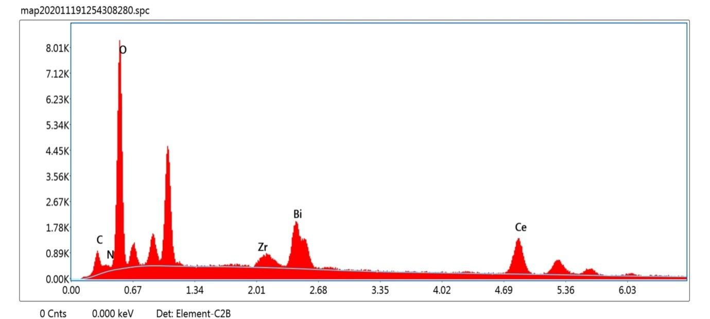
Department of Chemistry, Vel Tech High Tech Dr.R. Rangarajan & Dr.R.Sakunthala Engineering College, Avadi, Chennai-600062, India
Corresponding author e-mail: nisharose2win@gmail.com
Fig. S1 SEM-EDAX profile of quaternary phase of CS-TMOs composites at room temperature.
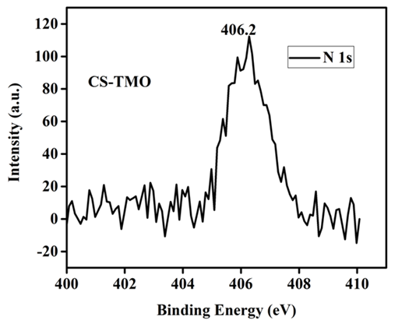

Fig. S2 The binding energy of N 1s (XPS analysis of CS-TMOs composite) at room temperature.

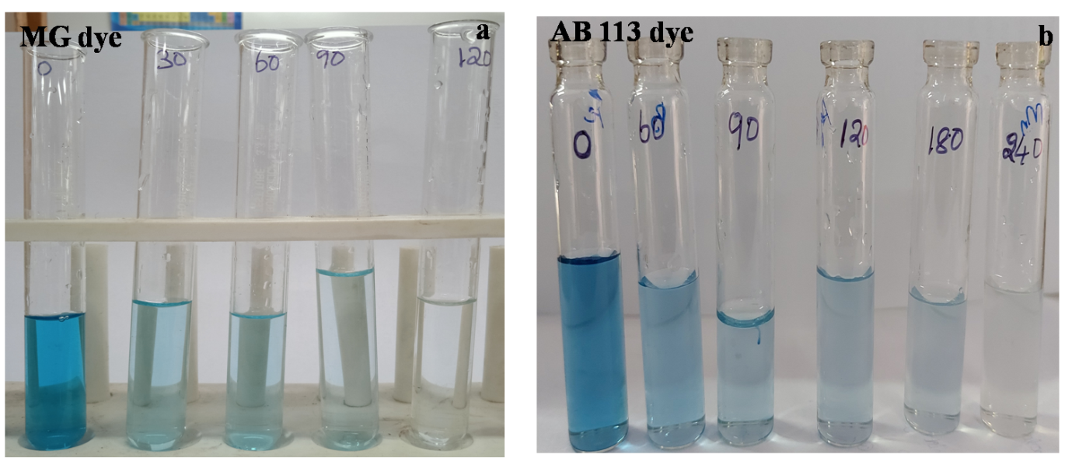
Fig. S3 Digital photographic images for the colour removal of a) MG and b) AB 113 dye molecules
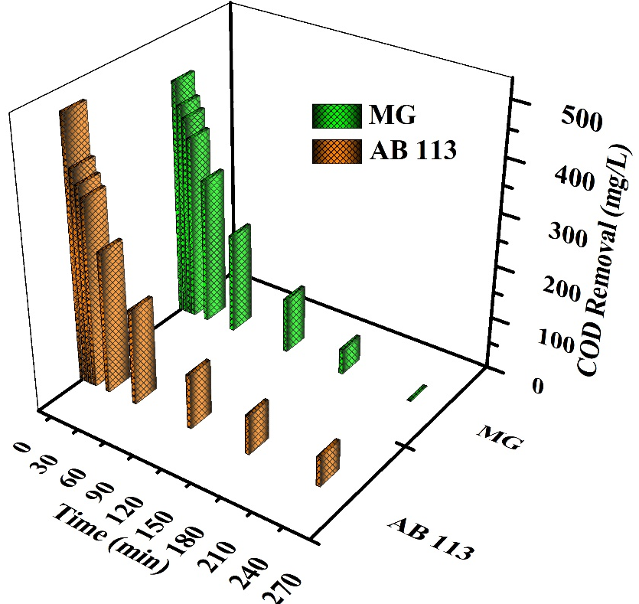

Fig. S4 COD removal of photodegradation of a) MG and b) AB 113 dye molecules

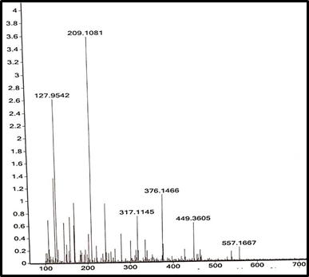

Fig. S5 ESI-Mass spectrum of photodegraded sample (CS-TMO) using MG dye

Fig. S6 ESI-Mass spectrum of photodegraded sample (CS-TMO) using AB 113 dye

