Supporting Information
1,5-dichloroethanoanthracene Derivatives: Synthesis and DFT computational Calculations
Mujeeb A. Sultan, Renjith Raveendran Pillai, Eman Alzahrani

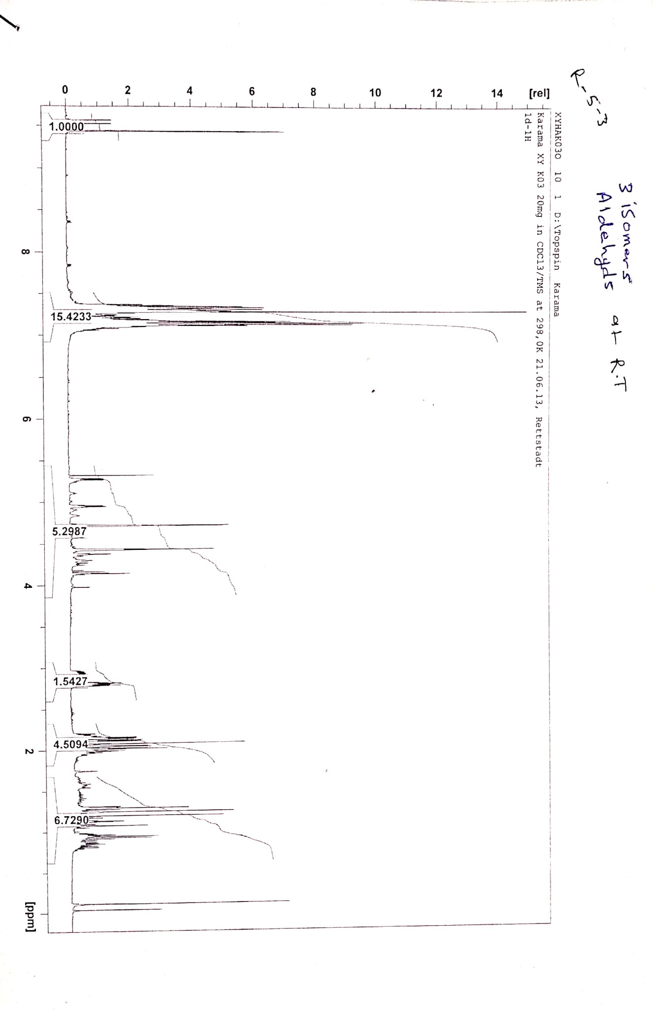
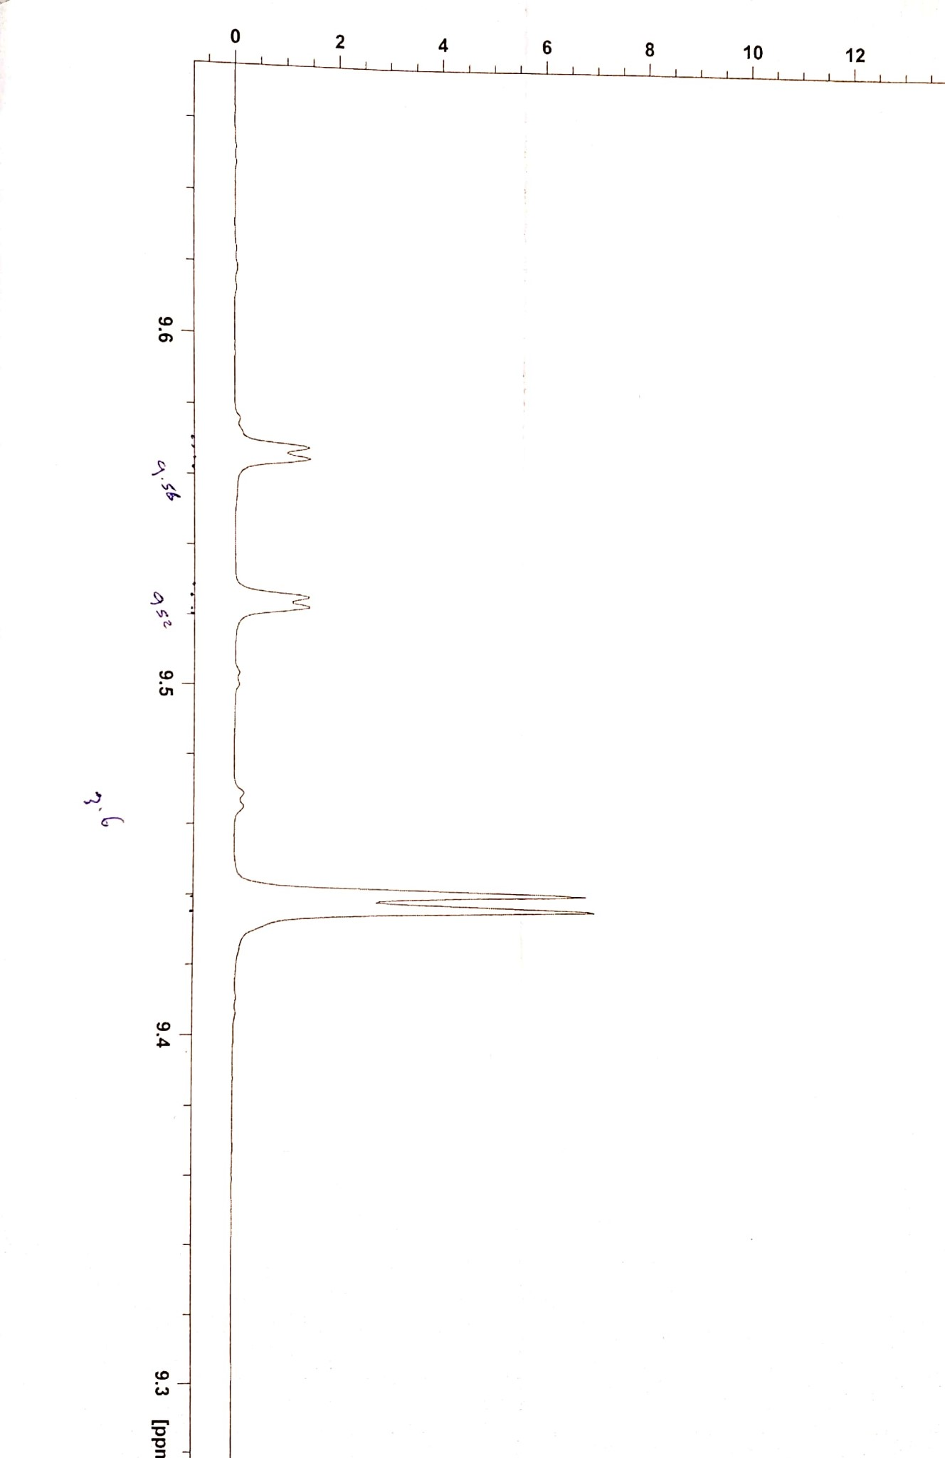
Fig. S1. ¹H-NMR spectrum of the crude compound 2

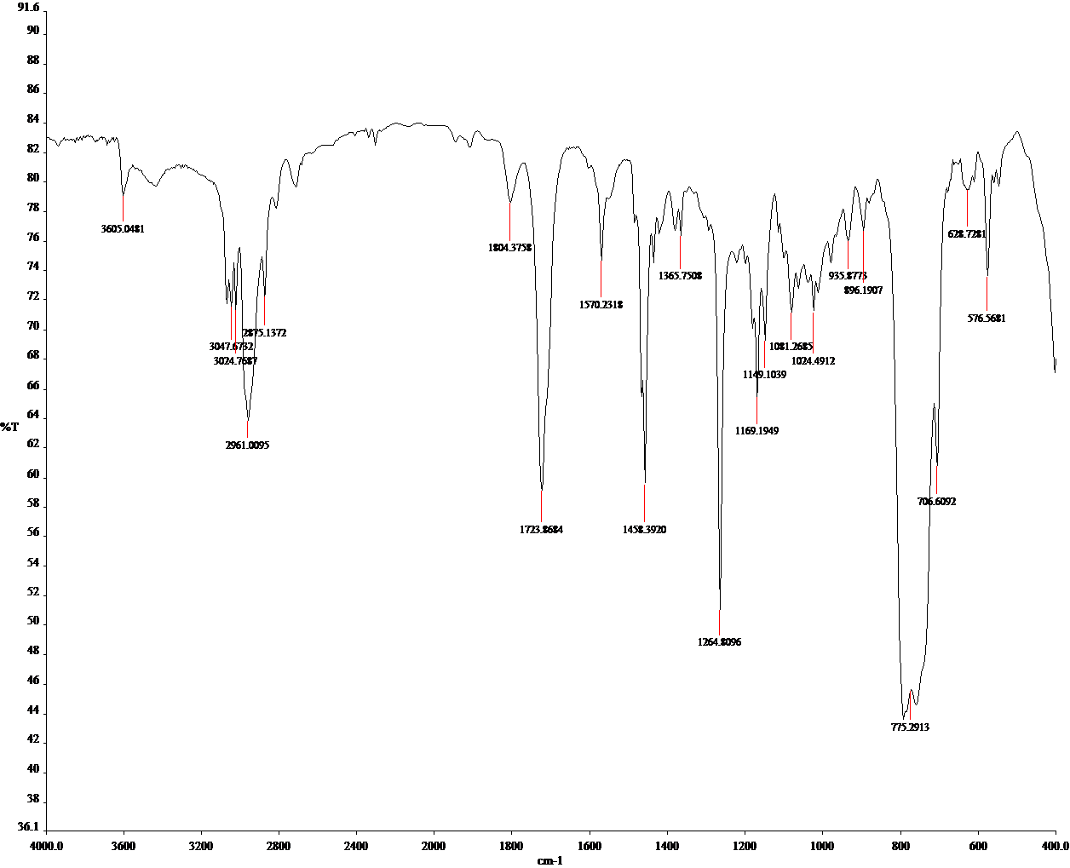
Fig. S2. IR spectrum of the crude compound 2

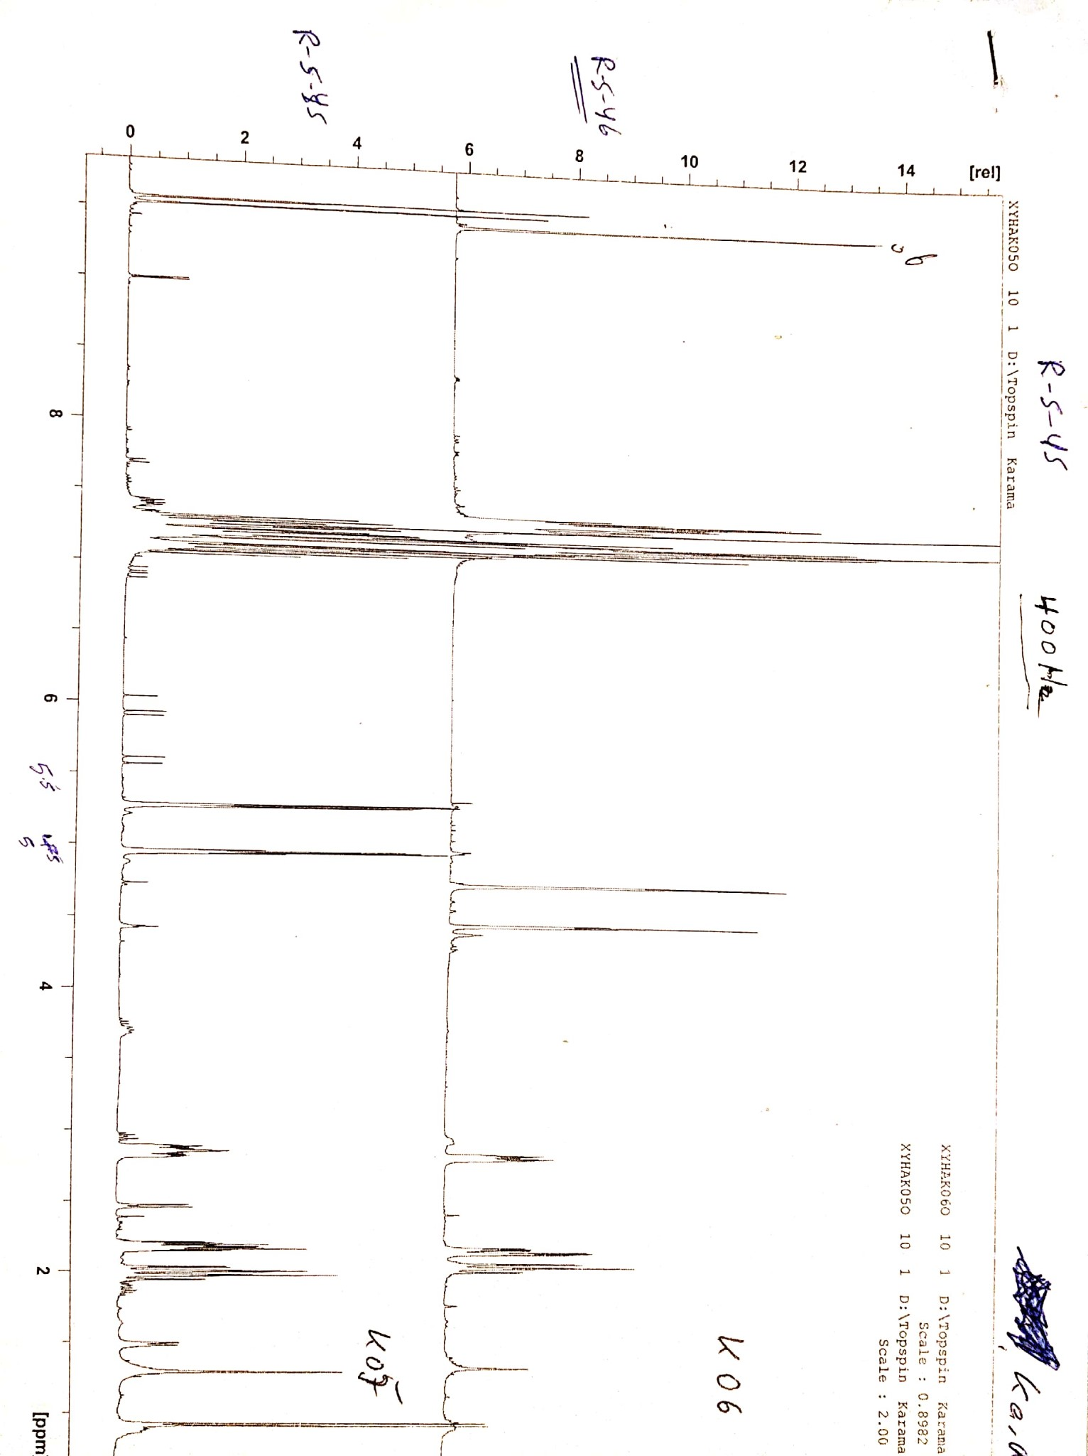
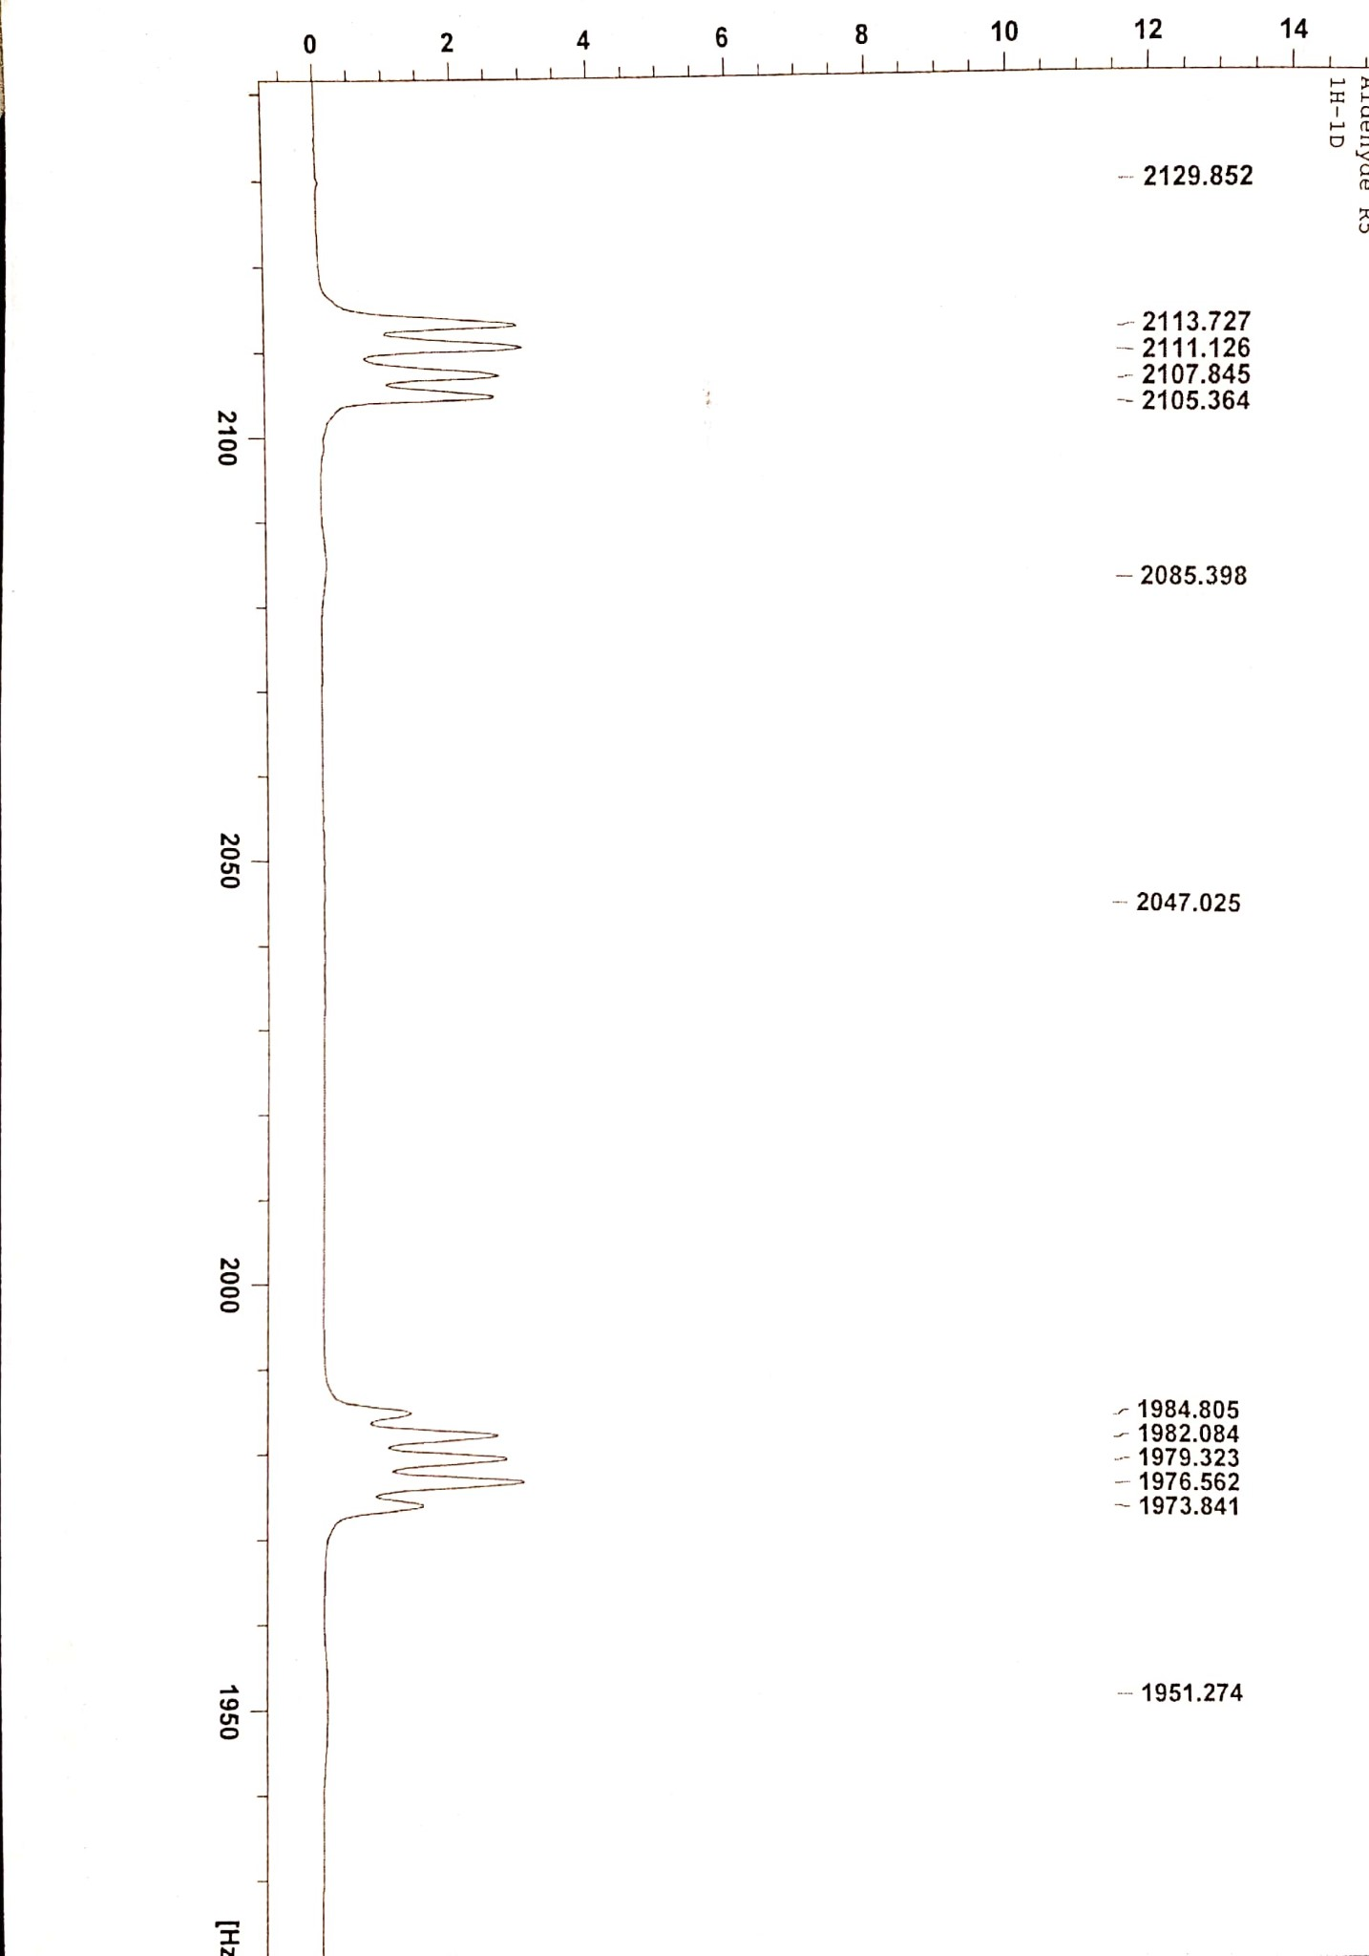
Fig. S3. a) ¹H-NMR spectrum of the 2a, b) ¹H-NMR spectrum of the 2b, c) Partial ¹H-NMR spectrum of the bridgehead protons (H-C9 and H-C10) of the 2a.
b) Aldehyde 2b
a) Aldehyde 2a
c)
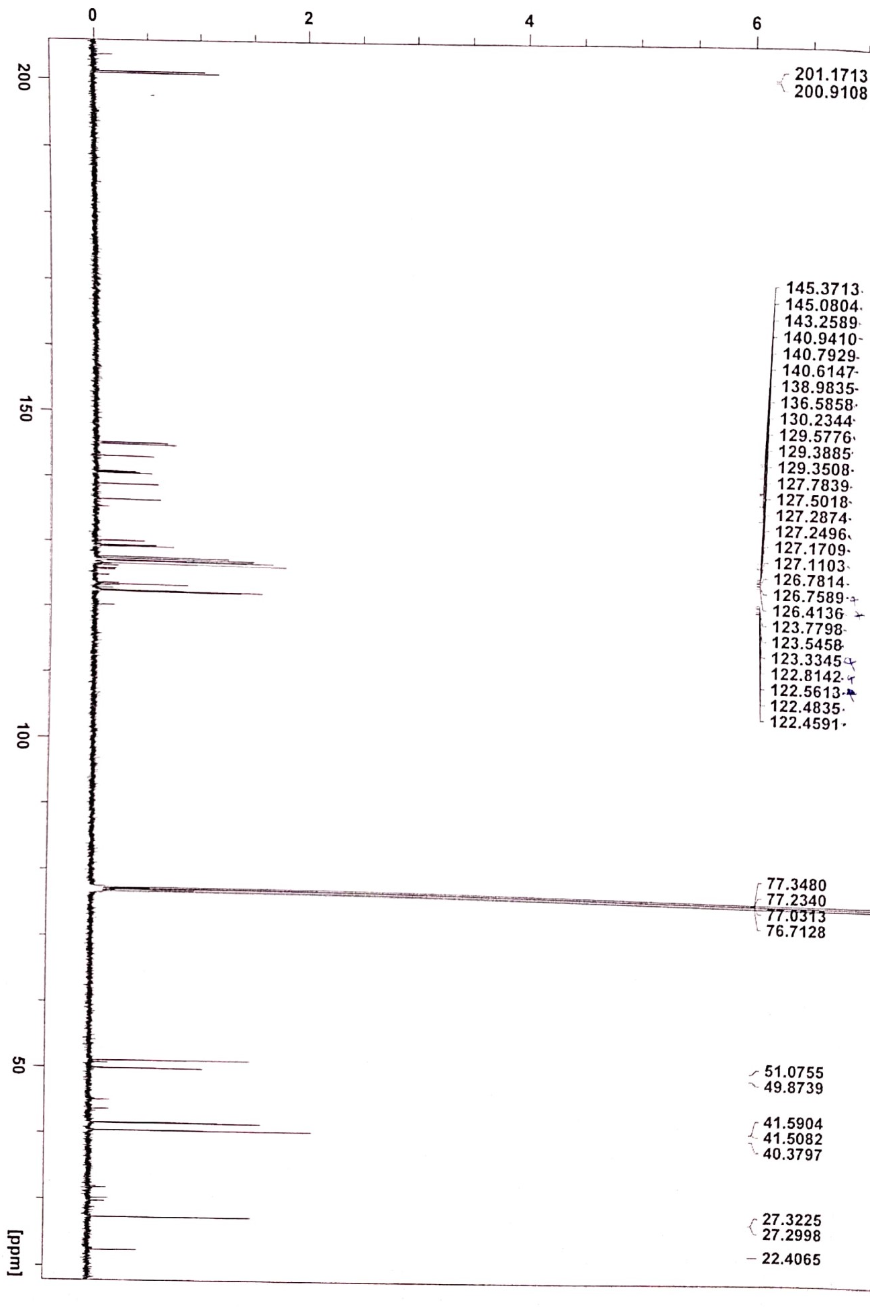
Fig. S4. ¹³C-NMR spectrum of the 2a
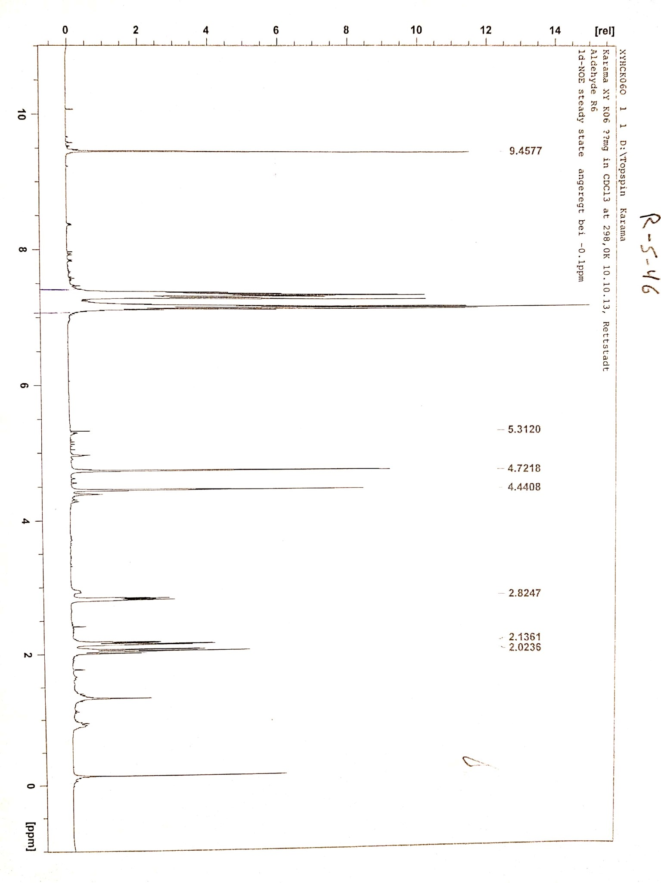
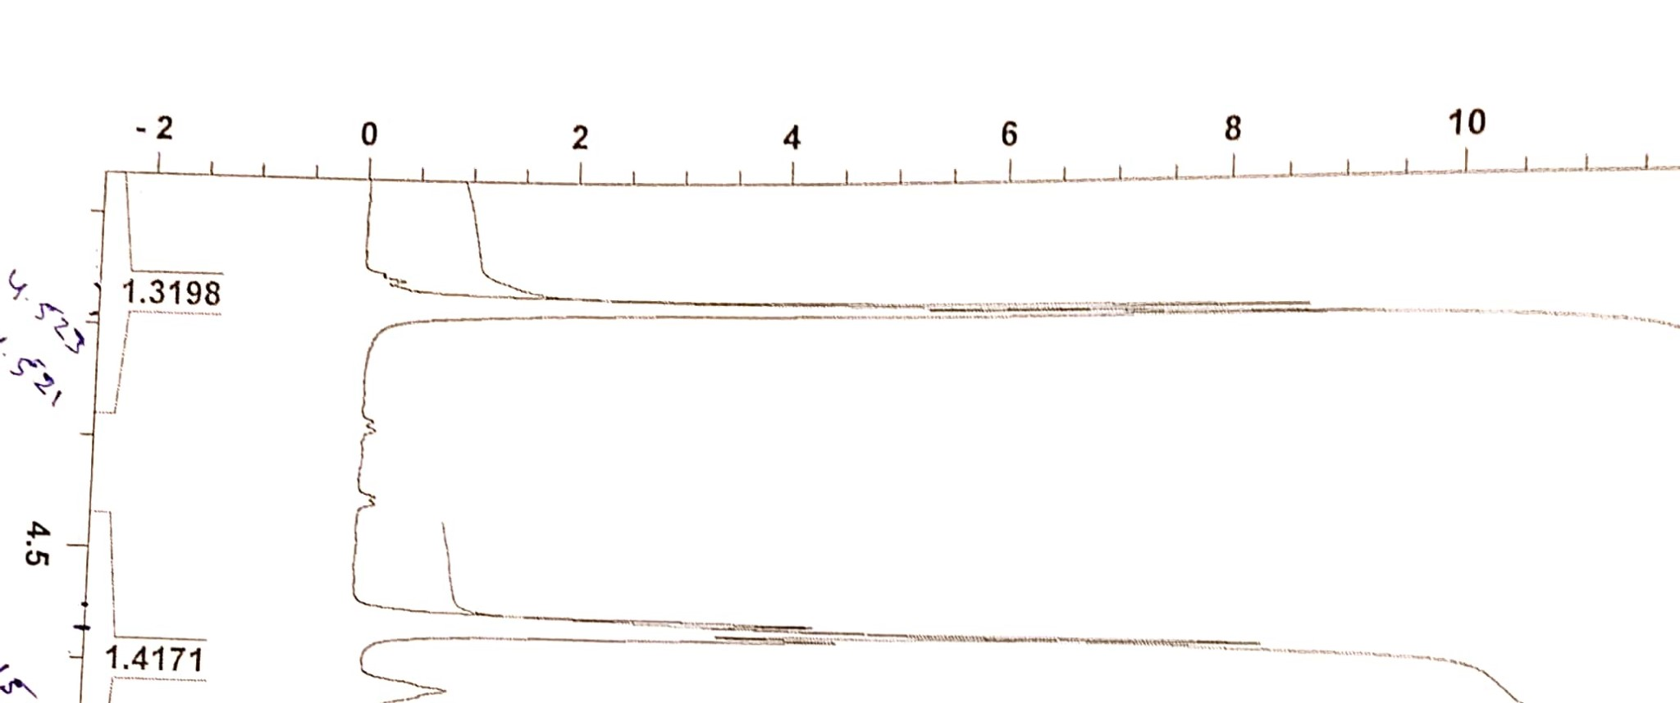
Fig. S5. a) ¹H-NMR spectrum of the 2b, b) Partial ¹H-NMR spectrum of the bridgehead protons (H-C9 and H-C10) of the 2b.
b)
a)
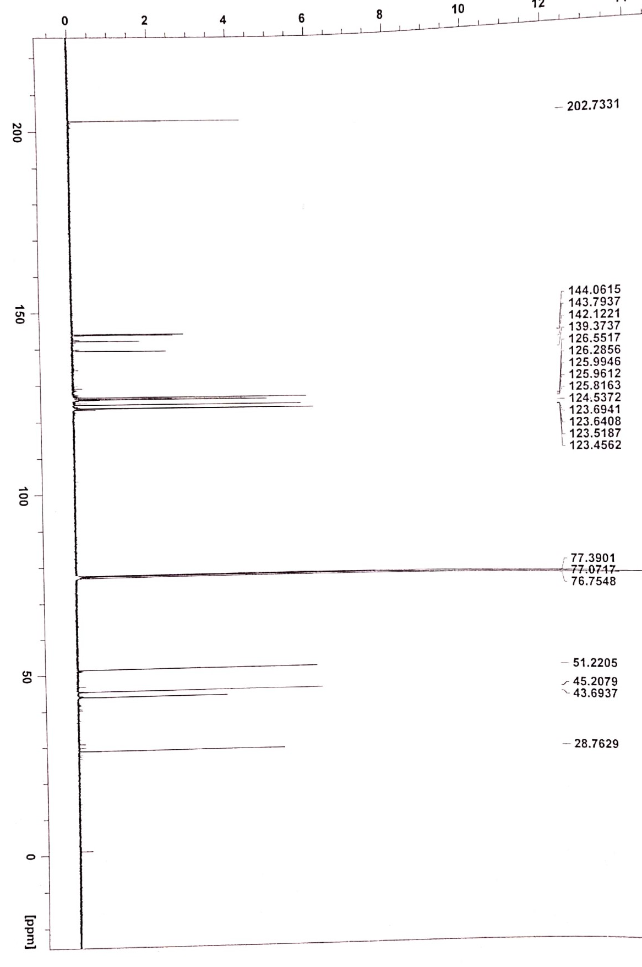
Fig. S6. ¹³C-NMR spectrum of the 2b

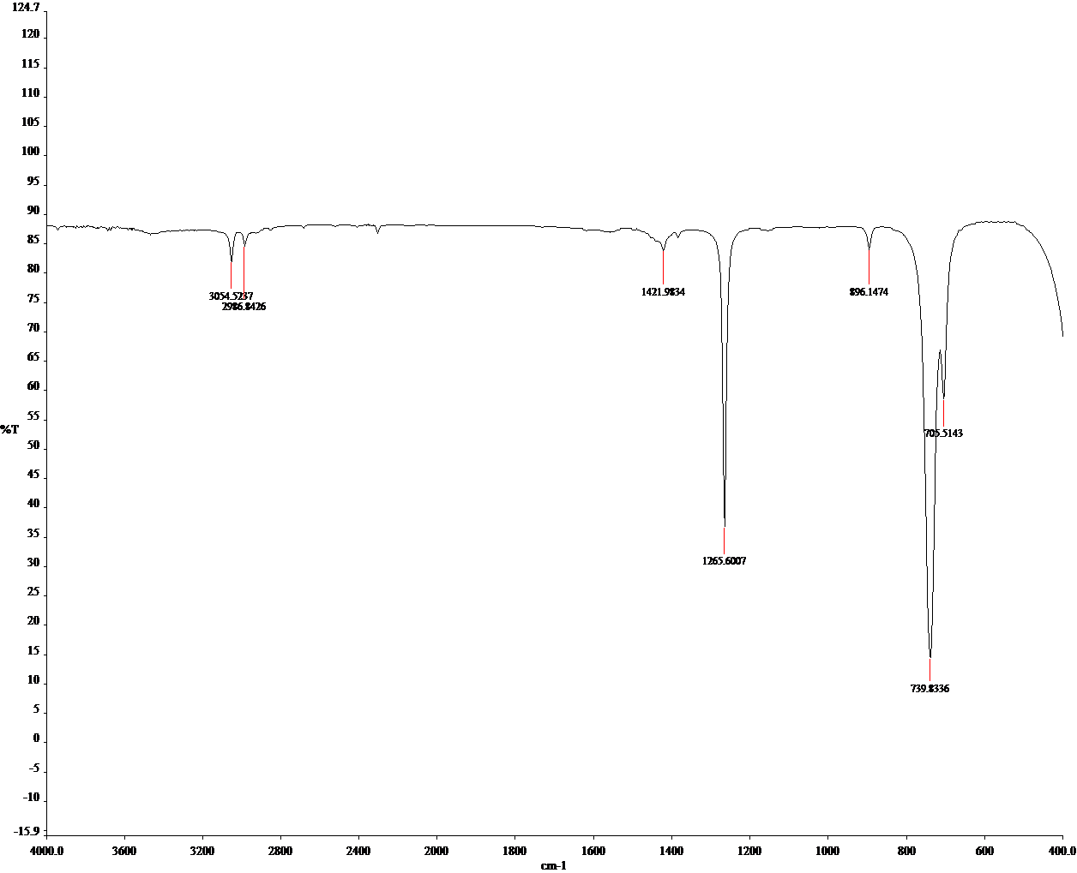
Fig S7. IR Spectrum of the compound 1.
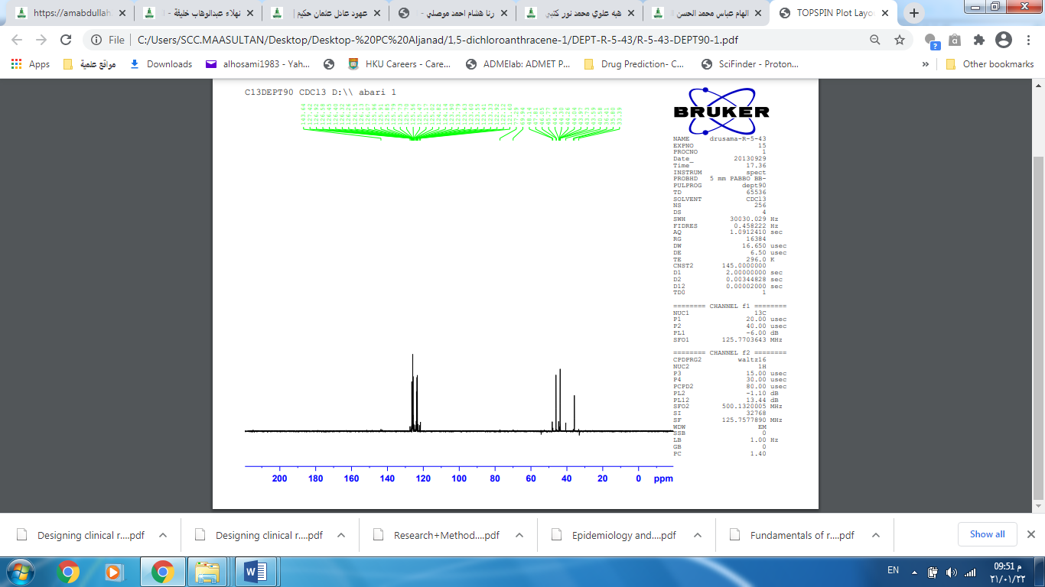
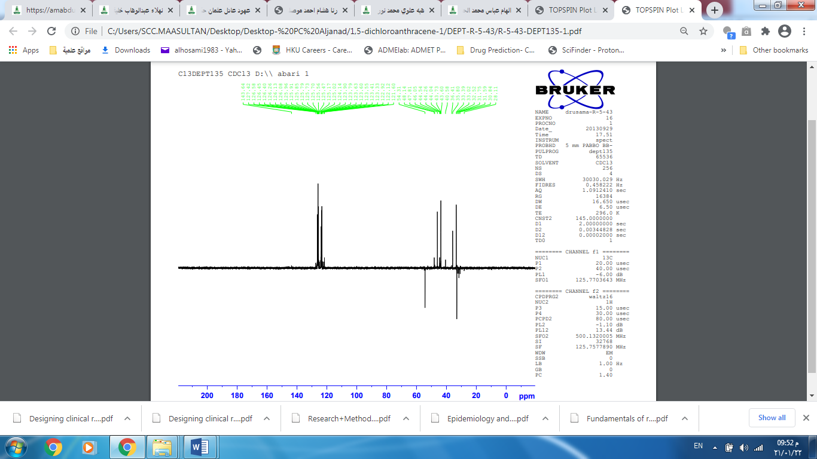
Fig S8. DEPT90 Spectrum of the compound 1. Fig S9. DEPT135 Spectrum of the compound 1.
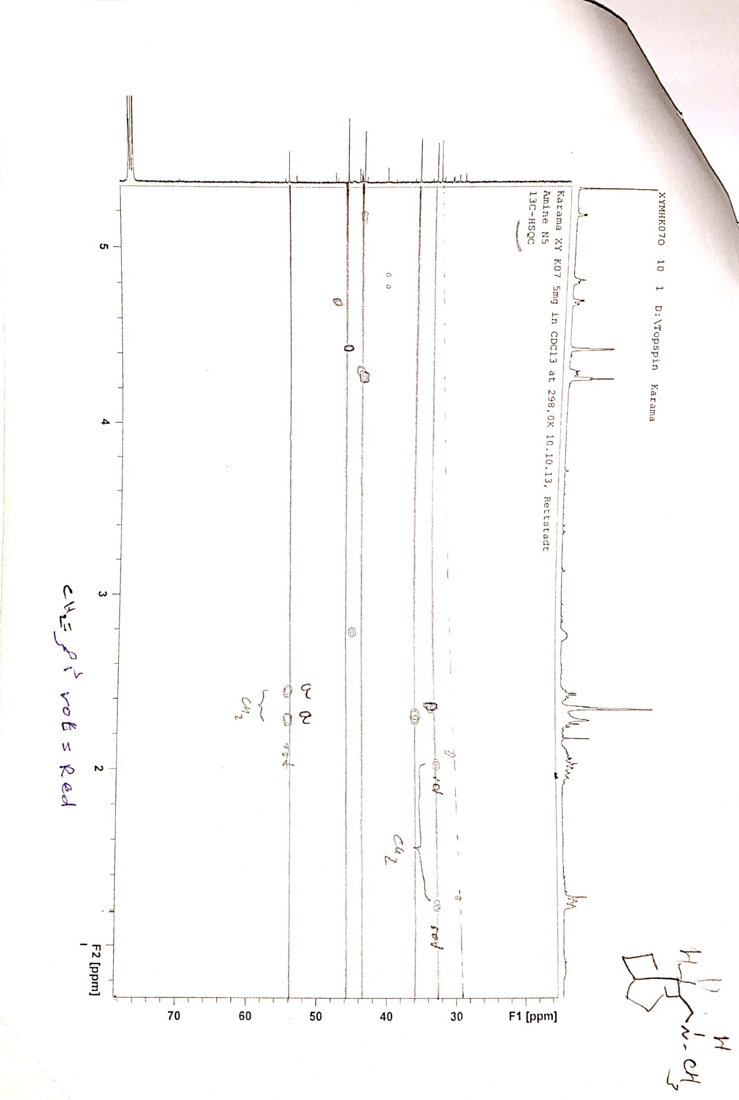
Fig. S10. HSQC spectrum of the compound 1.

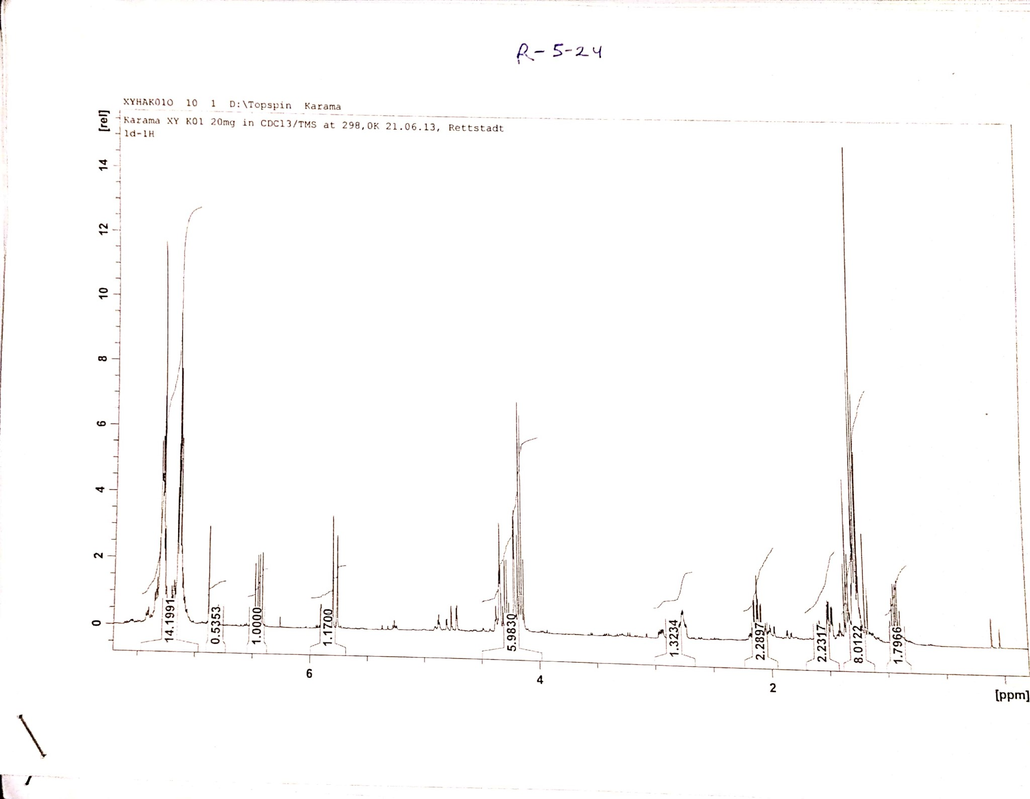
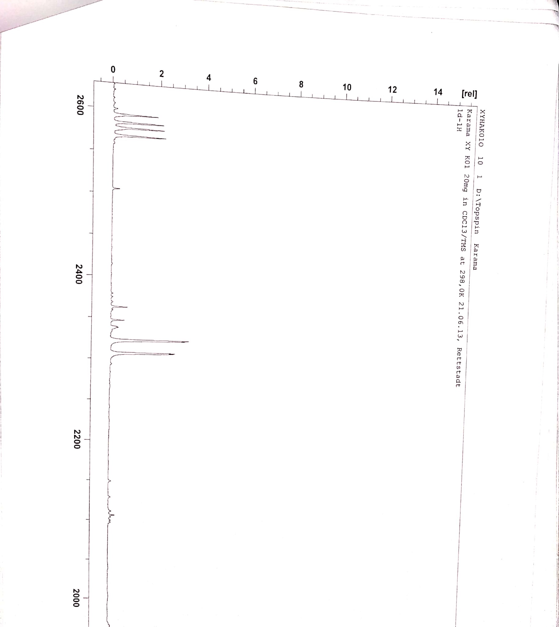
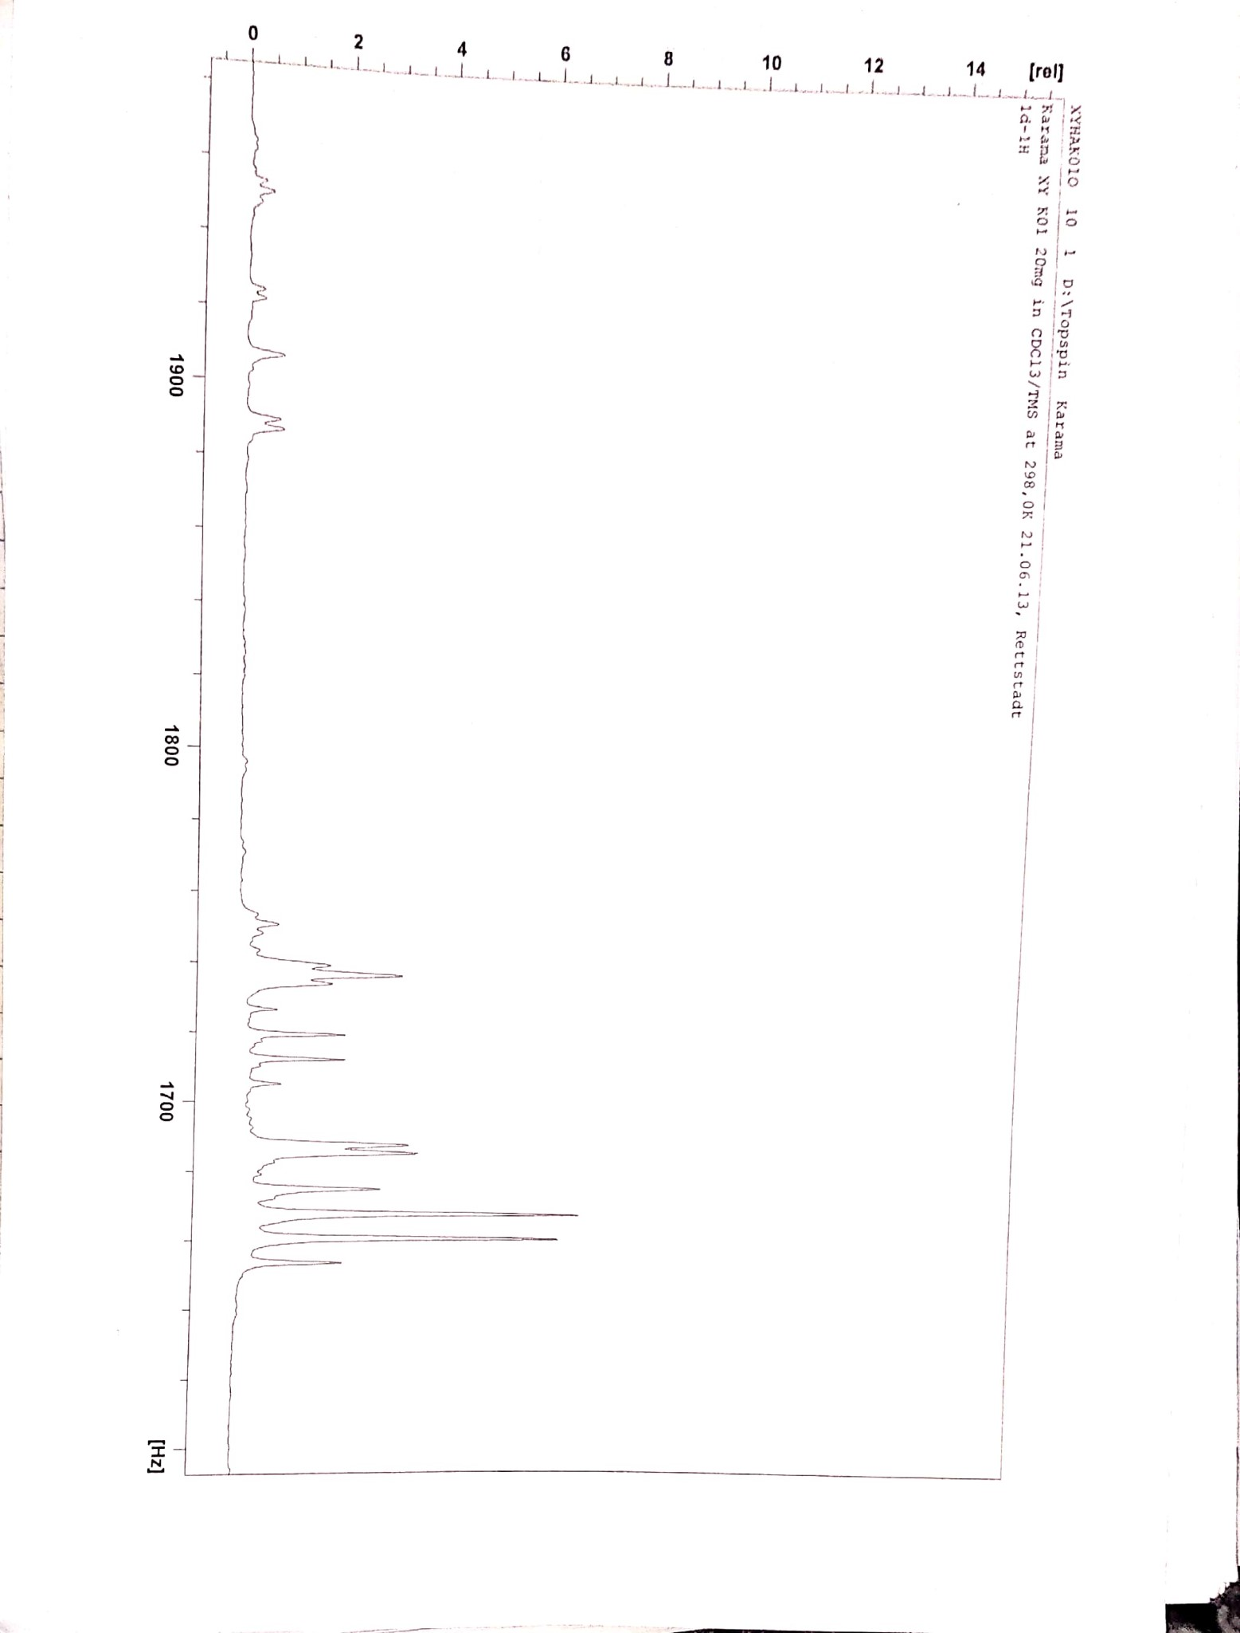
Fig. S11. a)¹H-NMR spectrum of the compound 5, b) Partial ¹H-NMR of trans isomer 5 at vinylic protons (-CH=CH-), c) Partial ¹H-NMR of trans isomer 5 at bridgehead protons (H-C9, H-C10) and methylene (-O-CH₂-CH₃) as quartet signals of both isomers 5 (cis/ trans)
a)
b)
c)
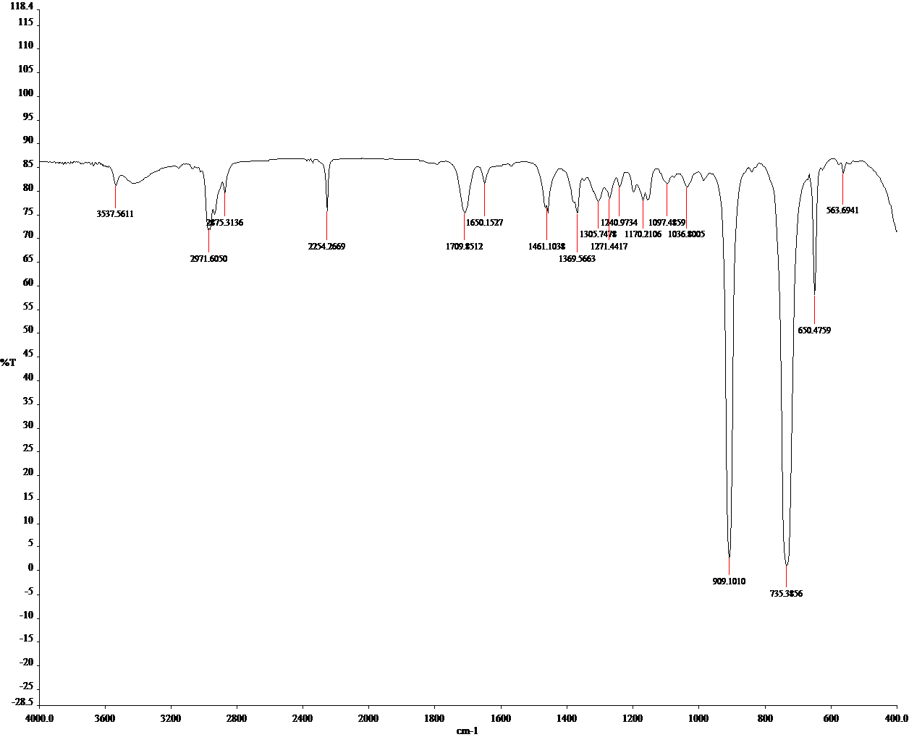

Fig. S12. IR spectrum of the compound 5
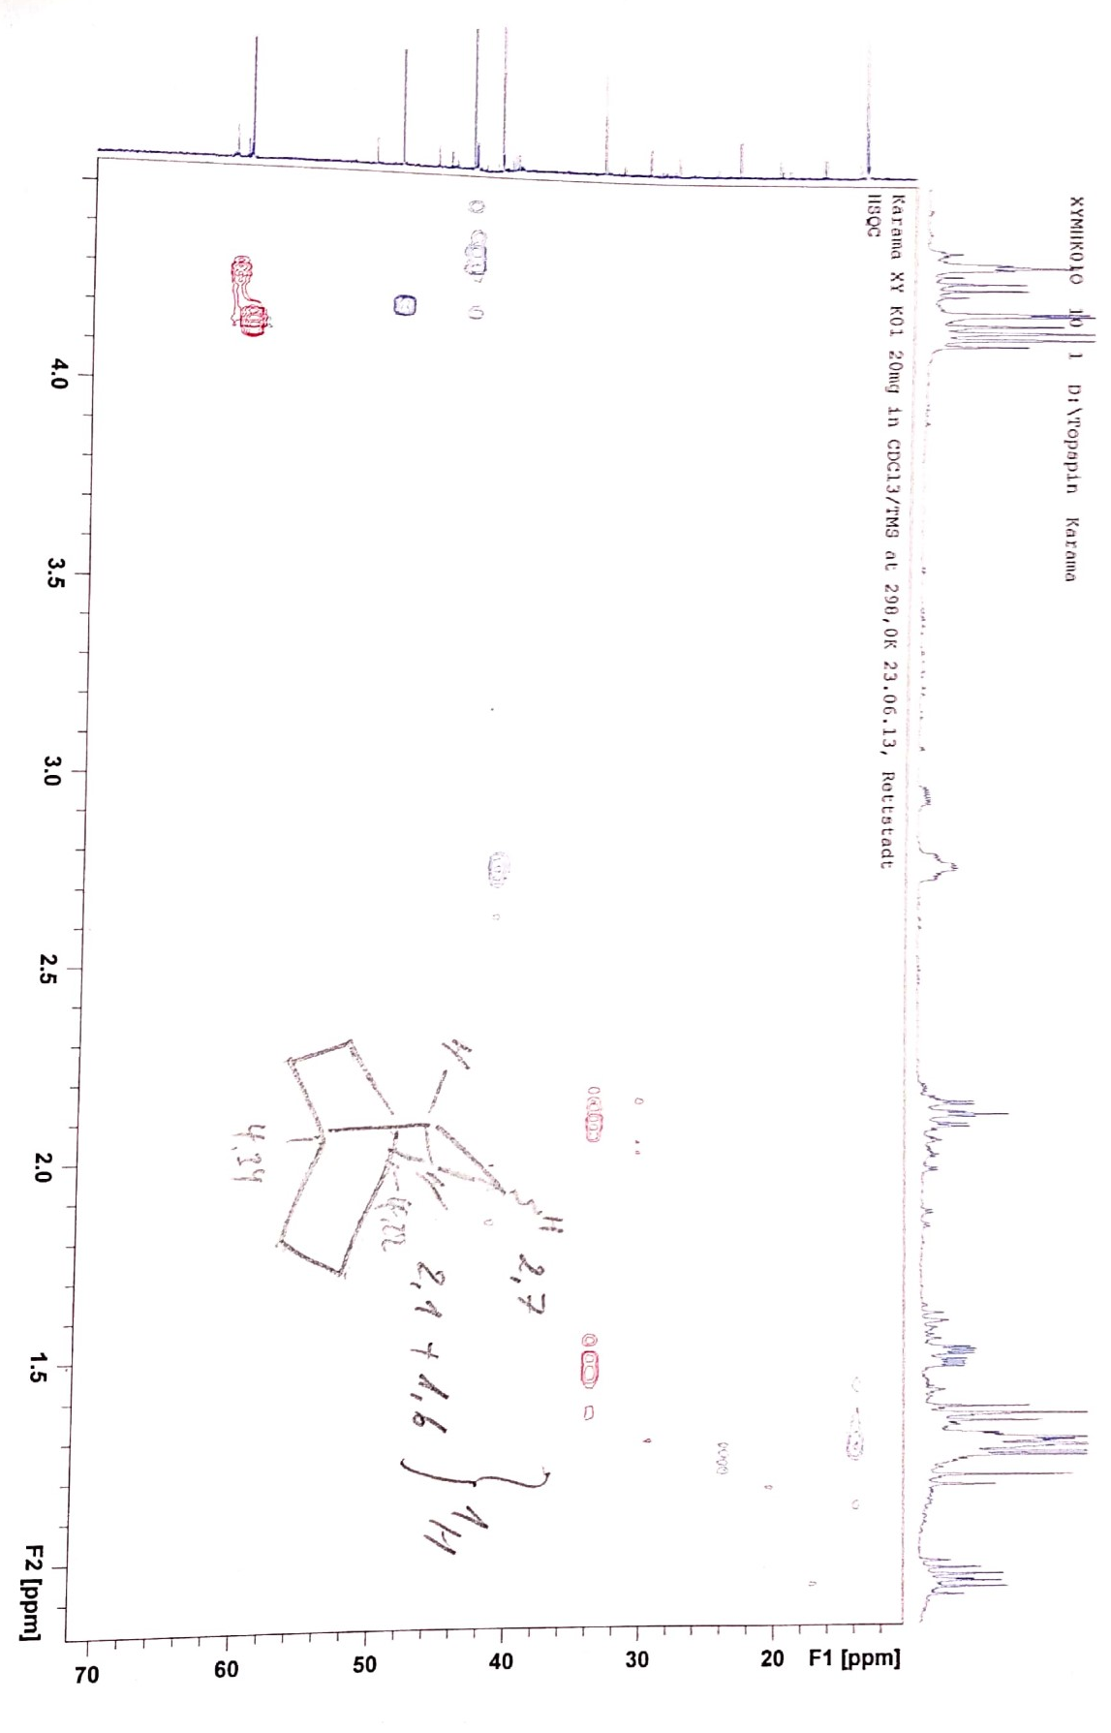
Fig. S13. HSQC spectrum of the compound 5

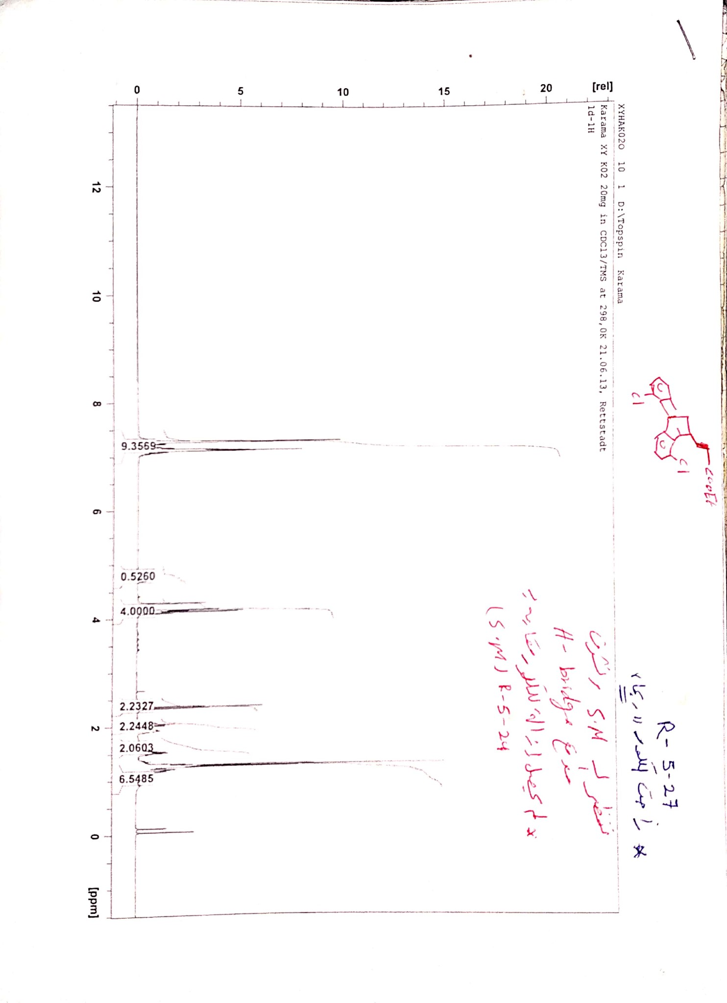
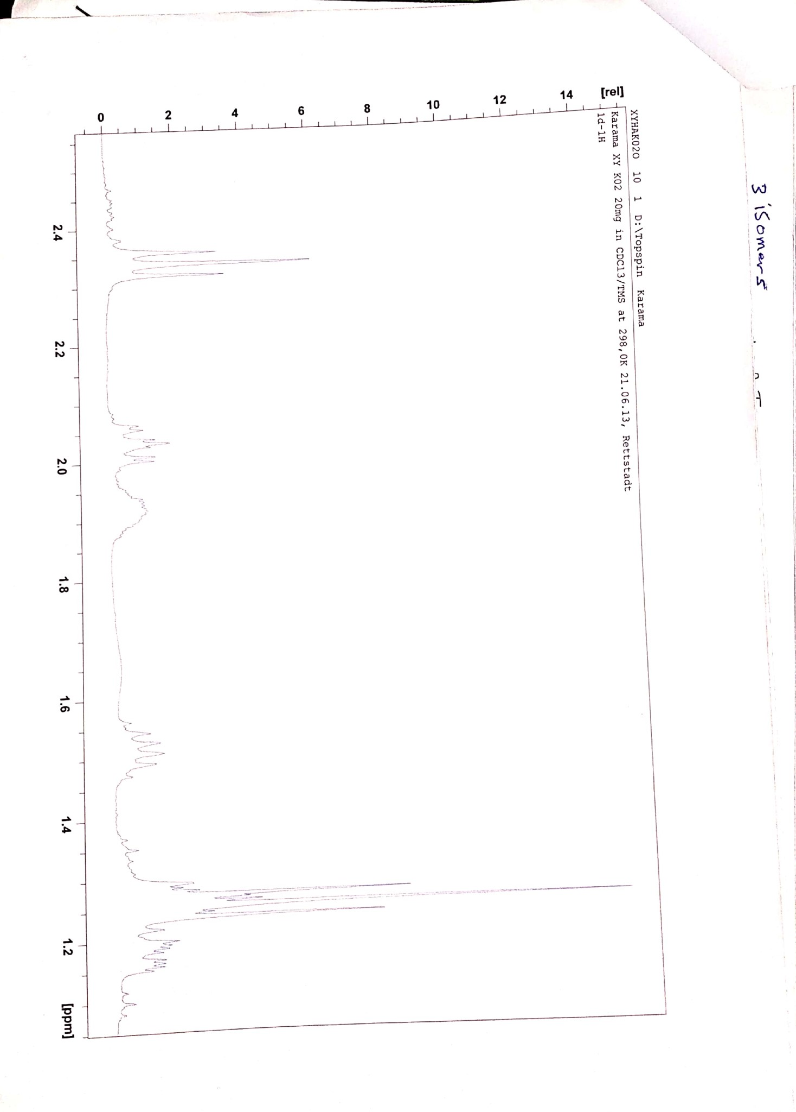
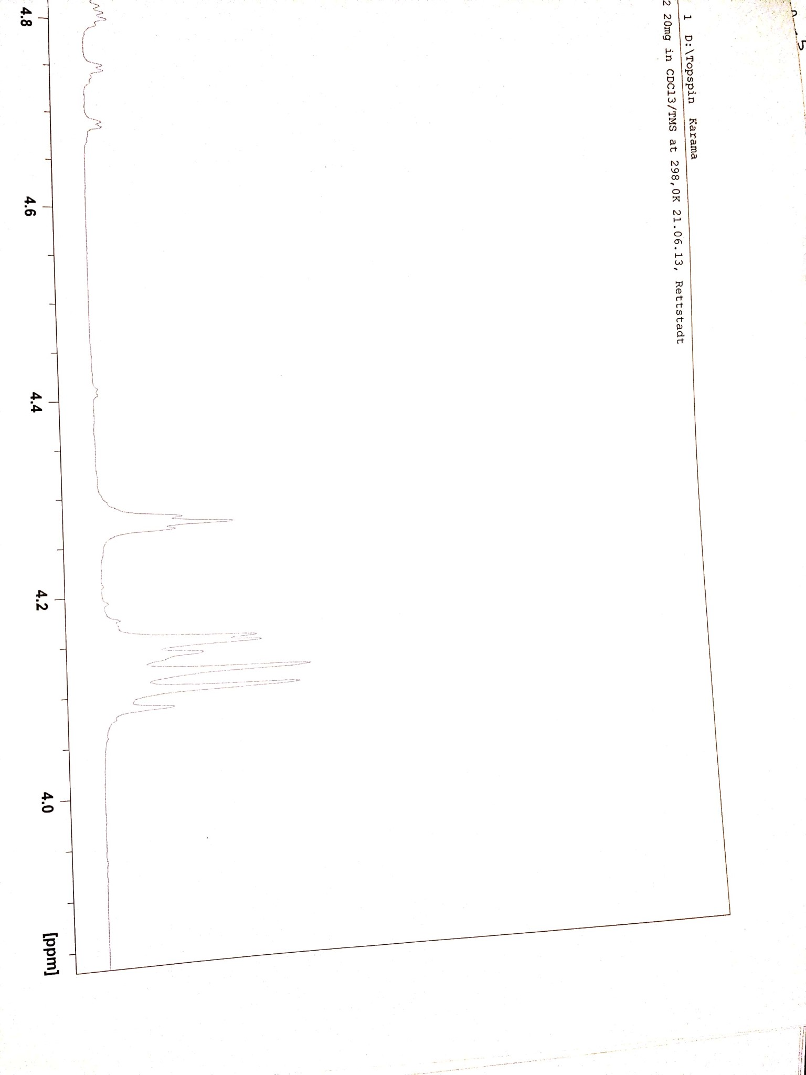
Fig. S14. ¹H-NMR spectrum of the compound 6
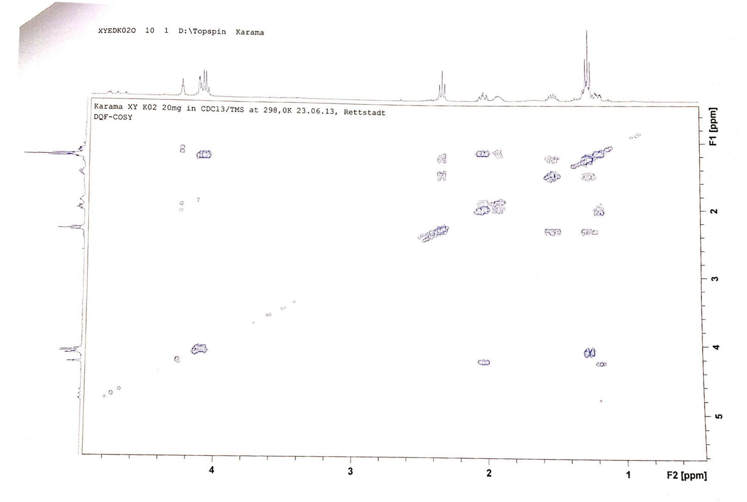
Fig. S15. ¹H-1H COSY spectrum of the compound 6
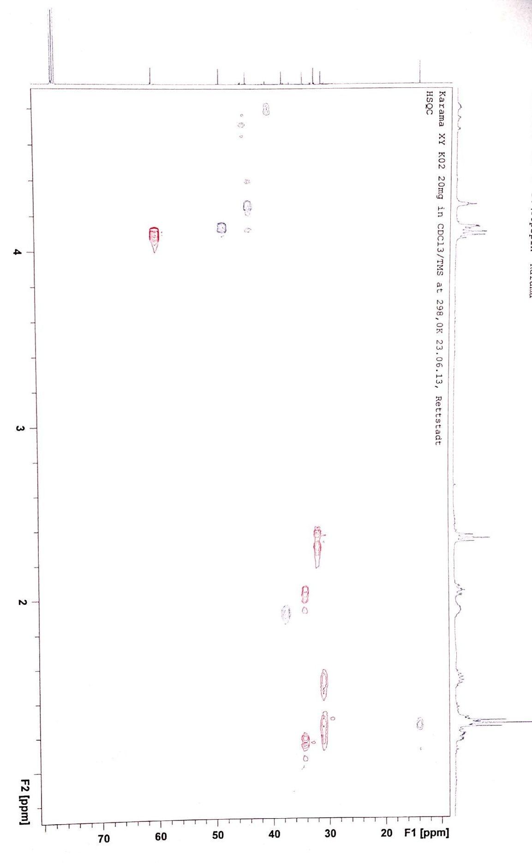
Fig. S16. HSQC spectrum of the compound 6

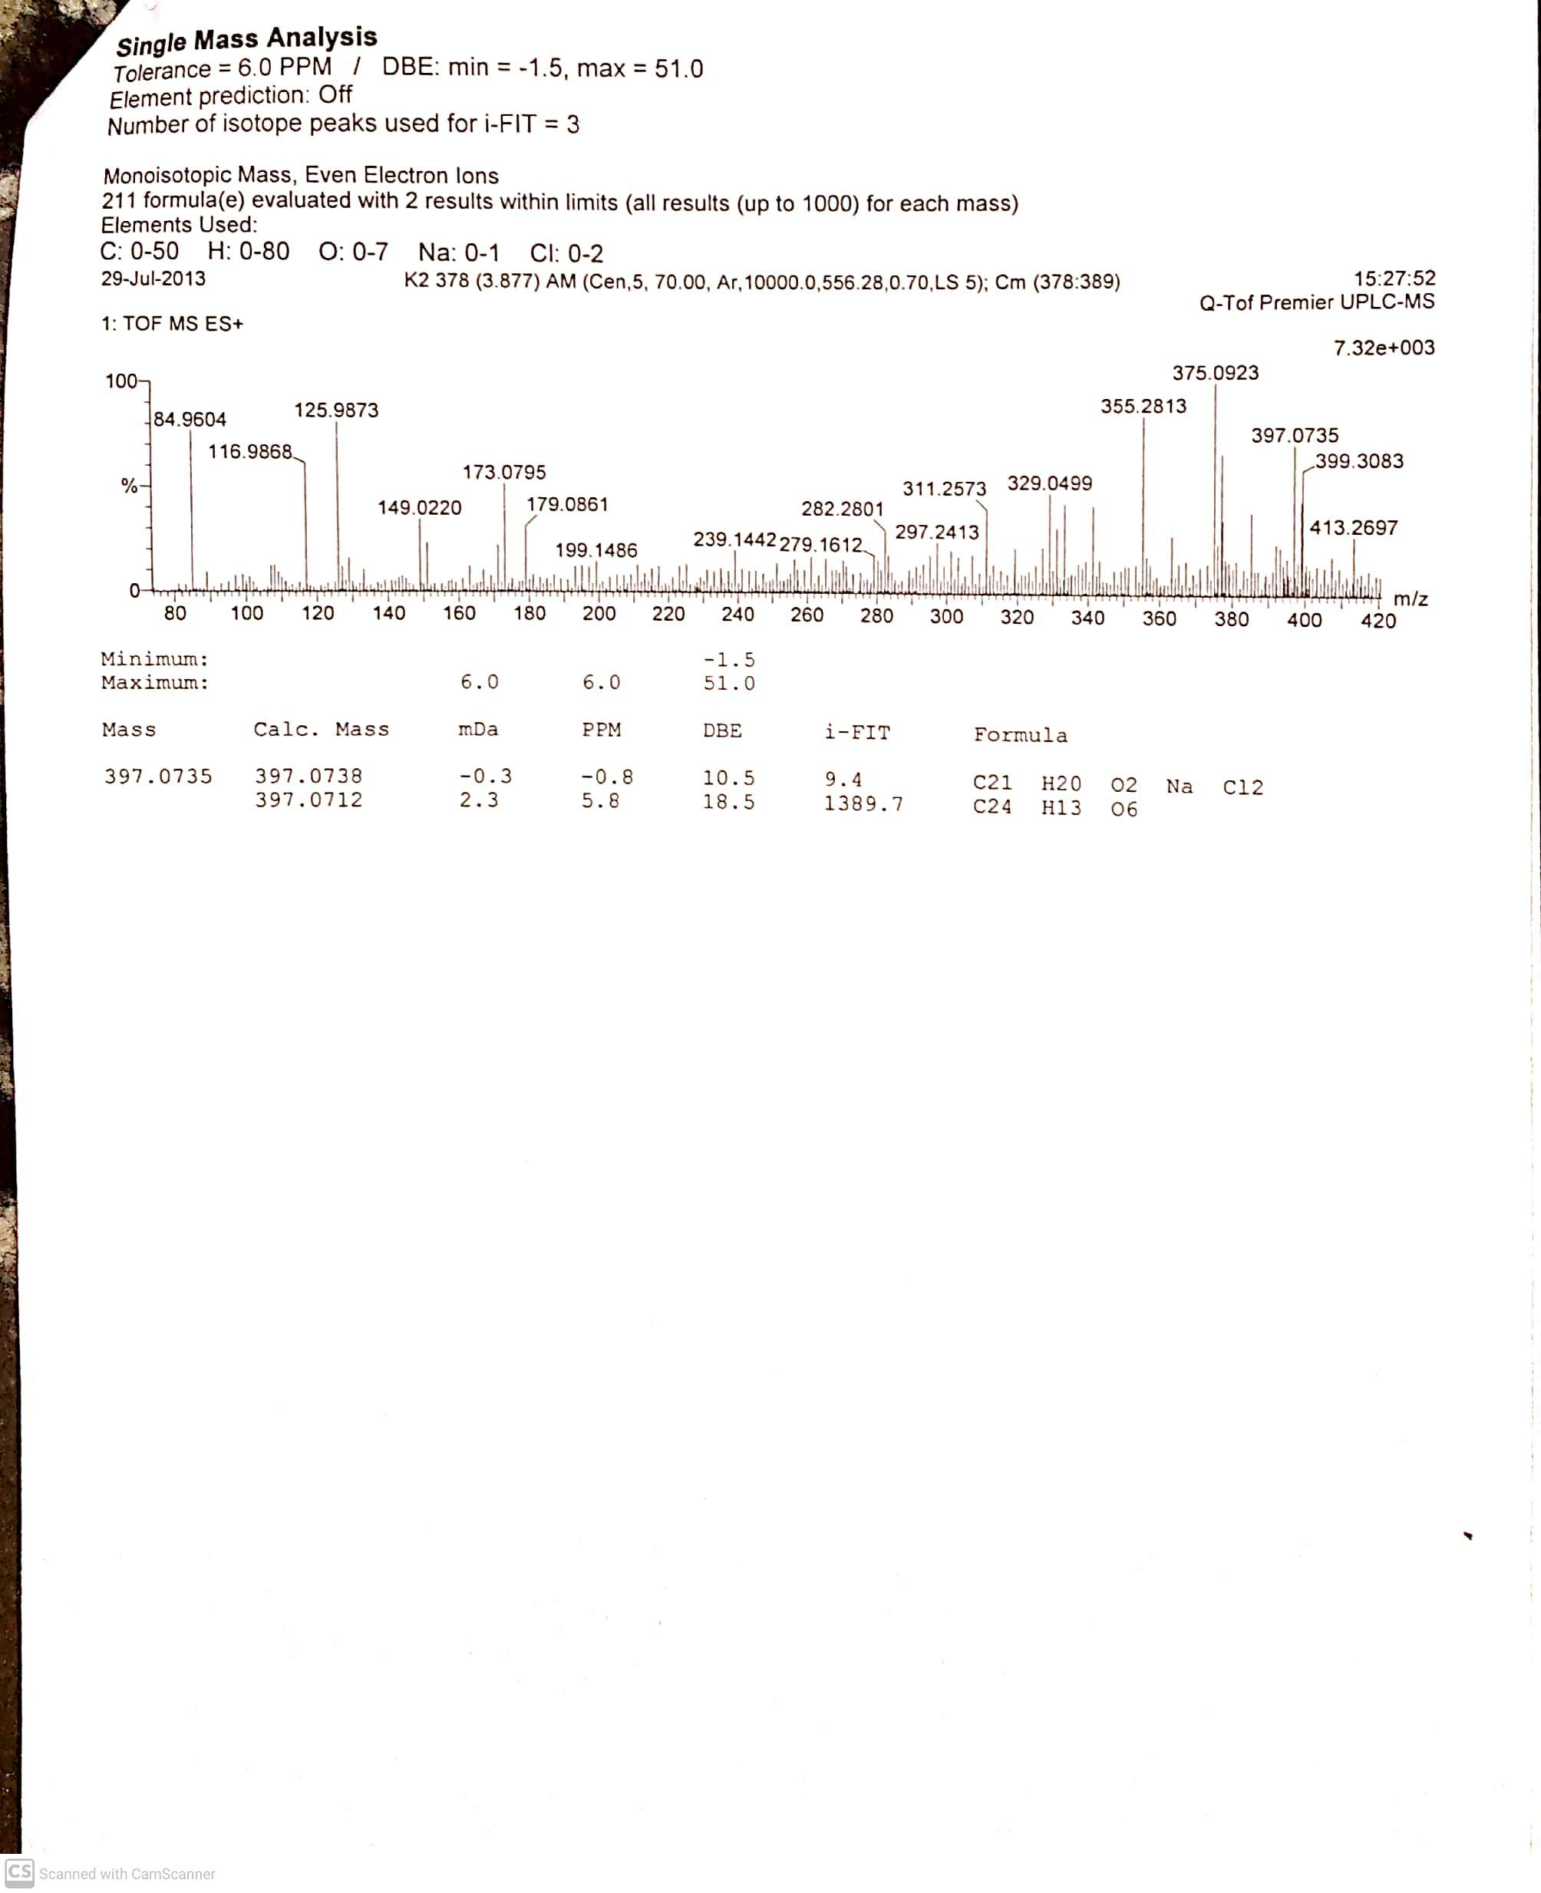

Fig. S17. HRMS of the compound 6

