Supplementary information

Effective oral cytology deep learning classifier for annotation labels with diagnostic differences

Shintaro Sukegawa^{1,2}*, Yusuke Misu³, Keisuke Nakano², Takeshi Hara^{3,4}, Takanaga Ochiai⁵, Katsumitsu Shimada⁶, Shin Ito³, Yuta Inoue³, Yoshihiro Taki³, Fumi Nakai¹, Yasuhiro Nakai¹, Masato Saika¹, Motohiko Nagayama⁵, Satoshi Murakami⁶, Hitoshi Nagatsuka², Minoru Miyake¹

¹ Department of Oral and Maxillofacial Surgery, Kagawa University Faculty of Medicine, 1750-1, Ikenobe, Miki-cho, Kita-gun, Kagawa 761-0793, Japan
² Department of Oral Pathology and Medicine, Graduate School of Medicine, Dentistry and Pharmaceutical Sciences, Okayama University, Okayama 700-8558, Japan
³ Department of Electrical, Electronic and Computer Engineering, Faculty of Engineering, Gifu University, 1-1 Yanagido, Gifu, Gifu 501-1193, Japan
⁴ Center for Research, Education, and Development for Healthcare Life Design, Tokai National Higher Education and Research System, 1-1 Yanagido, Gifu, Gifu 501-1193, Japan
⁵ Department of Oral Pathology, Division of Oral Pathogenesis & Disease Control, Asahi University School of Dentistry, Mizuho 501-0296, Japan
⁶ Department of Oral Pathology, Graduate School of Oral Medicine, Matsumoto Dental University, 1780 Hirooka-Gobara, Shiojiri, Nagano 399-0781, Japan

Supplementary Material S1
Method for determining probabilistic labels

Each pathologist label had one diagnostic result for each image, and the distribution was expressed as positive or negative. To express the probability distribution, the distribution was normalized such that the sum was 1. The methods used to determine this are outlined below:

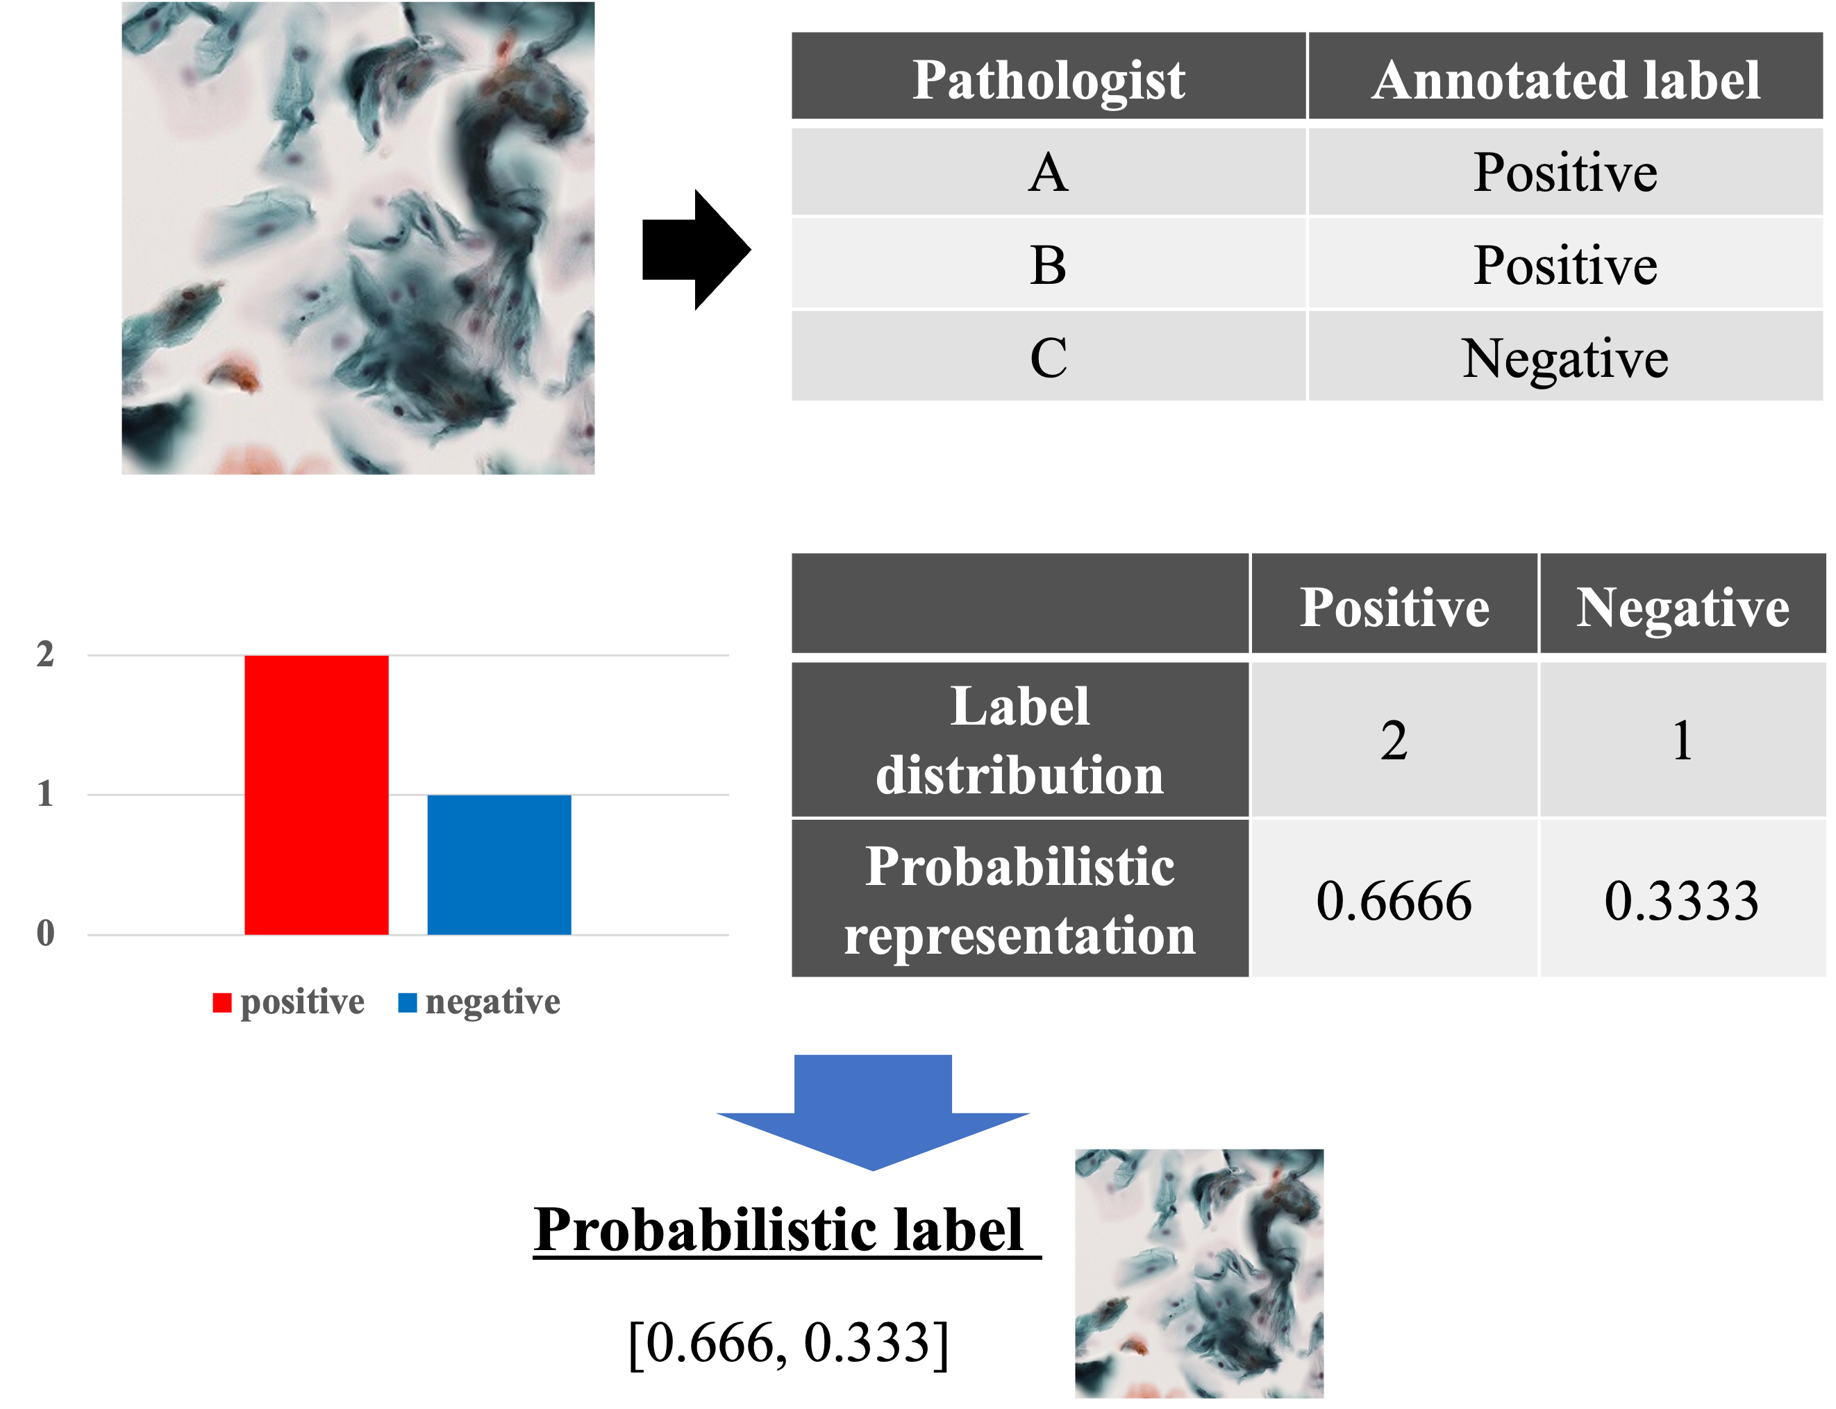

Supplementary Material S2

The following cross-entropy formula was used as the loss function:

$L= -\sum_{i=0}{t_{i}-\log{y_{i}}}$, (S1)

where t_{i} is the true label, and y_{i} is the predicted probability of class i.

Optimization algorithm. As the optimization algorithm, we selected stochastic gradient descent (SGD) with momentum, which advances conventional SGD and mitigates fluctuations by considering moving averages. The SGD with momentum is expressed as follows:

$∆w_{t}=η∇L\left(w\right)+α∆w_{t-1}$, (S2)
$w_{t}=w_{t-1}-∆w_{t}$, (S3)

where w_{t} denotes the t-th parameter, h is the learning rate, ∇L(w) denotes differentiation with the parameters of the loss function, and a denotes the momentum.

Learning rate scheduler. We adopted a cosine-annealing learning rate scheduler for stable deep learning by varying the learning rate across stages. This learning rate scheduler is expressed as follows:

h_{t​} = h_{min} ​+ $\frac{1}{2}$​(h_{max ​}− h_{min}​)(1+$\cos\left(\frac{T_{cur}}{T_{max}}π\right)$). (S4)

Supplementary Material S3
The CNN training was generalized using cross-validation in deep learning. Model validation was performed for all cases, with each slide representing the test data for leave-one-out cross-validation to avoid case-by-case overfitting and bias.
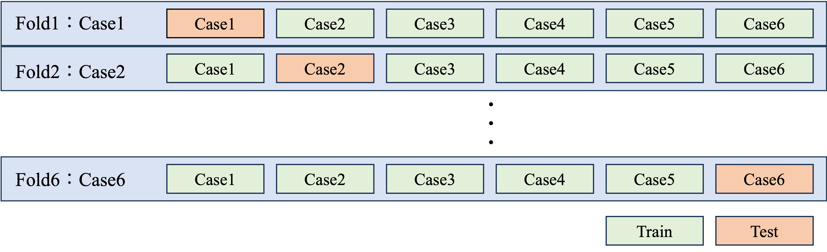

Supplementary Material S4
Performance indicators
We evaluated the performance indicators of accuracy, precision, recall, and F1-score, as defined in equations 1-4, along with the receiver operating characteristic (ROC) curve and the area under the ROC curve (AUC). The ROC curves were obtained for the complete dataset from four-fold cross-validation to determine the median AUC.
In the following equations, TP, TN, FP, and FN represent the true positives (correctly identified normal cases), true negatives (correctly identified abnormal cases), false positives (incorrectly identified abnormal cases), and false negatives (incorrectly identified normal cases), respectively.
$accuracy=\frac{TP + TN}{TP + FP + TN + FN}$ (S5)

$precision=\frac{TP}{TP + FP}$ (S6)

$recall=\frac{TP}{TP + FN}$ (S7)

$F1 score=2×\frac{precision × recall}{precision + recall}$ (S8)

Supplementary Material S5
Performance indicators per case and model
ROC AUC |  | SD | SD | SD | SD | SD | SD | SD
 |  | 95%CI | 95%CI | 95%CI | 95%CI | 95%CI | 95%CI | 95%CI
 | Pathologist A model | Pathologist B model | Pathologist C model | GT model | Majority model | Probabilistic model | Head fusion | Logit fusion
Case 1 | 0.71 | 0.542 | 0.736 | 0.691 | 0.686 | 0.795 | 0.722 | 0.689
Case 1 | 0.03 | 0.048 | 0.041 | 0.038 | 0.053 | 0.026 | 0.028 | 0.021
Case 1 | 0.691-0.728 | 0.512-0.572 | 0.711-0.762 | 0.667-0.714 | 0.653-0.719 | 0.779-0.810 | 0.704-0.739 | 0.676-0.703
Case 2 | 0.780 | 0.778 | 0.722 | 0.809 | 0.799 | 0.805 | 0.827 | 0.817
Case 2 | 0.014 | 0.017 | 0.034 | 0.009 | 0.023 | 0.014 | 0.011 | 0.009
Case 2 | 0.77-0.788 | 0.768-0.789 | 0.70-0.743 | 0.804-0.743 | 0.785-0.815 | 0.796-0.813 | 0.820-0.834 | 0.811-0.823
Case 3 | 0.733 | 0.795 | 0.726 | 0.802 | 0.697 | 0.763 | 0.803 | 0.793
Case 3 | 0.020 | 0.018 | 0.033 | 0.010 | 0.048 | 0.017 | 0.014 | 0.012
Case 3 | 0.720-0.745 | 0.784-0.806 | 0.706-0.746 | 0.797-0.809 | 0.668-0.727 | 0.753-0.774 | 0.794-0.811 | 0.786-0.801
Case 4 | 0.823 | 0.808 | 0.828 | 0.883 | 0.873 | 0.863 | 0.884 | 0.884
Case 4 | 0.021 | 0.026 | 0.018 | 0.015 | 0.009 | 0.019 | 0.013 | 0.01
Case 4 | 0.810-0.836 | 0.791-0.824 | 0.817-0.839 | 0.875-0.893 | 0.867-0.879 | 0.851-0.874 | 0.876-0.892 | 0.877-0.891
Case 5 | 0.630 | 0.932 | 0.956 | 0.891 | 0.927 | 0.979 | 0.88 | 0.865
Case 5 | 0.177 | 0.109 | 0.043 | 0.053 | 0.053 | 0.021 | 0.106 | 0.065
Case 5 | 0.520-0.740 | 0.864-0.999 | 0.929-0.983 | 0.858-0.924 | 0.894-0.960 | 0.966-0.992 | 0.815-0.946 | 0.825-0.905
Case 6 | 0.893 | 0.736 | 0.732 | 0.948 | 0.937 | 0.967 | 0.93 | 0.912
Case 6 | 0.039 | 0.077 | 0.037 | 0.015 | 0.046 | 0.019 | 0.018 | 0.031
Case 6 | 0.869-0.917 | 0.689-0.784 | 0.709-0.756 | 0.938-0.957 | 0.909-0.966 | 0.955-0.978 | 0.918-0.941 | 0.892-0.931
Accuracy |  | SD | SD | SD | SD | SD | SD | SD
 |  | 95%CI | 95%CI | 95%CI | 95%CI | 95%CI | 95%CI | 95%CI
 | Pathologist A model | Pathologist B model | Pathologist C model | GT model | Majority model | Probabilistic model | Head fusion | Logit fusion
Case 1 | 0.544 | 0.494 | 0.528 | 0.53 | 0.612 | 0.673 | 0.581 | 0.632
Case 1 | 0.12 | 0.224 | 0.114 | 0.136 | 0.116 | 0.099 | 0.137 | 0.202
Case 1 | 0.470-0.618 | 0.355-0.633 | 0.458-0.599 | 0.445-0.614 | 0.540-0.683 | 0.611-0.735 | 0.496-0.666 | 0.507-0.758
Case 2 | 0.740 | 0.723 | 0.656 | 0.750 | 0.758 | 0.753 | 0.782 | 0.778
Case 2 | 0.024 | 0.025 | 0.053 | 0.015 | 0.024 | 0.029 | 0.015 | 0.015
Case 2 | 0.725-0.755 | 0.707-0.738 | 0.623-0.689 | 0.741-0.759 | 0.743-0.773 | 0.735-0.771 | 0.773-0.792 | 0.769-0.788
Case 3 | 0.760 | 0.738 | 0.725 | 0.754 | 0.687 | 0.758 | 0.796 | 0.758
Case 3 | 0.101 | 0.045 | 0.090 | 0.049 | 0.063 | 0.078 | 0.048 | 0.049
Case 3 | 0.697-0.822 | 0.710-0.766 | 0.669-0.781 | 0.724-0.784 | 0.648-0.726 | 0.710-0.806 | 0.766-0.826 | 0.728-0.788
Case 4 | 0.794 | 0.716 | 0.780 | 0.809 | 0.803 | 0.768 | 0.809 | 0.78
Case 4 | 0.040 | 0.051 | 0.050 | 0.056 | 0.058 | 0.036 | 0.058 | 0.09
Case 4 | 0.770-0.819 | 0.684-0.748 | 0.749-0.811 | 0.775-0.844 | 0.768-0.839 | 0.745-0.790 | 0.773-0.844 | 0.724-0.836
Case 5 | 0.562 | 0.887 | 0.939 | 0.835 | 0.905 | 0.958 | 0.81 | 0.796
Case 5 | 0.271 | 0.176 | 0.048 | 0.099 | 0.057 | 0.039 | 0.156 | 0.088
Case 5 | 0.394-0.729 | 0.778-0.996 | 0.909-0.969 | 0.774-0.896 | 0.870-0.941 | 0.933-0.982 | 0.713-0.907 | 0.742-0.851
Case 6 | 0.823 | 0.702 | 0.683 | 0.854 | 0.866 | 0.930 | 0.833 | 0.794
Case 6 | 0.087 | 0.121 | 0.106 | 0.050 | 0.063 | 0.048 | 0.049 | 0.068
Case 6 | 0.769-0.877 | 0.627-0.777 | 0.618-0.748 | 0.823-0.885 | 0.827-0.905 | 0.900-0.960 | 0.802-0.863 | 0.752-0.836
Precision |  | SD | SD | SD | SD | SD | SD | SD
 |  | 95%CI | 95%CI | 95%CI | 95%CI | 95%CI | 95%CI | 95%CI
 | Pathologist A model | Pathologist B model | Pathologist C model | GT model | Majority model | Probabilistic model | Head fusion | Logit  fusion
Case 1 | 0.054 | 0.043 | 0.054 | 0.052 | 0.06 | 0.078 | 0.06 | 0.07
 | 0.008 | 0.009 | 0.009 | 0.008 | 0.01 | 0.018 | 0.012 | 0.035
 | 0.049-0.059 | 0.037-0.048 | 0.049-0.060 | 0.046-0.057 | 0.054-0.066 | 0.066-0.089 | 0.052-0.067 | 0.048-0.092
Case 2 | 0.531 | 0.507 | 0.437 | 0.539 | 0.557 | 0.549 | 0.592 | 0.588
 | 0.038 | 0.033 | 0.045 | 0.022 | 0.040 | 0.051 | 0.033 | 0.027
 | 0.508-0.555 | 0.487-0.528 | 0.409-0.465 | 0.525-0.552 | 0.532-0.582 | 0.517-0.581 | 0.571-0.612 | 0.572-0.605
Case 3 | 0.172 | 0.171 | 0.157 | 0.180 | 0.130 | 0.178 | 0.206 | 0.182
 | 0.046 | 0.023 | 0.038 | 0.024 | 0.022 | 0.036 | 0.035 | 0.029
 | 0.143-0.200 | 0.157-0.185 | 0.134-0.181 | 0.166-0.195 | 0.117-0.144 | 0.156-0.200 | 0.185-0.228 | 0.164-0.201
Case 4 | 0.366 | 0.300 | 0.355 | 0.408 | 0.392 | 0.347 | 0.402 | 0.384
 | 0.043 | 0.037 | 0.064 | 0.086 | 0.066 | 0.038 | 0.071 | 0.097
 | 0.340-0.393 | 0.277-0.323 | 0.315-0.394 | 0.354-0.461 | 0.351-0.433 | 0.323-0.370 | 0.358-0.446 | 0.324-0.444
Case 5 | 0.993 | 0.999 | 0.998 | 0.997 | 0.998 | 0.997 | 0.998 | 0.998
 | 0.005 | 0.002 | 0.002 | 0.002 | 0.002 | 0.001 | 0.002 | 0.002
 | 0.990-0.996 | 0.998-1.000 | 0.997-0.999 | 0.996-0.998 | 0.997-0.999 | 0.997-0.998 | 0.997-0.999 | 0.997-0.999
Case 6 | 0.151 | 0.077 | 0.073 | 0.172 | 0.188 | 0.372 | 0.147 | 0.127
 | 0.076 | 0.021 | 0.028 | 0.049 | 0.071 | 0.206 | 0.032 | 0.035
 | 0.104-0.198 | 0.064-0.090 | 0.056-0.091 | 0.142-0.203 | 0.144-0.232 | 0.244-0.499 | 0.127-0.167 | 0.106-0.149
Recall |  | SD | SD | SD | SD | SD | SD | SD
 |  | 95%CI | 95%CI | 95%CI | 95%CI | 95%CI | 95%CI | 95%CI
 | Pathologist A model | Pathologist B model | Pathologist C model | GT model | Majority model | Probabilistic model | Head fusion | Logit  fusion
Case 1 | 0.864 | 0.718 | 0.909 | 0.845 | 0.809 | 0.882 | 0.855 | 0.727
 | 0.123 | 0.229 | 0.113 | 0.136 | 0.174 | 0.105 | 0.156 | 0.21
 | 0.787-0.940 | 0.577-0.860 | 0.839-0.979 | 0.761-0.930 | 0.701-0.917 | 0.816-0.947 | 0.758-0.951 | 0.597-0.857
Case 2 | 0.671 | 0.697 | 0.721 | 0.751 | 0.689 | 0.722 | 0.731 | 0.702
 | 0.049 | 0.077 | 0.051 | 0.037 | 0.053 | 0.040 | 0.048 | 0.026
 | 0.641-0.701 | 0.649-0.744 | 0.689-0.753 | 0.728-0.773 | 0.656-0.721 | 0.698-0.746 | 0.701-0.760 | 0.685-0.718
Case 3 | 0.611 | 0.776 | 0.684 | 0.773 | 0.668 | 0.700 | 0.724 | 0.762
 | 0.127 | 0.057 | 0.064 | 0.053 | 0.108 | 0.093 | 0.042 | 0.038
 | 0.532-0.689 | 0.740-0.811 | 0.644-0.723 | 0.740-0.806 | 0.601-0.735 | 0.642-0.758 | 0.698-0.750 | 0.739-0.786
Case 4 | 0.783 | 0.878 | 0.783 | 0.843 | 0.813 | 0.887 | 0.843 | 0.852
 | 0.046 | 0.064 | 0.085 | 0.092 | 0.085 | 0.059 | 0.065 | 0.116
 | 0.754-0.811 | 0.838-0.918 | 0.730-0.835 | 0.786-0.901 | 0.761-0.865 | 0.851-0.923 | 0.803-0.884 | 0.780-0.924
Case 5 | 0.562 | 0.887 | 0.940 | 0.836 | 0.907 | 0.960 | 0.811 | 0.797
 | 0.272 | 0.177 | 0.048 | 0.099 | 0.057 | 0.040 | 0.158 | 0.089
 | 0.393-0.731 | 0.777-0.997 | 0.910-0.970 | 0.775-0.898 | 0.871-0.942 | 0.935-0.984 | 0.713-0.909 | 0.742-0.852
Case 6 | 0.864 | 0.773 | 0.764 | 0.973 | 0.909 | 0.945 | 0.955 | 0.973
 | 0.064 | 0.178 | 0.088 | 0.044 | 0.096 | 0.064 | 0.064 | 0.044
 | 0.824-0.903 | 0.662-0.883 | 0.709-0.818 | 0.946-1.000 | 0.850-0.968 | 0.906-0.985 | 0.915-0.994 | 0.946-1.000
F1 score |  | SD | SD | SD | SD | SD | SD | SD
 |  | 95%CI | 95%CI | 95%CI | 95%CI | 95%CI | 95%CI | 95%CI
 | Pathologist A model | Pathologist B model | Pathologist C model | GT model | Majority model | Probabilistic model | Head  fusion | Logit  fusion
Case 1 | 0.101 | 0.08 | 0.102 | 0.097 | 0.11 | 0.141 | 0.11 | 0.12
 | 0.014 | 0.015 | 0.016 | 0.014 | 0.015 | 0.03 | 0.019 | 0.043
 | 0.093-0.110 | 0.071-0.089 | 0.093-0.112 | 0.088-0.106 | 0.101-0.120 | 0.123-0.160 | 0.098-0.122 | 0.093-0.147
Case 2 | 0.590 | 0.583 | 0.541 | 0.626 | 0.614 | 0.621 | 0.652 | 0.639
 | 0.013 | 0.017 | 0.027 | 0.010 | 0.027 | 0.021 | 0.013 | 0.015
 | 0.582-0.598 | 0.572-0.594 | 0.525-0.558 | 0.620-0.632 | 0.597-0.631 | 0.608-0.634 | 0.644-0.660 | 0.630-0.648
Case 3 | 0.259 | 0.279 | 0.252 | 0.291 | 0.217 | 0.280 | 0.319 | 0.293
 | 0.041 | 0.026 | 0.047 | 0.028 | 0.030 | 0.040 | 0.042 | 0.035
 | 0.233-0.284 | 0.262-0.295 | 0.223-0.282 | 0.274-0.308 | 0.198-0.236 | 0.254-0.305 | 0.293-0.345 | 0.271-0.314
Case 4 | 0.497 | 0.445 | 0.482 | 0.540 | 0.521 | 0.496 | 0.538 | 0.514
 | 0.037 | 0.036 | 0.045 | 0.055 | 0.047 | 0.035 | 0.055 | 0.071
 | 0.474-0.520 | 0.423-0.467 | 0.454-0.509 | 0.505-0.574 | 0.492-0.551 | 0.475-0.518 | 0.504-0.572 | 0.470-0.558
Case 5 | 0.681 | 0.930 | 0.968 | 0.907 | 0.949 | 0.978 | 0.886 | 0.884
 | 0.237 | 0.121 | 0.027 | 0.063 | 0.032 | 0.021 | 0.112 | 0.057
 | 0.535-0.828 | 0.855-1.000 | 0.951-0.984 | 0.868-0.946 | 0.930-0.969 | 0.965-0.991 | 0.816-0.955 | 0.848-0.919
Case 6 | 0.249 | 0.137 | 0.131 | 0.289 | 0.306 | 0.503 | 0.254 | 0.223
 | 0.096 | 0.031 | 0.042 | 0.069 | 0.096 | 0.200 | 0.049 | 0.053
 | 0.189-0.308 | 0.117-0.156 | 0.105-0.157 | 0.247-0.332 | 0.246-0.365 | 0.379-0.627 | 0.224-0.284 | 0.190-0.256
SD: standard deviation, 95% CI: 95% confidence interval, AUC: Area under the ROC curve

