Dear Editor,
In the process of western blot, in order to detect multiple protein tables of the same specimen, we initially cut the membrane in the experiment. When we learned that your journal needed the original data of the whole membrane, we started to repeat the experiment again, and we will provide you with the required original data.
Thank you for your understanding.
Rong Hu
Fig 1 TSG101 Fig 1 CD81 Fig 1 CD63
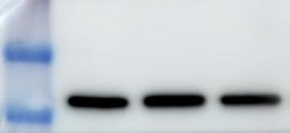
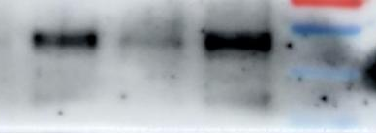
Fig 2 HDAC3/β-actin Fig 2 HDAC3 (repeated)

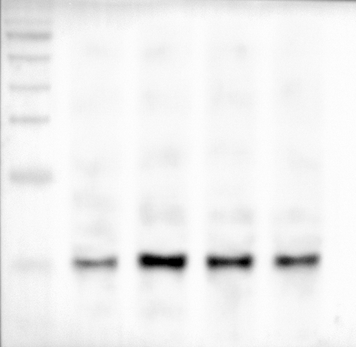
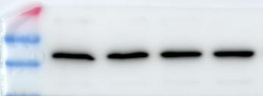
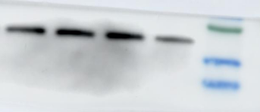
Fig 8 γH2A.X/β-actin Fig 8 γH2A.X (repeated)

