Supplementary Materials

Mediation Analysis
We sought to determine whether the BOLD signal change related to the anxiety measurement would predict sensory hyperreactivity in the ASD group. We confirmed that the SPM signal change at the right angular gyrus (rAng) correlating with STAI total score was positively correlated with the AASP sensory hyperreactivity score (Sensory sensitivity + Sensation avoiding score; r = 0.46, p = 0.02, [1 - β] = 0.66). To test how the right angular gyrus activation and STAI total score affected the AASP sensory hyperreactivity score, we performed a causal mediation analysis (Baron and Kenny, 1986).
In our mediation model, path a is the association between the SPM signal change at the rAng and the STAI total score; path b represents the association between STAI total and AASP sensory hyperreactivity score; and the indirect effect is the product of path a and path b. Path c represents the total effect of the relationship between rAng and AASP hyper ignoring the mediator, STAI total (path c = indirect effect + direct effect). Path c’ as the direct effect represents the effect of rAng on the proposed mediator.
The mediation analysis showed that STAI total score mediated the relationship between the signal change at the rAng and AASP sensory hyperreactivity score (β_{rAng→STAI} [path a] = 0.74, p < 0.0001; β_{STAI→AASP} [path b] = 0.60, p = 0.00156; β_{rAng→AASP} [path c] = 0.46, p = 0.021; β_{rAng→AASP} [path c’] = 0.04, p = 0.89; average causal mediation effect = 0.42, p = 0.0036; PM = 92% with 5000 bootstrap samples, Fig. S1).

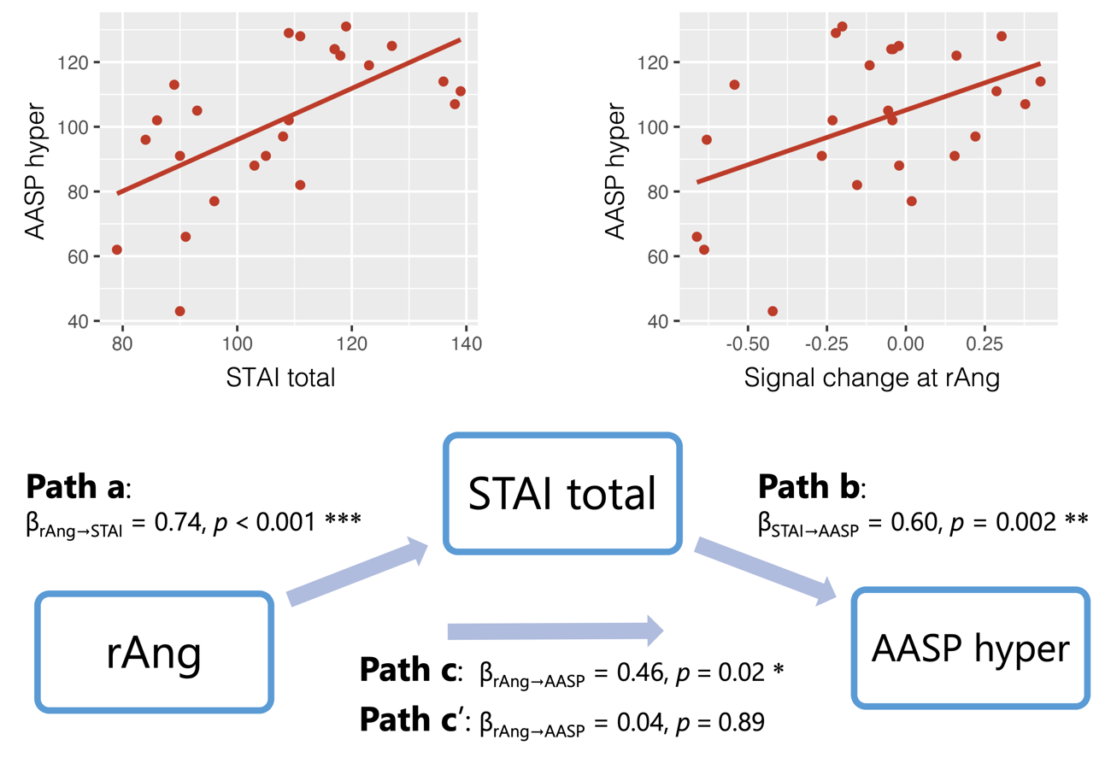
Figure S1. Results of the mediation analysis across the signal change of the right angular gyrus (rAng) for FE > NE contrast, STAI total score, and AASP hyperreactivity score (hyper) in ASD. The left upper panel shows the correlation between STAI total and AASP hyperreactivity scores, and the right upper panel shows rAng activation and AASP hyper. *p < 0.05; **p < 0.01; ***p < 0.001.

References
Baron, R. M., & Kenny, D. A. The moderator–mediator variable distinction in social psychological research: Conceptual, strategic, and statistical considerations. J Pers Soc Psychol. 51, 1173–1182 (1986). https://doi.org/10.1037/0022-3514.51.6.1173

