Nanocellulose Chiral Synergistic Effect Enhances Circularly Polarized Luminescence of Lanthanide Electric Dipole Transition Bands
Hui Changª, Wenjia Kangª, Xinyu Zhao^{b,} *, Shuai Chang^{b}, Xinping Li^{b}, Yuxia Luo^{b}, Chuanyin Xiong^{b}, Xunjin Zhu ^{c}, Zhao Zhang^{b,} *

ªCollege of Mechanical and Electrical Engineering, Shaanxi University of Science and Technology, Wude Road, Weiyang District, Xi'an 710021, P. R. China.
^{b} College of Bioresources Chemical and Materials Engineering, Shaanxi University of Science and Technology, Xi'an 710021, Shaanxi, P. R. China.
^{c} Department of Chemistry and State Key Laboratory of Environmental and Biological Analysis, Hong Kong Baptist University, Kowloon Tong, Hong Kong, China.
* To whom correspondence should be addressed:
E-mail: zhangzhaoqg@sust.edu.cn; 210111075@sust.edu.cn.

Contents:
Total number of pages: 2
Total number of Figures: 2
Contents
Figure S1…………………………………………………………………………..S2
Figure S2…………………………………………………………………………..S2

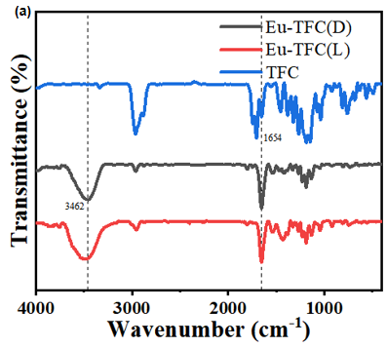
Figure S1. FT-IR spectra of TFC and Eu-TFC.

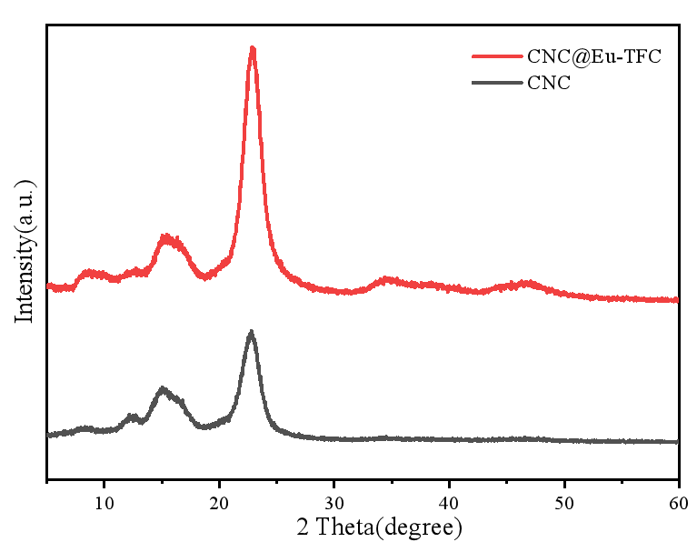
Figure S2. XRD spectra of CNC @ Eu-TFC (D30).

