Supplemental Digital Appendix 1
Supplementary File 1: Example search strategy from CINAHL
TI ( research OR researcher* OR research-related OR academic* )
AND
TI ( clinical OR clinician* OR practit* OR health OR hospital* OR nurs* OR medical OR medicine OR doctor OR doctors OR physician* OR healthcare OR surg* OR resident* OR residenc* OR registrar* OR trainee* OR specialist* OR consultant* OR neurol* OR neurosurg* OR cardiol* OR cardiothoracic OR trauma OR urolog* OR orthopaed* OR orthoped* OR otolaryngol* OR dermatol* OR endocrinol* OR gastroenterol* OR haematol* OR geriatric* OR oncol* OR neonatol* OR nephrol* OR rheumatol* OR (critical W1 care ) OR (sexual W1 health ) OR anaestheti* OR anesthesiol* OR obstetric* OR gynaecol* OR gynecol* OR opthalmol* OR patholog* OR emergency OR psychiatr* OR (intensive W1 care ) OR intensivist* OR internal OR internist* OR radiol* OR paediatric* OR pediatric* OR respiratory OR (palliative W1 care ) OR (family W1 practi* ) OR (general W1 practi* ) OR (speech N2 patholog* ) OR (speech N2 therap* ) OR (speech-language W1 pathol* ) OR (speech-language W1 therap* ) OR physiotherap* OR (physical W1 therap* ) OR (occupational W1 therap* ) OR (social W1 work* ) OR podiatr* OR audiolog* OR dietician* OR dietetic* OR (exercise W1 physiolog* ) OR (music W1 therap* ) OR psycholog* OR sonograph* )
AND
TI ( competenc* OR (career N2 pathway* ) )

N.B. Note that many medical specialties have the word “medicine” in them (e.g. fetal medicine, rehabilitation medicine, sleep medicine) thus will be covered by inclusion of “medicine” as a search term and are not separately listed.

Supplemental Digital Appendix 2
1. Authorship and publication
The capabilities in this theme focussed on both understanding and process of producing research outputs like peer reviewed journal articles, conference posters or presentations. This included understanding the components of a paper or presentation, producing outputs, fair attribution of authorship, concepts of plagiarism, open access and publication metrics. Half of studies (n=six) included capabilities associated with authorship and publication. Authorship and publication were not included in studies associated with health policy and systems researchers and non-investigators in clinical research support roles.

2. Research dissemination
Research dissemination related to sharing of research findings across a range of mediums and with a variety of stakeholder groups included scientific and non-scientific community. Seven studies described research dissemination within their capability with all professions represented by one study except non-investigators in clinical research support roles.

3. Knowledge translation
The capabilities in this theme described the process of understanding and applying knowledge translation practices along with implementing evidence based on research findings into practice and policy. Five studies across three professions (health policy and systems researchers, occupational therapists and nursing and midwives) identified knowledge translation within their competency frameworks. Within the competency frameworks of the three health policy and systems researchers studies there was a strong focus on implementation of research findings to impact policy and practice within real healthcare environments.

4. Personal attributes
Capabilities related to personal attributes that positively impacted on research outcomes such as organisational, interpersonal and cognitive skills and professionalism. Of the four studies which included personal attributes all highlighted effective interpersonal skills and three included teamwork and collaboration. Papers represented three groups; clinical research professionals (n=2), nurses and midwives (n=1), health professionals (n=1).

5. Communication
Communication-related capabilities included effective verbal, written and electronic communication to share ideas with a range of audiences, construct arguments, and communicate with participants and members of the research team. Five studies included communication in their competency framework, all of which highlighted the importance of needed to express ideas effectively.

6. Leadership
Leadership described two main concepts; research leadership and leading others or organisation. Research leadership capabilities identified skills in leading research projects or programs of research, expert in research field and contributes to the broader research landscape. Leading others or organisations including acting a role model, motivation of others, designation of tasks and performance management and shapes policies and research agendas within organisation and beyond. Leadership capabilities were included in all competency frameworks and with most including multiple capabilities describing leadership attributes.

7. Mentoring
Mentoring described providing support, training and mentorship to less experienced team members or staff which may include supervision of research students. Six studies included mentoring across four professions; occupational therapy, nursing (n=2), palliative care clinicians, clinical research professionals n=2). Mentoring was not included in health policy and systems research or non-investigator in clinical research roles competency frameworks.

8. Educator skills
Educator skills identified in the capability frameworks relate to providing education and training to support research such as teaching other researchers new techniques or use of technology and designing and providing professional development to staff. Seven studies included educator skills within their capabilities, however the frequency of educator skills within each study was low (1 – 6 capabilities). In five of the eight studies educator skills were described only once.

9. Ethics and governance
Ethics and governance covered a range of concepts including key concepts of research ethics and applying these in study design and conduct, understanding and gaining ethical and governance approvals, reporting requirements, risk identification, mitigation and reporting and managing conflicts of interest. Eight studies included capabilities associated with ethics and governance, with seven studies reporting at least three or more capabilities related to ethics and governance.

10. Regulatory requirements
The capabilities in this theme focussed on a range of regulatory requirements that are needed to conduct research which included understanding local and international regulatory requirements, identifying and reporting adverse events and auditing. Capabilities related to regulatory requirements were included in five studies, which included the three studies with clinical research professionals which focus on clinical trials research. The competency frameworks which related to clinical research professionals included multiple competences (10 – 52 capabilities) in each study demonstrating a key focus area for clinical trials research.

11. Product development
Product development focussed on the components of developing, trialling and implementing new products and including understanding regulations and differences between regions and countries. Three studies included product development all of which were capabilities for clinical research professionals. Three studies included no capabilities related to ethics and governance, regulatory requirements and product development. These studies came from three different professions; health policy and systems research (Bornstein et al, 2018), nursing (Coombs et al., 2012) and non-investigators in clinical research support roles.

12. Partnerships
The capabilities in Partnerships identified skills that would expand and build collaborative networks to support research, identify and develop relationships with key stakeholders, other professions and organisations. Eight studies included partnerships within their competency frameworks. All professions were represented in Partnerships across these studies, except Occupational Therapy.

13. Consumer engagement
Consumer engagement described the skills associated with valuing and actively engaging with consumers including co-design research, building relationships and empower vulnerable populations and supporting community advisory boards. Four studies included consumer engagement activities two in health policy and systems researcher competency frameworks (Forrest et al., 2018; Schleiff et al., 2022) and one in both palliative care clinicians (Mosoiu et al., 2024) and clinical research professionals (Jule et al., 2017). There were nine consumer engagement capabilities between the four studies.

14. Research question
Research question described the process of developing and articulating a research question along with describing key stakeholder engagement and ensuring research question is relevant to policy and practice. Research question capabilities were included in six studies across four professions, health policy and systems research (n=2), clinical research professionals (n=2), nursing and palliative care clinicians.

15. Evidence based practice and literature searching
Evidence based practice (EBP) and literature searching capabilities skills and knowledge related to understanding and use of research database, assess appropriateness of a range of resources, critical appraisal skills and describe relationship of findings to real word / clinical practice. Nine studies included capabilities related to EBP and literature searching with all professions represented except non-investigators in clinical research roles.

16. Methodology and protocol development
The capabilities included in methodology and protocol development describe the ability to understand and select appropriate research methods and outcome measures to answer the research question, appreciating the limitations of different methods. Capabilities related to understanding, executing and acting on standard operating procedures, adverse event reporting and risk mitigation. Eight studies included capabilities of methodology and protocol development with all professions represented except nursing and non-investigators in clinical research roles. This subtheme was represented frequently in clinical research professional competency frameworks (range 9 -51 capabilities).

17. Funding
Funding capabilities related to two main concepts: applying for and receiving grant funding and financial management of budgets for research projects. Applying for and receiving grant funding related to understanding available funding bodies both internally and externally to the organisation, drafting and editing of grant applications and successfully receiving a grant application. Two studies (Brouwer et al., 2017; Gebbie et al., 2008) reported these types of capabilities only. Financial planning and management included developing and managing research study budgets, maintaining accurate records and managing expenses. One study reported financial management capabilities only. Two studies (Smith et al. 2018 – investigators; Jule et al., 2017) describes both concepts relating to funding.

18. Consent and recruitment
Consent and recruitment related to undertaking recruitment and initial and continuing consent of participants in an ethical manner according to the protocol. This included developing consent and recruitment documents, understanding the forms of consent, communication with participants, screening, understanding inclusion and exclusion criteria, monitoring and acting on recruitment and retention rates. Six studies described capabilities detailing consent and recruitment, with all three clinical research professional studies describing this theme in detail (11 – 18 capabilities). Consent and recruitment was also described in competency frameworks in palliative care clinicians, health policy and systems and researchers and non-investigator research support roles.

19. Conducting research
Conducting research described the capabilities which encompassed the research cycle. The capabilities described some or all of the process of planning, conducting, analysing and disseminating research. Five studies included capabilities of conducting research which were found in occupational therapy, nursing and clinical research professional competency frameworks.

20. Data collection processes
Data collection described the process of collecting and maintaining data according to the protocol in an accurate and efficient manner and skills in data quality assurance, verification, security, storage and destruction. Nine of the twelve studies specifically identify capabilities related to data collection. All but two studies included multiple capabilities related to data collection (3 – 37 capabilities), with the clinical research professionals describing data collection processes in detail (24-37 capabilities).

21. Project management
Project management capabilities related to coordination or study activities such as site management and team communication, application of project management skills and ability to respond to the unexpected. Eight studies describe project management capabilities across six professions (health policy and services researchers n=2, clinical research professionals n = 2, nursing and midwifery, palliative care clinicians, non-investigator clinical research support roles). Six of the eight studies contained multiple capabilities related to project management within their framework.

22. Data analysis
Data analysis included capabilities that described the ability to analyse a range of data sources with rigor using statistics and identifying bias and ensuring data management, transparency and reproducibility. Six studies included capabilities related to data analysis. All but one study (Bornstein et al., 2018) had multiple capabilities devoted to data analysis, however the Bornstein (2018) study described a detailed competency which included many of the components of data analysis included in the other studies. Data analysis was represented in the professions of health policy and systems researchers, clinical research professionals and palliative care clinicians.

23. Use of technology
The use of research computer programs and technology described capabilities that related to general information technology literacy, use of basic and more advanced software (eg. Microsoft office, statistical and bibliometric software), database development and use of technology. Three of the four studies which describe capabilities in this subtheme had between five and eleven capabilities.

24. Broad research skills and knowledge
The capabilities in this subtheme described the skills relating to understand research concepts such as research terminology, the research cycle, basic scientific principles, identifying elements of a protocol and roles and responsibilities of members of research teams. Seven studies included capabilities that described the requirement for broad research skills and knowledge with four professions represented (occupational therapy, clinical research professionals (n=2), health policy and systems researchers (n=2) and nursing).

25. Clinical or subject matter expertise
Clinical or subject matter expertise details the capabilities that identify skills and knowledge in specialty areas of practice or study design. Eight studies included clinical or subject matter expertise within the competency frameworks which represent five professions, health policy and systems researchers (n=3), occupational therapy, nursing (n=2), clinical research professional and palliative care clinician.

Supplemental Digital Appendix 3

Self-Assessment Mapping Tool

Complete the following to identify your research capabilities relevant to Queensland Health research practice and roles
a) Rate your proficiency on each capability statement
Rate your proficiency for each capability statement using the 1-5 rating scale below (Note: you can score using 0.5 scale points if desired), and enter the number at the end of the row.
- No proficiency – May have some awareness of the area but no experience or skill in the area and no ability to demonstrate capability.
- Emerging proficiency - Gaining experience in the described knowledge and skills and starting to apply that knowledge to research activities and tasks. Requires support or mentoring to achieve outcomes.
- Consolidating proficiency - Furthering skills and knowledge and can complete research activities or tasks independently. Requires guidance to deliver complex or advanced levels of activity or tasks.
- Advanced proficiency - Becoming an expert in skill and knowledge required to demonstrate behaviour or activity. Able to apply skills and knowledge across a range of contexts and integrate expertise across domains. Able to support others in learning and applying knowledge, skills, and behaviour.
- Expert proficiency - Acknowledged leader with in-depth knowledge and demonstrated strategic leadership in the area of knowledge, skill, or behaviour. Integrates, evaluates, and adapts knowledge, skills, or behaviour at an advanced level.
b) Calculate overall domain scores: Add together scores for all capability statements in each domain, and enter in the “total” cell. Then calculate the mean for each domain by dividing the total by the number of capability statements in that domain.

c) Plot domain scores on Research Development Spider Diagram: Plot the mean domain scores onto the spider diagram using a dot, then connect each dot to create a spider plot as a visual display of your capability profile.

Example of a completed spider diagram
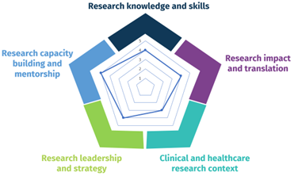
Domain 1: Research knowledge and skills

This domain reflects the technical knowledge and skills required to do research across all stages of the study lifecycle, from planning to dissemination.

Capability |  | Score (1-5)  (0.5 scale allowed)
- Understands general scientific principles of the research cycle and recognises different types of research methodologies and study types and designs
- Understands the value of consumer/community involvement including co-design of research with consumers, and applies to appropriate research studies
- Conducts literature searches and critically evaluates the literature to inform own research
- Develops and implements research protocols, including articulating clear research questions/aims and selecting appropriate research methods and outcome measures
- Understands and applies key concepts relating to research ethics, completing ethics applications, and research integrity
- Understands and complies with local/international governance and regulatory requirements
- Undertakes participant screening, recruitment, and consent procedures in an ethical manner according to the protocol
- Accurately and safely collects, manages, stores, and disposes of research data
- Plans, selects, and conducts appropriate data analysis and critically interprets results
- Applies project management skills to coordinate study activities
- Understands research funding landscape (including knowledge of a variety of funding sources), writes and applies for grants
- Establishes revenue streams to support research through competitive grant funding or industry partnerships
- Effectively disseminates research findings to scientific and non-scientific communities through presentations, publications and other mediums
 | Total
 | Mean (divide by 13)

Domain 2: Research impact and translation

This domain focuses on competencies related to ensuring research is translated into practice and has an impact on society. This may be through evidence-based practice, knowledge translation, and embedding impact in the design and conduct of clinical research.

Capability |  | Score (1-5)  (0.5 scale allowed)
- Uses and promotes evidence-based practice in own setting
- Promotes translation of research findings by engaging relevant stakeholders, including consumers, in the project lifecycle
- Engages in dialogue and understands working with stakeholders including policymakers, professional organisations, consumer representatives, industry partners and government representatives
- Understands different types of research impact and how research impact can be measured or reported
- Engages in multidisciplinary knowledge exchange to enhance research impact
- Participates in research that is close to practice with the potential for translation
- Understands and applies knowledge translation methodology
- Communicates research findings in an accessible way to diverse health system stakeholders
- Produces research which informs the development of health policy
 | Total
 | Mean (divide by 9)

Domain 3: Clinical and healthcare research context

This domain includes the unique competencies required to conduct research in a clinical or healthcare context, including ensuring research projects are embedded appropriately in the context.

Capability |  | Score (1-5)  (0.5 scale allowed)
- Maintains up-to-date knowledge of research and practice in their clinical area
- Conducts research in the area of specialty practice
- Applies healthcare and clinical knowledge to designing and conducting research, including developing practice-relevant research questions
- Understands and interfaces research with other health service improvement processes (e.g., Quality improvement, healthcare innovation, evaluation, service, and workforce development)
- Maintains a high level understanding of health systems at a local, national and/or international level
- Brokers clinical and research expertise at a local, statewide, national and/or international level
- Influences patient care by combining expert clinical and research skills
- Generates innovative research-related ideas and puts them into action within clinical/healthcare area or organisation
- Consults and collaborates with healthcare professionals, consumers, and other relevant health service staff to develop and conduct practice-relevant research appropriate to the healthcare setting
- Navigates the interaction between healthcare and research roles including ethical complexities and governance requirements
 | Total
 | Mean (divide by 10)

Domain 4: Research leadership and strategy

This domain includes those competencies required to lead research strategy, research projects, or teams, including research staff.

Capability |  | Score (1-5)  (0.5 scale allowed)
- Challenges traditional ways of thinking within area of research and/or clinical expertise
- Understands the strategic landscape across research and healthcare and anticipates future directions and promising ideas
- Contributes to or leads the development of research strategies and communicates strategy to the relevant stakeholders
- Shapes and contributes to local policy and procedures
- Promotes and supports good research practices and governance in line with relevant standards and legislation
- Creates opportunities for and promotes the skills and research careers of others
- Initiates, leads, and sustains research projects and/or a program of research
- Establishes a reputation as a leader and drives agenda in research field
- Serves on key research committees within their organisation and beyond (e.g., strategic advisory committees, grant review panels)
- Promotes a culture of equity and opportunity for all staff engaged in research
- Forms research teams that are fit for purpose (including consumers as appropriate), appropriately navigates team dynamics and creates a positive team culture
- Establishes partnerships that enable the development of a clinical research workforce
- Engages in effective research workforce planning and research budget management
- Establishes, manages, and sustains research networks and collaborations across organisations to enhance the quality of research
 | Total
 | Mean (divide by 14)

Domain 5: Research capacity building and mentorship

This domain includes competencies related to building research capacity in researchers and healthcare staff, including one-on-one mentorship, education, and contributing to the structure of research.

Capability |  | Score (1-5)  (0.5 scale allowed)
- Engages less experienced researchers with potential mentors and collaborators
- Mentors and guides less experienced researchers
- Seeks opportunities to engage staff in research and embed researchers into departments
- Assists staff in identifying appropriate funding schemes and developing/writing targeted funding proposals
- Supports staff through the research project lifecycle (e.g., literature search, data collection, data analysis)
- Encourages and inspires staff in their research journey
- Provides formal supervision associated with a research degree (e.g., honours, PhD)
- Supports staff to develop their research careers and track record
- Understands research training requirements and needs of the organisation
- Supports and organises research learning opportunities for staff and other relevant stakeholders, such as consumers
- Designs and delivers research training and development sessions and/or programs
- Contribute to the strategy and structure of research mentoring/supervision in the organisation
- Knows and uses different research-informed research development practices (e.g., teaching, education strategies, supervision, mentoring)
- Undertakes evaluation and research on own research development activities (e.g., teaching, education strategies, supervision, mentoring)
- Contributes to the promotion of research in the health service
 | Total
 | Mean (divide by 15)

Allied Health Research Careers Development Framework

Spider Diagram

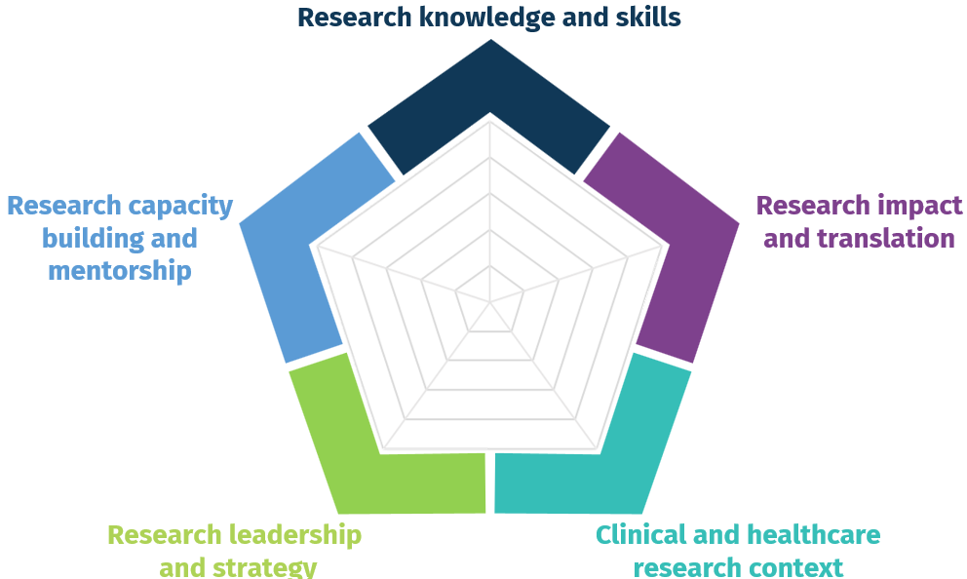

Completed by: _________________________________ Signature _________________________

Date: ____/______/______

