Supplementary information

Supplementary Figures:

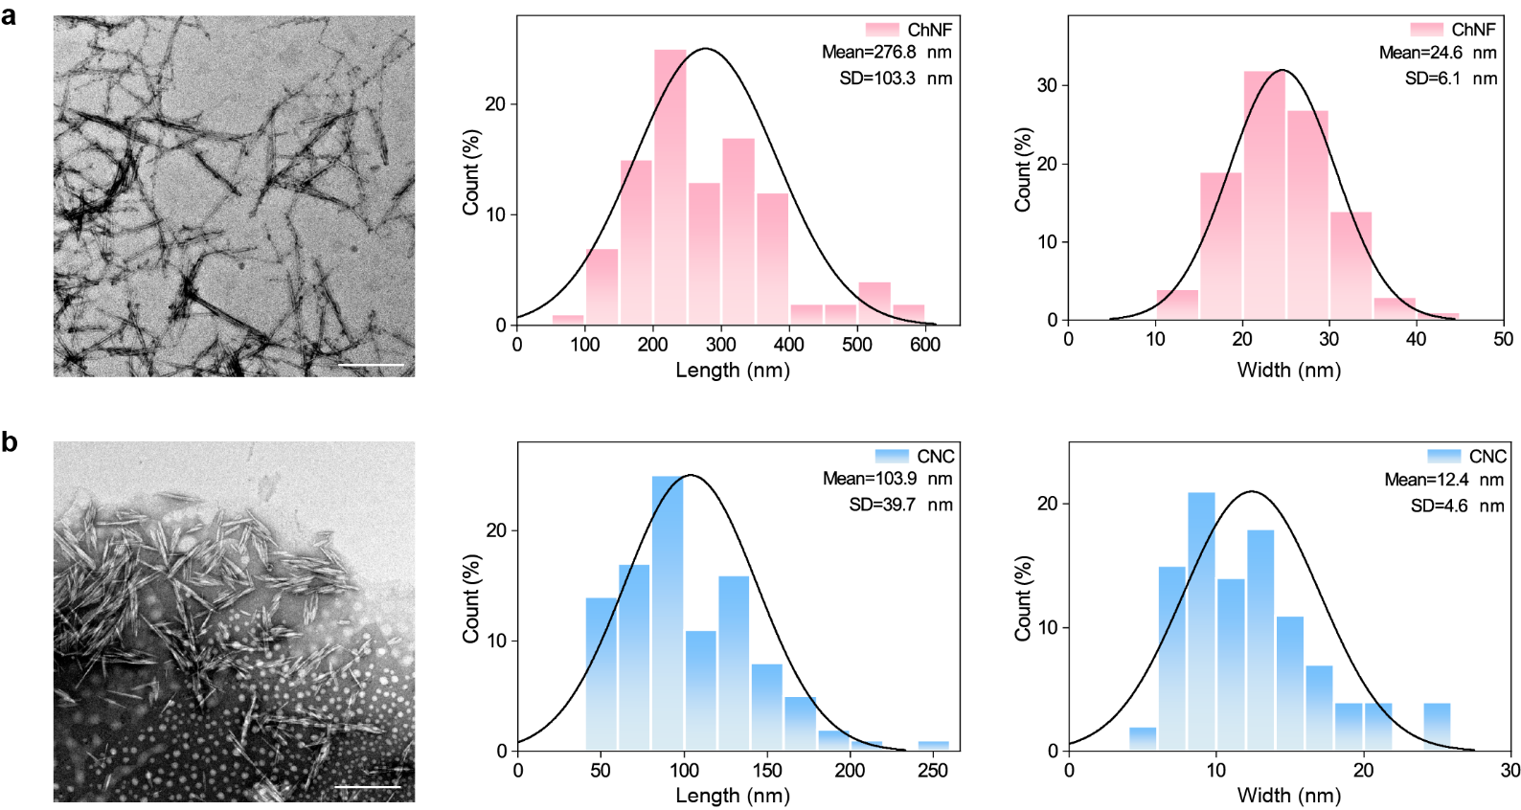
Figure S1. Transmission electron microscope (TEM) image and histogram distribution for length and width of a) ChNF and b) CNC. The scale bar is 300 nm.

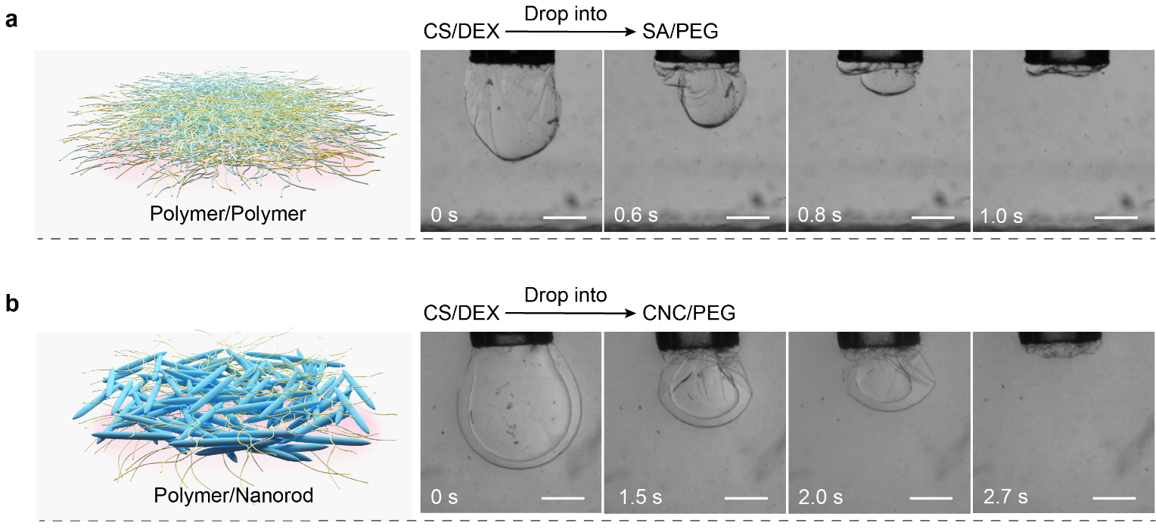
Figure S2. Morphology evolution of the pendant droplet encapsulated by a) ChNF/CNC, b) CS/SA and c) CS/CNC complex upon extracting liquid DEX phase in the droplet at a speed of 2 μL/s. Both of the concentration of DEX (1 wt% ChNF or CS) and PEG (1 wt% SA or CNC) is 10 wt%. The scale bar is 500 μm.

Figure S3. Time-dependent fluorescent images of the DEX-in-PEG microcapsule encapsulated with the ChNF/CNC complex. The 10 wt% DEX phase (1 wt% ChNF) was injected into 10 wt% PEG phase (1 wt% CNC). The PEG phase contains 0.001 wt% FITC-PEG. The left, middle, and right rows correspond to the bright field image of the microcapsule, stained PEG phase, and the merged image. The scale bar is 400 μm.

Figure S4. Time-dependent fluorescent images of the DEX-in-PEG microcapsule encapsulated with the a) CS/SA and b) CS/CNC complex respectively. a) The 10 wt% DEX phase (1 wt% CS) was injected into 10 wt% PEG phase (1 wt% SA). b) The 10 wt% DEX phase (1 wt% CS) was injected into 20 wt% PEG phase (1 wt% CNC). The PEG phase contains 0.001 wt% FITC-PEG. The left, middle, and right rows correspond to the bright field image of the microcapsule, stained PEG phase, and the merged image. The scale bar is 400 μm.

Figure S5. Time-dependent fluorescent images of the DEX-in-PEG microcapsule encapsulated with the ChNF/CNC complex. The 20 wt% DEX phase (1 wt% ChNF) was injected into 5 wt% PEG phase (1 wt% CNC). The PEG phase contains 0.001 wt% FITC-labeled polystyrene (PS) spheres. The left, middle, and right rows correspond to the bright field image of the microcapsule, stained PEG phase, and the merged image. The scale bar is 400 μm.

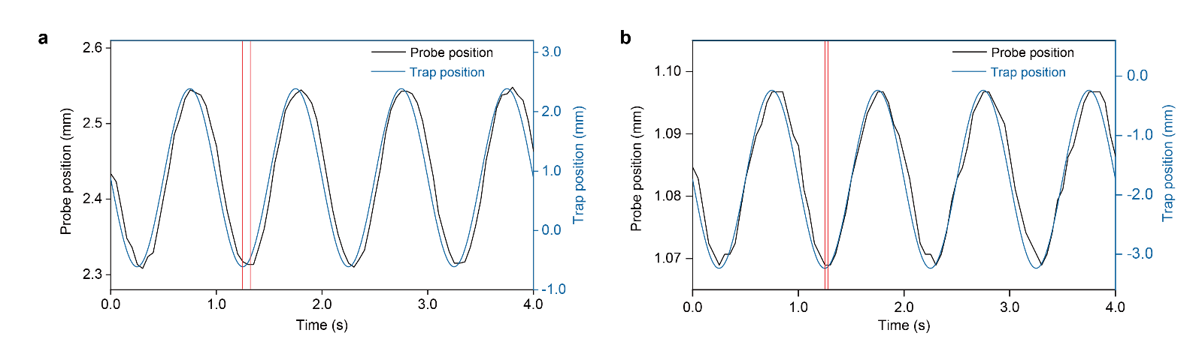
Figure S6. a) Experimental set-up used to access the interfacial shear rheology of the complexes. b) Storage (G’, closed symbol) and loss (G”, open symbol) moduli of the complexes assembled from ChNF/CNC (yellow square) and chitosan (CS)/CNC (blue circle). Overlapping identified between the magnetic probe and the trap for a) ChNF/CNC and b) CS/CNC complex upon in situ interfacial shear rheology measurements.

Figure S7. a) Time-dependent fluorescent microscope images of the DEX-in-PEG microcapsule encapsulated with the ChNF/CNC complex at Π_(5 wt% PEG)<Π_(20 wt% DEX). Both the concentration of ChNF (DEX phase) and CNC (PEG phase) is 1 wt%. The DEX phase contains 0.001 wt% FITC-DEX. The left, middle, and right rows correspond to the bright field image of the microcapsule, stained PEG phase, and the merged image. The scale bar is 400 μm. b) The image in the red dashed box shows the magnified fluorescence observation of the droplets formed in the microcapsule. The scale bar is 400 μm.

Figure S8. Time-dependent morphology evolution of the DEX-in-PEG droplet encapsulated with the CS/SA complex at a₁) $Π_{25 wt\% PEG}<Π_{5 wt\% DEX}$ and a₂) $Π_{10 wt\% PEG}>Π_{10 wt\% DEX}$. Both the concentration of CS (DEX phase) and SA (PEG phase) is 1 wt%. b) Optical and c) polarized optical microscope images of the DEX-in-PEG microcapsule at different osmotic stresses upon storage. The scale bar is 400 μm.

Figure S9. Time-dependent morphology evolution of the DEX-in-PEG droplet encapsulated with the CS/CNC complex at a₁) $Π_{10 wt\% PEG}<Π_{10 wt\% DEX}$and a₂) $Π_{20 wt\% PEG}>Π_{10 wt\% DEX}$. Both the concentration of CS (DEX phase) and CNC (PEG phase) is 1 wt%. b) Optical and c) polarized optical microscope images of the DEX-in-PEG microcapsule at different osmotic stresses upon storage. The scale bar is 400 μm.

Figure S10. Time-dependent fluorescent microscope images of the DEX-in-PEG microcapsule encapsulated with the ChNF/CNC complex at $Π_{8 wt\% PEG}=Π_{10 wt\% DEX}$. Both the concentration of ChNF (DEX phase) and CNC (PEG phase) is 1 wt%. The DEX phase contains 0.001 wt% FITC-DEX. The left, middle, and right rows correspond to the bright field image of the microcapsule, stained DEX phase, and the merged image. The scale bar is 400 μm.

Figure S11. Time-dependent fluorescent microscope images of the DEX-in-PEG microcapsule encapsulated with the ChNF/CNC complex at $Π_{10 wt\% PEG}>Π_{10 wt\% DEX}$. Both the concentration of ChNF (DEX phase) and CNC (PEG phase) is 1 wt%. The DEX phase contains 0.001 wt% FITC-DEX. The left, middle, and right rows correspond to the bright field image of the microcapsule, stained DEX phase, and the merged image. The scale bar is 400 μm.

Figure S12. a) Time-dependent morphology evolution of the DEX-in-PEG droplet encapsulated with the CNC/ChNF complex at $Π_{10 wt\% PEG}>Π_{10 wt\% DEX}$. Both the concentration of CNC (DEX phase) and ChNF (PEG phase) is 1 wt%. The dashed white circle indicates rupture of the microcapsule. b) Optical and c) polarized optical microscope images of the DEX-in-PEG microcapsule at $Π_{10 wt\% PEG}>Π_{10 wt\% DEX}$ upon storage. The scale bar is 400 μm.

Figure S13. Time-dependent fluorescent microscope images of the DEX-in-PEG microcapsule encapsulated with the ChNF/CNC complex where anionic FSS was retained in the DEX phase. Both the concentration of DEX (1 wt% ChNF) and PEG (1 wt% CNC) is 10 wt%. 0.001 wt% FSS was added in the PEG phase. The left, middle, and right rows correspond to the bright field image of the microcapsule, stained PEG phase, and the merged image. The scale bar is 400 μm.

Figure S14. Time-dependent fluorescent microscope images of the DEX-in-PEG microcapsule encapsulated with the ChNF/CNC complex where cationic NBA was excluded from the DEX phase. Both the concentration of DEX (1 wt% ChNF) and PEG (1 wt% CNC) is 10 wt%. 0.001 wt% NBA is added in the DEX phase. The left, middle, and right rows correspond to the bright field image of the microcapsule, stained DEX phase, and the merged image. The scale bar is 400 μm.

Figure S15. Time-dependent fluorescent microscope images of the DEX-in-PEG microcapsule encapsulated with the ChNF/CNC complex where mixed ionic species were separated. Both the concentration of DEX (1 wt% ChNF) and PEG (1 wt% CNC) is 10 wt%. The mixed FSS and NBA (both at 0.001 wt%) are added in the DEX phase. The left, middle (two), and right rows correspond to the bright field image of the microcapsule, stained DEX phase, and the merged image. The scale bar is 400 μm.

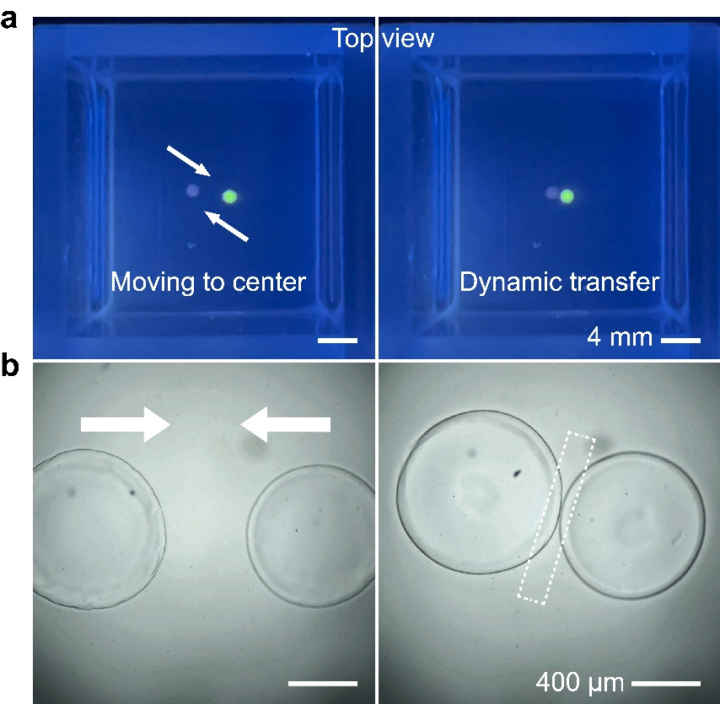
Figure S16. a) Visual observation and b) optical microscope images (top view) of the hanging DEX-in-PEG microcapsules moving toward the container center. The microcapsules encapsulated with the ChNF/CNC complex are placed in the container at arbitrary positions. Both the concentration of DEX (1 wt% ChNF) and PEG (1 wt% CNC) is 10 wt%. In a), 0.001 wt% FSS is pre-added in the DEX phase of the microcapsule, following with an observation under ultraviolet light at a wavelength of 365 nm. The arrows indicate movement direction of the microcapsules. The dashed rectangle in b) indicates that no merging of the microcapsules after contacting.

Figure S17. Time-dependent evolution (side view) of density-difference-driven autonomous movement of DEX-in-PEG microcapsule with a 10 wt% DEX (1 wt% ChNF) droplet on the surface of 35 wt% PEG solution containing CNC at the concentration of 0.5 to 1.6 wt% in a container with inner dimension of 10*10*45 mm³. The scale bar is 3 mm.

Figure S18. Time-dependent evolution (side view) of density-difference-driven autonomous movement of DEX-in-PEG microcapsule with a 10 wt% DEX (1 wt% ChNF) droplet on the surface of 35 wt% PEG solution containing CNC at the concentration of 0.5 to 1.6 wt% in a container with inner dimension of 20*20*20 mm³. The scale bar is 3 mm.

Figure S19. Time-dependent evolution (side view) of density-difference-driven autonomous movement of DEX-in-PEG microcapsule with a 10 wt% DEX droplet containing varying ChNF concentration of 0.5 to 1.6 wt% on the surface of 35 wt% PEG (0.5 wt% CNC) solution in a container with inner dimensions of 10*10*45 mm³. The scale bar is 3 mm.

Figure S20. Time-dependent evolution (side view) of density-difference-driven autonomous movement of DEX-in-PEG microcapsule with a 10 wt% DEX droplet containing varying ChNF concentration of 0.5 to 1.6 wt% on the surface of 35 wt% PEG (0.5 wt% CNC) solution in a container with inner dimensions of 20*20*20 mm³. The scale bar is 3 mm.

Figure S21. Viscosity of 35 wt% PEG solution with varied CNC concentrations (0, 0.5, 1.0, 1.2, 1.4, and 1.6 wt%).

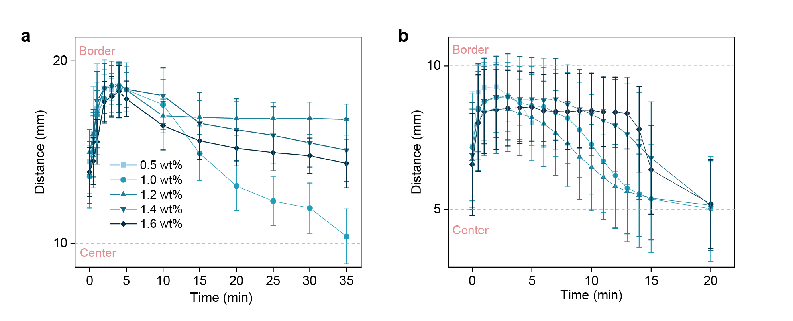
Figure S22. Horizontal tracking of density-difference-driven autonomous movement of microcapsule under varied ChNF concentrations (0.5 to 1.6 wt%) and 0.5 wt% CNC in a container with inner dimension of a) 20*20*20 mm³ and b) 10*10*45 mm³.

Figure S23. Feasibility of self-assembly of structured ATPS encapsulated with the ChNF/CNC complex at the water-water interface with ChNF concentration of 0.5 to 1.6 wt% in the DEX phase. The 10 wt% DEX is injected into the 10 wt% PEG (0.5 wt% CNC) at an extrusion speed of 20 μL/s. The pH is fixed at 3. The scale bar is 1 mm.

Figure S24. Feasibility of self-assembly of structured ATPS encapsulated with the ChNF/CNC complexes at the water-water interface with CNC concentration of 0.5 to 1.6 wt% in the PEG phase. The 10 wt% DEX phase (1.0 wt% ChNF) is injected to the 10 wt% PEG phase at an extrusion speed of 20 μL/s. The pH is fixed at 3. The scale bar is 1 mm.

Figure S25. Map of structured ATPS complexed by nanoparticles at the interface and switchable movement of the microcapsules in containers with different dimensions.

Figure S26. Time-dependent evolution (side view) of density-difference-driven autonomous movement of DEX-in-PEG microcapsule with a 10 wt% DEX (1.0 wt% CNC) droplet on the surface of 35 wt% PEG (0.5 wt% ChNF) solution in a container with inner dimension of 10*10*45 mm³. The scale bar is 3mm.

Figure S27. Time-dependent evolution (side view) of density-difference-driven autonomous movement of DEX-in-PEG microcapsule with a 10 wt% DEX (1.0 wt% CNC) droplet on the surface of 35 wt% PEG (0.5 wt% ChNF) solution in a container with inner dimension of 20*20*20 mm³. The scale bar is 3mm.

Supplementary table
Table S1. Osmolarity and density of the starting materials at 25 ℃
Solution | Osmolarity [mOsm/kg] | Density [g/cm³]
H₂O | -1 | 0.9996
10 wt% DEX | 26 | 1.0471
10 wt% DEX + 1.0 wt% ChNF | 145 | 1.0520
10 wt% DEX + 1.2 wt% ChNF | 173 | 1.0531
10 wt% DEX + 1.4 wt% ChNF | 211 | 1.0556
10 wt% DEX + 1.6 wt% ChNF | 254 | 1.0581
10 wt% DEX + 1.0 wt% CNC | 177 | 1.0532
10 wt% DEX + 1.0 wt% CS | 389 | 1.0588
20 wt% DEX + 1.0 wt% ChNF | 186 | 1.1010
25 wt% DEX + 1.0 wt% CS | 435 | 1.1605
10 wt% PEG | 99 | 1.0208
5.0 wt% PEG + 1.0 wt% CNC | 144 | 1.0156
5.0 wt% PEG + 1.0 wt% SA | 284 | 1.0163
8.0 wt% PEG + 1.0 wt% CNC | 153 | 1.0185
10 wt% PEG + 1.0 wt% CNC | 251 | 1.0372
10 wt% PEG + 1.0 wt% ChNF | 203 | 1.0409
10 wt% PEG + 1.0 wt% SA | 405 | 1.0226
20 wt% PEG + 1.0 wt% CNC | 587 | 1.0500
35 wt% PEG + 0.5 wt% CNC | 715 | 1.0746

Supplementary experimental procedures
Materials.
Crab shells that were dried under ambient temperature were purchased from local market (Harbin, China). Dextran (DEX, $M_{w}$ = 45000), Poly (ethylene glycol) (PEG, $M_{w}$ = 20000), FITC-Dextran ($M_{w}$ = 4000), fluorescein sodium salt (FSS, $M_{w}$ = 376.27), Nile blue A (NBA, $M_{w}$ = 732.85), sodium hydroxide (NaOH) and acetic acid (CH₃COOH) were purchased from Sigma-Aldrich (Shanghai, China). FITC-PEG ($M_{w}$ = 10000), sodium alginate (SA), chitosan (CS), ferroferric oxide (Fe₃O₄), hydrochloric acid (HCl), and sodium hypochlorite (NaClO₂) were obtained from Aladdin (Shanghai, China). The FITC-labeled carboxyl-terminated polystyrene spheres (FITC-PS) with a diameter of 50 nm were purchased from Suzhou NanoLife Science & Technology Co., Ltd., under the product name PolymStar LF005G-Carboxyl. Stock solution of 1 wt% SA was prepared by dissolving 0.5 g of SA into 50 g of Milli-Q water, which was stirred overnight at room temperature to attain full dissolution. Stock solution of 1 wt% CS in 2% acetic acid was prepared using the same method.
Preparation of chitin nanofiber and cellulose nanocrystal.
The dry crab shells were processed by alternating 1 M HCl and 1 M NaOH immersion in 24 h cycles for at least three cycles to remove minerals and proteins. The obtained chitin flakes were decolorized using 0.5 wt% NaClO₂ solution (pH 5.0, acetic acid) at 70 ℃ for 2 h, followed with washing by running distilled water (hot and cold) and crushing by a household blender. Chitin nanofiber (ChNF) was prepared following a previous reported involving alkali and mechanical treatments.¹ Briefly, purified chitin flakes were treated with 33 wt% NaOH solution at 90 °C for 3.5 h at a liquid-to-solid ratio of 25 mL/g. The resultant deacetylated chitin (De-chitin) with a deacetylation degree of approximately 27.5% was washed with running water (hot and cold) until reaching a neutral pH. Subsequently, dialysis with Milli-Q water was conducted overnight to remove impurities from the De-chitin. Prior to mechanical nanofibrillation, the De-chitin was re-dispersed in Milli-Q water at a concentration of 0.1 wt%. The pH of the coarse suspension was adjusted to 3.0 using acetic acid, following with continuous stirring to ensure full protonation of the amine groups on the De-chitin. This coarse suspension was further homogenized at room temperature using a high-speed homogenizer (T-25 Ultra-Turrax Digital Homogenizer, IKA, Germany) to generate finer fibrils. Finally, the fine De-chitin suspension obtained was disintegrated into nanofibers through ultrasonication with a tip sonicator (Xinzhi, Ningbo, China) at a power of 300 W for 35 min, with alternating intervals of 5 s on and 2 s off. The obtained ChNF was stored at 4 ℃ until further use.
Following a previous report,² cellulose nanocrystal (CNC) was obtained from bleached wood pulp by hydrolysis with 64 wt% sulfuric acid at 45 °C and 45 min. The hydrolysis precipitate was rinsed, centrifuged and dialyzed until the conductivity was $<$ 5 μS/cm. The obtained CNC aqueous suspension (1 wt% concentration, pH = 2.8) was filtered and sonicated (Sonifier 450, Branson Ultrasonics Co., Danbury, CT, USA) before storage 4 ℃ in the fridge.
Morphology and $ζ$-potential of ChNF and CNC
Morphology.
The morphology of ChNF and CNC was observed by transmission electron microscope (TEM, JEM-2100, Japan) at an acceleration voltage of 120 kV. The diluted suspension (0.005%) of ChNF or CNC was applied onto a carbon-reinforced formavar film-coated electron microscope grid, which was then negatively stained using phosphotungstic acid solution prior to drying at room temperature. The dimensions of ChNF and CNC were measured using ImageJ software (imagej.nih.gov), by analyzing at least 100 nanoparticles.
The morphology of the ChNF/CNC complex at the interface was observed using TEM. Specifically, same volume of 10 wt% DEX (1 wt% ChNF) solution and 10 wt% PEG (1 wt% CNC) solution was sequentially added into a container to form the complex. After collecting the complex from the interface, it was attached to a carbon-reinforced formavar film-coated electron microscope grid and observed after staining with phosphotungstic acid.
$ζ$-potential.
The $ζ$-potential of ChNF and CNC was measured using Zetasizer Nano (ZS, Malvern Panalytical, Malvern, U.K.) under various pH conditions. The pH of ChNF and CNC suspensions was adjusted using 1 M HCl or 1 M NaOH. Each measurement was conducted in triplicate to present averaged value.
Permeability.
In order to characterize the permeability of the complex, the DEX and PEG phases were simultaneously observed with a polarized optical microscope (MP41, Mshot, China) equipped with a 5× objective lens and a fluorescent optical microscope (Axio Imager A2, ZEISS, Germany) equipped with a 5× objective lens under different osmotic pressure gradient. Prior to fluorescent observation, respectively the DEX phase was stained by 0.001 wt% FITC-DEX and the PEG phase was labeled with 0.001 wt% FITC-PEG or FITC-PS. The stained sample was gently mixed using a pipette and then equilibrated at room temperature for at least 10 min. The excitation/emission spectra used in this study were 492/518 nm for FITC-DEX, FITC-PEG and FITC-PS. The fluorescence signal (green) in the images and merged images were processed using ImageJ.
Movement under external magnetic field.
To achieve the controllable movement of the microcapsule under the action of an external magnet, 1 wt% Fe₃O₄ nanoparticle was loaded into one of the two microcapsules. This progress was recorded by camera and optical microscope respectively.
Preparation of structured ATPS.
In order to evolute feasibility of forming structured ATPS via complexation of nanoparticles at the interface, the structured liquid channels were created using an optical tensiometer (Attension Theta Flex, Biolin Scientific, Espoo, Finland) by injecting 10 wt% DEX solution containing ChNF into 10 wt% PEG solution containing CNC at an extrusion speed of 20 μL/s. To obtained varied complexation conditions, the ChNF and CNC suspensions were diluted (0.5 to 1.6 wt%) using the Milli-Q water, and the pH of ChNF suspension was adjusted (4 or 5) using 0.5 or 1 M HCl and NaOH.
Measurement of the osmotic pressure.
The osmotic pressure of different solution was tested by freezing point osmometer (Advanced, USA) at room temperature. For the CS/SA complex, the loading level of SA and CS were both 1 wt%, resulting in $Π_{5 wt\% PEG}$ $<$ $Π_{25 wt\% DEX}$ and $Π_{10 wt\% PEG}$ $>$ $Π_{10 wt\% DEX}$. For the CS/CNC complex, the loading level of CS and CNC were both 1 wt%, resulting in$Π_{10 wt\% PEG}$ $<$ $Π_{10 wt\% DEX}$ and $Π_{20 wt\% PEG}$ $>$ $Π_{10 wt\% DEX}$. For the ChNF/CNC complex, the loading level of ChNF and CNC were both 1 wt%, resulting in $Π_{5 wt\% PEG}$ $<$ $Π_{20 wt\% DEX}$, $Π_{8 wt\% PEG}$＝ $Π_{10 wt\% DEX}$, and $Π_{10 wt\% PEG}$ $>$ $Π_{10 wt\% DEX}$.

Supplementary references

1. Bai, L. et al. Self-Assembled Networks of Short and Long Chitin Nanoparticles for Oil/Water Interfacial Superstabilization. ACS Sustain. Chem. Eng. 7, 6497–6511 (2019).
2. Bai, L., Huan, S., Xiang, W. & Rojas, O. Pickering Emulsions by Combining Cellulose Nanofibrils and Nanocrystals: Phase Behavior and Depletion Stabilization. Green Chem. 20, (2018).

