Supporting Information

Triphenylphosphine-catalyzed Alkylative Iododecarboxylation with Lithium Iodide under Visible Light

Ming-Chen Fu,¹ Jia-Xin Wang¹, and Rui Shang,^{1,2}*

¹ Department of Chemistry, University of Science and Technology of China, Hefei 230026, China; ²Department of Chemistry, School of Science, The University of Tokyo, 7-3-1 Hongo, Bunkyo-ku, Tokyo 113-0033, Japan.

rui@chem.s.u-tokyo.ac.jp

Table of Contents

- General Information | S3
- Investigation of the Key Reaction Parameters | S4
- Experimental Procedures and Characterization Data | S7
- Experimental Studies on Mechanism | S24
- Decarboxylative Elimination | S28
- Further Transformations for Decarboxylative Construction of C-O, C-N, C-F, and C-SCN bonds | S31
- References | S36
- NMR Spectra | S37

1. General Information
A. Materials:
All reactions were conducted in oven-dried Schlenk tubes under argon atmosphere (purity ≥ 99.99%) unless otherwise mentioned. Commercial reagents were purchased from Energy Chemical, Adamas-beta, TCI and Aldrich. Organic solutions were concentrated under reduced pressure on Buchi rotary evaporator. The LED lamps were purchased from Kessil (PR160-390 nm, 427 nm, 440 nm, 456 nm, 467 nm, 520 nm). The Photo Reaction Setup was purchased from Anhui kemi machinery technology Co., Ltd.
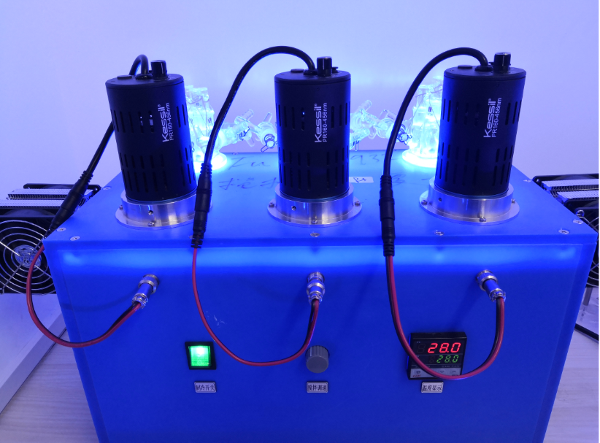
Figure S1. The Photo Reaction Setup and Kessil blue LED lamps
B. Analytical Methods:
¹H-NMR and ¹³C-NMR spectra were recorded on a Bruker Avance 400 spectrometer at ambient temperature. ¹H-NMR, ¹⁹F-NMR and ¹³C-NMR spectra were recorded on a Bruker Avance 400 spectrometer at ambient temperature. Data for ¹H-NMR are reported as follows: chemical shift (ppm, scale), multiplicity (s = singlet, d = doublet, t = triplet, q = quartet, m = multiplet and/or multiplet resonances, br = broad), coupling constant (Hz), and integration. Data for ¹³C-NMR are reported in terms of chemical shift (ppm, scale), multiplicity, and coupling constant (Hz). HRMS analysis was performed on Finnigan LCQ advantage Max Series MS System. ESI-mass data were acquired using a Thermo LTQ Orbitrap XL Instrument equipped with an ESI source and controlled by Xcalibur software. UV-Vis spectrum was measured by UV-3600. Flash column chromatographic purification of products was accomplished using forced-flow chromatography on Silica Gel (200-300 mesh).
2. Investigation of the Key Reaction Parameters
Table S1: Screening of different iodides
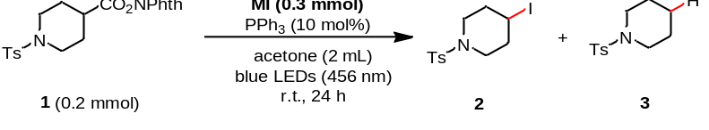
entry | MI | 2 (%) | 3 (%)
1 | LiI | 91 | trace
2 | NaI | 72 | trace
3 | KI | 64 | trace
4 | RbI | 56 | 40
5 | CsI | 10 | 40
6 | CaI₂ | 46 | trace
7 | ZnI₂ | trace | trace
8 | ^{n}Bu₄NI | trace | trace
The yield was determined by ¹H-NMR used diphenylmethane as internal standard.

Table S2: Screening of different solvents
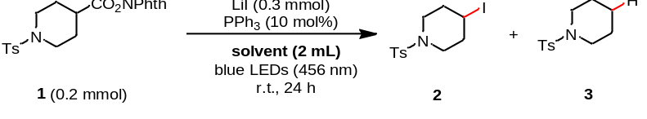
entry | solvent | 2 (%) | 3 (%)
1 | DMF | trace | 60
2 | DMA | 15 | 50
3 | CH₃CN | 8 | trace
4 | THF | 81 | trace
5 | dioxane | 0 | trace
6 | EtOAc | 16 | trace
7 | CH₂Cl₂ | 0 | 0
8 | PhCF₃ | 0 | trace
9 | acetone+THF (1:1) | 92 | trace
10 | 3-methylbutan-2-one | 0 | trace
11 | acetone | 91 | trace
12 | butan-2-one, | 83 | trace
13 | nonan-5-one | 0 | trace
The yield was determined by ¹H-NMR used diphenylmethane as internal standard.

Table S3: Screening of different catalysts
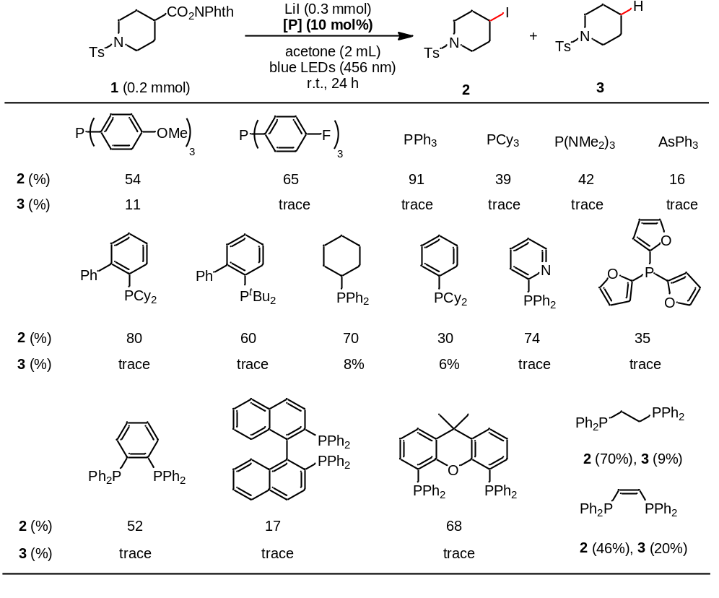
The yield was determined by ¹H-NMR used diphenylmethane as internal standard.

Table S4: Screening of different light sources
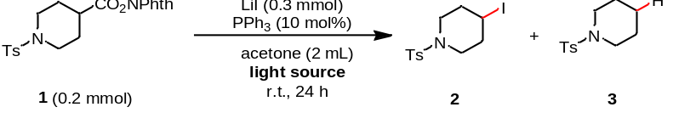
entry | light source (nm) | 2 (%) | 3 (%)
1 | 620 nm | 0 | 0
2 | 520 nm | 0 | 0
3 | 467 nm | 87 | trace
4 | 456 nm | 91 | trace
5 | 440 nm | 93 | trace
6 | 427 nm | 90 | trace
7 | 390 nm | 92 | trace
The yield was determined by ¹H-NMR used diphenylmethane as internal standard.

Table S5: Control experiments
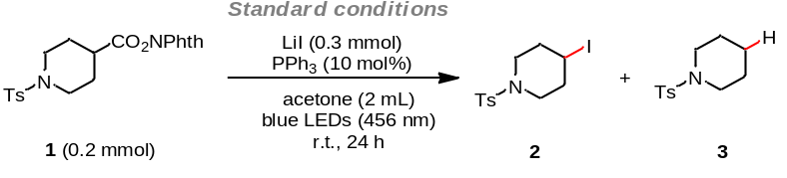
entry | variations from the standard conditions | 2 (%) | 3 (%)
1 | no change | 91 (85) | trace
2 | w/o PPh₃ | 20 | trace
3 | O=PPh₃ instead of PPh₃ | 21 | trace
4 | addition of O=PPh₃ (10 mol%) | 90 | trace
5 | w/o light, 60 ºC | 0 | 0
6 | reaction time: 15 h | 76 | trace
7 | addition of I₂ (20 mol%) | 0 | 0
8 | acetone (0.25 M) | 70 | trace
9 | acetone (0.05 M) | 38 | trace
10 | LiI (0.2 mmol) | 85 | trace
11 | LiI (0.35 mmol) | 89 | trace
12 | S1 instead of 1 | 0 | 0
13 | S2 instead of 1 | 0 | 0
14 | S3 instead of 1 | 0 | 0
15 | S4 instead of 1 | 83 | trace
The yield was determined by ¹H-NMR used diphenylmethane as internal standard. Yields of isolated products in parentheses.
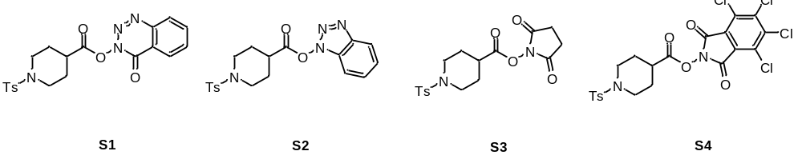

The phenomena of model reaction mixture before and after the reaction

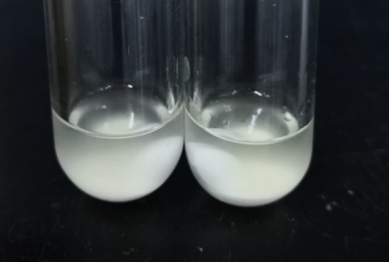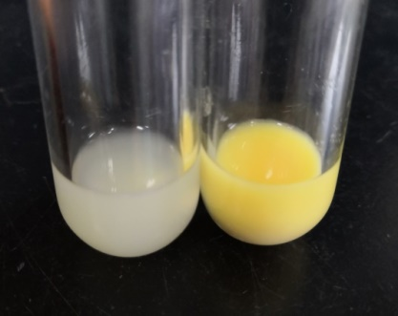
before the reaction after the reaction
(Left: TS5 entry 1; Right: TS5 entry 2) (Left: TS5 entry 1; Right: TS5 entry 2)

3. Experimental Procedures and Characterization Data

3.1 General Procedure A: Decarboxylative iodination
Redox-active esters (1.0 eq., 0.2 mmol) (if solid), LiI (1.5 eq., 0.3 mmol), PPh₃ (10 mol%) were added to a 10 mL transparent Schlenk tube equipped with a stirring bar. The tube was evacuated and filled with argon (three cycles). To these solids, redox-active esters (1.0 eq., 0.2 mmol) (if liquid), acetone (2.0 mL) were added under argon atmosphere. The reaction mixture was stirred under irradiation with blue LEDs (Kessil, PR160-456 nm), maintained at approximately room temperature (28 ± 2 ºC). After 24 h, the mixture was transferred to a round bottom flask and concentrated on rotary evaporator. The product was purified via flash column chromatography on silica gel. (Eluent: petroleum ether/ethyl acetate).

3.2 Characterization data for Decarboxylative iodination products

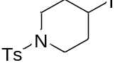
4-iodo-1-tosylpiperidine (2): Following the general procedure A, using LiI (1.5 eq., 0.3 mmol), PPh₃ (10 mol%), 2.0 mL acetone, obtained in 85% yield as white solid. The gram-scale reaction condition of this transformation: 1,3-dioxoisoindolin-2-yl 1-tosylpiperidine-4-carboxylate (3.0 mmol, 1.0 eq.), LiI (1.5 eq.), PPh₃ (10 mol%), 30 mL acetone, 81% isolated yield (Eluent: petroleum ether/ethyl acetate = 10/1 to 5/1). The compound data was in agreement with the literature (Ref. J. Am. Chem. Soc. 2018, 140, 155).
¹H NMR (400 MHz, CDCl₃) δ 7.65 (d, J = 7.9 Hz, 2H), 7.34 (d, J = 7.9 Hz, 2H), 4.33 – 4.26 (m, 1H), 3.21 – 3.14 (m, 2H), 3.02 – 2.95 (m, 2H), 2.45 (s, 3H), 2.18 – 2.07 (m, 4H).
¹³C NMR (101 MHz, CDCl₃) δ 143.8, 133.2, 129.8, 127.6, 45.7, 36.5, 25.6, 21.6.

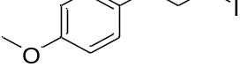
1-(3-iodopropyl)-4-methoxybenzene (4): Following the general procedure A, using LiI (1.5 eq., 0.3 mmol), PPh₃ (10 mol%), 2.0 mL acetone, obtained in 85% yield as colorless liquid (Eluent: petroleum ether/ethyl acetate = 100/1). The compound data was in agreement with the literature (Ref. J. Am. Chem. Soc. 2017, 139, 8110).
¹H NMR (400 MHz, CDCl₃) δ 7.04 (d, J = 8.6 Hz, 2H), 6.76 (d, J = 8.6 Hz, 2H), 3.71 (s, 3H), 3.08 (t, J = 6.8 Hz, 2H), 2.59 (t, J = 7.2 Hz, 2H), 2.05 – 1.98 (m, 2H).
¹³C NMR (101 MHz, CDCl₃) δ 157.0, 131.4, 128.4, 112.8, 54.2, 34.2, 34.0, 5.5.

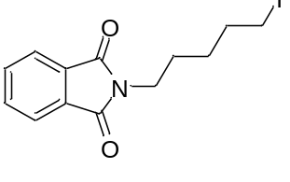
2-(5-iodopentyl)isoindoline-1,3-dione (5): Following the general procedure A, using LiI (1.5 eq., 0.3 mmol), PPh₃ (10 mol%), 2.0 mL acetone, obtained in 85% yield as white solid (Eluent: petroleum ether/ethyl acetate = 10/1).
¹H NMR (400 MHz, CDCl₃) δ 7.87 – 7.82 (m, 2H), 7.74 – 7.70 (m, 2H), 3.69 (t, J = 7.2 Hz, 2H), 3.17 (t, J = 7.0 Hz, 2H), 1.91 – 1.83 (m, 2H), 1.74 – 1.66 (m, 2H), 1.50 – 1.41 (m, 2H).
¹³C NMR (101 MHz, CDCl₃) δ 168.5, 134.0, 132.1, 123.3, 37.7, 32.9, 27.7, 27.5, 6.5.
HRMS (ESI) calcd. for C₂₃H₂₁O₂NNaI⁺ [M+Na]⁺: 366.1465, found: 366.1465.

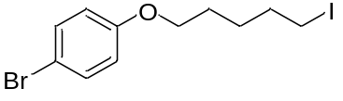
1-bromo-4-((5-iodopentyl)oxy)benzene (6): Following the general procedure A, using LiI (1.5 eq., 0.3 mmol), PPh₃ (10 mol%), 2.0 mL acetone, obtained in 76% yield as colorless liquid (Eluent: petroleum ether/ethyl acetate = 100/1).
¹H NMR (400 MHz, CDCl₃) δ 7.36 (d, J = 9.0 Hz, 2H), 6.77 (d, J = 9.0 Hz, 2H), 3.92 (t, J = 6.3 Hz, 2H), 3.22 (t, J = 7.0 Hz, 2H), 1.94 – 1.86 (m, 2H), 1.84 – 1.76 (m, 2H), 1.65 – 1.51 (m, 2H).
¹³C NMR (101 MHz, CDCl₃) δ 157.0, 131.2, 115.2, 111.7, 66.8, 32.1, 27.1, 26.1, 5.6.
HRMS (EI) calcd. for [C₁₁H₁₄OBrI]⁺: 367.9267, found: 367.9267.

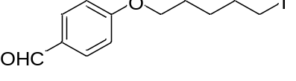
4-((5-iodopentyl)oxy)benzaldehyde (7): Following the general procedure A, using LiI (1.5 eq., 0.3 mmol), PPh₃ (10 mol%), 1.0 mL acetone and 1.0 mL THF, obtained in 76% yield as colorless liquid (Eluent: petroleum ether/ethyl acetate = 10/1).
¹H NMR (400 MHz, CDCl₃) δ 9.86 (s, 1H), 7.81 (d, J = 8.7 Hz, 2H), 6.97 (d, J = 8.7 Hz, 2H), 4.03 (t, J = 6.3 Hz, 2H), 3.21 (t, J = 6.9 Hz, 2H), 1.94 – 1.79 (m, 4H), 1.63 – 1.54 (m, 2H).
¹³C NMR (101 MHz, CDCl₃) δ 190.8, 164.1, 132.0, 129.9, 114.8, 68.0, 33.1, 28.0, 27.1, 6.6.
HRMS (EI) calcd. for [C₁₂H₁₅O₂I]⁺: 318.0111, found: 318.0111.

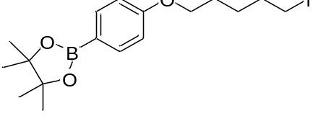
2-(4-((5-iodopentyl)oxy)phenyl)-4,4,5,5-tetramethyl-1,3,2-dioxaborolane (8): Following the general procedure A, using LiI (1.5 eq., 0.3 mmol), PPh₃ (10 mol%), 1.0 mL acetone and 1.0 mL THF, obtained in 72% yield as white solid (Eluent: petroleum ether/ethyl acetate = 20/1).
¹H NMR (400 MHz, CDCl₃) δ 7.75 (d, J = 8.7 Hz, 2H), 6.88 (d, J = 8.7 Hz, 2H), 3.99 (t, J = 6.4 Hz, 2H), 3.21 (t, J = 7.0 Hz, 2H), 1.94 – 1.86 (m, 2H), 1.85 – 1.77 (m, 2H), 1.59 (ddd, J = 8.2, 6.9, 4.0 Hz, 2H), 1.34 (s, 12H).
¹³C NMR (101 MHz, CDCl₃) δ 161.6, 136.5, 113.9, 83.6, 67.3, 33.2, 28.2, 27.2, 24.9, 6.7. (the carbon directly attached to the boron atom was not detected due to quadrupolar broadening)
HRMS (APCl) calcd. for C₁₇H₂₇BIO₃⁺ [M+H]⁺: 417.1083, found: 417.1092.

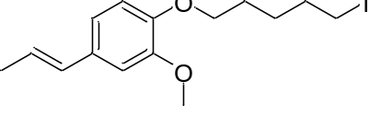
(E)-1-((5-iodopentyl)oxy)-2-methoxy-4-(prop-1-en-1-yl)benzene (9): Following the general procedure A, using LiI (1.5 eq., 0.3 mmol), PPh₃ (10 mol%), 2.0 mL acetone, obtained in 71% yield as white solid (Eluent: petroleum ether/ethyl acetate = 10/1).
¹H NMR (400 MHz, CDCl₃) δ 6.89 (d, J = 1.8 Hz, 1H), 6.85 – 6.77 (m, 2H), 6.33 (dd, J = 15.7, 1.5 Hz, 1H), 6.10 (dq, J = 15.7, 6.6 Hz, 1H), 4.00 (t, J = 6.6 Hz, 2H), 3.87 (s, 3H), 3.21 (t, J = 7.0 Hz, 2H), 1.95 – 1.81 (m, 7H), 1.62 – 1.54 (m, 2H).
¹³C NMR (101 MHz, CDCl₃) δ 149.4, 147.5, 131.3, 130.6, 123.8, 118.7, 113.1, 109.0, 68.7, 55.9, 33.3, 28.2, 27.1, 18.4, 6.8.
HRMS (EI) calcd. for [C₁₅H₂₁IO₂]⁺: 360.0581, found: 360.0581.

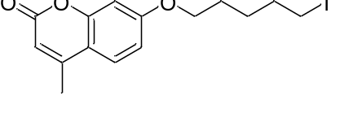
7-((5-iodopentyl)oxy)-4-methyl-2H-chromen-2-one (10): Following the general procedure A, using LiI (1.5 eq., 0.3 mmol), PPh₃ (10 mol%), 2.0 mL acetone, obtained in 77% yield as white solid (Eluent: petroleum ether/ethyl acetate = 10/1).
¹H NMR (400 MHz, CDCl₃) δ 7.48 (d, J = 8.8 Hz, 1H), 6.84 (dd, J = 8.8, 2.5 Hz, 1H), 6.78 (d, J = 2.4 Hz, 1H), 6.12 (s, 1H), 4.02 (t, J = 6.3 Hz, 2H), 3.22 (t, J = 6.9 Hz, 2H), 2.39 (d, J = 0.8 Hz, 3H), 1.95 – 1.80 (m, 4H), 1.64 – 1.56 (m, 2H).
¹³C NMR (101 MHz, CDCl₃) δ 162.0, 161.4, 155.3, 152.6, 125.5, 113.6, 112.6, 111.9, 101.4, 68.2, 33.1, 28.0, 27.1, 18.7, 6.5.
HRMS (EI) calcd. for [C₁₅H₁₇IO₃]⁺: 372.0217, found: 372.0217.

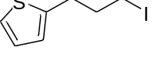
2-(3-iodopropyl)thiophene (11): Following the general procedure A, using LiI (1.5 eq., 0.3 mmol), PPh₃ (10 mol%), 2.0 mL acetone, obtained in 48% yield as light yellow liquid (Eluent: petroleum ether/ethyl acetate = 100/1).
¹H NMR (400 MHz, CDCl₃) δ 7.14 (dd, J = 5.1, 1.0 Hz, 1H), 6.93 (dd, J = 5.1, 3.4 Hz, 1H), 6.85 (dd, J = 3.3, 0.7 Hz, 1H), 3.21 (t, J = 6.7 Hz, 2H), 2.97 (t, J = 7.1 Hz, 2H), 2.16 (p, J = 6.9 Hz, 2H).
¹³C NMR (101 MHz, CDCl₃) δ 142.9, 126.9, 124.9, 123.5, 35.0, 30.4, 5.9.
HRMS (EI) calcd. for [C₇H₉IS]⁺: 251.9464, found: 251.9465.

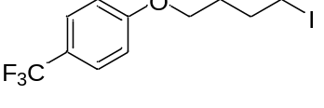
1-(4-iodobutoxy)-4-(trifluoromethyl)benzene (12): Following the general procedure A, using LiI (1.5 eq., 0.3 mmol), PPh₃ (10 mol%), 2.0 mL acetone, obtained in 70% yield as colorless liquid (Eluent: petroleum ether/ethyl acetate = 100/1).
¹H NMR (400 MHz, CDCl₃) δ 7.53 (d, J = 8.6 Hz, 2H), 6.94 (d, J = 8.6 Hz, 2H), 4.02 (t, J = 5.9 Hz, 2H), 3.26 (t, J = 6.7 Hz, 2H), 2.07 – 1.99 (m, 2H), 1.96 – 1.88 (m, 2H).
¹³C NMR (101 MHz, CDCl₃) δ 161.3, 126.9 (q, J_{C-F} = 3.7 Hz), 124.4 (q, J_{C-F} = 271.0 Hz), 122.9 (q, J_{C-F} = 32.5 Hz), 114.4, 66.9, 30.0, 30.0, 6.21.
¹⁹F NMR (376 MHz, CDCl₃) δ -61.41.
HRMS (EI) calcd. for [C₁₁H₁₂F₃IO]⁺: 343.9879, found: 343.9879.

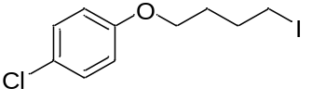
1-chloro-4-(4-iodobutoxy)benzene (13): Following the general procedure A, using LiI (1.5 eq., 0.3 mmol), PPh₃ (10 mol%), 2.0 mL acetone, obtained in 62% yield as colorless liquid (Eluent: petroleum ether/ethyl acetate = 100/1).
¹H NMR (400 MHz, CDCl₃) δ 7.15 (d, J = 9.0 Hz, 2H), 6.73 (d, J = 9.0 Hz, 2H), 3.87 (t, J = 6.0 Hz, 2H), 3.18 (t, J = 6.8 Hz, 2H), 1.98 – 1.90 (m, 2H), 1.85 – 1.78 (m, 2H).
¹³C NMR (101 MHz, CDCl₃) δ 157.5, 129.3, 125.6, 115.7, 67.0, 30.1, 30.1, 6.4.
HRMS (EI) calcd. for [C₁₀H₁₂ClIO]⁺: 309.9616, found: 309.9616.

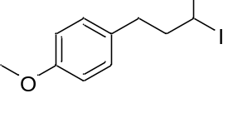
1-(3-iodobutyl)-4-methoxybenzene (14): Following the general procedure A, using LiI (1.5 eq., 0.3 mmol), PPh₃ (10 mol%), 2.0 mL acetone, obtained in 91% yield as colorless liquid (Eluent: petroleum ether/ethyl acetate = 100/1). The compound data was in agreement with the literature (Ref. Angew. Chem. Int. Ed. 2019, 58, 6713).
¹H NMR (400 MHz, CDCl₃) δ 7.04 (d, J = 8.6 Hz, 2H), 6.75 (d, J = 8.7 Hz, 2H), 4.07 – 3.97 (m, 1H), 3.71 (s, 3H), 2.75 – 2.66 (m, 1H), 2.60 – 2.51 (m, 1H), 2.09 – 1.99 (m, 1H), 1.86 (d, J = 6.8 Hz, 3H), 1.80 – 1.71 (m, 1H).
¹³C NMR (101 MHz, CDCl₃) δ 158.0, 132.8, 129.5, 113.9, 55.29, 44.6, 34.9, 29.8, 29.0.

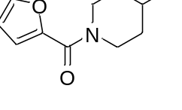
furan-2-yl(4-iodopiperidin-1-yl)methanone (15): Following the general procedure A, using LiI (1.5 eq., 0.3 mmol), PPh₃ (10 mol%), 2.0 mL acetone, obtained in 83% yield as yellow liquid (Eluent: petroleum ether/ethyl acetate = 5/1).
¹H NMR (400 MHz, CDCl₃) δ 7.48 (dd, J = 1.8, 0.8 Hz, 1H), 6.99 (d, J = 3.5 Hz, 1H), 6.48 (dd, J = 3.5, 1.8 Hz, 1H), 4.55 (p, J = 5.8 Hz, 1H), 4.00 – 3.90 (m, 2H), 3.71 – 3.61 (m, 2H), 2.13 (q, J = 5.7 Hz, 4H).
¹³C NMR (101 MHz, CDCl₃) δ 159.3, 147.8, 143.7, 116.5, 111.3, 37.7, 26.9.
HRMS (EI) calcd. for [C₁₀H₁₂INO₂]⁺: 304.9903, found: 304.9907.

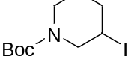
tert-butyl 3-iodopiperidine-1-carboxylate (16): Following the general procedure A, using LiI (1.5 eq., 0.3 mmol), PPh₃ (10 mol%), 2.0 mL acetone, obtained in 70% yield as yellow liquid (Eluent: petroleum ether/ethyl acetate = 10/1).
¹H NMR (400 MHz, CDCl₃) δ 4.33 – 3.65 (m, 3H), 3.52 – 3.01 (m, 2H), 2.27 (br, 1H), 2.09 – 1.94 (m, 1H), 1.71 (br, 1H), 1.63 – 1.54 (m, 1H), 1.46 (s, 9H).
¹³C NMR (101 MHz, CDCl₃) δ 154.1, 80.0, 53.7, 53.1, 44.1, 43.2, 37.4, 28.4, 27.5, 26.7, 26.1, 25.3.
HRMS (EI) calcd. for [C₁₀H₁₂INO₂]⁺: 304.9903, found: 304.9907.

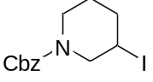
benzyl 3-iodopiperidine-1-carboxylate (17): Following the general procedure A, using LiI (1.5 eq., 0.3 mmol), PPh₃ (10 mol%), 2.0 mL acetone, obtained in 70% yield as yellow liquid (Eluent: petroleum ether/ethyl acetate = 10/1).
¹H NMR (400 MHz, CDCl₃) δ 7.38 – 7.30 (m, 5H), 5.20 – 5.08 (m, 2H), 4.31 – 4.07 (m, 2H), 3.87 (br, 1H), 3.54 – 3.31 (m, 1H), 3.16 (br, 1H), 2.27 (br, 1H), 2.07 – 1.97 (m, 1H), 1.73 (br, 1H), 1.59 (br, 1H).
¹³C NMR (101 MHz, CDCl₃) δ 154.8, 136.6, 128.5, 128.1, 128.0, 67.3, 53.5, 44.0, 37.3, 27.4, 26.7, 25.3, 24.6.
HRMS (ESI) calcd. for C₁₃H₁₇INO₂⁺ [M+H]⁺: 346.0292, found: 346.0299.

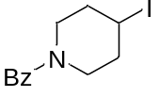
(4-iodopiperidin-1-yl)(phenyl)methanone (18): Following the general procedure A, using LiI (1.5 eq., 0.3 mmol), PPh₃ (10 mol%), 2.0 mL acetone, obtained in 84% yield as white solid (Eluent: petroleum ether/ethyl acetate = 5/1). The compound data was in agreement with the literature (Ref. Chem. Commun. 2016, 52, 5324).
¹H NMR (400 MHz, CDCl₃) δ 7.44 – 7.36 (m, 5H), 4.52 (p, J = 5.8 Hz, 1H), 4.03 – 3.29 (m, 4H), 2.08 (br, 4H).
¹³C NMR (101 MHz, CDCl₃) δ 170.5, 135.6, 129.8, 128.6, 126.9, 47.7, 42.2, 37.9, 37.1, 26.7.

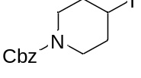
benzyl 4-iodopiperidine-1-carboxylate (19): Following the general procedure A, using LiI (1.5 eq., 0.3 mmol), PPh₃ (10 mol%), 2.0 mL acetone, obtained in 70% yield as colorless liquid (Eluent: petroleum ether/ethyl acetate = 10/1). The compound data was in agreement with the literature (Ref. Org. Lett. 2018, 20 ,4677).
¹H NMR (400 MHz, CDCl₃) δ 7.40 – 7.29 (m, 5H), 5.13 (s, 2H), 4.50 – 4.41 (m, 1H), 3.65 (dt, J = 13.3, 5.2 Hz, 2H), 3.39 (dt, J = 13.7, 5.8 Hz, 2H), 2.03 (br, 4H).
¹³C NMR (101 MHz, CDCl₃) δ 155.2, 136.6, 128.5, 128.1, 127.9, 67.3, 43.9, 37.2, 27.2.

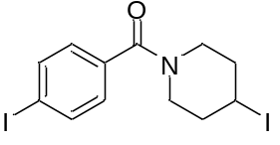
(4-iodophenyl)(4-iodopiperidin-1-yl)methanone (20): Following the general procedure A, using LiI (1.5 eq., 0.3 mmol), PPh₃ (10 mol%), 2.0 mL acetone, obtained in 92% yield as light yellow solid (Eluent: petroleum ether/ethyl acetate = 5/1).
¹H NMR (400 MHz, CDCl₃) δ 7.75 (d, J = 8.2 Hz, 2H), 7.13 (d, J = 8.2 Hz, 2H), 4.55 – 4.47 (m, 1H), 3.96 – 3.27 (m, 4H), 2.28 – 1.91 (m, 4H).
¹³C NMR (101 MHz, CDCl₃) δ 169.6, 137.7, 134.9, 128.6, 96.0, 47.6, 42.1, 37.8, 37.0, 26.3.
HRMS (ESI) calcd. for C₁₂H₁₄I₂NO⁺ [M+H]⁺: 441.9150, found: 441.9159.

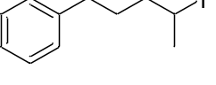
(4-iodopentyl)benzene (21): Following the general procedure A, using LiI (1.5 eq., 0.3 mmol), PPh₃ (10 mol%), 2.0 mL acetone, obtained in 60% yield as colorless liquid (Eluent: petroleum ether). The compound data was in agreement with the literature (Ref. Tetrahedron Lett. 2015, 56, 1713).
¹H NMR (400 MHz, CDCl₃) δ 7.31 – 7.26 (m, 2H), 7.21 – 7.16 (m, 3H), 4.23 – 4.14 (m, 1H), 2.71 – 2.56 (m, 2H), 1.90 (d, J = 6.8 Hz, 3H), 1.89 – 1.78 (m, 2H), 1.76 – 1.60 (m, 2H).
¹³C NMR (101 MHz, CDCl₃) δ 141.9, 128.4, 128.4, 125.9, 42.3, 35.0, 31.5, 30.2, 29.0.

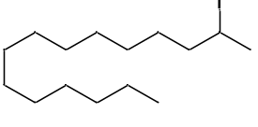
2-iodopentadecane (22): Following the general procedure A, using LiI (1.5 eq., 0.3 mmol), PPh₃ (10 mol%), 2.0 mL acetone, obtained in 88% yield as colorless liquid (Eluent: petroleum ether).
¹H NMR (400 MHz, CDCl₃) δ 4.24 – 4.14 (m, 1H), 1.92 (d, J = 6.8 Hz, 3H), 1.89 – 1.79 (m, 1H), 1.65 – 1.56 (m, 1H), 1.50 – 1.22 (m, 22H), 0.88 (t, J = 6.9 Hz, 3H).
¹³C NMR (101 MHz, CDCl₃) δ 43.0, 32.0, 30.8, 29.8, 29.7, 29.7, 29.7, 29.7, 29.6, 29.5, 29.4, 29.0, 28.8, 22.7, 14.2.
HRMS (EI) calcd. for [C₁₅H₃₁I]⁺: 338.1465, found: 338.1465.

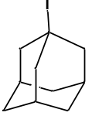
1-iodoadamantane (23): Following the general procedure A, using LiI (1.5 eq., 0.3 mmol), PPh₃ (10 mol%), 2.0 mL acetone, obtained in 90% NMR yield (colorless liquid, eluent: petroleum ether). The compound data was in agreement with the literature (Ref. J. Org. Chem. 1992, 57, 2850).
¹H NMR (400 MHz, CDCl₃) δ 2.64 (d, J = 3.0 Hz, 6H), 1.96 (s, 3H), 1.87 – 1.76 (m, 6H).
¹³C NMR (101 MHz, CDCl₃) δ 52.5, 51.3, 35.6, 33.1.

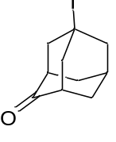
5-iodoadamantan-2-one (24): Following the general procedure A, using LiI (1.5 eq., 0.3 mmol), PPh₃ (10 mol%), 2.0 mL acetone, obtained in 89% yield as white solid (Eluent: petroleum ether/ethyl acetate = 50/1). The compound data was in agreement with the literature (Ref. J. Am. Chem. Soc. 2001, 123, 4717).
¹H NMR (400 MHz, CDCl₃) δ 2.87 – 2.72 (m, 6H), 2.48 (s, 2H), 2.19 – 2.05 (m, 5H).
¹³C NMR (101 MHz, CDCl₃) δ 214.4, 52.5, 50.7, 50.1, 41.3, 37.4, 31.7.

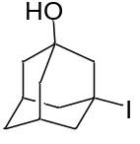
3-iodoadamantan-1-ol (25): Following the general procedure A, using LiI (1.5 eq., 0.3 mmol), PPh₃ (10 mol%), 2.0 mL acetone, obtained in 77% yield as white solid (Eluent: petroleum ether/ethyl acetate = 3/1). The compound data was in agreement with the literature (Ref. J. Org. Chem. 1987, 52, 356).
¹H NMR (400 MHz, CDCl₃) δ 2.56 (s, 2H), 2.51 – 2.40 (m, 4H), 2.16 – 2.09 (m, 2H), 1.85 – 1.74 (m, 4H), 1.66 (br, 3H).
¹³C NMR (101 MHz, CDCl₃) δ 69.8, 59.7, 50.6, 45.3, 43.4, 34.1, 33.7.

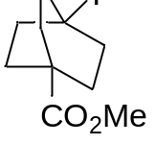
methyl 4-iodobicyclo[2.2.2]octane-1-carboxylate (26): Following the general procedure A, using LiI (1.5 eq., 0.3 mmol), PPh₃ (10 mol%), 2.0 mL acetone, obtained in 74% yield as white solid (Eluent: petroleum ether/ethyl acetate = 30/1). The compound data was in agreement with the literature (Ref. J. Org. Chem. 1992, 57, 2850).
¹H NMR (400 MHz, CDCl₃) δ 3.63 (s, 3H), 2.53 – 2.42 (m, 6H), 1.98 – 1.87 (m, 6H).
¹³C NMR (101 MHz, CDCl₃) δ 177.4, 51.9, 43.1, 39.8, 35.6, 31.8.

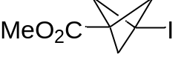
methyl 3-iodobicyclo[1.1.1]pentane-1-carboxylate (27): Following the general procedure A, using LiI (1.5 eq., 0.3 mmol), PPh₃ (10 mol%), 2.0 mL acetone, obtained in 34% yield as white solid (Eluent: petroleum ether/ethyl acetate = 30/1). The compound data was in agreement with the literature (Ref. J. Org. Chem. 1992, 57, 2850).
¹H NMR (400 MHz, CDCl₃) δ 3.68 (s, 3H), 2.56 (s, 6H).
¹³C NMR (101 MHz, CDCl₃) δ 167.1, 60.6, 52.2, 46.0, 5.8.

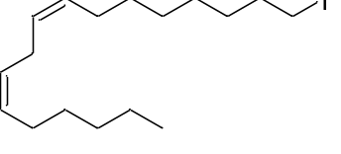
(6Z, 9Z)-17-iodoheptadeca-6,9-diene (28): Following the general procedure A, using LiI (1.5 eq., 0.3 mmol), PPh₃ (10 mol%), 2.0 mL acetone, obtained in 84% yield as colorless liquid (Eluent: petroleum ether/ethyl acetate = 100/1). The compound data was in agreement with the literature (Ref. J. Chem. Ecol. 1998, 24, 867).
¹H NMR (400 MHz, CDCl₃) δ 5.43 – 5.29 (m, 4H), 3.19 (t, J = 7.0 Hz, 2H), 2.77 (t, J = 6.4 Hz, 2H), 2.05 (q, J = 6.8 Hz, 4H), 1.86 – 1.78 (m, 2H), 1.43 – 1.22 (m, 14H), 0.89 (t, J = 6.9 Hz, 3H).
¹³C NMR (101 MHz, CDCl₃) δ 130.3, 123.0, 128.1, 127.9, 33.6, 31.6, 30.5, 29.6, 29.4, 29.1, 28.5, 27.2, 27.2, 25.7, 22.6, 14.1, 7.3.

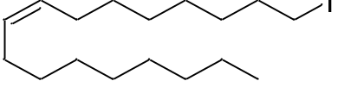
(Z)-1-iodoheptadec-8-ene (29): Following the general procedure A, using LiI (1.5 eq., 0.3 mmol), PPh₃ (10 mol%), 2.0 mL acetone, obtained in 90% yield as colorless liquid (Eluent: petroleum ether/ethyl acetate = 100/1).
¹H NMR (400 MHz, CDCl₃) δ 5.33 – 5.23 (m, 2H), 3.12 (t, J = 7.0 Hz, 2H), 2.00 – 1.91 (m, 4H), 1.79 – 1.71 (m, 2H), 1.36 – 1.18 (m, 20H), 0.81 (t, J = 6.8 Hz, 3H).
¹³C NMR (101 MHz, CDCl₃) δ 130.1, 129.7, 33.6, 31.9, 30.5, 29.8, 29.7, 29.6, 29.4, 29.1, 28.5, 27.3, 27.2, 22.7, 14.2, 7.3. (one carbon signal was overlapped)
HRMS (EI) calcd. for C₁₇H₃₃I⁺ [M+H]⁺: 364.1627, found: 364.1625.

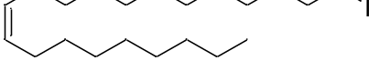
(Z)-21-iodohenicos-9-ene (30): Following the general procedure A, using LiI (1.5 eq., 0.3 mmol), PPh₃ (10 mol%), 2.0 mL acetone, obtained in 75% yield as colorless liquid (Eluent: petroleum ether/ethyl acetate = 100/1).
¹H NMR (400 MHz, CDCl₃) δ 5.39 – 5.31 (m, 2H), 3.18 (t, J = 7.1 Hz, 2H), 2.07 – 1.97 (m, 4H), 1.86 – 1.78 (m, 2H), 1.41 – 1.23 (m, 28H), 0.88 (t, J = 6.8 Hz, 3H).
¹³C NMR (101 MHz, CDCl₃) δ 129.9, 129.9, 33.6, 31.9, 30.6, 29.8, 29.8, 29.6, 29.6, 29.5, 29.4, 29.3, 28.6, 27.2, 27.2, 22.7, 14.2, 7.3. (three carbons signal were overlapped)
HRMS (EI) calcd. for C₂₁H₄₁I⁺ [M+H]⁺: 420.2253, found: 420.2253.

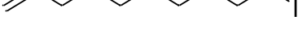
10-iododec-1-ene (31): Following the general procedure A, using LiI (1.5 eq., 0.3 mmol), PPh₃ (10 mol%), 2.0 mL acetone, obtained in 76% yield as colorless liquid (Eluent: petroleum ether/ethyl acetate = 100/1). The compound data was in agreement with the literature (Ref. Bioorg. Med. Chem. 2013, 21, 2346).
¹H NMR (400 MHz, CDCl₃) δ 5.87 – 5.75 (m, 1H), 5.02 – 4.91 (m, 2H), 3.19 (t, J = 7.1 Hz, 2H), 2.07 – 2.01 (m, 2H), 1.86 – 1.78 (m, 2H), 1.41 – 1.27 (m, 10H).
¹³C NMR (101 MHz, CDCl₃) δ 139.1, 114.2, 33.8, 33.5, 30.5, 29.3, 29.0, 28.9, 28.5, 7.4.

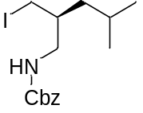
(S)-benzyl (2-(iodomethyl)-4-methylpentyl)carbamate (32): Following the general procedure A, using LiI (1.5 eq., 0.3 mmol), PPh₃ (10 mol%), 2.0 mL acetone, obtained in 62% yield as colorless liquid (Eluent: petroleum ether/ethyl acetate = 10/1).
¹H NMR (500 MHz, CDCl₃) δ 7.38 – 7.30 (m, 5H), 5.17 – 5.05 (m, 2H), 4.89 (br, J = 68.0 Hz, 1H), 3.33 – 3.18 (m, 3H), 3.00 – 2.92 (m, 1H), 1.70 – 1.47 (m, 2H), 1.20 – 1.07 (m, 2H), 0.96 – 0.83 (m, 6H).
¹³C NMR (126 MHz, CDCl₃) δ 156.5, 136.4, 128.6, 128.2, 128.2, 66.9, 45.3, 41.3, 36.2, 24.9, 23.1, 22.2, 13.6.
HRMS (EI) calcd. for [C₁₅H₂₂INO₂]⁺: 375.0690, found: 375.0690.

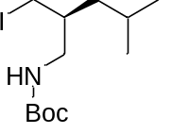
(S)-tert-butyl (2-(iodomethyl)-4-methylpentyl)carbamate (33): Following the general procedure A, using LiI (1.5 eq., 0.3 mmol), PPh₃ (10 mol%), 2.0 mL acetone, obtained in 75% yield as colorless liquid (Eluent: petroleum ether/ethyl acetate = 10/1).
¹H NMR (400 MHz, CDCl₃) δ 4.67 (br, 1H), 3.36 – 3.16 (m, 3H), 2.87 (dt, J = 14.1, 7.0 Hz, 1H), 1.64 (tt, J = 12.8, 6.4 Hz, 2H), 1.44 (s, 9H), 1.19 – 1.06 (m, 2H), 0.92 (d, J = 6.6 Hz, 3H), 0.88 (d, J = 6.6 Hz, 3H).
¹³C NMR (101 MHz, CDCl₃) δ 156.0, 79.4, 44.8, 41.3, 36.2, 28.4, 24.9, 23.1, 22.3, 14.1.
HRMS (ESI) calcd. for C₁₂H₂₄INO₂Na⁺ [M+Na]⁺: 364.0744, found: 364.0744.

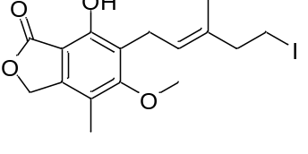
(E)-7-hydroxy-6-(5-iodo-3-methylpent-2-en-1-yl)-5-methoxy-4-methylisobenzofuran-1(3H)-one (34): Following the general procedure A, using LiI (1.5 eq., 0.3 mmol), PPh₃ (10 mol%), 2.0 mL acetone, obtained in 55% yield as white solid (Eluent: petroleum ether/ethyl acetate = 5/1).
¹H NMR (400 MHz, CDCl₃) δ 7.68 (s, 1H), 5.29 (ddd, J = 8.2, 5.8, 1.2 Hz, 1H), 5.20 (s, 2H), 3.78 (s, 3H), 3.39 (d, J = 6.9 Hz, 2H), 3.20 (t, J = 7.7 Hz, 2H), 2.53 (t, J = 7.5 Hz, 2H), 2.15 (s, 3H), 1.80 (s, 3H).
¹³C NMR (101 MHz, CDCl₃) δ 172.9, 163.7, 153.7, 144.1, 134.4, 124.8, 121.8, 116.8, 106.4, 70.1, 61.2, 43.8, 22.7, 15.6, 11.6, 4.6.
HRMS (ESI) calcd. for C₁₆H₁₉IO₄Na⁺ [M+Na]⁺: 425.0220, found: 425.0220.

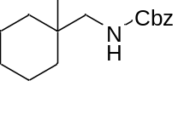
benzyl ((1-(iodomethyl)cyclohexyl)methyl)carbamate (35): Following the general procedure A, using LiI (1.5 eq., 0.3 mmol), PPh₃ (10 mol%), 2.0 mL acetone, obtained in 52% yield as white solid (Eluent: petroleum ether/ethyl acetate = 10/1).
¹H NMR (400 MHz, CDCl₃) δ 7.39 – 7.30 (m, 5H), 5.10 (s, 2H), 4.84 (s, 1H), 3.25 – 3.15 (m, 4H), 1.57 – 1.33 (m, 10H).
¹³C NMR (101 MHz, CDCl₃) δ 156.8, 136.4, 128.6, 128.2, 66.9, 47.8, 36.9, 32.9, 25.9, 21.6, 19.4. (one carbon signal was overlapped)
HRMS (EI) calcd. for [C₁₆H₂₂INO₂]⁺: 387.0690, found: 387.0690.

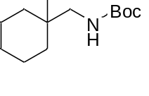
tert-butyl ((1-(iodomethyl)cyclohexyl)methyl)carbamate (36): Following the general procedure A, using LiI (1.5 eq., 0.3 mmol), PPh₃ (10 mol%), 2.0 mL acetone, obtained in 70% yield as white solid (Eluent: petroleum ether/ethyl acetate = 10/1).
¹H NMR (400 MHz, CDCl₃) δ 4.59 (br, 1H), 3.21 (s, 2H), 3.14 (d, J = 6.6 Hz, 2H), 1.57 – 1.33 (m, 19H).
¹³C NMR (101 MHz, CDCl₃) δ 156.2, 79.3, 47.2, 36.9, 32.9, 28.4, 25.9, 21.7, 19.8.
HRMS (ESI) calcd. for C₁₃H₂₄INO₂Na⁺ [M+Na]⁺: 376.0744, found: 376.0744.

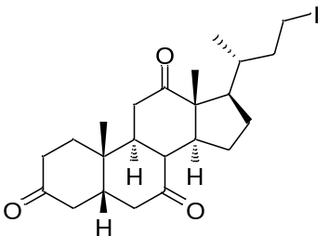
(5S,9S,10S,13R,14S,17R)-17-((R)-4-iodobutan-2-yl)-10,13-dimethyldecahydro-1H-cyclopenta[a]phenanthrene-3,7,12(2H,4H,8H)-trione (37): Following the general procedure A, using LiI (1.5 eq., 0.3 mmol), PPh₃ (10 mol%), 1.0 mL acetone and 1.0 mL THF, obtained in 90% yield (white solid, eluent: petroleum ether/ethyl acetate = 5/1).
¹H NMR (400 MHz, CDCl₃) δ 3.40 – 3.32 (m, 1H), 3.17 – 3.09 (m, 1H), 2.96 – 2.82 (m, 3H), 2.39 – 1.94 (m, 12H), 1.89 – 1.82 (m, 1H), 1.69 – 1.56 (m, 3H), 1.41 (s, 3H), 1.37 – 1.24 (m, 3H), 1.10 (s, 3H), 0.84 (d, J = 6.6 Hz, 3H).
¹³C NMR (101 MHz, CDCl₃) δ 211.9, 209.0, 208.7, 57.0, 51.8, 49.0, 46.9, 45.6, 45.4, 45.0, 42.8, 39.5, 38.6, 37.1, 36.5, 36.0, 35.3, 27.7, 25.1, 21.9, 18.1, 11.9, 5.6.
HRMS (ESI) calcd. for C₂₃H₃₃IO₃Na⁺ [M+Na]⁺: 507.1367, found: 507.1372.

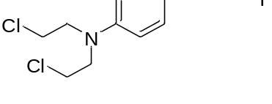
N,N-bis(2-chloroethyl)-4-(3-iodopropyl)aniline (38): Following the general procedure A, using LiI (1.5 eq., 0.3 mmol), PPh₃ (20 mol%), 1.0 mL acetone and 1.0 mL THF, obtained in 50% yield as yellow vicious liquid (Eluent: petroleum ether/ethyl acetate = 50/1).
¹H NMR (400 MHz, CDCl₃) δ 7.02 (d, J = 8.7 Hz, 2H), 6.58 (d, J = 8.7 Hz, 2H), 3.66 – 3.61 (m, 4H), 3.58 – 3.53 (m, 4H), 3.10 (t, J = 6.8 Hz, 2H), 2.57 (t, J = 7.2 Hz, 2H), 2.05 – 1.97 (m, 2H).
¹³C NMR (101 MHz, CDCl₃) δ 144.3, 129.8, 112.4, 53.7, 40.4, 35.1, 35.1, 6.6. (one carbon signal was overlapped)
HRMS (EI) calcd. for [C₁₃H₁₈Cl₂IN]⁺: 384.9855, found: 384.9856.

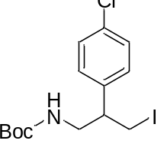
tert-butyl (2-(4-chlorophenyl)-3-iodopropyl)carbamate (39): Following the general procedure A, using LiI (1.5 eq., 0.3 mmol), PPh₃ (20 mol%), 2.0 mL acetone, obtained in 59% yield as yellow liquid (Eluent: petroleum ether/ethyl acetate = 10/1).
¹H NMR (400 MHz, CDCl₃) δ 7.32 (d, J = 8.5 Hz, 2H), 7.11 (d, J = 8.3 Hz, 2H), 4.50 (br, 1H), 3.62 – 3.54 (m, 1H), 3.44 – 3.38 (m, 1H), 3.33 – 3.24 (m, 2H), 3.14 – 3.05 (m, 1H), 1.40 (s, 9H).
¹³C NMR (101 MHz, CDCl₃) δ 155.8, 139.1, 133.3, 129.0, 128.9, 79.7, 47.6, 45.5, 28.4, 8.5.
HRMS (ESI) calcd. for C₁₄H₁₉ClINO₂Na⁺ [M+Na]⁺: 418.0041, found: 418.0041.

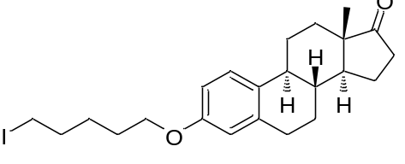
(8R,9S,13S,14S)-3-((5-iodopentyl)oxy)-13-methyl-7,8,9,11,12,13,15,16-octahydro-6H-cyclopenta[a]phenanthren-17(14H)-one (40): Following the general procedure A, using LiI (1.5 eq., 0.3 mmol), PPh₃ (10 mol%), 2.0 mL acetone, obtained in 86% yield as white solid (Eluent: petroleum ether/ethyl acetate = 10/1).
¹H NMR (400 MHz, CDCl₃) δ 7.19 (d, J = 8.6 Hz, 1H), 6.70 (dd, J = 8.6, 2.6 Hz, 1H), 6.64 (s, 1H), 3.94 (t, J = 6.3 Hz, 2H), 3.21 (t, J = 7.0 Hz, 2H), 2.93 – 2.86 (m, 2H), 2.56 – 2.46 (m, 1H), 2.44 – 2.36 (m, 1H), 2.29 – 2.21 (m, 1H), 2.20 – 1.87 (m, 6H), 1.84 – 1.74 (m, 2H), 1.65 – 1.40 (m, 8H), 0.90 (s, 3H).
¹³C NMR (101 MHz, CDCl₃) δ 221.0, 157.0, 137.8, 132.0, 126.4, 114.6, 112.1, 67.5, 50.4, 48.0, 44.0, 38.4, 35.9, 33.2, 31.6, 29.7, 28.3, 27.2, 26.6, 26.0, 21.6, 13.9, 6.8.
HRMS (ESI) calcd. for C₂₃H₃₁IO₂Na⁺ [M+Na]⁺: 489.1261, found: 489.1261.

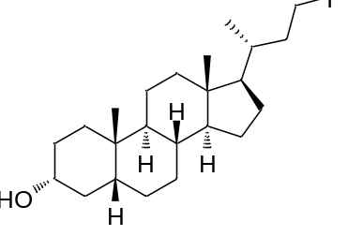
(3R,5R,8R,9S,10S,13R,14S,17R)-17-((R)-4-iodobutan-2-yl)-10,13-dimethylhexadecahydro-1H-cyclopenta[a]phenanthren-3-ol (41): Following the general procedure A, using LiI (1.5 eq., 0.3 mmol), PPh₃ (10 mol%), 1.0 mL acetone and 1.0 mL THF, obtained in 50% yield as white solid (Eluent: petroleum ether/ethyl acetate = 10/1).
¹H NMR (400 MHz, CDCl₃) δ 3.68 – 3.58 (m, 1H), 3.31 (td, J = 9.3, 4.0 Hz, 1H), 3.10 (dd, J = 17.6, 8.3 Hz, 1H), 2.07 – 1.93 (m, 2H), 1.88 – 1.63 (m, 6H), 1.62 – 1.47 (m, 4H), 1.45 – 1.02 (m, 15H), 0.91 (d, J = 5.2 Hz, 6H), 0.66 (s, 3H).
¹³C NMR (101 MHz, CDCl₃) δ 71.9, 56.5, 55.9, 42.8, 42.1, 40.4, 40.3, 40.2, 37.2, 36.4, 35.8, 35.4, 34.6, 30.5, 28.2, 27.2, 26.4, 24.2, 23.4, 20.8, 17.9, 12.1, 5.3.
HRMS (EI) calcd. for C₂₃H₃₉IO⁺ [M+H]⁺: 458.2046, found: 458.2047.

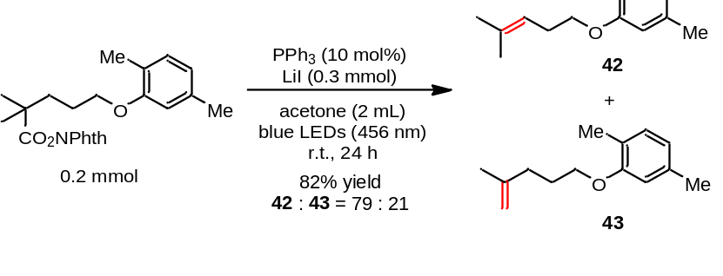
Following the general procedure A, the decarboxylative elimination product was obtained in 82% yield as colorless liquid (Eluent: petroleum ether/ethyl acetate = 100/1, the ratio of terminal olefin and internal olefin was 21/79). The compound data was in agreement with the literature (Ref. Nat Commun, 2018, 9, 5215).
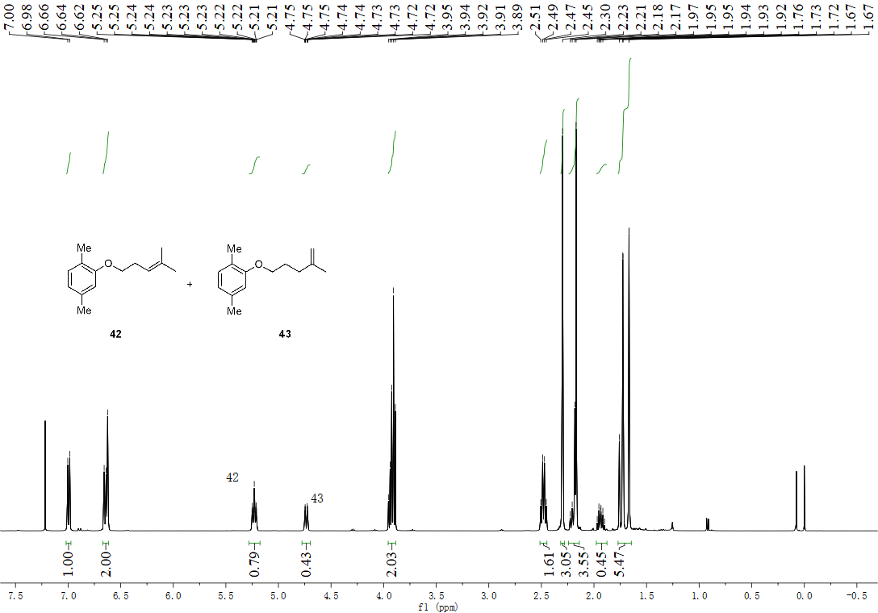

4. Experimental Studies on Mechanism
4.1 UV-Vis measurement

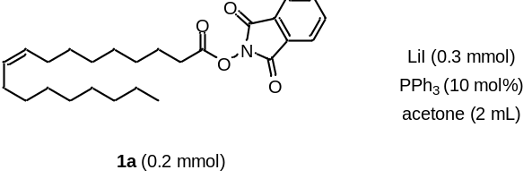
Stock solutions of 1a, PPh₃ and LiI were prepared with the same concentration used in the reaction. The solutions were prepared in the presence of air using acetone as solvent.
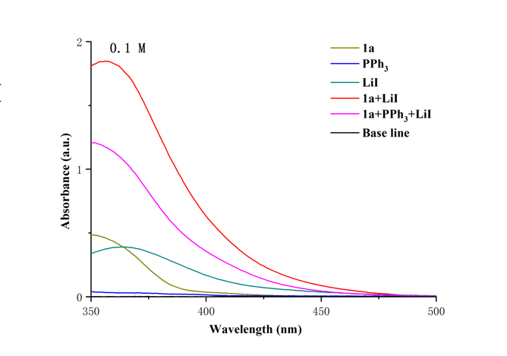
Figure S1: UV/vis absorption spectra of the combination between different starting materials recorded in acetone as solvent
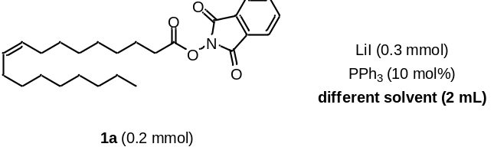
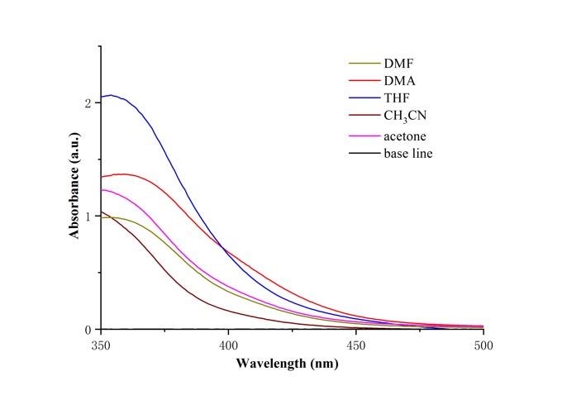
Figure S2: UV/vis absorption spectra of the combination of 1a, PPh₃ and LiI in different solvent
4.2 Determination of the Quantum Yield
The quantum yield of this reaction was determined by chemical actinometry. Following a similar procedure reported by Melchiorre³, an aqueous solution of potassium ferrioxalate was prepared and stored in the dark. This actinometer solution measures the photodecomposition of ferric oxalate anions to ferrous oxalate anions, which are then reacted with 1,10-phenanthroline to form [Fe(phen)₃]²⁺. The concentration of this complex is then estimated by UV/Vis absorbance at 510 nm. The number of moles of [Fe(phen)₃]²⁺ complex formed is related to the numbers of photons absorbed by the actinometer solution.

Determination of the light intensity at 390 nm:
The actinometry measurements were done as follows: A 0.15 M solution of ferrioxalate was prepared by dissolving potassium ferrioxalate hydrate (0.737 g) in H₂SO₄ (10 mL of a 0.05 M solution). A buffered solution of 1,10-phenanthroline was prepared by dissolving 1,10-phenanthroline (25 mg) and sodium acetate (5.63 g) in H₂SO₄ (25 mL of a 0.5 M solution). Both solutions were stored in the dark. To determine the photon flux of the LED, the ferrioxalate solution (1.0 mL) was placed in a cuvette and irradiated for 15 minutes at λmax = 390 nm. After irradiation, the phenanthroline solution (0.175 mL) was added to the cuvette and the mixture was allowed to stir in the dark for 1.0 h to allow the ferrous ions to completely coordinate to the phenanthroline. The absorption of the solution was measured at 510 nm. A non-irradiated sample was also prepared and the absorption at 510 nm was measured. Each sample preparation and measurement was repeated two more times. Using then the Beer’s Law, the number of moles of Fe²⁺ produced by light irradiation is obtained by:
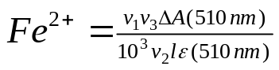
where ʋ₁ is the irradiated volume (1 mL), ʋ ₂ is the aliquot of the irradiated solution taken for the determination of the ferrous ions (1 mL), ʋ ₃ is the final volume after complexation with phenanthroline (10 mL), l is the optical path-length of the irradiation cell (1 cm), ΔA(510 nm) the optical difference in absorbance between the irradiated solution and theone stored in the dark, ε(510 nm) is that of the complex Fe(phen)₃²⁺(11100 L mol⁻¹cm⁻¹).
The photon flux (F) is obtained by using the following equation:
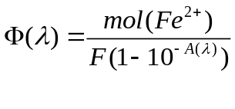
The quantum yield (Φ) for Fe²⁺ at 400 nm is 1.13,⁴ and A(λ) is the absorbance at the excitation wavelength (390 nm). The absorbance at this wavelength, A(440) was measured in 1 mm path quartz cuvettes in the presence of the band pass filter of 390 nm employed to carry out the measurements, obtaining an absorbance of 4.1576. The determined incident photons per unit time (F) is 2.93×10⁻⁹ einstein s⁻¹.

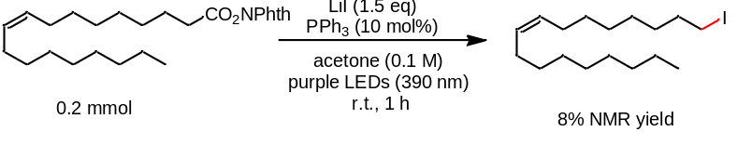
The number of moles of product formed upon irradiation of a reaction on 0.1 mmol scale of 1,3-dioxoisoindolin-2-yl oleate using the same reaction setup used before for the actinometer was determined by ¹H NMR analysis using diphenylmethane as internal standard after 1 h of light irradiation at room temperature (Note: keeping the temperature of the reaction solution at room temperature in the air-conditioned room). Under these conditions, 8% of product was observed. Before irradiation, the measured absorbance of the reaction solution at 390 nm by UV/Vis spectrophotometry was 1.04. Using the following equation, the quantum yield of the reaction was determined to be 0.69:
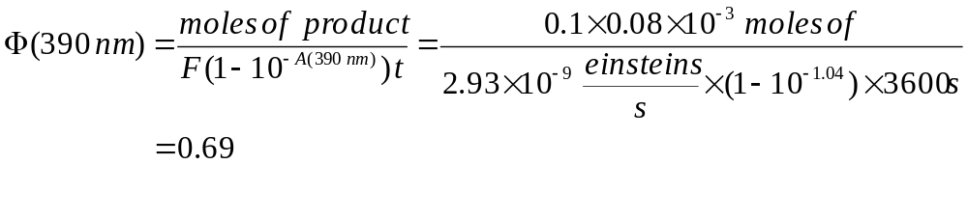

4.3 Radical cyclization experiments
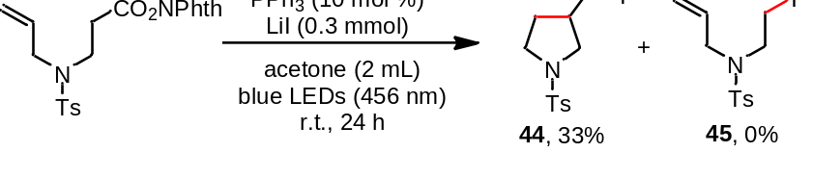
3-(iodomethyl)-1-tosylpyrrolidine (44): Following the general procedure A, using LiI (1.5 eq., 0.3 mmol), PPh₃ (10 mol%), 2.0 mL acetone, the product 44 was obtained in 33% yield as vicious liquid (Eluent: petroleum ether/ethyl acetate = 5/1). The compound data was in agreement with the literature (Ref. Org. Lett. 2016, 18, 4900).
¹H NMR (400 MHz, CDCl₃) δ 7.65 (d, J = 8.2 Hz, 2H), 7.27 (d, J = 7.9 Hz, 2H), 3.39 (dd, J = 10.2, 7.3 Hz, 1H), 3.35 – 3.29 (m, 1H), 3.20 – 3.13 (m, 1H), 3.00 – 2.87 (m, 3H), 2.37 (s, 3H), 2.36 – 2.28 (m, 1H), 1.99 – 1.91 (m, 1H), 1.53 – 1.43 (m, 1H).
¹³C NMR (101 MHz, CDCl₃) δ 143.7, 133.4, 129.8, 127.6, 53.7, 47.5, 41.3, 32.2, 21.6, 7.2.

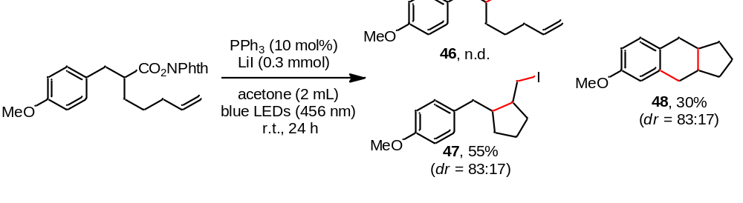
Following the general procedure A, using LiI (1.5 eq., 0.3 mmol), PPh₃ (10 mol%), 2.0 mL acetone, the decarboxylative cyclization iodination and cyclization products 46 and 47 were obtained with 55% yield (dr = 83:17) and 30% (dr = 83:17) yield, respectively, without the formation of direct decarboxylative iodination product 46. (Eluent: petroleum ether/ethyl acetate = 100/1). The compound data was in agreement with the literature (Ref. Nat Commun, 2018, 9, 5215).
1-((2-(iodomethyl)cyclopentyl)methyl)-4-methoxybenzene (47):
¹H NMR (400 MHz, CDCl₃) δ 7.04 – 6.98 (m, 2H), 6.78 – 6.73 (m, 2H), 3.71 (s, 3H), 3.27 – 2.93 (m, 2H), 2.68 – 2.60 (m, 1H), 2.40 – 2.27 (m, 1H), 2.23 – 2.09 (m, 1H), 1.88 – 1.78 (m, 1H), 1.74 – 1.26 (m, 6H). HRMS (EI) calcd. for [C₁₄H₁₉IO]⁺: 330.0466, found: 330.0475.
6-methoxy-2,3,3a,4,9,9a-hexahydro-1H-cyclopenta[b]naphthalene (48):
¹H NMR (500 MHz, CDCl₃) δ 7.01 (d, J = 8.1 Hz, 1H), 6.73 – 6.63 (m, 2H), 3.78 (s, 3H), 3.03 – 2.67 (m, 2H), 2.40 – 2.24 (m, 3H), 2.00 – 1.81 (m, 2H), 1.78 – 1.51 (m, 2H), 1.44 – 1.32 (m, 1H), 1.20 – 1.09 (m, 2H). HRMS (EI) calcd. for [C₁₄H₁₈O]⁺: 202.1358, found: 202.1357.

5. Decarboxylative Elimination

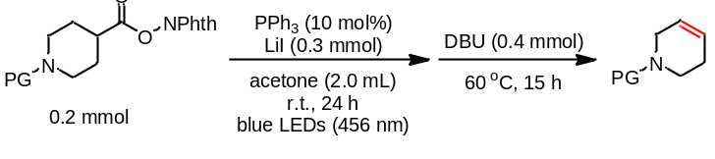
General Procedure B: Redox-active esters (1.0 eq., 0.2 mmol), LiI (1.5 eq., 0.3 mmol), PPh₃ (10 mol%) were placed in a 10 mL transparent Schlenk tube equipped with a stirring bar. The tube was evacuated and filled with argon (three times). To these solids, acetone (2.0 mL) was added via a gastight syringe under argon atmosphere. The reaction mixture was stirred under irradiation with blue LEDs (Kessil, PR160-456 nm), maintained at approximately room temperature (28 ± 2 ºC). After 24 h, the Schlenk tube was removed from the photo reaction setup, and DBU (0.4 mmol) was added to the reaction mixture under argon atmosphere, then heated at 60 ºC (oil bath) for another 15 h. Then the mixture was transferred to a round bottom flask and concentrated on a rotary evaporator. The product was purified via flash column chromatography on silica gel (Eluent: petroleum ether/ethyl acetate).

Characterization Data for Decarboxylative Elimination Products
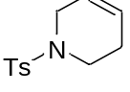
1-tosyl-1,2,3,6-tetrahydropyridine (49): Following the general procedure B, the desired product was obtained in 89% yield as white solid (Eluent: petroleum ether/ethyl acetate = 10/1). The compound data was in agreement with the literature (Ref. Nat Commun, 2018, 9, 5215).
¹H NMR (400 MHz, CDCl₃) δ 7.67 (d, J = 8.2 Hz, 2H), 7.33 (d, J = 8.1 Hz, 2H), 5.79 – 5.72 (m, 1H), 5.64 – 5.58 (m, 1H), 3.60 – 3.55 (m, 2H), 3.17 (t, J = 5.7 Hz, 2H), 2.43 (s, 3H), 2.25 – 2.18 (m, 2H).
¹³C NMR (101 MHz, CDCl₃) δ 143.5, 133.3, 129.6, 127.7, 125.1, 122.7, 44.8, 42.7, 25.3, 21.5.

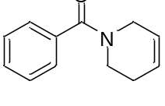
(5,6-dihydropyridin-1(2H)-yl)(phenyl)methanone (50): Following the general procedure B, the desired product was obtained in 86% yield as white solid (Eluent: petroleum ether/ethyl acetate = 3/1). The compound data was in agreement with the literature (Ref. Org. Lett. 2017, 19, 1614).
¹H NMR (400 MHz, CDCl₃) δ 7.41 (s, 5H), 5.93 – 5.50 (m, 2H), 4.29 – 3.44 (m, 4H), 2.33 – 2.10 (m, 2H).
¹³C NMR (101 MHz, CDCl₃) δ 170.9, 136.3, 129.7, 128.5, 127.0, 126.8, 126.4, 124.9, 124.5, 123.8, 47.6, 44.5, 42.5, 39.3, 25.9, 24.9.

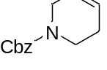
benzyl 5,6-dihydropyridine-1(2H)-carboxylate (51): Following the general procedure B, the desired product was obtained in 79% yield as colorless liquid (Eluent: petroleum ether/ethyl acetate = 10/1). The compound data was in agreement with the literature (Ref. Angew. Chem. Int. Ed. 2015, 54, 13538).
¹H NMR (400 MHz, CDCl₃) δ 7.42 – 7.29 (m, 5H), 5.90 – 5.59 (m, 2H), 5.15 (s, 2H), 3.99 – 3.92 (m, 2H), 3.57 (t, J = 5.7 Hz, 2H), 2.15 (s, br, 2H).
¹³C NMR (101 MHz, CDCl₃) δ 155.36, 136.88, 128.50, 127.99, 127.91, 127.82, 125.46, 125.09, 124.48, 123.89, 67.02, 44.88, 43.42, 40.67, 40.24, 25.18, 24.90.

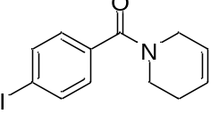
(5,6-dihydropyridin-1(2H)-yl)(4-iodophenyl)methanone (52): Following the general procedure B, the desired product was obtained in 88% yield as light yellow solid (Eluent: petroleum ether/ethyl acetate = 3/1).
¹H NMR (400 MHz, CDCl₃) δ 7.76 (d, J = 7.6 Hz, 2H), 7.16 (d, J = 8.5 Hz, 2H), 6.01 – 5.46 (m, 2H), 4.28 – 3.39 (m, 4H), 2.39 – 2.00 (m, 2H).
¹³C NMR (101 MHz, CDCl₃) δ 169.9, 137.7, 135.6, 128.8, 128.6, 126.5, 124.9, 124.4, 123.6, 95.9, 47.6, 44.5, 42.5, 39.4, 25.9, 24.8.
HRMS (EI) calcd. for [C₁₂H₁₂INO]⁺: 311.9958, found: 311.9880.

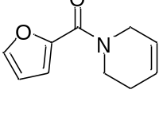
(5,6-dihydropyridin-1(2H)-yl)(furan-2-yl)methanone (53): Following the general procedure B, the desired product was obtained in 88% yield as yellow vicious liquid (Eluent: petroleum ether/ethyl acetate = 2/1).
¹H NMR (500 MHz, CDCl₃) δ 7.49 (d, J = 0.9 Hz, 1H), 6.99 (d, J = 3.4 Hz, 1H), 6.48 (dd, J = 3.4, 1.7 Hz, 1H), 5.93 – 5.86 (m, 1H), 5.70 (s, 1H), 4.22 (s, 2H), 3.83 (s, 2H), 2.28 (s, 2H).
¹³C NMR (101 MHz, CDCl₃) δ 177.71, 159.57, 148.12, 143.69, 124.12, 115.93, 111.20, 43.82, 43.35, 29.72.
HRMS (EI) calcd. for [C₁₀H₁₁NO₂]⁺: 177.0784, found: 177.0784.

6. Further Transformations for Decarboxylative Construction of C-O, C-N, C-F, and C-SCN bonds
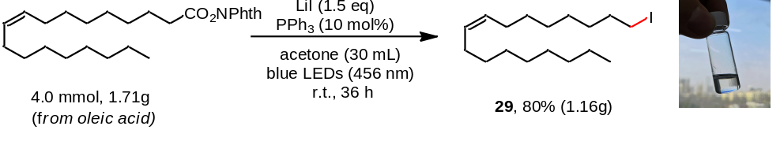
LiI (6.0 mmol, 1.5 eq.), PPh₃ (10 mol%) were placed in a 50 mL transparent Schlenk tube equipped with a stirring bar. The tube was evacuated and filled with argon (three times). To these solids, 1,3-dioxoisoindolin-2-yl oleate (1.0 eq., 4.0 mmol, vicious liquid, dissolved in 5 mL acetone) and acetone (25 mL) was added via a gastight syringe under argon atmosphere. The reaction mixture was stirred under irradiation with blue LEDs (Kessil, PR160-456 nm), maintained at approximately room temperature (28 ± 2 ºC). After 36 h, the mixture was transferred to a round bottom flask and concentrated on a rotary evaporator. The product was purified via flash column chromatography on silica gel. The desired product of 29 was obtained in 80% yield as colorless liquid (1.16g, Eluent: petroleum ether).
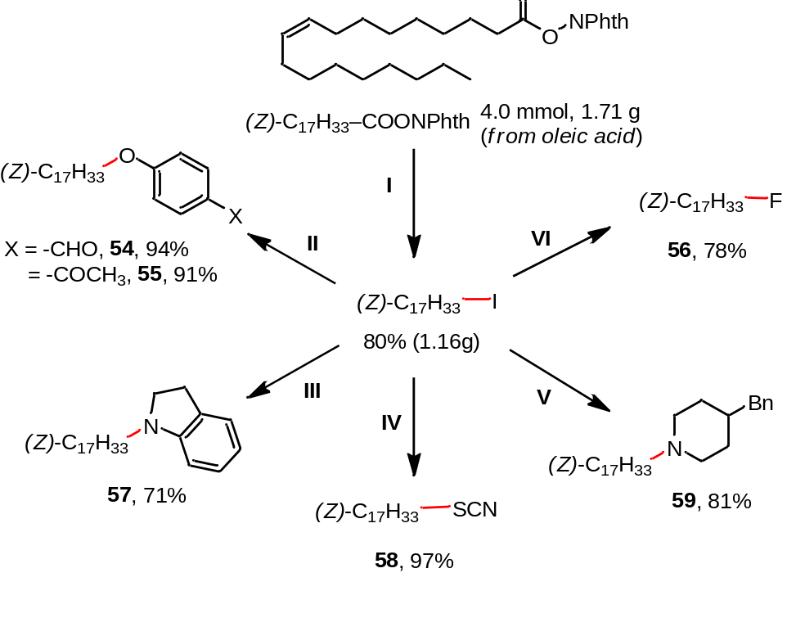
Reaction conditions:
- REAs (4.0 mmol, 1.0 eq.), LiI (1.5 eq.), PPh₃ (10 mol%), acetone (30 mL), 36 h, r.t., blue LEDs (456 nm);
- 29 (0.2 mmol, 1.0 eq.), phenol (2.0 eq.), K₂CO₃ (1.25 equiv), acetone (2 mL), 60 ºC, 20 h;
- 29 (0.2 mmol, 1.0 eq.), Indoline (1.5 eq.), K₂CO₃ (1.25 equiv), acetone (2 mL), 60 ºC, 20 h;
- 29 (0.2 mmol, 1.0 eq.), KSCN (0.3 mmol), acetone (2 mL), 60 ºC, 20 h.
- 29 (0.2 mmol, 1.0 eq.), 4-benzylpiperidine (1.5 eq.), K₂CO₃ (1.0 equiv), acetone (2 mL), 60 ºC, 20 h;
- 29 (0.2 mmol, 1.0 eq.), TBAF (3.0 eq., 1 M in THF), acetone (1 mL), r.t., 20 h.

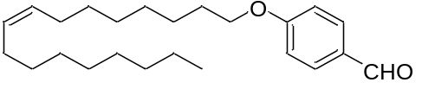
(Z)-4-(heptadec-8-en-1-yloxy)benzaldehyde (54):
¹H NMR (400 MHz, CDCl₃) δ 9.87 (s, 1H), 7.82 (d, J = 8.8 Hz, 2H), 6.98 (d, J = 8.7 Hz, 2H), 5.42 – 5.29 (m, 2H), 4.03 (t, J = 6.5 Hz, 2H), 2.11 – 1.97 (m, 4H), 1.88 – 1.76 (m, 2H), 1.52 – 1.22 (m, 20H), 0.88 (t, J = 6.9 Hz, 3H).
¹³C NMR (101 MHz, CDCl₃) δ 190.9, 164.3, 132.0, 130.1, 129.7, 129.7, 114.7, 68.4, 31.9, 29.8, 29.7, 29.5, 29.3, 29.3, 29.2, 29.1, 27.2, 27.2, 26.0, 22.7, 14.1.
HRMS (ESI) calcd. for C₂₄H₃₉O₂⁺ [M+H]⁺: 359.2942, found: 359.2945.

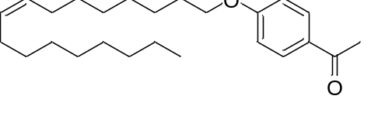
(Z)-1-(4-(heptadec-8-en-1-yloxy)phenyl)ethanone (55):
¹H NMR (400 MHz, CDCl₃) δ 7.92 (d, J = 8.9 Hz, 2H), 6.91 (d, J = 8.9 Hz, 2H), 5.40 – 5.29 (m, 2H), 4.01 (t, J = 6.6 Hz, 2H), 2.55 (s, 3H), 2.01 (dd, J = 12.1, 6.0 Hz, 4H), 1.84 – 1.76 (m, 2H), 1.52 – 1.42 (m, 2H), 1.41 – 1.24 (m, 18H), 0.88 (t, J = 6.9 Hz, 3H).
¹³C NMR (101 MHz, CDCl₃) δ 196.9, 163.2, 130.6, 130.1, 129.7, 114.1, 68.2, 31.9, 29.8, 29.7, 29.5, 29.3, 29.3, 29.2, 29.1, 27.2, 27.2, 26.3, 26.0, 22.7, 14.1.
HRMS (ESI) calcd. for C₂₅H₄₁O₂⁺ [M+H]⁺: 373.3096, found: 373.3101.

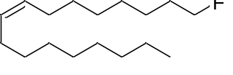
(Z)-1-fluoroheptadec-8-ene (56):
¹H NMR (500 MHz, CDCl₃) δ 5.44 – 5.26 (m, 2H), 4.49 (t, J = 6.2 Hz, 1H), 4.39 (t, J = 6.2 Hz, 1H), 2.08 – 1.97 (m, 4H), 1.75 – 1.63 (m, 2H), 1.42 – 1.25 (m, 20H), 0.88 (t, J = 6.7 Hz, 3H).
¹³C NMR (126 MHz, CDCl₃) δ 130.1, 129.7, 84.3 (d, J = 163.9 Hz), 31.9, 30.4 (d, J = 19.4 Hz), 29.8, 29.7, 29.6, 29.4, 29.2, 27.2, 27.2, 25.1 (d, J = 5.5 Hz), 22.7, 14.2. ¹⁹F NMR (471 MHz, CDCl₃) δ -217.96.
HRMS (EI) calcd. for [C₁₇H₃₃F]⁺: 256.2561, found: 256.2561.

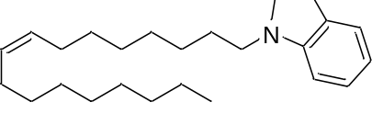
(Z)-1-(heptadec-8-en-1-yl)indoline (57):
¹H NMR (400 MHz, CDCl₃) δ 7.09 – 7.02 (m, 2H), 6.63 (t, J = 7.3 Hz, 1H), 6.46 (d, J = 7.9 Hz, 1H), 5.41 – 5.31 (m, 2H), 3.33 (t, J = 8.3 Hz, 2H), 3.06 – 3.01 (m, 2H), 2.95 (t, J = 8.3 Hz, 2H), 2.08 – 1.98 (m, 4H), 1.60 (dt, J = 14.8, 7.3 Hz, 2H), 1.42 – 1.24 (m, 20H), 0.89 (t, J = 6.8 Hz, 3H).
¹³C NMR (101 MHz, CDCl₃) δ 151.6, 129.0, 129.0, 128.7, 126.2, 123.3, 116.3, 106.0, 52.0, 48.4, 30.9, 28.8, 28.7, 28.5, 28.4, 28.3, 28.3, 27.5, 26.3, 26.2, 26.2, 26.2, 21.7, 13.1.
HRMS (ESI) calcd. for C₂₅H₄₂N⁺ [M+H]⁺: 356.3307, found: 356.3312.

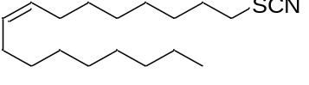
(Z)-1-thiocyanatoheptadec-8-ene (58):
¹H NMR (400 MHz, CDCl₃) δ 5.33 – 5.22 (m, 2H), 2.90 – 2.84 (m, 2H), 2.01 – 1.90 (m, 4H), 1.79 – 1.71 (m, 2H), 1.41 – 1.34 (m, 2H), 1.31 – 1.18 (m, 18H), 0.81 (t, J = 6.9 Hz, 3H).
¹³C NMR (101 MHz, CDCl₃) δ 129.3, 128.5, 111.4, 33.0, 30.9, 28.9, 28.7, 28.6, 28.52, 28.3, 28.0, 27.8, 26.9, 26.2, 26.1, 21.7, 13.1.
HRMS (ESI) calcd. for C₁₈H₃₄NS⁺ [M+H]⁺: 296.2403, found: 296.2407.

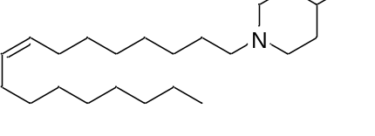
(Z)-4-benzyl-1-(heptadec-8-en-1-yl)piperidine (59):
¹H NMR (400 MHz, CDCl₃) δ 7.22 – 7.16 (m, 2H), 7.12 – 7.04 (m, 3H), 5.31 – 5.22 (m, 2H), 2.82 (d, J = 11.7 Hz, 2H), 2.45 (d, J = 7.0 Hz, 2H), 2.19 (dd, J = 9.2, 6.6 Hz, 2H), 1.97 – 1.89 (m, 4H), 1.75 (td, J = 11.7, 2.1 Hz, 2H), 1.55 (d, J = 12.5 Hz, 2H), 1.47 – 1.36 (m, 3H), 1.30 – 1.16 (m, 22H), 0.81 (t, J = 6.8 Hz, 3H).
¹³C NMR (101 MHz, CDCl₃) δ 140.7, 123.0, 129.8, 129.1, 128.2, 125.8, 59.2, 54.0, 43.2, 38.0, 32.1, 31.9, 29.8, 29.7, 29.6, 29.5, 29.4, 29.2, 27.7, 27.2, 27.2, 27.0, 22.7, 14.2.
HRMS (ESI) calcd. for C₂₉H₅₀N⁺ [M+H]⁺: 412.3934, found: 412.3938.

One-pot decarboxylative thiocyanation

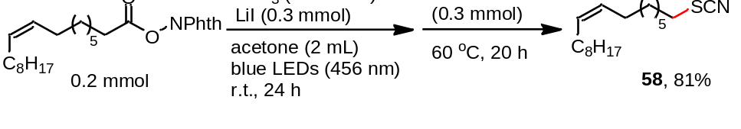
LiI (1.5 eq., 0.3 mmol), PPh₃ (10 mol%) were placed in a 10 mL transparent Schlenk tube equipped with a stirring bar. The tube was evacuated and filled with argon (three times). To these solids, 1,3-dioxoisoindolin-2-yl oleate (0.2 mmol, 1.0 eq.) and acetone (2.0 mL) was added via a gastight syringe under argon atmosphere. The reaction mixture was stirred under irradiation with blue LEDs (Kessil, PR160-456 nm), maintained at approximately room temperature (28 ± 2 ºC). After 24 h, the Schlenk tube was removed from the photo reaction setup, and KSCN (0.3 mmol) was added to the reaction mixture under argon atmosphere, then heated at 60 ºC (oil bath) for another 15 h. Then the mixture was transferred to a round bottom flask and concentrated on a rotary evaporator. The product was purified via flash column chromatography on silica gel (Eluent: petroleum ether/ethyl acetate).

One-pot decarboxylative amination
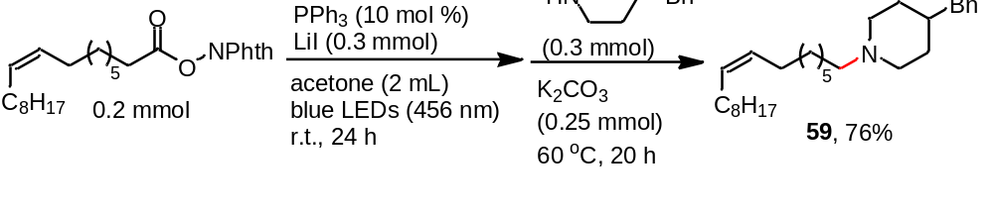
LiI (1.5 eq., 0.3 mmol), PPh₃ (10 mol%) were placed in a 10 mL transparent Schlenk tube equipped with a stirring bar. The tube was evacuated and filled with argon (three times). To these solids, 1,3-dioxoisoindolin-2-yl oleate (0.2 mmol, 1.0 eq.) and acetone (2.0 mL) were added via a gastight syringe under argon atmosphere. The reaction mixture was stirred under irradiation with blue LEDs (Kessil, PR160-456 nm), maintained at approximately room temperature (28 ± 2 ºC). After 24 h, the Schlenk tube was removed from the photo reaction setup, 4-benzylpiperidine (0.3 mmol) and K₂CO₃ (0.25 mmol) were added to the reaction mixture under argon atmosphere, then heated at 60 ºC (oil bath) for another 20 h. Then the mixture was transferred to a round bottom flask and concentrated on a rotary evaporator. The product was purified via flash column chromatography on silica gel (Eluent: petroleum ether/ethyl acetate).

7. References
(1) Lu, X., Xiao, B., Liu, L. & Fu, Y. Formation of C(sp³)-C(sp³) bonds through nickel-catalyzed decarboxylative olefin hydroalkylation reactions. Chem. Eur. J. 22, 11161–11164 (2016).
(2) Pontiki, E., Hadjipavlou-Litina, D., Litinas, K., Nicolotti, O. & Carotti, A. Design, synthesis and pharmacobiological evaluation of novel acrylic acid derivatives acting as lipoxygenase and cyclooxygenase-1 inhibitors with antioxidant and anti-inflammatory activities . Eur. J. Med. Chem. 46, 191–200 (2011).
(3) Wozniak, Ł., Murphy, J. J. & Melchiorre, P. Photo-organocatalytic enantioselective perfluoroalkylation of β-ketoesters. J. Am. Chem. Soc. 137, 5678–5681 (2015).
(4) Kandukuri, S. R., Bahamonde, A., Chatterjee, I., Jurberg, I. D., Escudero-Adán, E. C. & Melchiorre, P. X-ray characterization of an electron Donor-Acceptor Complex that drives the photochemical alkylation of indoles. Angew. Chem. Int. Ed. 54, 1485–1489(2015).

8. NMR Spectra
¹H NMR spectrum of 4-iodo-1-tosylpiperidine (2):
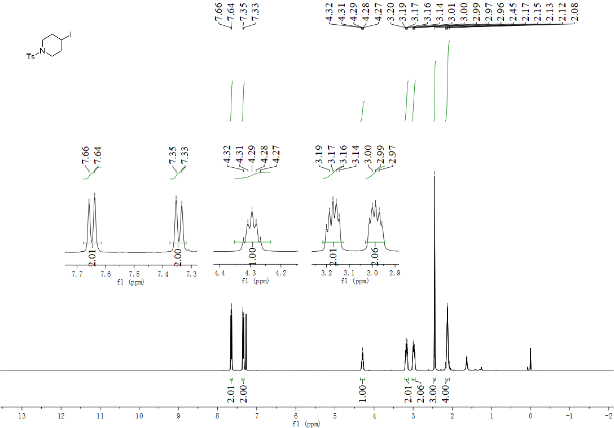

¹³C NMR spectrum of 4-iodo-1-tosylpiperidine (2):
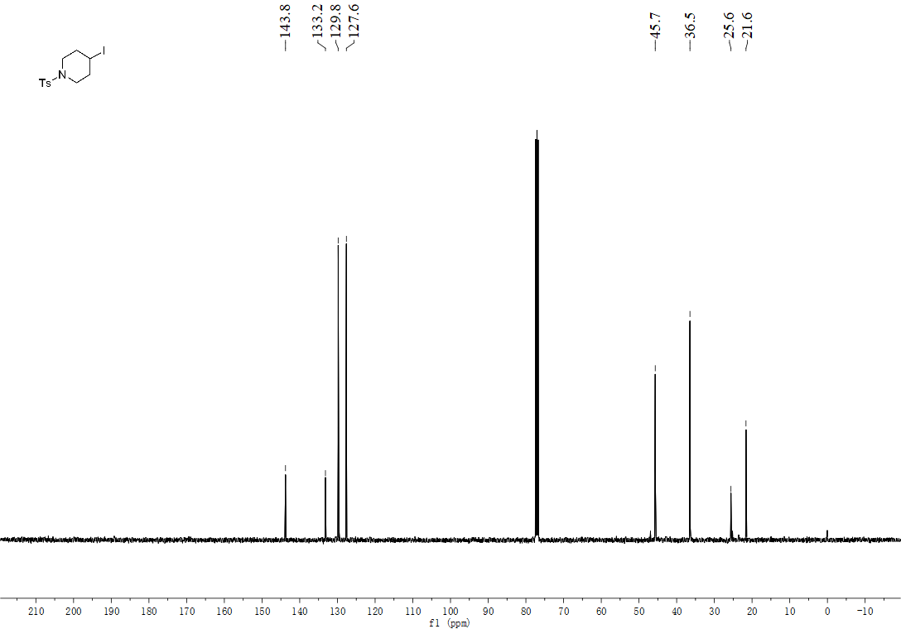

¹H NMR spectrum of 1-(3-iodopropyl)-4-methoxybenzene (4):
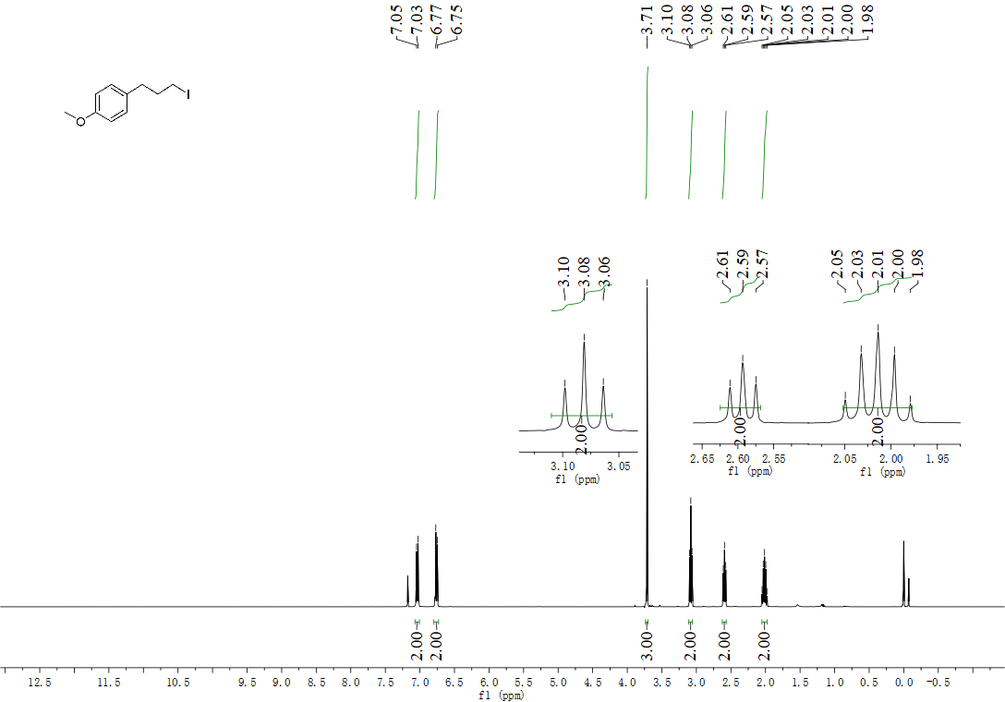
¹³C NMR spectrum of 1-(3-iodopropyl)-4-methoxybenzene (4):
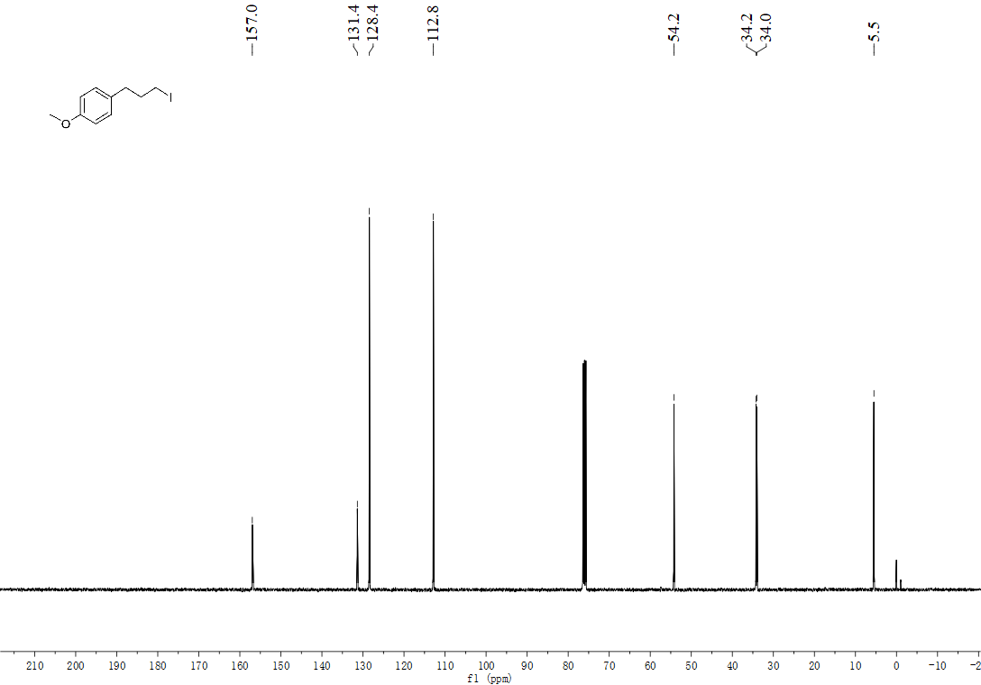

¹H NMR spectrum of 2-(5-iodopentyl)isoindoline-1,3-dione (5):
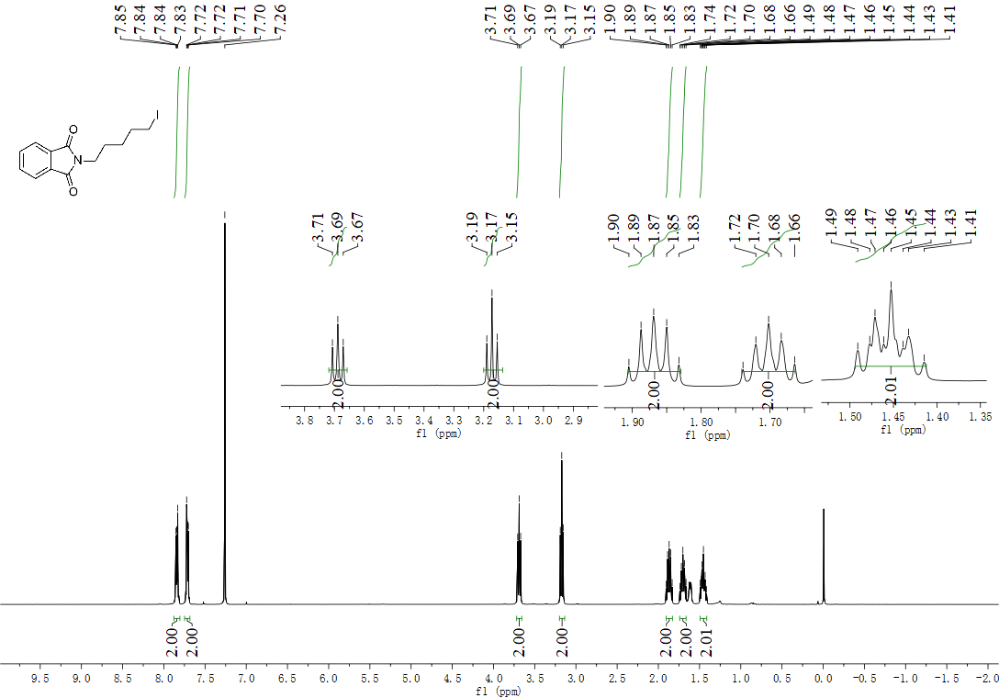
¹³C NMR spectrum of 2-(5-iodopentyl)isoindoline-1,3-dione (5):
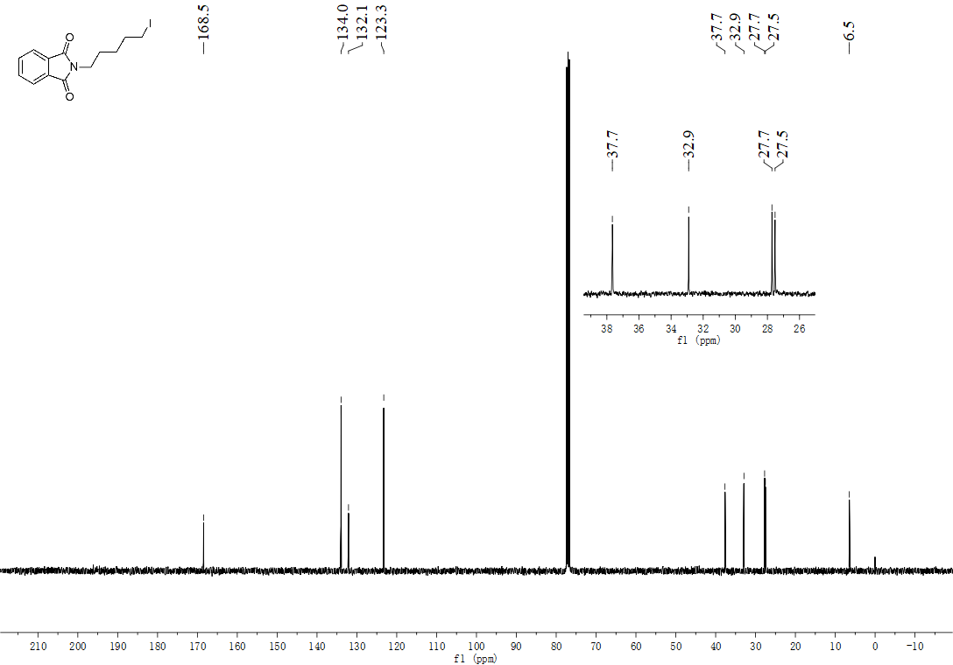

¹H NMR spectrum of 1-bromo-4-((5-iodopentyl)oxy)benzene (6):
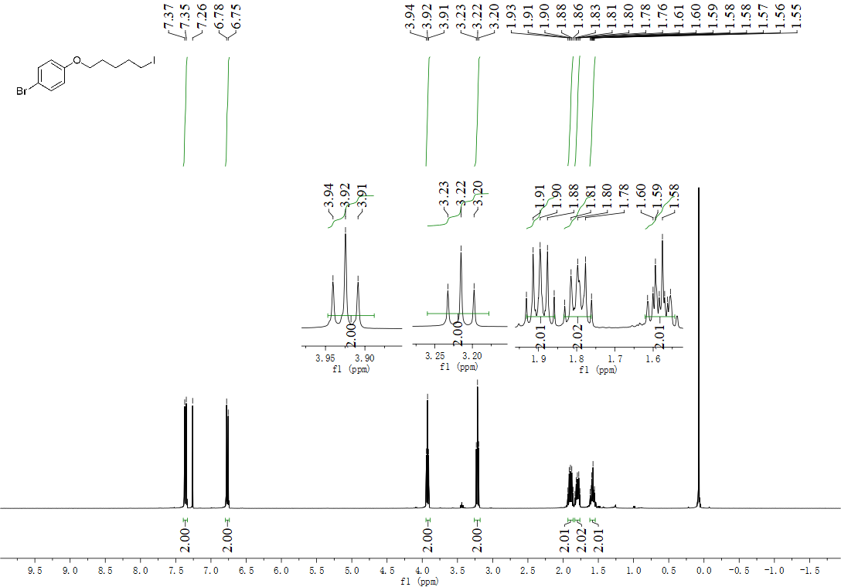
¹³C NMR spectrum of 1-bromo-4-((5-iodopentyl)oxy)benzene (6):
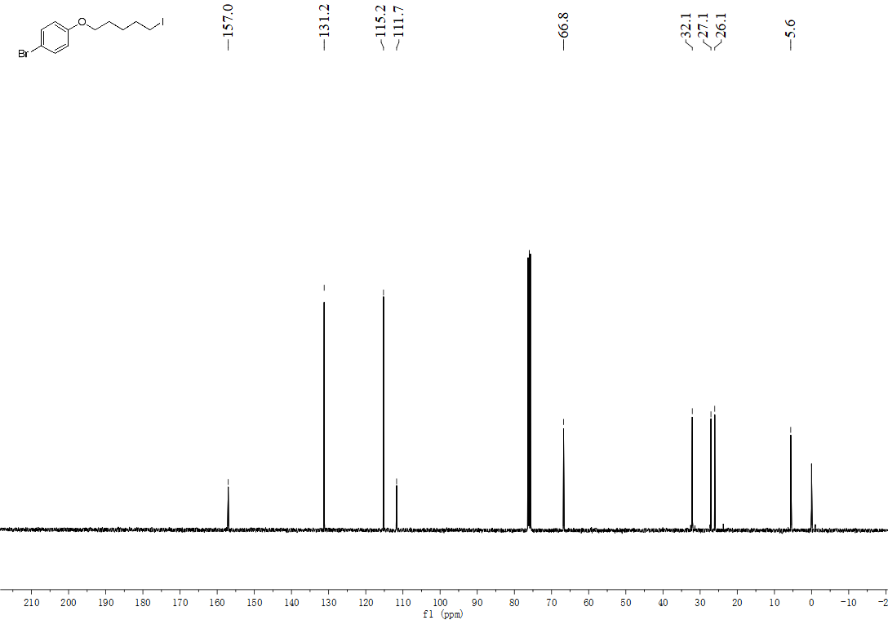

¹H NMR spectrum of 4-((5-iodopentyl)oxy)benzaldehyde (7):
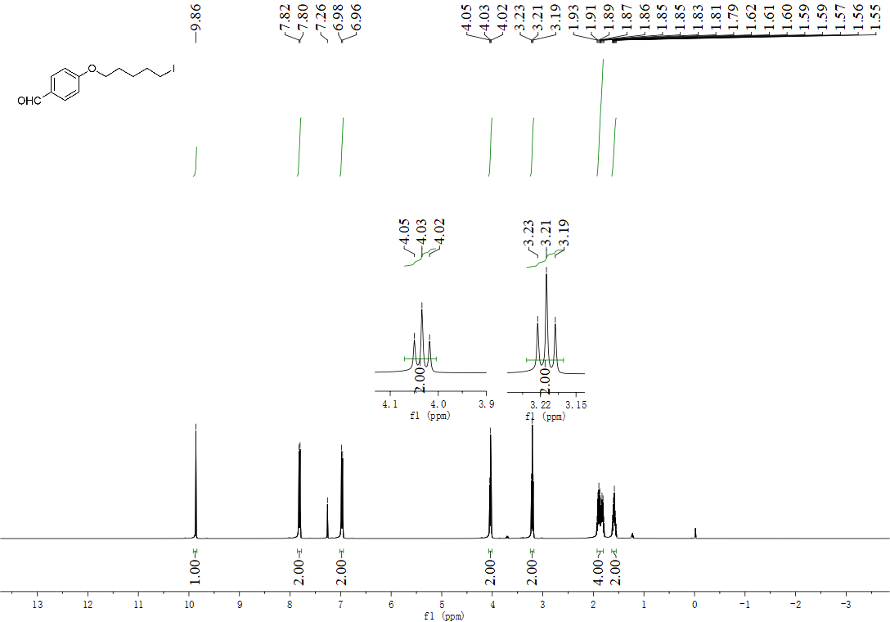
¹³C NMR spectrum of 4-((5-iodopentyl)oxy)benzaldehyde (7):
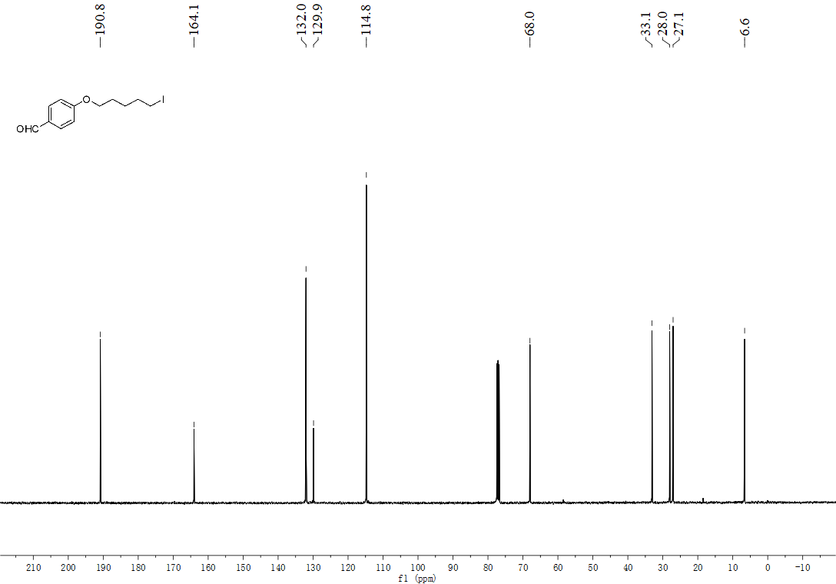

¹H NMR spectrum of 2-(4-((5-iodopentyl)oxy)phenyl)-4,4,5,5-tetramethyl-1,3,2-dioxaborolane (8):
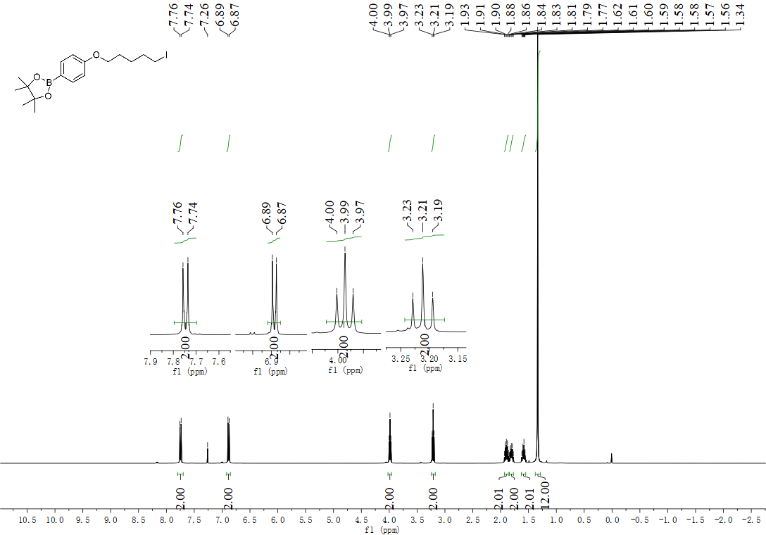
¹³C NMR spectrum of 2-(4-((5-iodopentyl)oxy)phenyl)-4,4,5,5-tetramethyl-1,3,2-dioxaborolane (8):
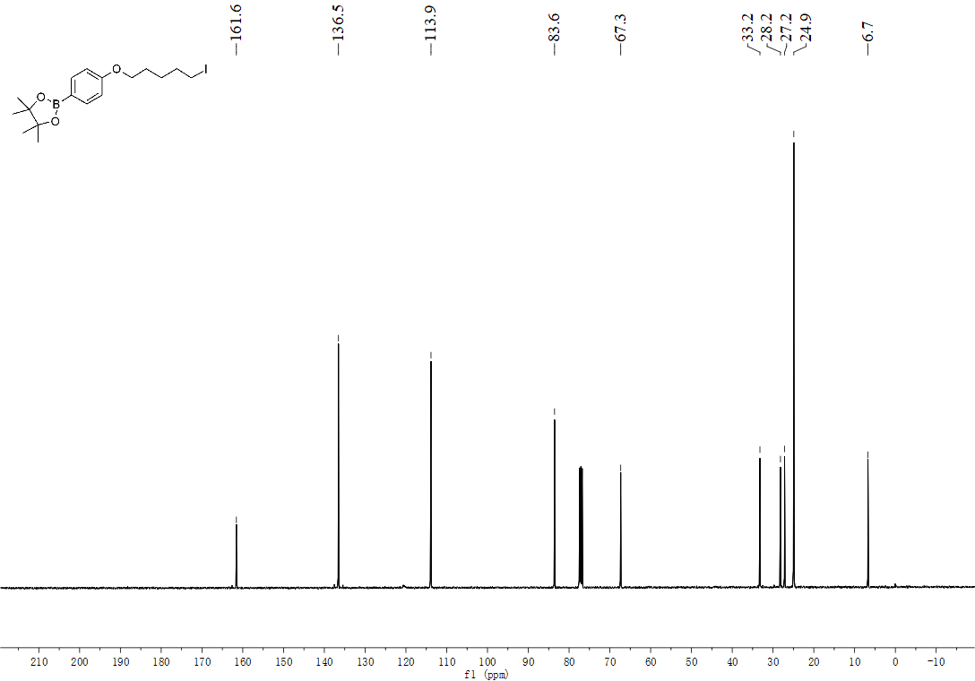

¹H NMR spectrum of (E)-1-((5-iodopentyl)oxy)-2-methoxy-4-(prop-1-en-1-yl)benzene (9):
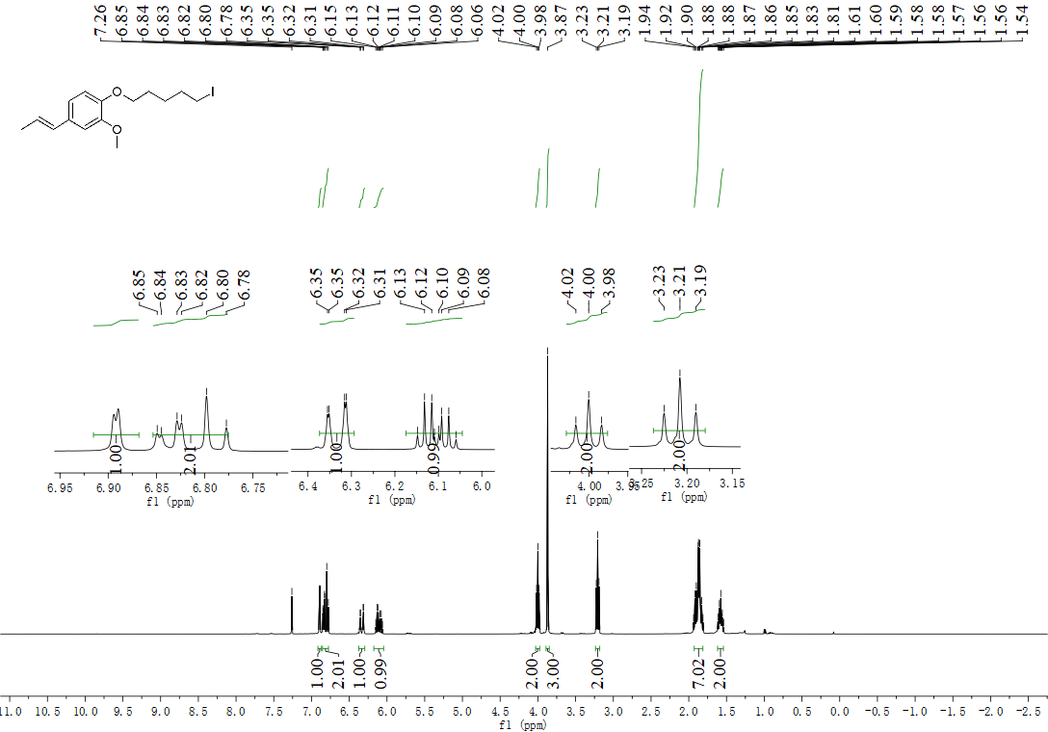
¹³C NMR spectrum of (E)-1-((5-iodopentyl)oxy)-2-methoxy-4-(prop-1-en-1-yl)benzene (9):
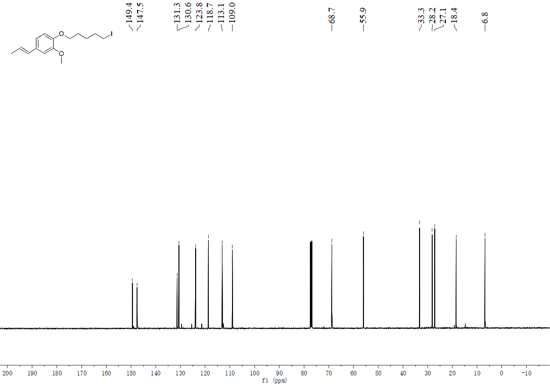

¹H NMR spectrum of 7-((5-iodopentyl)oxy)-4-methyl-2H-chromen-2-one (10):
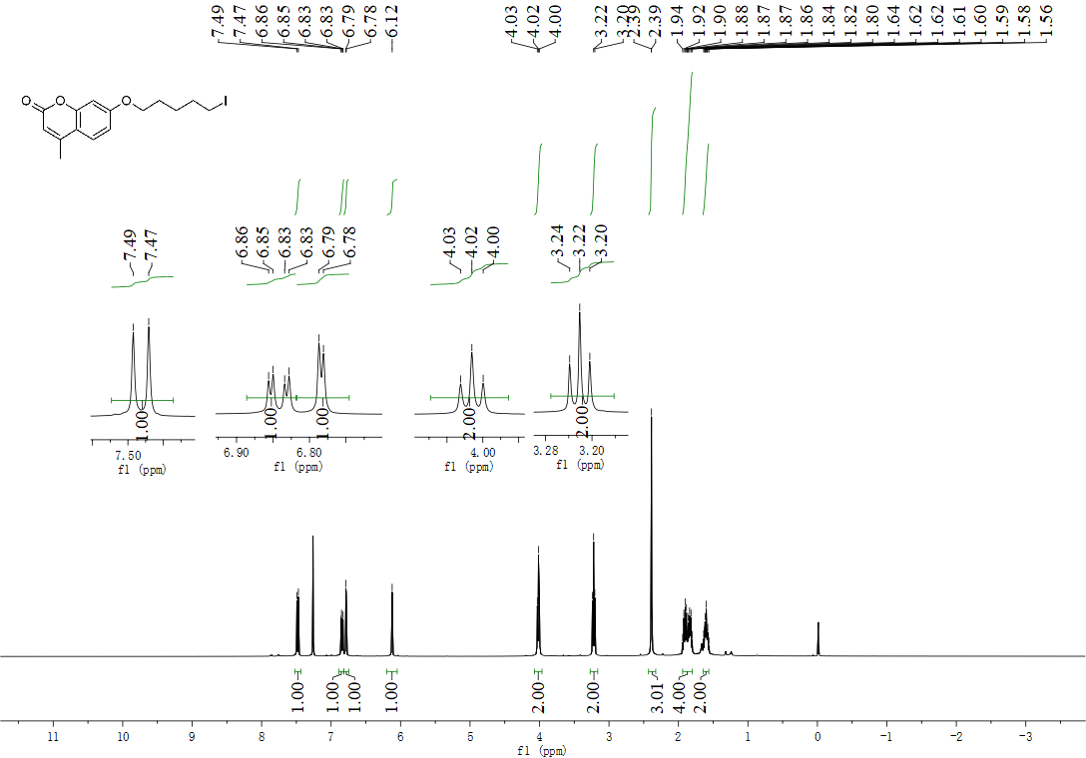
¹³C NMR spectrum of 7-((5-iodopentyl)oxy)-4-methyl-2H-chromen-2-one (10):
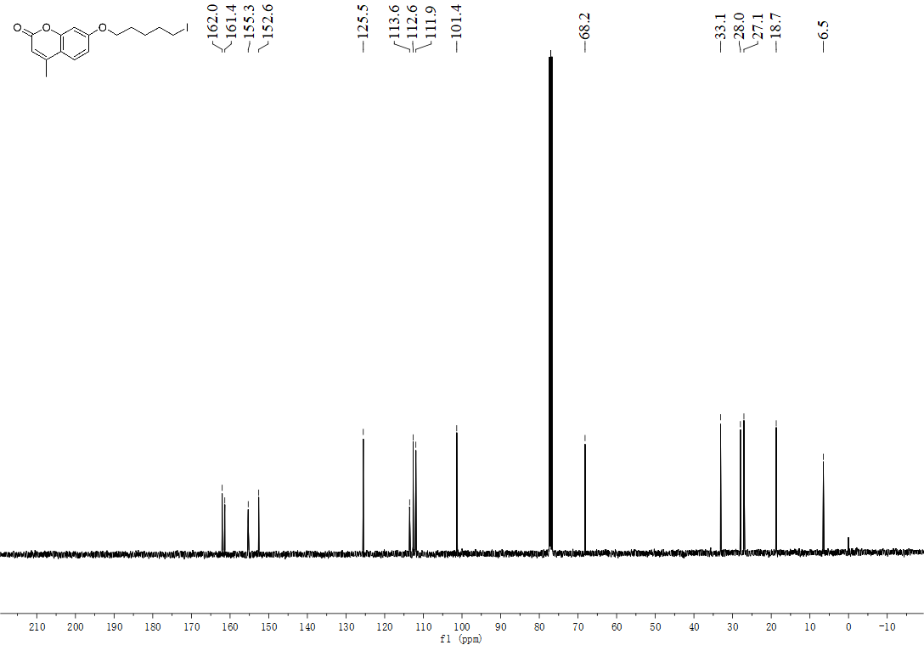

¹H NMR spectrum of 2-(3-iodopropyl)thiophene (11):
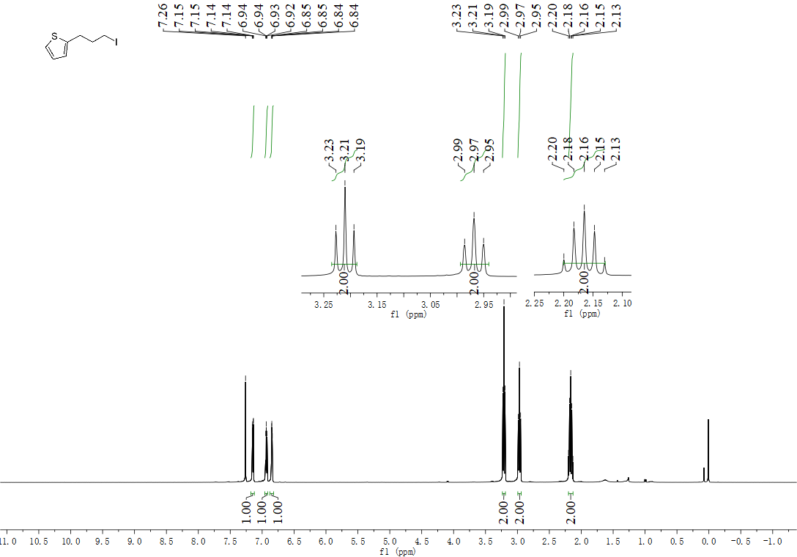
¹³C NMR spectrum of 2-(3-iodopropyl)thiophene (11):
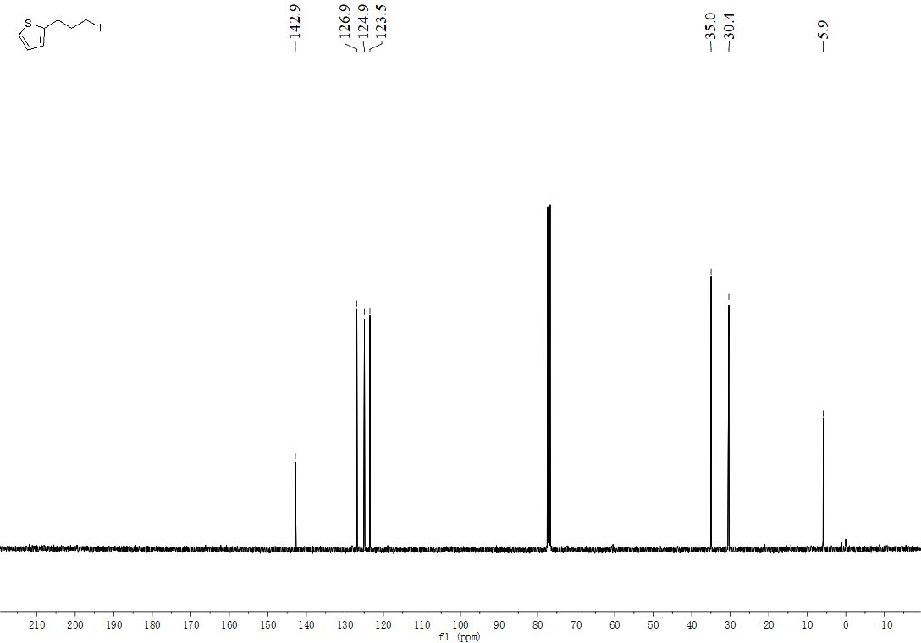

¹H NMR spectrum of 1-(4-iodobutoxy)-4-(trifluoromethyl)benzene (12):
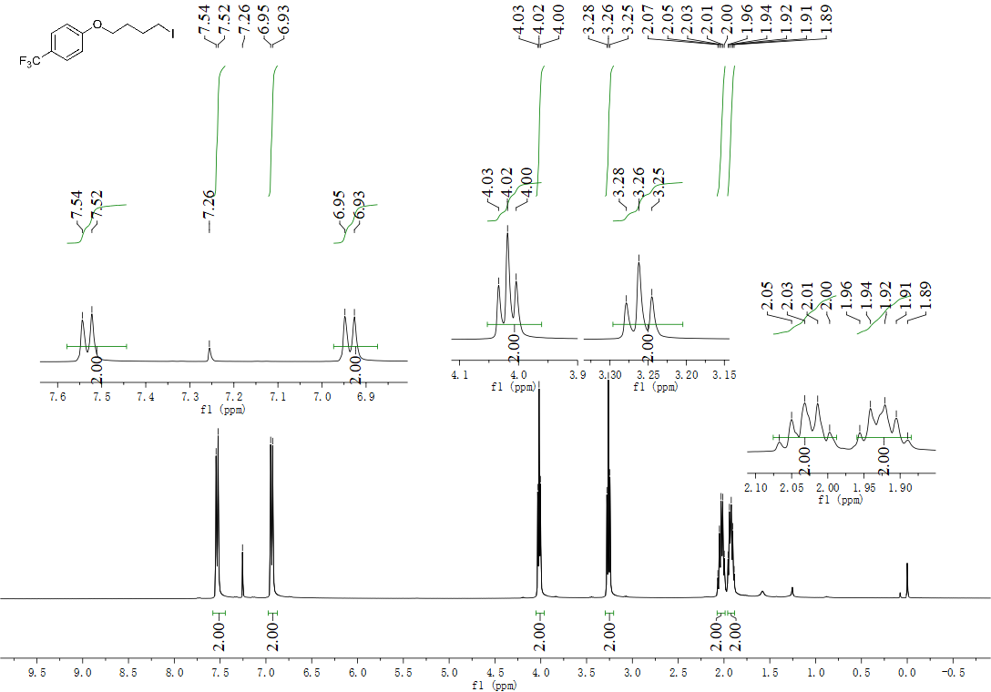
¹³C NMR spectrum of 1-(4-iodobutoxy)-4-(trifluoromethyl)benzene (12):
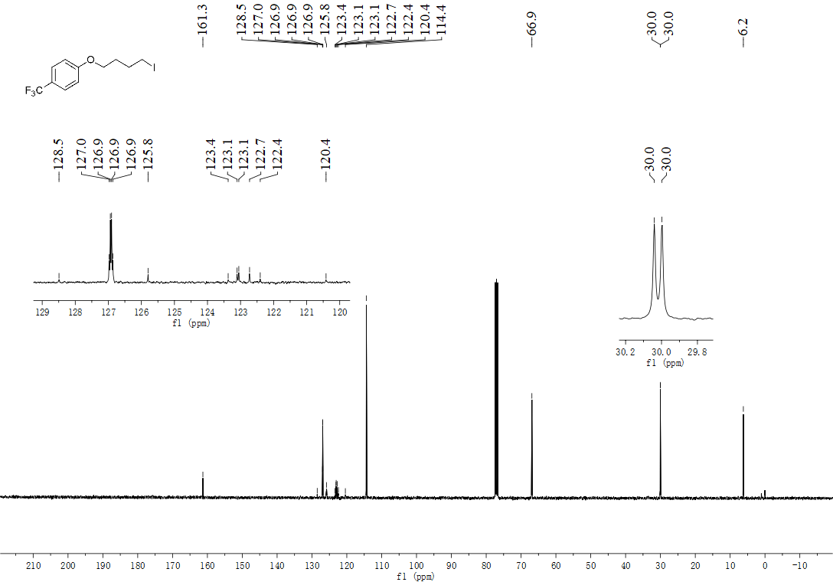

¹⁹F NMR spectrum of 1-(4-iodobutoxy)-4-(trifluoromethyl)benzene (12):
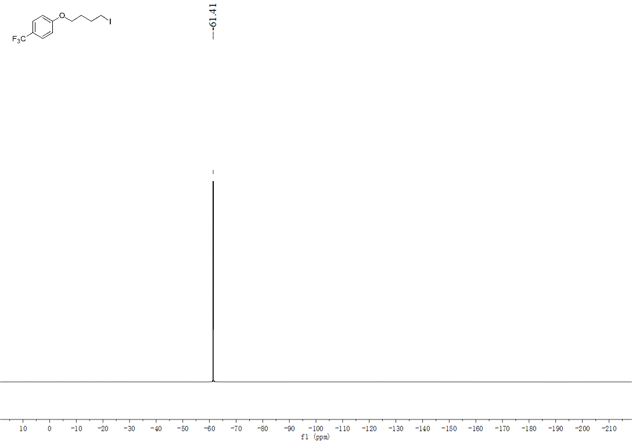

¹H NMR spectrum of 1-chloro-4-(4-iodobutoxy)benzene (13):
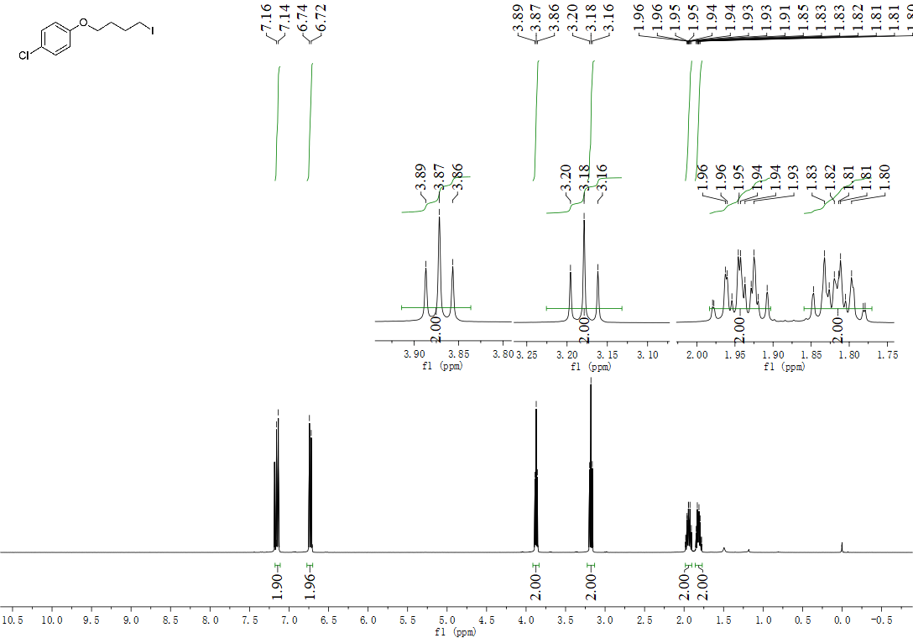
¹³C NMR spectrum of 1-chloro-4-(4-iodobutoxy)benzene (13):
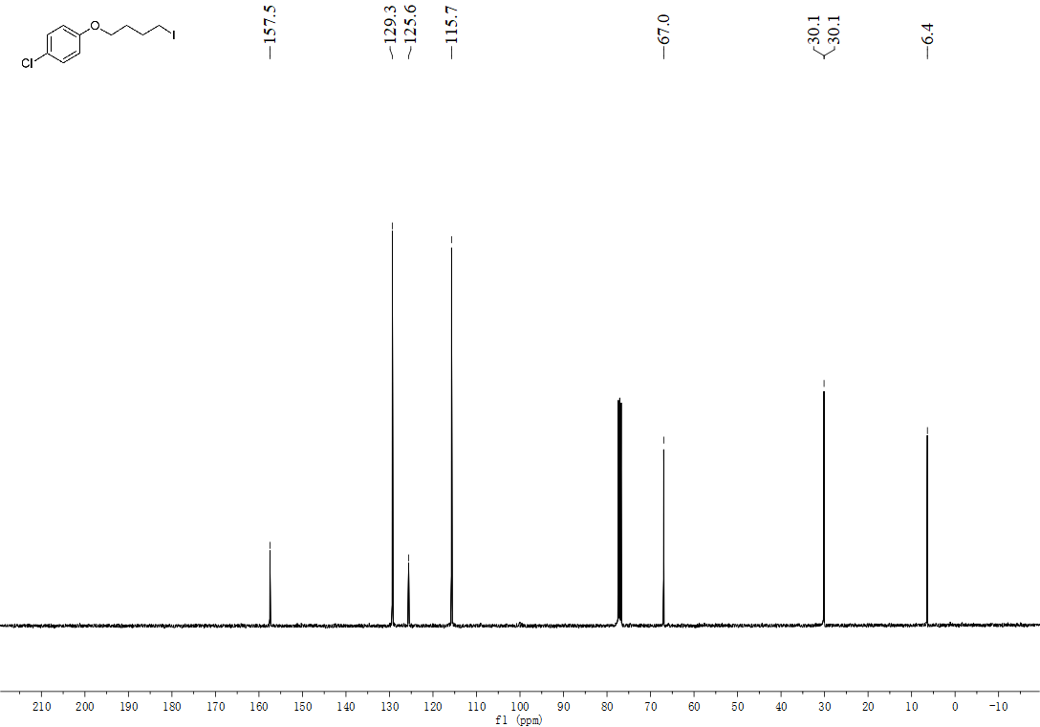

¹H NMR spectrum of 1-(3-iodobutyl)-4-methoxybenzene (14):
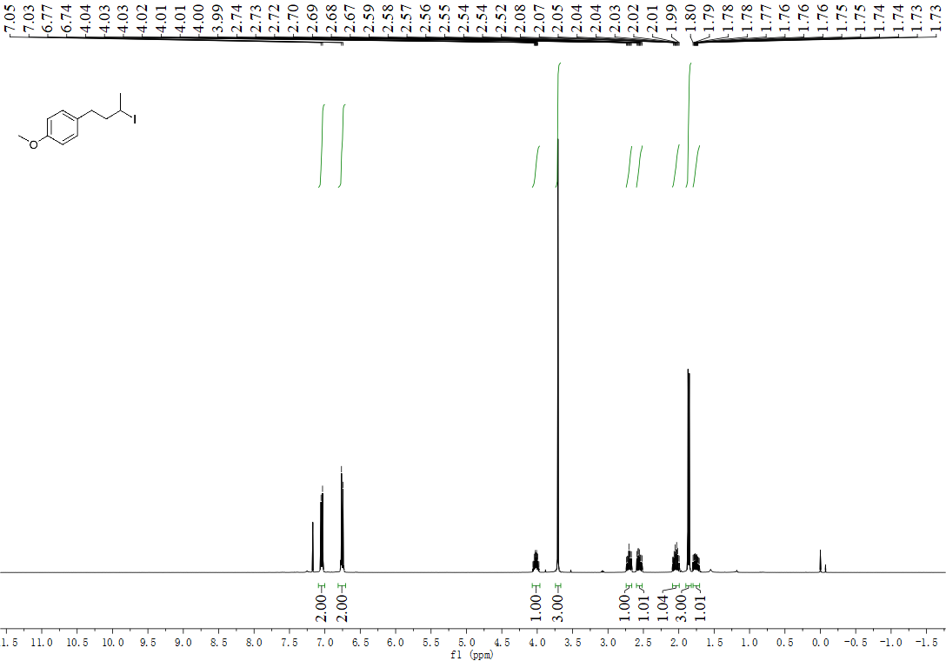

¹³C NMR spectrum of 1-(3-iodobutyl)-4-methoxybenzene (14):
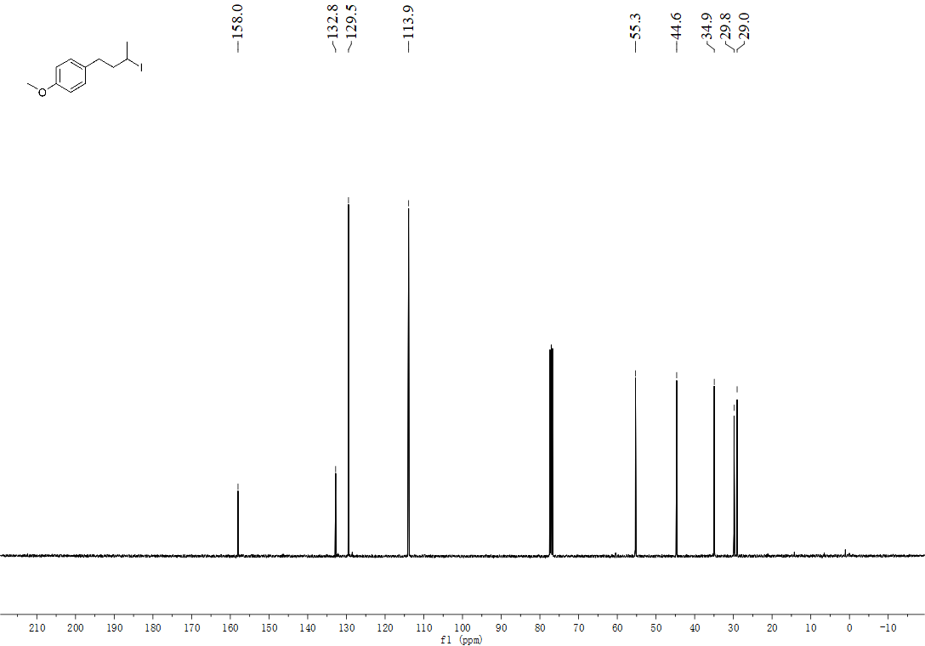

¹H NMR spectrum of furan-2-yl(4-iodopiperidin-1-yl)methanone (15):
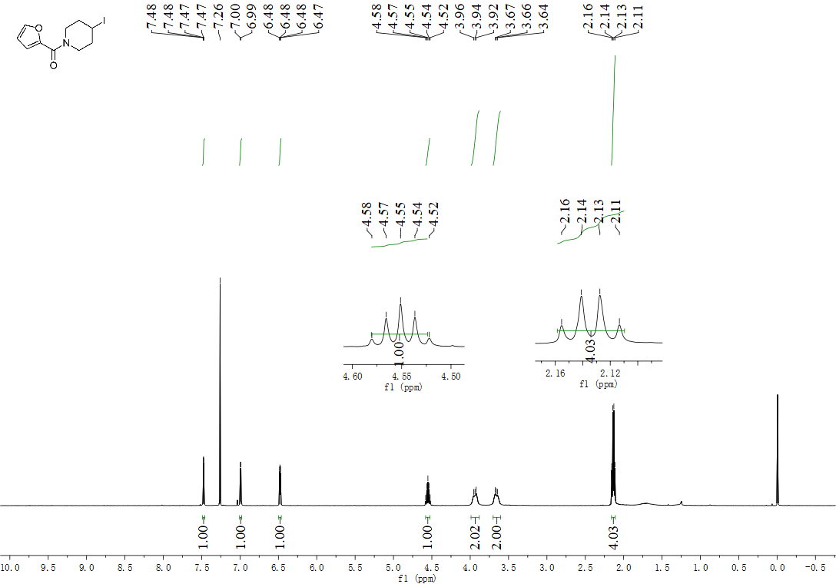

¹³C NMR spectrum of furan-2-yl(4-iodopiperidin-1-yl)methanone (15):
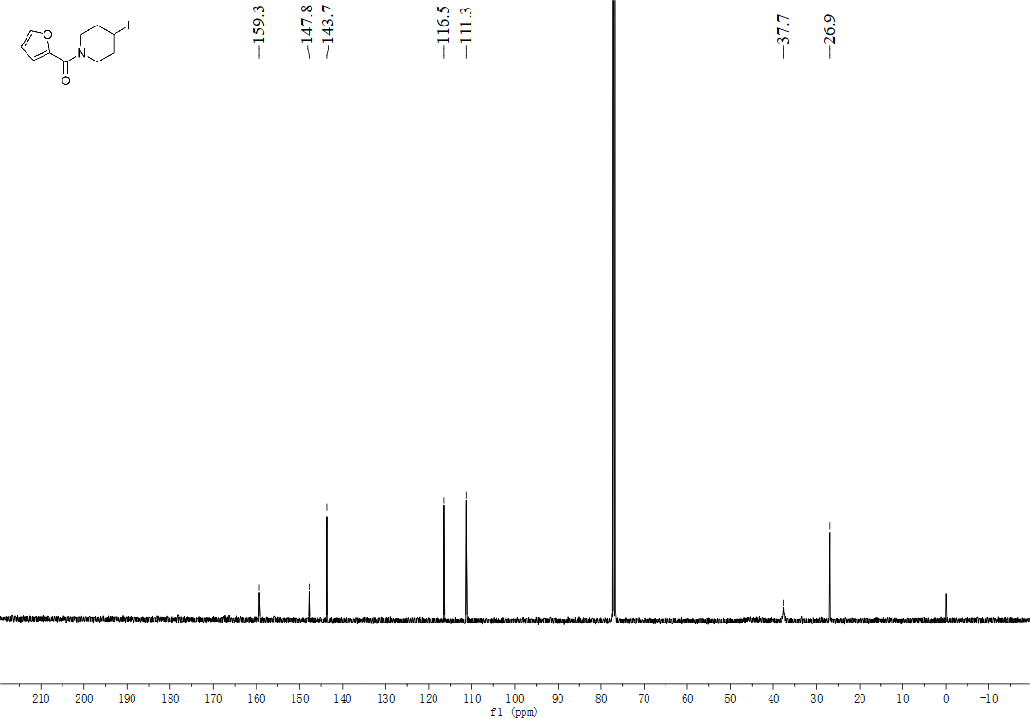

¹H NMR spectrum of tert-butyl 3-iodopiperidine-1-carboxylate (16):
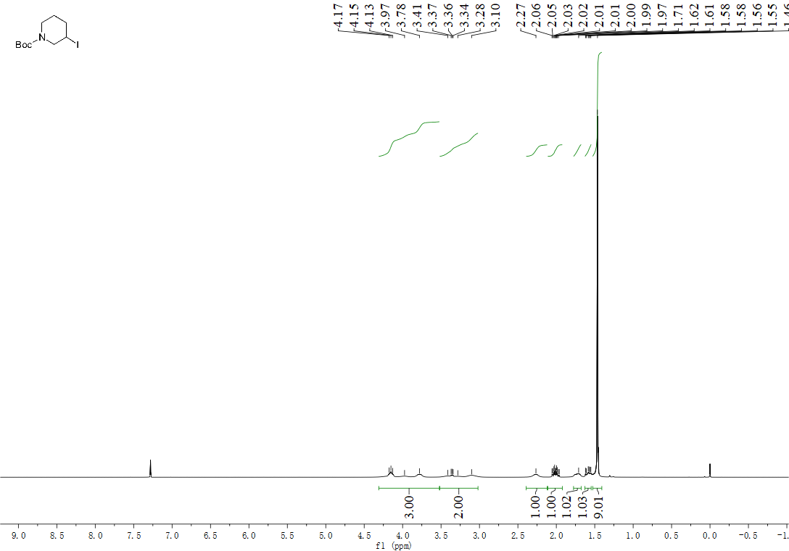

¹³C NMR spectrum of tert-butyl 3-iodopiperidine-1-carboxylate (16):
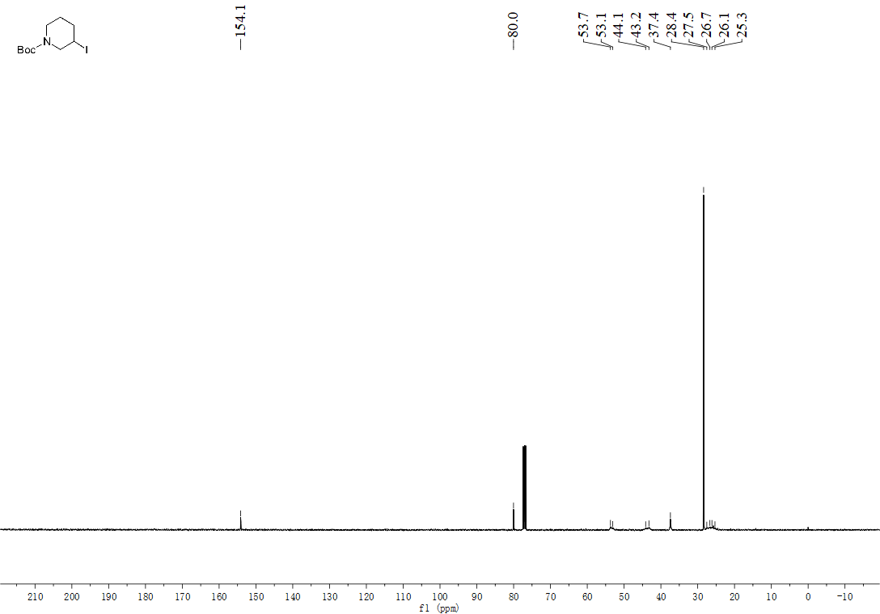

¹H NMR spectrum of benzyl 3-iodopiperidine-1-carboxylate (17):
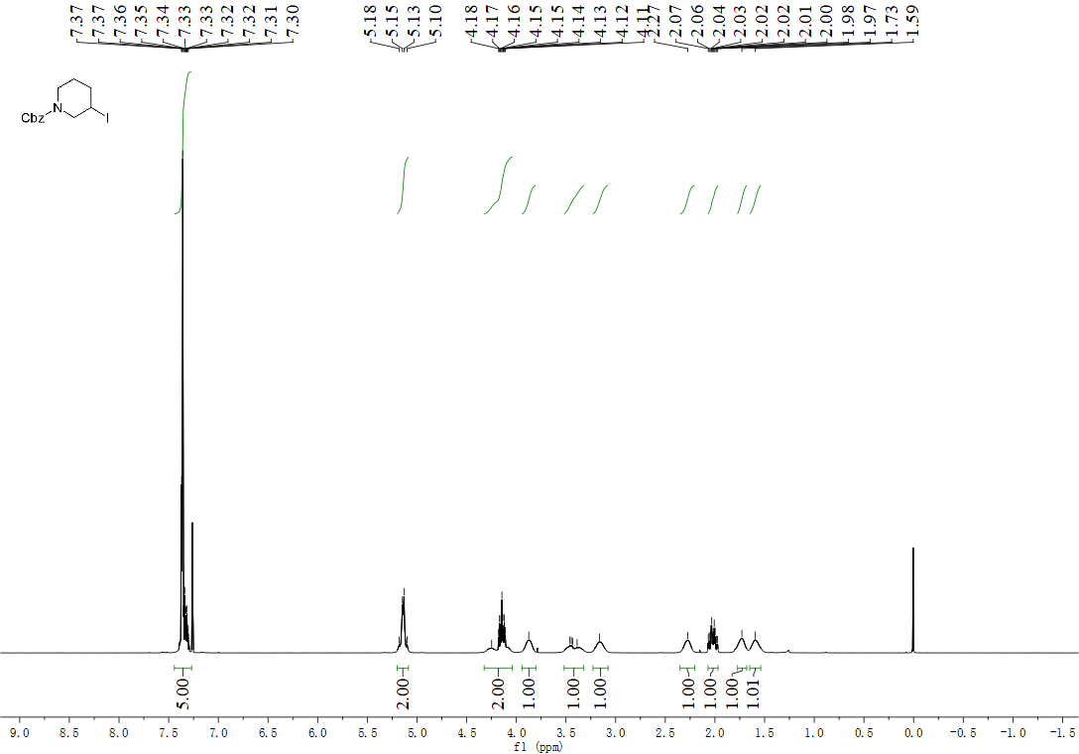

¹³C NMR spectrum of benzyl 3-iodopiperidine-1-carboxylate (17):
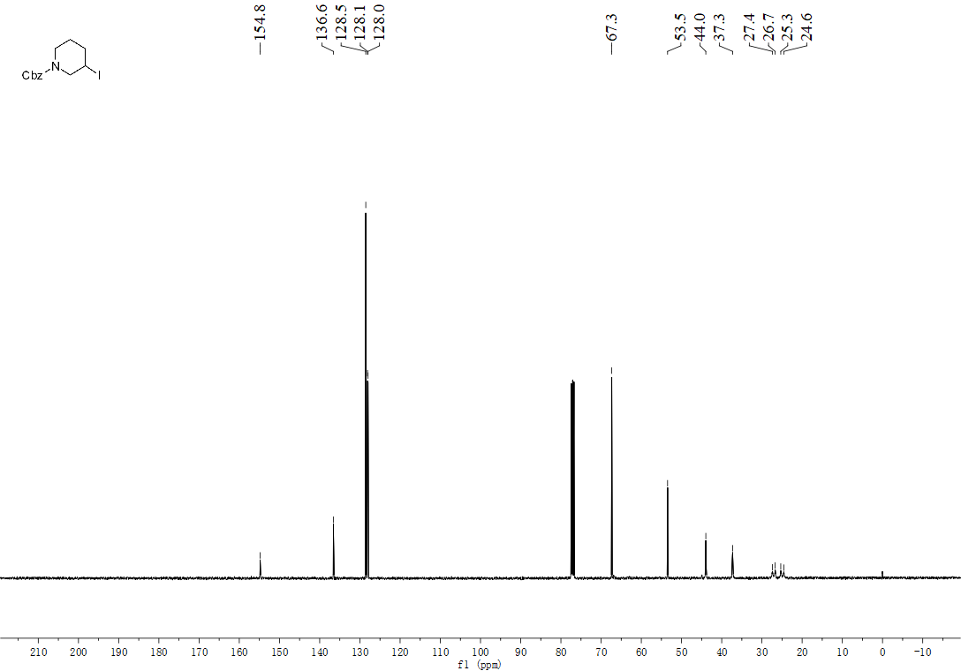

¹H NMR spectrum of (4-iodopiperidin-1-yl)(phenyl)methanone (18):
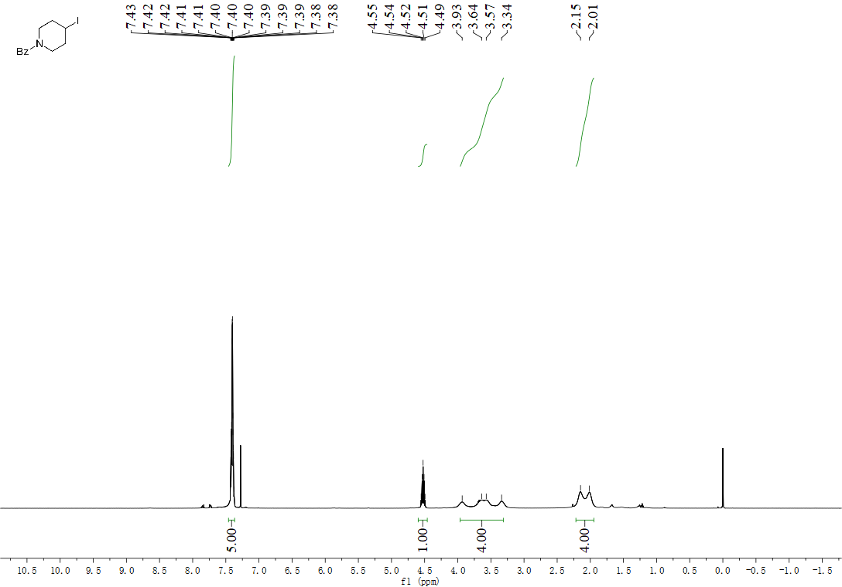

¹³C NMR spectrum of (4-iodopiperidin-1-yl)(phenyl)methanone (18):
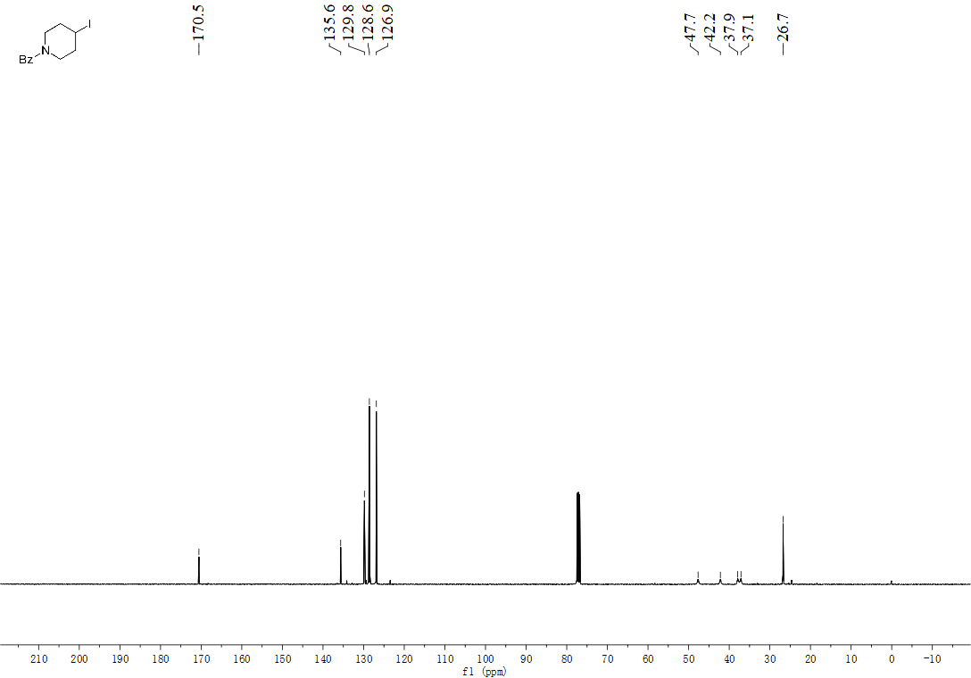

¹H NMR spectrum of benzyl 4-iodopiperidine-1-carboxylate (19):
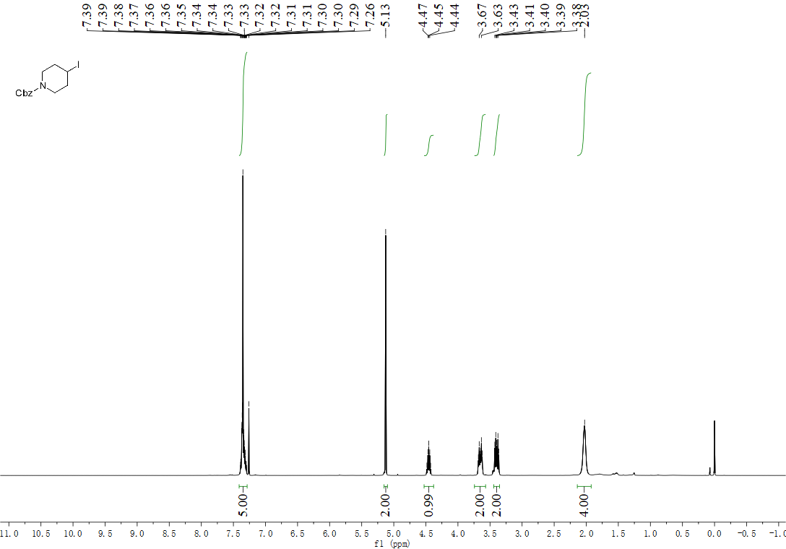

¹³C NMR spectrum of benzyl 4-iodopiperidine-1-carboxylate (19):
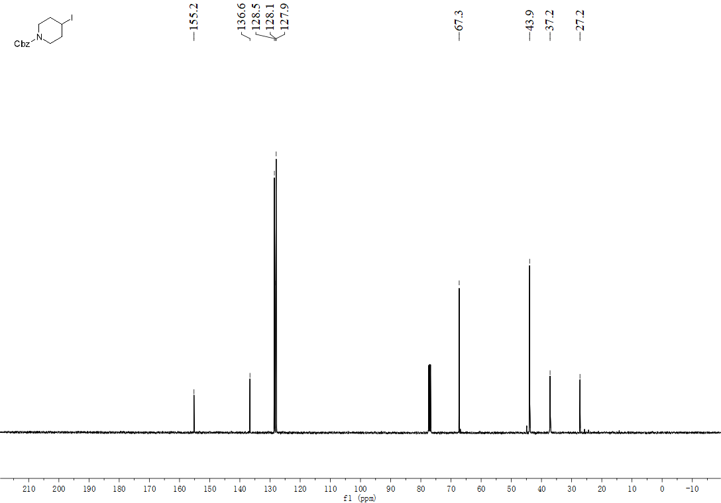
¹H NMR spectrum of (4-iodophenyl)(4-iodopiperidin-1-yl)methanone (20):
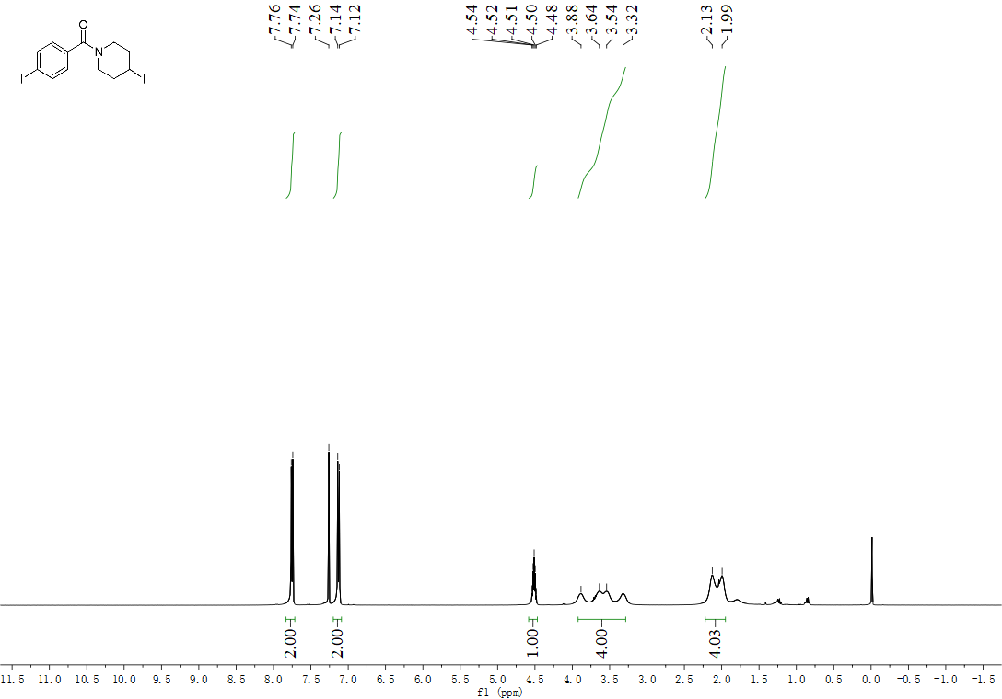

¹³C NMR spectrum of (4-iodophenyl)(4-iodopiperidin-1-yl)methanone (20):
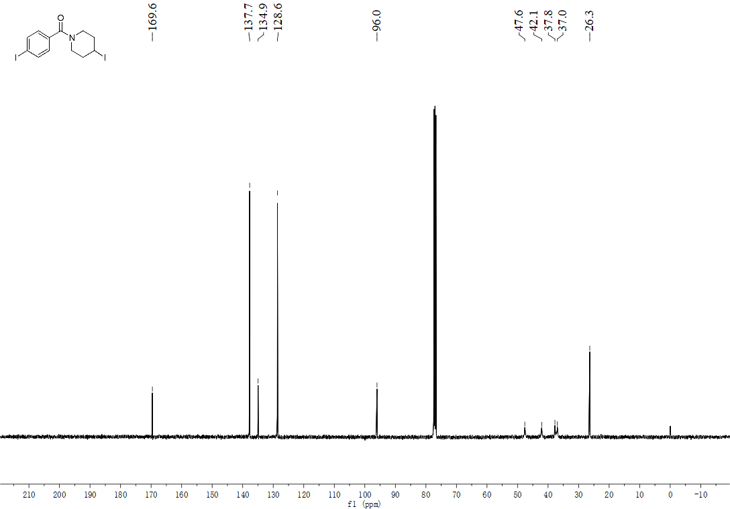
¹H NMR spectrum of (4-iodopentyl)benzene (21):
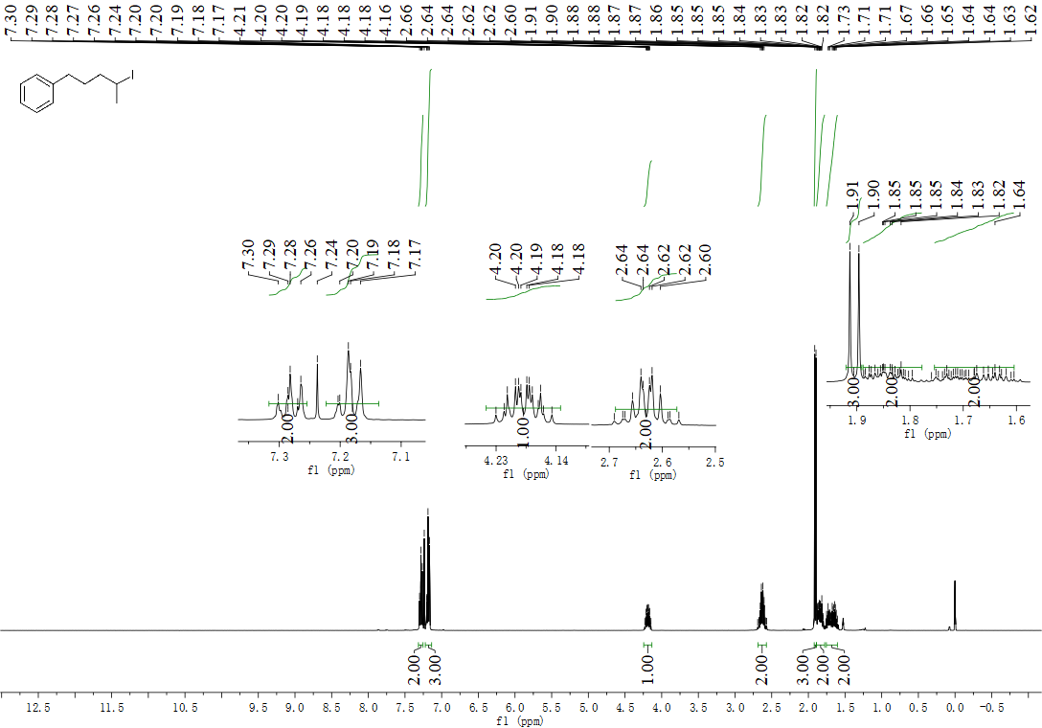

¹³C NMR spectrum of (4-iodopentyl)benzene (21):
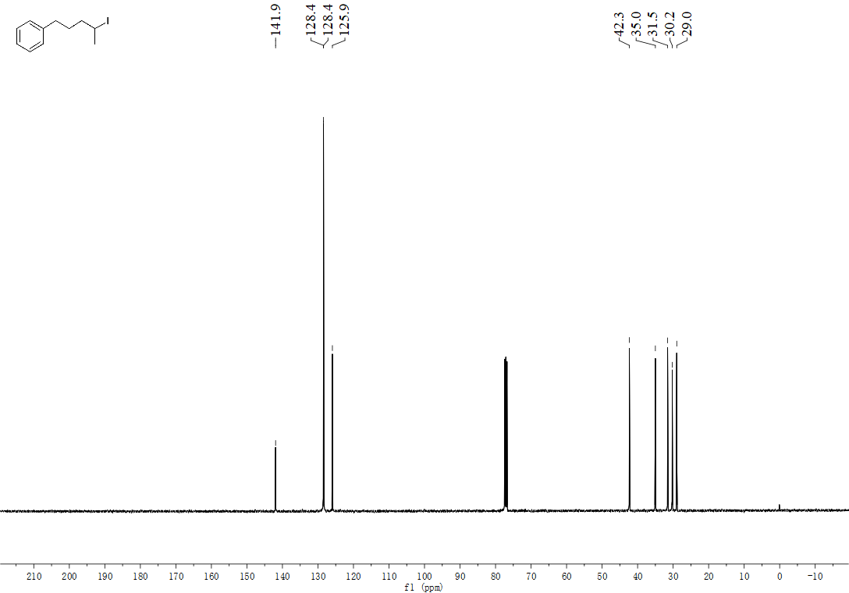
¹H NMR spectrum of 2-iodopentadecane (22):
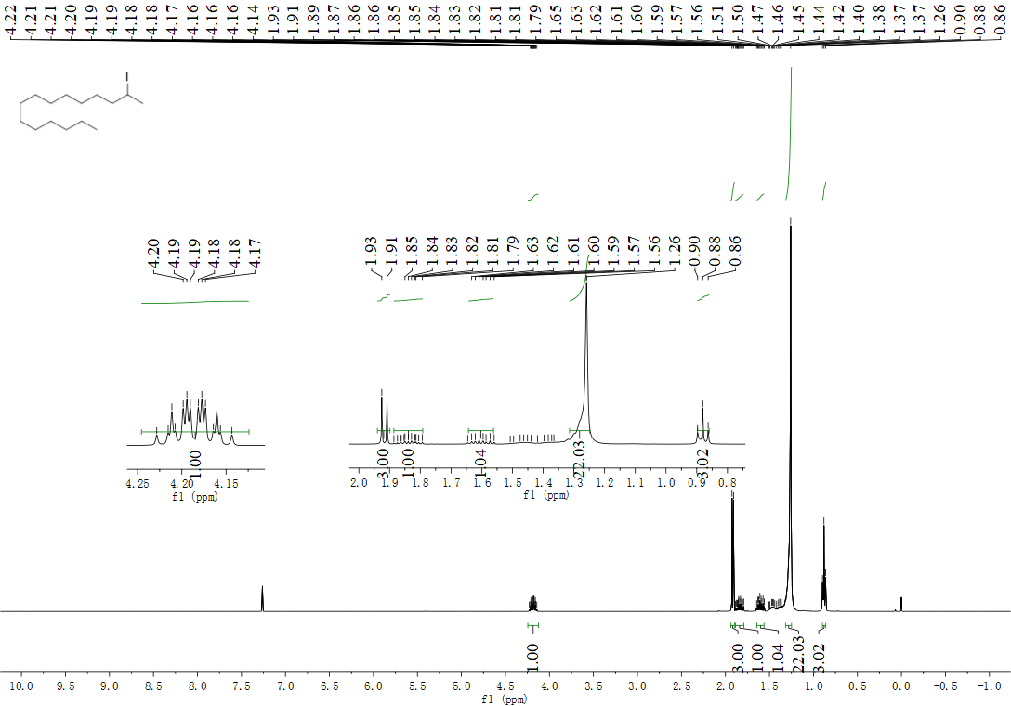

¹³C NMR spectrum of 2-iodopentadecane (22):
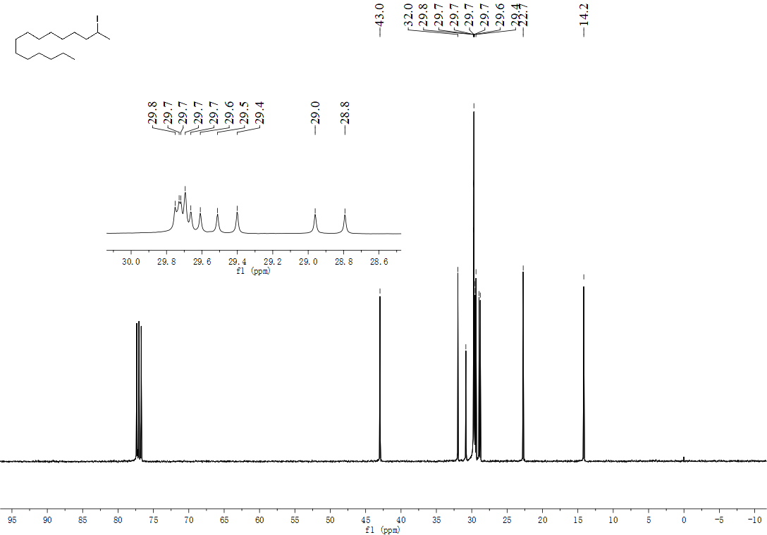
¹H NMR spectrum of 1-iodoadamantane (23):
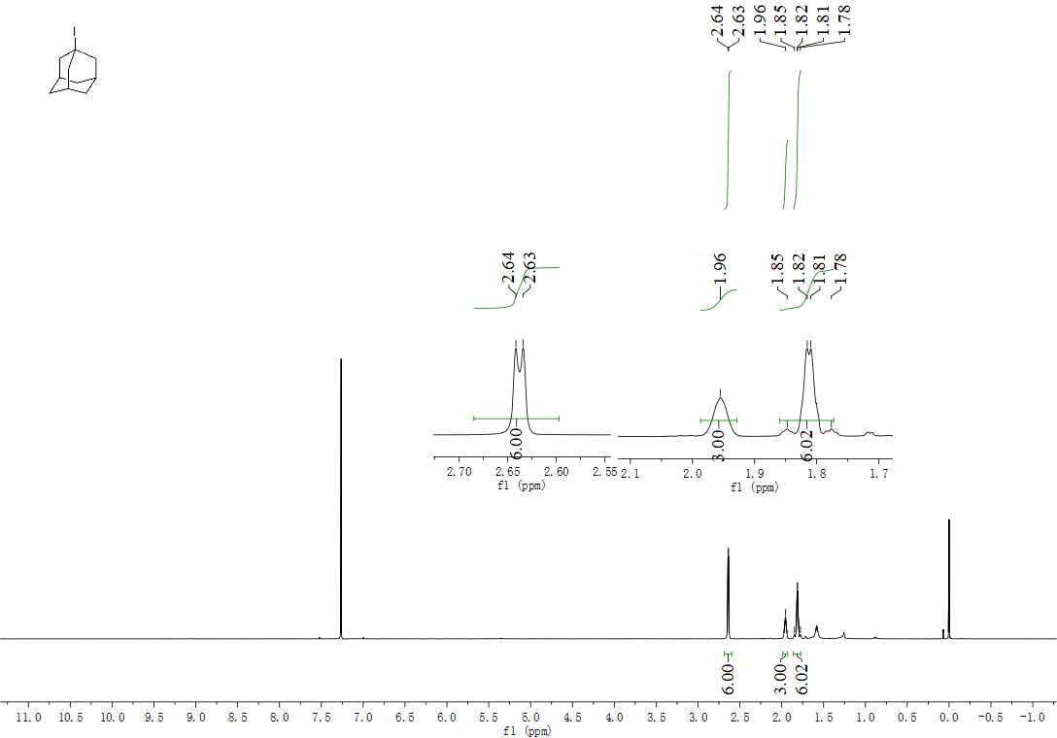

¹³C NMR spectrum of 1-iodoadamantane (23):
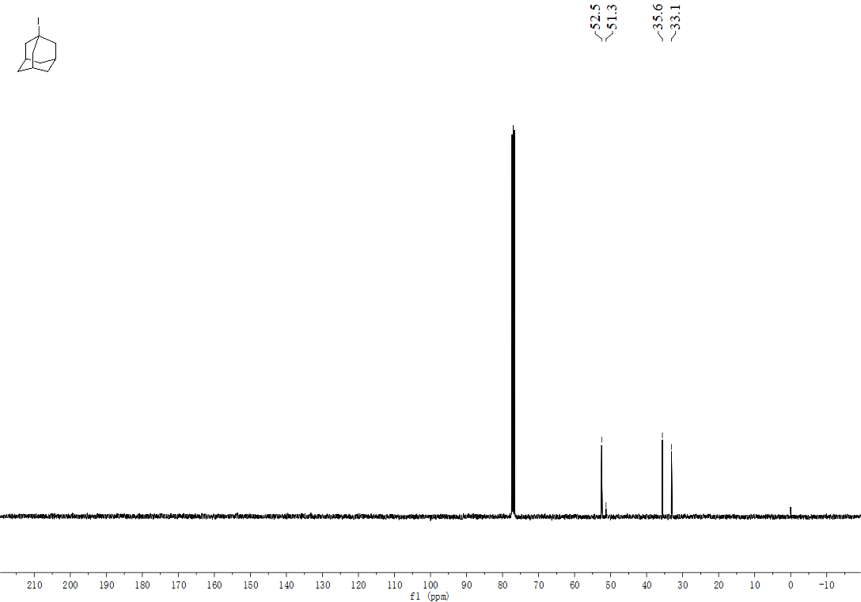

¹H NMR spectrum of 5-iodoadamantan-2-one (24):
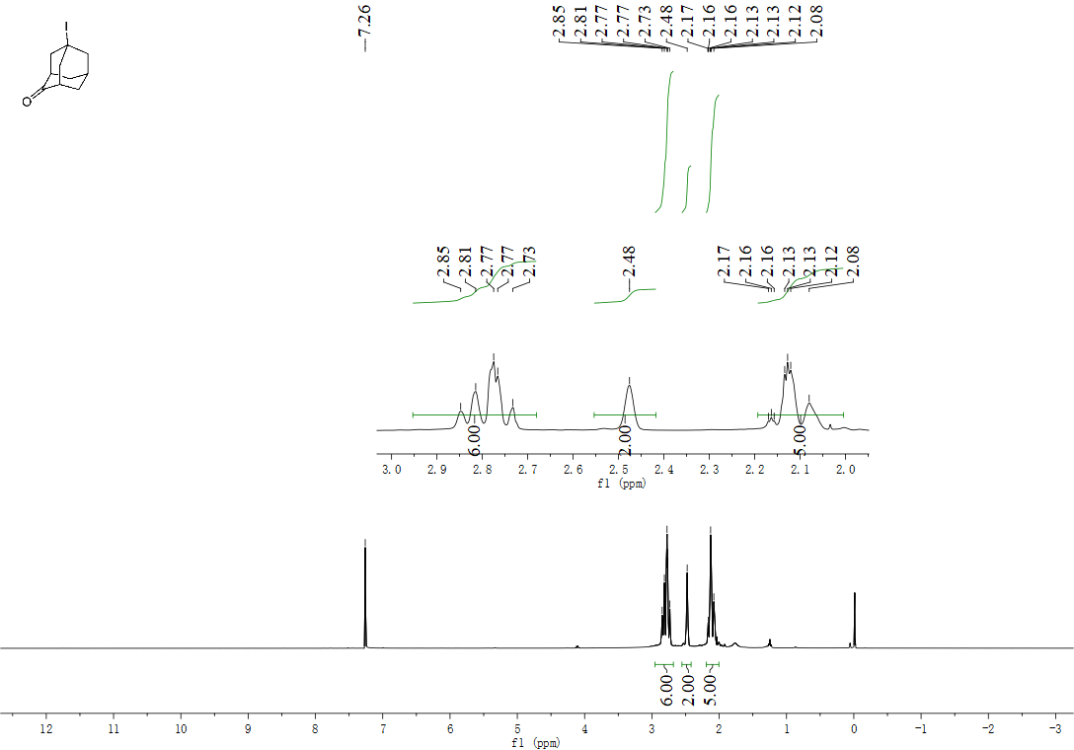

¹³C NMR spectrum of 5-iodoadamantan-2-one (24):
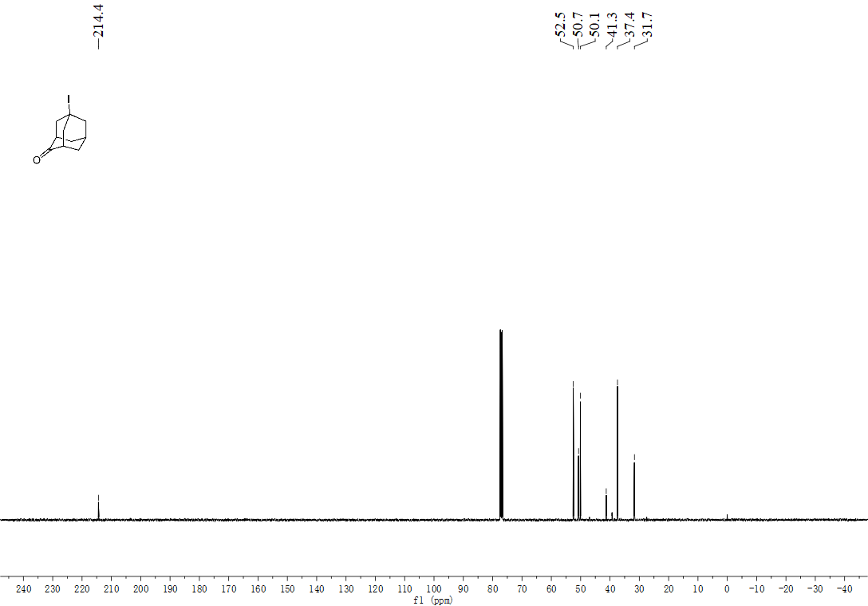

¹H NMR spectrum of 3-iodoadamantan-1-ol (25):
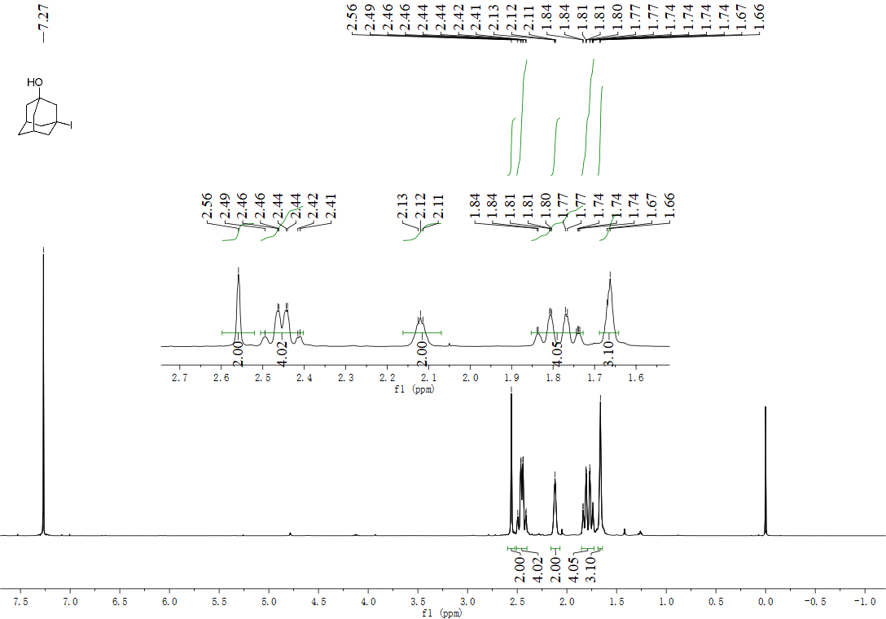

¹³C NMR spectrum of 3-iodoadamantan-1-ol (25):
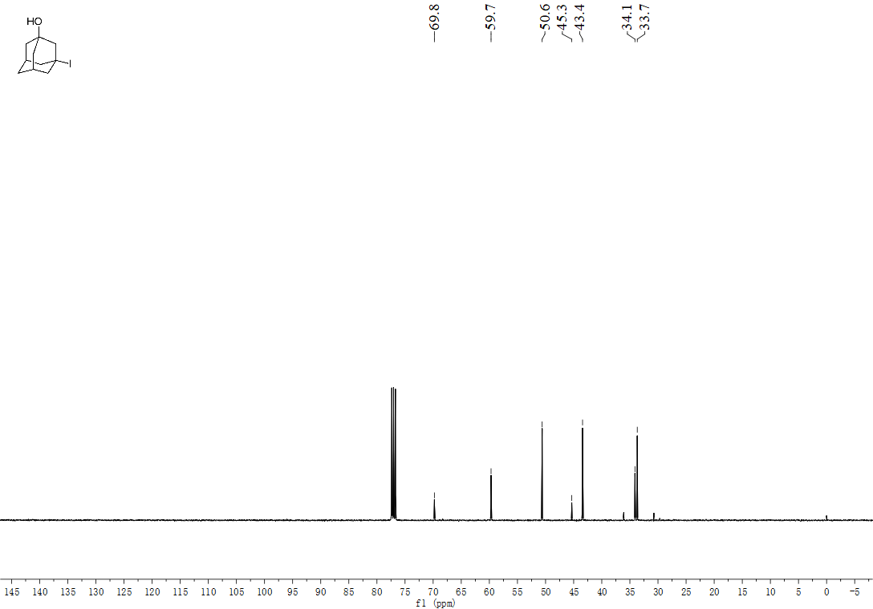
¹H NMR spectrum of methyl 4-iodobicyclo[2.2.2]octane-1-carboxylate (26):
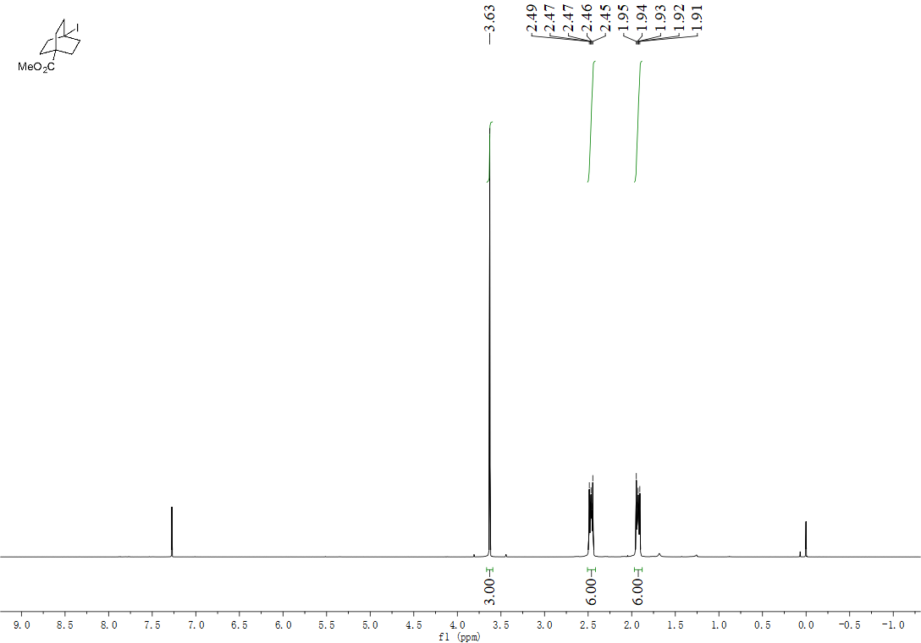

¹³C NMR spectrum of methyl 4-iodobicyclo[2.2.2]octane-1-carboxylate (26):
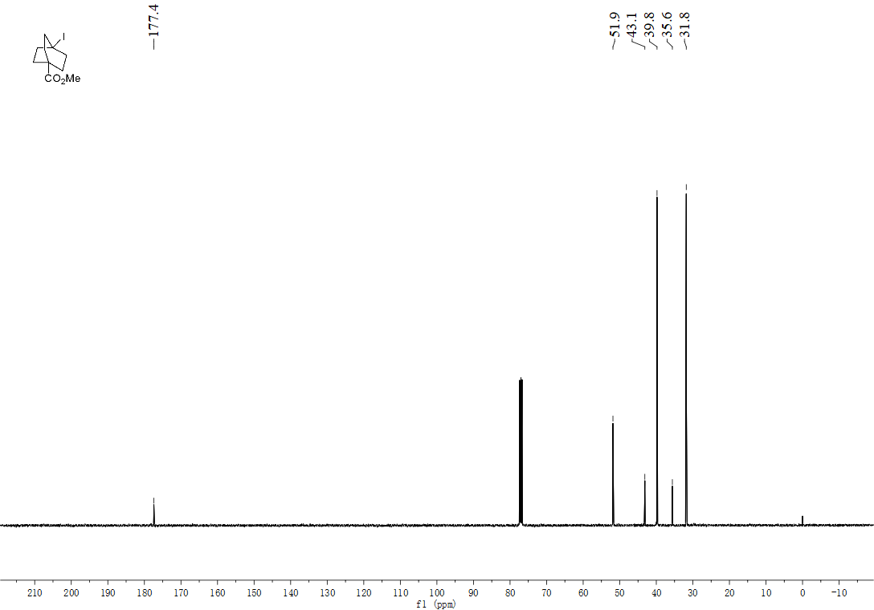
¹H NMR spectrum of methyl 3-iodobicyclo[1.1.1]pentane-1-carboxylate (27):
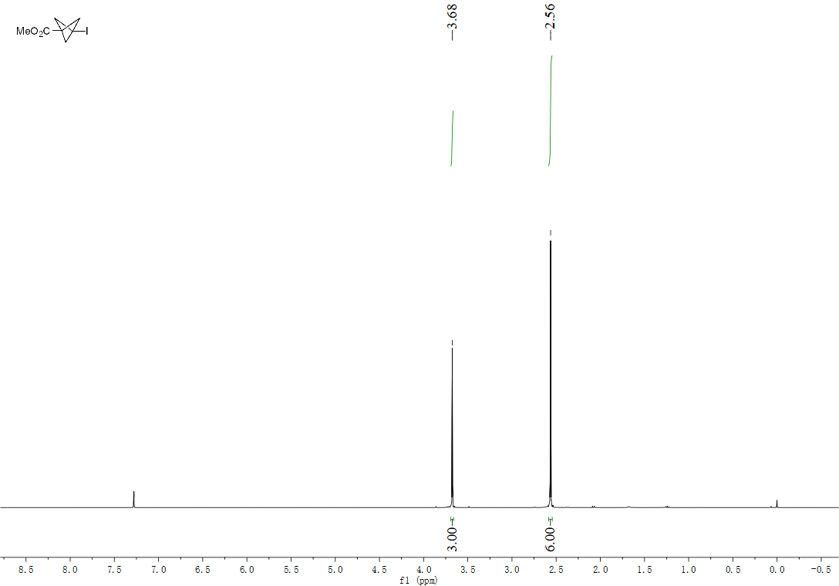

¹³C NMR spectrum of methyl 3-iodobicyclo[1.1.1]pentane-1-carboxylate (27):
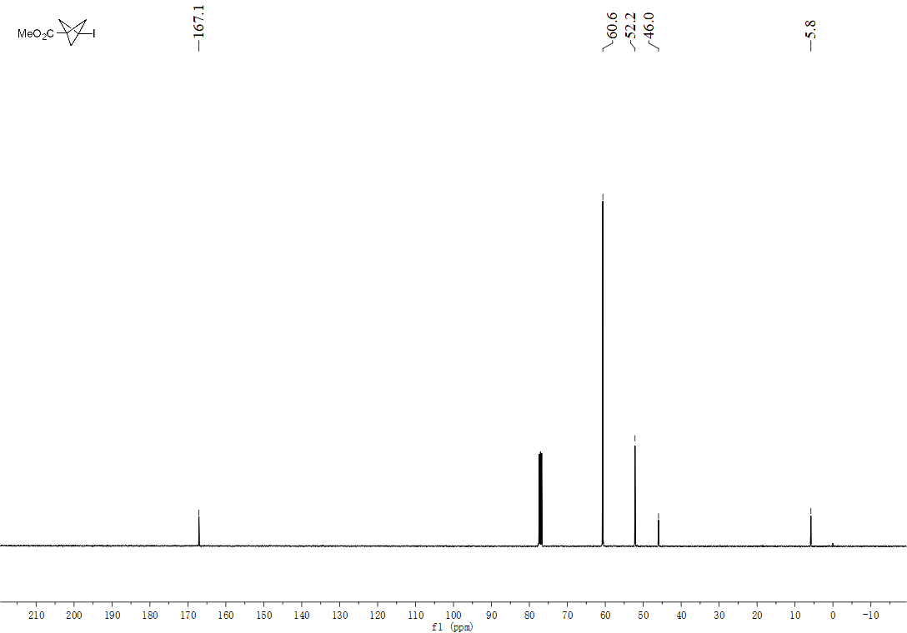

¹H NMR spectrum of (6Z, 9Z)-17-iodoheptadeca-6,9-diene (28):
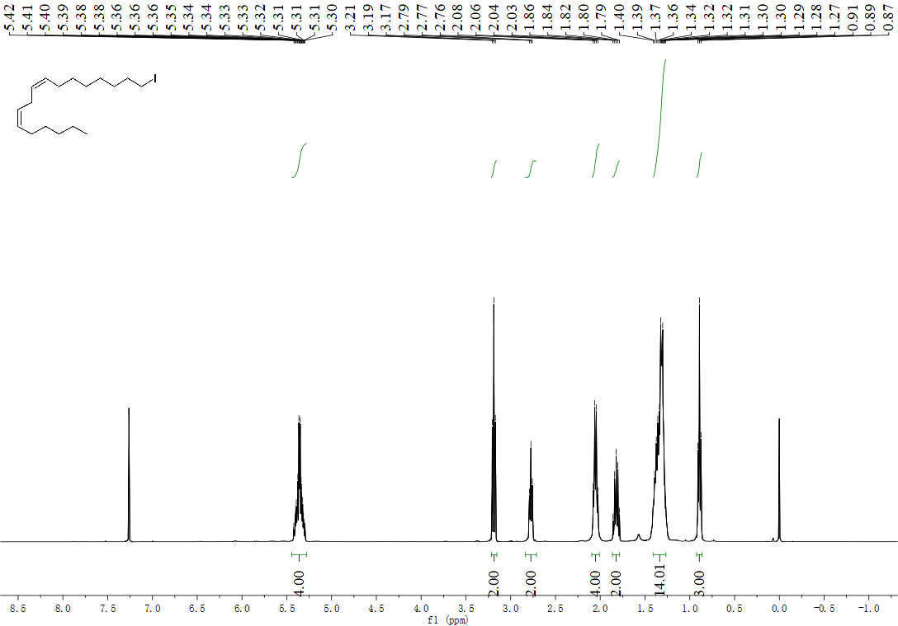

¹³C NMR spectrum of (6Z, 9Z)-17-iodoheptadeca-6,9-diene (28):
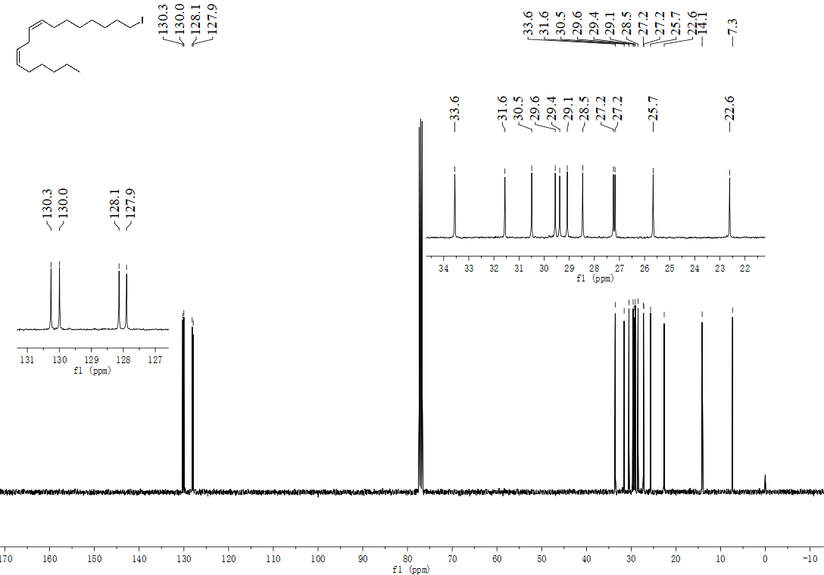
¹H NMR spectrum of (Z)-1-iodoheptadec-8-ene (29):
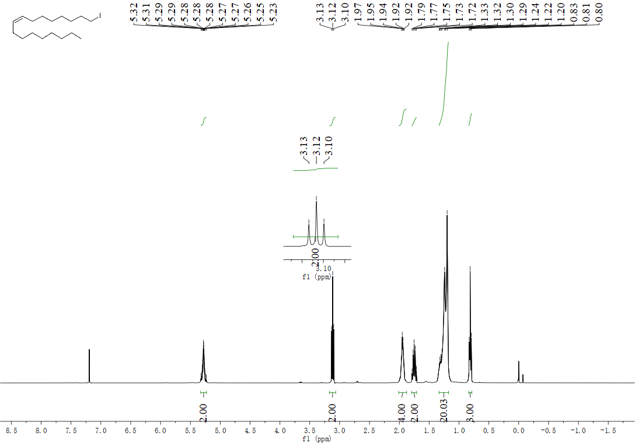

¹³C NMR spectrum of (Z)-1-iodoheptadec-8-ene (29):
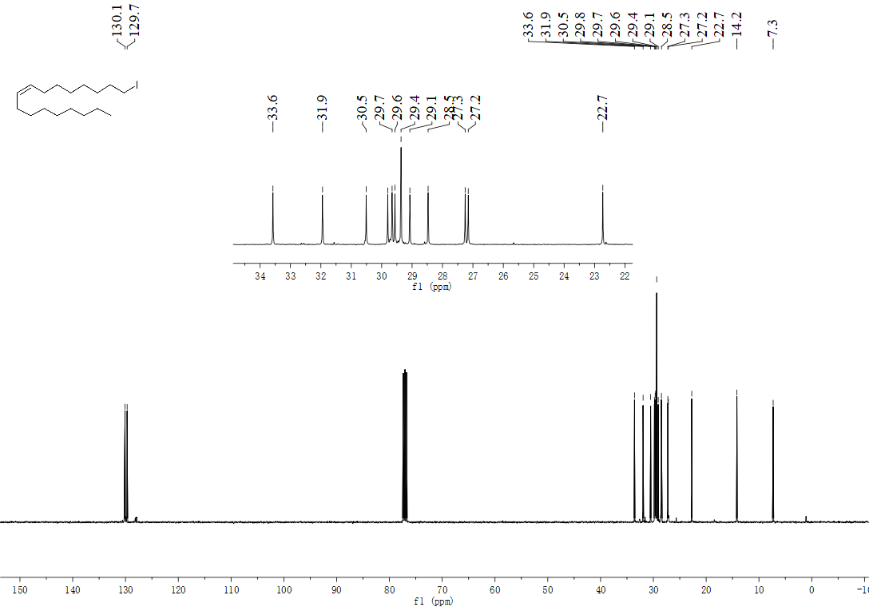

¹H NMR spectrum of (Z)-21-iodohenicos-9-ene (30):
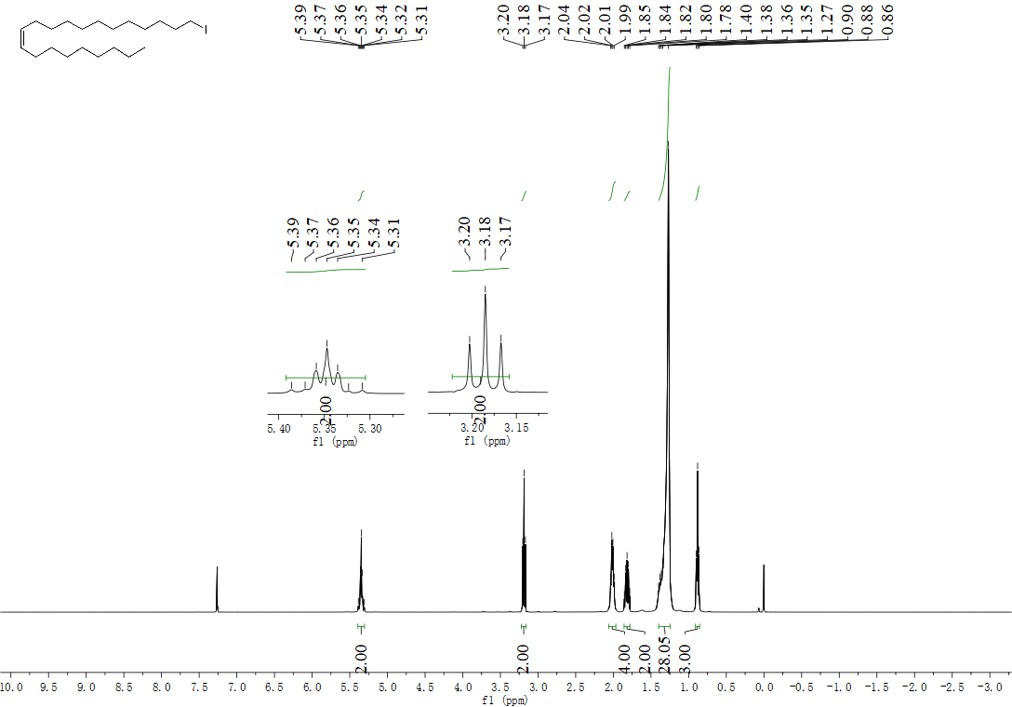

¹³C NMR spectrum of (Z)-21-iodohenicos-9-ene (30):
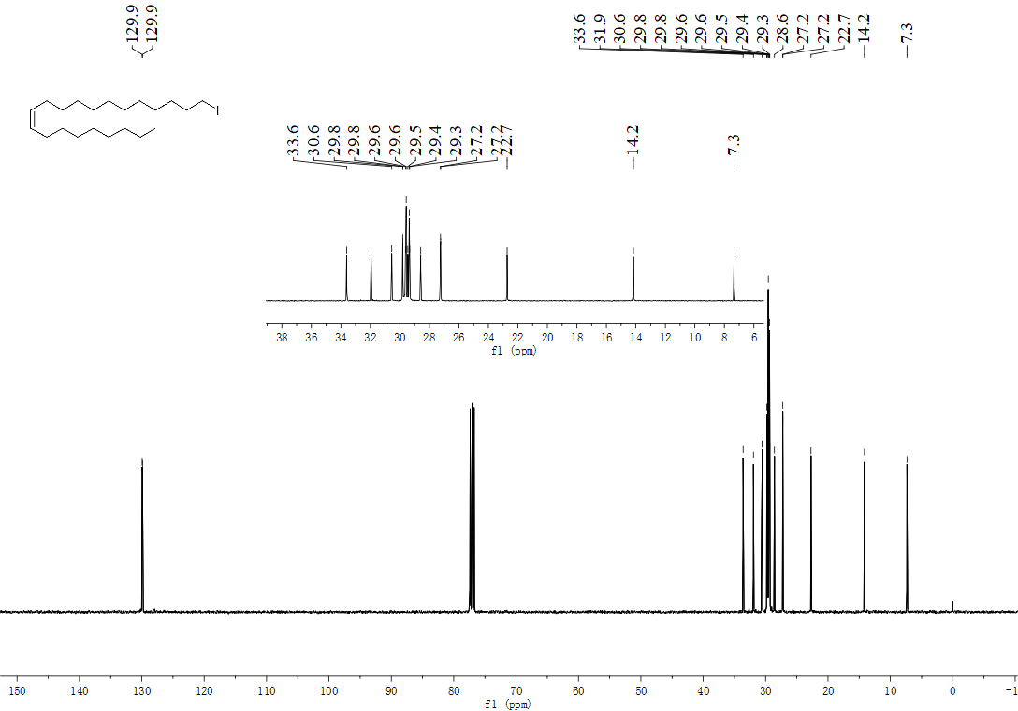
¹H NMR spectrum of 10-iododec-1-ene (31):
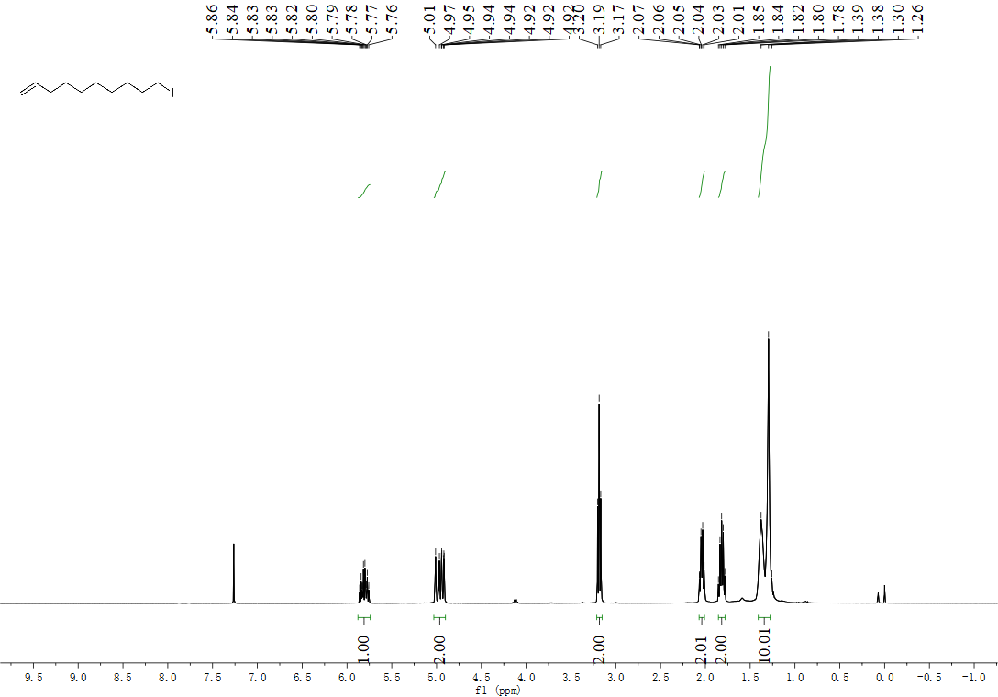

¹³C NMR spectrum of 10-iododec-1-ene (31):
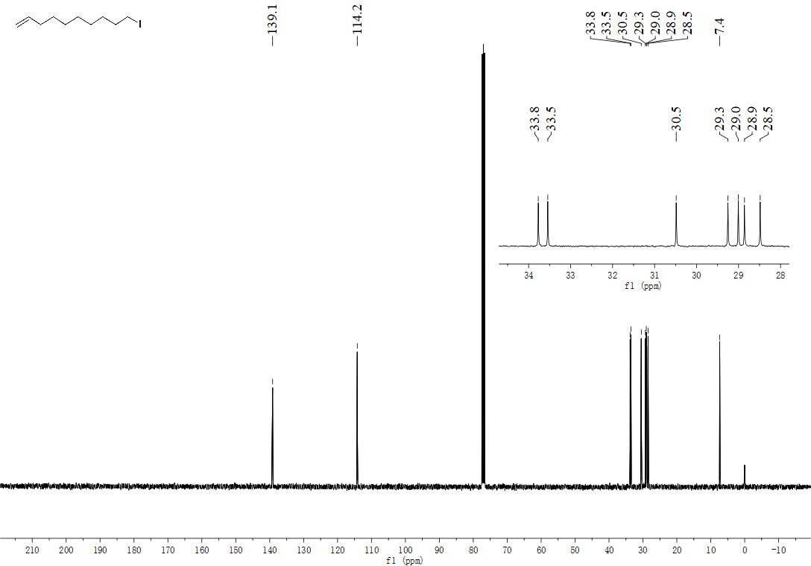

¹H NMR spectrum of (S)-benzyl (2-(iodomethyl)-4-methylpentyl)carbamate (32):
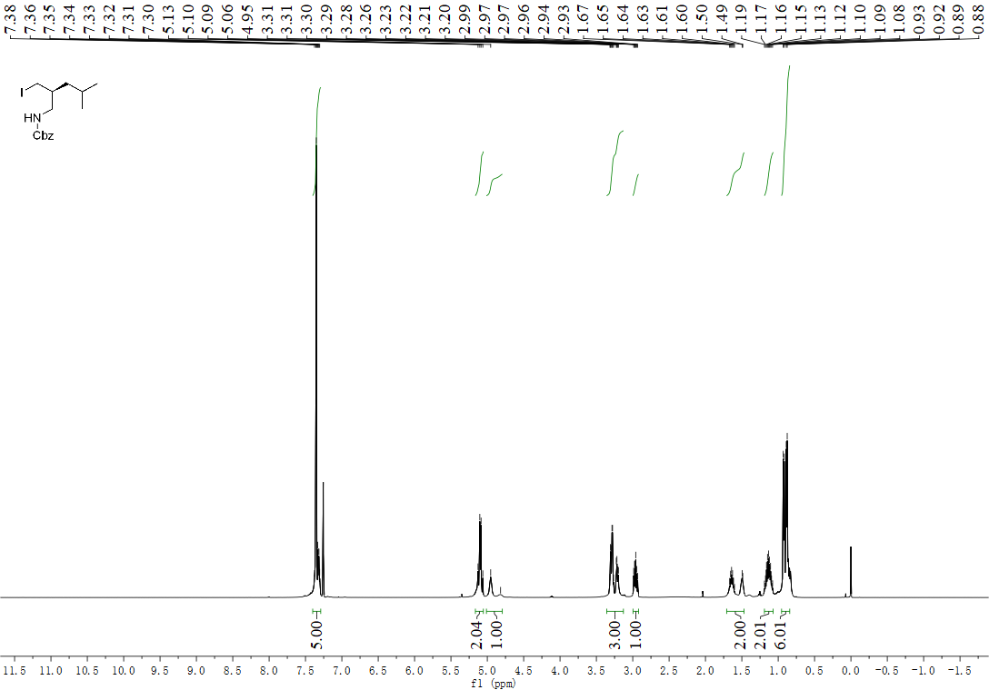

¹³C NMR spectrum of (S)-benzyl (2-(iodomethyl)-4-methylpentyl)carbamate (32):
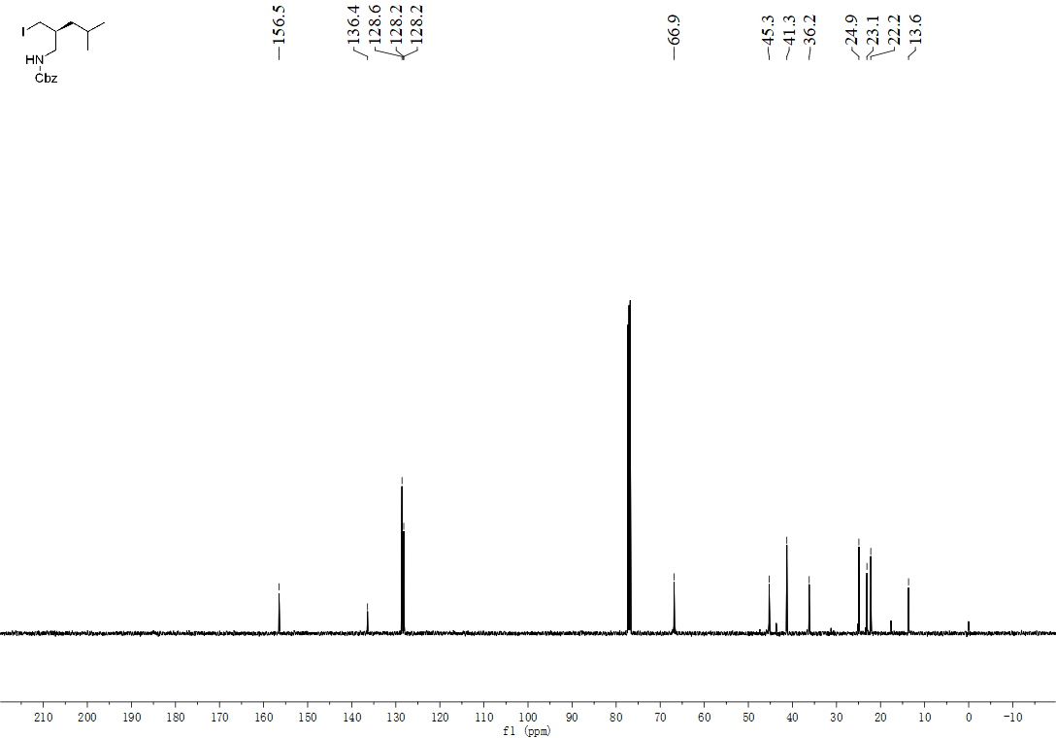
¹H NMR spectrum of (S)-tert-butyl (2-(iodomethyl)-4-methylpentyl)carbamate (33):
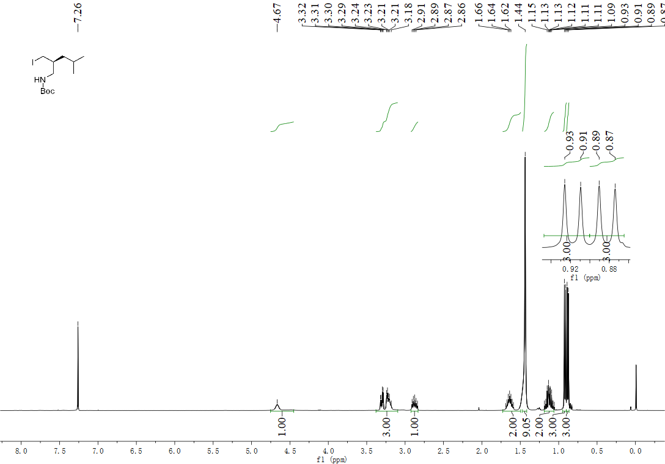

¹³C NMR spectrum of (S)-tert-butyl (2-(iodomethyl)-4-methylpentyl)carbamate (33):
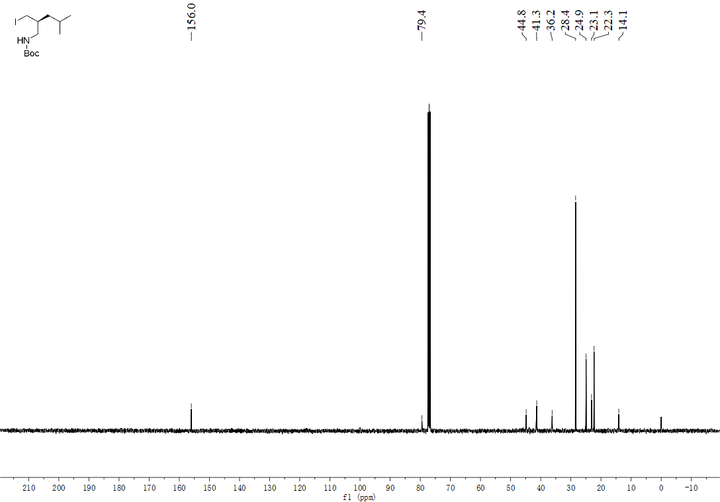
¹H NMR spectrum of (E)-7-hydroxy-6-(5-iodo-3-methylpent-2-en-1-yl)-5-methoxy-4-methylisobenzofuran-1(3H)-one (34):
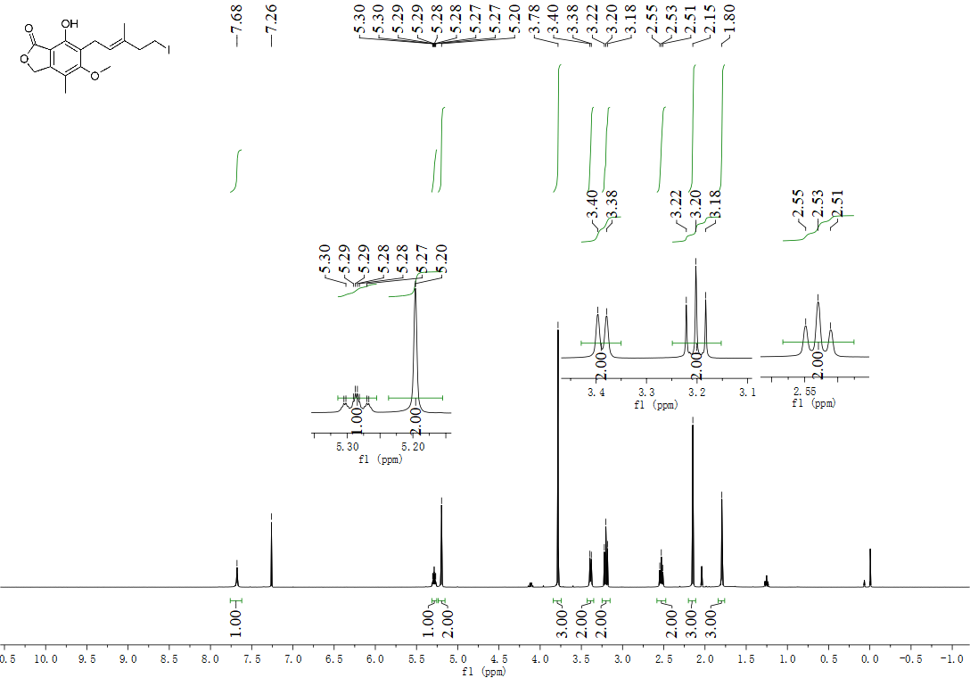
¹³C NMR spectrum of (E)-7-hydroxy-6-(5-iodo-3-methylpent-2-en-1-yl)-5-methoxy-4-methylisobenzofuran-1(3H)-one (34):
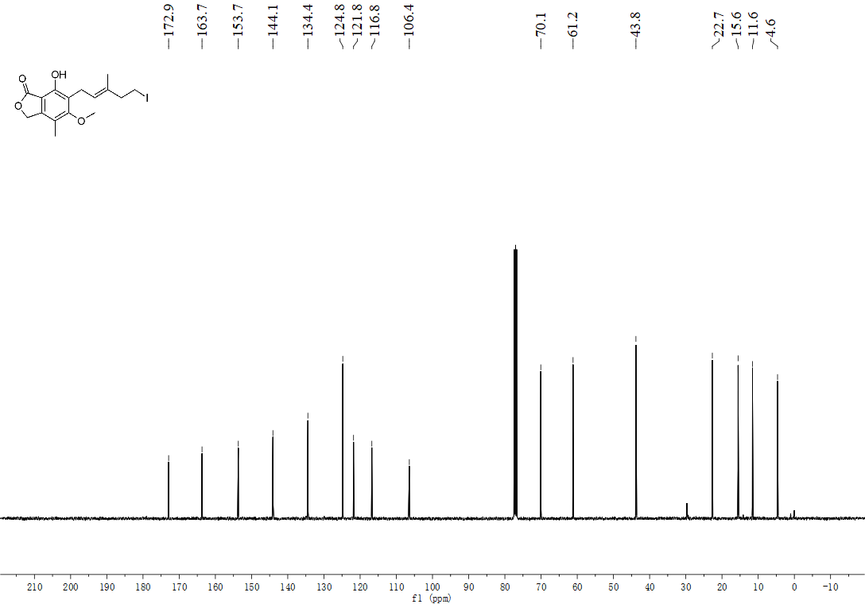
¹H NMR spectrum of benzyl ((1-(iodomethyl)cyclohexyl)methyl)carbamate (35):
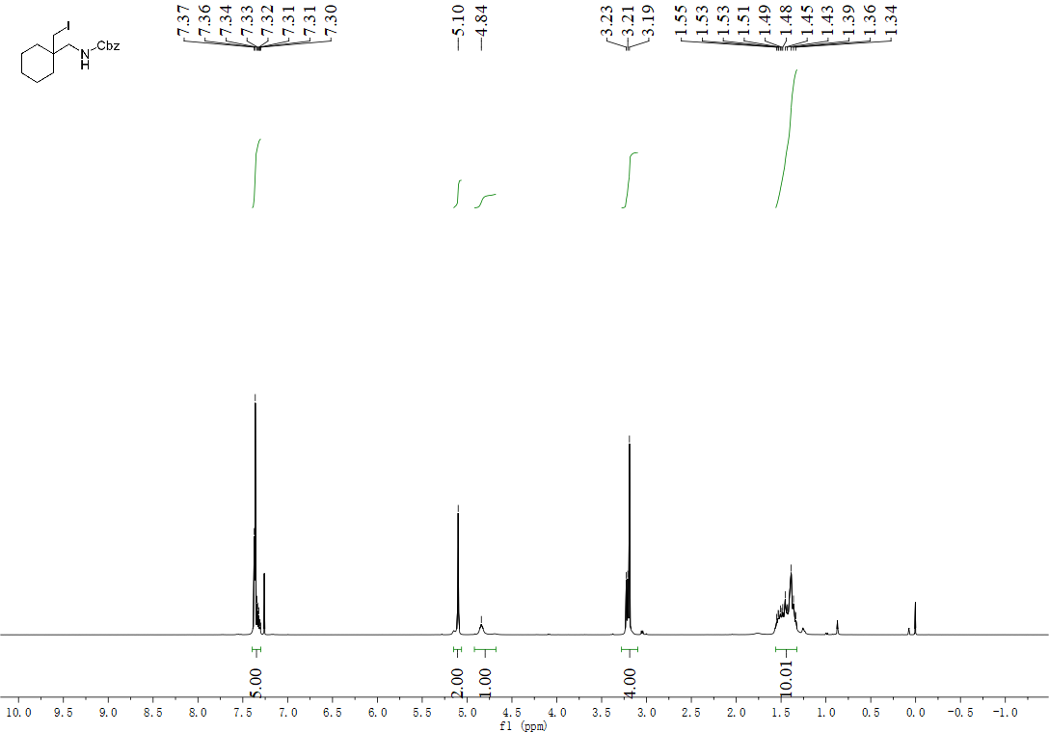

¹³C NMR spectrum of benzyl ((1-(iodomethyl)cyclohexyl)methyl)carbamate (35):
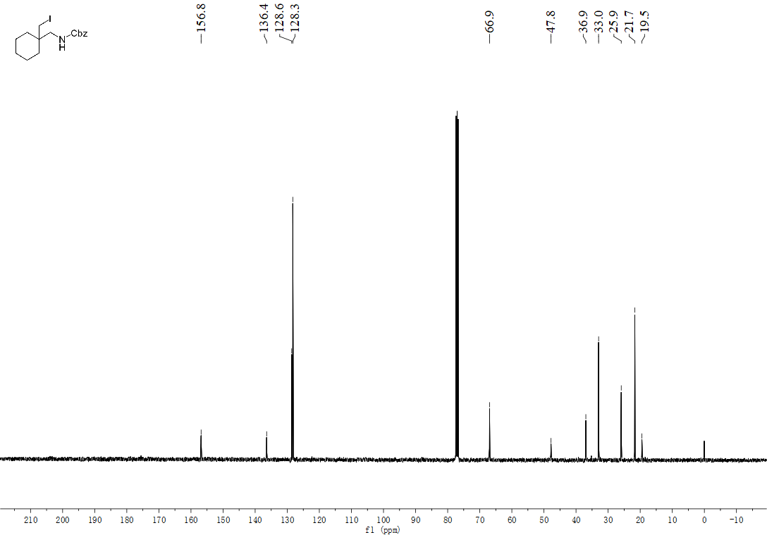
¹H NMR spectrum of tert-butyl ((1-(iodomethyl)cyclohexyl)methyl)carbamate (36):
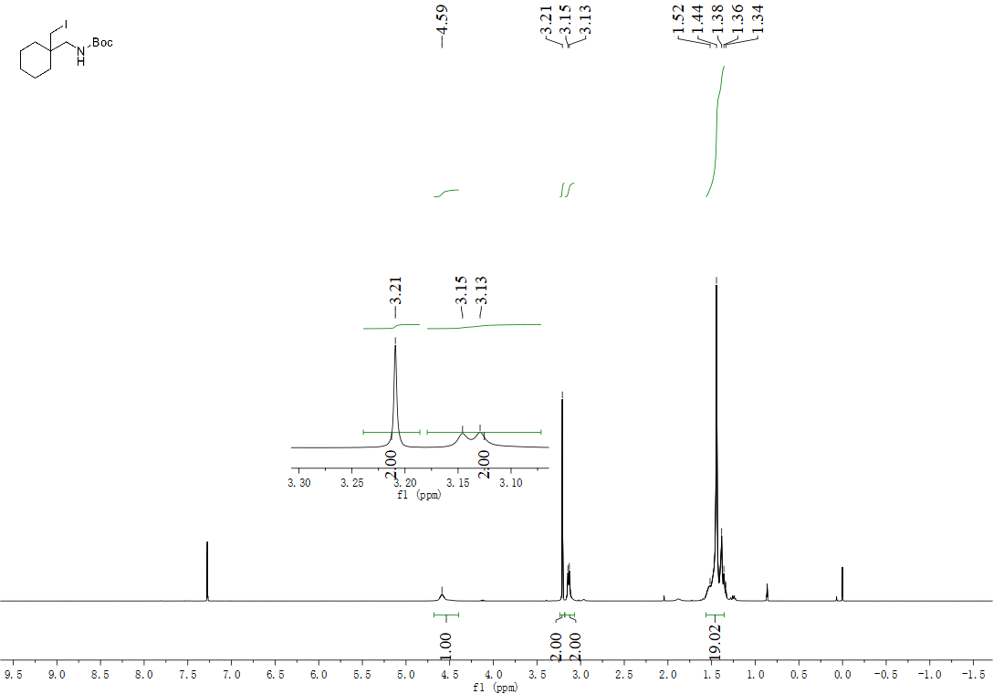

¹³C NMR spectrum of tert-butyl ((1-(iodomethyl)cyclohexyl)methyl)carbamate (36):
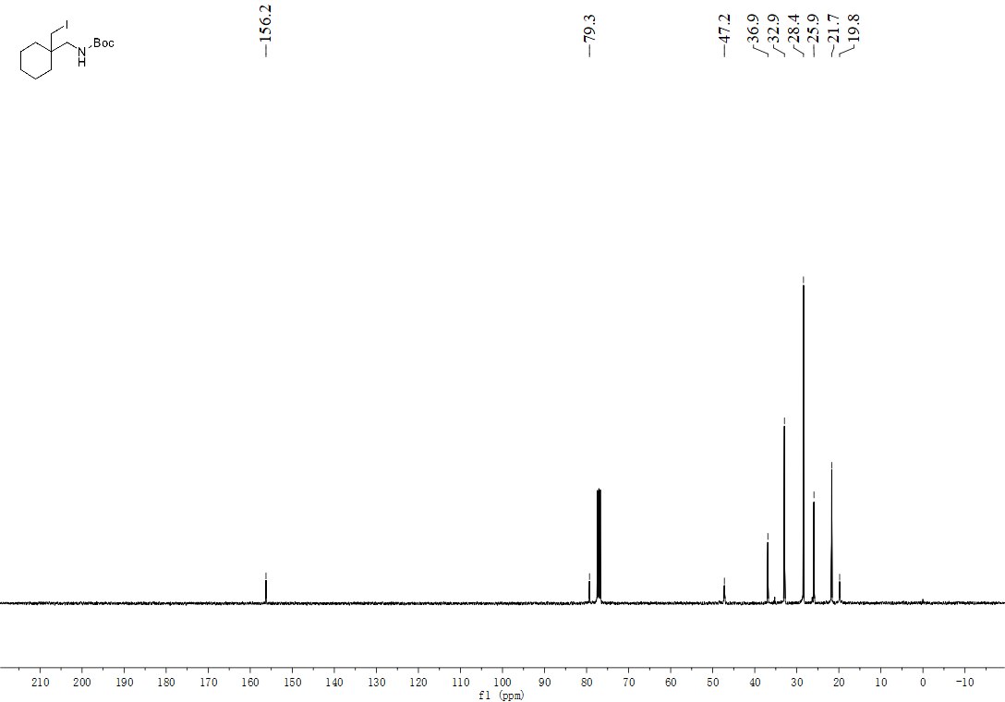
¹H NMR spectrum of (5S,9S,10S,13R,14S,17R)-17-((R)-4-iodobutan-2-yl)-10,13-dimethyldecahydro-1H-cyclopenta[a]phenanthrene-3,7,12(2H,4H,8H)-trione (37):
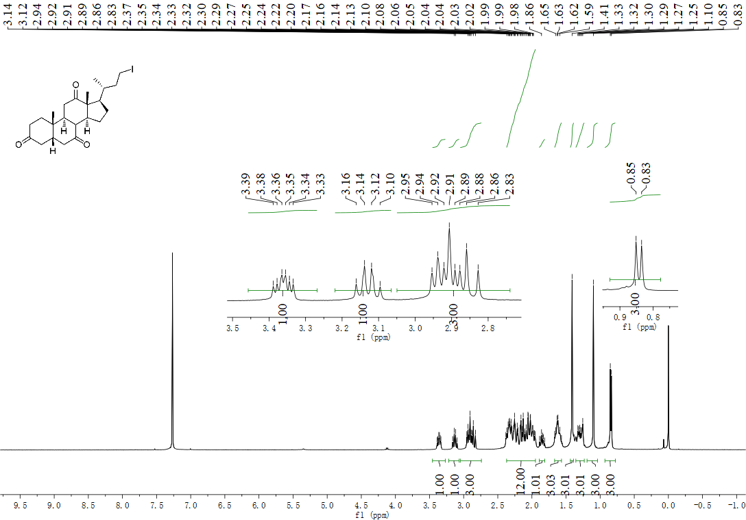
¹³C NMR spectrum of (5S,9S,10S,13R,14S,17R)-17-((R)-4-iodobutan-2-yl)-10,13-dimethyldecahydro-1H-cyclopenta[a]phenanthrene-3,7,12(2H,4H,8H)-trione (37):
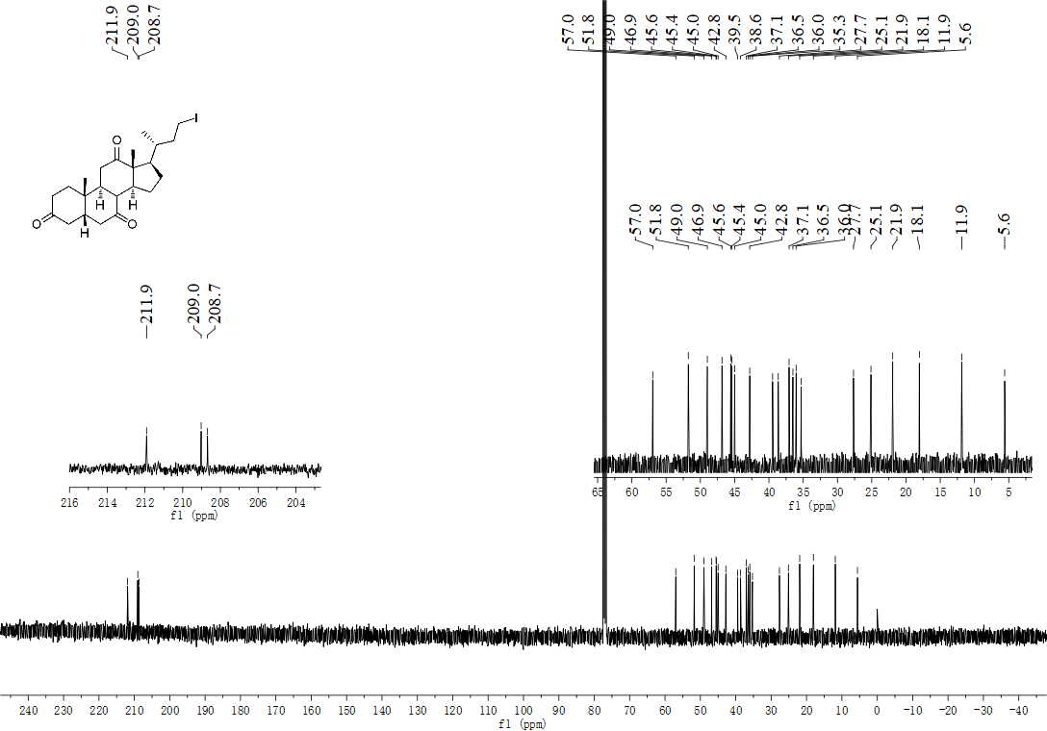
¹H NMR spectrum of N,N-bis(2-chloroethyl)-4-(3-iodopropyl)aniline (38):
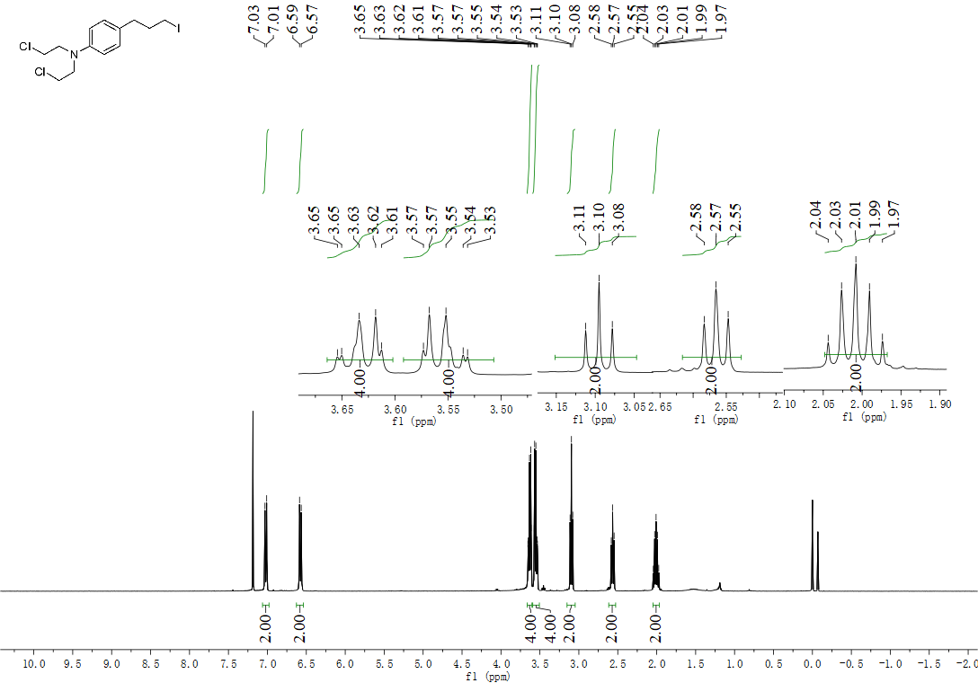

¹³C NMR spectrum of N,N-bis(2-chloroethyl)-4-(3-iodopropyl)aniline (38):
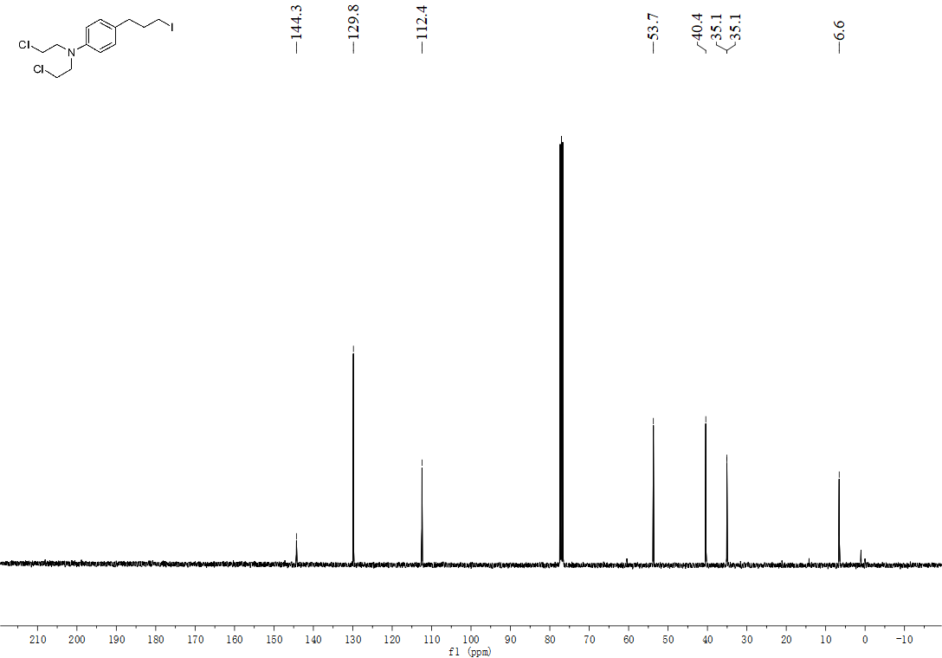
¹H NMR spectrum of tert-butyl (2-(4-chlorophenyl)-3-iodopropyl)carbamate (39):
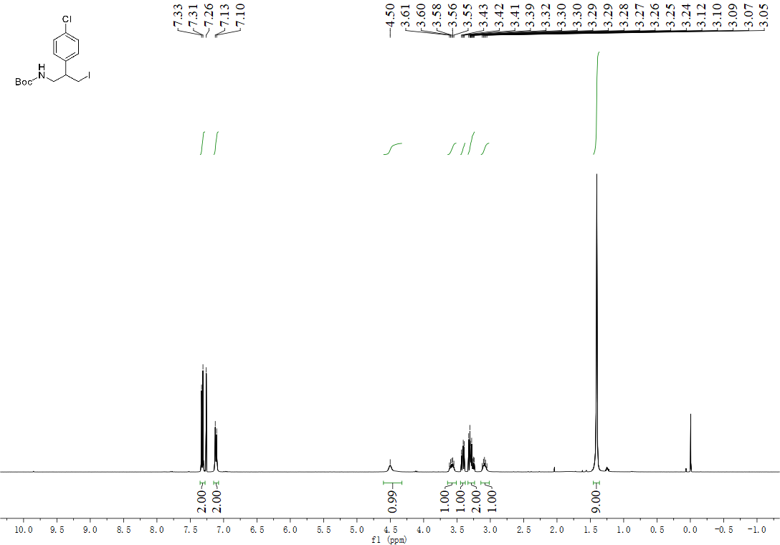

¹³C NMR spectrum of tert-butyl (2-(4-chlorophenyl)-3-iodopropyl)carbamate (39):
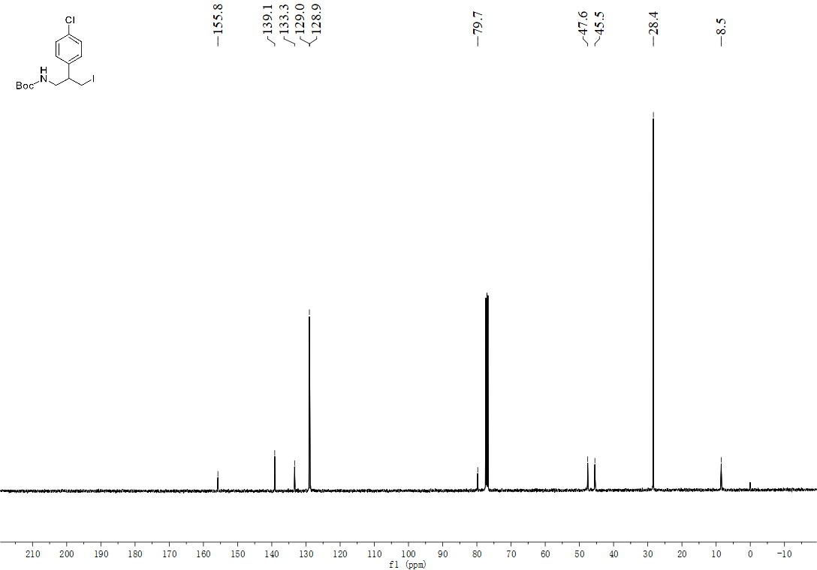
¹H NMR spectrum of (8R,9S,13S,14S)-3-((5-iodopentyl)oxy)-13-methyl-7,8,9,11,12,13,15,16-octahydro-6H-cyclopenta[a]phenanthren-17(14H)-one (40):
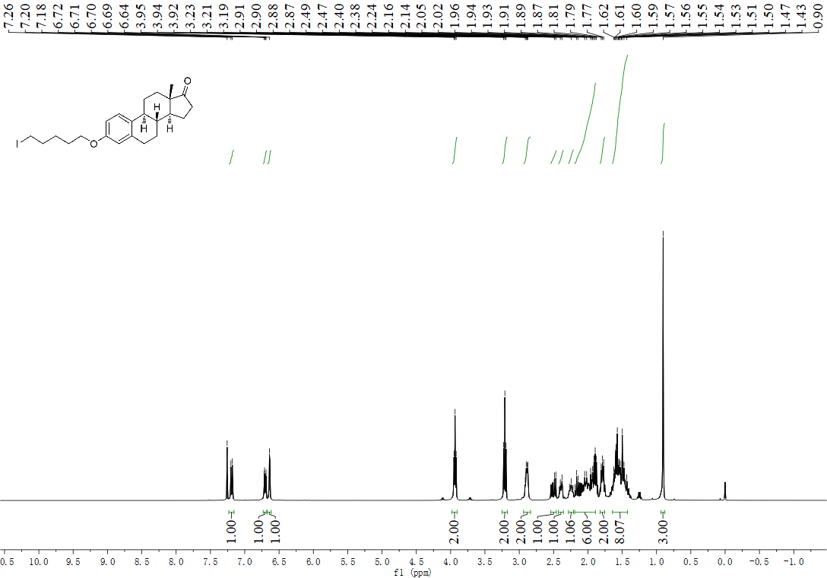

¹³C NMR spectrum of (8R,9S,13S,14S)-3-((5-iodopentyl)oxy)-13-methyl-7,8,9,11,12,13,15,16-octahydro-6H-cyclopenta[a]phenanthren-17(14H)-one (40):
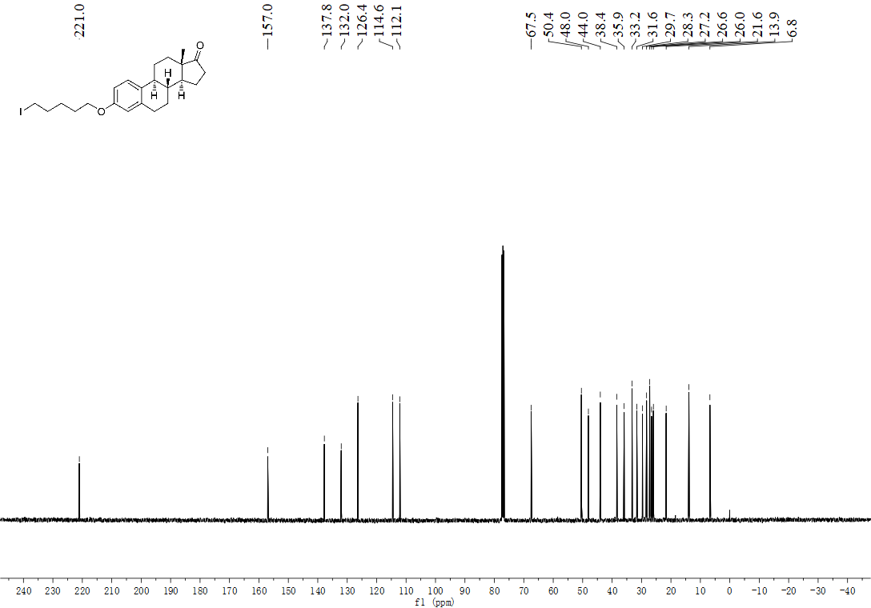
¹H NMR spectrum of (3R,5R,8R,9S,10S,13R,14S,17R)-17-((R)-4-iodobutan-2-yl) -10,13-dimethylhexadecahydro-1H-cyclopenta[a]phenanthren-3-ol (41):
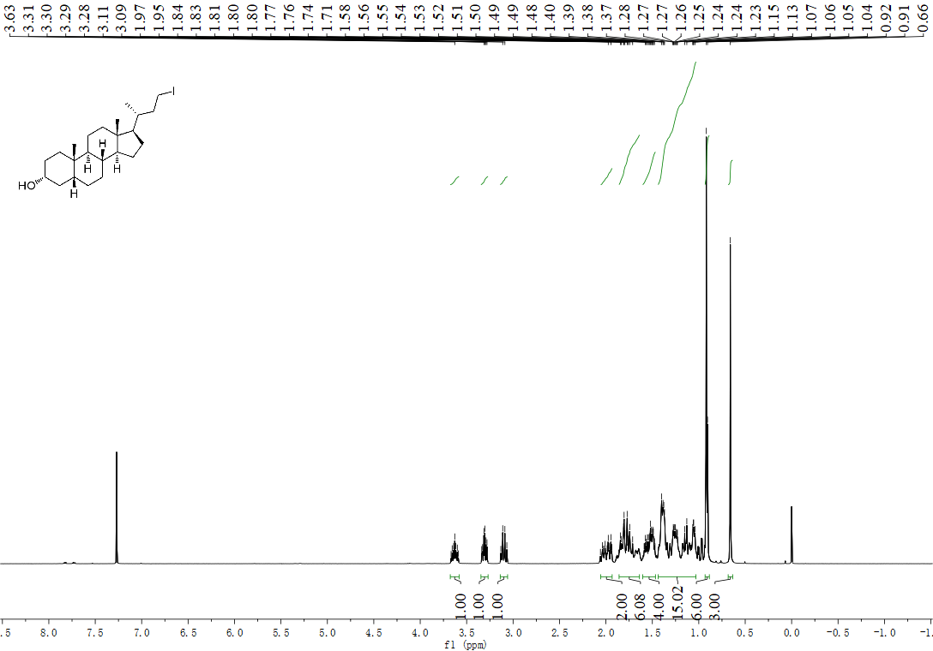
¹³C NMR spectrum of (3R,5R,8R,9S,10S,13R,14S,17R)-17-((R)-4-iodobutan-2-yl)- 10,13-dimethylhexadecahydro-1H-cyclopenta[a]phenanthren-3-ol (41):
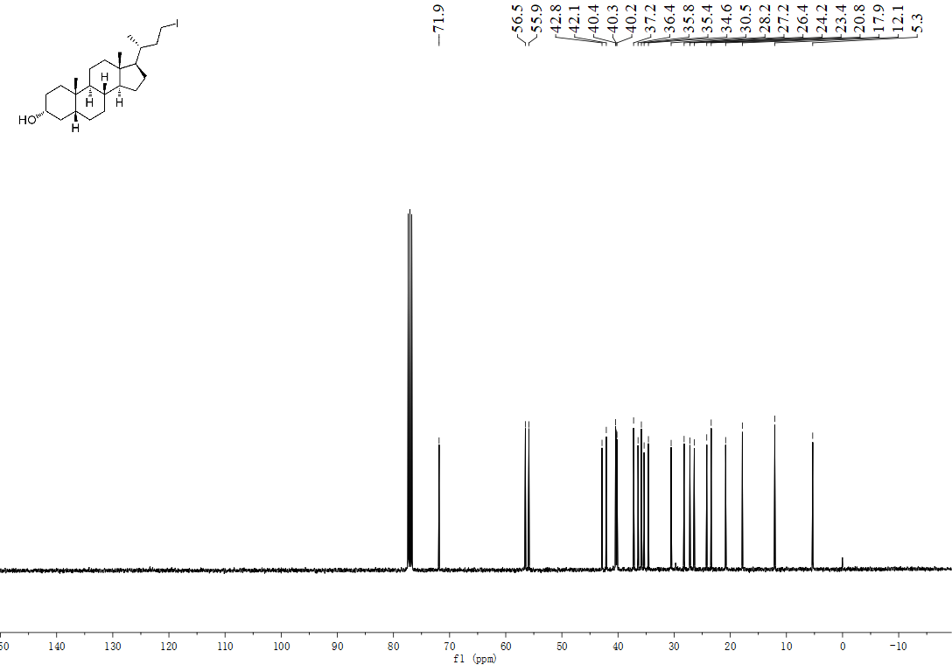

¹H NMR spectrum of 3-(iodomethyl)-1-tosylpyrrolidine (44):
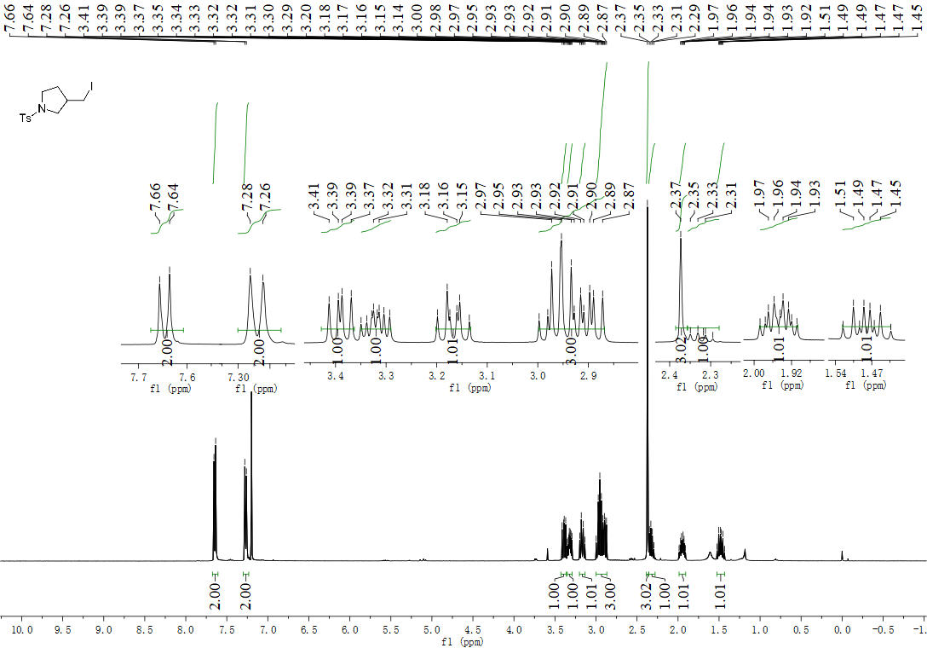

¹³C NMR spectrum of 3-(iodomethyl)-1-tosylpyrrolidine (44):
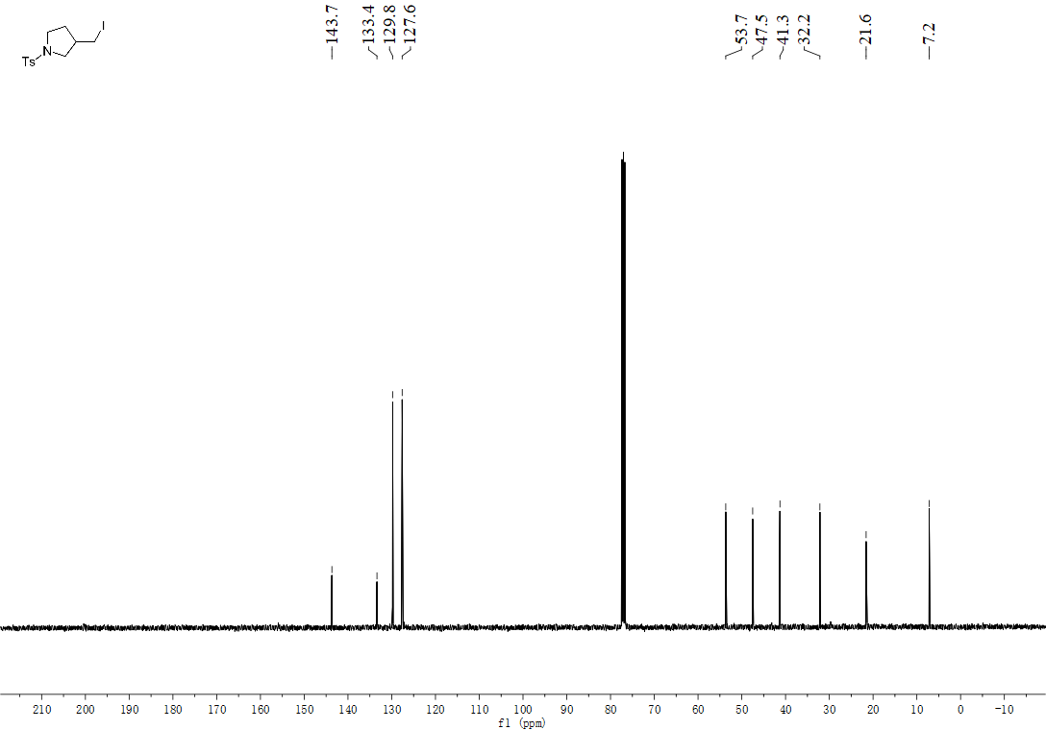

¹H NMR spectrum of 1-((2-(iodomethyl)cyclopentyl)methyl)-4-methoxybenzene (47):
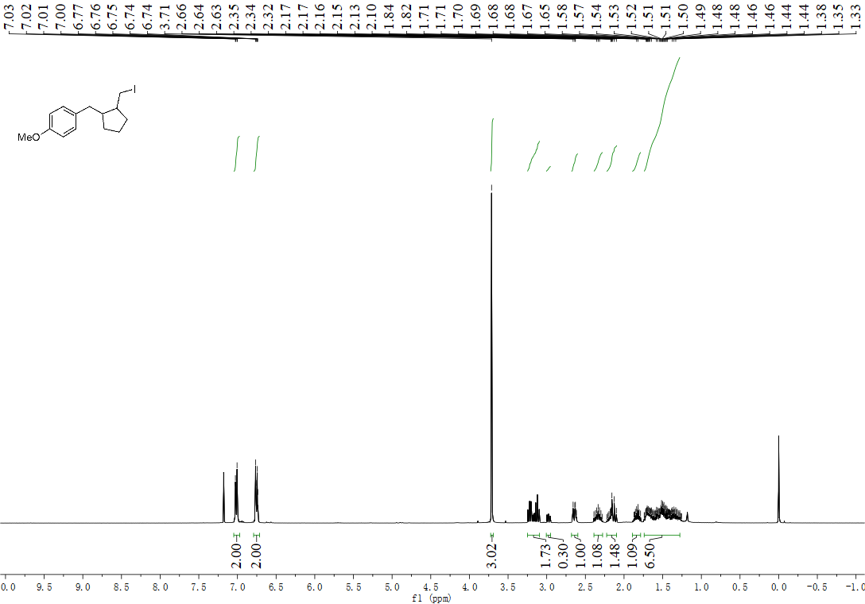

¹H NMR spectrum of 6-methoxy-2,3,3a,4,9,9a-hexahydro-1H-cyclopenta[b] naphthalene (48):
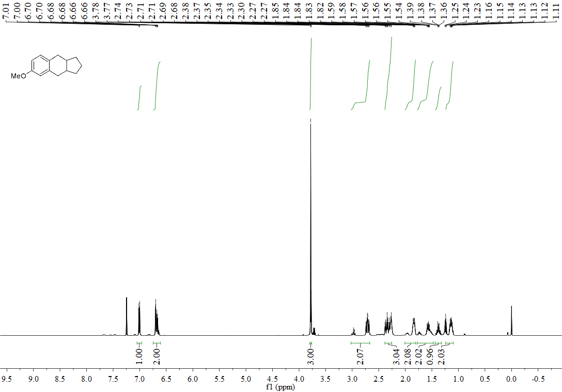

¹H NMR spectrum of 1-tosyl-1,2,3,6-tetrahydropyridine (49):
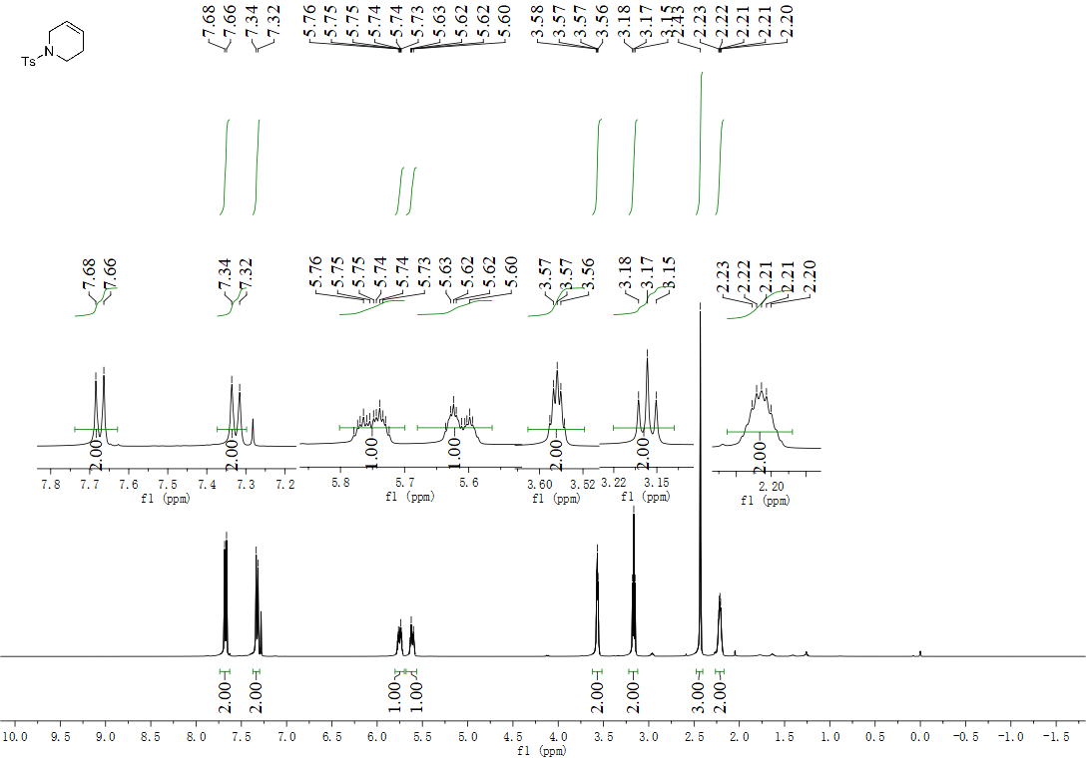

¹³C NMR spectrum of 1-tosyl-1,2,3,6-tetrahydropyridine (49):
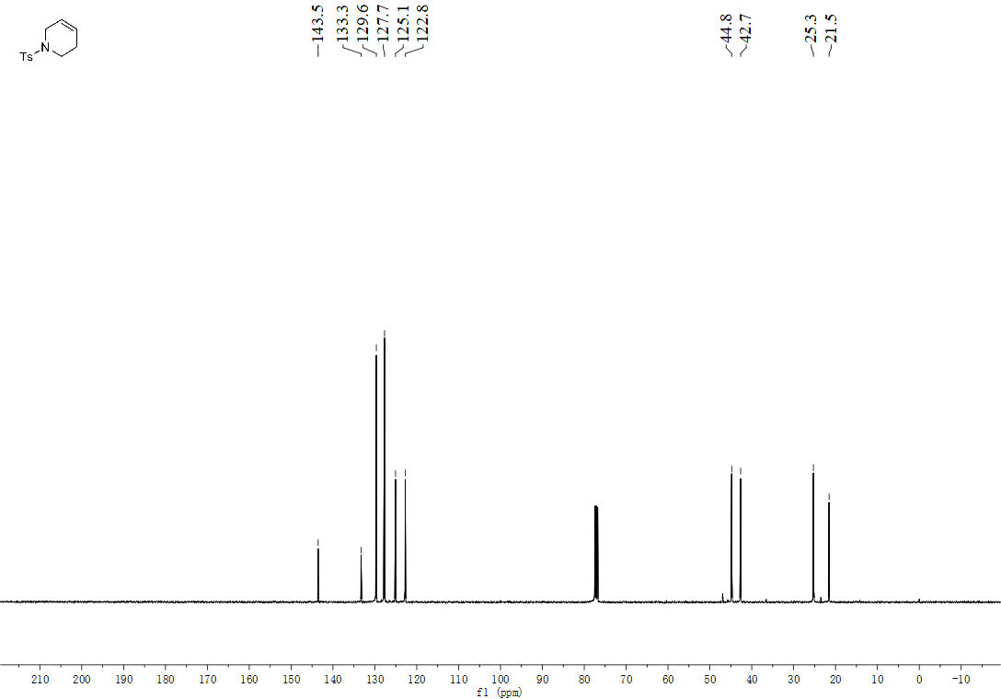

¹H NMR spectrum of (5,6-dihydropyridin-1(2H)-yl)(phenyl)methanone (50):
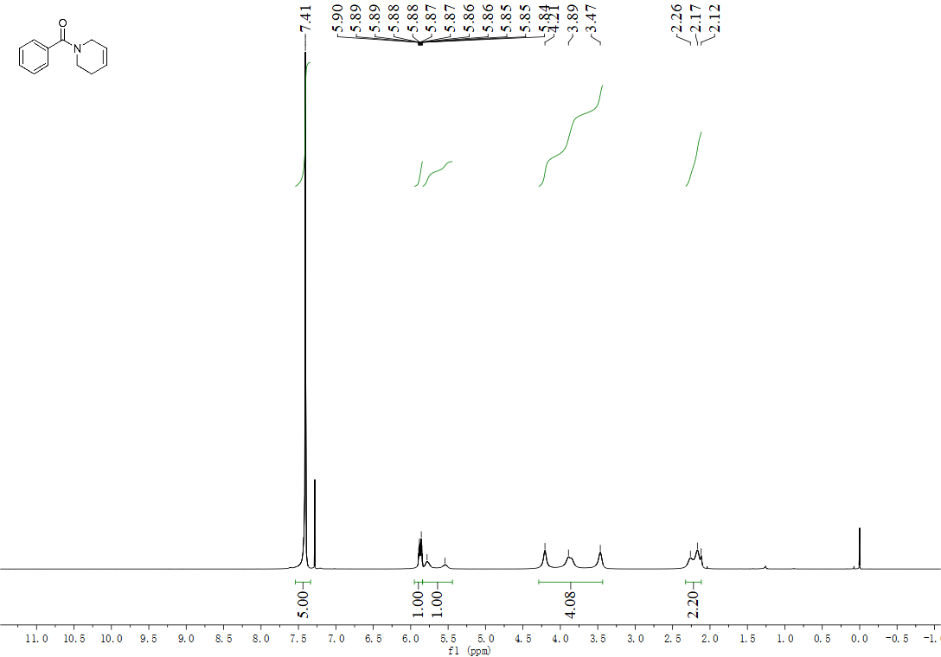

¹³C NMR spectrum of (5,6-dihydropyridin-1(2H)-yl)(phenyl)methanone (50):
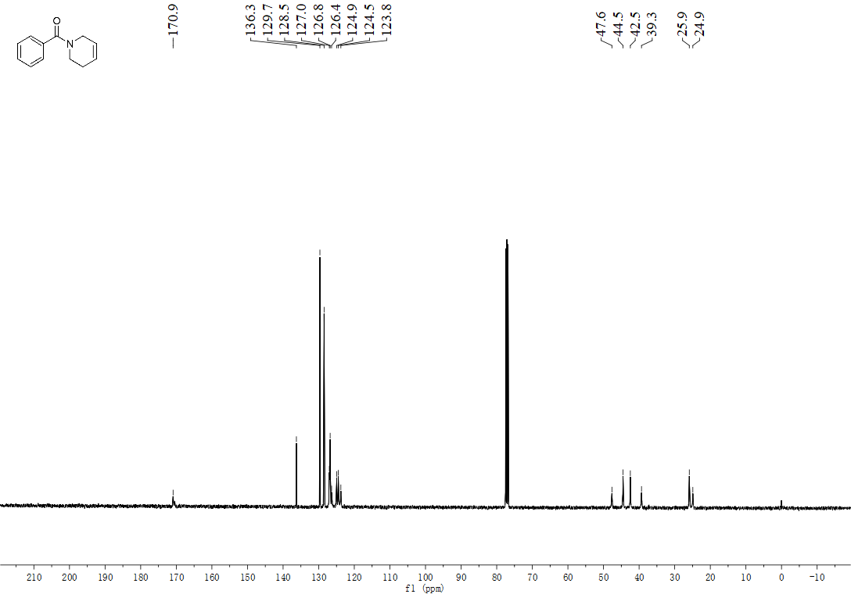

¹H NMR spectrum of benzyl 5,6-dihydropyridine-1(2H)-carboxylate (51):
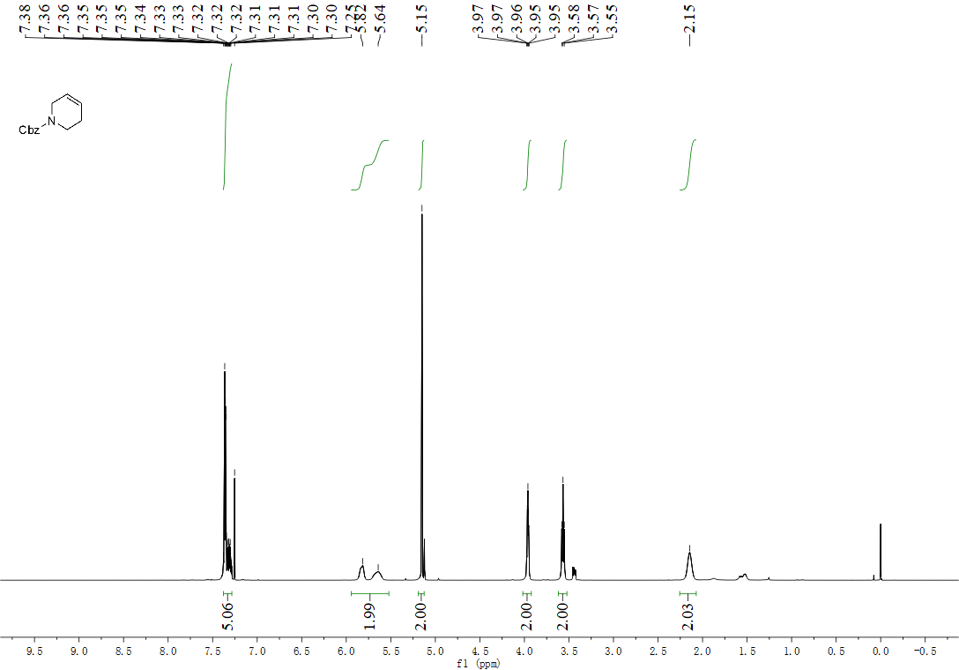

¹³C NMR spectrum of benzyl 5,6-dihydropyridine-1(2H)-carboxylate (51):
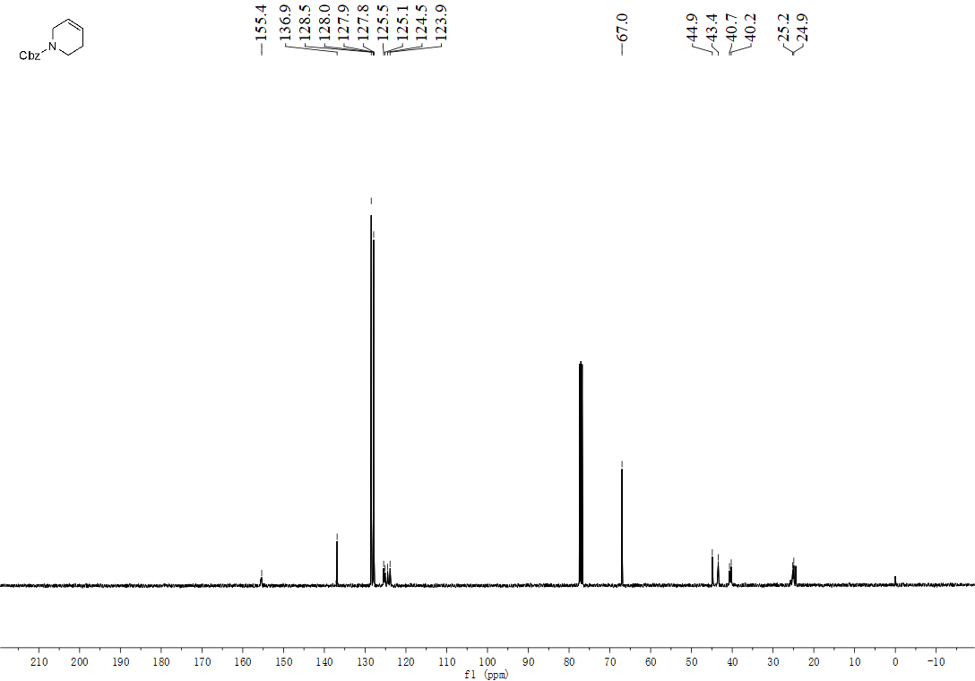

¹H NMR spectrum of (5,6-dihydropyridin-1(2H)-yl)(4-iodophenyl)methanone (52):
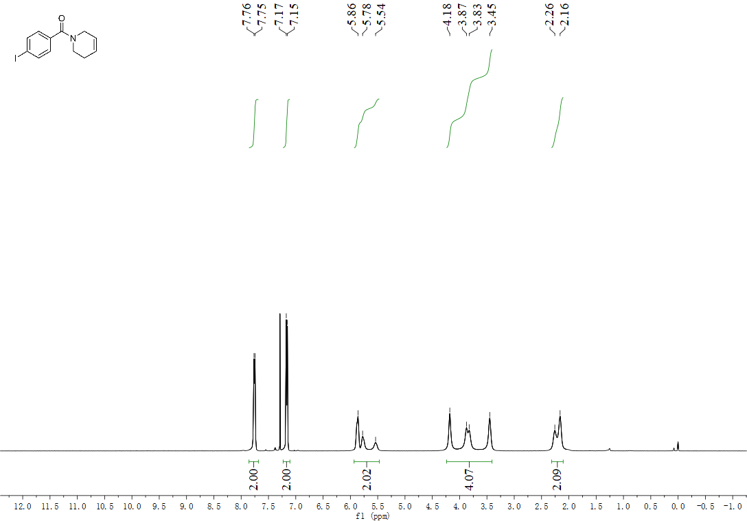

¹³C NMR spectrum of (5,6-dihydropyridin-1(2H)-yl)(4-iodophenyl)methanone (52):
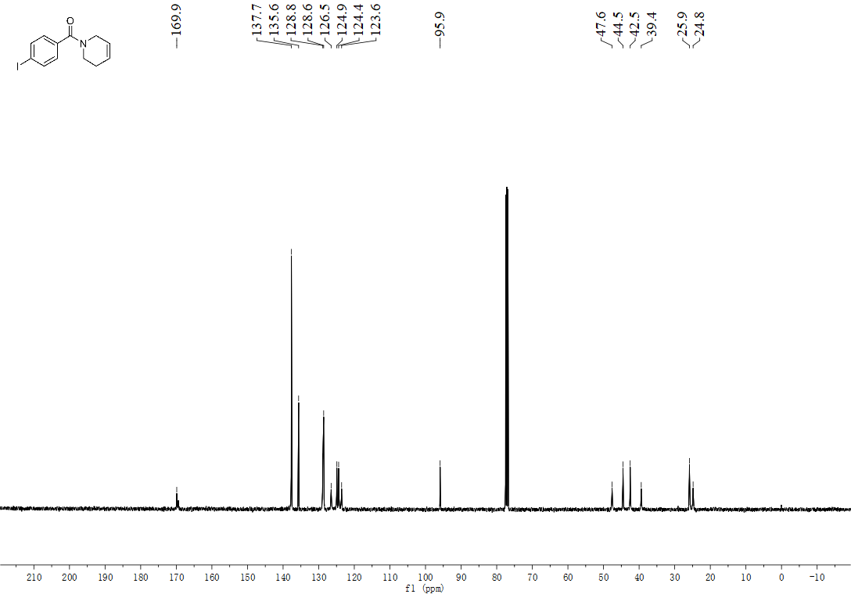

¹H NMR spectrum of (5,6-dihydropyridin-1(2H)-yl)(furan-2-yl)methanone (53):
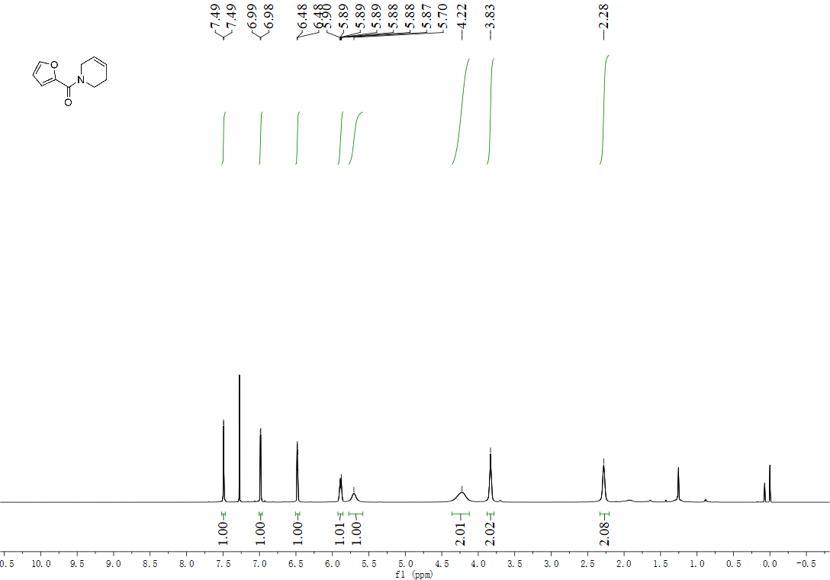
¹³C NMR spectrum of (5,6-dihydropyridin-1(2H)-yl)(furan-2-yl)methanone (53):
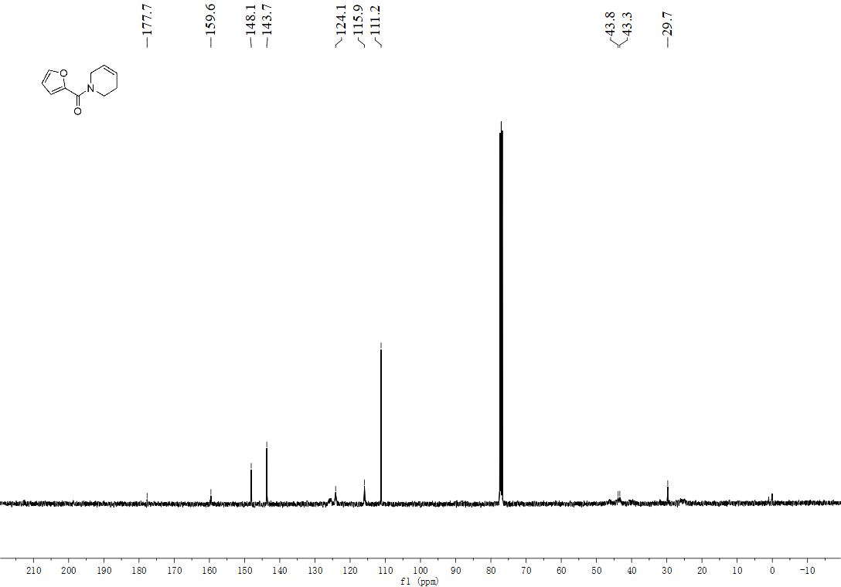

¹H NMR spectrum of (Z)-4-(heptadec-8-en-1-yloxy)benzaldehyde (54):
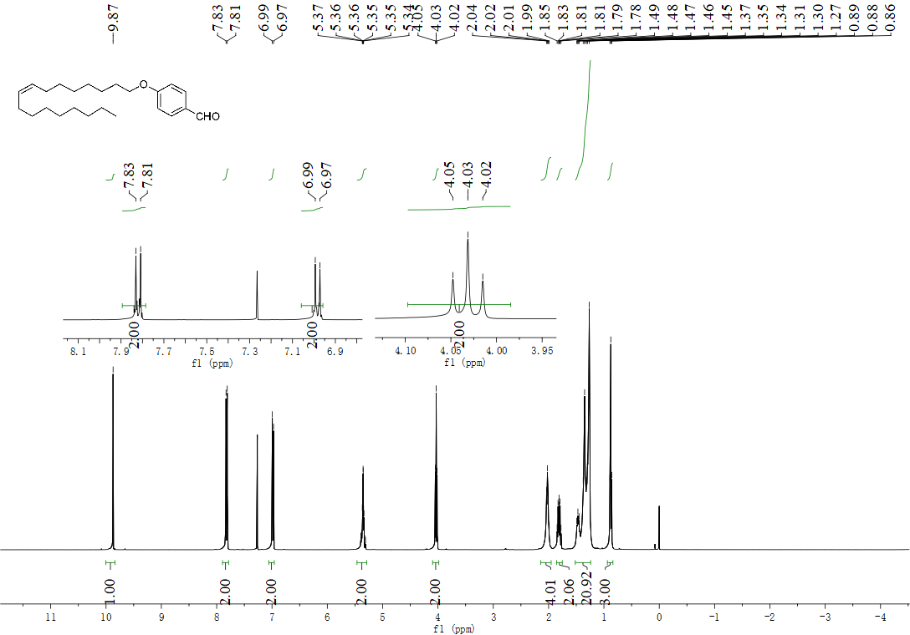

¹³C NMR spectrum of (Z)-4-(heptadec-8-en-1-yloxy)benzaldehyde (54):
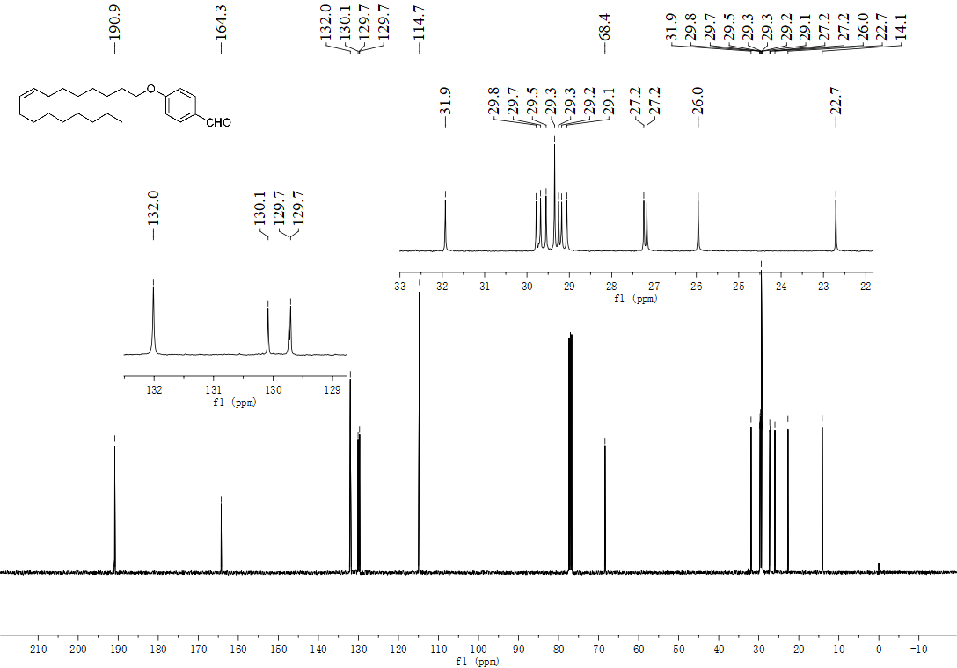

¹H NMR spectrum of (Z)-1-(4-(heptadec-8-en-1-yloxy)phenyl)ethanone (55):
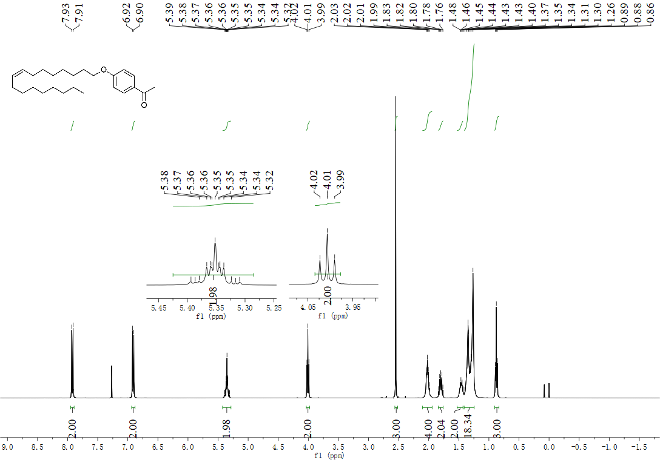

¹³C NMR spectrum of (Z)-1-(4-(heptadec-8-en-1-yloxy)phenyl)ethanone (55):
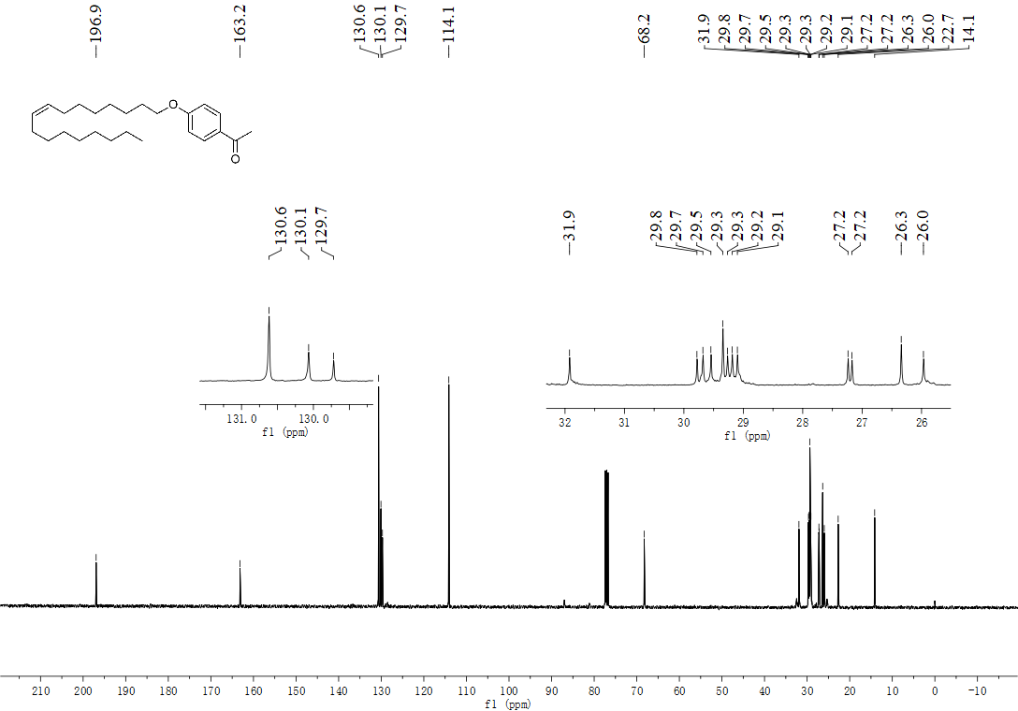

¹H NMR spectrum of (Z)-1-fluoroheptadec-8-ene (56):
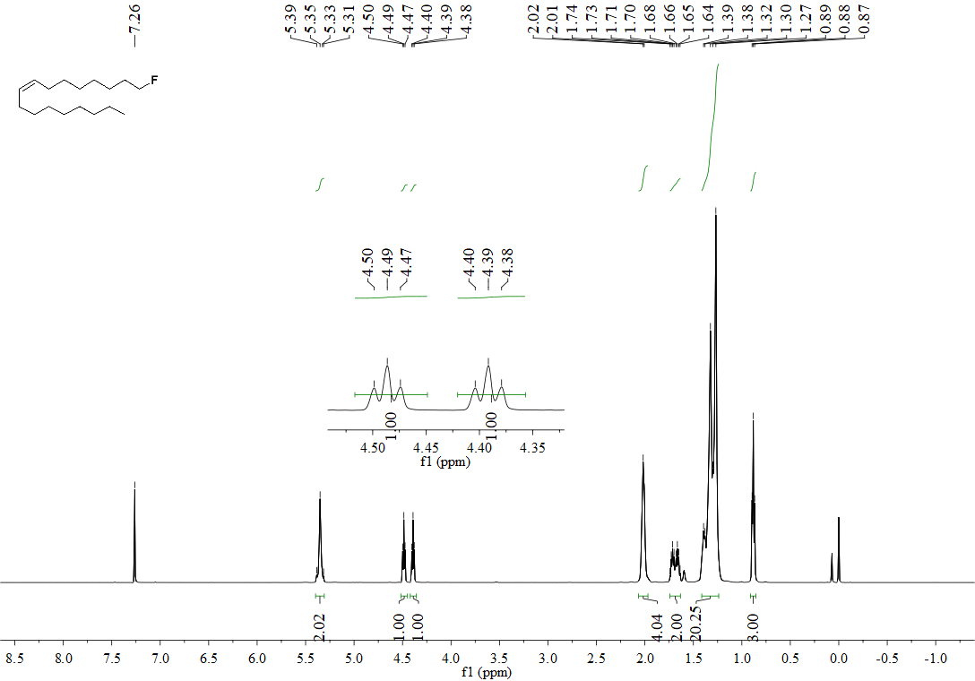

¹³C NMR spectrum of (Z)-1-fluoroheptadec-8-ene (56):
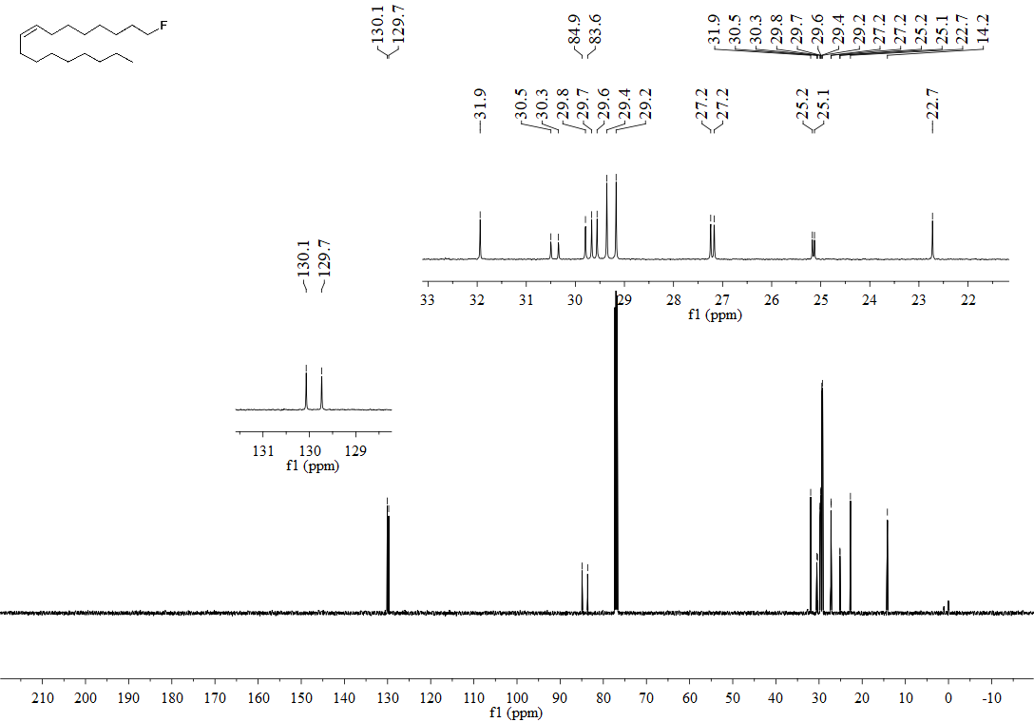

¹⁹F NMR spectrum of (Z)-1-fluoroheptadec-8-ene (56):
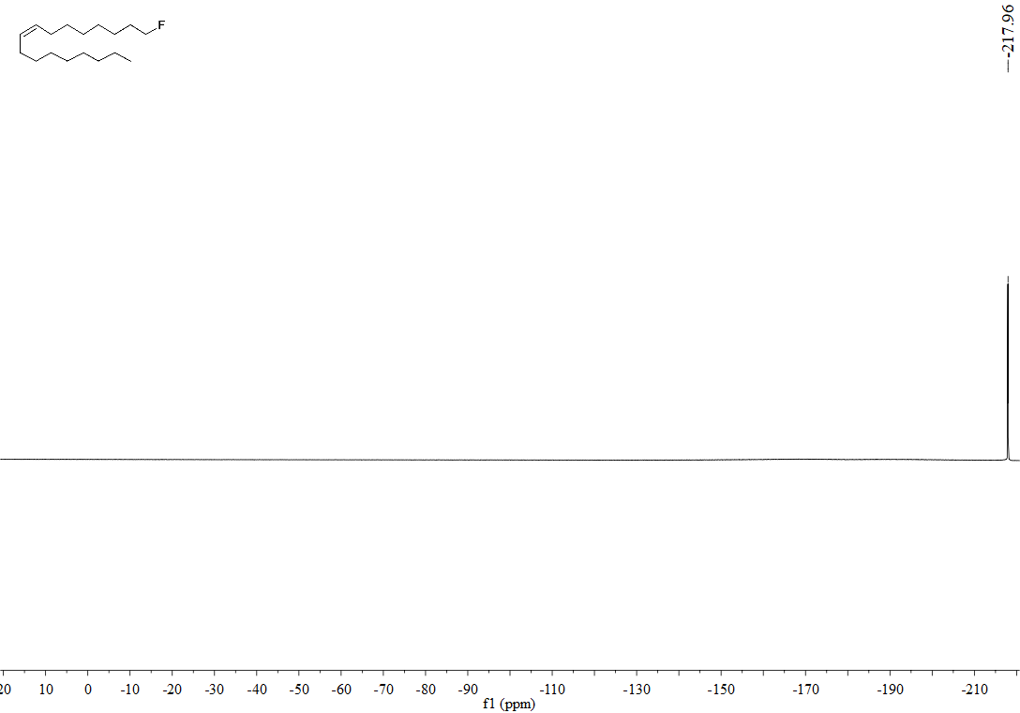

¹H NMR spectrum of (Z)-1-(heptadec-8-en-1-yl)indoline (57):
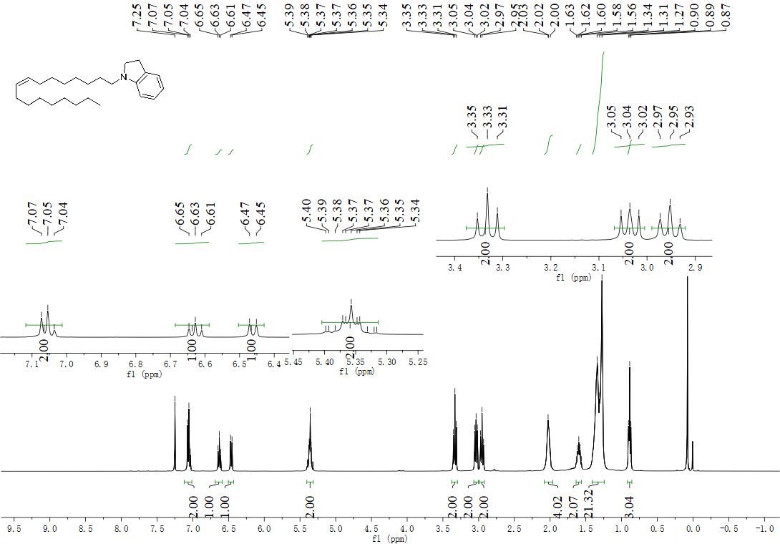

¹³C NMR spectrum of (Z)-1-(heptadec-8-en-1-yl)indoline (57):
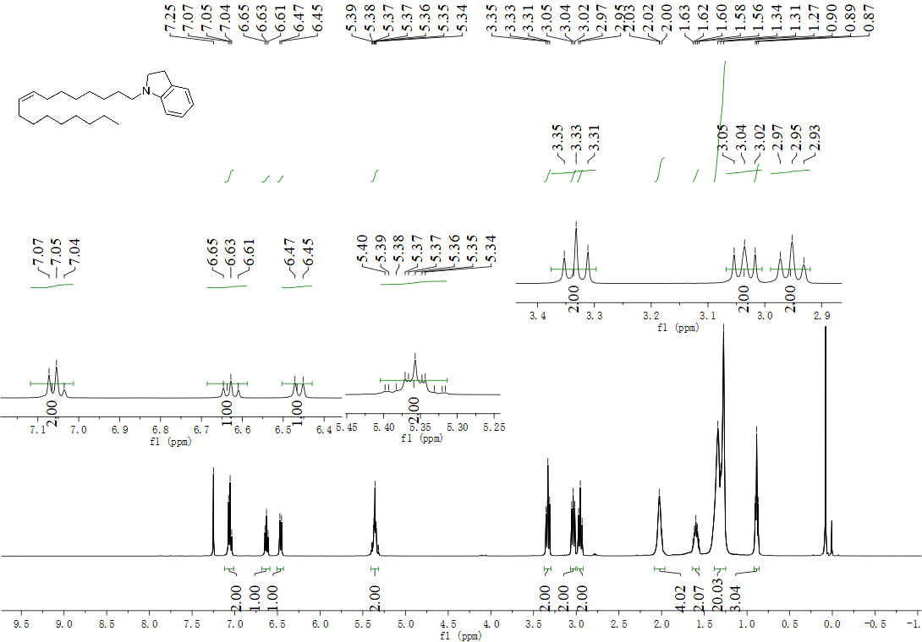

¹H NMR spectrum of (Z)-1-thiocyanatoheptadec-8-ene (58):
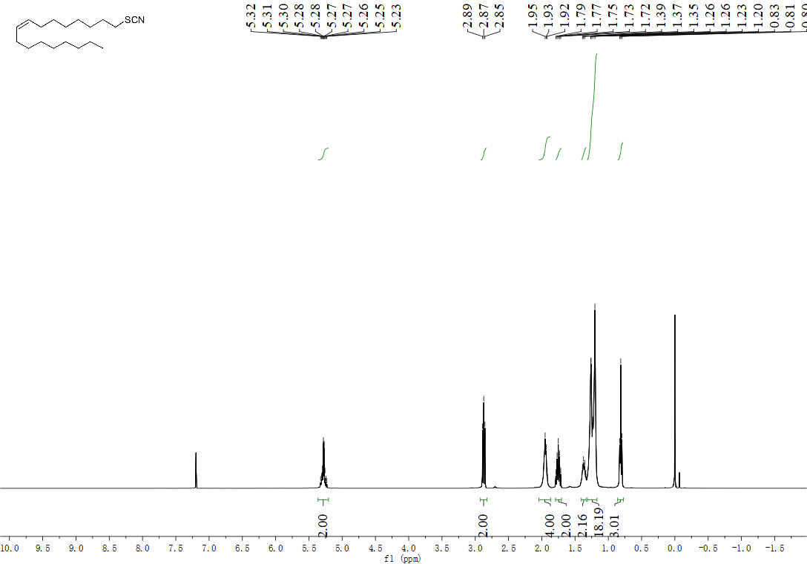

¹³C NMR spectrum of (Z)-1-thiocyanatoheptadec-8-ene (58):
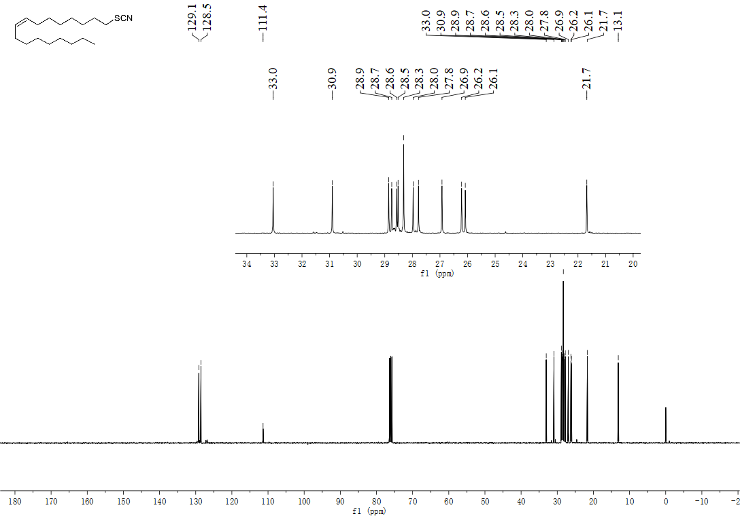

¹H NMR spectrum of (Z)-4-benzyl-1-(heptadec-8-en-1-yl)piperidine (59):
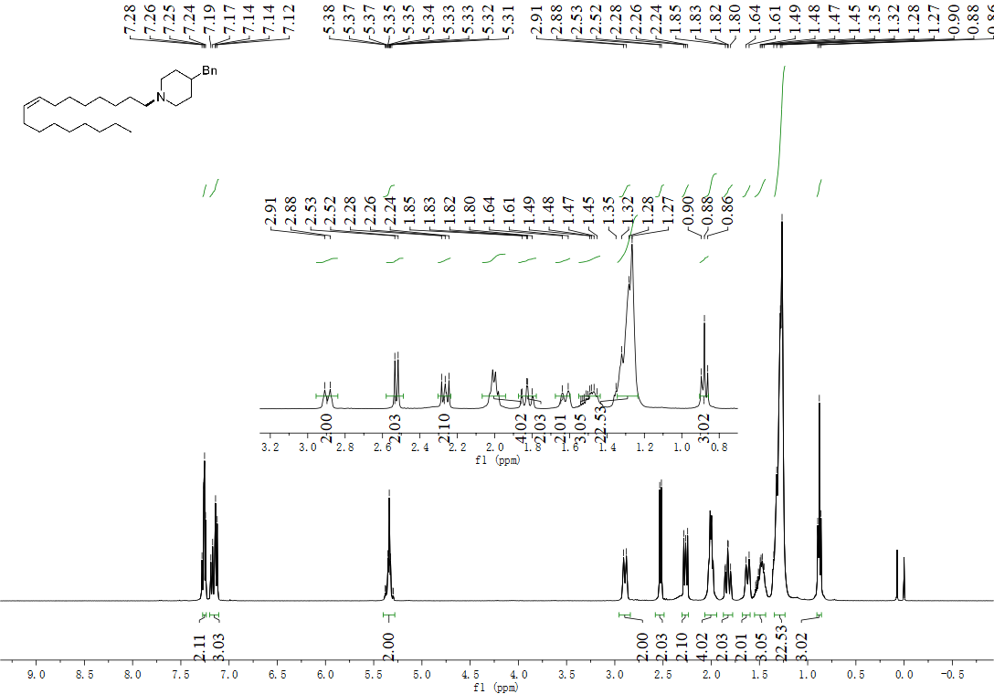

¹³C NMR spectrum of (Z)-4-benzyl-1-(heptadec-8-en-1-yl)piperidine (59):
