Table S1 Mineral composition of basalt rock
Mineral | Concentration | S.D. | Unit | Mineral | Concentration | S.D. | Unit
P₂O₅ | 0.1965 | 0.001 | % | Nb | 3.54 | 0.4 | µg/g
Na₂O | 3.82 | 0.05 | % | Mo | 0.205 | 0 | µg/g
MgO | 5.057 | 0.016 | % | Ru | 1.525 | 0.48 | µg/g
Al₂O₃ | 13.13 | 0.01 | % | Rh | 0 | 0 | µg/g
SiO₂ | 56.32 | 0.02 | % | Pd | 1.593 | 0.45 | µg/g
SO₃ | 5.04E-05 | 0 | % | Ag | 1.441 | 0.49 | µg/g
Cl | 6.58E-03 | 7.30E-05 | % | Cd | 0.205 | 0 | µg/g
K₂O | 0.269 | 0.0009 | % | In | 0.305 | 0 | µg/g
CaO | 7.742 | 0.004 | % | Sn | 1.634 | 0.85 | µg/g
Ti | 4874 | 6 | µg/g | Sb | 0.405 | 0 | µg/g
V | 254.1 | 2 | µg/g | Te | 0.505 | 0 | µg/g
Cr | 44.31 | 0.59 | µg/g | I | 0.605 | 0 | µg/g
MnO | 1412 | 2 | µg/g | Cs | 0.805 | 0 | µg/g
Fe₂O₃ | 9.288 | 0.004 | % | Ba | 117.3 | 6.7 | µg/g
Co | 1.005 | 0 | µg/g | La | 1.505 | 0 | µg/g
Ni | 11.1 | 0.33 | µg/g | Ce | 1.505 | 0 | µg/g
Cu | 26.13 | 0.46 | µg/g | Hf | 5.036 | 1.5 | µg/g
Zn | 61.86 | 0.55 | µg/g | Ta | 0.805 | 0 | µg/g
Ga | 13.67 | 0.26 | µg/g | W | 0.505 | 0.15 | µg/g
As | 0.205 | 0 | µg/g | Au | 2.034 | 1.4 | µg/g
Se | 0.105 | 0 | µg/g | Hg | 3.772 | 1.4 | µg/g
Rb | 11.2 | 0.28 | µg/g | Tl | 0.205 | 0 | µg/g
Sr | 184.2 | 0.4 | µg/g | Pb | 7.376 | 0.4 | µg/g
Y | 21.19 | 0.2 | µg/g | Bi | 0.305 | 0 | µg/g
Br | 0.205 | 0 | µg/g | Th | 0.305 | 0 | µg/g
Zr | 56.45 | 0.37 | µg/g | U | 0.305 | 0.12 | µg/g

Fig. S1
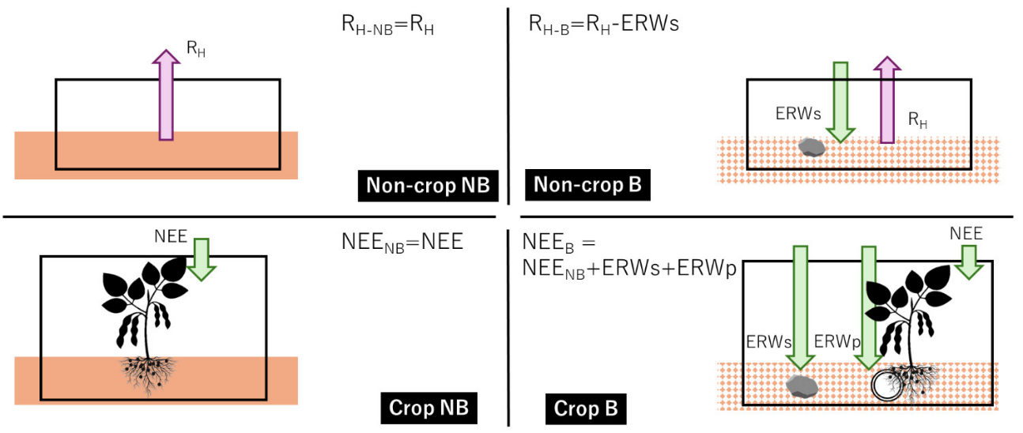
Examples of CO₂ flow in B and NB in the crop and non-crop area. R_{H}: heterotrophic respiration, NEE: net ecosystem exchange, R_{H-NB}: R_{H} in NB, R_{H-B}: R_{H} in B, NEE_{NB}: NEE in NB, NEE_{B}: NEE in B, ERWs: ERW-induced CO₂ removal in non-crop area, ERWs: ERW-induced CO₂ removal in non-crop area, ERWp: ERW-induced CO₂ removal in crop area.

Fig. S2
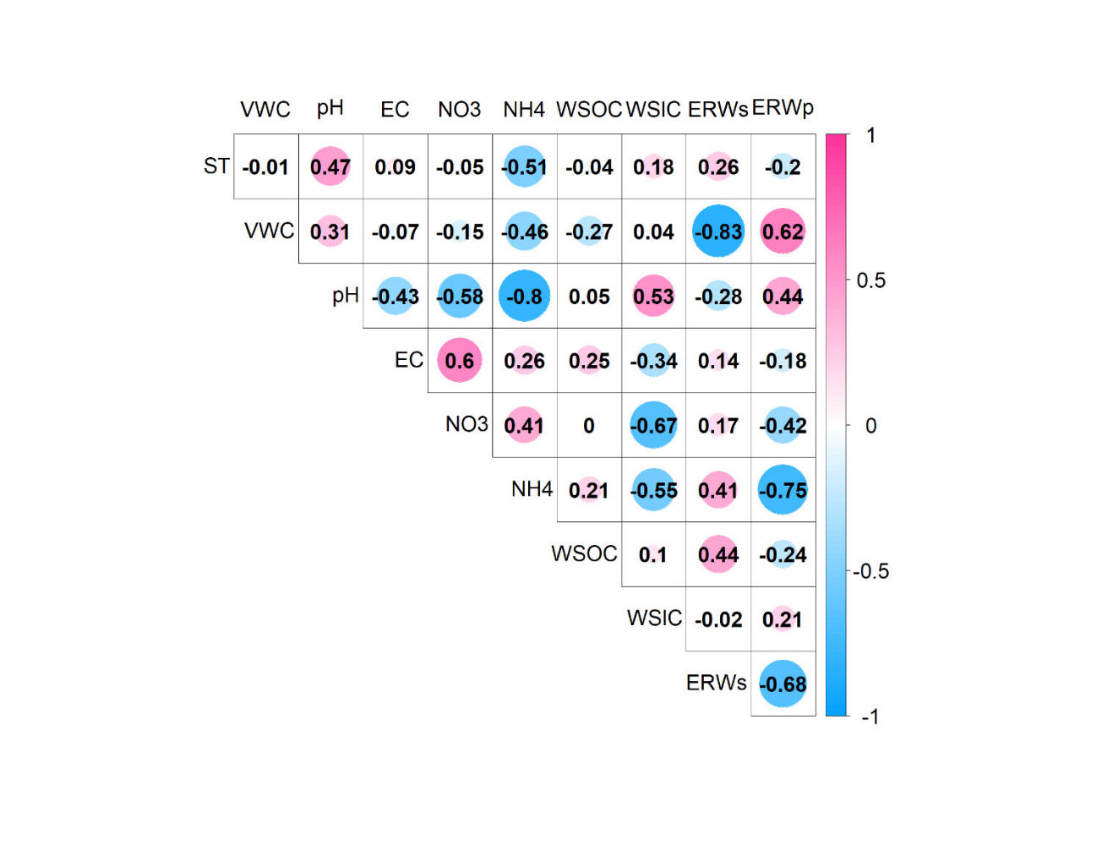
Correlation analysis of soil properties and ERWs, ERWp. ST is soil temperature, VWC is volumetric water content, NO3 is NO₃⁻-N conc., NH4 is NH₄⁺-N conc., WSOC is water-soluble organic carbon conc., WSIC is water-soluble inorganic carbon conc. The value is Pearson correlation coefficient.

