1. Rockwall erosion rates in the European Alps

Table S1. Present-day erosion rates of NCA and European Alps. Error values indicate range of rockwall elevation or measured erosion rate. The rates were derived from terrestrial laserscanning campaigns (LS), from rockfall collectors (RC), laserscanning derived volume changes of rock glaciers (RG) and from painted rockwalls (PW) and incorporate different errors depending on applied technique.
Location | Longitude  Latitude  (WGS 84) | Lithology | Elevation (m) | Relief  (m) | Rockwall erosion rate (mm a⁻¹) | Method | Ref
Lauterbrunnen | 46.592522°N  7.908153°E | limestone | 1,300 ±500 | $${500}_{-100}^{+300}$$ | $${0.05}_{-0.02}^{+0.03}$$ | LS | ¹
Tegelberg | 47.553889°N  10.772778°E | limestone, dolostone | 1,550 ±250 | NA | $${0.14}_{-0.06}^{+0.06}$$ | RC | ²
Reintal | 47.411381°N 11.074081°E | limestone | 1,750 ±450 | $${407}_{-82}^{+43}$$ | $${0.09}_{-0.08}^{+0.17}$$ | LS | ³
Reintal | 47.411381°N 11.074081°E | limestone | 1,750 ±450 | $${500}_{-100}^{+100}$$ | $${0.03}_{-0.28}^{+0.58}$$ | RC | ^{3,4}
Dammkar | 47.435353°N  11.305375°E | limestone | 1,800 ±500 | NA | $${0.2}_{-0.1}^{+0.1}$$ | RC | ²
Hoher Ifen | 47.354558°N  10.099522°E | limestone | 1,900 ±200 | NA | $${0.065}_{-0.035}^{+0.035}$$ | RC | ²
Dammkar | 47.435353°N  11.305375°E | limestone | 2,025 ±425 | $${400}_{-150}^{+150}$$ | $${0.15}_{-0.15}^{+0.88}$$ | LS | This Study
Kühtai | 47.205714°N  11.026183°E | gneiss, mica schist | 2,550 ±450 | NA | $${0.10}_{-0.05}^{+0.50}$$ | RC | ²
Parzinn | 47.239892°N  10.57525°E | dolostone | 2,350 ±250 | NA | $${0.225}_{-0.075}^{+0.075}$$ | RC | ²
Kauner Valley | 46.87129°N  10.771063°E | paragneiss,  orthogneiss,  amphibolite | 2,572.5 ±552.5 | NA | $${3.74}_{-3.73}^{+10.23}$$ | RC | ^{5,6}
Dachstein | 47.475°N  13.605°E | limestone | 2,600 ±300 | $${200}_{-50}^{+50}$$ | $${0.01}_{-0.01}^{+0.01}$$ | LS | This Study
Zugspitze | 47.420564°N  10.985539°E | limestone | 2,709 ±230.5 | NA | $${0.4}_{-0.3}^{+0.3}$$ | RC | ²
Chlein Schwarzhorn | 46.751159°N  9.94856°E | amphibolite | 2,703 ±193 | $${260}_{-220}^{+220}$$ | 0.64 | LS | ⁷
Trais Fuors | 46.530653°N  9.82082°E | dolomite,  limestone,  shale | 2,875 ±25 | NA | $${0.11}_{-0.11}^{+0.19}$$ | PR | ⁸

Table S1. Continued.
Location | Longitude  Latitude  (WGS 84) | Lithology | Elevation (m) | Relief  (m) | Rockwall erosion rate (mm a⁻¹) | Method | Ref
Kitzsteinhorn | 47.183333°N  12.683333°E | mica schist | 2,900 ±160 | $${200}_{-30}^{+60}$$ | $${1.9}_{-1.55}^{+8.40}$$ | LS | ^{9,10}
Hungerli | 46. 183898°N  7.729674°E | quartz slate, amphibolite, aplite | 2,913.5 ±363.5 | $${150}_{-25}^{+25}$$ | $${0.86}_{-0.84}^{+1.18}$$ | LS | ¹¹
Gemsstock | 46.601789°N  8.611396°E | granodiorite | 2,939 ±23 | $${45}_{-15}^{+15}$$ | $$6.5$$ | LS | ¹²
Murtel Corvatsch | 46.408742°N 9.807017°E | granite, schist | 2,942.5 ±242.5 | $${365}_{-10}^{+10}$$ | $$2$$ | RG | ¹³
Roc Noir du Combeynot | 45.011244°N  6.40067°E | granite | 3,000 ±0 | NA | $${1.58}_{-1.42}^{+1.53}$$ | RC | ¹⁴
Le Drus | 45.934257°N  6.962167°E | granite | 3,427 ±327 | $${450}_{-50}^{+50}$$ | 14.4 | LS | ¹⁵
Tour Ronde | 45.844048°N  6.90766°E | granite | 3,606 ±186 | $${350}_{-12}^{+12}$$ | 8.4 | LS | ¹⁶
Tour Ronde | 45.844048°N  6.90766°E | granite | 3,616 ±176 | $${350}_{-12}^{+12}$$ | $${18.3}_{-0.2}^{+0.2}$$ | LS | ¹⁷
Brenva | 45.835351°N  6.885476°E | granite | 3,766 ±150 | $${330}_{-20}^{+20}$$ | $${15.5}_{-2.3}^{+2.3}$$ | LS | ¹⁸
LS = laserscanning, PR = painted rockwalls, RC = rockfall collection, RG = laserscanning of rock glaciers.

2. Relief analysis on NCA scale
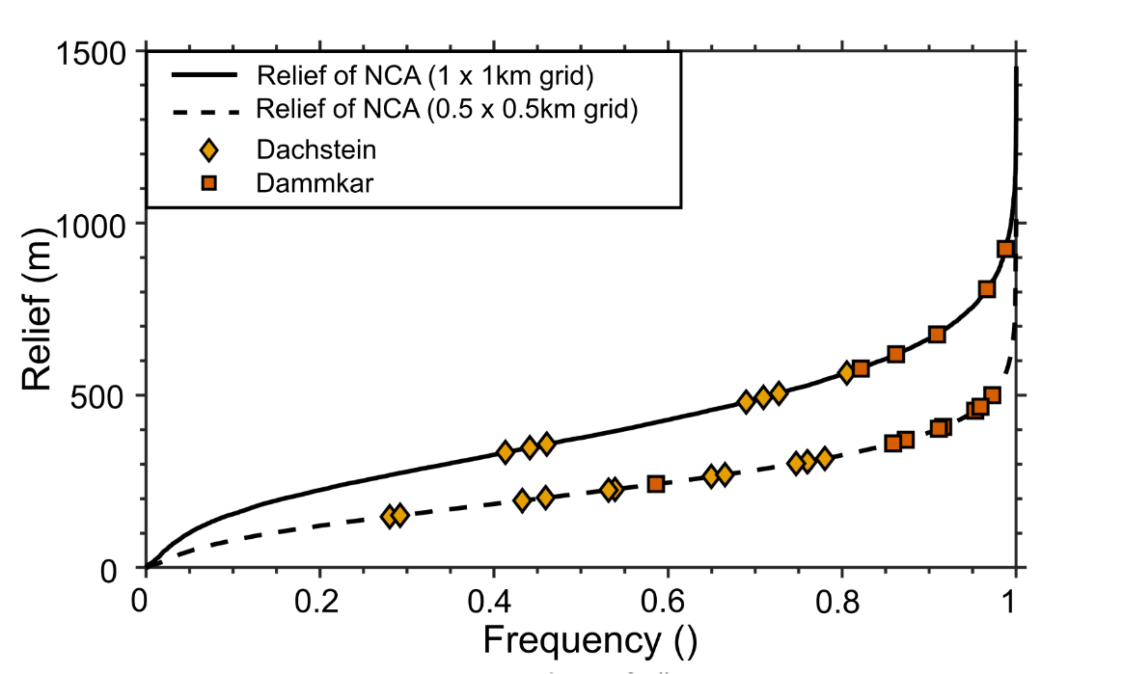
Figure S1. Effect of fishnet grid size for calculating relief. Dachstein and Dammkar cover the entire range of relief in the Northern Calcareous Alps (NCA) regardless of grid size. The larger 1x1 km grid captures more of the flat, valley floor topography, which is less representative of the rockwall topography of interest, so the smaller grid size was adopted in our analyses.

3. Study areas

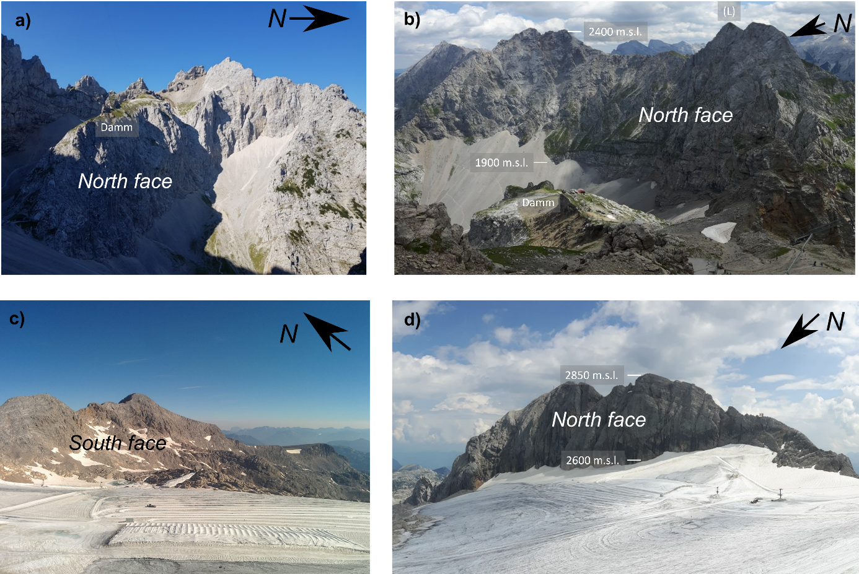
Figure S2. Photos of field sites a,b) Dammkar and c,d) Dachstein. Situated within the vast Karwendel group, the largest mountain range in the Northern Calcareous Alps (NCA) spanning over 900 km², the Dammkar features two narrow valleys aligned from east to west. A saddle-like formation, known as the Damm, divides these valleys. The Dammkar's relief can reach heights of up to 500 meters, with the most notable feature being the towering rockwall at the north faces of the Larchetfleckspitzen (L). Located in the eastern segment of the NCA, the Dachstein area is crowned by Hoher Dachstein at 2995 m, the highest peak within this mountain range and the second highest in the NCA. The relief in Dachstein features rockwalls up to 250 m in height, with north faces being notably steeper than the gentler south faces.
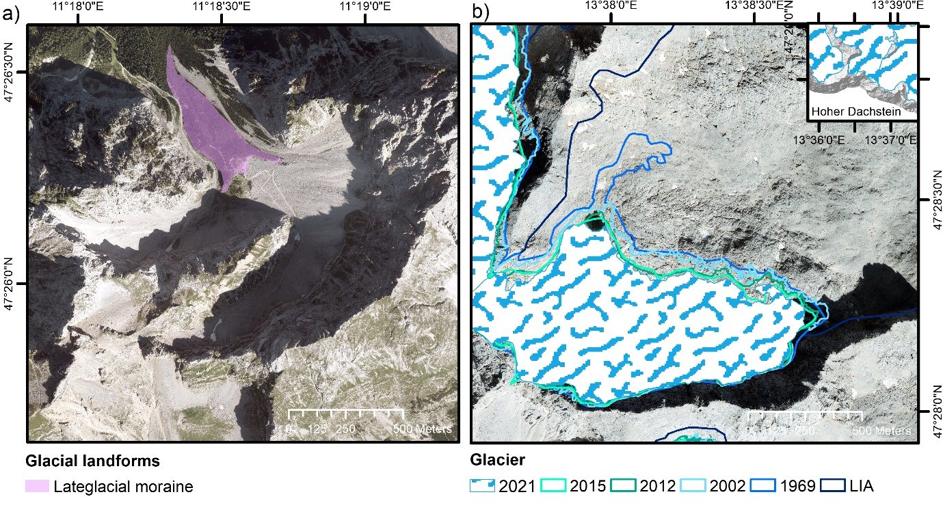
Figure S3. Orthophoto and glacier extend for a) Dammkar (orthophoto source: Bayerische Vermessungsverwaltung) and for b) Dachstein (orthophoto source: Open Data Oberösterreich). Contemporary glaciation within the NCA is confined to smaller, residual cirque glaciers in elevated catchments, with the Hallstätter Glacier in Dachstein being the largest within the NCA, encompassing an area of 2.48 km² (own mapping 2021). Adjacent to this is the Schladminger Glacier, spanning 0.67 km² (own mapping 2021), which represents the primary focus of our surveyed area. Moraines in the Dammkar are probably from Steinach stadial 14000 years ago¹⁹ and the area was glacier free during Little Ice Age (LIA). Glacier extent visualizes glacier retreat at Dachstein from LIA²⁰ to 1969²¹, 2002²¹, 2012²⁰, 2015²² and 2021. The glacier experienced the most significant retreat in its length.

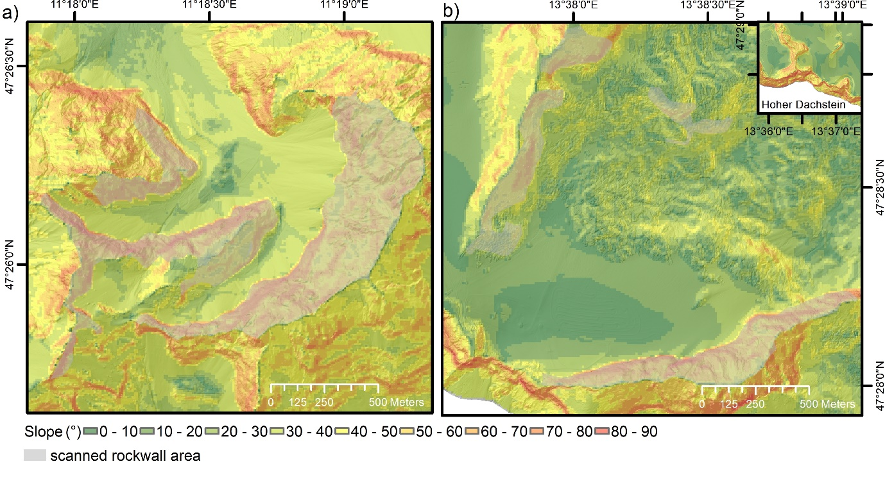
Figure S4. Slope angle calculated form DEM with 10 m resolution for a) Dammkar (DEM source: Bayerische Vermessungsverwaltung and Tiris) and for b) Dachstein (DEM source: Open Data Oberösterreich).

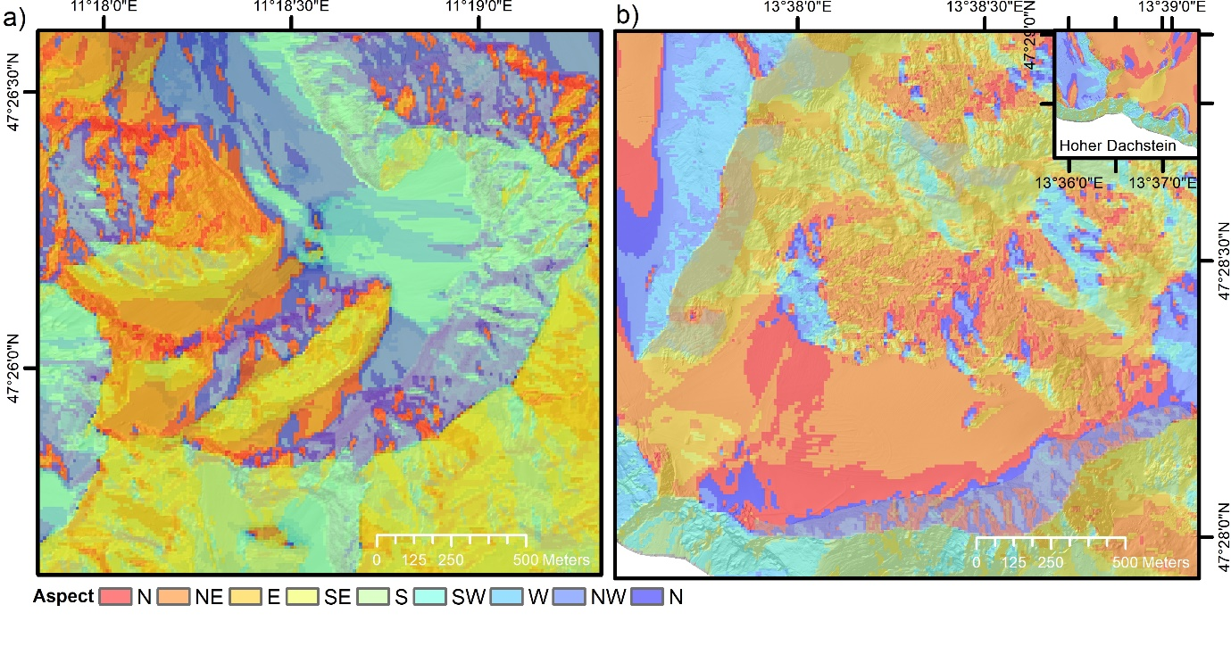
Figure S5. Aspect calculated form DEM with 10 m resolution for a) Dammkar (DEM source: Bayerische Vermessungsverwaltung and Tiris) and for b) Dachstein (DEM source: Open Data Oberösterreich).

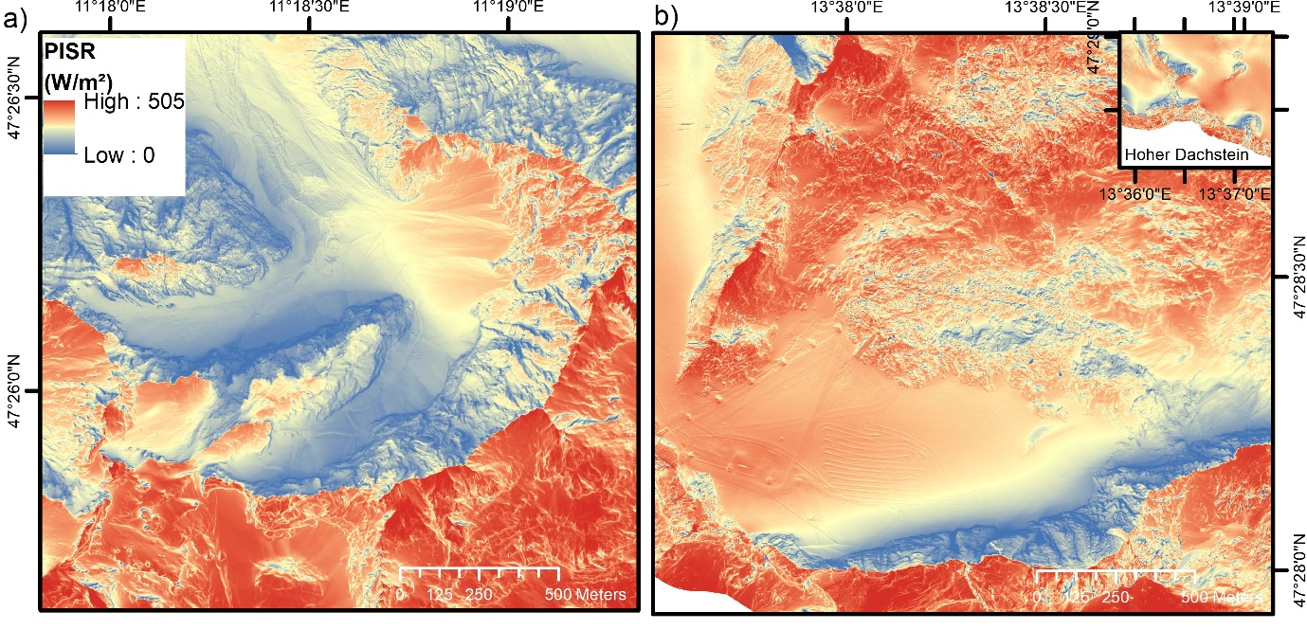
Figure S6. Potential incoming solar radiation (PISR) for a) Dammkar (DEM source: Bayerische Vermessungsverwaltung and Tiris) and for b) Dachstein (DEM source: Open Data Oberösterreich).

4. Rock thermal regime

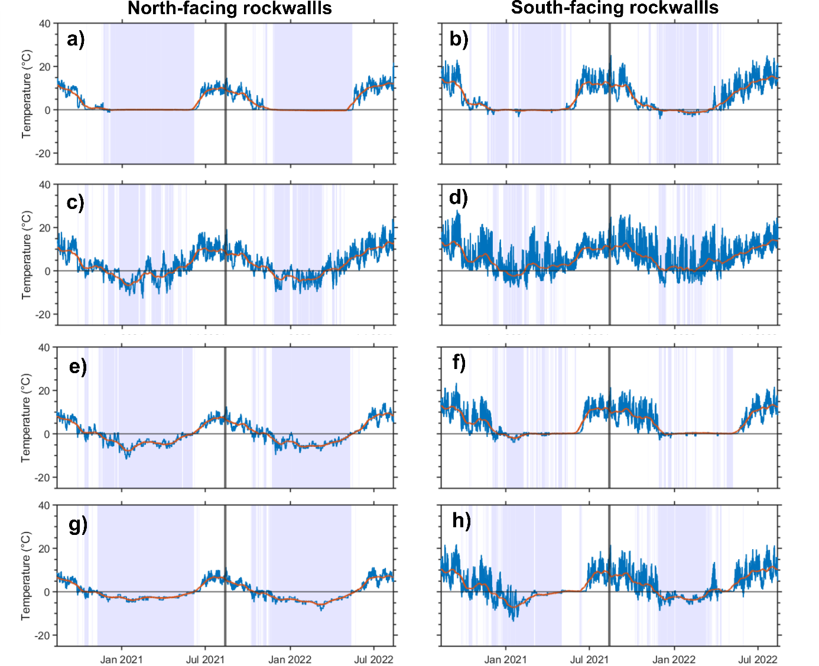
Figure S7. Rock surface temperature data for Dammkar and Dachstein for 2020 to 2022, as measured by iButton temperature loggers at 0.1 m. Elevation for Dammkar a-b) 1800 m. c-d) 2300 m and Dachstein, e) 2330 m, f) 2380 m g-h) 2650 m. a) ,c) ,e), g) are north-facing rockwalls while b,d,f,h are south-facing rockwalls. The presence of snow cover, highlighted by light violet rectangles, is enhanced on north-facing rockwalls due to the effect of topographic shading.

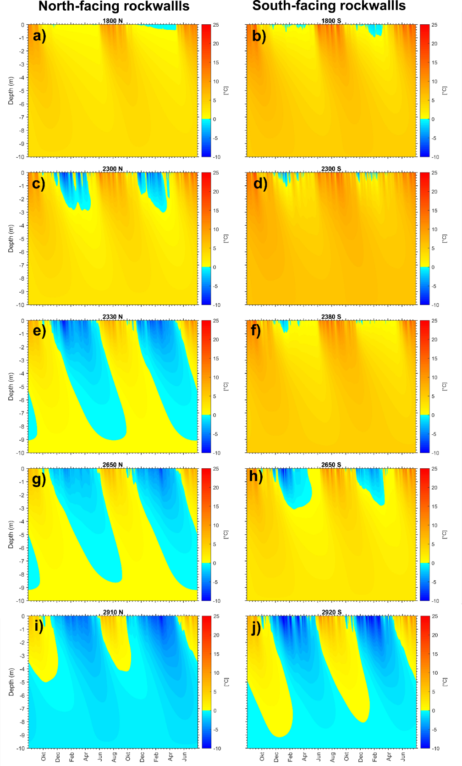
Figure S8. Modelled rock temperatures at elevations for Dammkar a-b) 1800 m. c-d) 2300 m and Dachstein, e) 2330 m, f) 2380 m g-h) 2650 m. i) 2910 m and j) 2920 m Hoher Dachstein. Rock temperature data show that seasonal freezing is intensified on north-facing rockwalls up to an elevation of 2650 m. Permafrost and seasonal thawing have been identified exclusively on the north-facing rockwall of Hoher Dachstein at elevations surpassing 2810 m, and on the southern aspects beyond 2920 m.

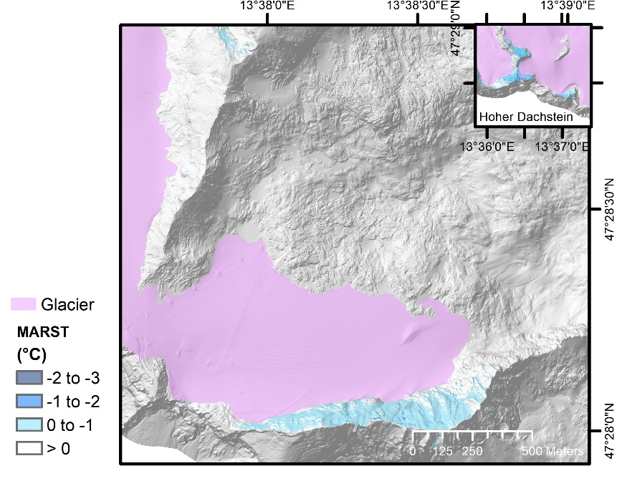
Figure S9. Modelled permafrost distribution at Dachstein. We used a multiple linear regression model²³ fitted with multi-annual rock surface temperatures from our temperature loggers, potential incoming solar radiation (PISR, Fig. S14) and mean annual air temperature (MAAT). MARST between 0 and -1°C indicate ‘possible patchy permafrost’, while temperatures below -1°C are interpreted as permafrost²⁴. The permafrost model indicates only ‘possible patchy permafrost’ at the investigated north-facing rockwall with temperature above -0.5°C suggesting that occurrence of permafrost is unlikely. Only temperatures at Hoher Dachstein reveal temperatures in the range of permafrost restricting permafrost occurrence to the highest peaks.

5. Laserscanning and observed rockfall volumes at Dammkar and Dachstein

Table S2. Laserscanning parameters.
Parameter | Riegl VZ2000i
Range (90% reflectivity) | 1,850 m
Range (20% reflectivity) | 950 m
Laser repetition rate | 100 kHz
Raw range accuracy | 5 mm @ 100 m
Field of view (horizontal x vertical) | 360 ° x 100 °
Angular step width | 0.01°
Laser beam divergence | 0.27 mrad

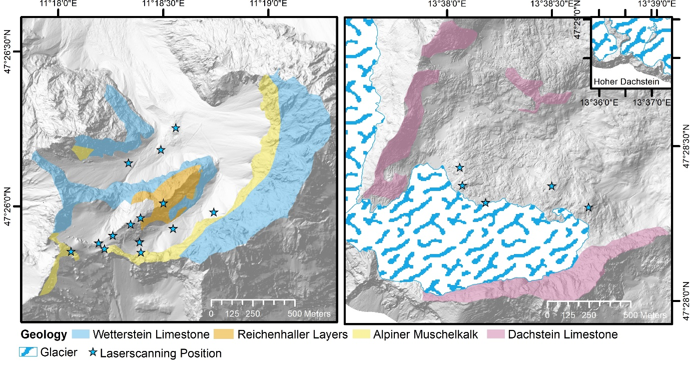
Figure S10. Laserscanning positions and scanned rockwalls classified into lithological units for a) Dammkar (DEM source: Bayerische Vermessungsverwaltung and Tiris) and for b) Dachstein (DEM source: Open Data Oberösterreich).

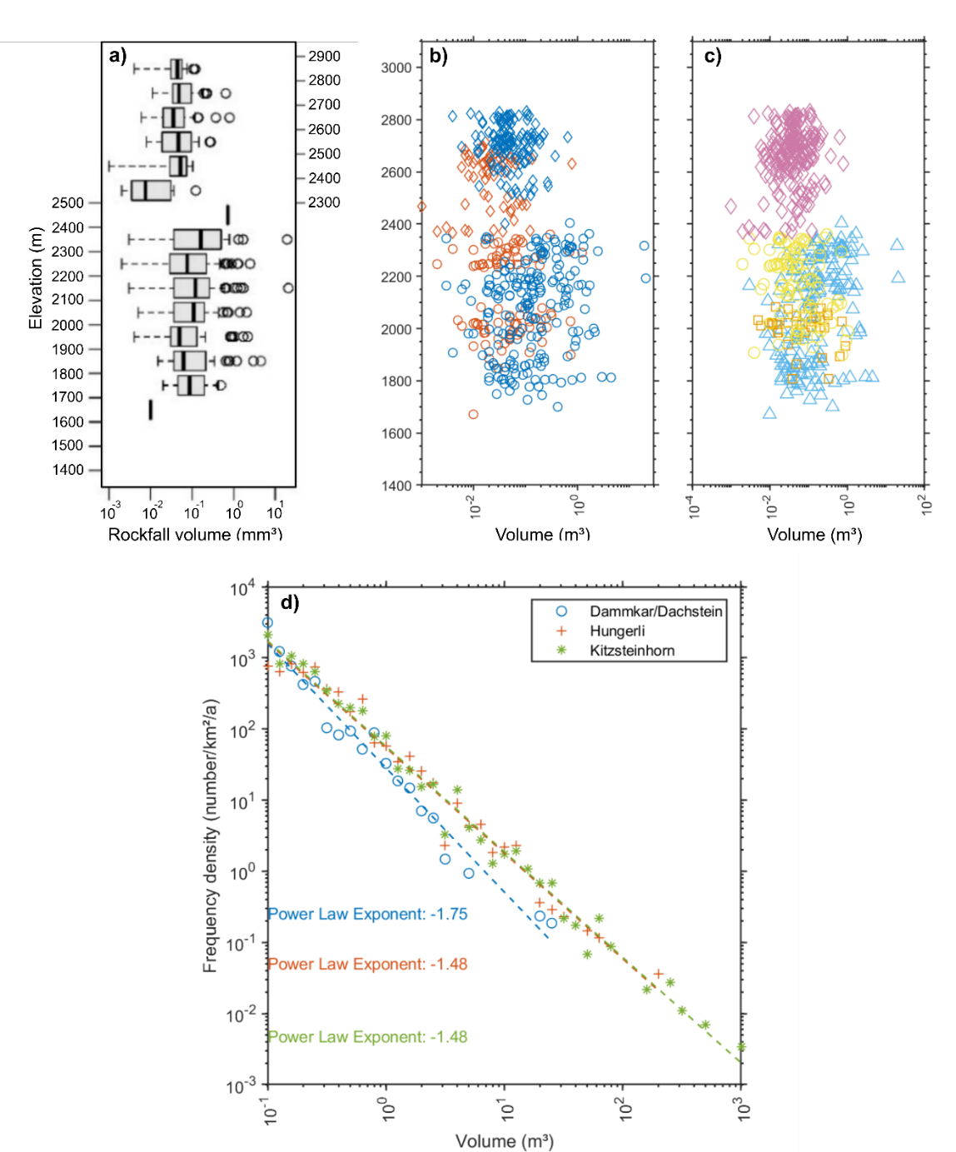

Figure S11. Volume of rockfall events per a) elevation b) exposition c) lithology. d) Magnitude frequency compared to studies of Hungerli¹¹ and Kitzsteinhorn⁹. The sites with active permafrost and glacier activity, Hungerli and Kitzsteinhorn, exhibit a higher power law exponent, indicating a greater frequency of larger rockfall volumes. This results in increased erosion rates when compared to those observed in Dammkar and Dachstein.

6. Frost cracking and thermal stress modelling

Table S3. Parameters of the frost cracking model.
Parameter |  | Dammkar | Dachstein | Ref.
Rock density (kg m⁻³) | ρ_{r} | 2.7 | 2.69 | This study
Rock porosity (%) | n_{r} | 0.4 | 0.1
Rock thermal conductivity (W m⁻¹ K⁻¹) | κ_{r} | 2.5 |  | ²⁵
Rock specific heat capacity (kJ kg⁻¹ K⁻¹) | c_{r} | 2.5 |  | ²⁵
Latent heat (kJ kg⁻¹) | L | 334
Rock water content (%) | W | 3 |  | ^{26,27}
Water content below pore freezing point (%) | W_{u} | 5 |  | ²⁸
Ice density (kg m⁻³) | ρ_{i} | 920
Ice thermal conductivity (W m⁻¹ K⁻¹) | κ_{i} | 2.24
Ice specific heat capacity (kJ kg⁻¹ K⁻¹) | c_{i} | 2.09
Water density (kg m⁻³) | ρ_{w} | 1000
Water thermal conductivity (W m⁻¹ K⁻¹) | κ_{w} | 0.56
Water specific heat capacity (kJ kg⁻¹ K⁻¹) | c_{w} | 4.18
Water viscosity (mPa s) | μ | 1.8 |  | ²⁹
Initial crack radius (m) | x_{i} | 0.005 |  | ²⁹
Angle between crack plane and rockwall (°) | ϕ | 0
Critical fracture toughness (MPa m^{1/2}) | K_{C} | 1.0 – 1.1* | 1.15
Young Modulus (GPa) | E | 58 | 63.74
Bulk melting temperature (K) | T_{m} | 273 |  | ²⁹
Unfrozen permeability (m²) | k_{p0} | 10⁻¹⁸ |  | ³⁰
Power law exponent () | α | 4 |  | ²⁹
Undercooling for ice formation (°C) | ∆T_{f} | 0.1
* We determined in the laboratory for Wetterstein Limestone (1.10 MPa m^{-1/2}). For the other similar lithologies, we assumed in discussion with Georg Stockinger and Philipp Hubacek a reduced fracture toughness of Wetterstein Limestone by 5% for Alpiner Muschelkalk and 10% for Reichenhaller Formation.

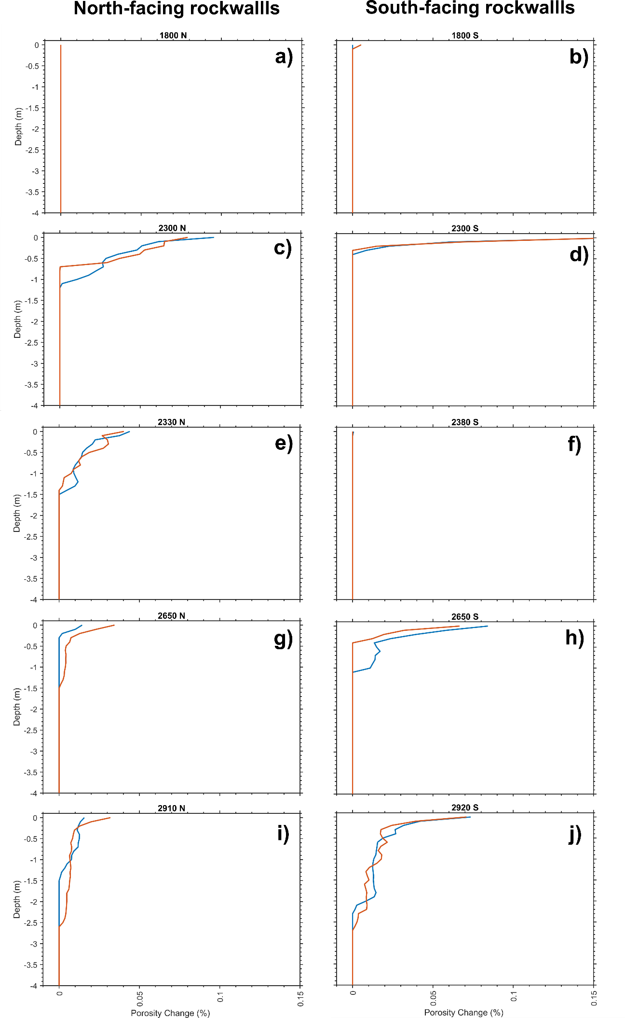
Figure S12. Simulated frost cracking at elevations for Dammkar a-b) 1800 m. c-d) 2300 m and Dachstein, e) 2330 m, f) 2380 m, g-h) 2650 m, i-j) 2900 m. a), c), e), g), and i) are north-facing rockwalls while b), d), f), h), and j) are south-facing rockwalls. Frost cracking increases with elevation in Dammkar and Dachstein for north and south faces.

Table S4: Parameters used for thermal stress model.
Parameter |  | Dammkar | Dachstein | Ref.
Shear modulus (GPa) | G | 24.02 | 9.32 | this study
Poison ratio () | ν | 0.327 | 0.43 | this study
Thermal expansion coefficient (C°⁻¹) | α_{T} | 6 x 10⁻⁶ |  | ³¹

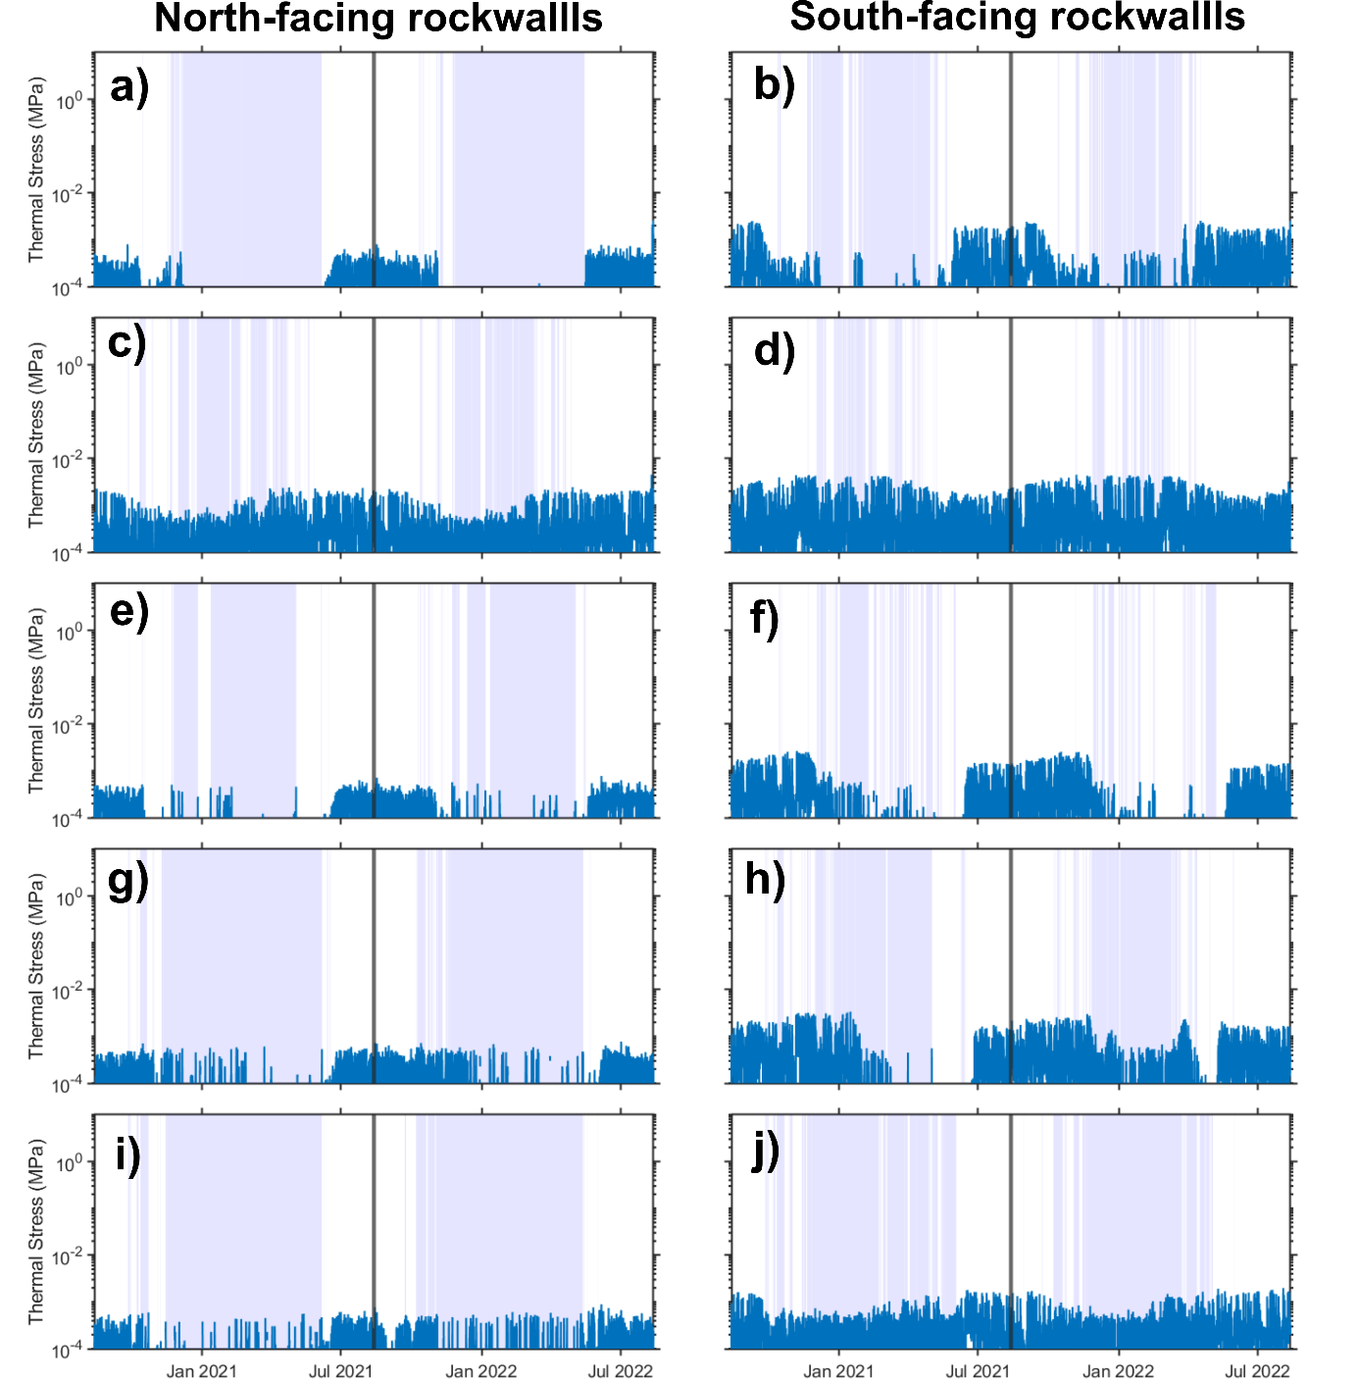
Figure S13. Modelled thermal stress at elevations for Dammkar a-b) 1800 m. c-d) 2300 m and Dachstein, e) 2330 m, f) 2380 m, g-h) 2650 m, i-j) 2900 m. a), c), e), g), and i) are north-facing rockwalls while b), d), f), h), and j) are south-facing rockwalls. Thermal stress is increased on south-facing rockwalls compared to north-facing rockwalls.

6. Geotechnical mapping results

Table S5. Detailed results of geotechnical mapping to determine Rock Mass Strength (RMS).
Elevation (m) | Aspect | Lithology | Rockwall Slope (°) | Intact rock strength Q (r) | Weathering (r) | Spacing in m (r) | Joint orientation | Width of joints in m (r) | Continuity in m (r) | Outflow of groundwater (r) | Rock Mass Strength (RMS)
Dammkar North
1490 | NE | Wetterstein | 75 | 36.9±7.3 (10) | Moderate (7) | 0.01-0.7 (12.8) | 30 ° out (9) | 0.001 (6.0) | 2-inf (6.25) | none (6.0) | 58±12.4
1530 | NE | Wetterstein | 80 | 44.8±8.4 (14) | Slightly (9) | 0.1-2.5 (20.8) | 0° out (14) | 0.001-0.01 (6.6) | 1-inf (5.2) | none (6.0) | 75.6±15.6
1770 | NNW | Wetterstein | 90 | 45.9 ±6 (14) | Slightly (9) | 0.03-0.4 (16.5) | 0° out (14) | 0.001 (6.0) | 2-inf (6.0) | none (6.0) | 71.5±10.2
1800 | N | Wetterstein | 75 | 54.7 ±3.8 (18) | Slightly (9) | 0.03-1 (14.8) | 60 ° in (20) | 0.001 (6.0) | 1-inf (6.2) | none (6.0) | 80±9.6
1900 | NNW | Wetterstein | 60 | 42.5 ±5.5 (14) | Moderate (7) | 0.1-1 (18.2) | 0° out (14) | 0.001-0.01 (6.0) | 2-inf (5.3) | none (6.0) | 70.5±11.7
1960 | NNW | Alpiner Muschelkalk | 85 | 45.9 ±3.8 (14) | Moderate (7) | 0.05-1 (18) | 0° out (14) | 0.001-0.02 (4.75) | inf (4.5) | none-trace (5.8) | 67.8±8.9
2070 | NNO | Alpiner Muschelkalk | 90 | 48.5 ±6.2 (14) | Slightly (9) | 0.01-1 (19) | 30 ° in (18) | 0.001 (6.0) | 2-inf (5.3) | none (6.0) | 77.3±10.3
2120 | NNO | Reichenhaller Formation | 75 | 39.0 ±7.5 (10) | Slightly (9) | 1-3 (28) | 60 ° in (20) | 0.001 (6.0) | inf (5.0) | none (6.0) | 84.0±7.5
2200 | ONO | Alpiner Muschelkalk | 65 | 39.2 ±3.7 (10) | Moderate (7) | 0.03-0.4 (15) | 30 ° in (18) | 0.001-0.01 (5.5) | 3-inf (5.5) | none-trace (5.8) | 62.5±5.9
2300 | SSO | Alpiner Muschelkalk | 70 | 48.9 ±4.1 (14) | Moderate (7) | 0.03-0.8 (18) | 30 ° in (18) | 0.001-0.02 (4.8) | 3-inf (5.5) | none-trace (5.8) | 73.0±9.6
2350 | NW | Alpiner Muschelkalk | 75 | 44.1 ±4.8 (14) | Slightly (9) | 0.1-1 (18) | 30 ° in (18) | 0.01-0.05 (2.5) | 1.5-inf (5.3) | none-trace (5.8) | 72.5±11.0
Dammkar South
1740 | SO | Wetterstein | 70 | 45.9 ±3.8 (14) | Slightly (9) | 0.2-3 (22.3) | 60 ° in (20) | 0.001-0.05 (4.3) | 0.5-inf (5.7) | none-trace (5.8) | 81.0±10.4
1800 | SSO | Wetterstein | 75 | 53.0 ±4.3 (18) | Moderate (7) | 0.05-1.2 (16.5) | 30 ° in (18) | 0.0001-0.02 (4.0) | 2-inf (5.3) | none (6.0) | 74.8±7.9
1850 | SO | Wetterstein | 70 | 51.2 ±4.5 (18) | Moderate (7) | 0.02-0.15 (10) | 60 ° in (20) | 0.0001-0.02 (4.0) | inf (5.0) | none (6.0) | 70.0±8.7
1900 | S | Wetterstein | 75 | 47.5 ±6.1 (14) | Slightly (9) | 0.2-0.8 (19.5) | 30 ° in (18) | 0.001-0.05 (4.0) | 2-inf (5.5) | none (6.0) | 76.0±11.5
2040 | OSO | Reichenhaller Formation | 60 | 40.4 ±8.7 (14) | Moderate (7) | 0.3-1.5 (23.3) | 60 ° in (20) | 0.001-0.03 (4.3) | inf (5.0) | none (6.0) | 79.7±13.4
2120 | S | Reichenhaller Formation | 85 | 32.4 ±4.4 (10) | Slightly (9) | 1-3 (28) | 60 ° in (20) | 0.001-0.03 (4.7) | inf (5.0) | none-trace (5.8) | 82.3±7.3
2200 | SSW | Alpiner Muschelkalk | 70 | 47.4 ±6.3 (14) | Moderate (7) | 0.05-1 (21.3) | 60 ° in (20) | 0.001-0.03 (5.0) | inf (5.0) | none (6.0) | 78.3±12.8
2300 | SSO | Alpiner Muschelkalk | 85 | 49.2 ±4.9 (14) | Slightly (9) | 0.3-0.5 (19.5) | 30 ° in (18) | 0.01-0.1 (4.0) | 1-inf (5.5) | none-trace (5.8) | 75.8±9.4
Dachstein North
2270 | N | Dachsteinkalk | 80 | 48.9 ±4.9 (14) | Slightly (9) | 0.05-0.6 (14.8) | 30 ° out (9) | 0.001-0.01 (5.5) | inf (5.0) | none (6.0) | 63.3±10.4
2330 | N | Dachsteinkalk | 80 | 47.4 ±4.7 (14) | Moderate (7) | 0.02-0.5 (15) | 30 ° out (9) | 0.001-0.01 (5.7) | 1-inf (5.3) | none (6.0) | 62.0±5.9
2460 | N | Dachsteinkalk | 60 | 53.1 ±3.5 (18) | Slightly (9) | 1-2 (28) | 60 ° in (20) | 0.001-0.05 (5) | inf (5.0) | none (6.0) | 91.0±3.5
2520 | N | Dachsteinkalk | 60 | 57.8 ±3.8 (18) | Slightly (9) | 0.1-1 (18.3) | 30 ° out (9) | 0.001-0.04 (5) | 1-inf (5.3) | none (6.0) | 70.5±10.8
2660 | N | Dachsteinkalk | 90 | 54.5 ±5 (18) | Slightly (9) | 0.3-1 (18) | 30 ° in (18) | 0.001-0.01 (5) | 1-inf (5.3) | none (6.0) | 80.0±7.0
2810 | N | Dachsteinkalk | 85 | 47.8 ±3.5 (14) | Slightly (9) | 0.1-1 (16) | 30 ° out (9) | 0.001-0.02 (5) | 1-inf (5.7) | none (6.0) | 64.7±5.8
2910 | N | Dachsteinkalk | 60 | 40.4 ±6.1 (14) | Moderate (7) | 0.1-0.5 (15) | 30 ° in (18) | 0.001-0.01 (5) | inf (5.0) | none (6.0) | 70.0±6.1
Dachstein South
2260 | S | Dachsteinkalk | 65 | 55.1 ±7.8 (18) | Slightly (9) | 0.02-1.8 (16.7) | 30 ° out (9) | 0.001 (5) | inf (5.0) | none (6.0) | 68.7±15.3
2380 | S | Dachsteinkalk | 80 | 51.4 ±3.3 (18) | Slightly (9) | 0.3-4 (26.3) | 60 ° in (20) | 0.001-0.05 (4) | 1-inf (5.3) | none (6.0) | 88.7±10.4
2450 | S | Dachsteinkalk | 80 | 51.4 ±3.3 (18) | Slightly (9) | 0.2-1 (23.3) | 0° out (14) | 0.001-0.02 (5) | inf (5.0) | none (6.0) | 80.3±8.0
2520 | S | Dachsteinkalk | 85 | 51.4 ±3.3 (18) | Slightly (9) | 0.4-2 (22.8) | 0° out (14) | 0.001-0.02 (5) | inf (5.0) | none (6.0) | 83.8±7.9
2650 | S | Dachsteinkalk | 85 | 47.4 ±3.2 (14) | Slightly (9) | 0.3-1.2(21) | 30 ° in (18) | 0.001-0.04 (4.7) | inf (5.0) | none (6.0) | 77.7±3.8
2770 | S | Dachsteinkalk | 50 | 46.9 ±3.7 (14) | Slightly (9) | 0.2-2 (20.5) | 30 ° out (9) | 0.001-0.01 (5) | inf (5.0) | none (6.0) | 68.5±8.6
2920 | S | Dachsteinkalk | 90 | 48.0 ±5.2 (14) | Moderate (7) | 0.2-2 (19) | 0° out (14) | 0.001-0.01 (5) | 2-inf (5.3) | none (6.0) | 70.3±11.9
3000 | S | Dachsteinkalk | 65 | 50.8 ±5.8 (18) | Slightly (9) | 0.2-2 (20.3) | 30 ° in (18) | 0.001-0.02 (4.7) | inf (5.0) | none (6.0) | 81.0±13.2

7. Summary rockfall, erosion, geotechnical mapping and stress modelling results

Table S6. The results include geotechnical mapping, laser scanning, thermal stress, and frost cracking modelling. They are categorised by lithology, field site, aspect, and overall.
Study site | Lithology/  Aspect | Rockfall volume (m ³) | Rockwall erosion rate (mm a⁻¹) | RMS | Thermal stress  (kPa a⁻¹) | Frost cracking (mm a⁻¹)
Analysis based on lithology
Dammkar | Wetterstein Limestone | 0.09 ±0.05 |  | 73.0 ± 6.8 | 172.8±190.6 | 0.02 ±0.03
Dammkar | Alpiner Muschelkalk | 0.08 ±0.04 |  | 72.4 ± 5.6 | 368.3±579.6 | 0.19 ±0.15
Dammkar | Reichenhall Layers | 0.05 ±0.04 |  | 82.0 ± 2.2 | 354.2±509.6 | 0.14 ±0.16
Dachstein | Dachstein Limestone | 0.09 ±0.05 |  | 74.7 ± 9.2 | 143.2±325.1 | 0.18 ±0.19
Analysis based on aspect
Dammkar | North | 0.22 ±0.07 | $${0.16}_{-0.16}^{+0.87}$$ | 72.1 ±7.5 | 113.9 ±217.4 | 0.12 ±0.16
Dammkar | South | 0.16 ±0.02 | $${0.03}_{-0.03}^{+0.1}$$ | 77.2 ±4.0 | 183.1 ±428.3 | 0.10 ±0.14
Dachstein | North | 0.05 ±0.00 | $${0.01}_{-0.01}^{+0.02}$$ | 71.6 ±10.5 | 81.3 ±171.9 | 0.17 ±0.11
Dachstein | South | 0.01 ±0.01 | $${0.00}_{-0.00}^{+0.01}$$ | 77.4 ±7.5 | 203.4 ±418.6 | 0.20 ±0.25
Both sides | North | 0.14 ± 0.04 | $${0.09}_{-0.09}^{+0.94}$$ | 71.9 ±8.5 | 97.8 ±195.7 | 0.14 ±0.14
Both sides | South | 0.09 ± 0.02 | $${0.02}_{-0.02}^{+0.11}$$ | 77.3 ±5.8 | 193.2 ±420.5 | 0.15 ±0.20
overall |  | 0.10 ± 0.04 | $${0.06}_{-0.06}^{+0.53}$$
Dammkar |  | 0.073 ± 0.04 | $${0.15}_{-0.15}^{+0.88}$$ | 74.2 ±6.6 | 148.5 ±339.0 | 0.12 ±0.15
Dachstein |  | 0.09 ±0.05 | $${0.01}_{-0.01}^{+0.01}$$ | 74.7± 9.2 | 143.2 ±325.1 | 0.18 ±0.19

8. Statistical Analysis of rockfall events and rockwall erosion

Table S7. The statistical outcomes of the Kendall rank correlation test examining the relationships between frost cracking, thermal stress, and Rock Mass Strength (RMS) with elevation, as derived from the data shown in Figure 3 of the main manuscript.
 |  | Dachstein | Dammkar | Dachstein |  | Dammkar
 |  | Dachstein | Dammkar | North | South | North | South
Thermal stress | Kendal tau | -0.04 | 0.3 | -0.8 | 0.29 | 0.11 | 0.57
Thermal stress | p-value | 8.40e-01 | 0.09 | 0.01 | 0.4 | 0.72 | 0.06
Frost cracking | Kendal tau | 0.35 | 0.69 | -0.28 | 0.79 | 0.68 | 0.69
Frost cracking | p-value | 0.08 | 0.00008 | 0.56 | 0.005 | 0.003 | 0.02
RMS | Kendal tau | 0.01 | 0.06 | 0.14 | -0.14 | 0.09 | 0.07
RMS | p-value | 1 | 0.75 | 0.77 | 0.72 | 0.76 | 0.9

Figure S14. Scatterplots between the most important factors influencing erosion, accompanied by density plots.
References
1 Mohadjer, S. et al. Temporal variations in rockfall and rock-wall retreat rates in a deglaciated valley over the past 11 k.y. Geology 48, 594-598 (2020).
2 Sass, O. Spatial patterns of rockfall intensity in the northern Alps. Zeitschrift für Geomorphologie, Supplementary Issues 138, 51-65 (2005).
3 Jacobs, B. & Krautblatter, M. LiDAR-basierte Quantifizierung von strukturellen Einflüssen auf Steinschlagaktivität in alpinen Kalksteinwänden in DGGT-Fachsektionstage Geotechnik. 362-367 (2017).
4 Krautblatter, M., Moser, M., Schrott, L., Wolf, J. & Morche, D. Significance of rockfall magnitude and carbonate dissolution for rock slope erosion and geomorphic work on Alpine limestone cliffs (Reintal, German Alps). Geomorphology 167, 21-34 (2012).
5 Vehling, L., Rohn, J. & Moser, M. Rockfall at Proglacial Rockwalls—A Case Study from the Kaunertal, Austria: Landform and Sediment Dynamics in Recently Deglaciated Alpine Landscapes in Geomorphology of Proglacial Systems Ch. 9, 143-156 (Springer International Publishing, 2019).
6 Vehling, L. et al. Quantification of sediment transport by rockfall and rockslide processes on a proglacial rock slope (Kaunertal, Austria). Geomorphology 287 (2016).
7 Kenner, R. Mass wasting processes affecting the surface of an alpine talus slope: Annual sediment budgets 2009–2018 at Flüelapass, eastern Swiss Alps. Land Degrad Dev 31, 451-462 (2020).
8 Matsuoka, N. Frost weathering and rockwall erosion in the southeastern Swiss Alps: Long-term (1994-2006) observations. Geomorphology 99, 353-368 (2008).
9 Hartmeyer, I. et al. A 6-year lidar survey reveals enhanced rockwall retreat and modified rockfall magnitudes/frequencies in deglaciating cirques. Earth Surf. Dynam. 8, 753-768 (2020).
10 Hartmeyer, I. et al. Current glacier recession causes significant rockfall increase: the immediate paraglacial response of deglaciating cirque walls. Earth Surf. Dynam. 8, 729-751 (2020).
11 Draebing, D., Mayer, T., Jacobs, B. & McColl, S. T. Alpine rockwall erosion patterns follow elevation-dependent climate trajectories. Commun Earth Environ 3, 21 (2022).
12 Kenner, R. et al. Investigation of rock and ice loss in a recently deglaciated mountain rock wall using terrestrial laser scanning: Gemsstock, Swiss Alps. Cold Reg Sci Technol 67, 157-164 (2011).
13 Müller, J., Gärtner-Roer, I., Kenner, R., Thee, P. & Morche, D. Sediment storage and transfer on a periglacial mountain slope (Corvatsch, Switzerland). Geomorphology 218, 35-44 (2014).
14 Coutard, J.-P. & Francou, B. Rock Temperature Measurements in Two Alpine Environments: Implications for Frost Shattering. Arct. Alp. Res. 21, 399-416 (1989).
15 Guerin, A., Ravanel, L., Matasci, B., Jaboyedoff, M. & Deline, P. The three-stage rock failure dynamics of the Drus (Mont Blanc massif, France) since the June 2005 large event. Scientific Reports 10, 17330 (2020).
16 Rabatel, A., Deline, P., Jaillet, S. & Ravanel, L. Rock falls in high-alpine rock walls quantified by terrestrial lidar measurements: A case study in the Mont Blanc area. Geophys Res Lett 35, L10502 (2008).
17 Courtial-Manent, L. et al. 18-years of high-Alpine rock wall monitoring using terrestrial laser scanning at the Tour Ronde east face, Mont-Blanc massif. Environ Res Lett 19, 034037 (2024).
18 Fei, L. et al. Assessing the rock failure return period on an unstable Alpine rock wall based on volume-frequency relationships: The Brenva Spur (3916 m a.s.l., Aosta Valley, Italy). Eng Geol 323, 107239 (2023).
19 Sass, O. & Wollny, K. Investigations regarding Alpine talus slopes using ground-penetrating radar (GPR) in the Bavarian Alps, Germany. Earth Surf. Process. Landf. 26, 1071-1086 (2001).
20 Fischer, A., Seiser, B., Stocker Waldhuber, M., Mitterer, C. & Abermann, J. Tracing glacier changes in Austria from the Little Ice Age to the present using a lidar-based high-resolution glacier inventory in Austria. Cryosphere 9, 753-766 (2015).
21 Lambrecht, A. & Kuhn, M. Glacier changes in the Austrian Alps during the last three decades, derived from the new Austrian glacier inventory. Annals of Glaciology 46, 177-184 (2007).
22 Buckel, J., Otto, J. C., Prasicek, G. & Keuschnig, M. Glacial lakes in Austria - Distribution and formation since the Little Ice Age. Glob Planet Change 164, 39-51 (2018).
23 Magnin, F. et al. Permafrost distribution in steep rock slopes in Norway: measurements, statistical modelling and implications for geomorphological processes. Earth Surf. Dynam. 7, 1019-1040 (2019).
24 Kenner, R., Noetzli, J., Hoelzle, M., Raetzo, H. & Phillips, M. Distinguishing ice-rich and ice-poor permafrost to map ground temperatures and ground ice occurrence in the Swiss Alps. Cryosphere 13, 1925-1941 (2019).
25 Cermák, V. & Rybach, L. Thermal conductivity and specific heat of minerals and rocks in Landolt–Börnstein Zahlenwerte and Funktionen aus Naturwissenschaften und Technik, Neue Serie, Physikalische Eigenschaften der Gesteine (V/1a) (ed G. Angeneister) 305–343 (Springer, 1982).
26 Draebing, D., Haberkorn, A., Krautblatter, M., Kenner, R. & Phillips, M. Thermal and Mechanical Responses Resulting From Spatial and Temporal Snow Cover Variability in Permafrost Rock Slopes, Steintaelli, Swiss Alps. Permafr Periglac Process 28, 140-157 (2017).
27 Noetzli, J., Gruber, S., Kohl, T., Salzmann, N. & Haeberli, W. Three-dimensional distribution and evolution of permafrost temperatures in idealized high-mountain topography. J. Geophys. Res.-Earth Surf. 112, F02S13 (2007).
28 Anderson, R. S., Anderson, S. P. & Tucker, G. E. Rock damage and regolith transport by frost: an example of climate modulation of the geomorphology of the critical zone. Earth Surf. Process. Landf. 38, 299-316 (2013).
29 Rempel, A. W., Marshall, J. A. & Roering, J. J. Modeling relative frost weathering rates at geomorphic scales. Earth Planet Sci Lett 453, 87-95 (2016).
30 Krautblatter, M. Detection and quantification of permafrost change in alpine rock walls and implications for rock instability PhD Thesis thesis, Universität Bonn, (2009).
31 Pei, L. et al. Thermal strain in a water-saturated limestone under hydrostatic and deviatoric stress states. Tectonophysics 688, 49-64 (2016).

