Supplementary material to

Predicting earthquake-induced wavefield and stress dynamics in high-alpine mountains using full waveform modeling
Fabian Limberger^{1*}, Georg Rümpker^{1,2}, Jan Philipp Kruse¹ and Thibault Duretz¹

¹Institute of Geosciences, Goethe-University Frankfurt, 60438 Frankfurt am Main, Germany
²Frankfurt Institute for Advanced Studies, 60438 Frankfurt am Main, Germany

Correspondence to: Fabian Limberger (f.limberger@geophysik.uni-frankfurt.de)

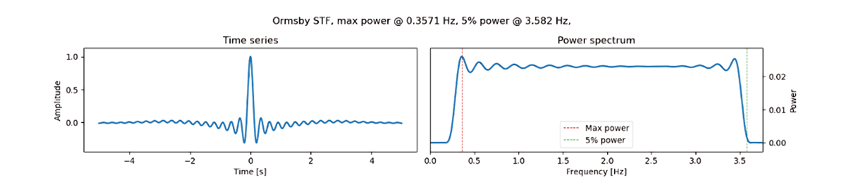

Figure S1: Ormsby wavelet, which is used as a source time function. The spectra is flat between 0.3 Hz and 3.5 Hz.

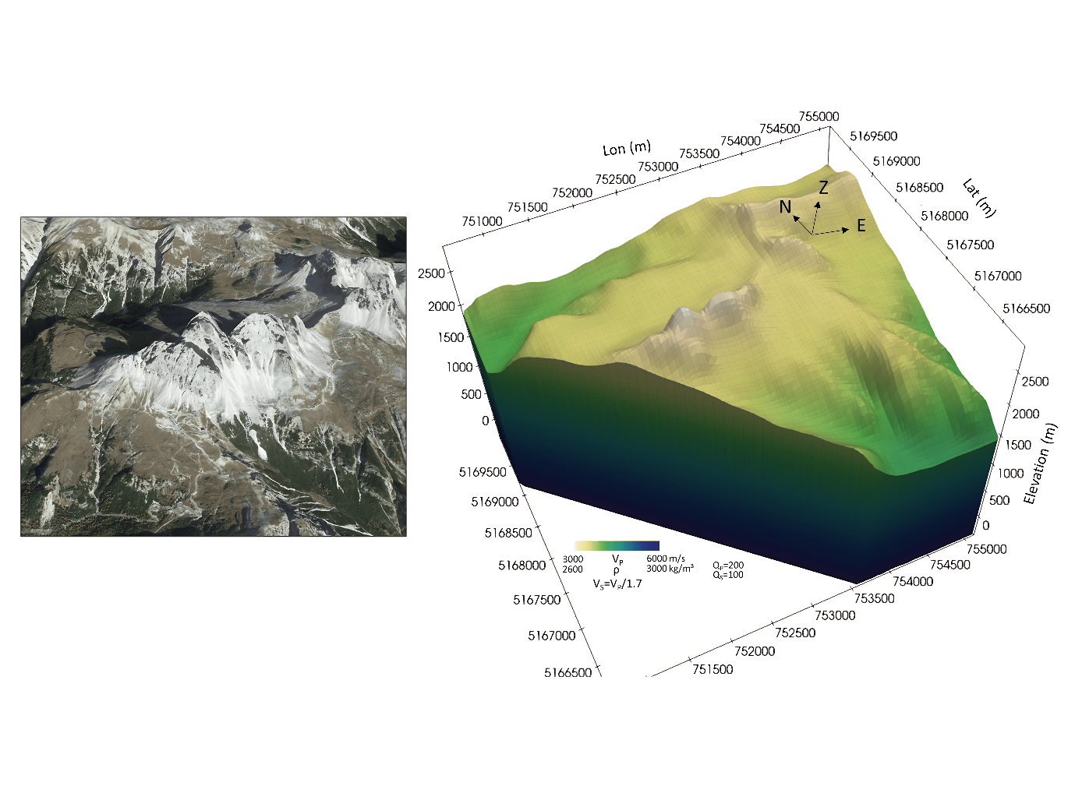Figure S2: Geometrical model and seismic velocity gradient of the Tre Cime di Lavaredo (Italy). Image data: ©Google Earth, 2024.

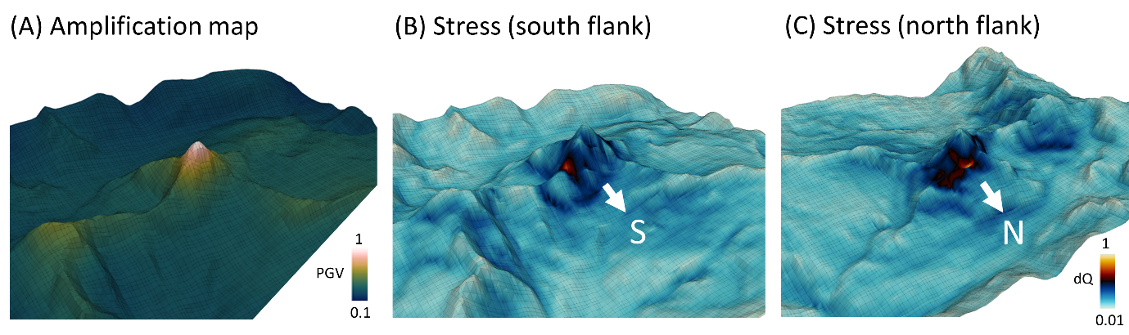
Figure S3: Maximum PGV (A) and deviatoric stress $dQ (B and C)$ across all time steps during the simulated earthquake in three dimensions. The incoming wave is a vertical plane wave with a dominant frequency of 0.4 Hz (according to Fig. 5A). The values (color scale) is normalized to the respective maximum.

In the following, the governing formulations to calculated the deviatoric stress are listed:

The isotropic stress-strain relation (with plain strain $ϵ_{xx}=0$) is

$$\left(\begin{matrix} σ_{xx} \\ σ_{yy} \\ σ_{zz} \end{matrix}\right) = \left(\begin{matrix} K + \frac{4G}{3} & K - \frac{2G}{3} & K - \frac{2G}{3} \\ K - \frac{2G}{3} & K + \frac{4G}{3} & K - \frac{2G}{3} \\ K - \frac{2G}{3} & K - \frac{2G}{3} & K + \frac{4G}{3} \end{matrix}\right) \left(\begin{matrix} ϵ_{xx} \\ ϵ_{yy} \\ 0 \end{matrix}\right)$$

and can be expressed with Poisson’s number $ν$ and elastic modulus E
$$\left(\begin{matrix} σ_{xx} \\ σ_{yy} \\ σ_{zz} \end{matrix}\right)=\frac{1}{E}\left(\begin{matrix}1 & -ν & -ν \\ -ν & 1 & -ν \\ -ν & -ν & 1\end{matrix}\right)\left(\begin{matrix} ϵ_{xx} \\ ϵ_{yy} \\ 0 \end{matrix}\right)$$

The out-of-plane stress (in z-direction) for a model domain in x-y-direction is
$$σ_{zz}= (K - \frac{2G}{3} )(ϵ_{xx}+ϵ_{yy})$$

and can be expressed using the stress components $σ_{xx} and σ_{yy}$
$$σ_{zz}= \frac{3K -2G}{2(3K + G)}(σ_{xx}+σ_{yy})$$
or
$$σ_{zz}= ν (σ_{xx}+σ_{yy})$$

where the Poisson’s number is a function of the seismic velocities
$$ν=\frac{V_{p}^{2}-2V_{s}^{2}}{2\left(V_{p}^{2}-V_{s}^{2}\right)}$$

The strain components are
$$ϵ_{xx}= \frac{1}{E} σ_{xx} -\frac{ν}{E} σ_{yy}$$
$$ϵ_{yy}= -\frac{ν}{E} σ_{xx} + \frac{1}{E} σ_{yy}$$
where
$$E=\frac{9KG}{3K + G}$$
$$ν=\frac{3K -2G}{2(3K + G)}$$

The hydrostatic pressure is defined by
$$P=- \frac{1}{3}\left(σ_{xx} +σ_{yy} +σ_{zz}\right)$$

Hence, the deviatoric stress (2nd invariant of the deviatoric stress tensor) is given by

$$dQ=\sqrt{J_{2}}=\sqrt{\frac{1}{2}\left({\left(σ_{xx}+P\right)}^{2}+{\left(σ_{yy}+P\right)}^{2}{+ \left(σ_{zz}+P\right)}^{2}+2σ_{xy}^{2}\right)}$$

