Supplementary Methods

Methods
Ethical approval and consent
The ethical foundations for the concept of whole-body donation and research in deceased persons for xenotransplantation research have been previously published^{1,2}. The selected decedent was repeatedly confirmed brain dead by four clinical assessments and had been ruled out for organ donation by the China Organ Donation Administrative Center. The study protocol was approved by the Institutional Review Board of Guangzhou Medical University First Affiliated Hospital (No. ES-2024-056-02). Written informed consent was obtained from the family of the brain-dead recipient. The Institutional Review Board of Guangzhou Medical University also reviewed our plans for zoonotic disease surveillance, hazardous material handling, and embalming procedures before transport and burial. The Guangdong Red Cross reviewed and provided oversight for the protocol.

Donor pig preparation
A Chinese Bama Xiang pig with a six gene-edited lung (GTKO/B4GalNT2KO/CMAHKO/CD55/CD46/TBM) (Clonorgan Biotechnology, Chengdu, China) was selected as the donor. The pig, a 22-month-old male weighing 70 kg, was housed under standard conditions with access to food and water ad libitum. All procedures involving animals were conducted in accordance with institutional guidelines for animal care and use. This study was approved by the Laboratory Animal Ethics Committee of the Affiliated First Hospital of Guangzhou Medical University (20240419). The pig lung was procured in a clinical-grade operating room. The donor pig was anesthetized, the lung xenograft was perfused with PERFADEX Plus solution (XVIVO, Gothenburg, Sweden), and static cold preservation was completed.

Trial design and surgical procedure
A brain-dead patient who was deemed unsuitable for organ donation by the Organ Ethics Committee, was included as the recipient in this study. The study endpoints were (1) complete failure of the xenotransplant lung, (2) hemodynamic circulation instability, (3) severe infection, and (4) family refusal to continue the experiment.
The donor pig's left pulmonary artery (LPA), left pulmonary vein (LPV), and bronchus were trimmed to appropriate lengths for transplantation, while the right lung of the donor pig was used for pathogen testing. Respiratory support was provided through double-lumen endotracheal mechanical ventilation. To prevent intraoperative hypoxemia or circulatory instability, the recipient underwent a median sternotomy, and the pig's left lung was transplanted into the recipient using standard surgical techniques, including the anastomosis of the left bronchus, LPV, and LPA (Fig. S1).
Peripheral blood and lung tissue samples were collected from the donor pig pre-transplant and from the recipient on postoperative day (POD) 9 to detect porcine pathogens (Table S1).

Immunosuppression and clinical monitoring
One day before surgery, immunoinduction was initiated (Fig. 1A). The patient received 25 mg of rabbit thymoglobulin (rATG) for T-cell depletion, 0.5 mg of mycophenolate mofetil (MMF), and 5 mg of tacrolimus (FK). On the day of transplantation (May 15, 2024), the patient was administered 50 mg of rATG and 20 mg of basiliximab for T-cell depletion. On the first postoperative day (POD 1), 300 mg of rituximab was administered for B-cell depletion. On POD 2, 600 mg of eculizumab was administered to inhibit complement activation, and 50 mg of tofacitinib was used to suppress proinflammatory cytokines. On POD 3, 20 mg of masiliximab was given again for T-cell depletion, and on POD 6, the costimulation blocker belatacept (250 mg) was administered. Maintenance therapy included FK506 (tacrolimus) at 5 mg/day and MMF starting at 1 g/day on POD 0, increasing to 2 g/day on POD 1 and 2.5 g/day on POD 2, and being maintained at 2.5 g/day from POD 3 to POD 9. Methylprednisolone was administered at 750 mg on POD 0 and reduced to 60 mg by POD 6. Postoperative monitoring of FK blood concentration was conducted to maintain levels between 15 and 20 ng/ml. Physiological parameters, including body temperature, central venous pressure (CVP), urine output, blood glucose levels, heart rate, blood pressure, fluid balance, and drainage volume, were continuously monitored in the xenograft lung recipient from transplantation through the postoperative day (POD) 9. These measurements were recorded at regular intervals to assess the recipient's physiological stability (Fig. S2). The recipient's immune status was assessed by regularly monitoring immune cells and inflammatory cytokine levels in peripheral blood (Fig. S3).

Pathological biopsy and xenograft function assessment
Regular pathological biopsies and xenograft function assessments were conducted to monitor the damage and functionality of the lung xenograft at multiple time points: 2 hours’ postperfusion, 24 hours’ postperfusion, POD 2, POD 3, POD 4, POD 6, and POD 9. Pathological biopsies were performed through a left-side incision at the fifth intercostal space. Tissue samples from the lung xenograft were collected for pathological examination. Concurrently, blood was drawn under direct vision from the left LPA and LPV, respectively, for blood gas analysis to evaluate the oxygenation function of the lung xenograft. Lung compliance testing was conducted to assess the function of the xenograft. Dynamic lung compliance (Cdyn), static lung compliance (Cstat), respiratory parameters, and tidal volume were measured while the left xenograft lung was ventilated independently.

Histological and immunological assessments
Hematoxylin and eosin (HE) staining was used to assess tissue morphology and general pathology. Immunohistochemistry for CD3 and CD68 was performed to evaluate T-cell and macrophage infiltration. Immunofluorescence staining for immunoglobin (Ig)G, IgM, C4c, and C3 was conducted to assess antibody deposition and complement activation.

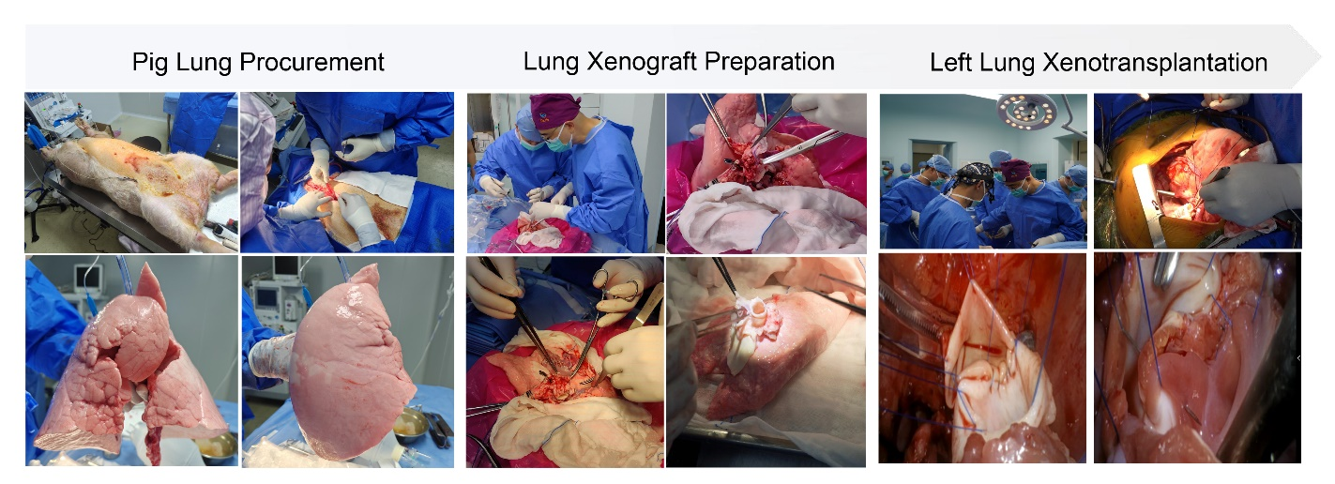
Fig. S1 The surgical procedure for pig-to-human lung xenotransplantation.

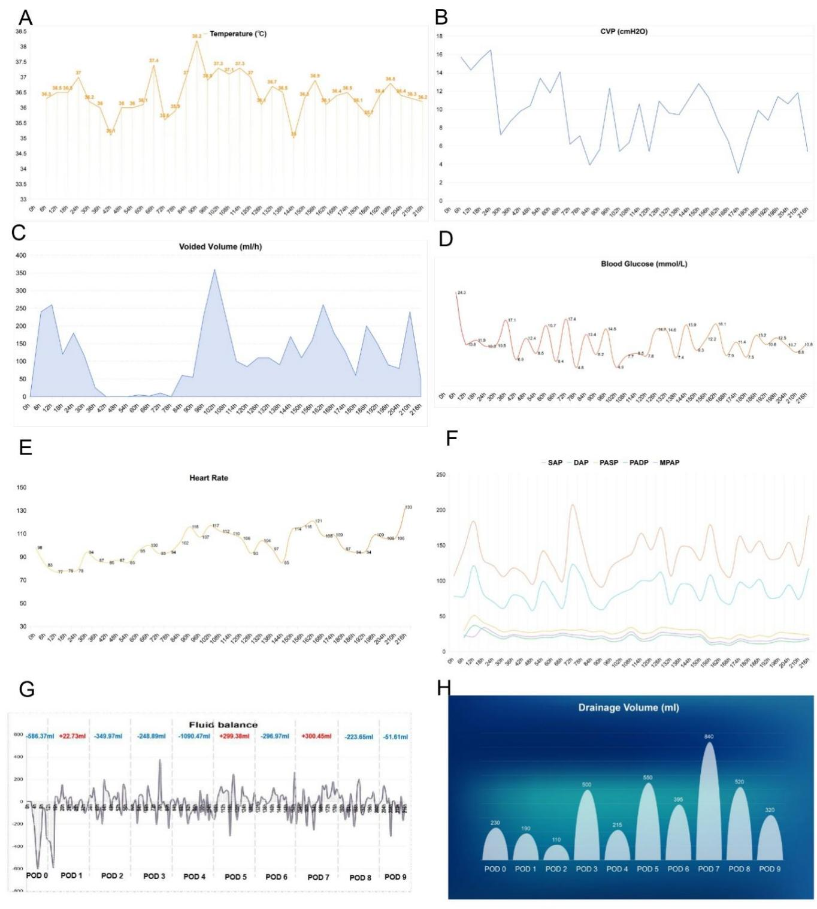
Fig. S2. Dynamic physiological measurements in xenograft lung recipient.
CVP, central venous pressure; SAP, systolic arterial pressure; DAP, diastolic arterial pressure; PASP, pulmonary artery systolic pressure; PADP, pulmonary artery diastolic pressure; MPAP, mean pulmonary artery pressure; POD, postoperative day.
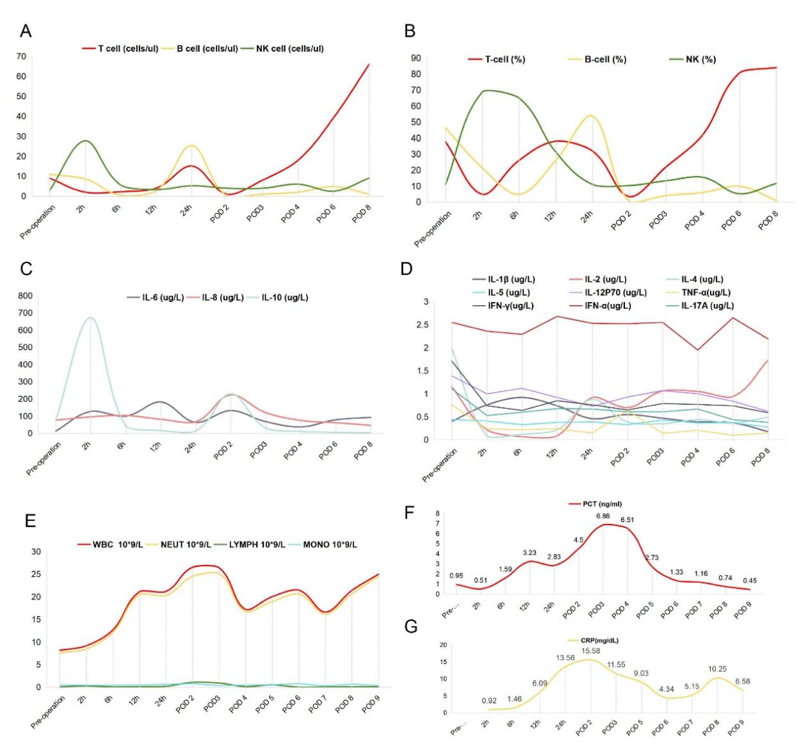Fig. S3 Inflammatory markers and cytokine responses in the xenograft lung recipient. NK, natural killer cell; IL, interleukin; WBC, white blood cell; NEUT, neutrophil; LYMPH, lymphocyte; MONO, monocyte; PCT, procalcitonin; CRP, C-reactive protein; TNF-α, tumor necrosis factor-alpha; IFN-γ, interferon-gamma; IFN-α, interferon-alpha.

Table S1 Porcine pathogen detection by metagenomics and meta-transcriptomics
Pathogens | Porcine peripheral blood (pretransplant, reads) | Porcine lung (pretransplant, reads) | Recipient peripheral blood (POD 9, reads) | Xenograft lung (POD 9, reads)
Pathogens in metagenomics
Porcine endogenous retrovirus C (PERV-C) | 9 | 89 | 3 | 5
Porcine lymphotropic herpesvirus 1 (PLHV-1) | 16 | 53 | 1 | Negative
Porcine lymphotropic herpesvirus 3 (PLHV-3) | 276 | 19 | Negative | Negative
Suid betaherpesvirus 2 (porcine CMV) | 3 | Negative | 1 | Negative
Porcine circovirus 1 | Negative | Negative | Negative | 2
Staphylococcus equorum | 32,157 | Negative | Negative | Negative
Corynebacterium camporealensis | 17,450 | Negative | Negative | Negative
Corynebacterium stationis | 8,671 | Negative | Negative | Negative
Moraxella porci | 6,727 | Negative | Negative | Negative
Aerococcus suis | 2,216 | Negative | Negative | Negative
Streptococcus suis | 921 | Negative | Negative | Negative
Actinobaculum suis | 605 | Negative | Negative | Negative
Pathogens in meta-transcriptomics
Suid gammaherpesvirus 5 | 42 | Negative | Negative | Negative
Streptococcus suis | 4 | Negative | Negative | Negative
Porcine endogenous retrovirus C (PERV-C) | Negative | Negative | Negative | 16
Porcine circovirus 1 | Negative | Negative | 3 | Negative

Supplementary references
1. Moazami, N,et al. Pig-to-human heart xenotransplantation in two recently deceased human recipients. Nat Med.29:1989-1997(2023).
2. Montgomery, R.A.,et al. Results of Two Cases of Pig-to-Human Kidney Xenotransplantation. N Engl J Med.386:1889-1898(2022).

