Appendix A: Supplementary materials

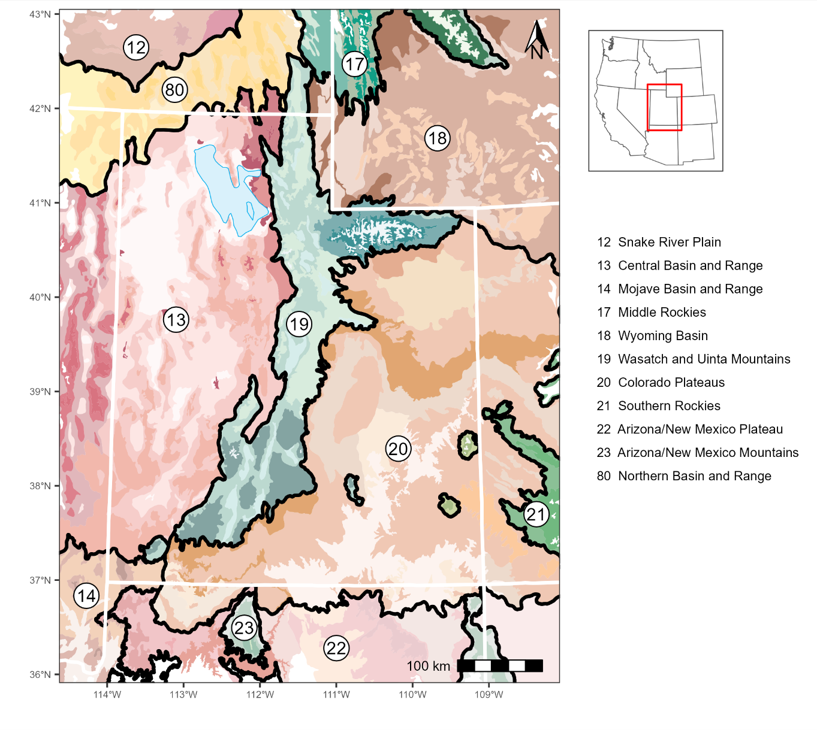
Figure A1: Ecoregion map of Utah, USA and surrounding states. The white boundaries delineate the states, the dark boundaries and corresponding numbers delineate and indicate to the Level III ecoregions, and the colors within the boundaries indicate the Level IV ecoregions.

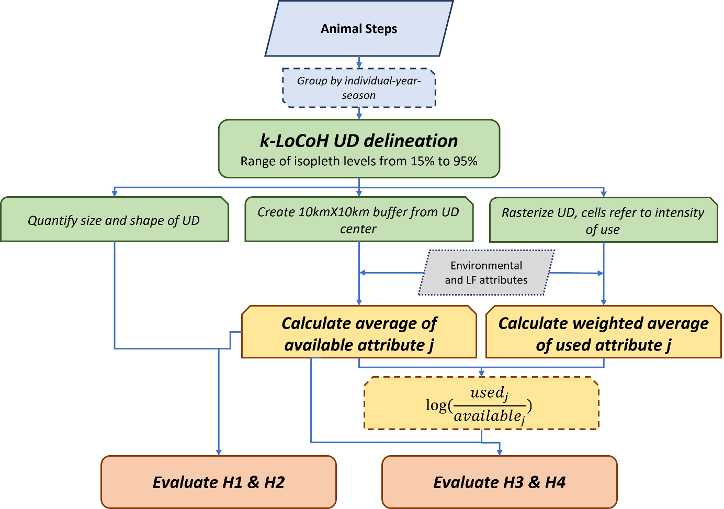
Figure A2: Flowchart of methods.

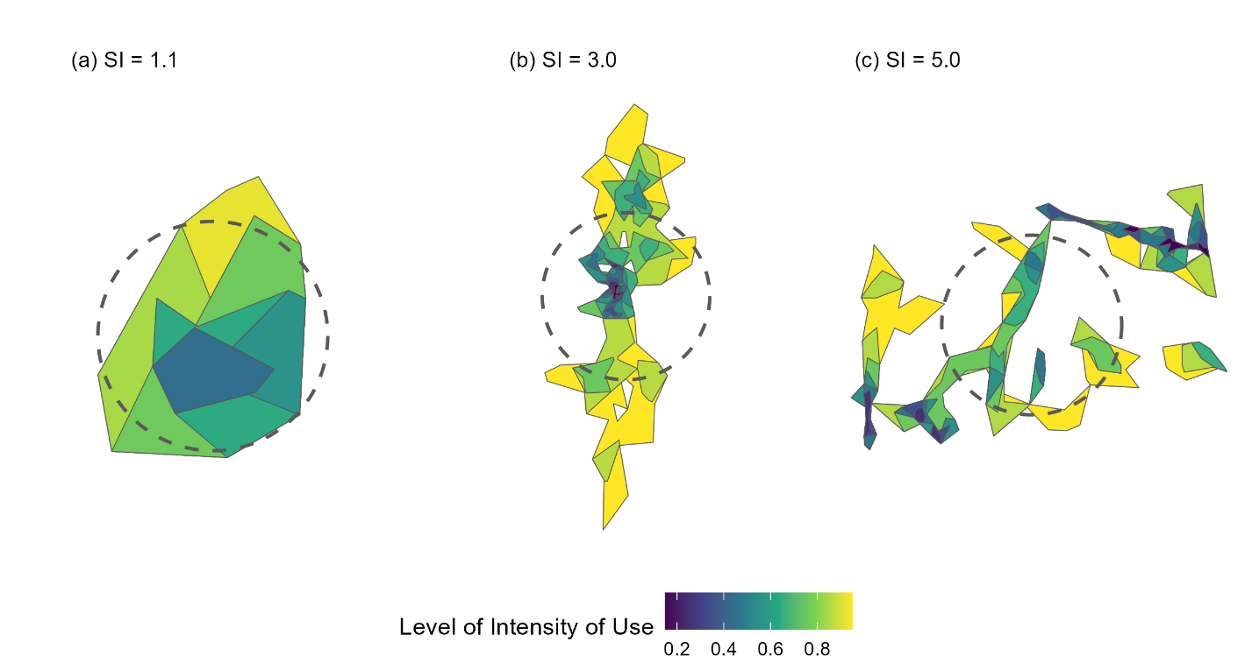
Figure A3: A sample of three ODs of differing compactness to show a shape index of around (a) 1, (b) 3, and (c) 5. The darker areas are more intensely used areas while the lighter areas are less intensely used areas. The dashed circle represents the same area as the OD to show the OD shape’s deviation from optimality.

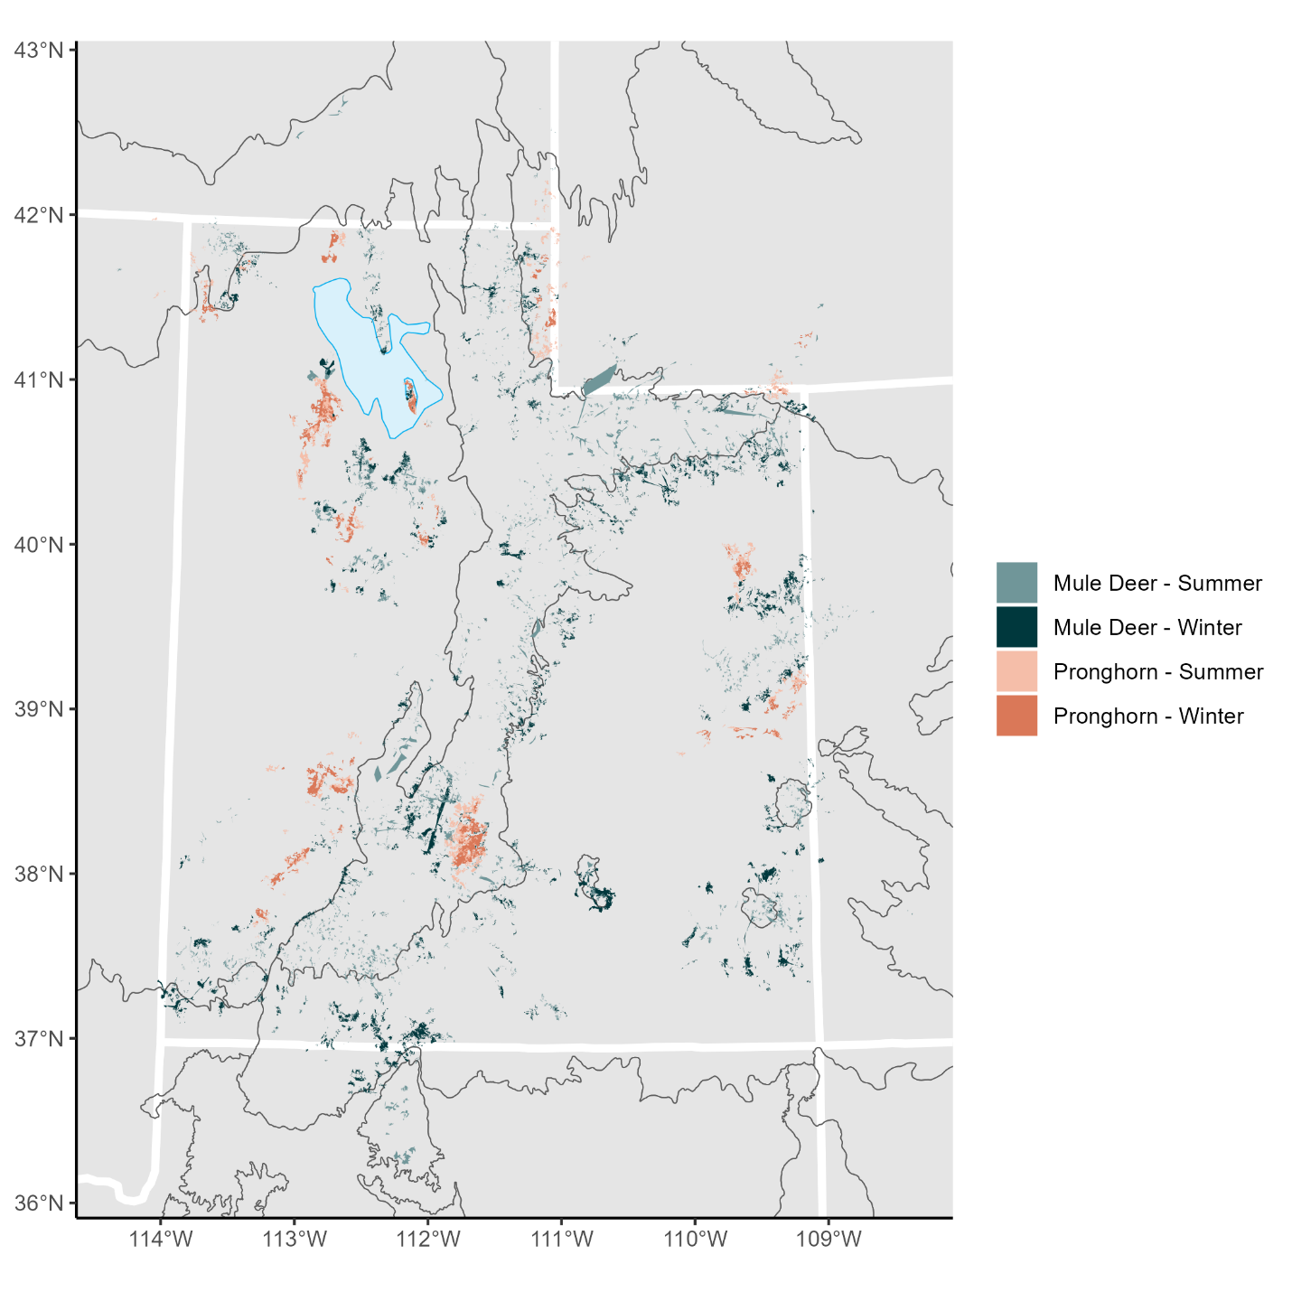
Figure A4: Mule deer and pronghorn summer (light blue and light orange, respectively) and winter (dark blue and dark orange, respectively) ODs within the study area. The white boundaries delineate the states, and the grey boundaries delineate the Level III ecoregions.

Appendix B: Results for males, unpaved road effects, and selection patterns for other habitat attributes

B.1 Home Range Size
Like their female counterparts, increased paved road density was significantly correlated with smaller male mule deer ODs (winter: -0.157±0.05; summer: -0.139±0.07), and their OD sizes did not significantly respond to increased fence density (winter: -0.011±0.05; summer: -0.036±0.07; Fig. B1a). Male pronghorn winter ODs also significantly decreased in size as paved road density increased (-0.323±0.26), but otherwise male pronghorn OD sizes did not show a significant response to increased paved road (summer: -0.068±0.31) nor fence density (winter: 0.107±0.27; summer: -0.087±0.22; Fig. B1b).

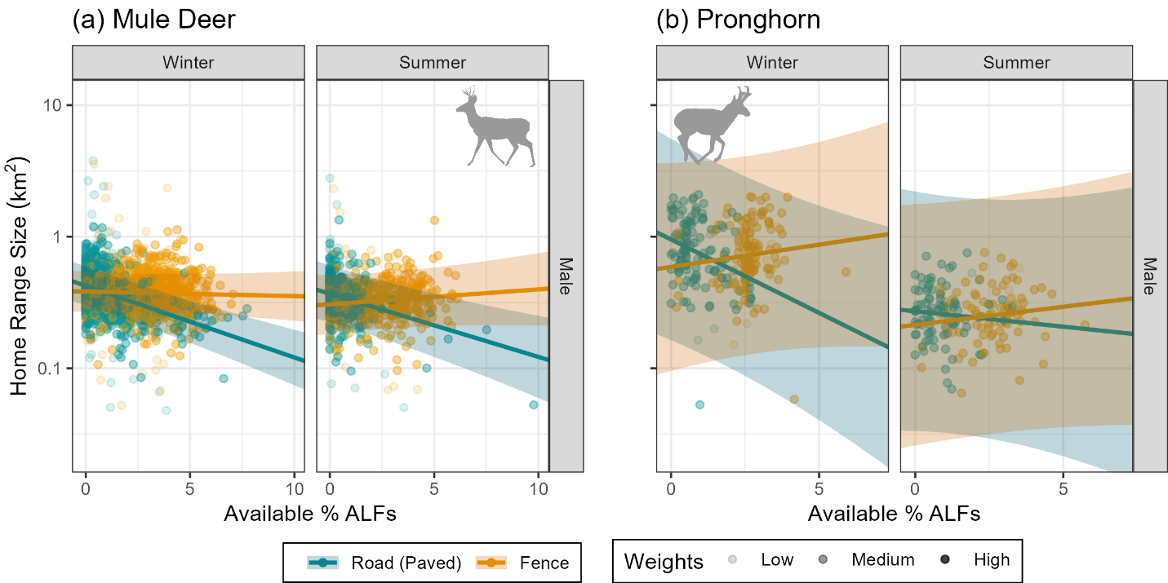
Figure B1: Male mule deer (a) and pronghorn (b) OD size (95% isopleth) in response to paved road (dark cyan) and fence (orange) density by season (columns).

Mule deer OD sizes, across sex and season, did not significantly respond to increased unpaved roads (female-winter: -0.004±0.03, female-summer: -0.052±0.04; male-winter: 0.001±0.05, male-summer: -0.015±0.08; Fig. B2a). Female pronghorn OD sizes did not respond to increased unpaved road density in either winter (-0.031±0.12) nor summer (0.119±0.12), and neither did male-winter pronghorn ODs (0.143±0.21). However, male-summer pronghorn ODs slightly increased in size as unpaved road density increased (0.331±0.21; Fig. B2b).

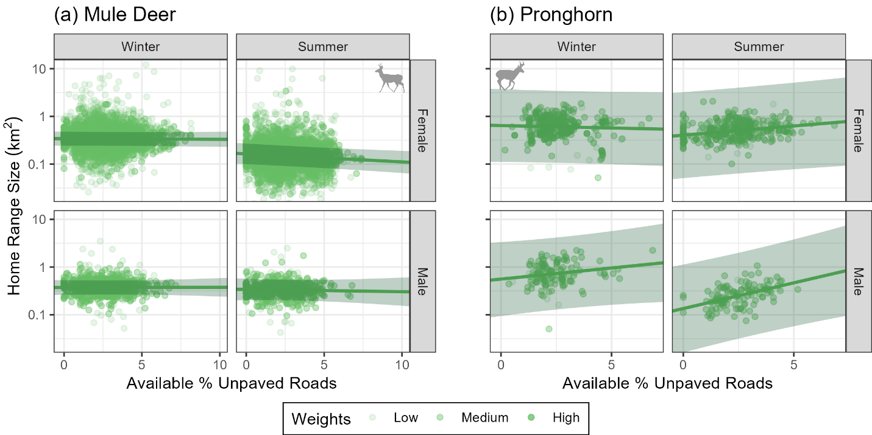
Figure B2: Mule deer (a) and pronghorn (b) OD size (95% isopleth) in response to unpaved road density by sex (rows) and season (columns).

B.2 Home Range Shape
Across season and species, male OD shapes neither significantly responded to paved roads (deer-winter: -0.014±0.01, deer-summer: 0.008±0.02; pronghorn-winter: -0.030±0.06, pronghorn-summer: 0.003±0.07) nor fences (deer-winter: -0.009±0.01, deer-summer: 0.010±0.02; pronghorn-winter: 0.016±0.07, pronghorn-summer: -0.022±0.05; Fig. B3). While female deer ODs in both seasons significantly became more compact as unpaved road density increased (winter: -0.015±0.01; summer: -0.010±0.01; Fig. B4a), these responses were minor. Otherwise, OD shapes did not significantly respond to increasing unpaved roads (male deer-winter: -0.013±0.02, male deer-summer: -0.012±0.02; female pronghorn-winter: -0.019±0.03, female pronghorn-summer: -0.003±0.03; male pronghorn-winter: -0.004±0.05, male pronghorn-summer: 0.024±0.04; Fig. B4).

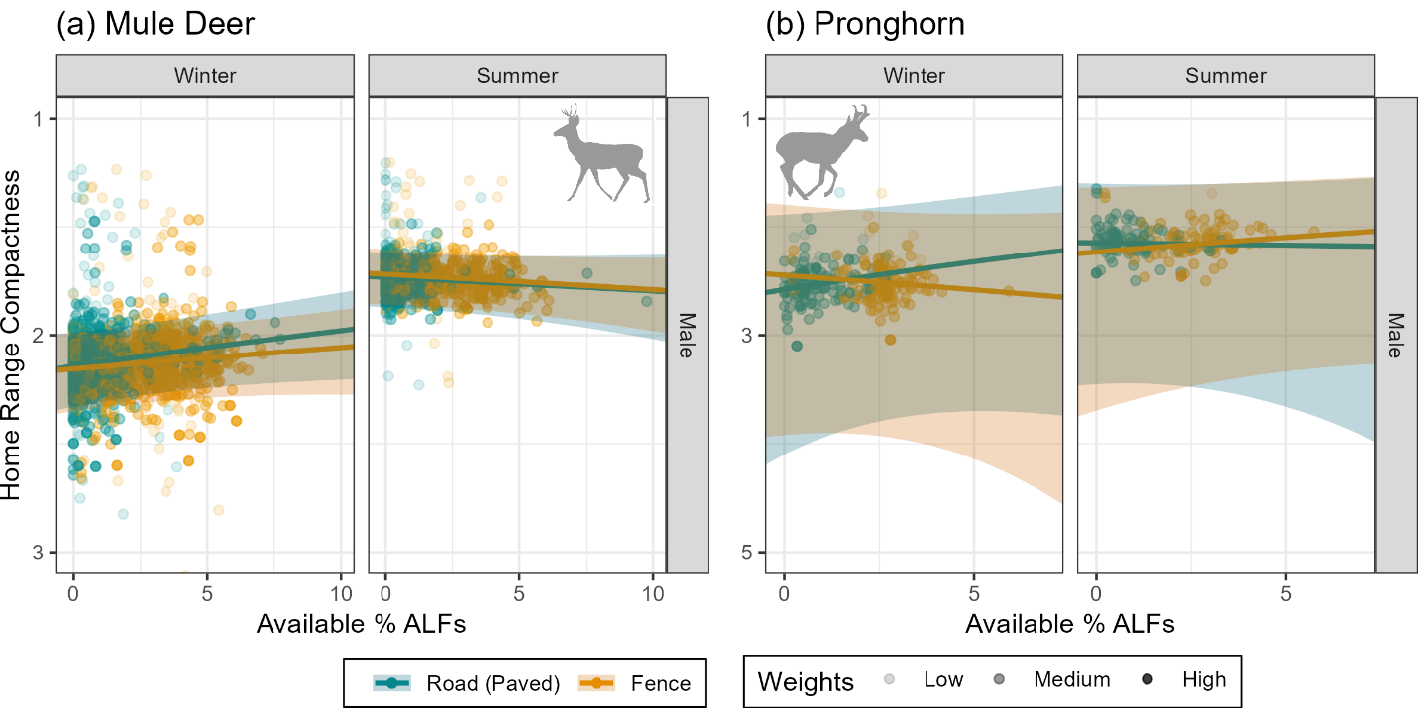
Figure B3: Male mule deer (a) and pronghorn (b) OD compaction (1 indicates a more compact OD and ≫1 indicates a more complex OD) in response to paved road (dark cyan) and fence (orange) density by season (columns).

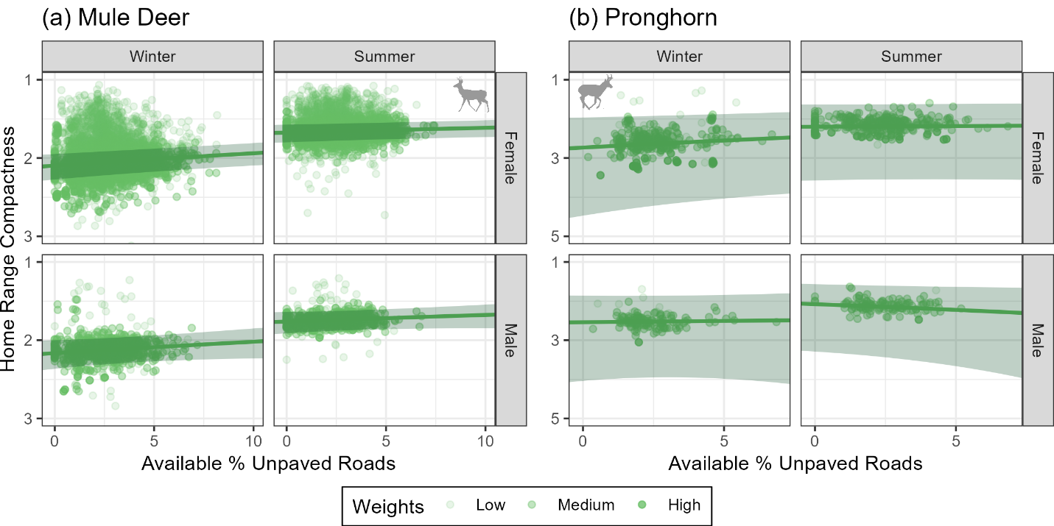
Figure B4: Male mule deer (a) and pronghorn (b) OD compaction in response to unpaved road density by sex (rows) and season (columns).

B.3 Anthropogenic Linear Feature Selection Patterns
Like their female counterparts, male mule deer and pronghorn significantly avoided paved roads (except for male pronghorn in summer: -0.171±0.22), and this avoidance intensely increased as paved road density increased (deer-winter: -0.421±0.06; deer-summer: -0.113±0.08; pronghorn-winter: -0.479±0.22; Fig. B5). For the most part, neither mule deer nor pronghorn significantly selected nor avoided unpaved roads and this did not change as unpaved road density increased (female deer-winter: 0.007±0.03; male deer-winter: -0.047±0.06; male deer-summer: -0.077±0.09; female pronghorn-winter: 0.015±0.06; female pronghorn-summer: -0.052±0.09; male pronghorn-winter: -0.089±0.011; male pronghorn-summer: 0.094±0.17; Fig. B6). The exception is female deer in summer, who slightly avoided unpaved roads as unpaved road density increased, but this avoidance was not intense (-0.070±0.04; Fig. B6a).

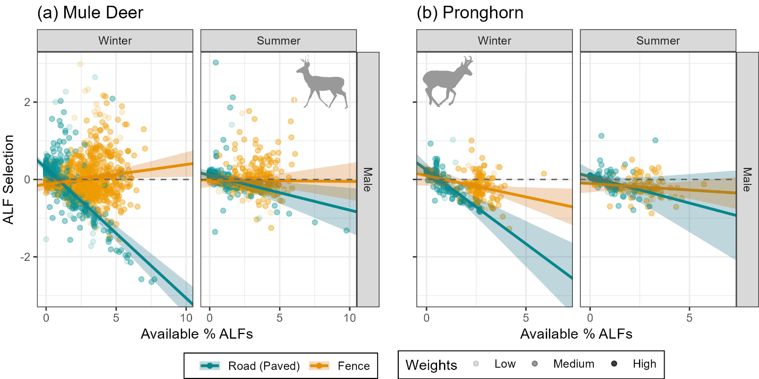
Figure B5: Male mule deer (a) and pronghorn (b) selection patterns for paved roads (dark cyan) and fences (orange) in response to the respective ALF density by season (columns).

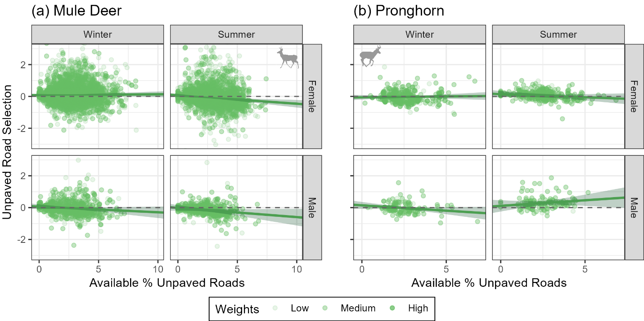
Figure B6: Mule deer (a) and pronghorn (b) selection patterns for unpaved roads in response to unpaved road density by sex (rows) and season (columns).

B.4 Habitat Selection Patterns
As expected, mule deer tended to select for elevation in the summer (female: 0.124±0.05; male: 0.465±0.1) and avoided elevation in the winter (female: -0.139±0.03; male: -0.122±0.06). Increased paved road density was significantly correlated with mule deer increasing their avoidance of elevation (female-winter: -0.100±0.02; male-winter: -0.111±0.04; female-summer: -0.401±0.05; male-summer: -0.199±0.08), causing mule deer in the summer to switch their elevation selection patterns from selection to avoidance (Fig. B7a). Increased fence density was significantly correlated with mule deer increasing their elevation avoidance in the winter (except for males: -0.004±0.05; females: -0.041±0.02), but in the summer mule deer significantly increased their elevation selection as fence density increased (female: 0.111±0.04; male: 0.229±0.08). Unpaved roads were not significantly correlated with changes in mule deer elevation selection patterns (female-winter: 0.041±0.02; male-winter: 0.001±0.05; female-summer: -0.025±0.04; male-summer: -0.179±0.09). While female-winter and male-summer patterns significantly responded to unpaved road density, these responses were muted (Fig. B8a).
Pronghorn significantly avoided elevation in the winter (female: -0.095±0.04; male: -0.057±0.05) but showed no significant avoidance nor selection in the summer (female: 0.075±0.08; male: -0.047±0.10). Pronghorn selection patterns for elevation did not respond significantly or intensely to increased ALF density. Female pronghorn in the summer increased their elevation avoidance as paved road density increased (-0.191±0.11), but otherwise paved roads did not significantly affect pronghorn selection for elevation (female-winter: -0.033±0.06; male-winter: -0.079±0.09; male-summer: -0.108±0.16; Fig. B7b). While pronghorn significantly increased their avoidance of elevation as fence density increased (except for female-summer: 0.025±0.07), these responses were not strong (female-winter: -0.094±0.05; male-winter: -0.095±0.09; male-summer: -0.145±0.12; Fig. B7b). Apart from female-winter (-0.054±0.04), pronghorn selection for elevation did not significantly respond to increased unpaved road density (male-winter: -0.054±0.06; female-summer: -0.053±0.06; male-summer: -0.017±0.11; Fig. B8b).

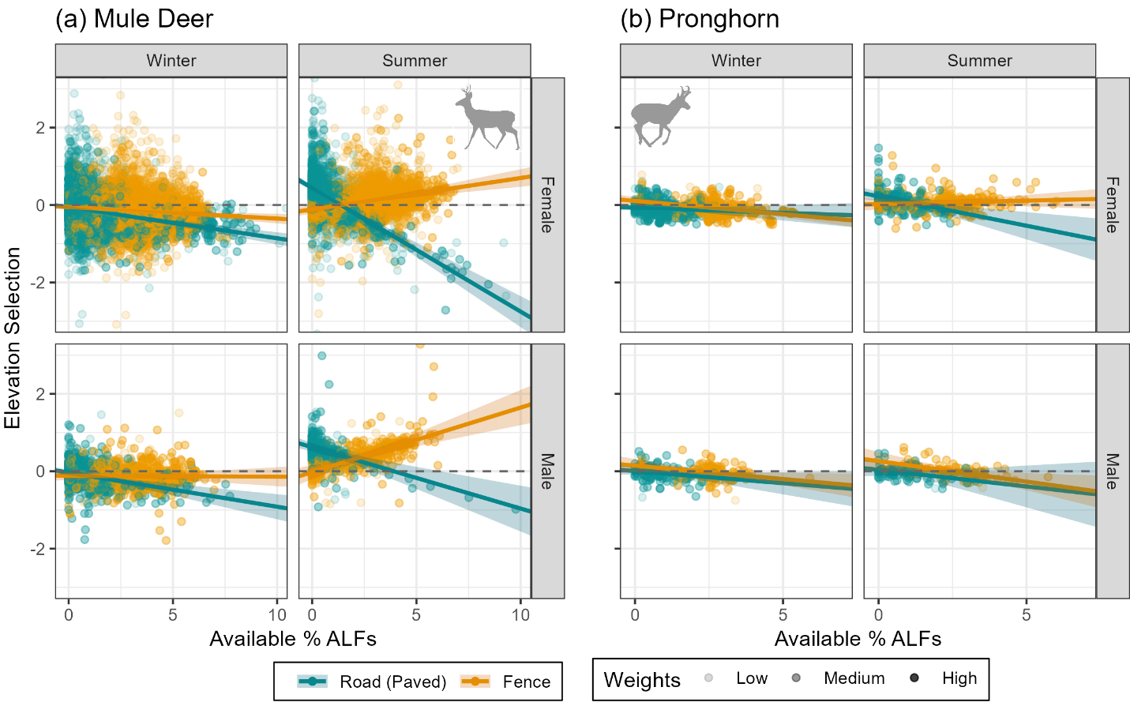
Figure B7: Mule deer (a) and pronghorn (b) selection for elevation in response to paved road (dark cyan) and fences (orange) density by sex (rows) and season (columns).

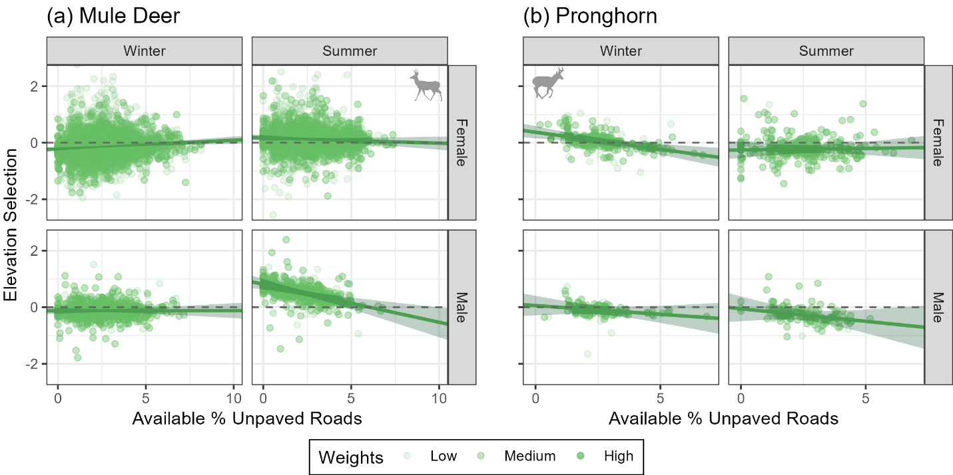
Figure B8: Mule deer (a) and pronghorn (b) selection for elevation in response to unpaved road density by sex (rows) and season (columns).

Interestingly, female mule deer significantly selected for roughness in the winter (0.082±0.04) but not in the summer (-0.004±0.07), while male mule deer significantly avoided roughness in the summer (-0.114±0.09) but not in the winter (0.002±0.04). Increased paved road density was significantly correlated with increased roughness selection for female mule deer in the winter (0.042±0.03) and increased avoidance for female mule deer in the summer (-0.069±0.05), while male mule deer selection patterns for roughness did not significantly respond to paved road density (winter: -0.036±0.06; summer: -0.032±0.07; Fig. B9a). In the winter, mule deer of both sexes increased their avoidance of roughness as fence density increased (female: -0.085±0.03; male: -0.104±0.06), while their summer selection patterns for roughness did not significantly respond to fences (female: 0.028±0.04; male: 0.012±0.07). Overall, mule deer selection or avoidance of roughness did not respond to increased unpaved road density, except for females in the summer (-0.073±0.04), however this response was muted (female-winter: 0.001±0.03; male-winter: -0.013±0.06; male-summer: -0.035±0.08; Fig. B10a).
Pronghorn, in contrast, across sex and season, significantly avoided roughness (female-winter: -0.360±0.14; male-winter: -0.441±0.15; female-summer: -0.530±0.12; male-summer: -0.410±0.13). However, these selection patterns did not significantly respond to paved roads (female-winter: 0.030±0.0.9; male-winter: 0.038±0.13; female-summer: 0.024±0.09; male-summer: -0.128±0.14) nor fences (female-winter: 0.043±0.07; male-winter: -0.083±0.13; female-summer: -0.014±0.06; male-summer: 0.008±0.10; Fig. B9b). While changes in pronghorn selection patterns for elevation were significantly correlated with increased unpaved road density, these responses were muted and did not cause their selection patterns to switch from avoidance to selection (female-winter: 0.073±0.05; male-winter: -0.016±0.09; female-summer: -0.059±0.05; male-summer: -0.115±0.10; Fig. B10b)

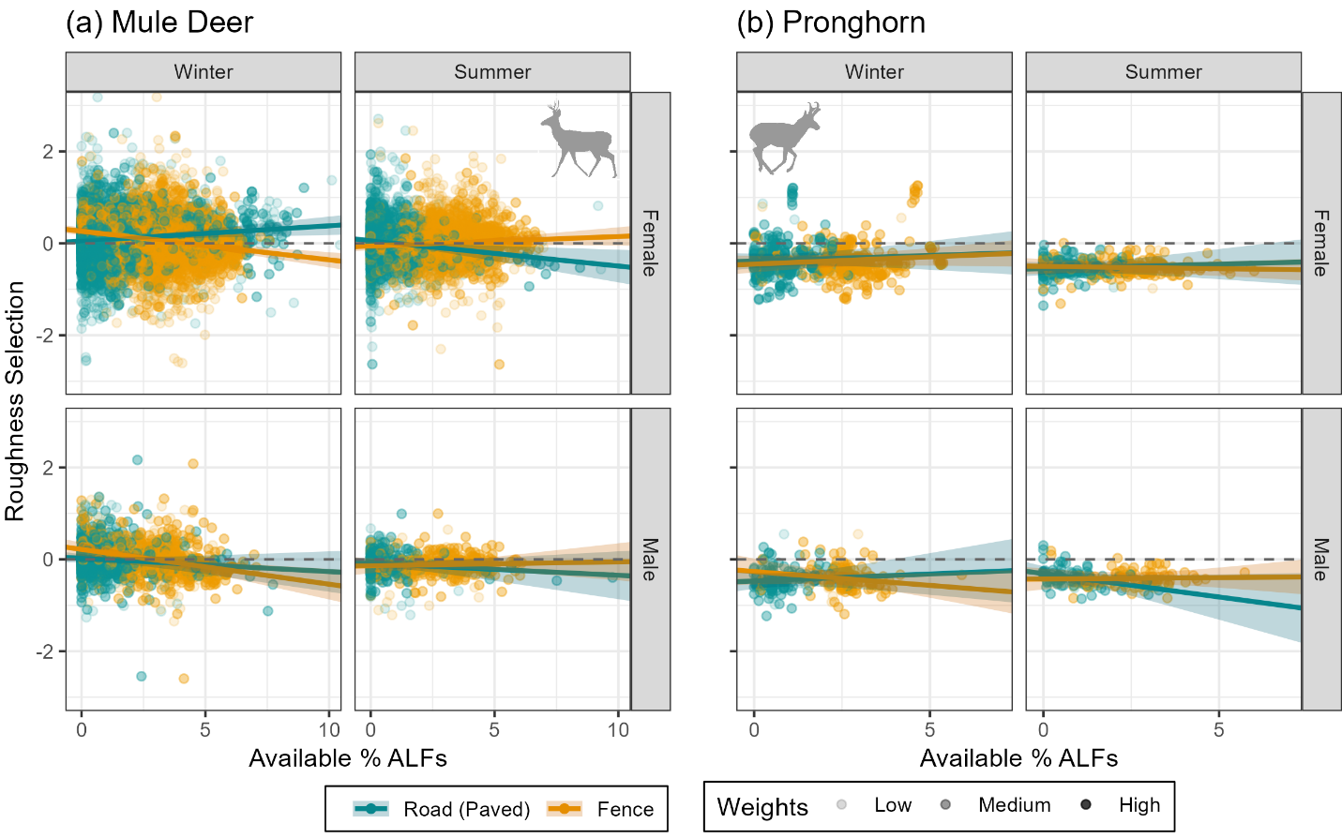
Figure B9: Mule deer (a) and pronghorn (b) selection for roughness in response to paved road (dark cyan) and fences (orange) density by sex (rows) and season (columns).

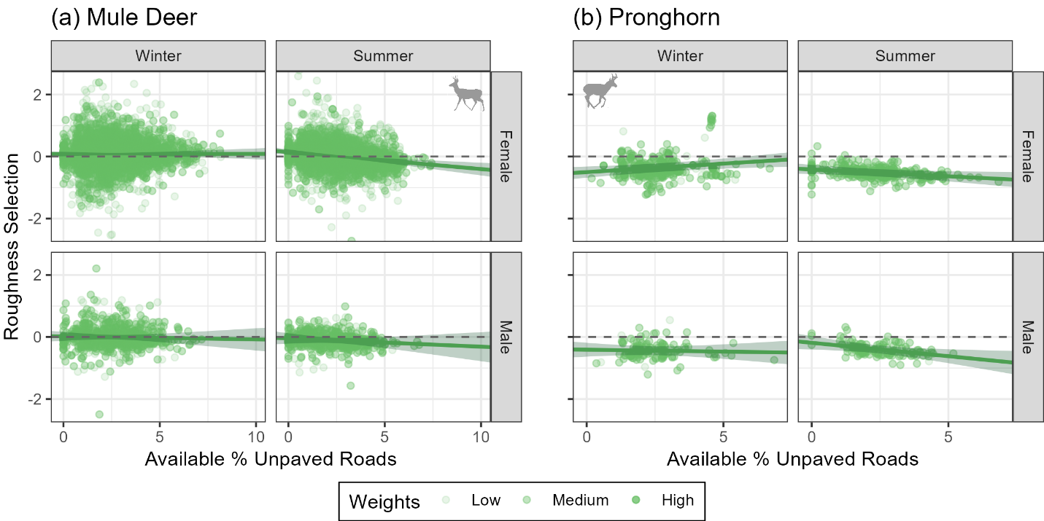
Figure B10: Mule deer (a) and pronghorn (b) selection for roughness in response to unpaved road density by sex (rows) and season (columns).

Like their female counterparts, male deer tended to select for forage, especially in the summer (winter: 0.004±0.05; summer: 0.264±0.12). These selection patterns were unaffected by both paved (male-winter: -0.021±0.04; male-summer: 0.036±0.10; Fig. B11a) and unpaved roads (female-winter: -0.006 ±0.02; male-winter: -0.015±0.04; female-summer: -0.090±0.05), with the exception of male deer in the summer, who increased their selection as unpaved road density increased (-0.091±0.11; Fig. B12a).
Male pronghorn, against expectations, avoided forage during both seasons, particularly in the summer (winter: -0.100±016; summer: -0.283±0.18). Increased paved road density did not significantly affect male pronghorn forage selection (winter: 0.024±0.20; summer: -0.036±0.32). Increased fence density, however, was significantly correlated with male pronghorn avoiding forage (winter: -0.316±0.20; summer: -0.169±0.22; Fig. B11b). Increased unpaved road density did not significantly affect pronghorn forage selection for either sex or season, apart from female pronghorn in winter who only slightly increased their avoidance of forage (female-winter: -0.161±0.09; male-winter: -0.082±0.15; female-summer: 0.015±0.11; male-summer: -0.118±0.21; Fig. B12b).

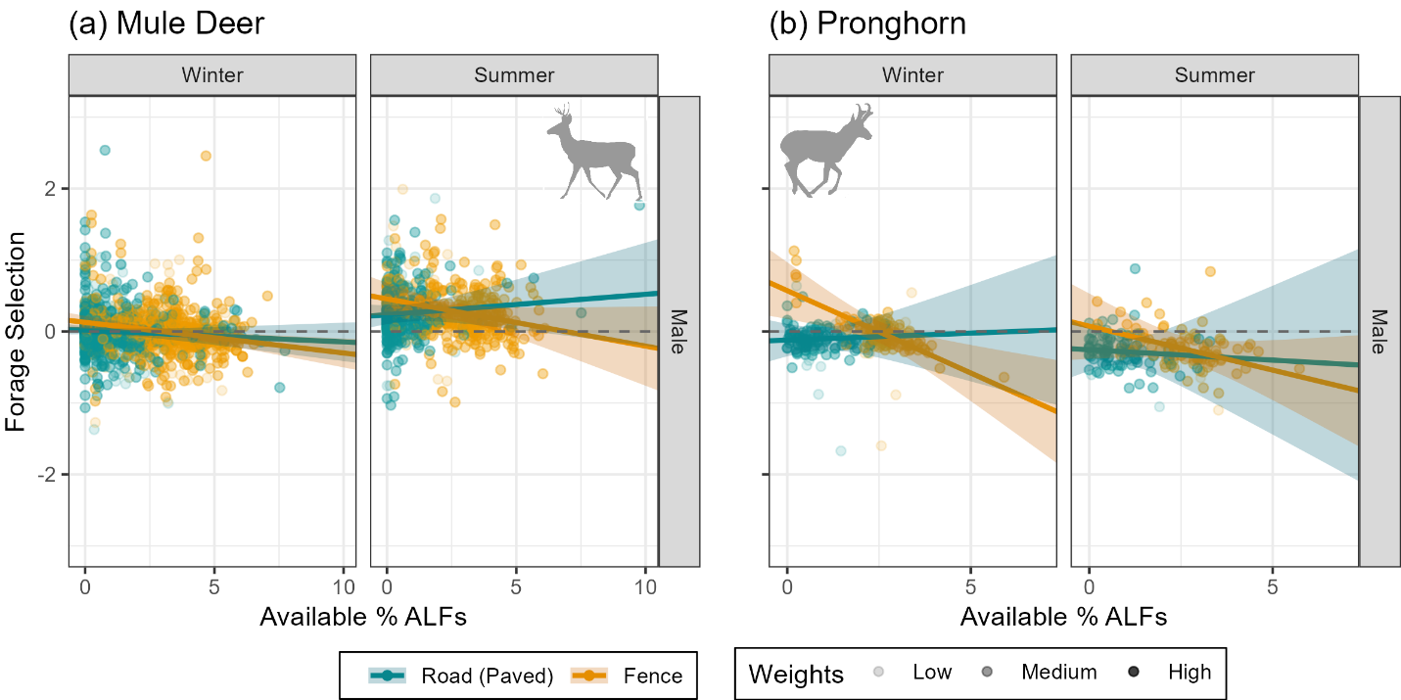
Figure B11: Male mule deer (a) and pronghorn (b) selection for forage in response to paved road (dark cyan) and fences (orange) density by season (columns).

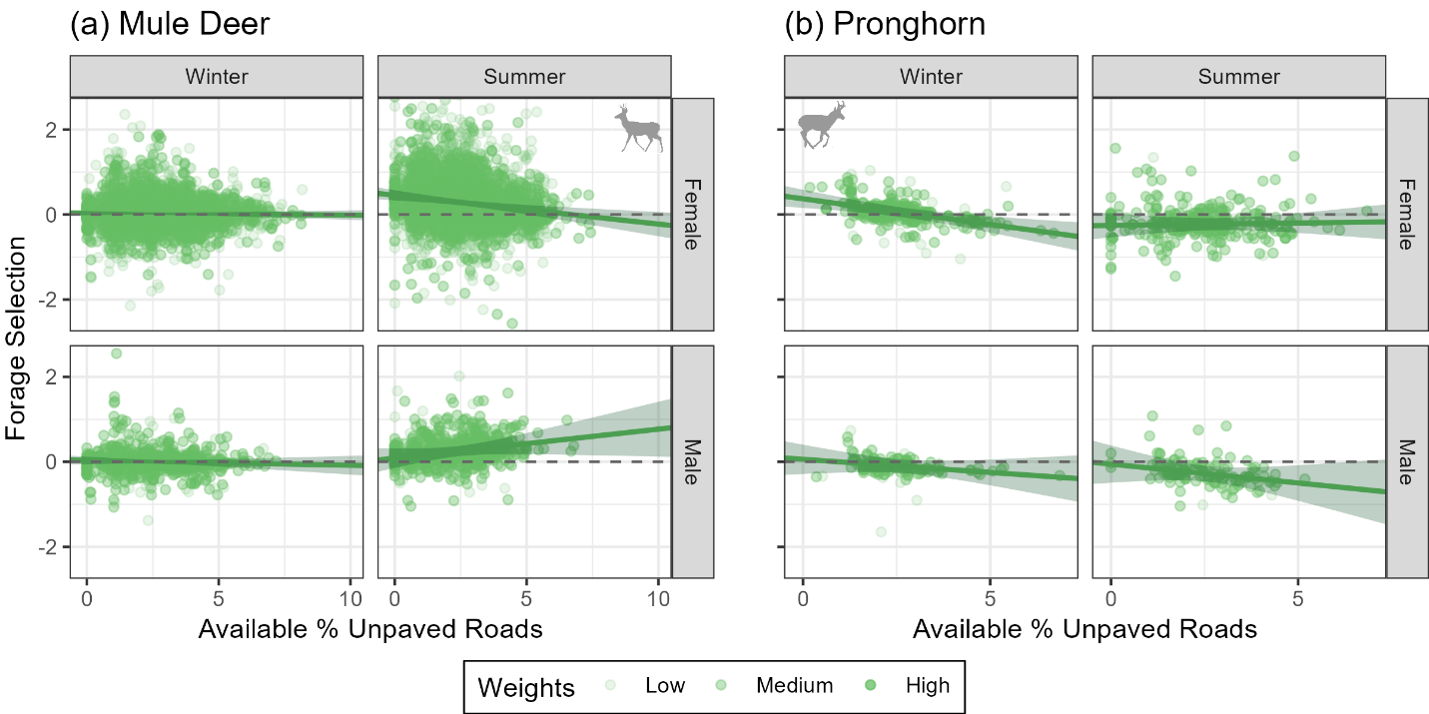
Figure B12: Mule deer (a) and pronghorn (b) selection for forage in response to unpaved road density by sex (rows) and season (columns).

Mule deer ten to avoid shrub cover in the winter (female: -0.117±0.03; male: -0.116±0.05) and select in the summer (female: 0.279±0.05; male: 0.067±0.10). Across sex and season, mule deer selection patterns for shrub cover did not significantly or intensely respond to increased paved road density (female-winter: -0.011±0.02; male-winter: -0.009±0.05; female-summer: -0.103±0.05; male-summer: -0.055±0.08), fence density (female-winter: -0.038±0.02; male-winter: -0.008±0.05; female-summer: 0.015±0.04; male-summer: 0.005±0.08), nor unpaved road density (female-winter: 0.034±0.02; male-winter: -0.025±0.05; female-summer: -0.024±0.04; male-summer: -0.022±0.09; Figs B13a, B14a).
Against expectations, pronghorn across sex and season strongly avoided shrub cover (female-winter: -0.087±0.06; male-winter: -0.178±0.09; female-summer: -0.429±0.06; male-summer: -0.319±0.09). In winter, this avoidance switched to selection as paved road density increased (female: 0.209±0.10; male: 0.212±0.15), though their selection remained unaffected by paved roads in the summer (female: 0.094±0.10; male: -0.015±0.15; Fig. B13b). As fence density increased, female pronghorn in the winter significantly increased their selection for shrub cover (0.174±0.08), switching from avoidance to selection. In all other seasons, however, pronghorn of either sex did not significantly change their shrub cover selection in response to fences (male-winter: -0.102±0.15; female-summer: -0.048±0.06; male-summer: -0.015±0.11; Fig. B13b). As unpaved road density increased, female pronghorn in winter significantly avoided shrub cover (-0.084±0.06) but increased unpaved road density was not significantly correlated with changes in shrub cover selection for the other seasons (male-winter: 0.050±0.11; female-summer: 0.017±0.06; male-summer: -0.031±0.10; Fig. B14b).

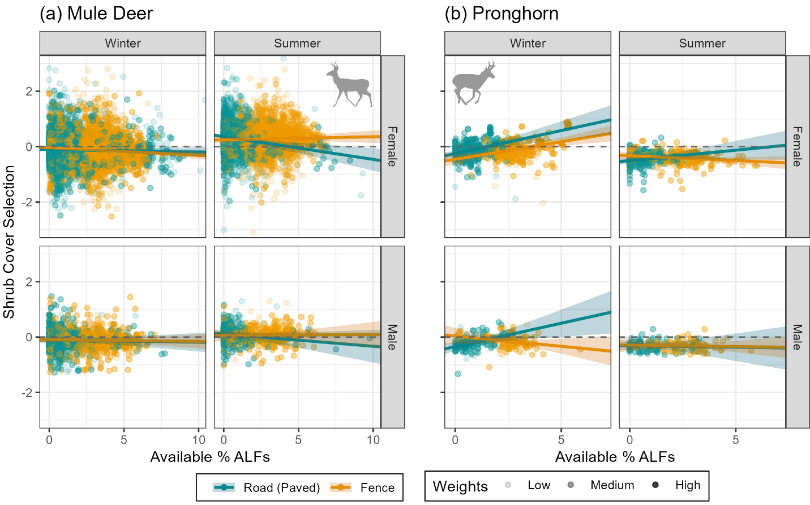
Figure B13: Mule deer (a) and pronghorn (b) selection for shrub cover in response to paved road (dark cyan) and fences (orange) density by sex (rows) and season (columns).

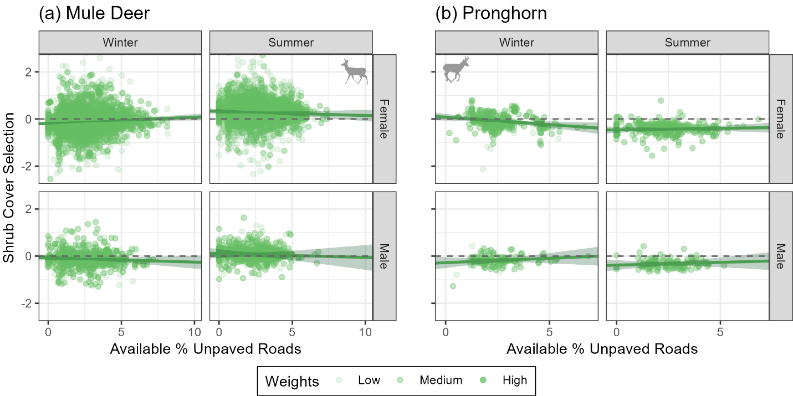
Figure B14: Mule deer (a) and pronghorn (b) selection for shrub cover in response to unpaved road density by sex (rows) and season (columns).

As expected, mule deer avoided tree cover in the winter and selected in the summer, however this was significant only for females (winter: -0.130±0.03; summer: 0.227±0.05) while male deer did not significantly select nor avoid trees (winter: 0.054±0.06; summer: 0.026±0.09). While female deer in the winter significantly increased their selection of tree cover as paved road density increased (0.045±0.02), this response was muted, and in all other sex-season combinations, deer tree selection did not respond significantly to paved road density (male-winter: 0.039±0.05; female-summer: -0.051±0.05; male-summer: 0.006±0.07). Fences similarly did not affect deer selection patterns for trees, apart from male deer in the summer who slightly increased their avoidance (female-winter: 0.020±0.03; male-winter: -0.006±0.05; female-summer: 0.007±0.04; male-summer: -0.084±0.08; Fig. B15a). Increasing unpaved road density, however, was significantly correlate with increased deer avoidance of tree cover, except for male deer in the summer whose selection patterns did not significantly change (female-winter: -0.041±0.03; male-winter: -0.060±0.05; female-summer: -0.096±0.04; male-summer: 0.075±0.08; Fig. B16a).
As expected, pronghorn significantly and intensely avoided tree cover across sex and season (female-winter: -1.264±0.05; male-winter: -1.238±0.05; female-summer: -1.133±0.06; male-summer: -1.025±0.07). Increased paved road density was significantly correlated with increased pronghorn selection for tree cover, apart from female pronghorn in the summer (0.037±0.05), however this response did not push their selection patterns from avoidance to selection (female-winter: 0.023±0.05; male-winter: 0.054±0.03; male-summer: 0.089±0.08). Increased fence density did not significantly affect pronghorn tree cover selection, except for females in the winter who significantly but not intensely increased their avoidance (female-winter: -0.040±0.02; male-winter: -0.004±0.03; female-summer: -0.013±0.03; male-summer: 0.014±0.05; Fig. B15b). Unpaved road density similarly did not impact pronghorn tree cover selection, with the exception of males in the summer who increased their selection, but this response did not push their selection patterns from avoidance to selection (female-winter: -0.007±0.01; male-winter: -0.022±0.02; female-summer: 0.017±0.03; male-summer: 0.063±0.05; Fig. B16b).

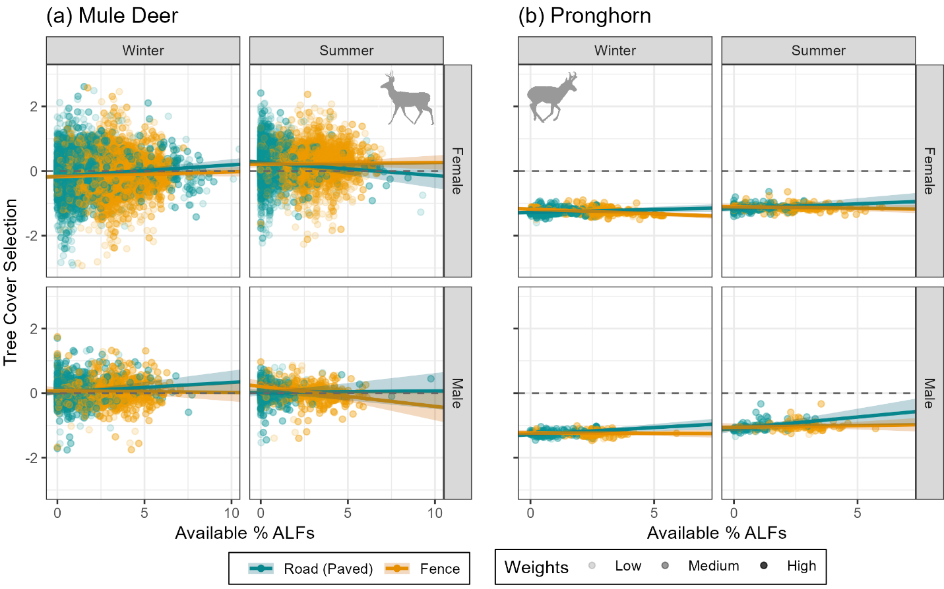
Figure B15: Mule deer (a) and pronghorn (b) selection for tree cover in response to paved road (dark cyan) and fences (orange) density by sex (rows) and season (columns).

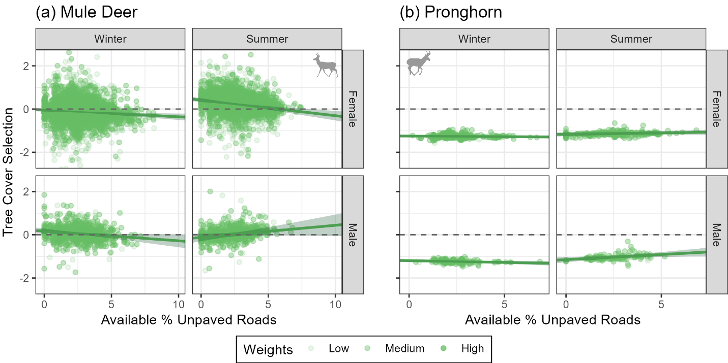
Figure B16: Mule deer (a) and pronghorn (b) selection for tree cover in response to unpaved road density by sex (rows) and season (columns).

Male deer did not show a particular selection nor avoidance of snow depth (0.050±0.08). Like their female counterparts, male deer significantly increased their avoidance of snow depth as paved road density increased (-0.118±0.07) and slightly increased their selection as fence density increased (0.089±0.07; Fig. B17a). Female mule deer significantly, but slightly, increased their selection of snow depth as unpaved road density increased (0.056±0.04) while male deer snow depth selection did not significantly respond to unpaved roads (-0.007±0.07).
Unlike their female counterparts, male pronghorn did not particularly select nor avoid snow depth (0.064±0.10). However, like the females, paved road density was significantly and intensely correlated with increased avoidance of snow depth (-0.573±0.15) and fence density was significantly correlated with increased selection (0.226±0.16; Fig. B17b). However, pronghorn of both sexes did not significantly change their snow depth selection patterns as unpaved road density increased (female: -0.018±0.07; male: -0.028±0.12; Fig. B18b).
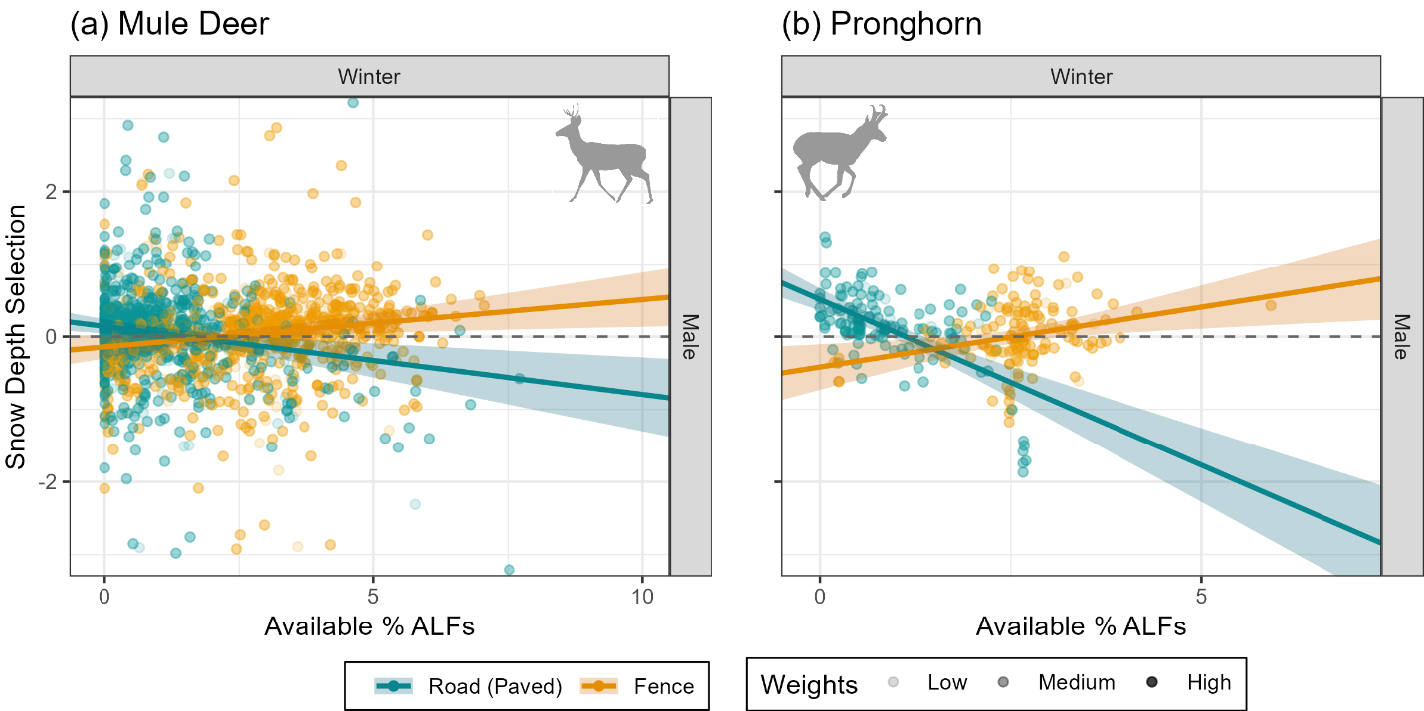
Figure B17: Male mule deer (a) and pronghorn (b) selection for snow depth in response to paved road (dark cyan) and fences (orange) density.

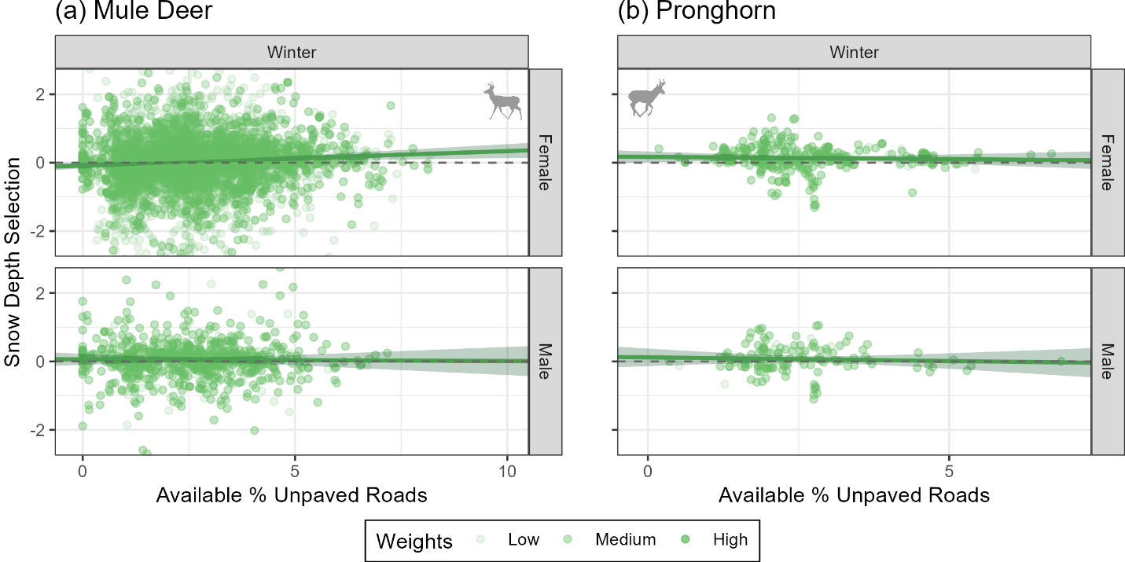
Figure B18: Mule deer (a) and pronghorn (b) selection for snow depth in response to unpaved road density by sex (rows).

