Multimodal tumor suppression by METTL3 gene knockdown in melanoma and colon cancer cells
Arezoo Bazargani¹, Masoumeh Fakhr Taha¹, Vida Babaali¹, Bahram Mohammad Soltani², Arash Javeri¹*
¹ Department of Stem Cells and Regenerative Medicine, Institute for Medical Biotechnology, National Institute of Genetics and Biotechnology, Tehran, Iran
² Department of Molecular Genetics, Faculty of Biological Sciences, Tarbiat Modares University, Tehran, Iran
* Corresponding author: Arash Javeri MD, PhD, Department of Stem Cells and Regenerative Medicine, Institute for Medical Biotechnology, National Institute of Genetic Engineering and Biotechnology (NIGEB), Pajoohesh Blvd., Tehran, P.O. Box 14965‐161, Iran, Email: arashj@nigeb.ac.ir.
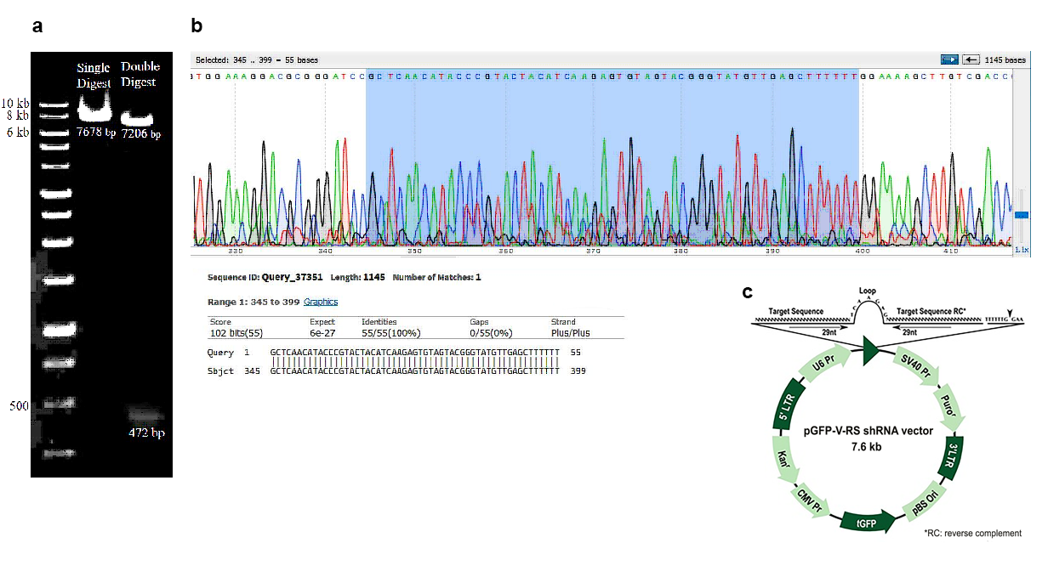
Supplementary figure S1. (a) The colony PCR product using the insertion primers appearing as a 472 bp band on agarose gel confirming successful shRNA insertion. The 7678 bp and 472 bp bands on the agarose gel appeared after single digestion reaction by EcoRI and the double digestion by HindIII and EcoRI, respectively. (b) DNA sequencing results confirmed successful construction of the plasmid. (c) pGFP-V-RS shRNA vector map.

