Supplement

Supplemental Items
- Supplemental Figures 1-7
- Supplemental Tables 1-4
- Supplemental Data 1-4

Supplemental Figure 1: Summary of Mutations and Stage Regressions.
- Stacked barplots indicating number of different types of mutations for individual samples that underwent whole genome sequencing. Functional class mutation annotations come from Annovar refGene. Shared and private phylogenetic mutation type is determined by whether a mutation is distinct to a specific sample or is detected in more than one sample. Description of how clonal status of a mutation is determined is in the Methods section. The bottom panel showing the multi-colored heatmap indicates which patient each sample comes from, the largest single dimension of the sample in millimeters (except for Mucosa samples for which size is unimportant), and Location of the colon that the sample was taken from. PercentWithoutNeoplasia, PercentWithCancer and PercentWithDysplasia are values estimated from our in house pathologist on HE slides of these samples. Purity and ploidy are estimated from Titan (PMID: 25060187). White boxes indicate “no data available”.
- To determine which clinical factor(s) is associated with the number of SNVs per sample, we compared various linear mixed effects regressions. The mixed effects model equations are presented in the ANOVA table at the bottom of the panels. We used the nlme software package available in R to perform the regression analysis and ANOVA. In the left panel, we are testing the fixed effects, mean mutation VAF per sample, mean mutation depth per sample, and sample Location to determine which can account for the highest amount of the variation observed in the SNVs. Because the p-value for the vafMean was so low (p-value = 5.55E-16), we plotted it and used this fixed effect as the null model to compare against the fixed effects of Stage_Stratifications and Polyp/tumor sizes in the right panel.

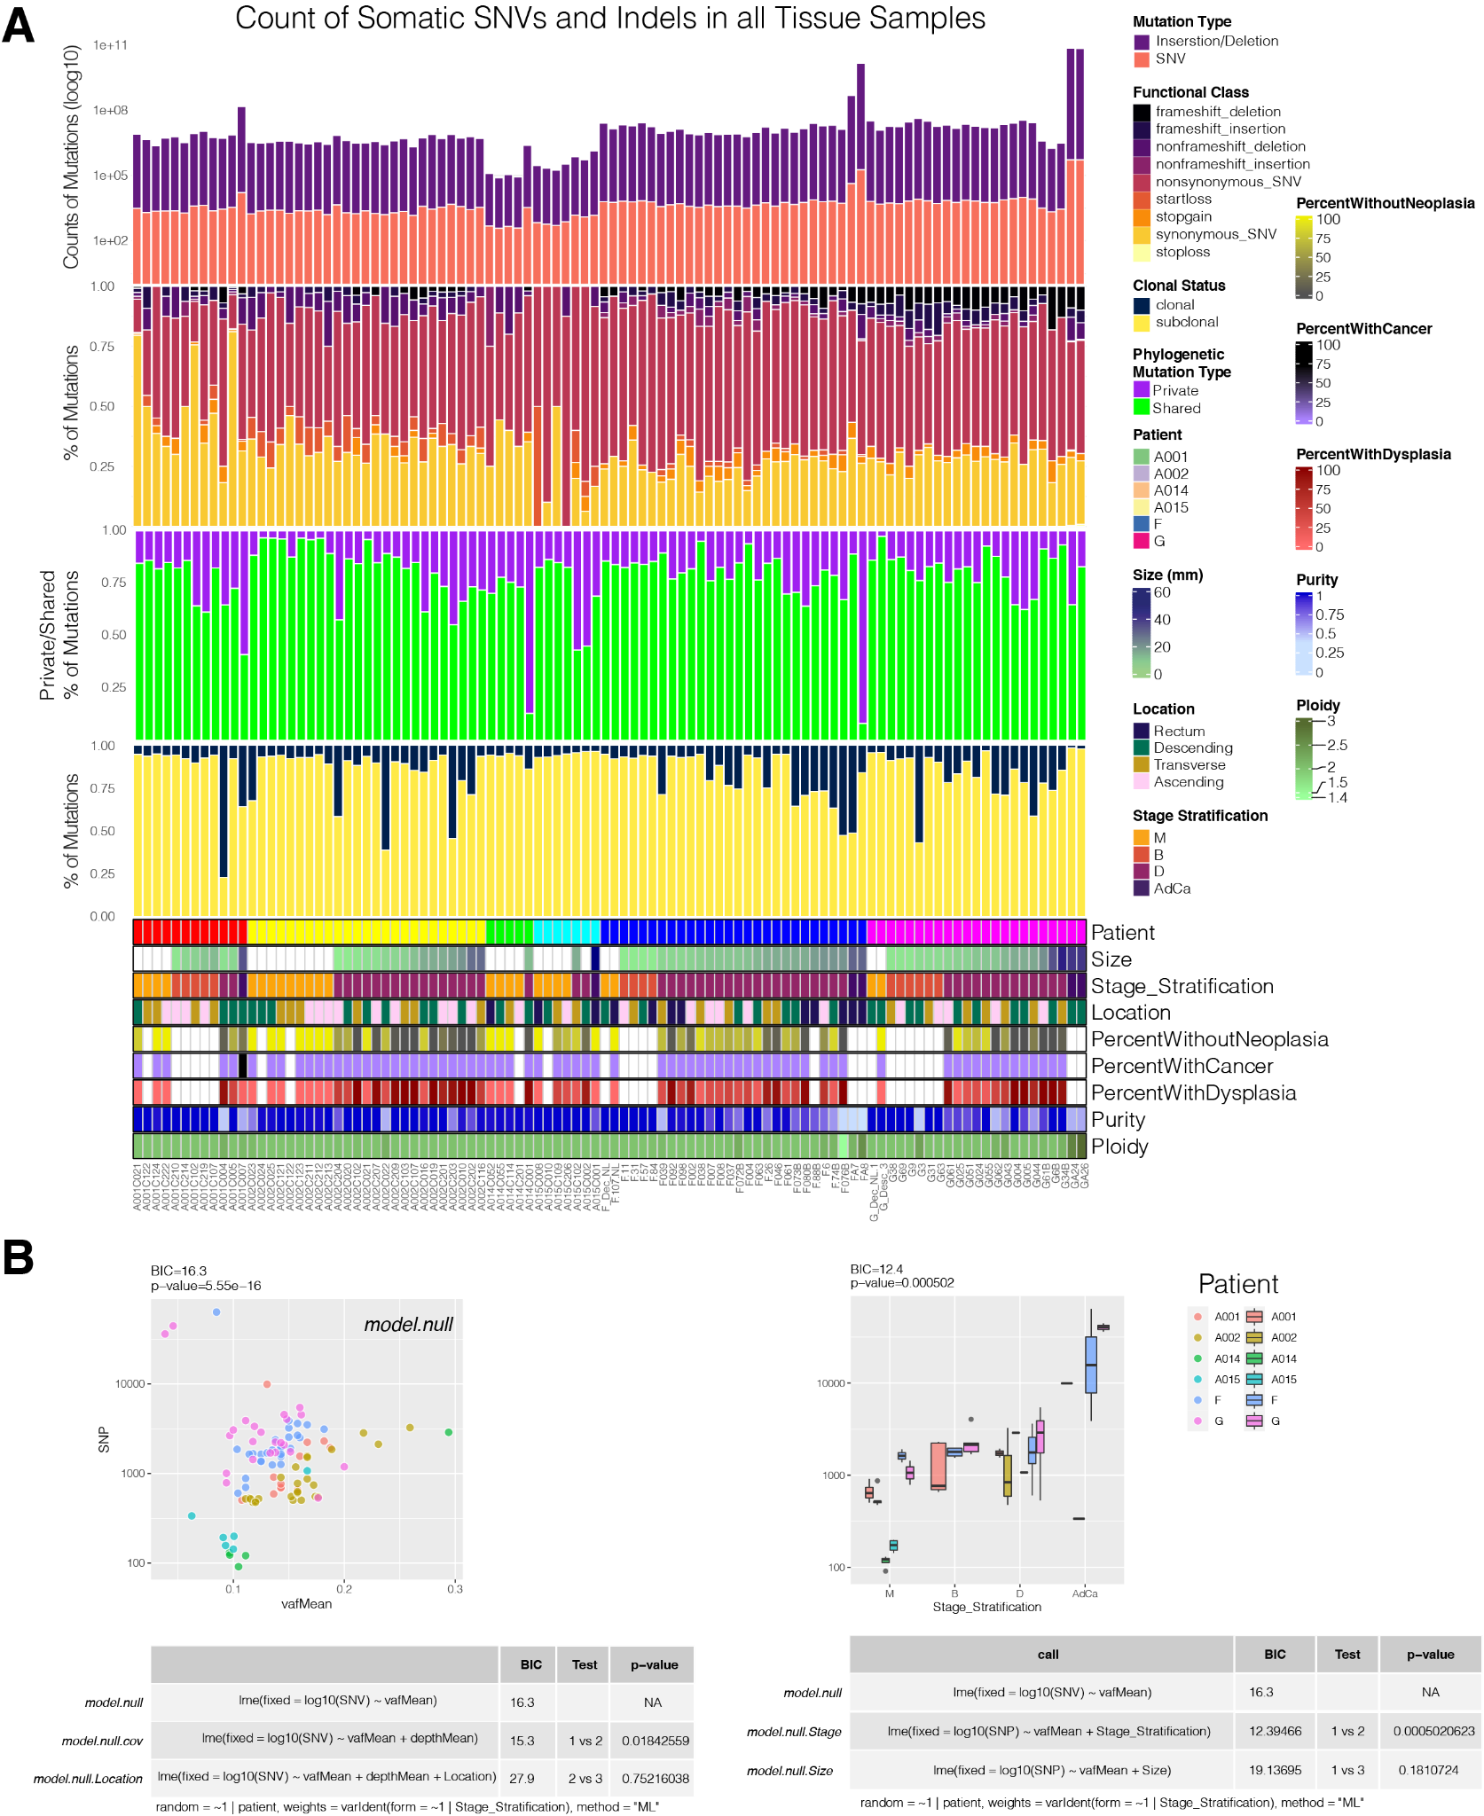

Supplemental Figure 2: Copy Number Size & Gain/Loss Status is Associated with Stage.
  - Scatterplot comparing the number of CNVs identified per sample to the size of the lesion.
  - Same as Panel A with small (<1e6 bp length) and large (>1e6 bp length) CN events separated.
  - Same as Panel A with gain events and loss events separated.
  - Boxplots showing the variation of the number of CNVs within each Stage Stratification group of tissues.
  - Same as Panel D with small (<1e6 bp length) and large (>1e6 bp length) CN events separated.
  - Same as Panel D with gain events and loss events separated. Blue lines in the scatter plots are linear models and grey bars are 95% CI in Panels A, B, and C. Mean comparisons between the boxplots uses Kruskall-Walis multiple comparison testing to produce the p values shown in Panels D, E and F.
  - Scatterplot of the size in millimeters of the largest dimension of a lesion compared with the log10 transformed length of a copy number alteration (or diploid state). Horizontal plots separate types of copy number alteration states into diploid states, Amplifications (gains) and losses.
  - Scatterplot examining the relationship between the percentage of the genome involved in a copy number alteration and the size in millimeters of the lesion. Horizontal plots separate types of copy number alteration states into diploid states, Amplifications (gains) and losses. Blue lines in the scatter plots are linear models and grey bars are 95% CI.
  - Summary table explaining the relationship examined by a linear model in which Size is the dependent variable and the percent of call number variants in Panel H that are loss of heterozygosity (LOH) is the independent variable.
  - Violin plots examining the relationship between the percent of the genome involved in a specific type of copy number alteration for each Stage Stratification group. A linear discriminant analysis model was 78% (± 0.02) accurate when it examined how well the interaction between percentage of the genome involved in a specific type of copy number alteration could predict the stage of the tissue lesion.
  - Positively selected genes with an average dN/dS for missense, nonsynonymous, splice variants and indels >1 plotted against their adjusted overall significance level (q<0.05, see methods) after considering each of the 4 types of variants. dN/dS values were calculated for different groupings of tissues: all together, Benign, Dysplasia and AdCa (results from Mucosa were not significant). Negatively selected genes (dN/dS<1 are not shown.)
  - Using the positively selected genes discovered in Panel K in all samples, we performed a pairwise clinical enrichment test using the R package maftools and its method clinicalEnrichment with the clinical feature “Stage Stratification” to produce Fisher’s Exact test p-values, which were subsequently FDR adjusted. The results are plotted here showing the percentage of the samples harbouring a mutation in one stage versus every other stage. The size of the gene name represents its -log(FDR) level of significant enrichment. For example, in the bottom right panel, LILRA2 is only observed in ~13% of the dysplastic samples but is observed in ~45% of the Benign samples. This relationship is not as significant as that observed for APC, for example, seen in the bottom left panel because the APC gene name is a larger font.
M - R. APC protein models showing where, along the APC protein, an exonic mutation occurs in each sample that has an exonic APC mutation. This is plotted for every patient distinctly.

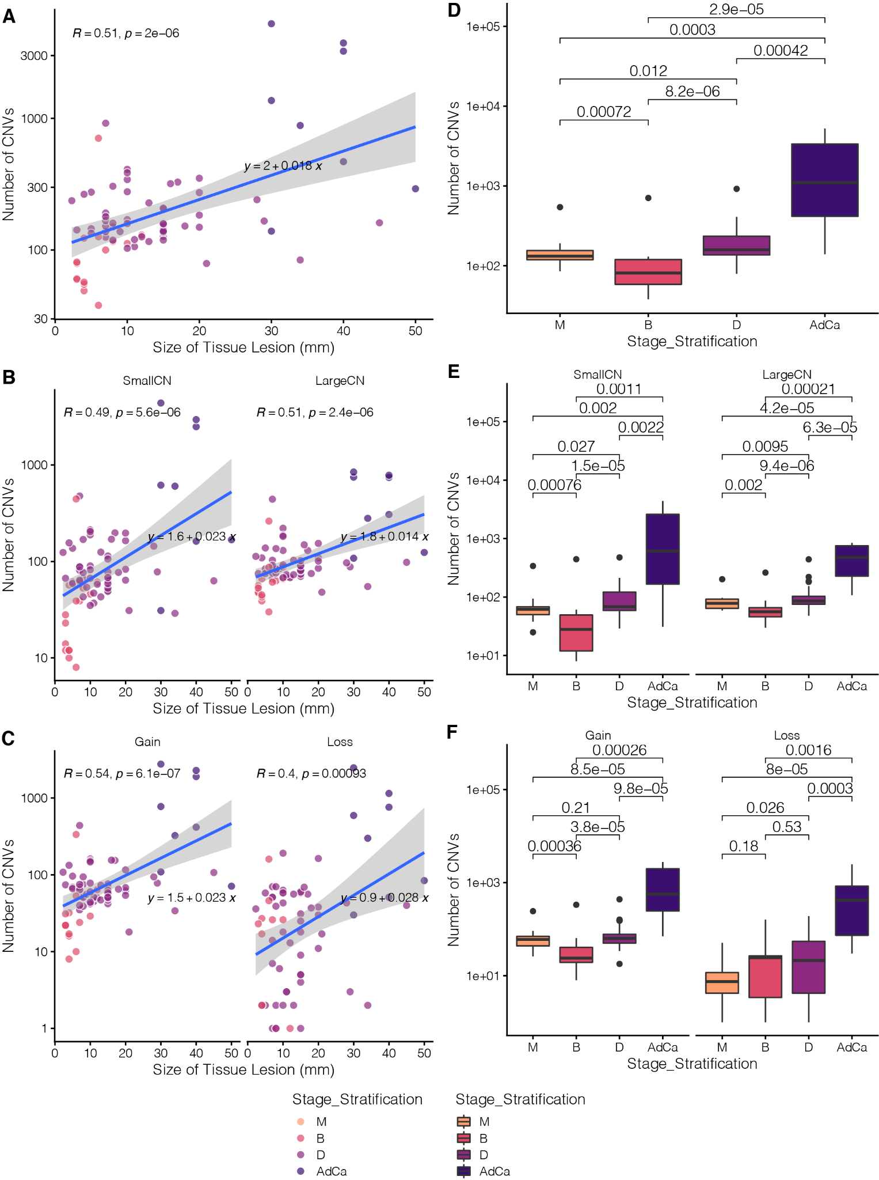
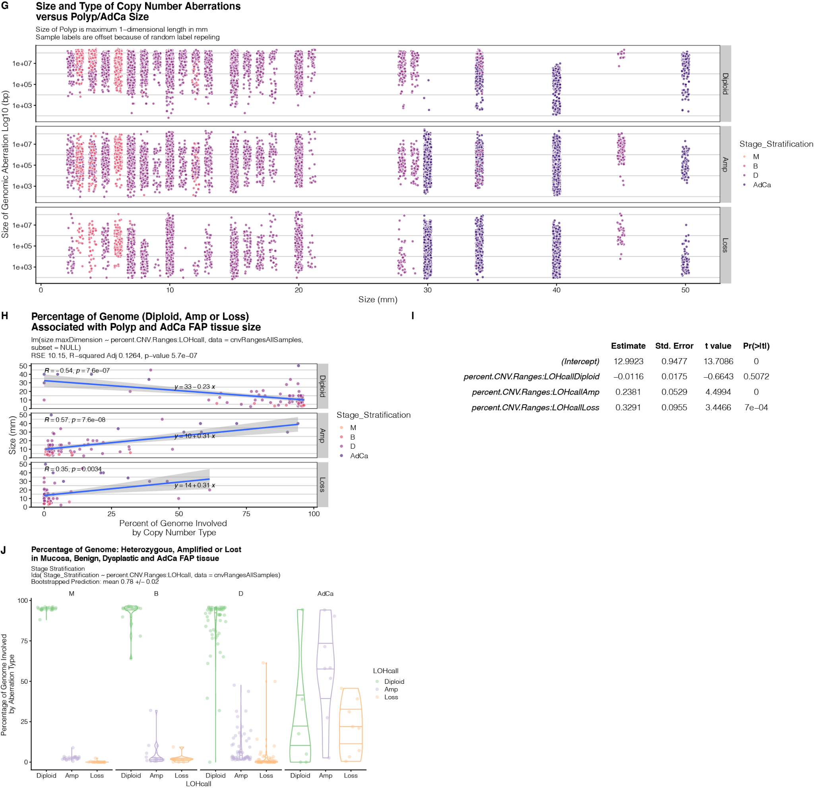
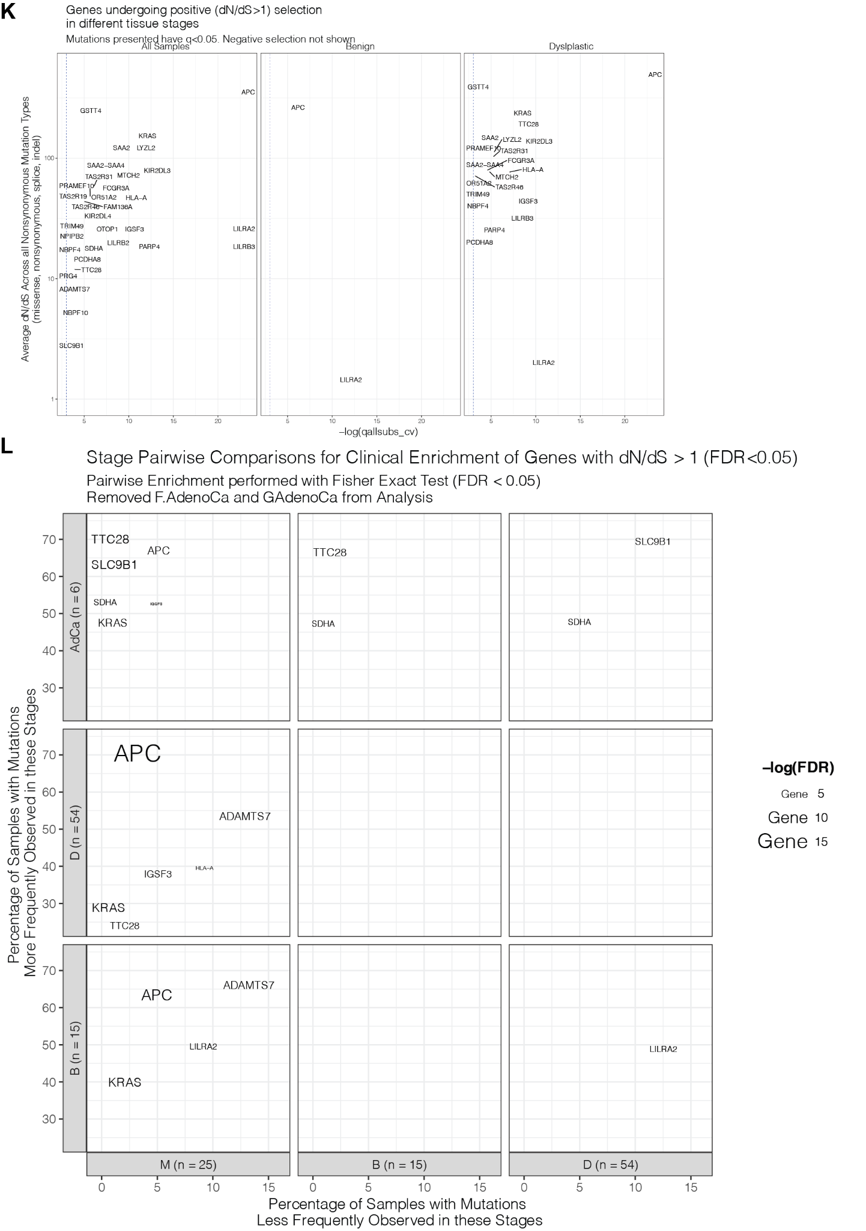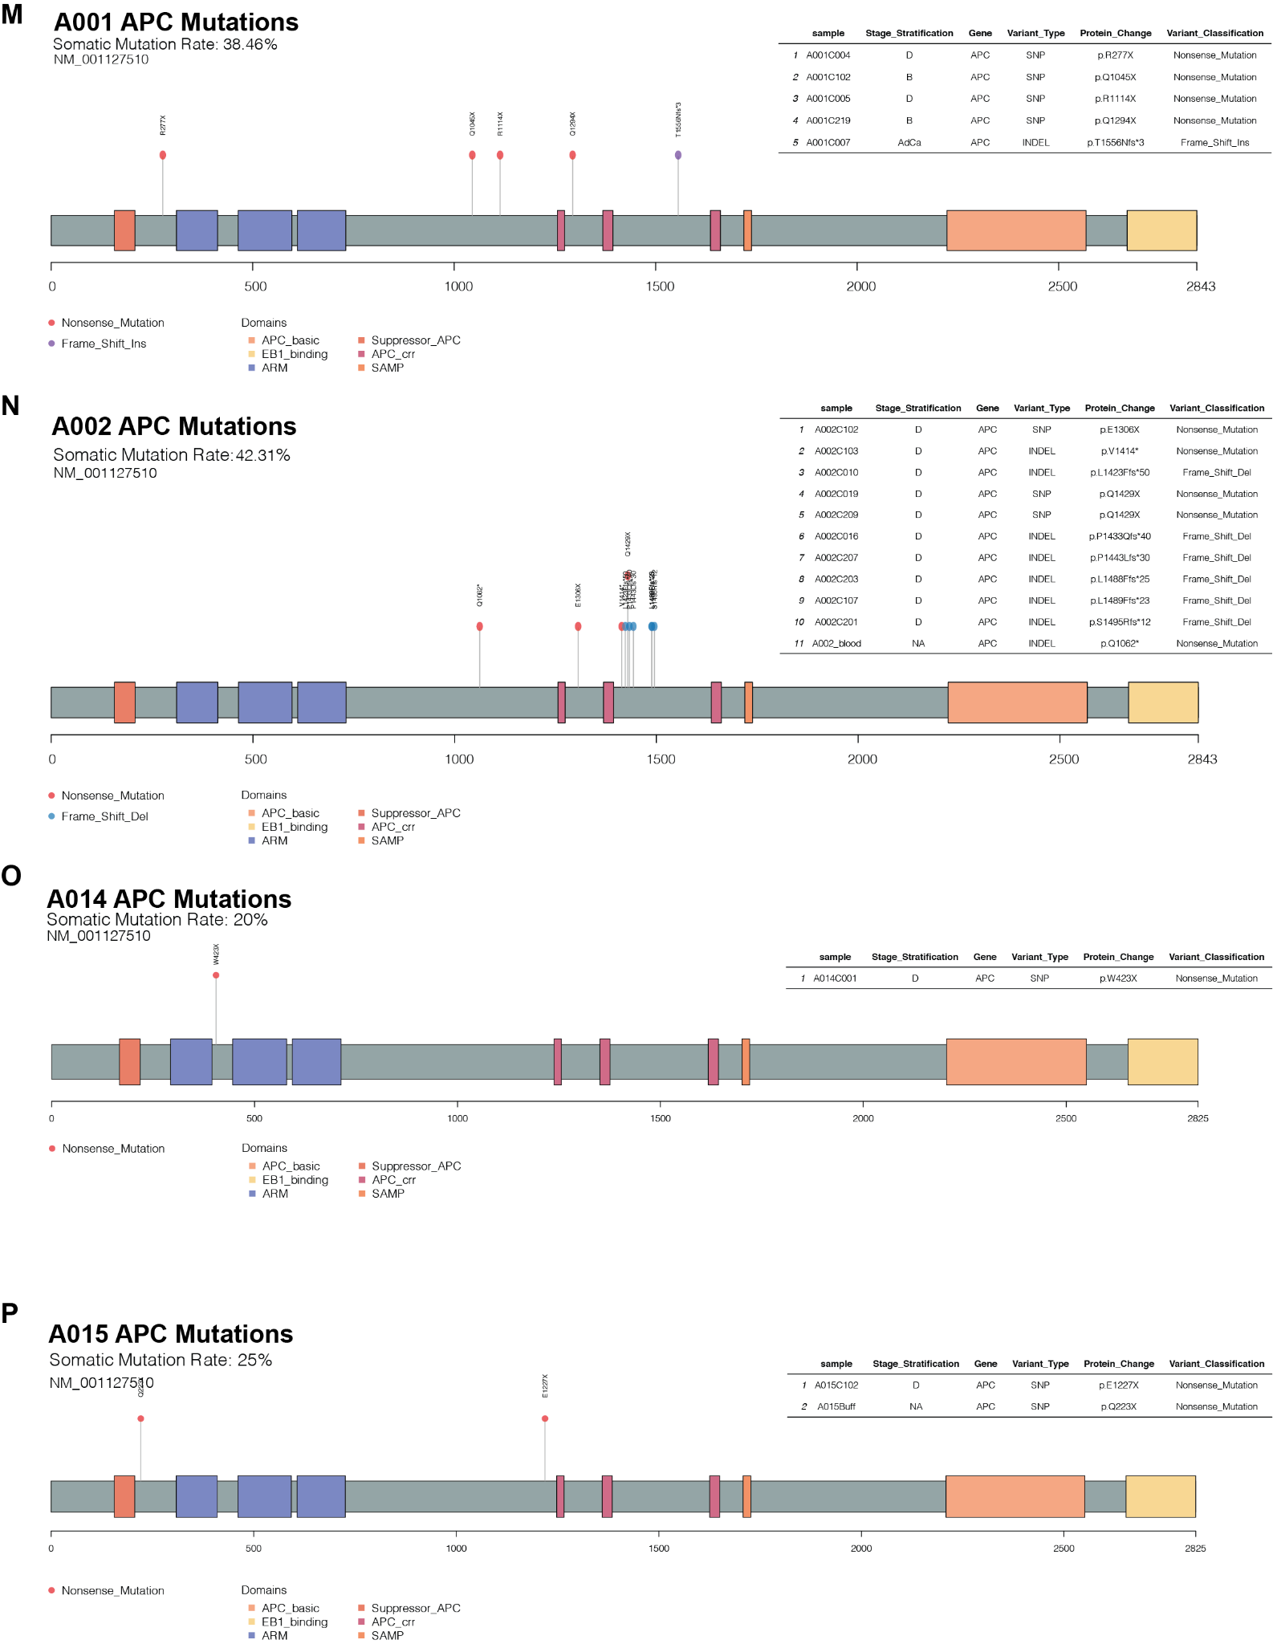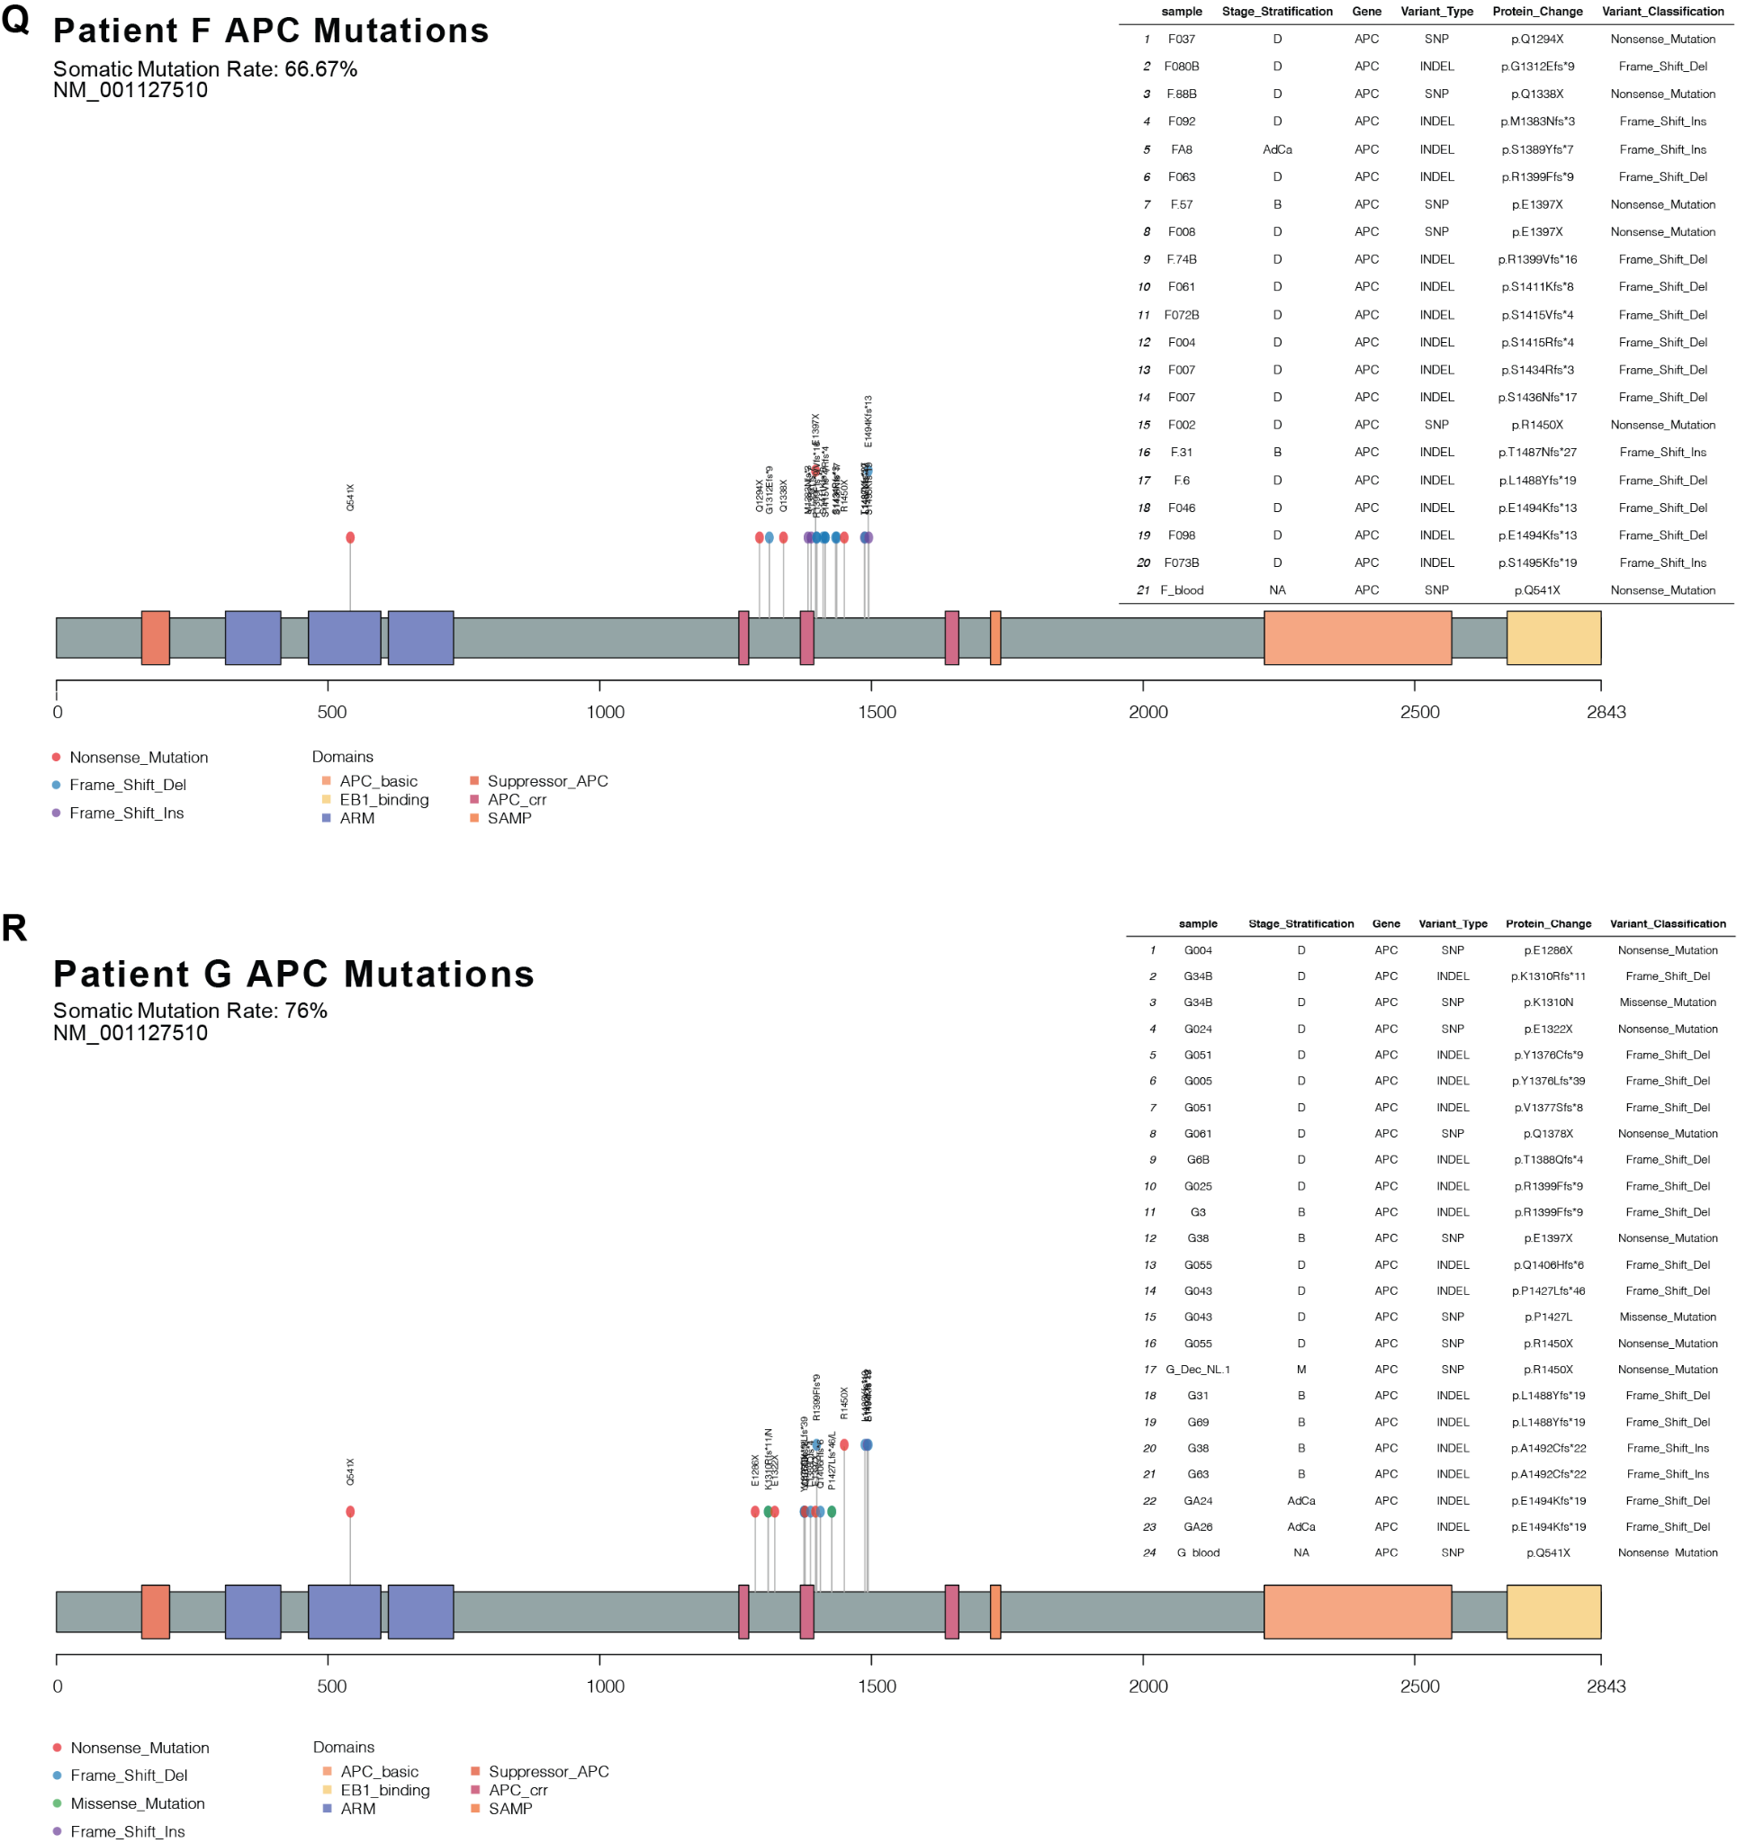

Supplemental Figure 3: Identical mutations across distant FAP lesions are often subclonal and tend to occur relatively early.
BEH. Schematics of patient A002’s, A014’s, and A015’s colons, respectively flayed open lengthwise at time of colectomy. Each point represents a tissue sample which was collected and subjected to whole genome sequencing.
AFILO. Maximum parsimony phylogenetic tree constructed with SNVs and Indels from samples sequenced from A002, A014, A015, patient F and patient G, respectively. Terminal branches are labelled with mutations occurring within cancer driver genes and which are deleterious (CADD>=20) or “pathogenic” in the Clinvar database. Terminal branches are colored based on the location within the colon that the sample was procured. Terminal branch points shapes and colors represent the stage of the tissue. Black numbers above branches represent the number of mutations at that branch and red numbers at nodes are bootstrap values (the number of times out of 100 that the same clade/branch was observed when the phylogenetic tree was reconstructed on a re-sampled set of the data).
CGJMP. Violin plots showing the cancer cell fractions (CCFs) of the mutations within each sample grouped by Shared and Private mutations for A002, A014, A015, patient F and patient G respectively. The phylogenetic tree’s labelled mutations (Panel 3B) are shown.
DKNQ. Upset plot showing the number of private and shared labelled mutations from Panels A,I,L,O across all of the samples in A002, A015, patient F and patient G, respectively (A014 didn’t have any deleterious shared mutations). The shared mutations are explicitly shown below the UpSet plot. The bar on the left shows the locations from the colon that the samples were taken from.
R - X. IGV plots showing representative examples of labelled mutations on the UpSet plots in Figure 3C and Panels D,K,N,Q. Each sample’s reads are ordered top to bottom to show the reads with the altered bases first. Each sample in the IGV plots shows at least 3 reads supporting the alternate allele in the FAP lesion samples and not the patient blood indicating that the mutations are indeed somatic. Panel V however does show 4 reads supporting the alternate allele however this is out of a total of 56 reads. We find it extremely unlikely that these 4 reads supporting the alternate allele represent a heterozygous germline mutation with an expected VAF 50% (p=5e-11, pbinom(4,56,.5,T)).
Y. Results of linear regression models in which stage is the dependent variable and (sub)clonal features of shared and private mutations are the independent variable; subclonal features are mapped numerically to the integer space as follows: mucosa is 1, benign or dysplastic polyp is 2, and adenocarcinoma is 3.
Z. Z-normalized linear discriminant values showing how the linear discriminant model (calculated from MASS Package in R), in which stage is the dependent variable and the dependent variables are the median private clonal CCF and the Kolmogrov Statistic between the shared and private CCF distributions, predicts where, along a 1-dimensional trajectory between normal mucosa and adenocarcinoma, each polyp is situated. See methods for more details.

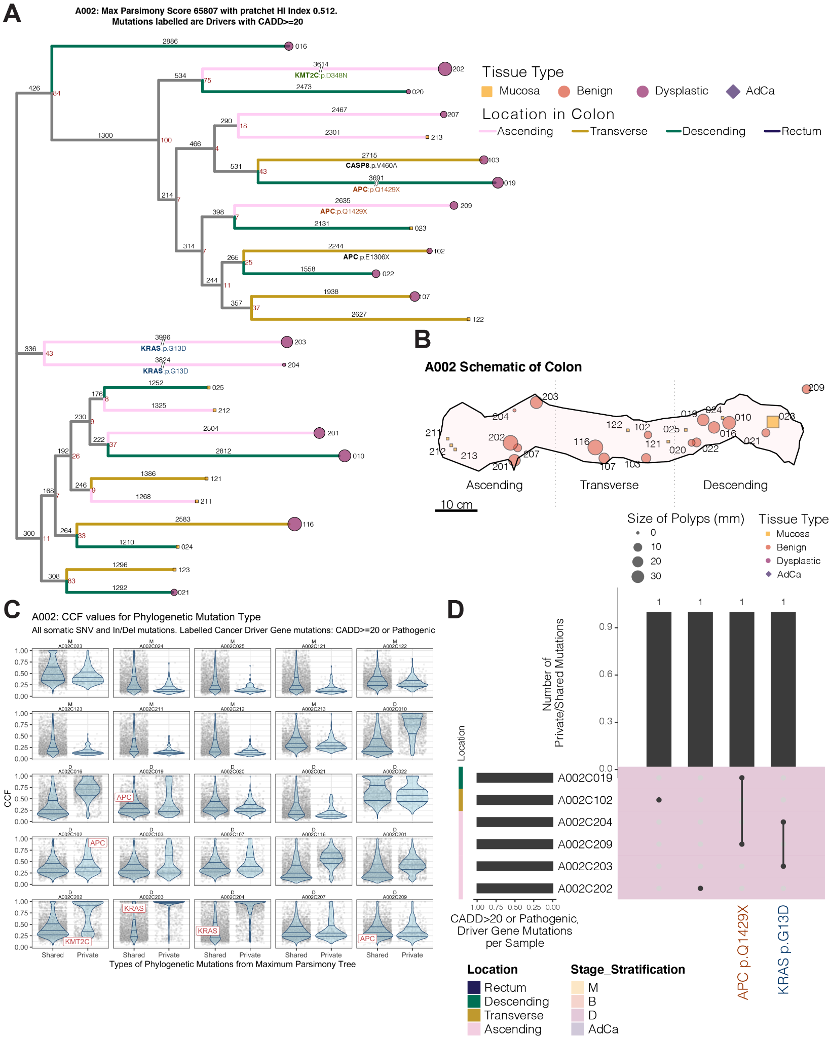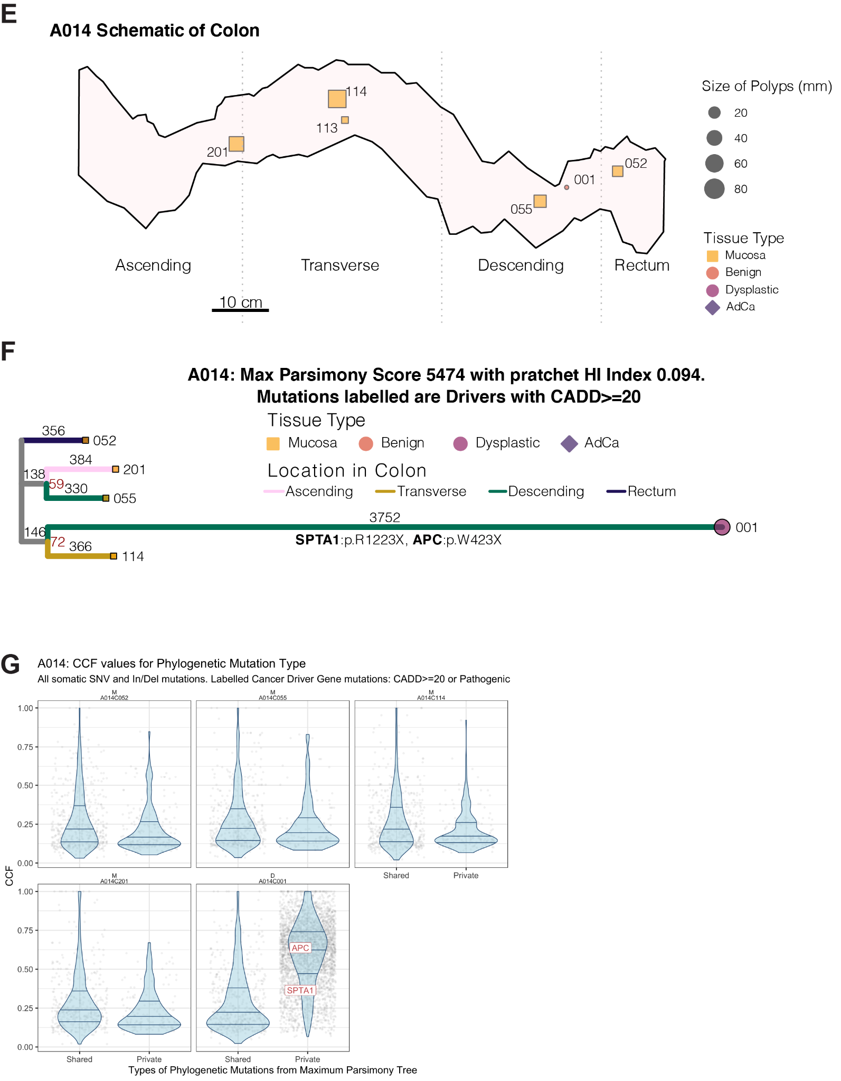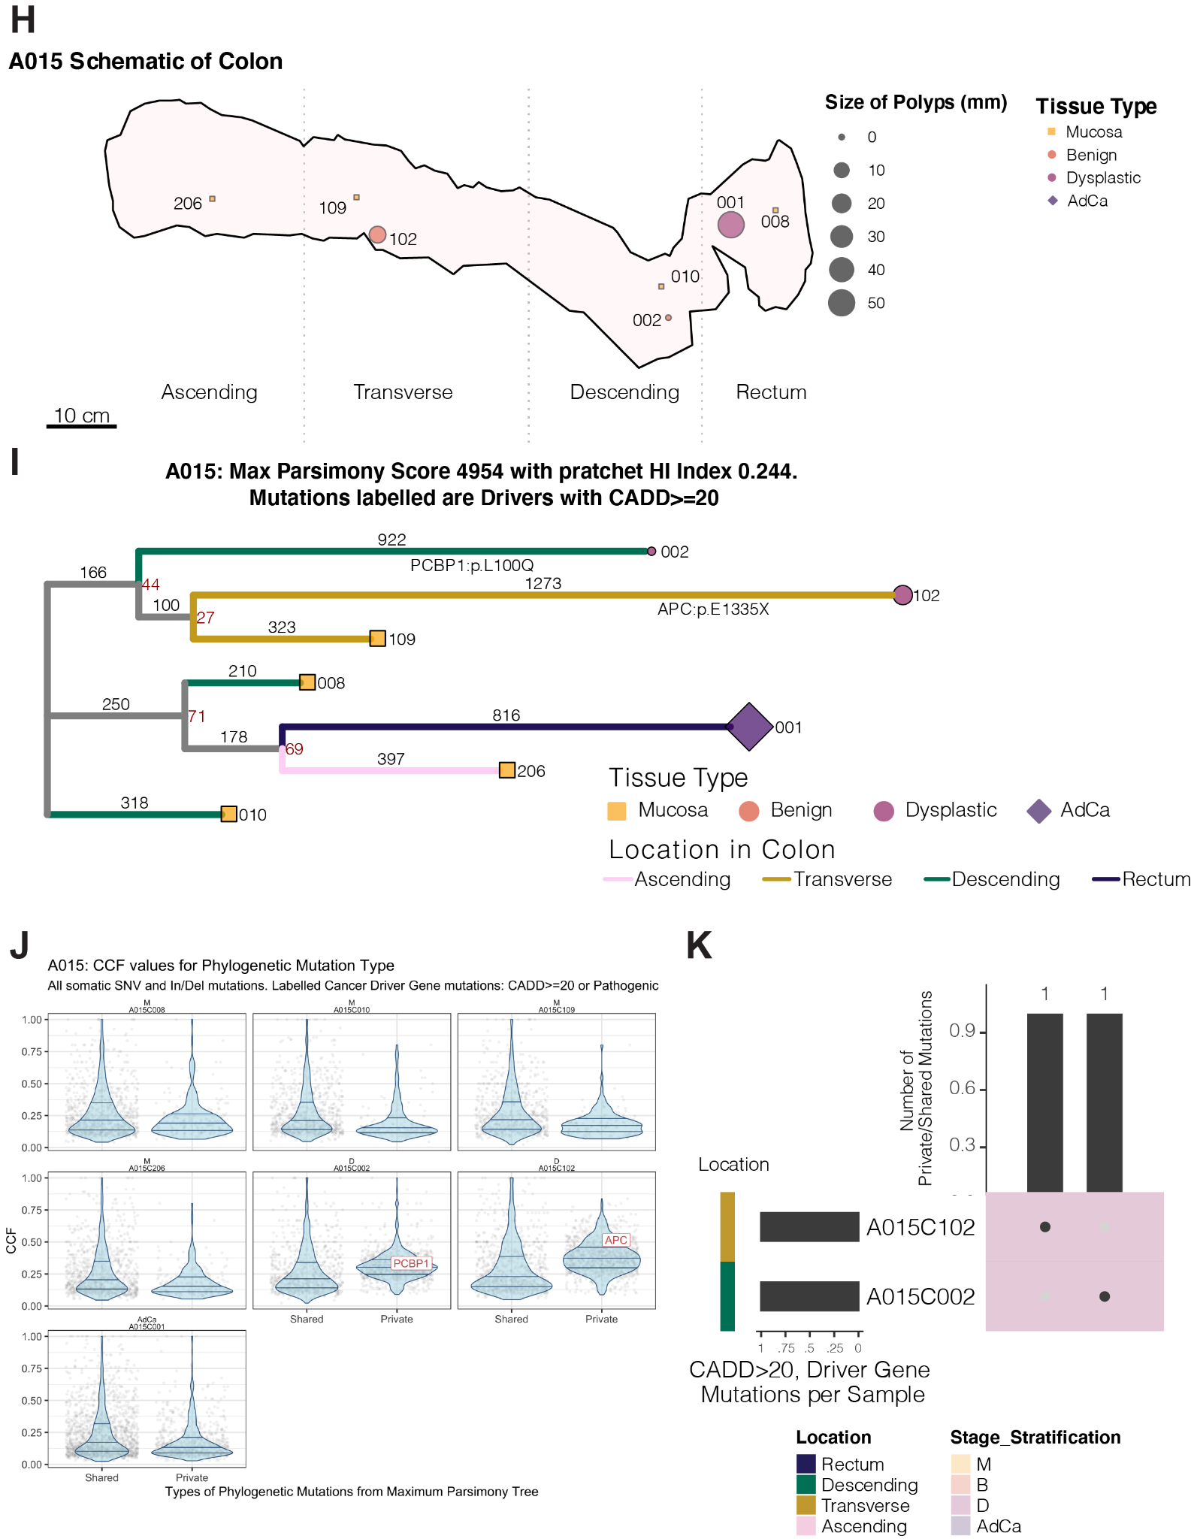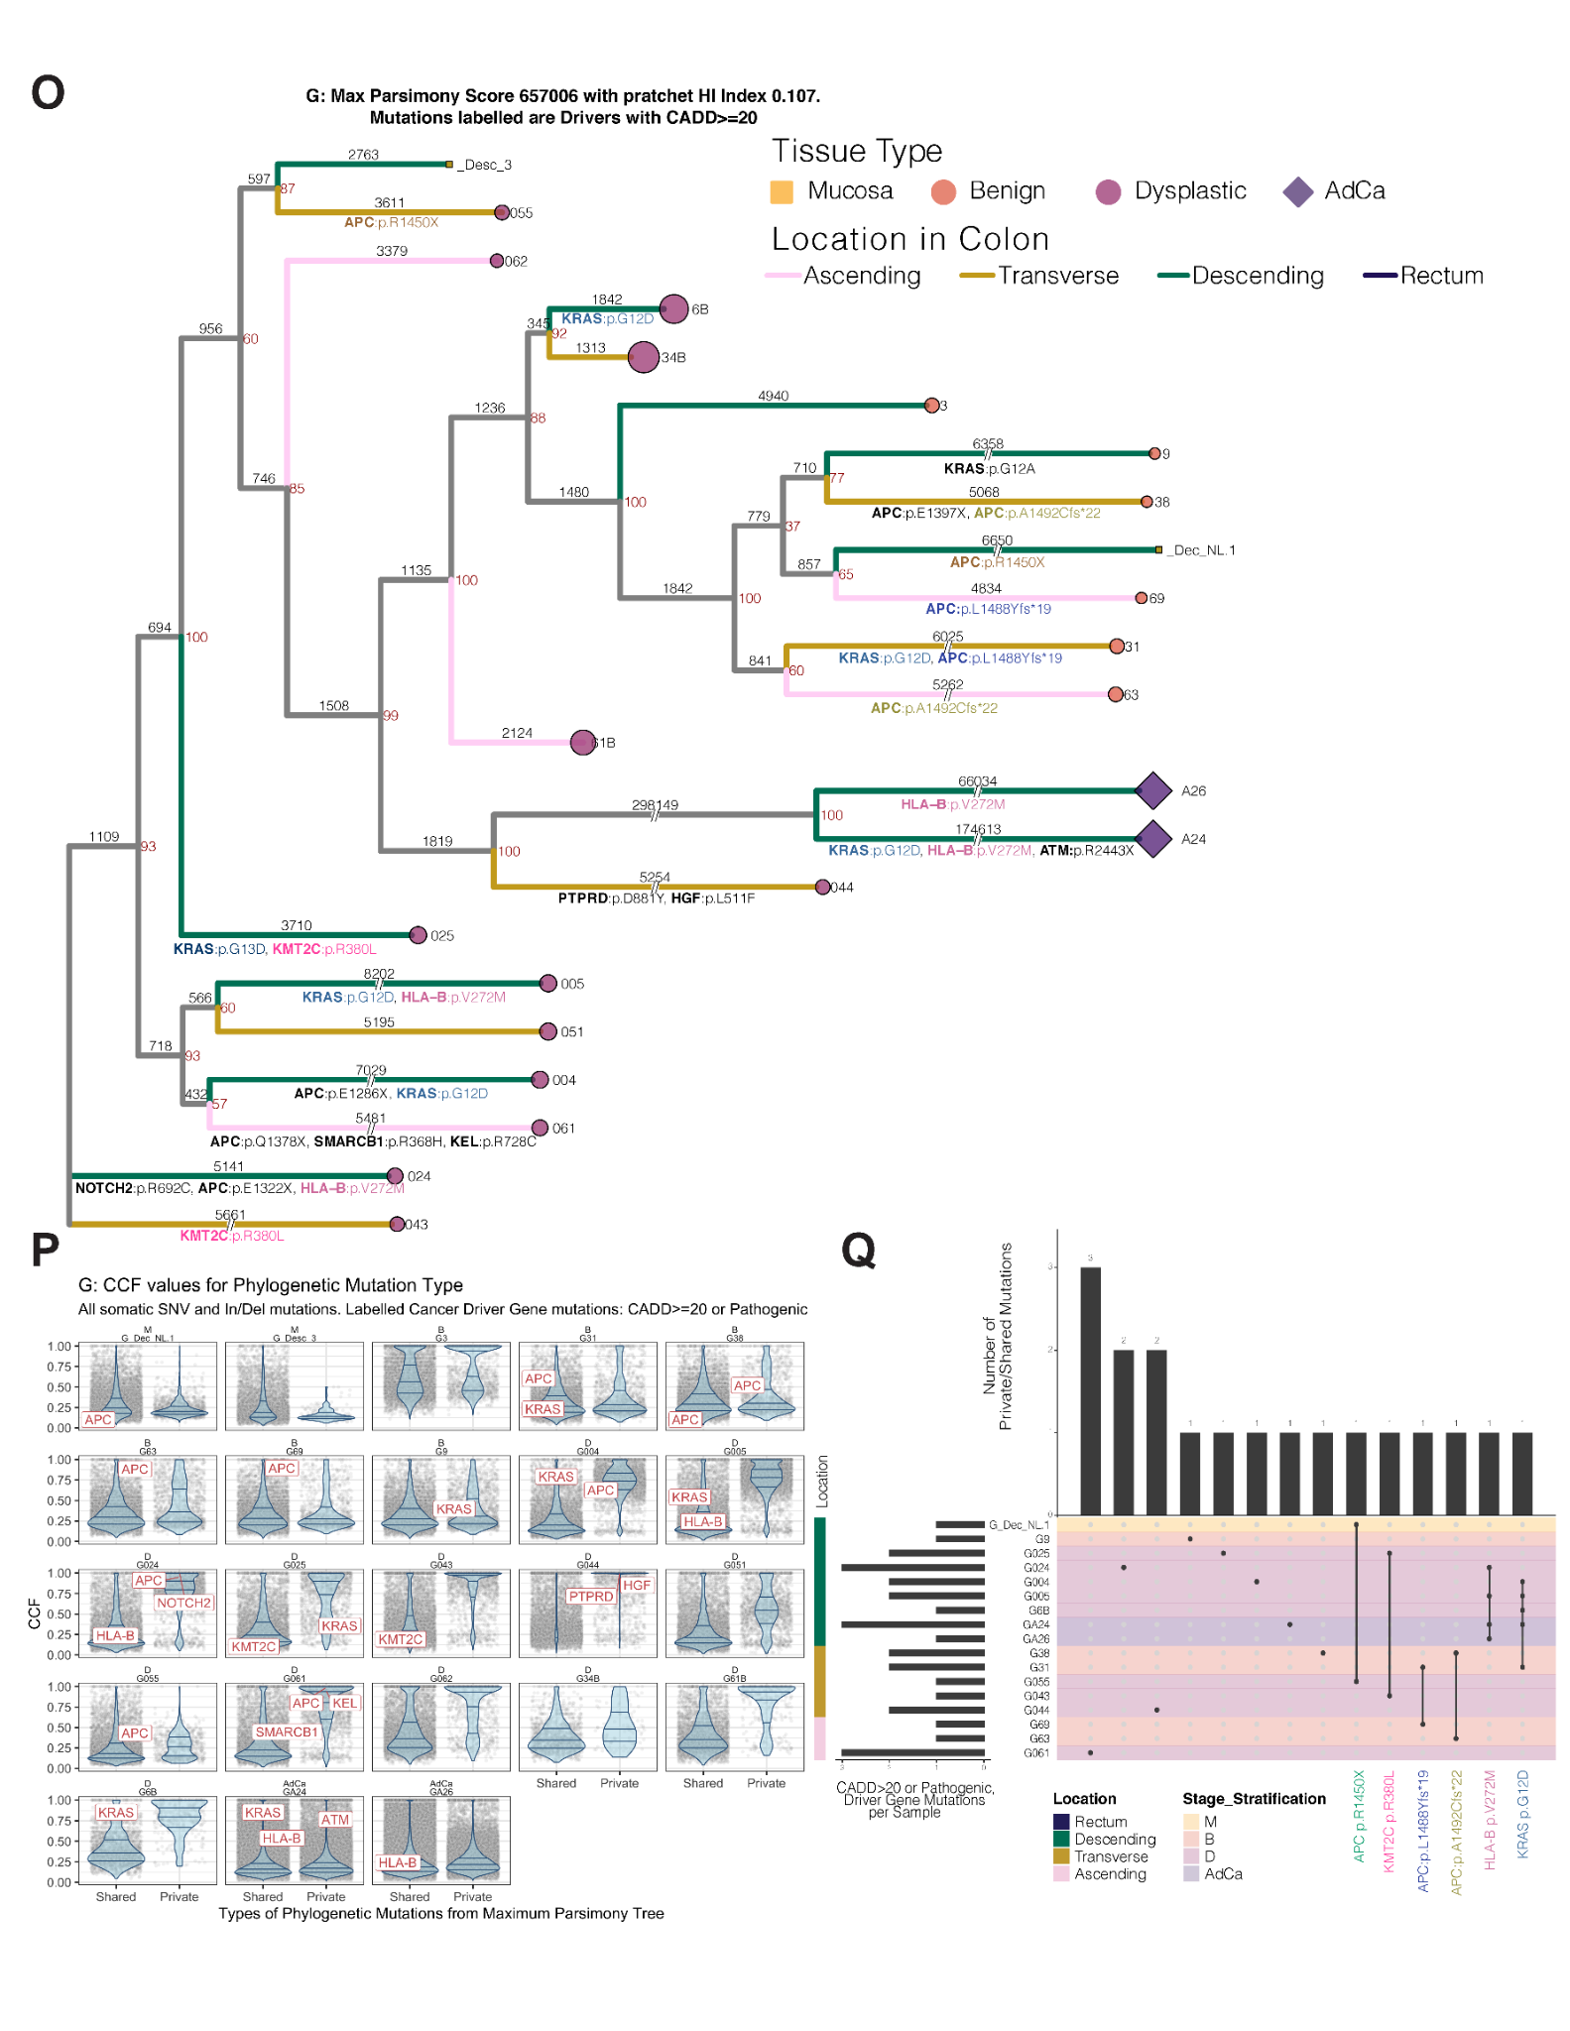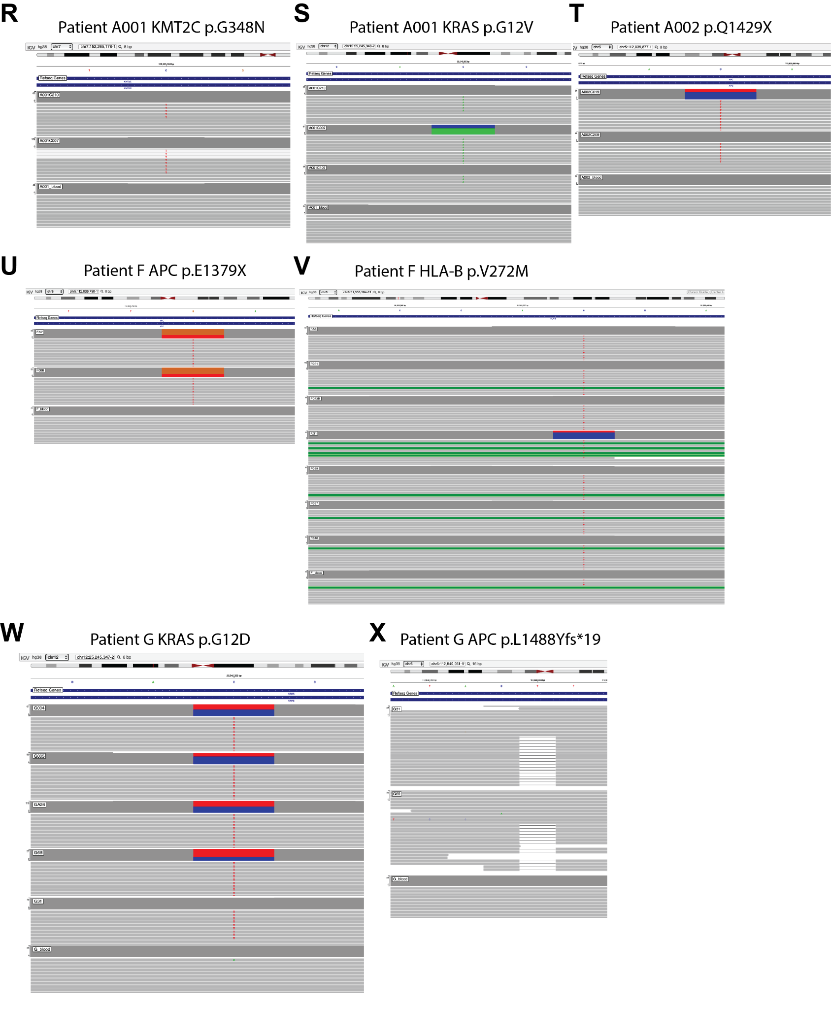

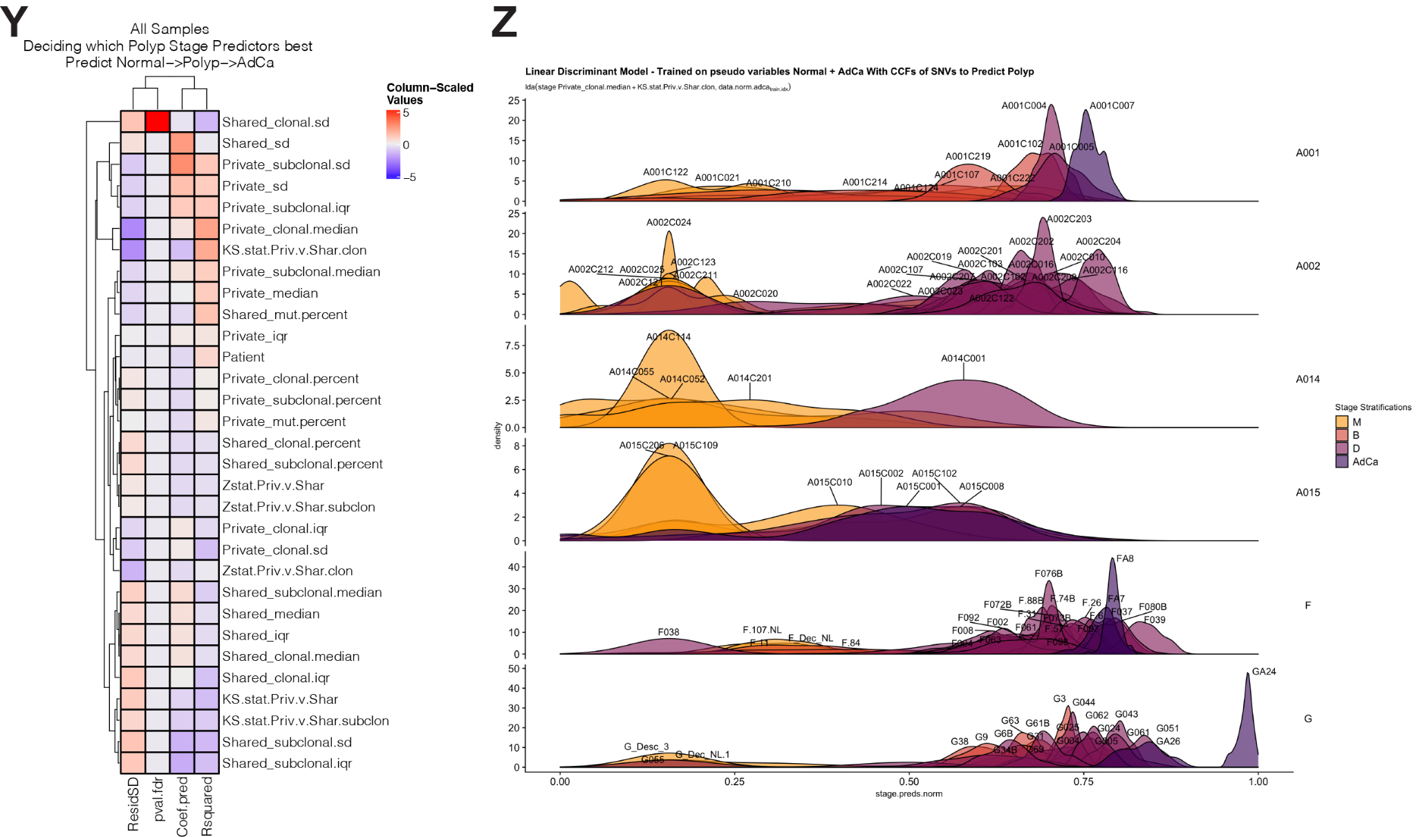

Supplemental Figure 4: Abundant subclonal mutation sharing across the colon, independent of distance, suggests FAP polyps are polyclonal.
ACEGIK. Violin plots of tissue sample similarity (JSI) for comparing between samples within the
same region of the colon (“within”) and when comparing samples between different
regions of the colon (“without”). To calculate the distributions, we performed 100
bootstraps on a random sampling of 60% of the data each time. Median JSI values are
shown.
BDFHJ. For all of the samples WGS’d in A002, A014, A015, patient F and patient G, these are pairwise scatterplot in which each point represents a mutation and its location is determined by the CCF. Green dots are subclonal mutations in each of the samples being compared (“shared”). Purple dots represent clonal mutations only found in one of the samples being compared (“private”). A Jaccard similarity index (JSI) is calculated by dividing the number of shared subclonal mutations by the sum of the shared subclonal and private clonal mutations between 2 samples.
L. Heatmap showing pairwise JSI comparisons of all of the samples in the WGS study.
M. Maximum parsimony phylogenetic tree constructed with SNVs and Indels from all of the samples in the WGS study. Terminal branch point colors represent the patient from which the sample originates. Black numbers above branches represent the number of mutations at that branch and red numbers at nodes are bootstrap values (the number of times out of 100 that the same clade/branch was observed when the phylogenetic tree was reconstructed on a re-sampled set of the data).
N. The scatterplot’s x-axis represents the number of polyp-specific samples within a patient with an identical subclonal mutation whereas the y-axis represents the median CCF of the aforementioned identical subclonal mutations. For example, patient F’s private subclonal mutations (samples that harbour identical mutations = 1) CCF is ~ 40%. Also, the median CCF of the identical subclonal mutations found in 24 of patient F’s polyps is ~47%. These mutations may be clonal in other polyp samples, but here we only calculate the median CCF for the polyps in which the identical mutations are subclonal.
O - Q. Same structure as the plot in N, these 3 scatter plots represent results from polyp development simulations under mono- and poly- clonal origins where polyps arise from 1, 20 or 40 cells, respectively.
R - T. Maximum parsimony rooted phylogenetic trees of polyp growth simulations representing the same number of polyps in A001 growing under mono- and poly- clonal conditions where the polyps arise from 1, 20 or 40 cells, respectively. Black numbers above branches represent the number of mutations at that branch and red numbers at nodes are bootstrap values (the number of times out of 100 that the same clade/branch was observed when the phylogenetic tree was reconstructed on a re-sampled set of the data).
U. Same tree analysis as Panels R - T except the trees are built from the real mutations acquired for the polyps from patient A001.
V. Branch score differences are calculated between the simulated and real-data polyp-only phylogenetic trees using the R package phangorn, in particular the KF.dist method (PMID: 8015439). The boxplot distribution and the jitter points are the result of rebuilding each of the phylogenetic trees randomly and making the tree comparison 100 times. P-values are calculated for comparing multiple means using Kruskal-Wallis. Asterisks are plotted accordingly: **** for p-value < 0.0001, *** for p-value < 0.001, ** for p-value < 0.01, * for p-value < 0.05.

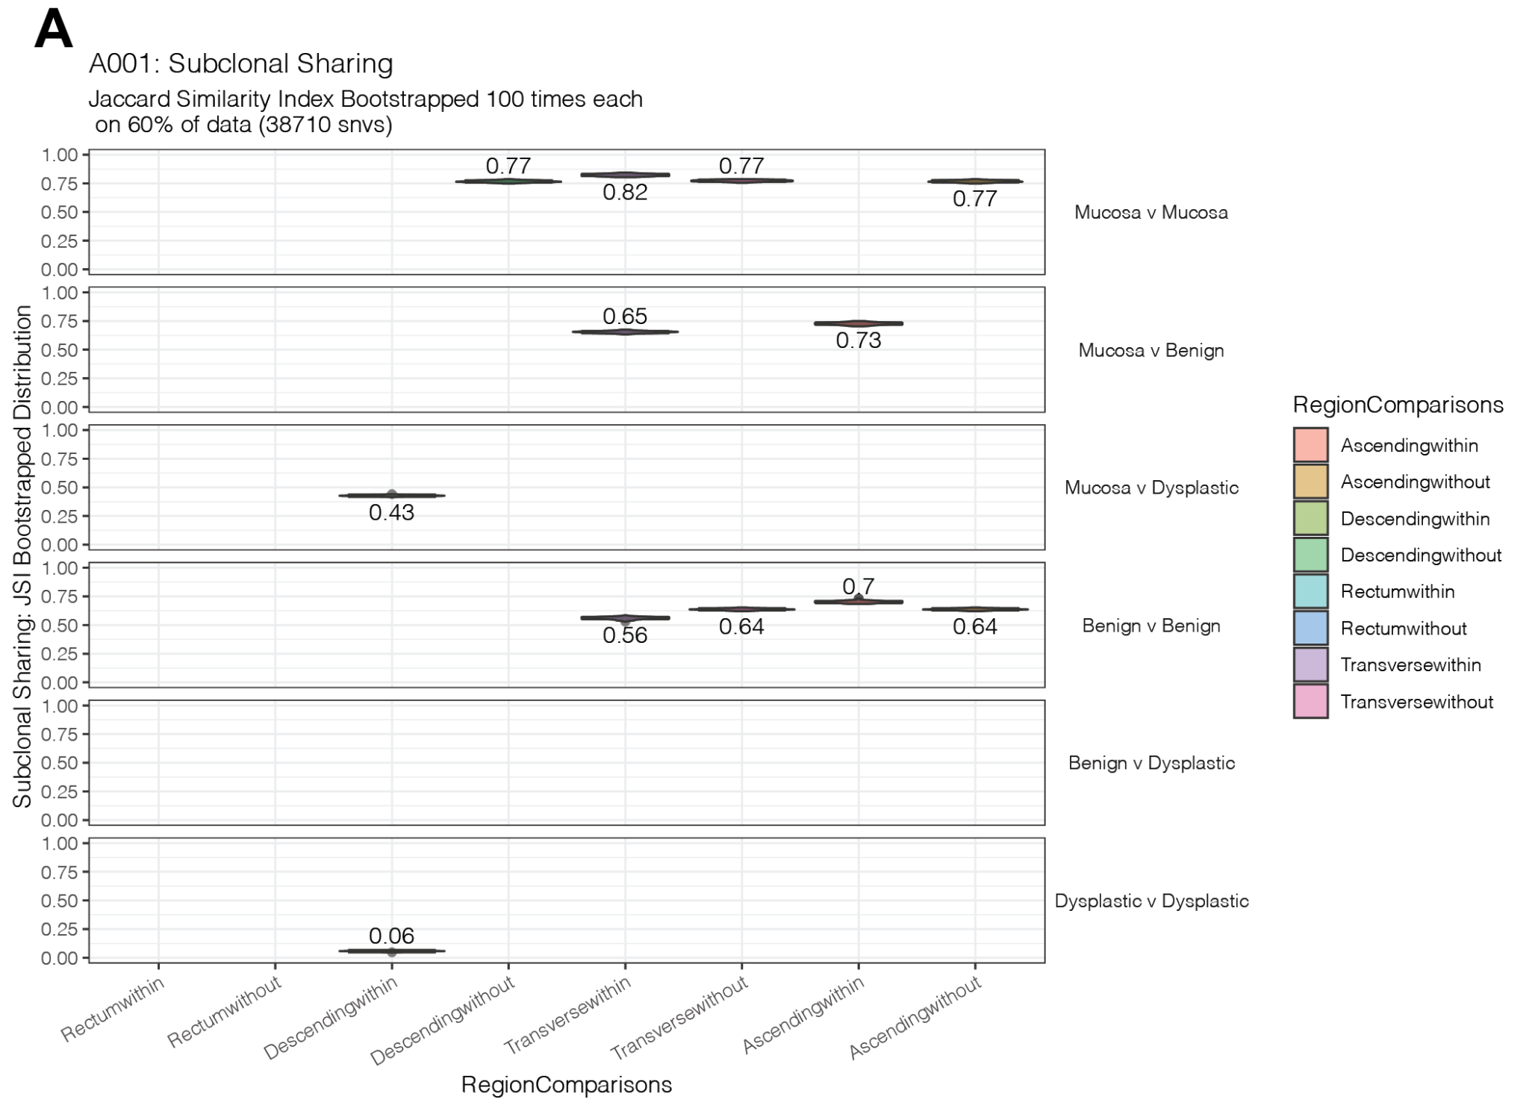
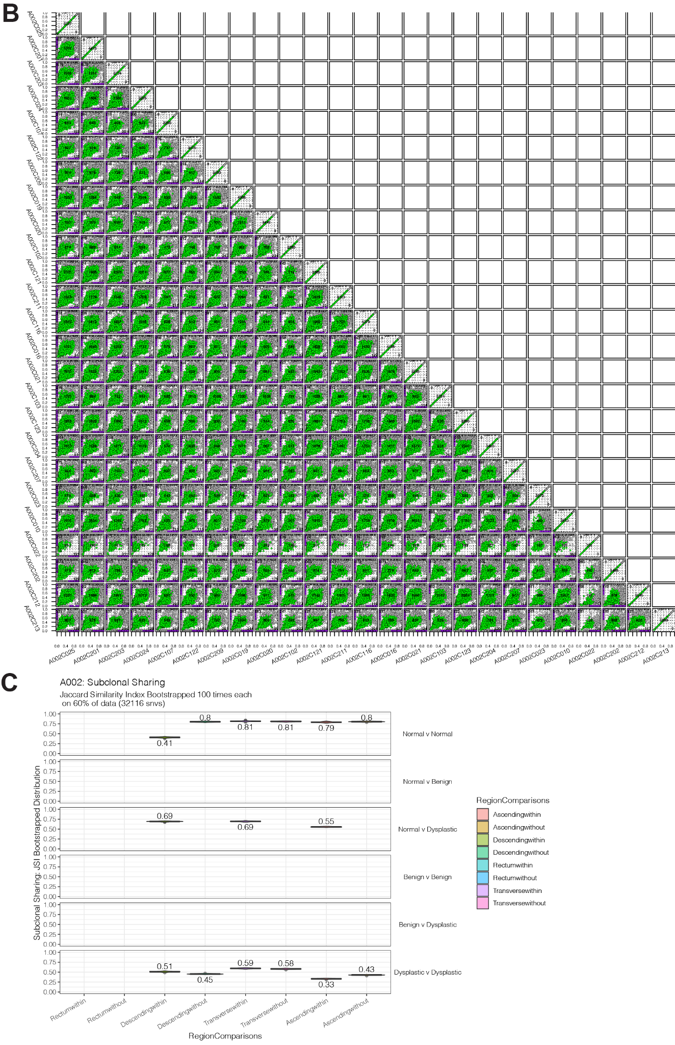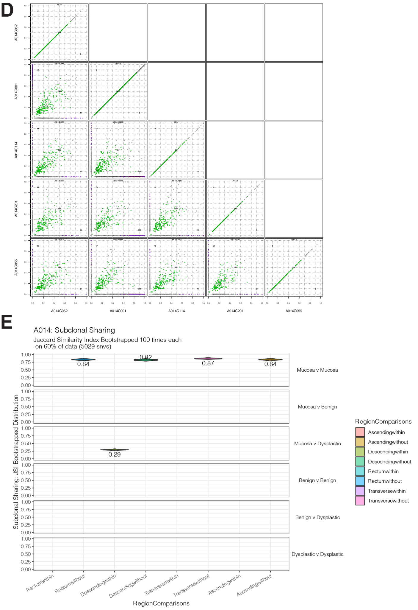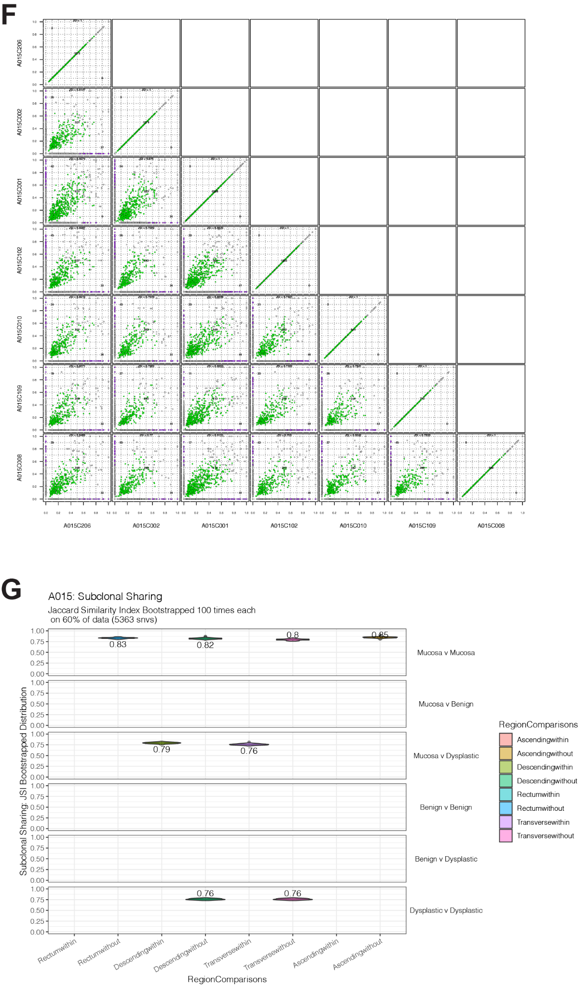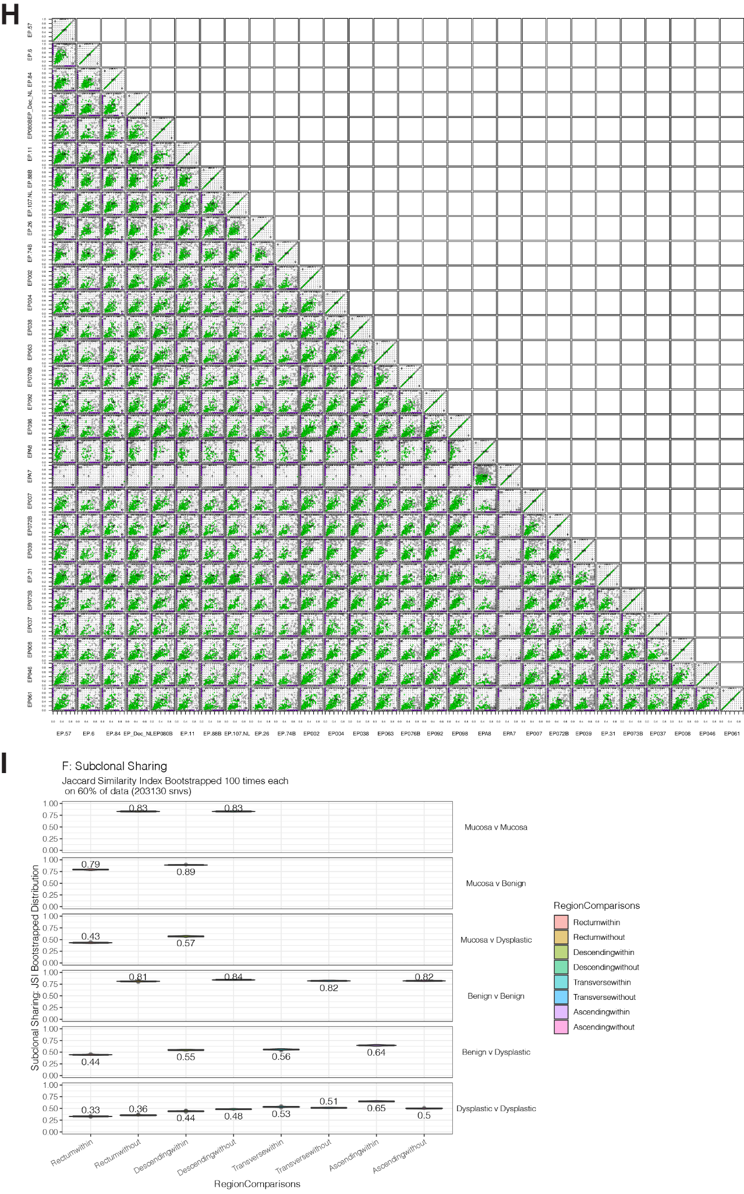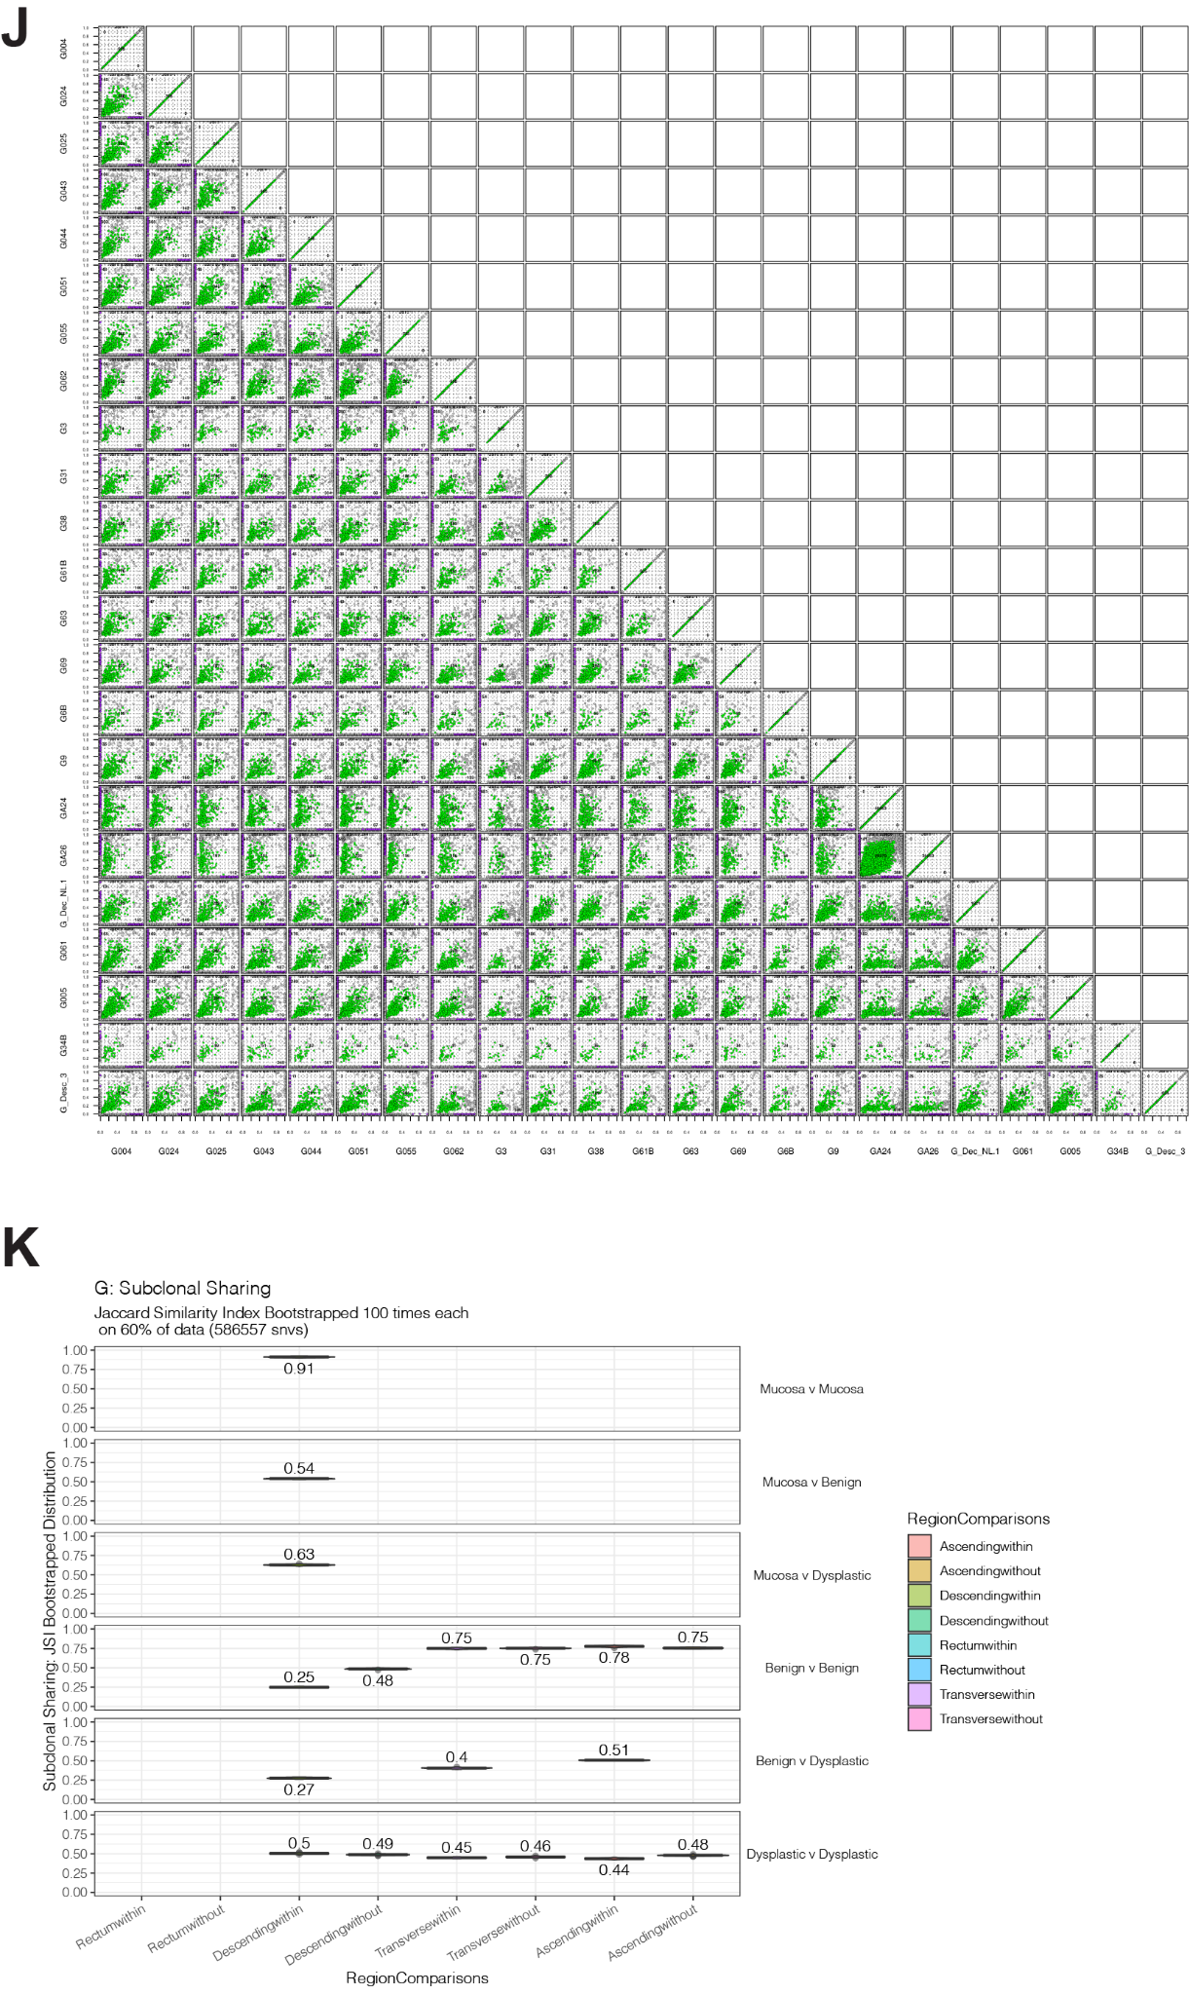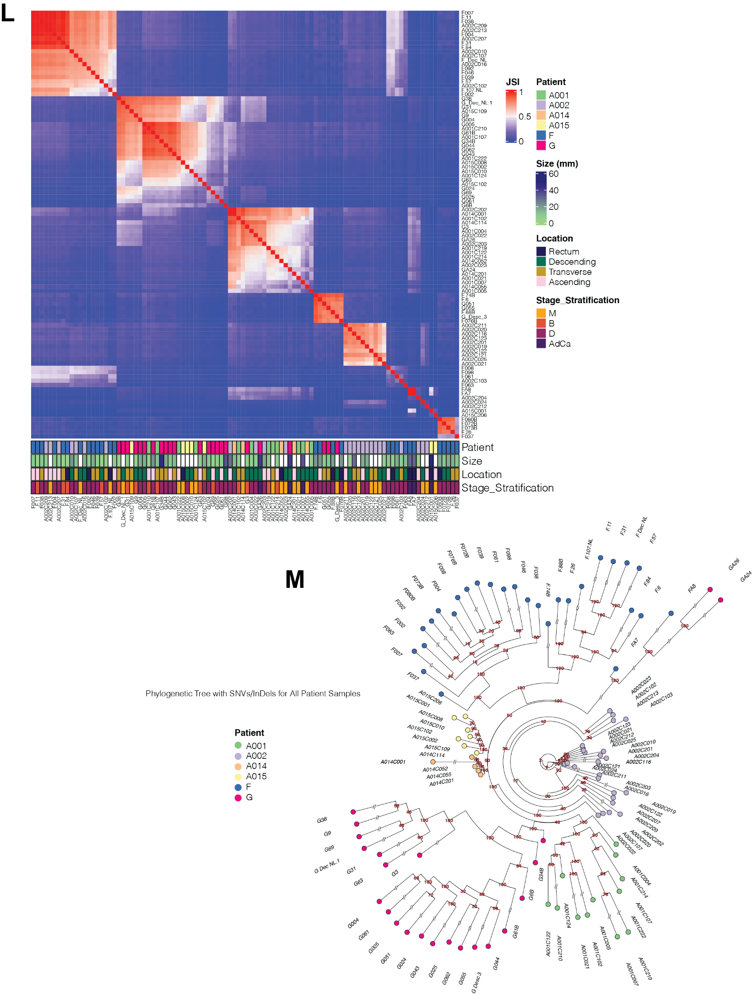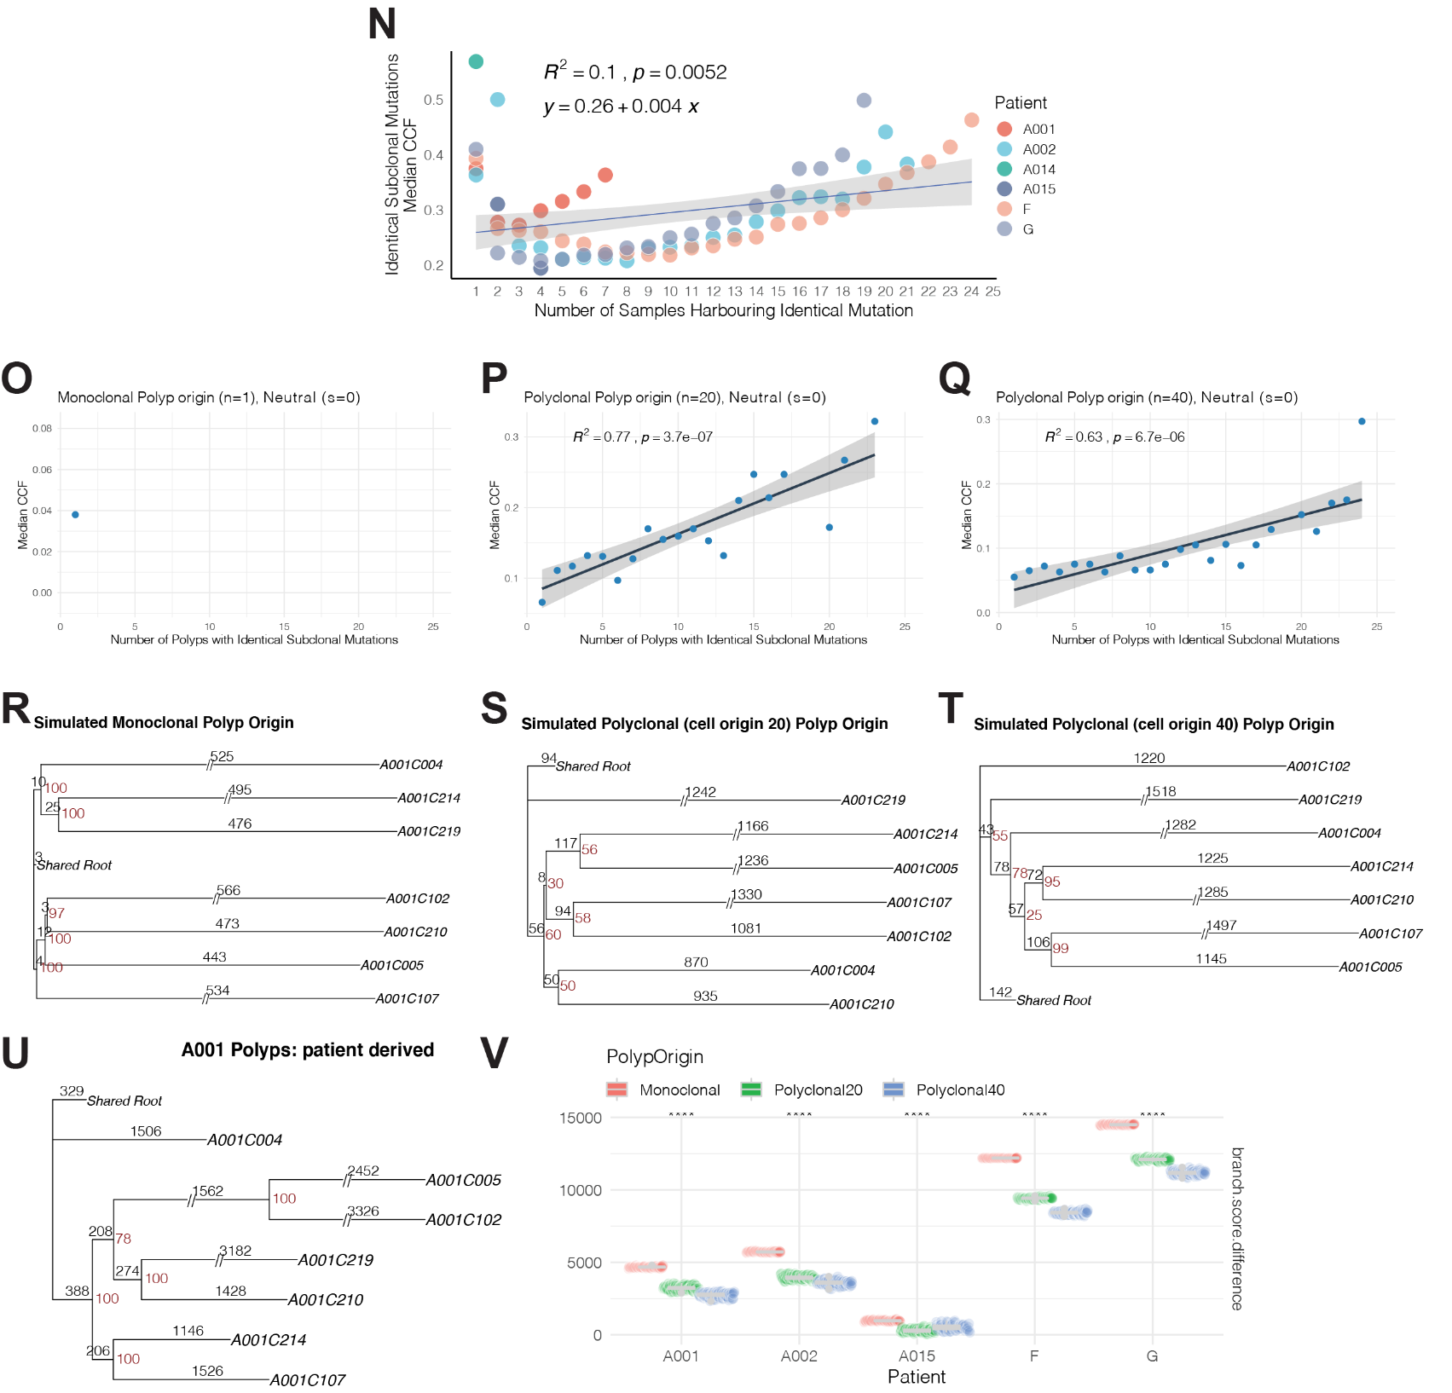

Supplemental Figure 5: Quality control of metabolomics/lipidomics data.
  - PCA plot of raw metabolomics data (left panel) and corrected data for batch effect (right panel). Technical replicates are colored, while dot shape indicates batch level.
  - PCA plot of normalized lipidomics data. Dots shapes and colored points represent biological/technical replicates & pooled plasma QCs, respectively.

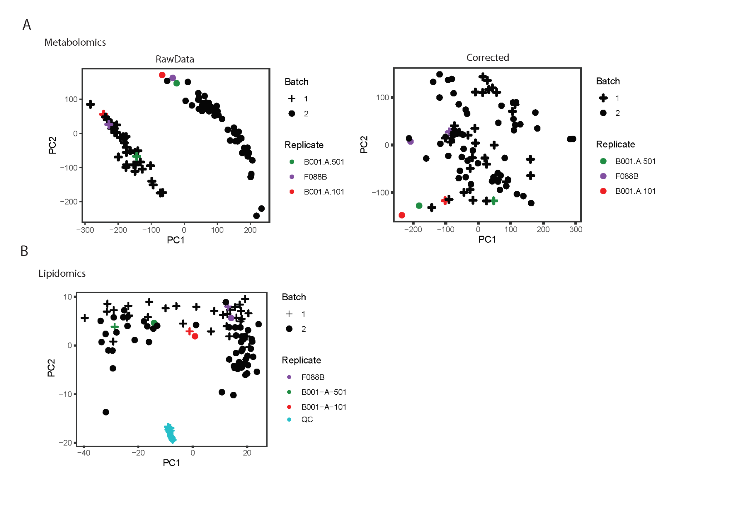

Supplemental Figure 6: Transcriptomic/Proteomic Immune Pathways

Shown are all 82 significantly (p-value < 0.05) enriched pathways related with immune responses in either the transcriptomic/proteomic datasets. Each dot represents a (contrast, pathway, direction) triplet with size corresponding to -log10 p-value (quantized into 4 discrete sizes) and color representing the median log2 fold change of molecules enriched within the pathway.

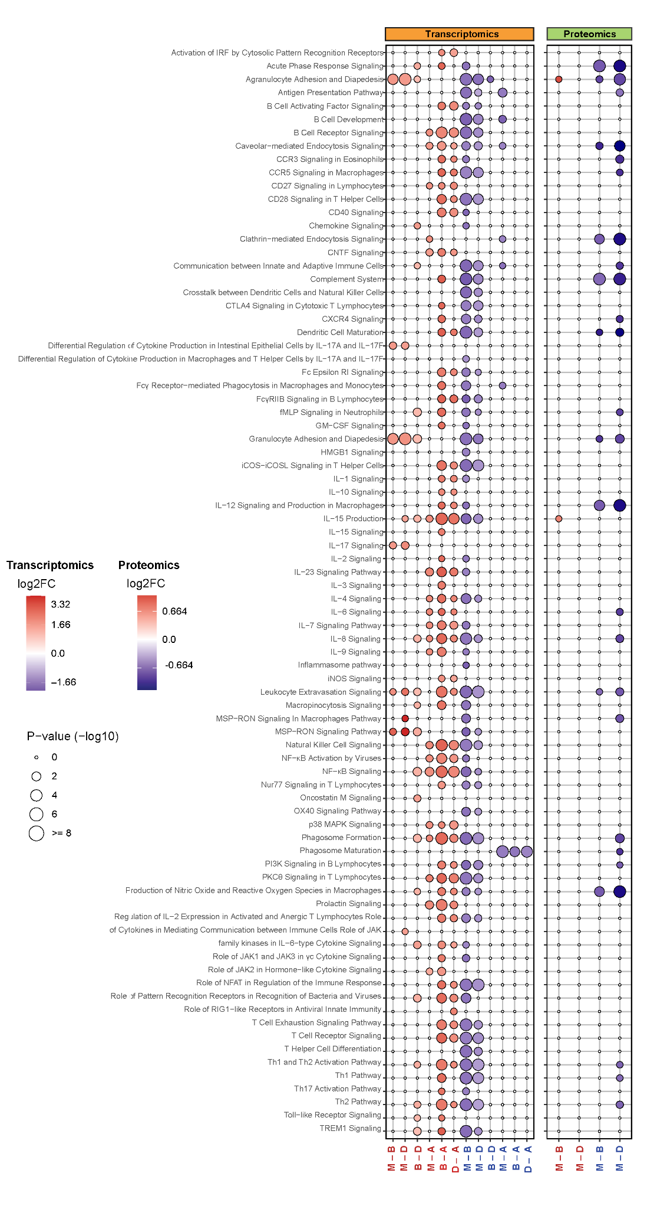

Supplemental Figure 7: Regulation pattern of TAG species.

From the lipidomics contrasts, shown are 373 TAGs detected with significantly decreased abundance in benign polyps relative to the mucosa. Tags with a negative log2FC are colored blue, while a dashed line defines nominal significance thresholds (p-value = 5%), with points above the line meeting the threshold (p-value < 5%).
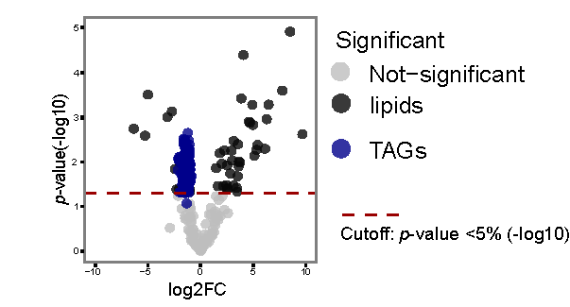

Supplemental Data 1: Samples and their associated pathological features.

File: Supplemental Data 1.xlsx

Supplemental Data 2: Identified mutated cancer driver genes.

File: Supplemental Data 2.xlsx

Supplemental Data 3: Transcriptomic Contrasts.

Transcriptomic contrasts (transcriptomic_contr.tsv) produced by mrna_pipeline.R and utils_slim.R.

The R code accepts as input a path to tab separated, gzipped file (tsv.gz) RSEM estimated gene counts for each Seq = (technical replicate, biological replicate, batch, sample) combination (with columns 'seq', 'gene_id', 'expected_count’), path to a tab-separated metadata file with information on each Seq (with columns ‘Seq’, ‘Spec’,’SBatch’,’Sample’,’Batch’,’Loc’,’Pt’,’Dx’,’Stage’,’Dys’ in which the 1st four provide unique IDs in a nested fashion in the order of (technical replicate, biological replicate, batch, sample), and an annotation file mapping each ensembl Gene ID to an HGNC Symbol (with 3 columns indicating the ensembl ID, the kind of mapping it is, and the mapped ID). It also accepts as output a path to an output directory which will store the results of the analysis. Missing values have the value NA.

File: Supplemental Data 3.zip

Supplemental Data 4: Proteomic Contrasts.

Proteomic contrasts (protein_contr.tsv).

This tab separated file contains columns for UniProtKB ids for each protein, contrast (Contr) codes, log2 fold changes (Log2FC), and FDR. Missing values have the value NA.

File: Supplemental Data 4.zip

Supplemental Data 5: Metabolomic Contrasts.

Metabolomic contrasts (Supplemental Data 5.xlsx) generated by lime_contr.tsv

File: Supplemental Data 5.zip

Supplemental Data 6: Lipidomic Contrasts.

Lipidomic contrasts (Supplemental Data 6.xlsx) - was also generated in a similar way to lime_contr.tsv

File: Supplemental Data 6.xlsx

Supplemental Data 7: Expression/Abundance pattern for each (molecule, -ome) pair.

The molecules for each -ome corresponding to each expression/abundance pattern in Figure 5.

File: Supplemental Data 7.xlsx

Supplemental Data 8: Multi-omic enriched pathways.

Enriched pathways showing -log10 nominal p-values for Transcriptomic/Proteomic analyses (IPA) and FDR adjusted p-values for Metabolomic/Lipidomic enrichment analyses (CPDB or MSEA).

File: Supplemental Data 8.xlsx

