Supplemental Figures
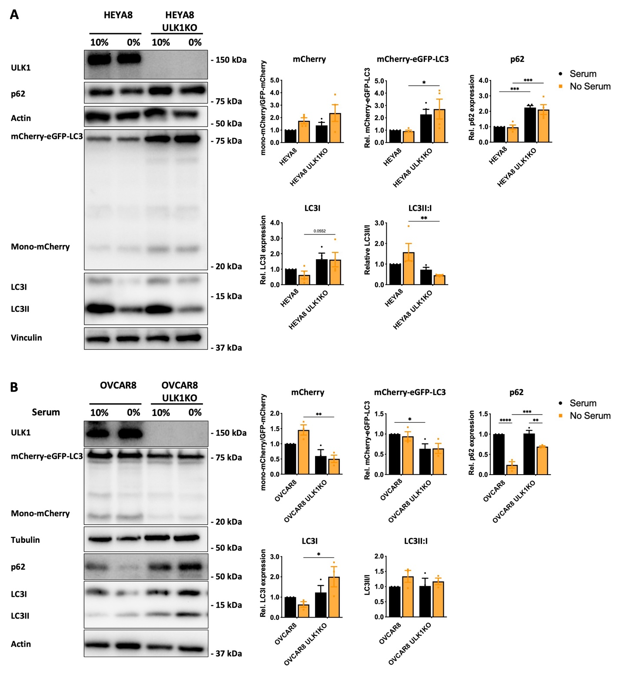
Supplemental Figure 1
HEYA8 (A) and OVCAR8 (B) parental and ULK1KO mCherry-eGFP-LC3B cells were seeded in adherent culture in complete media for 24 hours, followed by an additional 24-hour serum starvation. Protein lysates were harvested at 48-hours post seeding for western blot analysis. Densitometric analysis of canonical autophagy marker and autophagy reporter protein expression relative to parental cells in complete media. Data displayed as mean ± SEM (HEYA8; n=5, OVCAR8; n=3). Two-way ANOVA followed by Šidák’s multiple comparisons test, *P<0.01, **P<0.001, ****P<0.0001.
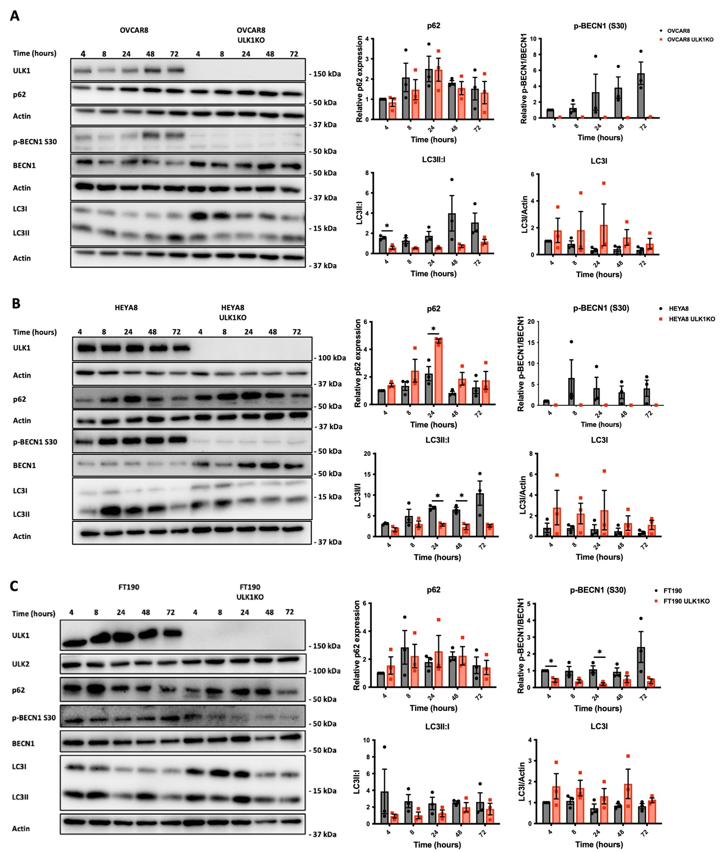
Supplemental Figure 2
OVCAR8 (A), HEYA8 (B), and FT190 (C) parental and ULK1KO cells were seeded in spheroid culture and protein lysates were harvested 4, 8, 24, 48, and 72 hours after seeding for western blot analysis. B) Densitometric analysis of canonical autophagy marker protein expression (n=3) relative to expression in parental 4-hour spheroids. Data displayed as mean ± SEM; Student’s t-test, *P<0.05.

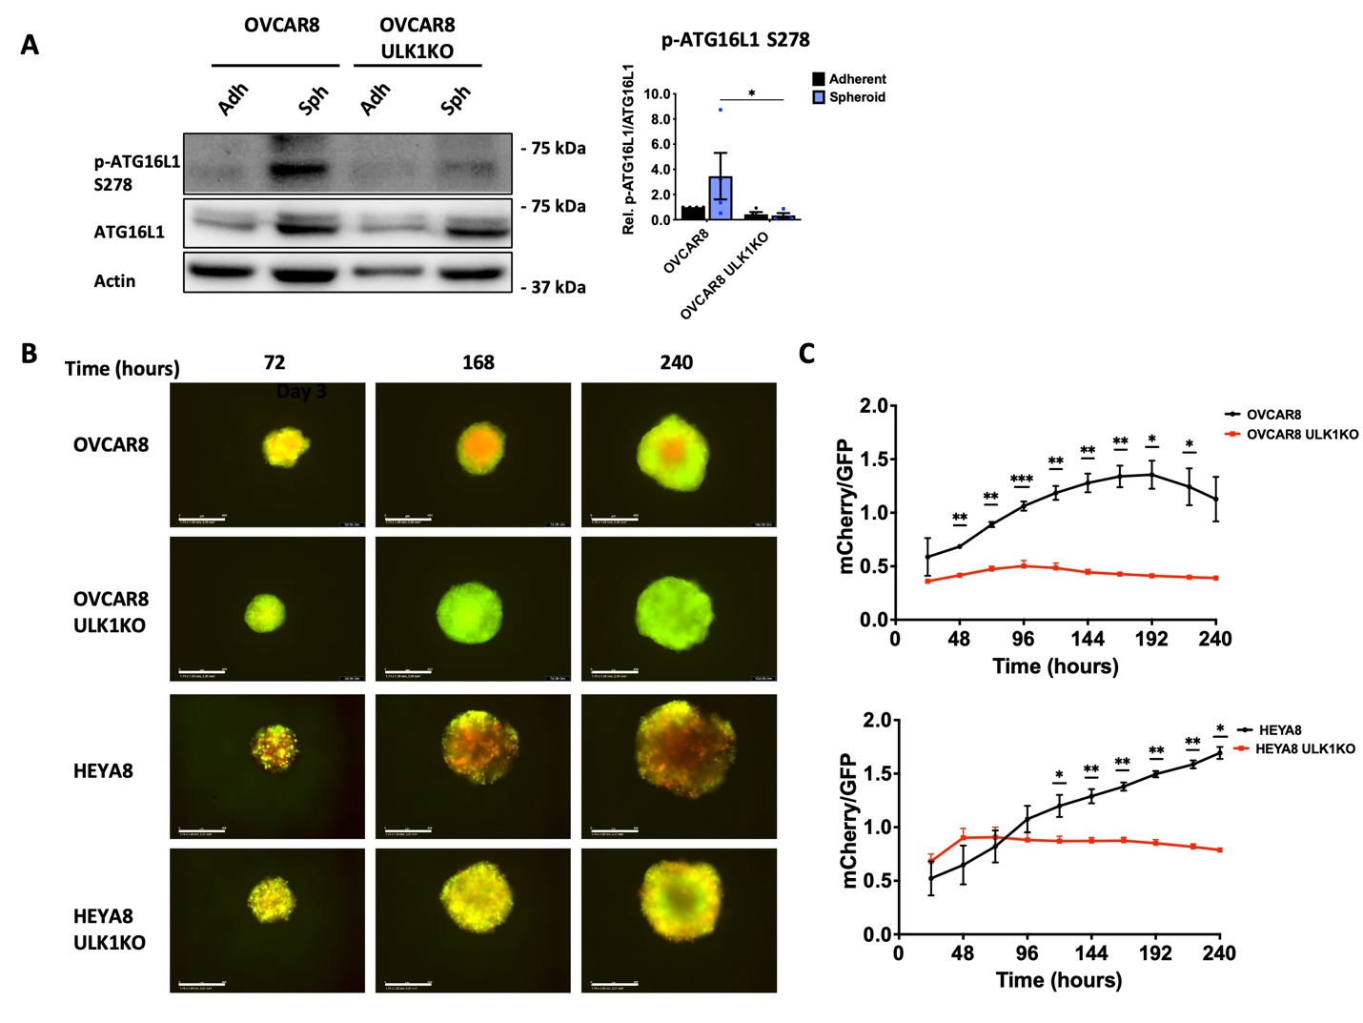
Supplemental Figure 3
A) OVCAR8 parental and ULK1KO cells were seeded in adherent and spheroid culture. Protein lysates were harvested 72h after seeding for western blot analysis of ULK1 activity. Densitometric analysis expression of p-ATG16L1 (S278) in OVCAR8 cells relative to expression in parental adherent conditions (n=3). Data displayed as mean ± SEM; Two-way ANOVA followed by Šidák’s multiple comparisons test, *P<0.01. B) Fluorescent images of spheroids were captured across multiple days using the IncuCyte S3 Live-Cell Analysis System. C) Line graphs reflect the ratios of mCherry/GFP in mCherry-eGFP-LC3B spheroids and displayed as mean ± SEM (n=3); Student’s t-test, *P<0.01, **P<0.001, ***P<0.0001.
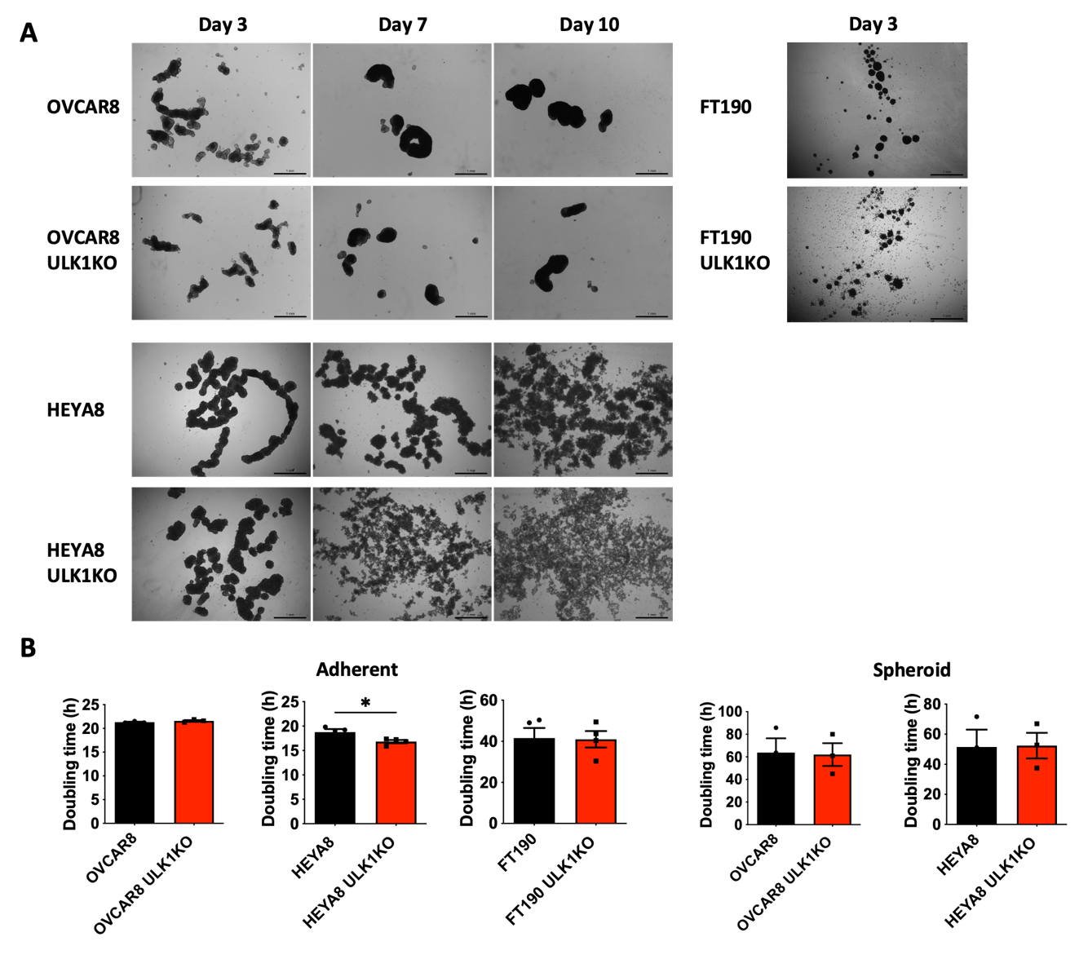
Supplemental Figure 4
A) Brightfield microscopy images of EOC spheroids seeded in 24-well ULA plates. Images were captured at day 3, 7, and 10 using a Leica DMI 400B inverted microscope. Scale bar represents 1mm. B) Doubling time values for adherent and spheroid cells. EOC cells expressing Nuclight GFP were seeded at 2000 cells/well in 96-well flat bottom and ULA round bottom plate, respectively. Doubling time was calculated on GraphPad Prism 9 using the Green Object Count and Green Mean Intensity feature for adherent and spheroids, respectively. Data displayed as mean ± SEM. Student’s t-test, *P<0.05.
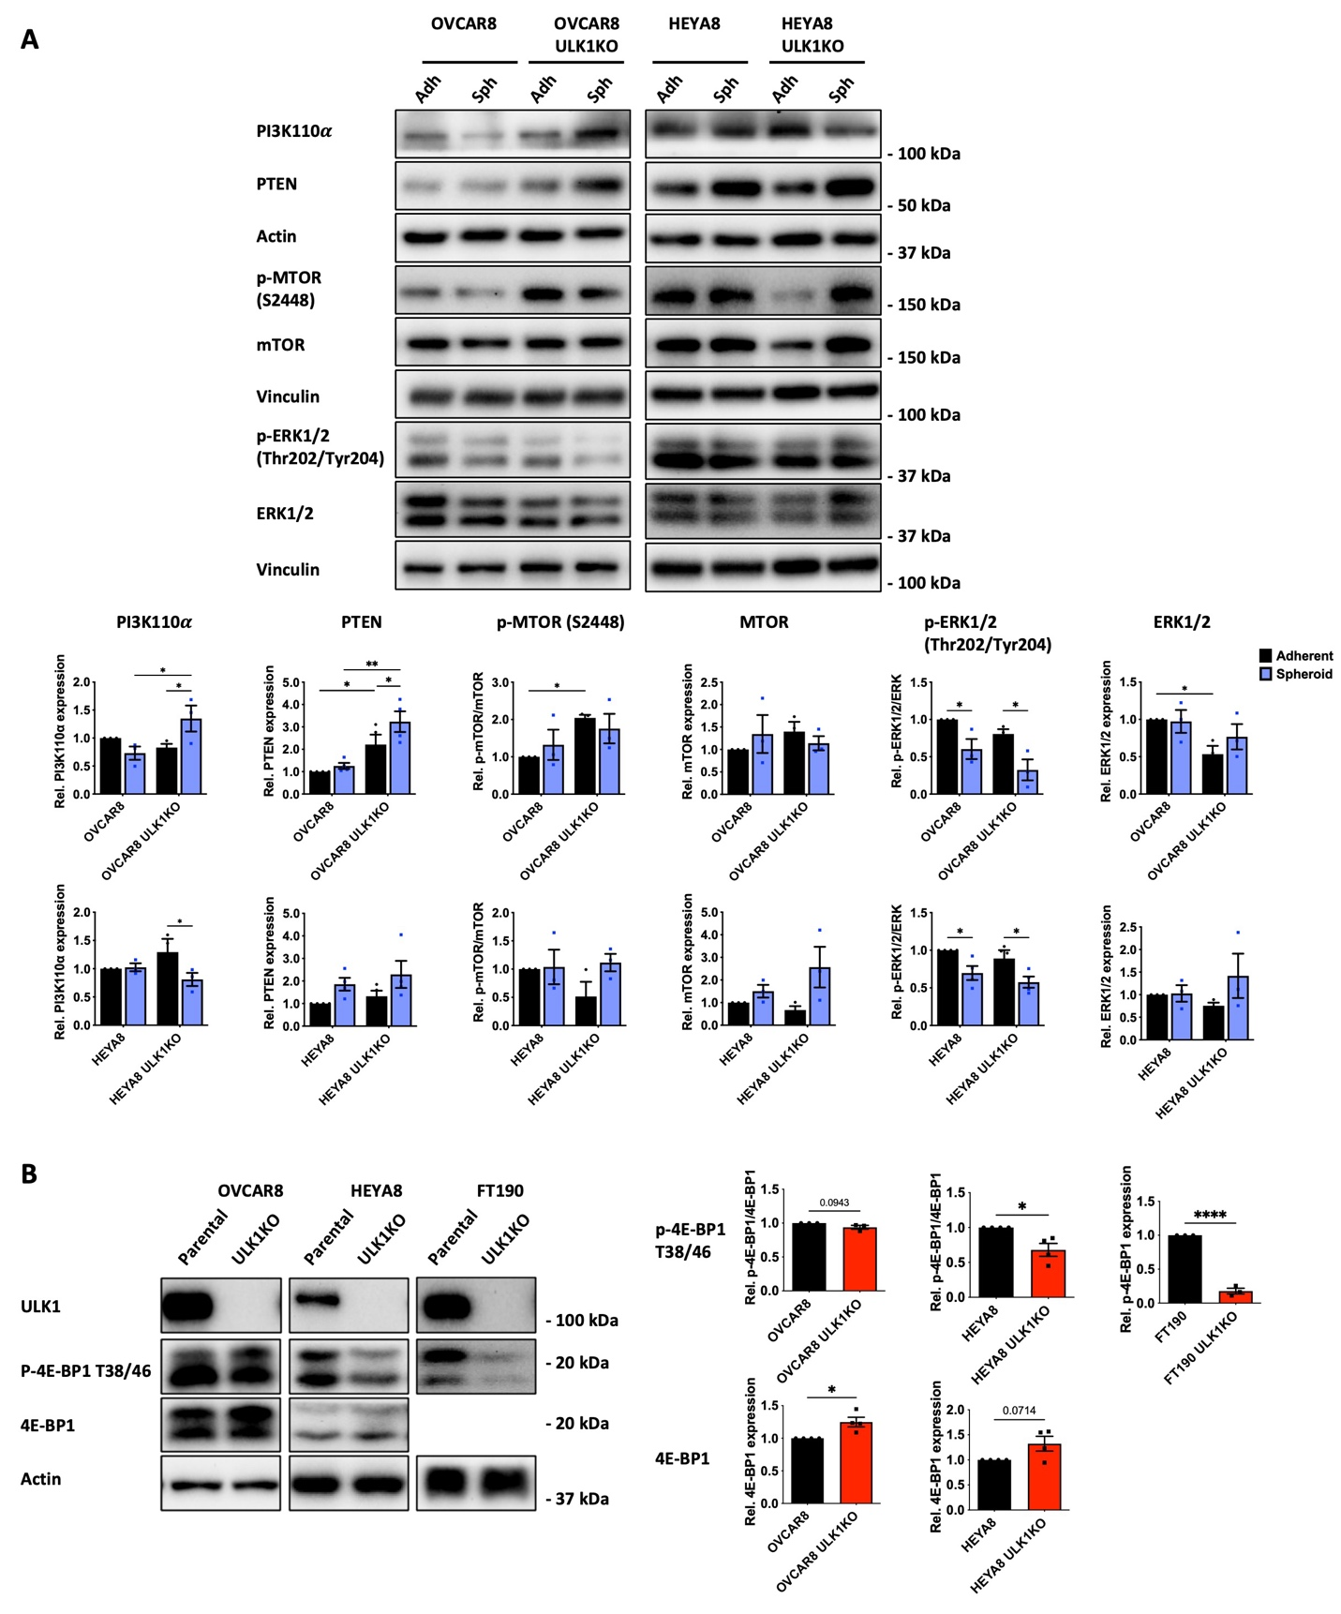
Supplemental Figure 5
A) OVCAR8 and HEYA8 ULK1KO cells were seeded in adherent and spheroid culture. Protein lysates were harvested 72h after seeding for western blot analysis of PI3K-AKT-mTOR and MAPK signaling. Densitometric analysis of proteins are relative to expression in parental spheroids. Data displayed as mean ± SEM; Student’s t-test, *P<0.05, **P<0.001, ****P<0.0001. B) OVCAR8, HEYA8 and FT190 parental and ULK1KO cells were seeded in spheroid culture. Protein lysates were harvested 72h after seeding for western blot analysis of PI3K-AKT-mTOR signaling. Densitometric analysis of proteins are relative to expression in parental spheroids. Data are displayed as mean ± SEM; Two-way ANOVA followed by Šidák’s multiple comparisons test, *P<0.01, **P<0.001, ****P<0.0001.
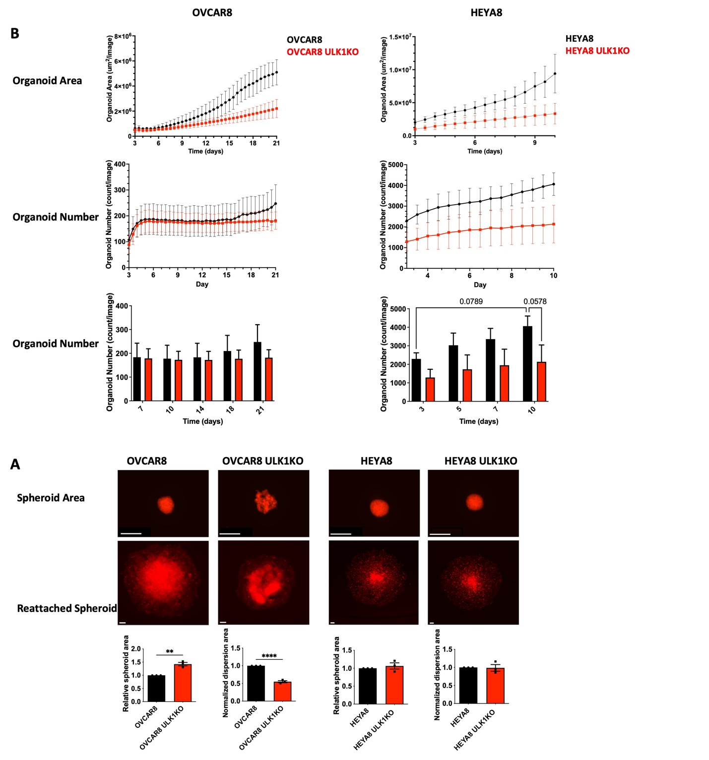
Supplemental Figure 6.
A) EOC parental and ULK1KO cells were grown as organoids and images were captured for up to 21 days using the IncuCyte S3 Live-Cell Analysis System. Organoid area was quantified using the IncuCyte S3 Live-Cell Analysis System. Data reflects the total organoid area and number and displayed as mean ± SEM. B) Spheroids expressing tdTomato were cultured for 24 hours, then seeded onto standard tissue culture plastic, and imaged after an additional 24 hours. The area of dispersion was then quantified using Fiji. The data represents the total RFP area, normalized to the original size of the spheroid and relative to the parental conditions, presented as the mean ± SEM. Scale bars represent the spheroid area as follows: 400µm for general spheroid measurements, 400µm for OVCAR8 reattached spheroids, and 300µm for HEYA8 reattached spheroids.
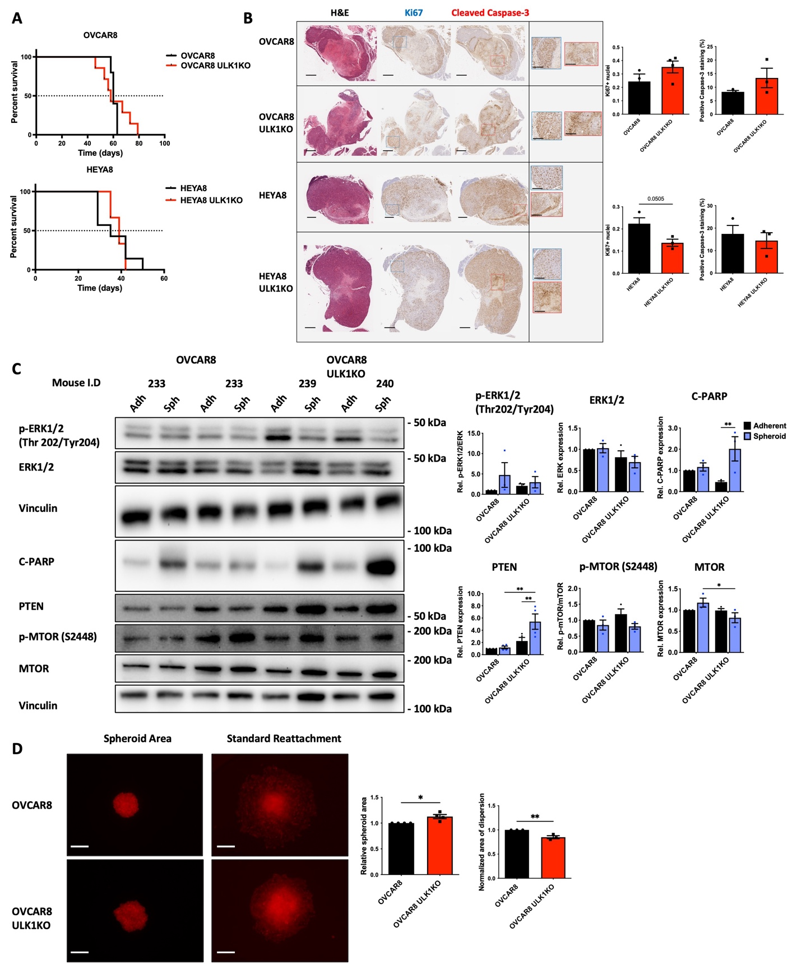
Supplemental Figure 7
A) Kaplan-Meier survival analysis shows the overall survival (in days) of mice injected with EOC parental and ULK1KO cells. Dotted line reflects median survival (OVCAR8 parental; 61.5d, ULK1KO; 57d, HEYA8 parental; 38d, ULK1KO; 40d). B) Serial sections were stained with hematoxylin and eosin (H&E), and immunostained using Ki67 for proliferation and cleaved caspase-3 for apoptosis. Scale bars represent 600 mm and 200 mm, respectively. Data displayed as mean number of Ki67 positive nuclei and Caspase-3 staining for each tumor and the overall mean. For every group, positivity was assessed in at least three independent tumors. Data displayed as mean ± SEM; C) Ascites-derived spheroids expressing tdTomato were cultured for 24 hours, then seeded onto standard tissue culture plastic, and imaged after an additional 24 hours. The area of dispersion was then quantified using Fiji. The data represents the total RFP area, normalized to the original size of the spheroid and relative to the parental conditions, presented as the mean ± SEM. Multiple Student’s t-test, *P<0.05, **P<0.001. Scale bar: 500𝜇m. D) OVCAR8 parental (233, 234) and ULK1KO (239, 240) cells derived from ascites fluid of xenografted mice were seeded in adherent and spheroid cultures. Protein lysates were harvested at 72h after seeding for western blot analysis. Densitometric analysis of proteins are relative to their expression in parental adherent conditions. Data are displayed as mean ± SEM; Two-way ANOVA followed by Šidák’s multiple comparisons test, *P<0.01, **P<0.001, ****P<0.0001.

