Supplementary Information - Single-mode Dispersion-engineered Nonlinear Integrated Waveguides for Ultra-broadband Optical Amplification and Wavelength Conversion
Ping Zhao, Vijay Shekhawat, Marcello Girardi, Zonglong He, Victor Torres-Company, and Peter A. Andrekson
Photonics Laboratory, Department of Microtechnology and Nanoscience, Chalmers University of Technology
Gothenburg 41296, Sweden
I. Balance between loss, nonlinearity and dispersion for parametric process
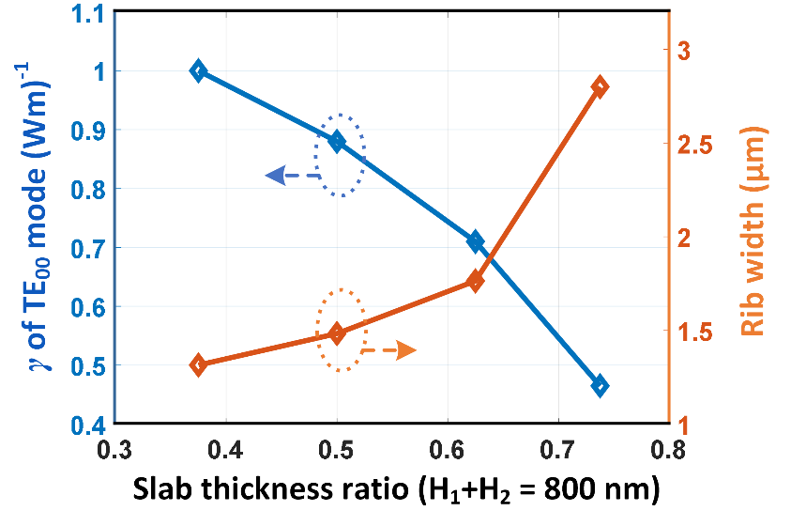
For the Si₃N₄ nonlinear platform, we find that anomalous dispersion is obtained mainly when the total thickness of the rib waveguide is more than 650 nm through typical simulations. Generally, the maximum thickness of crackless Si₃N₄ thin film we can achieve is about 800 nm via direct LPCVD on a flat silica substrate. Here, we focus on 800-nm-thick Si₃N₄ wafer. Although the confinement of the modes for this thickness may not be the highest, one advantage of maximizing the achievable waveguide thickness is that the bending technique of cutting off high-order modes in the rib Si₃N₄ waveguides would perform better for a moderate confinement. Figure S1 presents the simulated nonlinear coefficient (blue) of TE₀₀ mode and required width (red) of a straight rib Si₃N₄ waveguide varying with the slab thickness ratio at a targeted zero-dispersion wavelength of 1550 nm. The total thickness of the rib Si₃N₄ waveguide, i.e., H₁+H₂, is 800 nm. As can be seen in Fig. S1, the required rib width increases with slab thickness. Besides, the nonlinear coefficient drops when the slab thickness ratio increases, which is attributed to the field confinement decrease. The propagation loss (α) of the rib Si₃N₄ waveguide we fabricated is mainly determined by the rib sidewall roughness as well as the overlap area between optical field and the sidewall [1][2], if the nanoparticle issue is fully solved. A higher slab thickness ratio would lead to a lower propagation loss which corresponds to a larger effective nonlinear length, L_{eff} = (1-e^{-αL})/α, where L is the physical waveguide length [3]. At phase matching wavelengths, the gain of a waveguide parametric amplifier is proportional to the exponential term, $e^{-αL+2PγL_{eff}}$ [4]. As a result, a trade-off between nonlinearity and loss needs to be taken. We picked a slab ratio of 62.5%, i.e., H₁ = 300 nm and H₂ = 500 nm, for a strategy that the nonlinear coefficient is still large and the propagation loss would be small. Other slab ratios would be explored in our future work.
Figure S1. Nonlinear coefficient of TE₀₀ mode (blue line) and required rib width (red line) varying with slab thickness ratio for a total rib Si₃N₄ waveguide thickness of 800 nm when the targeted zero-dispersion wavelength is 1550 nm.

II. Single-mode maintaining in rib waveguides with finite slab width
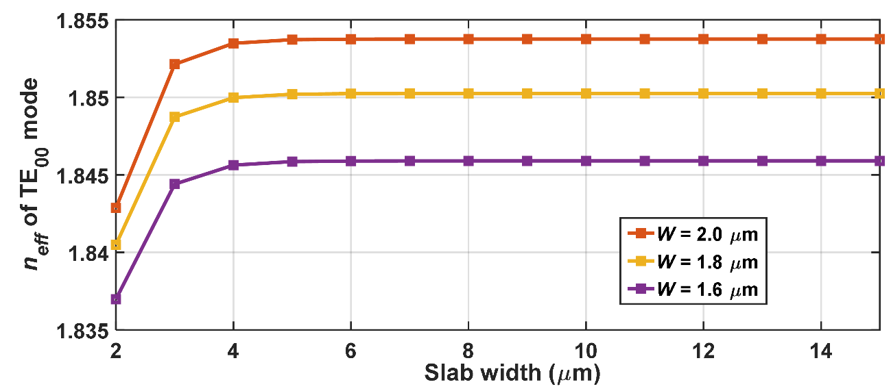
Ideally, A bent rib Si₃N₄ waveguide can be single mode if the slab is infinitely wide. When its thickness is more than 400 nm, practical Si₃N₄ slab is likely to crack due to huge temperature change during fabrication. In this work, we etched a part of the slab to release the stress of the Si₃N₄ slab and obtained sub-meter-long high-confinement rib Si₃N₄ integrated waveguides. As a result, the slab width is finite and slab modes are supported in the fabricated rib Si₃N₄ nonlinear integrated waveguides. The coupling between the fundamental and slab modes can be efficiently avoided by giving a wide Si₃N₄ slab. Figure S2 shows the simulated effective refractive index of TE₀₀ mode as a function of the slab width of straight rib Si₃N₄ nonlinear integrated waveguides. The thicknesses of the rib and slab are 300 nm and 500 nm. The purple, yellow and red lines correspond to the rib width of 1.6 μm, 1.8 μm and 2.0 μm, respectively. As can be seen in Fig. S2, the TE₀₀ effective refractive index is constant when the slab width is larger than 6 μm. This indicates that the TE₀₀ mode will not be disturbed by the slab with a sufficiently large width. We optimized the nanofabrication processes and obtained smooth rib Si₃N₄ waveguides with slab widths of more than 12 μm, considering different bent radii. In this manner, single-mode transmission was achieved in the sub-meter-long rib Si₃N₄ nonlinear integrated waveguides.
Figure S2. Simulated effective refractive index of TE₀₀ mode varying with the slab width of different straight rib Si₃N₄ nonlinear integrated waveguides at 1550 nm. The purple, yellow and red curves correspond to rib widths of 1.6 μm, 1.8 μm and 2.0 μm, respectively.
III. Dispersion in a spiral rib waveguide
The local radius of the proposed single-mode nonlinear waveguide changes along the waveguide. Figure S3 shows the simulated 2nd-order dispersion of TE₀₀ mode varying with the radius of a rib Si₃N₄ nonlinear integrated waveguide at 1550 nm wavelength. The dimension parameters of the rib Si₃N₄ waveguide cross section are W = 1.9 μm, H₁ = 300 nm and H₂ = 500 nm. For the 56-cm-long single-mode rib Si₃N₄ nonlinear integrated waveguide used in the experiment, the radius of the 80% waveguide in one spiral unit is in the shallow-yellow regime. As can be seen in Fig. S3, the designed second- and fourth-order dispersion is about -4 ps²/km and 1.75 fs⁴/ μm, respectively, which is in good agreement with the FWM measurements. Besides, the second-order dispersion is more sensitive to the bent radius of the rib Si₃N₄ nonlinear integrated waveguide than the fourth-order dispersion. We tried to use large bent radius to reduce the dispersion variation along the waveguide. Currently, the maximum radius is limited by the EBL writing field, i.e., 1 mm x 1 mm.
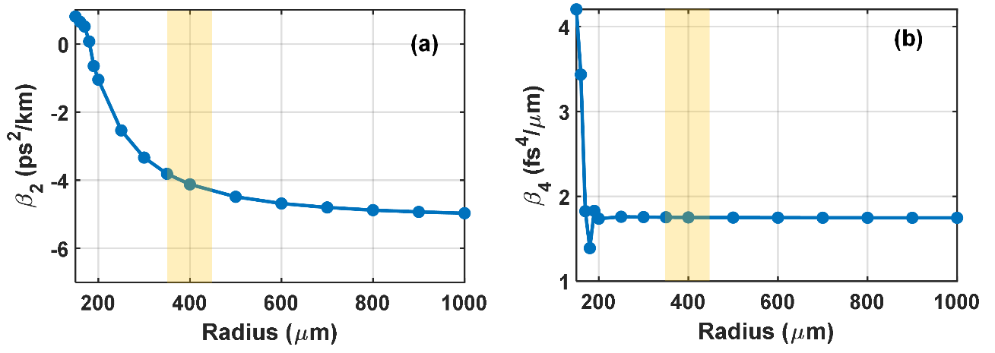
IV. Ultra-wideband PF spectra
Figure S3. (a) Second- and (b) fourth-order dispersion as a function of the radius of a rib Si₃N₄ nonlinear integrated waveguide at 1550 nm for TE₀₀ mode. The waveguide parameters of the cross section are W = 1.9 μm, H₁ = 300 nm and H₂ = 500 nm. The shallow-yellow regime corresponds to the radius range of eighty percent of the waveguide.
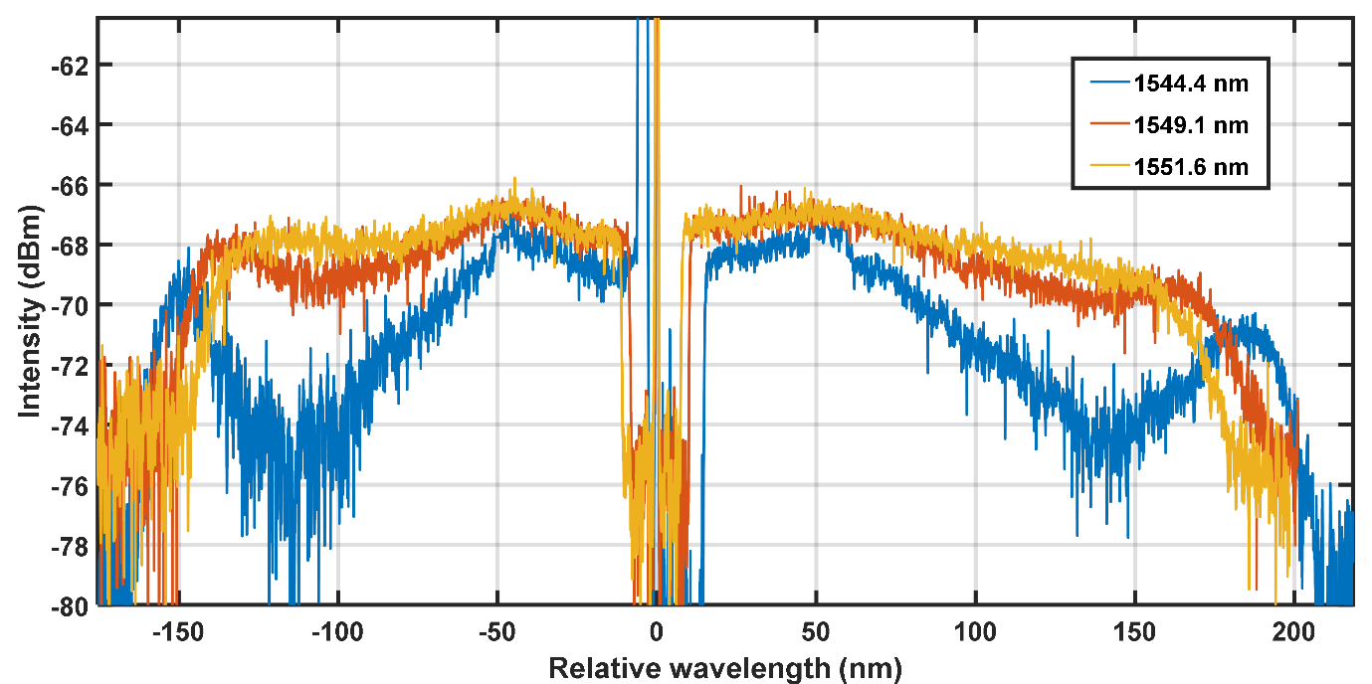
Although we used three widely wavelength-tunable ECLs (1355 nm ~ 1495 nm, 1480 nm ~ 1640 nm and 1580 nm ~ 1680 nm) for the FWM characterization, the measurement of the full parametric bandwidth of the 56-cm-long single-mode rib Si₃N₄ nonlinear integrated waveguide can still not be made due to limited single laser wavelength range. An alternative method to estimate the parametric bandwidth is to check the PF spectrum of the Si₃N₄ nonlinear integrated waveguide. By only feeding the continuous-wave pump wave into the Si₃N₄ nonlinear integrated waveguide, we achieved pure PF due to spontaneous FWM emission in the Si₃N₄ nonlinear waveguide. Figure S4 shows the PF spectra with pump wavelengths of 1544.4 nm (blue), 1549.1 nm (red) and 1551.6 nm (yellow). The on-chip pump power was about 34 dBm in TE₀₀ mode. The two PF peaks at the spectrum edges correspond to phase match wavelengths due to fourth-order dispersion for the 1544.4 nm pump wavelength. As is shown in Fig. S4, the PF flatness improves when the pump wavelength increases. The second- and fourth-order dispersion changes with the pump wavelength, which can be seen in Fig. E1 (a) and (b). Hence, there is an optimum pump wavelength to obtain a spectrally flat PF. The improvement of PF flatness is in agreement with theoretical expectations shown by Fig. 2(a). The PF flatness was also affected by the integrated tapers which were mainly optimized in the C and L bands.
Figure S4. Measured PF spectra with pump wavelengths of 1544.4 nm (blue), 1549.1 nm (red) and 1551.6 nm (yellow). The resolution of optical spectrum analyzer was 0.2 nm. The on-chip pump power was 34 dBm.
Reference
[1] F. P. Payne and J. P. R. Lacey, “A theoretical analysis of scattering loss from planar optical waveguides,” Opt. Quantum Electron., vol. 26, p. 977, 1994.
[2] K. K. Lee, D. R. Lim, H.-C. Luan, A. Agarwal, J. Foresi, and L. C. Kimerling, “Effect of size and roughness on light transmission in a Si/SiO2 waveguide: Experiments and model,” Applied Physics Letters, vol. 77, no. 11, pp. 1617–1619, Sep. 2000, DOI: 10.1063/1.1308532.
[3] G. Agrawal, Nonlinear Fiber Optics, Elsevier, 2013. DOI: 10.1016/b978-0-12-397023-7.00016-4.
[4] M. Karlsson, J. Schröder, P. Zhao, and P. A. Andrekson, “Analytic theory for parametric gain in lossy integrated waveguides,” in Conference on Lasers and Electro-Optics, San Jose, California, United States, 2021, p. JTh3A.5.

