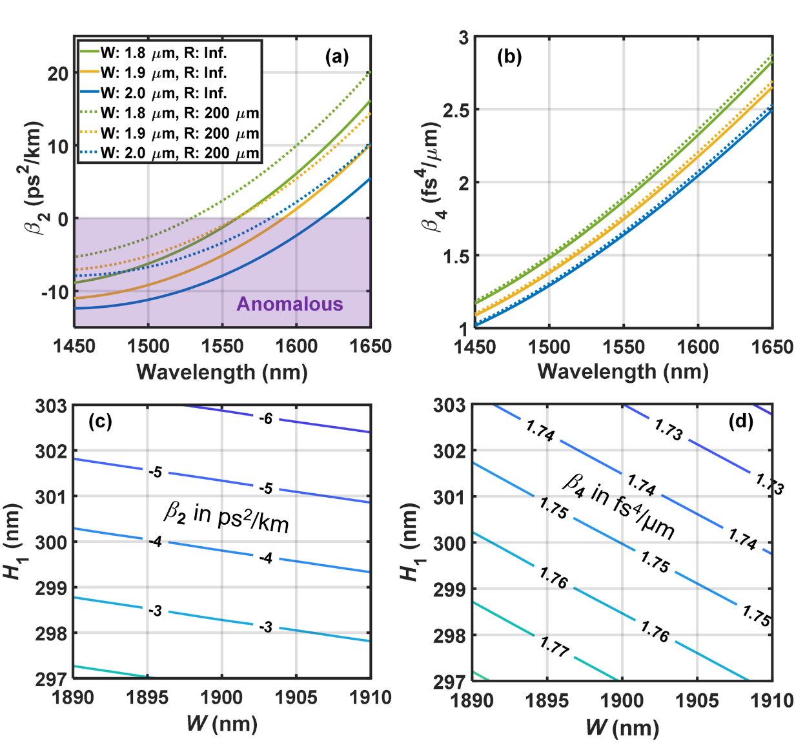
Extended figures
Figure E1. Dispersion properties of rib Si₃N₄ nonlinear integrated waveguides. (a) Second- and (b) fourth-order dispersion spectra of TE₀₀ mode in the proposed rib Si₃N₄ nonlinear integrated waveguides with H₁ = 300 nm and H₂ = 500 nm. The solid and dotted lines correspond to cases of straight waveguides and bent waveguides with a radius of 200 μm, respectively. The green, yellow and blue lines are for the cases of W = 1.8 μm, 1.9 μm and 2.0 μm, respectively. (c) Second- and (d) fourth-order dispersion at 1550 nm wavelength varying with W and H₁ when the radius of a single-mode rib Si₃N₄ nonlinear integrated waveguide is 400 μm for fabrication tolerance analysis. W, R, H₁ and H₂ are the rib width, radius, height, and slab thickness, respectively.

