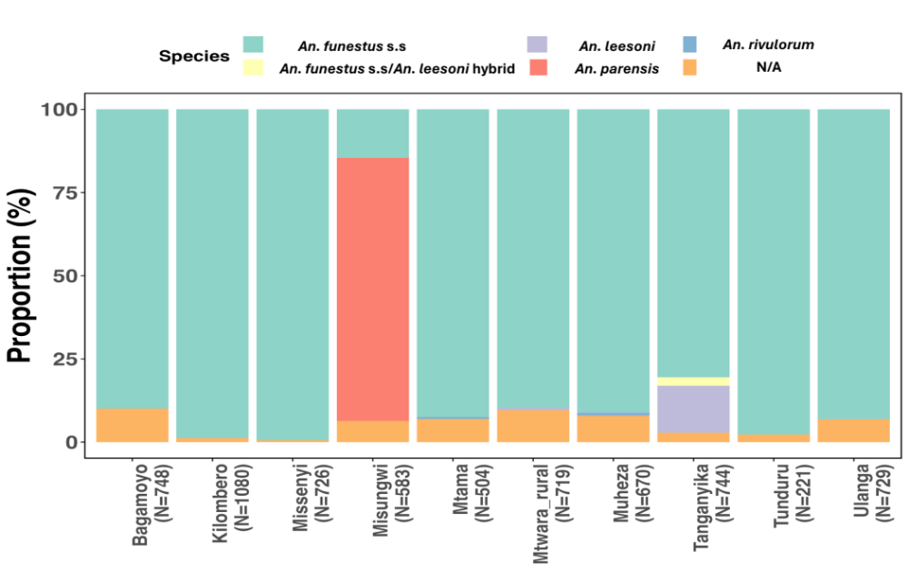
Additional file 1: Proportion of sibling species within the Anopheles funestus group across various districts in mainland Tanzania (Odero et al., Unpublished data).
Additional file 2: Analysis of parity status in Anopheles parensis
Variable | Total (N) | Parous n (%) | OR (95% LC-UC) | p-value
Resting | 100 | 49 (49) | 1 | 0.71
Host-seeking | 100 | 46 (46) | 0.10 (0.51-1.58) | 0.71
Dry | 100 | 55 (55) | 1 | 0.08
Wet | 100 | 41 (41) | 0.60 (0.34-1.05) | 0.08
*Percentage parous = parous (n)/Total number of mosquitoes examined (N)

Additional file 3: Multivariate analysis of insemination in Anopheles parensis
Variable | Total (N) | Insemination n (%) | OR (95% LC-UC) | p-value
Resting | 100 | 67 (67) | 1 | 0.58
Host-seeking | 100 | 70 (70) | 1.19 (0.65-2.17) | 0.58
Dry | 100 | 73 (73) | 1 | 0.20
Wet | 100 | 64 (64) | 0.68 (0.37-1.24) | 0.20
*Percentage insemination = insemination (n)/Total number of mosquitoes examined (N)

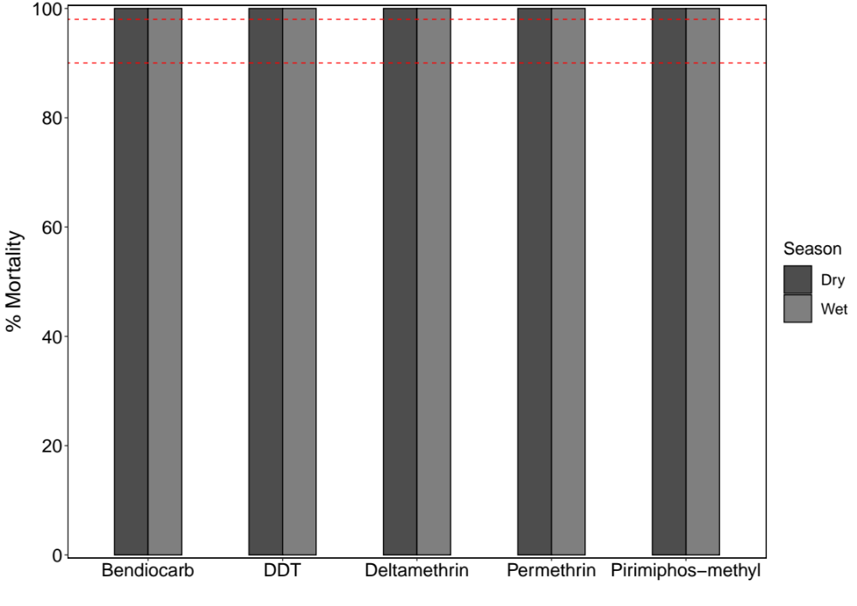
Additional file 4: Percentage mortality of Anopheles parensis mosquitoes exposed to discriminating concentrations of candidate insecticides. The red-dotted lines indicate 90% and 98% mortality thresholds, marking resistance and susceptibility.

