Supplementary Information for

Electrochemical Heteroarylation and Amidation of Alkanes using Activated Glassy Carbon Electrodes without Mediators

Loris Laze, Jose C. Gonzalez-Gomez,* Irene Bosque*

Instituto de Síntesis Orgánica (ISO) and Departamento de Química Orgánica
Universidad de Alicante, Apdo. 99, 03080 Alicante, Spain

Table of contents
MATERIALS AND METHODS 4
General methods 5
Preparation of HAT Catalysts 5
General Procedure for the Preparation of Pyridine N-oxides (HAT3 and HAT4): 5
Preparation of CDC starting materials 5
Synthesis of methyl quinoline-4-carboxylate 5
Synthesis of isopentyl-adamantane-1-carboxylate 5
Materials and set-up of the ECDC: 6
Optimization of the reaction conditions. 7
Activation of Glassy Carbon Electrodes (AGCE) 9
Characterization of the Activated Glassy Carbon Electrode (AGCE) 10
Cyclic Voltammetry (CV) analysis 10
Wettability 11
Infrared analysis 12
XPS analysis 13
Raman spectroscopy analysis 14
Scanning Electron Microscopy (SEM) with Energy Dispersive X-Ray Analysis (EDX) Testing Technique 15
C(sp²)-H alkylation of azaarenes with C(sp³)-H substrates: General Minisci procedure (GMP) for the CDC reaction 17
General Ritter procedure (GRP) for the Amidation reaction 17
Mechanistic studies 18
TEMPO addition 18
CuCl₂ addition 18
1,1-Diphenylethylene addition 19
β-Pinene addition 20
Large-scale synthesis using IKA Carousel 21
C(sp²)-H alkylation of Lepidine with Cyclohexane using batteries of 1.5 V in series (~4.0 V) 22
Amidation of adamantane using three batteries of 1.5 V in series (~4.0 V). 23
Characterization of Products 24
Alkylation of Lepidine with cyclohexane 24
Alkylation of Quinaldine with Cyclohexane 24
Alkylation of 4-Phenylquinoline with Cyclohexane 24
Alkylation of 2-Phenylquinoline with Cyclohexane 25
Alkylation of Methyl 2-Quinoline-4-Carboxylate with Cyclohexane 25
Alkylation of Quinoline with Cyclohexane 25
Alkylation of 3-Methylquinoline with Cyclohexane 26
Alkylation of 6-Bromo-2-methylquinoline with cyclohexane 27
Alkylation of 4-Bromoquinoline with cyclohexane 27
Alkylation of 6-Bromo-4-methylquinoline with cyclohexane 28
Alkylation of 7-Chloro-2-methylquinoline with cyclohexane 28
Alkylation of 2-Methyl-8-nitroquinoline with cyclohexane 29
Alkylation of 2,2'-biquinoline with cyclohexane 29
Alkylation of Phenanthridine with Cyclohexane 30
Alkylation of Cinchonine with Cyclohexane 30
Alkylation of Lepidine with Cyclopentane 30
Alkylation of Lepidine with cyclooctane 31
Alkylation of Lepidine with Cyclododecane 31
Alkylation of Lepidine with methylcyclopentane 32
Alkylation of Lepidine with Bicyclo[2.2.1]heptane 33
Alkylation of Lepidine with 1,4-Dioxane 33
Alkylation of Lepidine with pivalaldehyde 33
Alkylation of Lepidine with Adamantane 34
Alkylation of Lepidine with 1,3-dimethyladamantane 34
Alkylation of Lepidine with isopentyl-adamantane-1-carboxylate 35
Amidation of Adamantane 35
Amidation of 1,3-Dimethyladamantane 35
Amidation of Isopentyl-adamantane-1-carboxylate 36
Amidation of Adamantane with isobutyronitrile 36
Amidation of Cycloheptane 37
Amidation of Cyclooctane 37
Amidation of Indane 37
Copies of NMRs for new compounds 38
References 55

MATERIALS AND METHODS
Solvents and reagents: All solvents and commercially available reagents were purchased as reagent grades and were used without further purification unless otherwise stated.
General methods: All air- and moisture-insensitive reactions were carried out under an ambient atmosphere and monitored by thin-layer chromatography (TLC) and Gas Chromatography-Mass Spectroscopy (GC-MS). TLCs were performed on silica gel 60 F₂₅₄, using aluminum plates and visualized by exposure to ultraviolet light. Flash column chromatography (FC) was performed using Merck silica gel 60 (230–400 mesh). Yields refer to purified compounds unless otherwise stated.
Electrochemistry: The electrochemical reactions were carried out in an IKA ElectraSyn 2.0 bearing a carrousel. The electrodes were activated using an EmStat3 Blue PalmSens.
Analytical Information:
NMR spectra were recorded at 300 or 400 MHz for ¹H and 75 or 101 MHz for ¹³C, using CDCl₃ as solvent. For ¹H-NMR in CDCl₃, TMS was used as an internal standard (0.00 ppm). Data are reported as (s = singlet, d = doublet, t = triplet, q = quartet, m = multiplet or unresolved, brs = broad signal, coupling constant(s) in Hz, integration). ¹³C-NMR spectra were recorded with ¹H-decoupling at 101 MHz and referenced to CDCl₃ at 77.16 ppm.
LRMS were obtained using an Agilent 5977B mass spectrometer with a quadrupole analyzer coupled with a gas chromatographer Agilent 8890. The oven temperature was: 3 min at 80 ºC, then 20 ºC/min ramp until 300 ºC, then 3 min at 300 ºC.
HRMS analyses were carried out in the electron impact mode (EI) at 70 eV using a quadrupole mass analyzer or by Q-TOF using electrospray ionization (ESI) mode.
Infrared (IR) spectra were recorded in a JASCO FT/IR4100 equipped with an ATR component. Values are given in cm⁻¹.
Raman spectroscopy was recorded using an NRS-5100 microscope from Jasco with a 17 mW He-Ne laser (632.8 nm).
XPS spectra were recorded using a Thermo-Scientific K-Alpha XPS spectrometer equipped with a monochromatic Al-K source.

General methods

Preparation of HAT Catalysts

General Procedure for the Preparation of Pyridine N-oxides (HAT3 and HAT4):
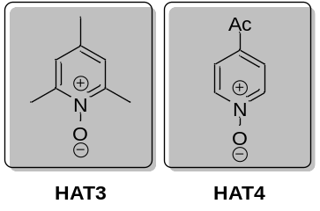
Following a procedure previously reported, pyridine N-oxides were prepared. A solution of the pyridine (1.0 equiv) in dry CH₂Cl₂ (0.17 M) was prepared, and m-CPBA (1.2 equiv, 77% w/w) was added portion-wise to the cooled solution at 0 °C. The mixture was stirred at room temperature overnight, concentrated to ¼ of its volume and purified by flash-column chromatography (silica, EtOAc to 10% MeOH/EtOAc).

Preparation of CDC starting materials
Substrates used in the CDC reaction were commercially available except for the following ones:

Synthesis of methyl quinoline-4-carboxylate
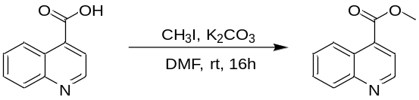
Following a reported protocol, a solution of quinoline-4-carboxylic acid (104 mg, 0.6 mmol), methyl iodide (112 µL, 1.8 mmol) and potassium carbonate (300 mg, 2.4 mmol) in DMF (4 mL) was stirred at room temperature for 16 h. The reaction mixture was diluted with brine and extracted with EtOAc. The combined organic layers were dried, filtered and concentrated in vacuo. After purification by FC, the product was obtained as a white oil (87 mg, 0.46 mmol, 77%) using from 5% to 10% EtOAc in n-hexane as the eluent.

Synthesis of isopentyl-adamantane-1-carboxylate
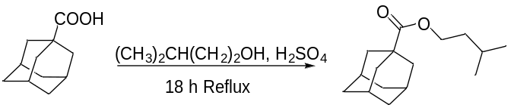
To a solution of adamantane-1-carboxylic acid (1.4 g, 10 mmol) and isoamyl alcohol (80 ml) was added concentrated H₂SO₄ (3.0 mL), and the resulting mixture was stirred at reflux for 18 h. After cooling to room temperature, the reaction mixture was quenched with a saturated solution of Na₂CO₃ (pH 7), extracted with EtOAc, dried over MgSO4, and filtrated. The filtered solution mixture was distilled. After distillation of the remaining isoamyl alcohol, the product was obtained as a white solid (2.25 g, 90 % yield, 9 mmol).

Materials and set-up of the ECDC:
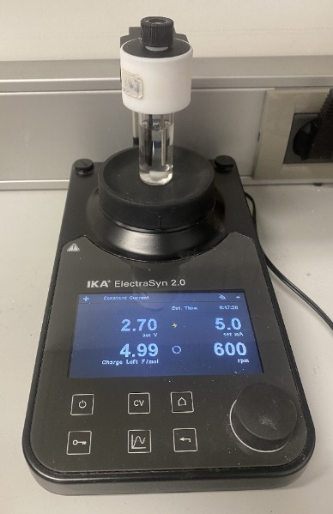
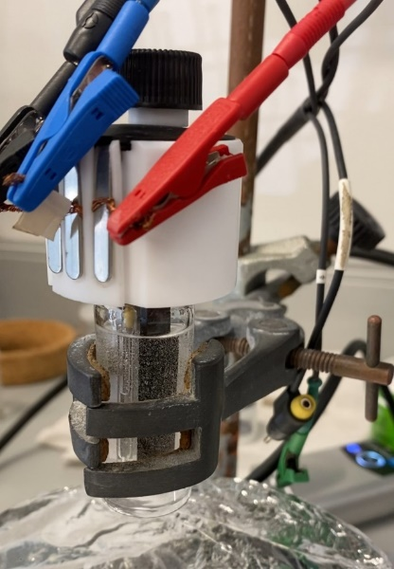
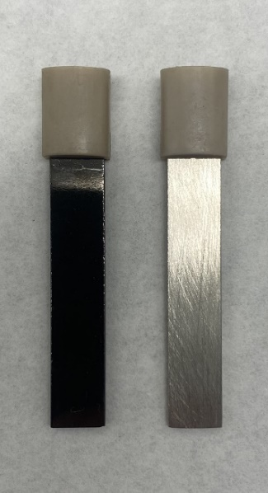
b)

Figure S1: a) Set of electrodes used in this work: Activated Glassy Carbon Electrode (AGCE) and Nickel Electrode. b) Activation of the Glassy Carbon electrode at the EmStat3 Blue PalmSens. c) Set up of the reaction in the IKA Electrasyn 2.0.

Optimization of the reaction conditions.

Table S1: Screening different HAT.
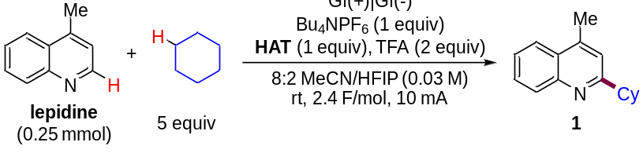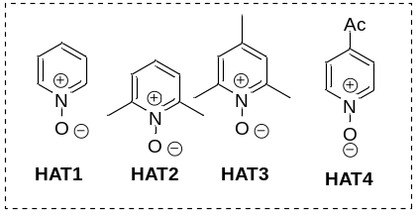
Entry | HAT | Yield of 1 (%)ª
1 | HAT1 | 0
2 | HAT2 | 0
3 | HAT3 | 9
4 | HAT4 | 1
5 | No HAT | 0
ªGC yield is based on the remaining SM without calibration.

Table S2: Screening different Electrodes.
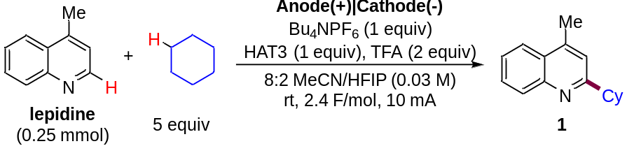

Entry | Anode(+)|Cathode(-) | Yield of 1 (%)ª
1 | Gf(+)|Gf(-) | 9
2 | Pt(+)|Pt(-) | 12
3 | Gf(+)|NiFoam(-) | 12
4 | RVC(+)|Pt(-) | 18
5 | RVC(+)|Zn(-) | 4
6 | RVC(+)|NiFoam(-) | 2
7 | RVC(+)|RVC(-) | 11
7 | Gf(+)|Ni(-) | 13
9 | Gf(+)|Pt-(-) | 12
10 | Glassy Carbon(+)|Ni(-) | 30
11 | RVC(+)|Stainless Steel(-) | 14
ªGC yield is based on the remaining SM without calibration.
Table S3: Optimization of Amidation.
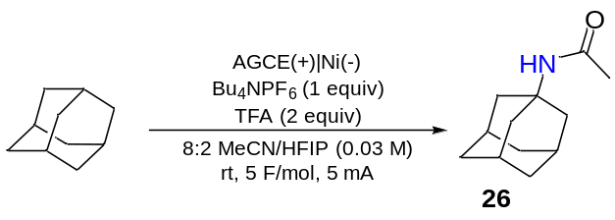

Entry | Modifications | Yield of 26 (%)ª
1 | none | 100
2 | KPF₆ | 92
3 | 9:1 MeCN/H₂O | 33
4 | GCE | 75
5 | LiClO₄ | 100
6 | No TFA | 82
7 | No Charge | 0
8 | 2.5 F/mol | 100
9 | 10 mA | 100
10 | LiClO₄, 2.5 F/mol, 10 mA | 100
ªGC yield is based on the remaining SM without calibration.

Activation of Glassy Carbon Electrodes (AGCE)
A modified procedure previously reported was followed to activate the Glassy Carbon Electrodes. The surface of the Glassy Carbon Electrode was cleaned via polishing using 0.05 μm alumina slurry on a micro cloth, followed by rinsing thoroughly with ethanol and distilled water. To obtain the Activated Glassy Carbon Electrode, the polished Glassy Carbon Electrode was immersed in 0.1 M Phosphate buffer solution (pH 7.0, prepared from Na₂HPO₄ (0.1 mol·L⁻¹) and NaH₂PO₄ (0.1 mol·L⁻¹)) and connected as working electrode. A Pt electrode acted as a counter electrode, and a Ag/AgCl (0.1 M KCl) electrode as a reference electrode. The system was cycled between −1.5 V and +2.5 V for 40 cycles at a scan rate of 100 mV/s. After this electrochemical treatment, the Activated Glassy Carbon Electrode (AGCE) was rinsed thoroughly with distilled water, let to dry and used directly in the reaction.
Table S4: Optimization of the number of scans (ns) for the activation of the GCE
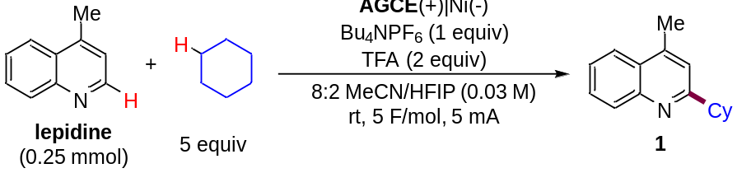
Entry | ns used to obtain AGCE | Yield of 1 (%)ª
1 | 10 | 20
2 | 20 | 40
3 | 30 | 70
4 | 35 | 83
5 | 40 | 85
6 | 50 | 70
ªGC yield is based on the remaining SM without calibration.

Characterization of the Activated Glassy Carbon Electrode (AGCE)

Cyclic Voltammetry (CV) analysis
A 3 mm diameter Glassy Carbon electrode was activated in a three-electrode set-up using a Pt counter electrode and a Ag/AgCl (0.1 M KCl) reference electrode. The three electrodes were submerged in a phosphate buffer solution (PBS, pH 7), and the cyclic voltammetry was swiped for 40 scans from 0 V to 2.5 V to -1.5 V and back to 0 V. (Figure S2. Notice that the first swipe contains no oxidation peak. This peak appears after swiping towards negative potentials). After this, the last scan was swiped from 0 V to 2.5 V to -1.5 V and stopped there.
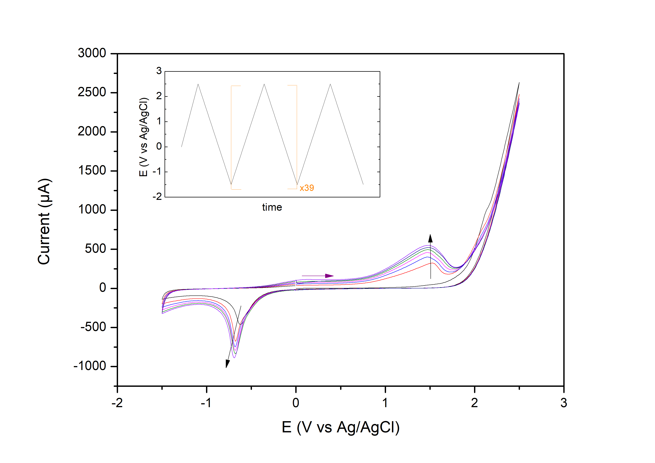
Figure S2: General profile for the activation of the GC electrode in a phosphate buffer solution. 5 scans are shown. Inset represents the change of potential over 40 cycles.

Wettability
The change in the nature of the Glassy Carbon Electrode after the electrochemical activation was tested using a wettability test. Visually (Figure S3), an added drop of water to the electrode prior to an after activation, resulted in a clear difference in the covered surface area, indicating a change in the nature of the surface of the electrode.
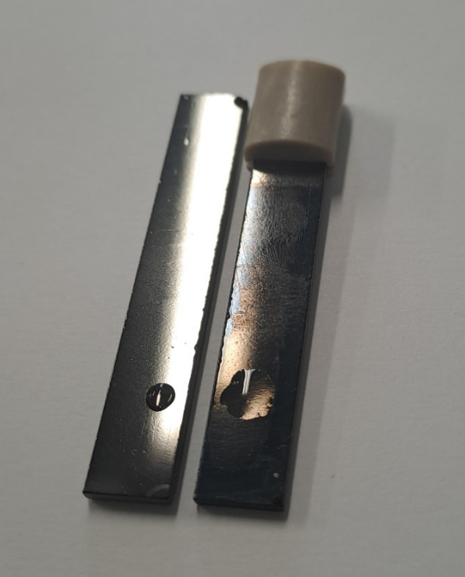
Figure S3: Visual wettability test of polished GC electrode (left) vs AGCE electrode (right) after addition of 10 µL of water.

Infrared analysis
The change in the nature of the Glassy Carbon Electrode after the electrochemical activation was analyzed by IR analysis (Figure S4). In the case of the polished electrode, no clear signals were observed. For the AGCE electrode, signals at > 3000 cm⁻¹ indicate the presence of hydroxyl groups in the surface of the GC electrode, whereas signals at 1020 to 1100 cm⁻¹ are due to C-O stretching. This change suggests that new hydroxyl groups were created on the surface of the electrode that, after oxidation, might be responsible for the C-H abstraction from the alkanes used in these reactions.

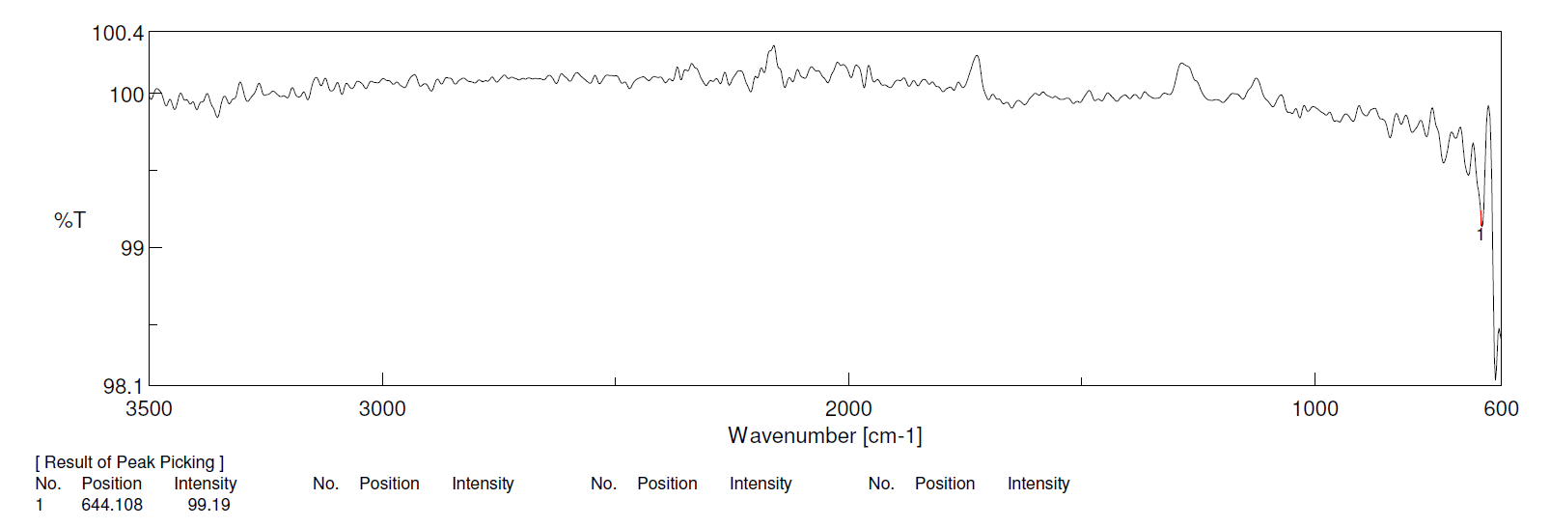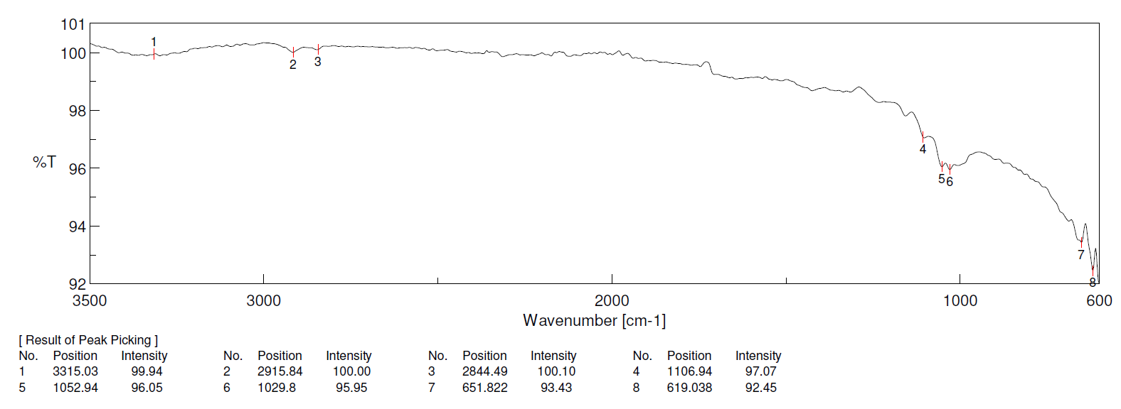
Figure S4: IR spectra for the polished GC electrode (top) and the AGCE electrode (bottom).

XPS analysis
Figure S5: Survey spectra of the polished and activated GC electrode in PSB pH 7. Activation procedure: 40 potential cycles between -1.5 and +2.5 V recorded at 100 mV·s⁻¹ followed by holding potential at -1.5 V for 1 s.
Figure S6: C 1s X-ray photoelectron spectra of polished (up) and activated (down) AGCE electrodes.

Raman spectroscopy analysis
The activation of the GCE does not induce the appearance of a novel peak. The two sharp peaks characteristics of carbon, the D band (1350 cm⁻¹) attributed to the sp² carbon ring breathing mode, and the G band (1590 cm⁻¹) attributed to the sp² bond carbon stretching mode are observed in both, the GCE and the AGCE. The relative intensity ratio between the D and G band [referred to as I(D/G)] is calculated as 1.39 and 1.36 for the GCE and the AGCE, respectively, which indicates a dominance of sp²-bonded carbons (values between 0.5 and 2.0).
The secondary peaks observed are attributed to the 2D band (first overtone of the D band, 2670 cm⁻¹) and the D + D’ band (2925 cm⁻¹). The 2D band is intense when there is substantial ordering, whereas a weak band indicates the absence of order in the sample. In this case, we can observe more order in the GCE compared to the AGCE.
Figure S7: Raman spectroscopy analysis of GCE (top) and AGCE (bottom).

Scanning Electron Microscopy (SEM) with Energy Dispersive X-Ray Analysis (EDX) Testing Technique

These analyses were performed in three different areas of each electrode.

  GCE EDX  10 µm | 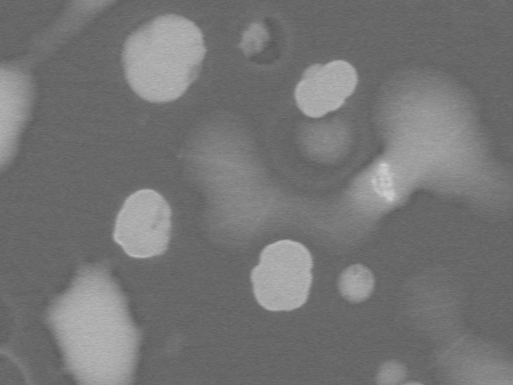  AGCE EDX  10 µm
Figure S8: SEM images for the GCE (left) and AGCE (right)
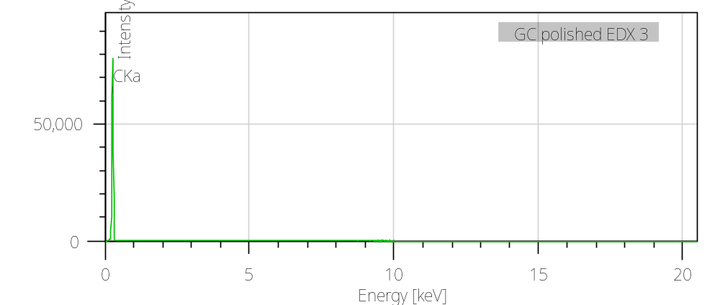
Element | Line | Mass% | Atom%
C | K | 100.00±0.08 | 100.00±0.08
Total |  | 100.00 | 100.00
GCE EDX | Fitting ratio 0.4389

Figure S9: EDX analysis for the GCE.
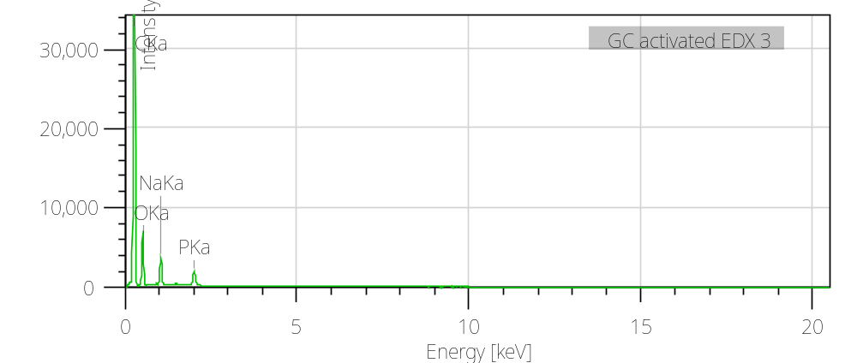
Element | Line | Mass% | Atom%
C | K | 58.99±0.06 | 68.63±0.07
O | K | 27.86±0.08 | 24.33±0.07
Na | K | 7.10±0.04 | 4.31±0.02
P | K | 6.06±0.04 | 2.73±0.02
Total |  | 100.00 | 100.00
AGCE EDX | Fitting ratio 0.3206

Figure S10: EDX analysis for the AGCE.

C(sp²)-H alkylation of azaarenes with C(sp³)-H substrates: General Minisci procedure (GMP) for the CDC reaction.
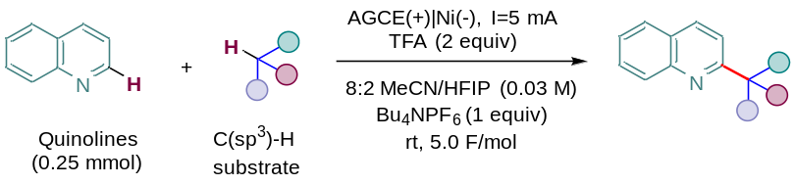
In a 10 mL ElectraSyn 2.0 vial, equipped with a stirring bar, was added the azaarene (0.25 mmol) and tetrabutylammonium hexafluorophosphate as supporting electrolyte (96.9 mg, 0.25 mmol, 1 equiv), followed by a mixture of acetonitrile/1,1,1,3,3,3-hexafluoro-2-propanol (8:2, 8 mL). Then TFA (38 µL, 0.60 mmol, 2 equiv) and the C(sp³)-H substrate (5 or 10 equiv, amount specified in the individual experiments) were added to the reaction mixture. All reagents were added in open-air conditions. After completely dissolving all the components, the electrodes were placed in the reaction media; the vial was closed and connected. A current of 5 mA with a total charge of 5.0 F/mol was set. Once all the charge passed, K₂CO₃ (273 mg, 1.25 mmol, 5 equiv) was added, and the reaction mixture was stirred for 30 min. After this time, the suspension was filtered through Celite, eluting with EtOAc (4 x 4 mL). After evaporating the solvent under vacuum, the residue was purified by FC.

General Ritter procedure (GRP) for the Amidation reaction
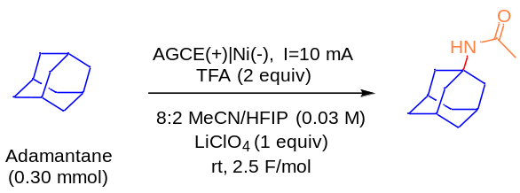
In a 10-mL ElectraSyn 2.0 vial, equipped with a stirring bar, was added the alkane (0.30 mmol) and lithium perchlorate as supporting electrolyte (31.8 mg, 0.30 mmol, 1 equiv), followed by a mixture of acetonitrile/1,1,1,3,3,3-hexafluoro-2-propanol (8:2, 8 mL). Then TFA (38 µL, 0.60 mmol, 2 equiv) was added to the reaction mixture. All reagents were added in open-air conditions. After completely dissolving all the components, the electrodes were placed in the reaction media; the vial was closed and connected. A current of 10 mA with a total charge of 2.5 F/mol was set. Once all the charge passed, K₂CO₃ (273 mg, 1.25 mmol, 5 equiv) was added, and the reaction mixture was stirred for 30 min. After this time, the suspension was filtered through Celite, eluting with EtOAc (4 x 4 mL). After evaporating the solvent under vacuum, the residue was purified by FC.

Mechanistic studies

TEMPO addition

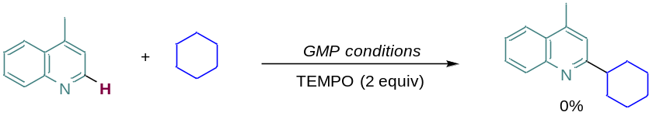
The general procedure was followed, but TEMPO (78 mg, 0.5 mmol, 2 equiv) was added to the reaction mixture. Once the time elapsed, the reaction mixture was directly analyzed by GC-MS (ESI). The formation of the TEMPO-cyclohexyl adduct was not detected. The radical species of TEMPO probably reacts with the activated surface of the Glassy Carbon Electrode, inactivating the surface of the electrode in this way and not allowing the abstraction of hydrogen from the cyclohexane. In GC-MS (ESI), only the starting lepidine (9.939 min) and the radical TEMPO (7.381 min) were detected. (Figure S11).
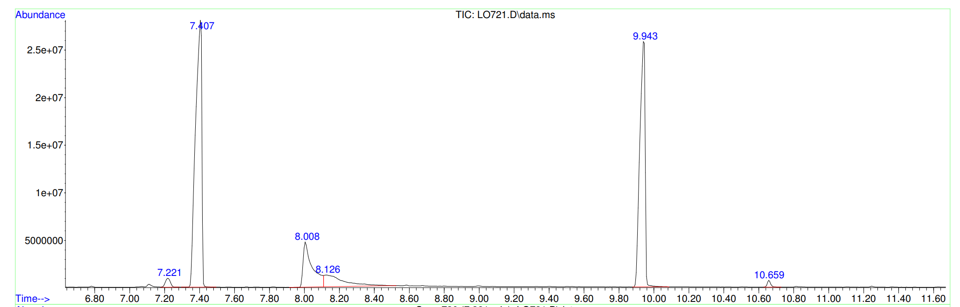
LEPIDINE
TEMPO

Figure S11: MS for the reaction with TEMPO.

CuCl₂ addition

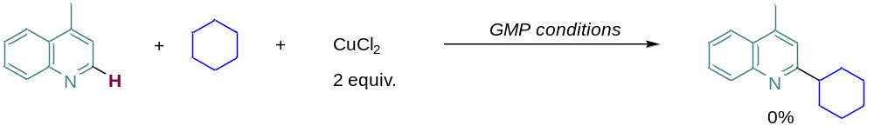
In a 10mL ElectraSyn 2.0 vial, equipped with a stirring bar, was added the lepidine (43 µL, 0.25 mmol) and supporting electrolyte (96.9 mg, 0.25 mmol, 1 equiv), followed by a mixture of acetonitrile/1,1,1,3,3,3-Hexafluoro-2-propanol (8:2, 8 mL). Then TFA (38 µL, 0.60 mmol, 2 equiv), cyclohexane (270 µL, 2.5 mmol, 10 equiv) and CuCl₂ (67 mg, 0.5 mmol, 2 equiv) were added to the reaction mixture. All reagents were added in open-air conditions. After complete dissolution, the electrodes were placed in the reaction media, the vial closed, and the current was circulated (5 mA, 5.0 F/mol). Once the time elapsed, the reaction mixture was analyzed by GC-MS (ESI). The formation of the desired product was not detected as expected.

1,1-Diphenylethylene addition

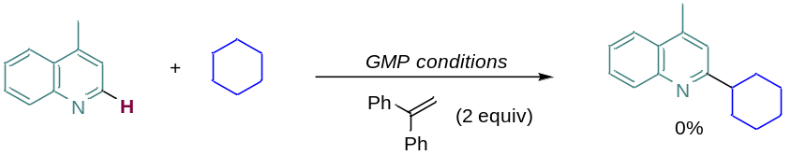
In a 10mL ElectraSyn 2.0 vial, equipped with a stirring bar, was added the lepidine (43 µL, 0.25 mmol) and supporting electrolyte (96.9 mg, 0.25 mmol, 1 equiv), followed by a mixture of acetonitrile/1,1,1,3,3,3-Hexafluoro-2-propanol (8:2, 8 mL). Then TFA (38 µL, 0.60 mmol, 2 equiv) and the cyclohexane (270 µL, 2.5 mmol, 10 equiv) and 1,1-diphenylethylene (88 µL, 0.5 mmol, 2 equiv) were added to the reaction mixture. All reagents were added in open-air conditions. After complete dissolution, the electrodes were placed in the reaction media, the vial closed, and the current was circulated (5 mA, 5.0 F/mol). Once the time elapsed, the reaction mixture was analyzed by GC-MS (ESI). The formation of the 1-cyclohexyl-2,2-diphenylethylene adduct was not detected. Probably, the 1,1-diphenylethylene reacts with the activated radical surface of the Glassy Carbon Electrode, inactivating the surface of the electrode in this way and not allowing the abstraction of the hydrogen from the cyclohexane. In GC-MS (ESI), a variety of peaks were detected, but none of them gave the mass of the TEMPO-1,1-diphenylethylene adduct (PM 225) (Figure S12).

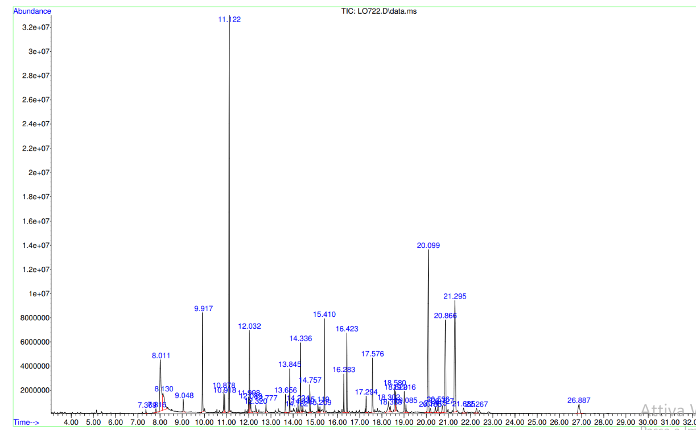
Figure S12: GC for the reaction with 1,1-diphenylethylene.

β-Pinene addition

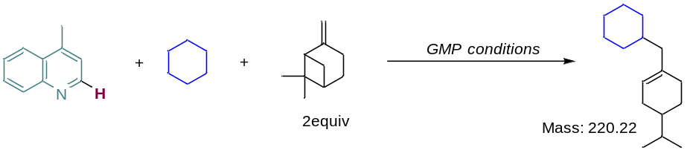
In a 10 mL ElectraSyn 2.0 vial, equipped with a stirring bar, was added the lepidine (43 µL, 0.25 mmol) and supporting electrolyte (96.9 mg, 0.25 mmol, 1 equiv), followed by a mixture of acetonitrile/1,1,1,3,3,3-Hexafluoro-2-propanol (8:2, 8 mL). Then TFA (38 µL, 0.60 mmol, 2 equiv), cyclohexane (270 µL, 2.5 mmol, 10 equiv), and β-pinene (198 µL, 0.5 mmol, 2 equiv) were added to the reaction mixture. All reagents were added in open-air conditions. After complete dissolution, the electrodes were placed in the reaction media, the vial closed, and the current was circulated (5 mA, 5.0 F/mol). Once the time elapsed, the reaction mixture was analyzed by HRMS (EI-TOF). The formation of cyclohexane and β-pinene adduct was detected (PM 220). The first step is probably forming the radical cyclohexyl, which is trapped by the structure of the β-pinene, giving the adduct with PM 220 and not allowing the cyclohexane to react with lepidine. (Figure S13).

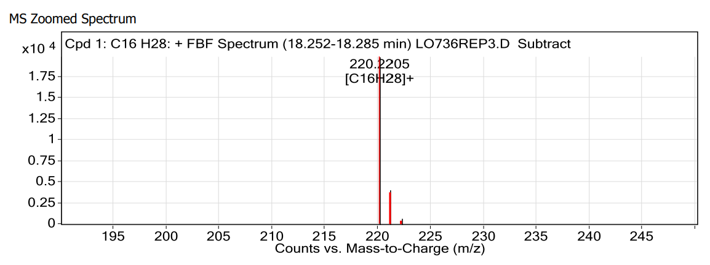

Figure S13: HRMS (EI-TOF) for the reaction with β-pinene.

Large-scale synthesis using IKA Carousel
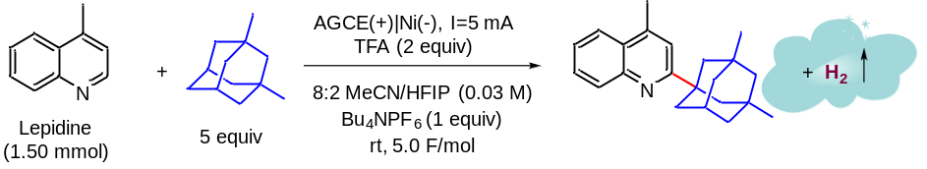
In a 10 mL ElectraSyn 2.0 vial, equipped with a stirring bar, was added the lepidine (0.25 mmol) and tetrabutylammonium hexafluorophosphate (96.9 mg, 0.25 mmol, 1 equiv), followed by a mixture of acetonitrile/1,1,1,3,3,3-hexafluoro-2-propanol (8:2, 8 mL). Then TFA (38 µL, 0.60 mmol, 2 equiv) and the 1,3-dimethyladamantane (205 µL, 1.25 mmol, 5 equiv) were added to the reaction mixture. All reagents were added in open-air conditions. After complete dissolution, the electrodes were placed in the reaction media, and the vial was closed. This operation was repeated six times, preparing six vials of the reaction mixture (total of 1.5 mmol, 6 x 0.25 mmol). The vials were placed in the IKA carousel (Figure S14), and the current was circulated (5 mA, 5.0 F/mol). Once all the charge passed, the reaction mixture of all six vials was reunited, K₂CO₃ was added (1.640 g, 7.5 mmol, 5 equiv), and the reaction mixture was stirred for 30 min. After this time, the suspension was filtered through Celite and eluted with EtOAc. After evaporating the solvent under vacuum, the residue was purified by FC. After purification by FC, the product was obtained as a yellow oil (0.311 g, 1.02 mmol, 68%) using 1% to 5% EtOAc in n-hexane as the eluent.
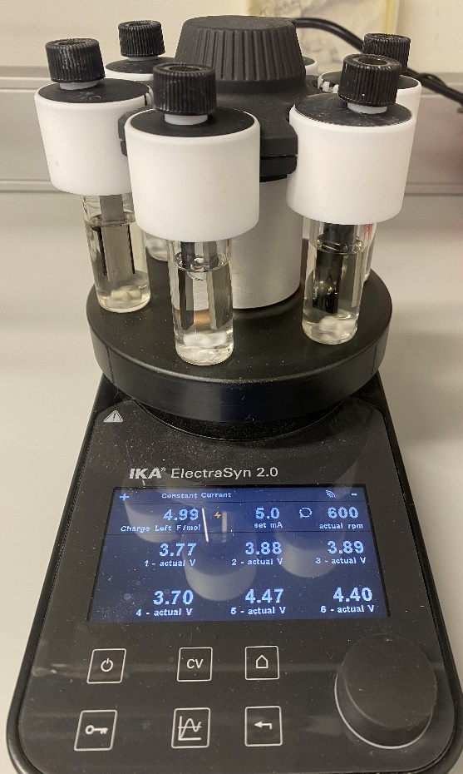
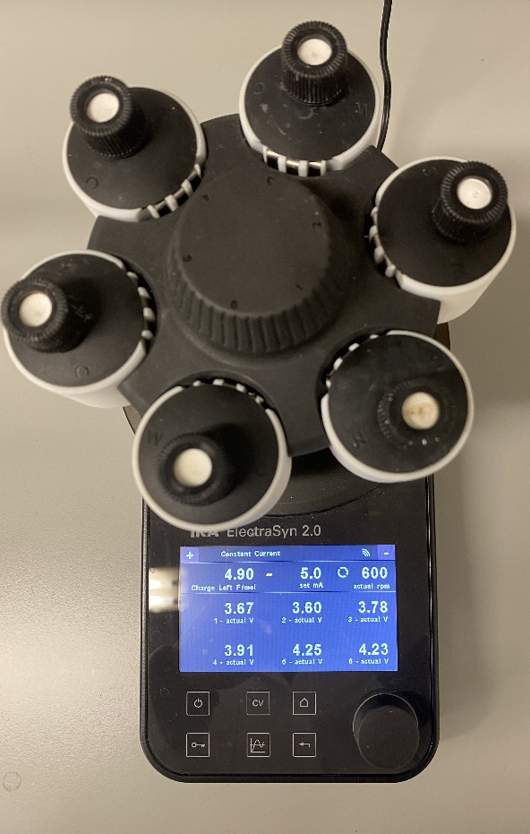

Figure S14: Set-up in the IKA Carousel for large-scale reaction.

C(sp²)-H alkylation of Lepidine with Cyclohexane using batteries of 1.5 V in series (~4.0 V)
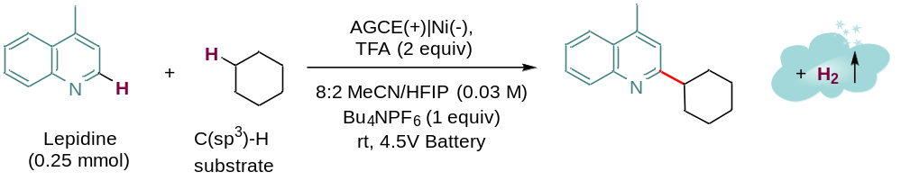
In a 10mL ElectraSyn 2.0 vial, equipped with a stirring bar, was added the Lepidine (0.25 mmol) and tetrabutylammonium hexafluorophosphate as supporting electrolyte (96.9 mg, 0.25 mmol, 1 equiv), followed by a mixture of acetonitrile/1,1,1,3,3,3-hexafluoro-2-propanol (8:2, 8 mL). Then TFA (38 µL, 0.60 mmol, 2 equiv) and the Cyclohexane as C(sp³)-H substrate (10 equiv) were added to the reaction mixture. All reagents were added in open-air conditions. After the complete dissolution of all the components, the electrodes were placed in the reaction media, the vial closed and connected to batteries of 1.5 V in series (4.5 V). After 10 hours, K₂CO₃ (273 mg, 1.25 mmol, 5 equiv) was added, and the reaction mixture was stirred for 30 min. After this time, the suspension was filtered through Celite, eluting with EtOAc (4 x 4 mL). After evaporating the solvent under vacuum, the product was obtained as a light-yellow oil (29.8 mg, 0.14 mmol, 53%) after FC using a gradient from 0% to 5% of EtOAc in n-hexane as the eluent.

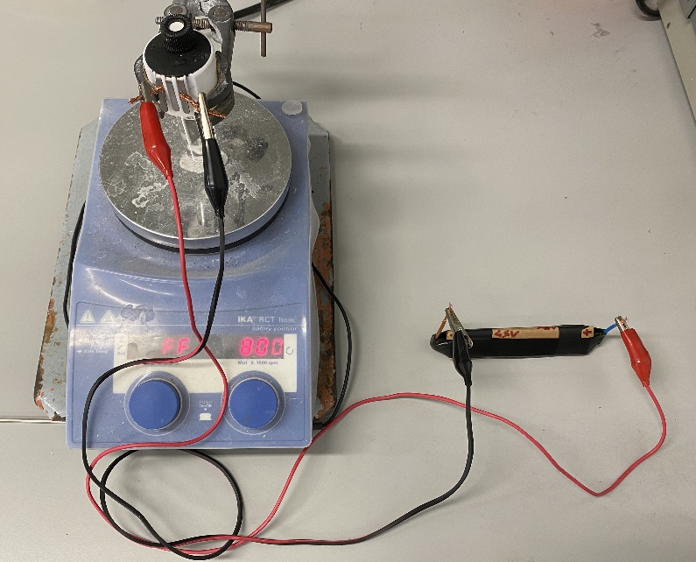 | 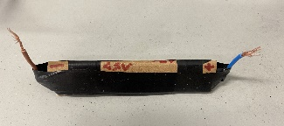  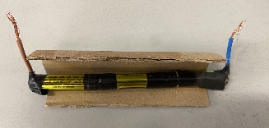  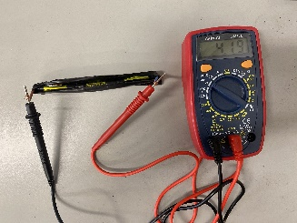
Figure S15: Set-up for the reaction using regular 1.5 V batteries in series

Amidation of adamantane using three batteries of 1.5 V in series (~4.0 V).
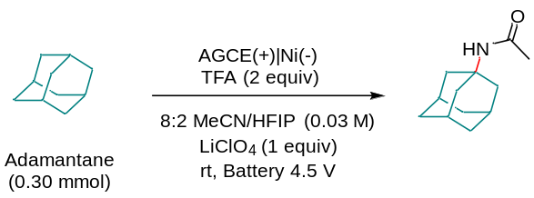
In a 10-mL ElectraSyn 2.0 vial, equipped with a stirring bar, was added the alkane (0.30 mmol) and lithium perchlorate as supporting electrolyte (31.8 mg, 0.30 mmol, 1 equiv), followed by a mixture of acetonitrile/1,1,1,3,3,3-hexafluoro-2-propanol (8:2, 8 mL). Then TFA (38 µL, 0.60 mmol, 2 equiv) was added to the reaction mixture. All reagents were added in open-air conditions. After completely dissolving all the components, the electrodes were placed in the reaction media; the vial was closed and connected to 3 batteries of 1.5 V in series (~4.0 V) (Figure S15). Aliquots were taken every 30 minutes and injected in GC/MS. All the starting material was converted into the desired product after 2.5 h. (Figure S16).

 | Reaction time (h) | GC yield (%)
 | 0 | 0
 | 0.5 | 32
 | 1.0 | 44
 | 1.5 | 62
 | 2.0  2.5 | 84  99
Figure S16: Evolution of the Ritter-type amidation over time.

Characterization of Products

Alkylation of Lepidine with cyclohexane
Following the GMP with lepidine (36 µL, 0.25 mmol) and cyclohexane (270 µL, 2.50 mmol, 10 equiv). The product was obtained as a light-yellow oil (46.1 mg, 0.20 mmol, 82%) after FC using a gradient from 0% to 5% of EtOAc in n-hexane as the eluent.
2-Cyclohexyl-4-methylquinoline (1):
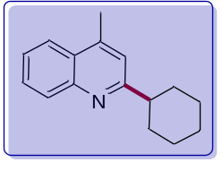
TLC: Rf = 0.4 (95:5 hexane/EtOAc, UV).
GC (Ti= 80 ºC): Rt 8.07 min.
MS: m/z (%) 225 (M⁺, 23), 224 (17), 210 (12), 196 (26), 184 (14), 171 (27), 157 (48).
¹H NMR The spectroscopy data matched what was previously reported in the literature.⁴
¹³C NMR The spectroscopy data matched what was previously reported in the literature.

Alkylation of Quinaldine with Cyclohexane
Following the GMP with 2-methylquinoline (36 µL, 0.25 mmol) and cyclohexane (270 µL, 2.5 mmol, 10 equiv). After purification by FC, the product was obtained as a colorless oil (24.8 mg, 0.11 mmol, 44%) using 0% to 5% EtOAc in n-hexane as the eluent.
4-Cyclohexyl-2-methylquinoline (2):
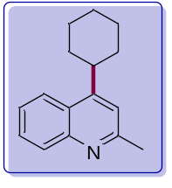
TLC: Rf = 0.27 (9:1 hexane/EtOAc, UV).
GC (Ti= 80 ºC): Rt 8.079 min.
MS: m/z (%) 225 (M⁺, 100), 224 (23), 210 (31), 182 (35), 170 (42), 169 (24), 157 (60).
¹H NMR The spectroscopy data matched what was previously reported in the literature.⁴
¹³C NMR The spectroscopy data matched what was previously reported in the literature.⁴

Alkylation of 4-Phenylquinoline with Cyclohexane
Following the GMP with 4-phenyloquinoline (52 µL, 0.25 mmol) and cyclohexane (270 µL, 2.5 mmol, 10 equiv). After purification by FC, the product was obtained as a colorless oil (30.1 mg, 0.11 mmol, 42%) using from 5% to 10% EtOAc in n-hexane as the eluent.
2-Cyclohexyl-4-phenylquinoline (3):
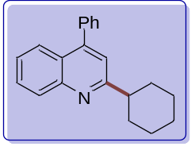
TLC: Rf = 0.46 (9:1 hexane/EtOAc, UV).
GC (Ti= 80 ºC): Rt 10.029 min.
MS: m/z (%) 287 (M⁺, 32), 232 (100), 219 (66), 232 (39), 287 (28), 258 (26), 286 (19).
¹H NMR The spectroscopy data matched with previously reported in the literature.⁴
¹³C NMR The spectroscopy data matched with what was previously reported in the literature.⁴

Alkylation of 2-Phenylquinoline with Cyclohexane
Following the GMP with 2-phenylquinoline (52 mg, 0.30 mmol) and cyclohexane (270 µL, 2.5 mmol, 10 equiv). After purification by FC, the product was obtained as a colorless oil (25.6 mg, 0.09 mmol, 36%) using 0% to 5% EtOAc in n-hexane as the eluent.
4-Cyclohexyl-2-phenylquinoline (4):
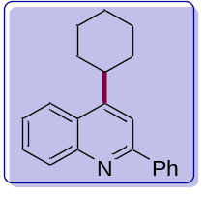
TLC: Rf = 0.51 (9:1 hexane/EtOAc, UV).
GC (Ti= 80 ºC): Rt 10.779 min.
MS: m/z (%) 287 (M⁺,100), 232 (75), 286 (68), 219 (37), 288 (29), 230 (26), 244 (219.
¹H NMR The spectroscopy data matched what was previously reported in the literature.⁴
¹³C NMR The spectroscopy data matched what was previously reported in the literature.⁴

Alkylation of Methyl 2-Quinoline-4-Carboxylate with Cyclohexane
Following the GMP with methyl quinoline-4-carboxylate (46 mg, 0.25 mmol) and cyclohexane (270 µL, 2.5 mmol, 10 equiv). After purification by FC, the product was obtained as a yellow oil (37 mg, 0.14 mmol, 56 %) using 1% to 5% EtOAc in n-hexane as the eluent.
Methyl 2-cyclohexylquinoline-4-carboxylate (5):
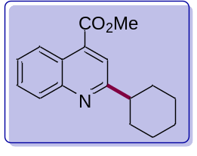
TLC: Rf = 0.56 (95:5 Hexane/EtOAc), UV).
GC (Ti= 80 ºC): 8.9 min.
MS: m/z (%) 214 (M⁺, 100) 202 (61), 210 (37), 215 (27), 254 (21), 240 (20).
¹H NMR The spectroscopy data matched with previously reported in the literature.⁴
¹³C NMR The spectroscopy data matched with previously reported in the literature.⁴

Alkylation of Quinoline with Cyclohexane
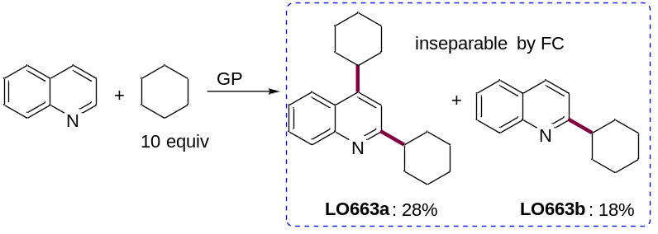
Following the GMP with quinoline (30 µL, 0.25 mmol) and cyclohexane (270 µL, 2.5 mmol, 10 equiv). After purification by FC, products 6a and 6b were obtained as an inseparable mixture (colorless oil, 31 mg, 0.07 mmol (28%) and 0.05 mmol (18%), respectively) using from 0% to 2% EtOAc in n-hexane as the eluent.
2,4-Dicyclohexylquinoline (6a):
TLC: Rf = 0.53 (9:1 hexane/EtOAc, UV).
GC (Ti= 80 ºC): Rt 10.057 min.
MS: m/z (%) 293 (M⁺, 21) 238 (100), 207 (71), 225 (56), 281 (46), 239 (29), 253 (28).
¹H NMR The spectroscopy data matched with previously reported in the literature.⁴
¹³C NMR The spectroscopy data matched with previously reported in the literature.⁴
2-Cyclohexylquinoline (6b):
TLC: Rf = 0.53 (9:1 hexane/EtOAc, UV).
GC (Ti= 80 ºC): Rt 7.530 min.
MS: m/z (%) 211 (M+, 28) 156 (100), 143 (57), 182 (32), 157 (23), 210 (19)
¹H NMR The spectroscopy data matched with previously reported in the literature.⁴
¹³C NMR The spectroscopy data matched with previously reported in the literature.⁴

Alkylation of 3-Methylquinoline with Cyclohexane
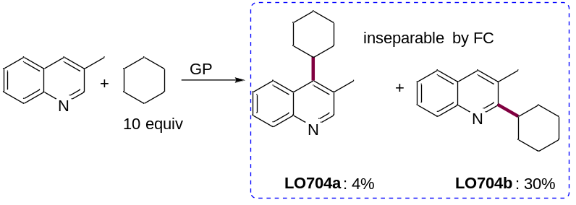
Following the GMP with 3-methylquinoline (36 µL, 0.25 mmol) and cyclohexane (270 µL, 2.5 mmol, 10 equiv). After purification by FC, products 7a and 7b were obtained as an 85:15 inseparable mixture (colorless oil, 19.1 mg, 0.01 mmol (4%) and 0.05 mmol (30%) calculated by ¹H-NMR, respectively) using from 0% to 5% EtOAc in n-hexane as the eluent.
4-Cyclohexyl-3-methylquinoline (7a) and 2-Cyclohexy-3-methyllquinoline (7b)
TLC (a): Rf = 0.67 (9:1 hexane/EtOAc, UV).
GC (a) (Ti= 80 ºC): Rt 7.56 min.
MS (a): m/z (%) 225 (M⁺, 54) 238 (100), 236 (16), 212 (5), 211 (8), 190 (4).
HRMS (a) (EI-TOF): m/z calcd for C₁₆H₁₉N 225.1517, found 225.1502.
TLC (b): Rf = 0.67 (9:1 hexane/EtOAc, UV).
GC (b) (Ti= 80 ºC): Rt 7.73 min.
MS (b): m/z (%) 225 (M+, 21) 210 (12), 196 (15), 171 (25), 170 (100), 157 (50).
¹H NMR (400 MHz, Chloroform-d) δ 8.11 (dd, J = 8.8, 1.1 Hz, 1H), 8.02 (dq, J = 8.4, 0.9 Hz, 1H), 7.99 (d, J = 2.0 Hz, 1H), 7.89 (s, 1H), 7.81 (t, J = 1.0 Hz, 1H), 7.76 (dd, J = 8.8, 2.1 Hz, 1H), 7.68 (dd, J = 8.1, 1.4 Hz, 1H), 7.59 (ddd, J = 8.4, 6.9, 1.5 Hz, 1H), 7.42 (ddd, J = 8.1, 6.9, 1.2 Hz, 1H), 3.01 (tt, J = 10.5, 4.2 Hz, 1H), 2.53 (d, J = 1.0 Hz, 3H), 2.50 (d, J = 1.0 Hz, 3H), 1.96 – 1.89 (m, 3H), 1.89 – 1.83 (m, 3H), 1.82 – 1.76 (m, 2H), 1.46 – 1.40 (m, 2H).
¹³C NMR (101 MHz, Chloroform-d) δ 168.4, 165.9, 146.9, 135.8, 130.1, 129.1, 129.0, 128.2, 127.2, 126.7, 125.6, 42.9, 31.9, 31.9, 26.9, 26.9, 26.3, 19.4.

Alkylation of 6-Bromo-2-methylquinoline with cyclohexane
Following the GMP with 6-bromo-2-methylquinoline (55 mg, 0.25 mmol) and cyclohexane (270 µL, 2.50 mmol, 10 equiv). The product was obtained as a light-yellow oil (40.1 mg, 0.13 mmol, 53%) after FC using a gradient from 0% to 5% of EtOAc in n-hexane as the eluent.
6-bromo-4-cyclohexyl-2-methylquinoline (8):
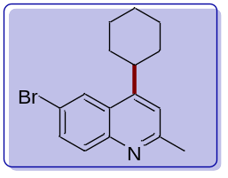
TLC: Rf = 0.41 (9:1 hexane/EtOAc, UV).
GC (Ti= 80 ºC): Rt 8.91 min.
MS: m/z (%) 303 (M⁺, 100), 225 (17), 224 (80), 207 (40), 281 (28), 168 (54), 142 (36).
HRMS (EI-TOF): m/z calcd for C₁₆H₁₈BrN 303.0623, found 303.0616.
¹H NMR (400 MHz, Chloroform-d) δ 8.14 (d, J = 2.2 Hz, 1H), 7.88 (d, J = 8.9 Hz, 1H), 7.71 (dd, J = 8.9, 2.2 Hz, 1H), 7.18 (s, 1H), 3.18 (ddd, J = 11.4, 8.4, 3.1 Hz, 1H), 2.69 (s, 3H), 2.02 – 1.90 (m, 4H), 1.86 (d, J = 12.7 Hz, 1H), 1.59 – 1.48 (m, 4H), 1.40 – 1.29 (m, 1H).
¹³C NMR (101 MHz, Chloroform-d) δ 159.5, 152.7, 146.9, 132.3, 131.4, 126.6, 125.4, 119.5, 119.3, 38.9, 33.7, 26.9, 26.4, 25.6.

Alkylation of 4-Bromoquinoline with cyclohexane
Following the GMP with 4-bromoquinoline (51.5 mg, 0.25 mmol) and cyclohexane (270 µL, 2.50 mmol, 10 equiv). The product was obtained as a light-yellow oil (43.3 mg, 0.15 mmol, 60%) after FC using a gradient from 0% to 5% of EtOAc in n-hexane as the eluent.
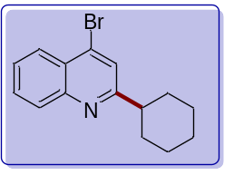
4-bromo-2-cyclohexylquinoline (9):
TLC: Rf = 0.91 (9:1 hexane/EtOAc, UV).
GC (Ti= 80 ºC): Rt 8.48 min.
MS: m/z (%) 290 (M⁺, 16), 236 (96), 235 (23), 234 (100), 223 (52), 210 (56), 142 (23).
¹H NMR (400 MHz, Chloroform-d) δ 8.13 (dd, J = 8.4, 1.4 Hz, 1H), 8.03 (d, J = 8.3 Hz, 1H), 7.71 (ddd, J = 8.4, 6.9, 1.5 Hz, 1H), 7.63 (s, 1H), 7.56 (ddd, J = 8.3, 6.9, 1.2 Hz, 1H), 2.88 (tt, J = 12.0, 3.4 Hz, 1H), 2.07 – 1.96 (m, 2H), 1.94 – 1.86 (m, 2H), 1.82 – 1.75 (m, 1H), 1.61 (qd, J = 12.5, 3.2 Hz, 2H), 1.46 (qt, J = 12.5, 3.2 Hz, 2H), 1.36 – 1.30 (m, 1H).
¹³C NMR (101 MHz, Chloroform-d) δ 166.8, 148.5, 134.2, 130.2, 129.4, 126.9, 126.5, 126.5, 123.7, 47.3, 32.7, 26.4, 26.0.

Alkylation of 6-Bromo-4-methylquinoline with cyclohexane
Following the GMP with 6-bromo-4-methylquinoline (55 mg, 0.25 mmol) and cyclohexane (270 µL, 2.50 mmol, 10 equiv). The product was obtained as a light-yellow oil (43.9 mg, 0.14 mmol, 58%) after FC using a gradient from 0% to 5% of EtOAc in n-hexane as the eluent.
6-bromo-2-cyclohexyl-4-methylquinoline (10):
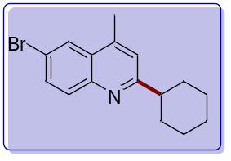
TLC: Rf = 0.56 (9:1 hexane/EtOAc, UV).
GC (Ti= 80 ºC): Rt 9.01 min.
MS: m/z (%) 303 (M⁺, 13), 281 (35), 262 (18), 250 (95), 248 (100), 235 (55).
¹H NMR (400 MHz, Chloroform-d) δ 8.08 (d, J = 2.2 Hz, 1H), 7.90 (d, J = 8.9 Hz, 1H), 7.72 (dd, J = 8.9, 2.2 Hz, 1H), 7.17 (s, 1H), 2.84 (tt, J = 12.5, 3.7 Hz, 1H), 2.64 (d, J = 0.9 Hz, 3H), 1.99 (d, J = 11.4 Hz, 2H), 1.89 (d, J = 12.9 Hz, 2H), 1.79 (d, J = 12.5 Hz, 1H), 1.66 – 1.55 (m, 3H), 1.49 (dt, J = 12.5, 3.3 Hz, 1H), 1.43 (dt, J = 12.5, 3.3 Hz, 1H).
¹³C NMR (101 MHz, Chloroform-d) δ 167.0, 146.3, 143.4, 132.3, 131.3, 128.3, 126.1, 121.1, 119.3, 47.5, 32.7, 26.5, 26.1, 18.8.

Alkylation of 7-Chloro-2-methylquinoline with cyclohexane
Following the GMP with 7-chloro-2-methylquinoline (44 mg, 0.25 mmol) and cyclohexane (270 µL, 2.50 mmol, 10 equiv). The product was obtained as a light-yellow oil (39.4 mg, 0.15 mmol, 61%) after FC using a gradient from 0% to 5% of EtOAc in n-hexane as the eluent.
7-Chloro-4-cyclohexyl-2-methylquinoline (11):
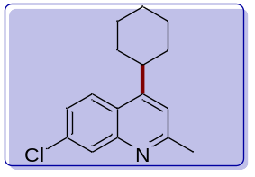
TLC: Rf = 0.31 (9:1 hexane/EtOAc, UV).
GC (Ti= 80 ºC): Rt 8.73 min.
MS: m/z (%) 259 (M⁺, 100), 224 (52), 206 (18), 204 (55), 193 (24), 168 (40).
HRMS (EI-TOF): m/z calcd for C₁₆H₁₈ClN(-CH₃) 244.0893, found 244.0882.
¹H NMR (400 MHz, Chloroform-d) δ 8.01 (d, J = 2.2 Hz, 1H), 7.95 (d, J = 9.0 Hz, 1H), 7.42 (dd, J = 9.0, 2.2 Hz, 1H), 7.15 (s, 1H), 3.22 (tt, J = 11.3, 3.1 Hz, 1H), 2.69 (s, 3H), 2.02 – 1.91 (m, 4H), 1.90 – 1.78 (m, 1H), 1.56 – 1.48 (m, 4H), 1.37 – 1.24 (m, 1H).
¹³C NMR (101 MHz, Chloroform-d) δ 160.3, 153.6, 148.8, 134.7, 128.6, 126.3, 124.4, 123.7, 118.7, 39.0, 33.7, 27.0, 26.4, 25.6.

Alkylation of 2-Methyl-8-nitroquinoline with cyclohexane
Following the GMP with 2-methyl-8-nitroquinoline (47 mg, 0.25 mmol) and cyclohexane (270 µL, 2.50 mmol, 10 equiv). The product was obtained as a light-yellow oil (25.6 mg, 0.09 mmol, 38%) after FC using a gradient from 0% to 5% of EtOAc in n-hexane as the eluent and obtained with an inseparable 10% of 2-methyl-8-nitroquinoline.
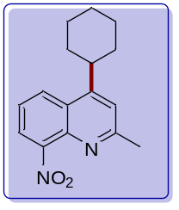
4-cyclohexyl-2-methyl-8-nitroquinoline (12):
TLC: Rf = 0.53 (9:1 hexane/EtOAc, UV).
HRMS (EI-TOF): m/z calcd for C₁₆H₁₈N₂O₂, 270.1368 found 270.1354.
¹H NMR (400 MHz, Chloroform-d) δ 8.20 (dd, J = 8.6, 1.3 Hz, 1H), 7.86 (dd, J = 7.4, 1.3 Hz, 1H), 7.52 (dd, J = 8.6, 7.4 Hz, 1H), 7.27 (s, 1H), 3.25 (d, J = 10.5 Hz, 1H), 2.72 (s, 3H), 2.09 – 1.91 (m, 4H), 1.86 (d, J = 13.6 Hz, 1H), 1.63 – 1.47 (m, 5H).
¹³C NMR (101 MHz, Chloroform-d) δ 161.8, 153.2, 149.1, 139.5, 126.6, 126.3, 123.7, 122.1, 120.0, 39.0, 33.6, 26.8, 26.1, 25.9.

Alkylation of 2,2'-biquinoline with cyclohexane
Following the GMP with 2,2'-biquinoline (64 mg, 0.25 mmol) and cyclohexane (270 µL, 2.50 mmol, 10 equiv). The product was obtained as a light-yellow oil (28.7 mg, 0.09 mmol, 34%) after FC using a gradient from 0% to 5% of EtOAc in n-hexane as the eluent. Traces of 2,2'-biquinoline were obtained after purification with the desired product as an inseparable mixture.
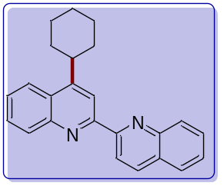
4-cyclohexyl- 2,2'-biquinoline (13):
TLC: Rf = 0.41 (9:1 hexane/EtOAc, UV).
GC (Ti= 80 ºC): Rt 10.01 min.
MS: m/z (%) 338 (M⁺, 79), 337 (94), 283 (100), 270 (34), 268 (9), 207 (59).
HRMS (EI-TOF): m/z calcd for C₂₄H₂₂N₂ 338.1783, found 338.1758.
¹H NMR (300 MHz, Chloroform-d) δ 8.87 (dd, J = 8.6, 3.6 Hz, 1H), 8.77 (s, 1H), 8.39 – 8.29 (m, 2H), 8.29 – 8.22 (m, 1H), 8.20 – 8.12 (m, 1H), 7.91 (dt, J = 8.1, 1.9 Hz, 1H), 7.77 (dddd, J = 9.7, 8.3, 6.8, 1.5 Hz, 2H), 7.60 (dddd, J = 8.9, 5.7, 2.9, 1.7 Hz, 2H), 3.44 (tt, J = 11.8, 3.1 Hz, 1H), 2.15 (d, J = 12.8 Hz, 2H), 2.07 –1.97 (m, 2H), 1.80 (td, J = 12.4, 3.0 Hz, 2H), 1.67 – 1.38 (m, 4H).
¹³C NMR (101 MHz, Chloroform-d) δ 156.7, 155.9, 154.0, 148.3, 147.9, 136.7, 130.9, 130.0, 129.4, 128.9, 128.4, 127.6, 126.9, 126.8, 126.5, 123.1, 119.6, 115.6, 39.4, 33.5, 27.1, 26.4.

Alkylation of Phenanthridine with Cyclohexane
Following the GMP with phenanthridine (45 mg, 0.30 mmol) and cyclohexane (270 µL, 2.5 mmol, 10 equiv). After purification by FC, the product was obtained as a colorless oil (24.5 mg, 0.09 mmol, 38%) using 0% to 5% EtOAc in n-hexane as the eluent.
6-Cyclohexylphenanthridine (14):
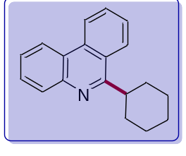
TLC: Rf = 0.72 (97:3 hexane/EtOAc, UV).
GC (Ti= 80 ºC): Rt 9.768 min.
MS: m/z (%) 261 (M⁺,44 ), 206 (100), 260 (68), 193 (44), 207 (33), 217 (17), 104 (16).
¹H NMR The spectroscopy data matched what was previously reported in the literature.⁴
¹³C NMR The spectroscopy data matched what was previously reported in the literature.⁴

Alkylation of Cinchonine with Cyclohexane
Following the GMP with cinchonine (73 mg, 0.30 mmol) and cyclohexane (270 µL, 2.5 mmol, 10 equiv), but using 3 equivalents of TFA (50 µL, 0.75 mmol, 3 equiv). After purification by FC, the product was obtained as a white solid (30 mg, 0.08 mmol, 35%) using a mixture of 70% n-hexane and 30% EtOAc:EtOH:NH₃ (75:25:2 v/v) as the eluent.
(S)-(2-Cyclohexylquinolin-4-yl)((2R,4S,5R)-5-vinylquinuclidin-2-yl)methanol (15)
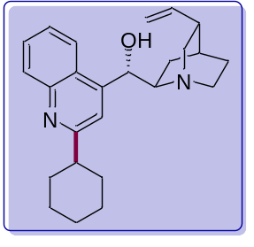
TLC: Rf = 0.3 (7:3 Hexane:(75:25:2, EtOAc/EtOH/NH₃), UV).
[α]_{D}²⁵ + 100.8 (c 1.0, MeOH)
¹H NMR The spectroscopy data matched what was previously reported in the literature.⁴
¹³C NMR The spectroscopy data matched what was previously reported in the literature.⁴

Alkylation of Lepidine with Cyclopentane
Following the GMP with lepidine (36 µL, 0.25 mmol) and cyclopentane (235 µL, 2.5 mmol, 10 equiv) in. After purification by FC, the product was obtained as a colorless oil (34.3 mg, 0.16 mmol, 65%) using 0% to 5% EtOAc in n-hexane as the eluent.
2-Cyclopentyl-4-methylquinoline (16):
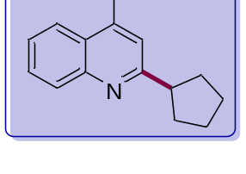TLC: Rf = 0.54 (95:5 hexane/EtOAc, UV).
GC (Ti= 80 ºC): Rt 7.551 min.
MS: m/z (%) 211 (M⁺,46 ), 170 (100), 182 (51), 183 (51), 171 (32), 168 (32), 210 (28), 167 (24).
¹H NMR The spectroscopy data matched what was previously reported in the literature.⁴
¹³C NMR The spectroscopy data matched what was previously reported in the literature.⁴

Alkylation of Lepidine with cyclooctane
Following the GMP with lepidine (36 µL, 0.25 mmol) and cyclooctane (333 µL, 2.5 mmol, 10 equiv). After purification by FC, the product was obtained as a yellow oil (28.5 mg, 0.11 mmol, 45%) using 1% to 5% EtOAc in n-hexane as the eluent.
2-cyclooctyl-4-methylquinoline (17):
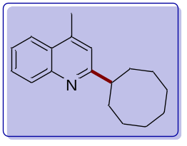
TLC: Rf = 0.46 (9:1 hexane/EtOAc, UV).
GC (Ti= 80 ºC): Rt: 8.96 min
MS: m/z (%) 253 (M⁺, 31), 212 (13), 210 (19), 196 (42), 170 (100), 157 (34).
¹H NMR (400 MHz, Chloroform-d) δ 8.04 (ddd, J = 8.4, 1.2, 0.6 Hz, 1H), 7.93 (dd, J = 8.4, 1.4 Hz, 1H), 7.66 (ddd, J = 8.4, 6.9, 1.4 Hz, 1H), 7.49 (ddd, J = 8.2, 6.8, 1.3 Hz, 1H), 7.12 (d, J = 1.0 Hz, 1H), 3.11 (tt, J = 9.8, 3.5 Hz, 1H), 2.67 (d, J = 1.0 Hz, 3H), 2.02 – 1.94 (m, 2H), 1.91 – 1.85 (m, 3H), 1.77 – 1.68 (m, 4H), 1.67 – 1.60 (m, 5H).
¹³C NMR (101 MHz, Chloroform-d) δ 168.0, 147.5, 144.4, 129.6, 129.0, 127.0, 125.4, 123.7, 120.8, 47.7, 33.7, 26.7, 26.6, 26.3, 18.0.

Alkylation of Lepidine with Cyclododecane
Following the GMP with lepidine (36 µL, 0.25 mmol) and cyclododecane (209.7 mg, 1.25 mmol, 5 equiv). After purification by FC, the product was obtained as a white solid (49.4 mg, 0.16 mmol, 63%) using from 0% to 5% EtOAc in n-hexane as the eluent.

2-Cyclododecyl-4-methylquinoline (18):
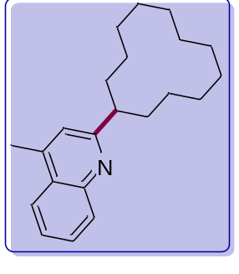TLC: Rf = 0.68 (95:5 hexane/EtOAc, UV).
GC (Ti= 80 ºC): Rt 10.490 min.
MS: m/z (%) 309 (M⁺,30 ), 170 (100), 157 (30), 171 (20), 196 (16), 226 (12).
¹H NMR The spectroscopy data matched what was previously reported in the literature.⁴
¹³C NMR The spectroscopy data matched what was previously reported in the literature.⁴

Alkylation of Lepidine with methylcyclopentane
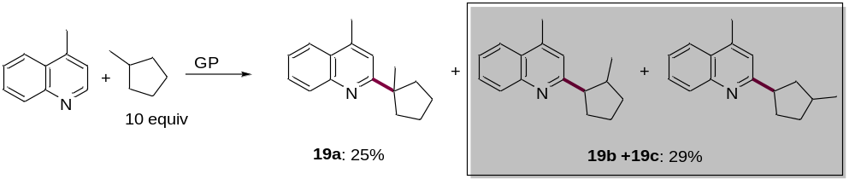
Following the GMP with lepidine (36 µL, 0.25 mmol) and methylcyclopentane (283 µL, 2.5 mmol, 10 equiv). After purification by FC, 19a (14.1 mg, 0.06 mmol, 25%) and 19b+19c (16.3 mg, 0.07 mmol, 29%) were isolated as colorless oils using from 0% to 5% EtOAc in n-hexane as the eluent.
4-Methyl-2-(1-methylcyclopentyl)quinoline (19a):
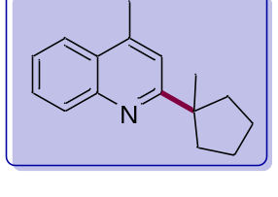TLC Rf = 0.76 (97:3 hexane/EtOAc, UV).
GC (Ti= 80 ºC): Rt 7.568 min.
MS: m/z (%) 225 (M⁺,30 ), 184 (100), 210 (64), 207 (27), 196 (27), 182 (21), 185 (18).
¹H NMR The spectroscopy data matched what was previously reported in the literature.⁴
¹³C NMR The spectroscopy data matched what was previously reported in the literature.⁴

4-Methyl-2-(2-methylcyclopentyl)quinoline+4-Methyl-2-(3-methylcyclopentyl)quinoline (19b+19c):
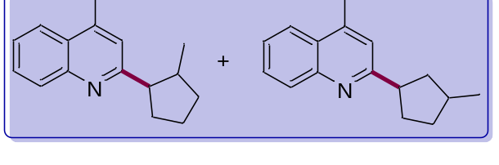TLC Rf = 0.70 (97:3 hexane/EtOAc, UV).
GC 19b (Ti= 80 ºC): Rt 7.584 min.
MS 19b: m/z (%) 225 (M⁺,30 ), 184 (100), 210 (64), 207 (27), 196 (27), 182 (21), 185 (19).
GC 19c (Ti= 80 ºC): Rt 7.568 min.
MS 19c: m/z (%) 225 (M⁺, 30), 184 (100), 210 (64), 207 (27), 196 (27), 182 (21), 185 (19).
¹H NMR The spectroscopy data matched what was previously reported in the literature.1
¹³C NMR The spectroscopy data matched what was previously reported in the literature.1

Alkylation of Lepidine with Bicyclo[2.2.1]heptane
Following the GMP with lepidine (36 µL, 0.25 mmol) and bicyclo[2.2.1]heptane (120 mg, 1.25 mmol, 5 equiv). After purification by FC, the product was obtained as a white solid (22.5 mg, 0.08 mmol, 38%) using from 0% to 2% EtOAc in n-hexane as the eluent.
2-(Bicyclo[2.2.1]heptan-2-yl)-4-methylquinoline (20):
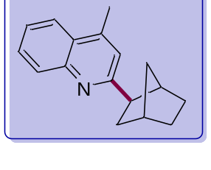TLC: Rf = 0.81 (95:5 hexane/EtOAc, UV).
GC (Ti= 80 ºC): Rt 8.384 min.
MS: m/z (%) 237 (M⁺,12 ), 170 (100), 208 (53), 171 (19), 209 (13).
¹H NMR The spectroscopy data matched what was previously reported in the literature.⁴
¹³C NMR The spectroscopy data matched what was previously reported in the literature.⁴

Alkylation of Lepidine with 1,4-Dioxane
Following the GMP with lepidine (36 µL, 0.25 mmol) and dioxane (215 µL, 2.5 mmol, 10 equiv). After purification by FC, the product was obtained as a colorless oil (21.7 mg, 0.09 mmol, 38%) using from 10% to 20% EtOAc in n-hexane as the eluent.
2-(1,4-dioxan-2-yl)-4-methylquinoline (21):
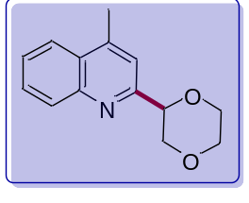
TLC: Rf = 0.18 (9:1 hexane/EtOAc, UV).
GC (Ti= 80 ºC): Rt 8.095 min.
MS: m/z (%) 229 (M⁺, 15), 172 (42), 171 (52), 143 (36), 142 (14), 115 (20).
¹H NMR The spectroscopy data matched what was previously reported in the literature.⁴
¹³C NMR The spectroscopy data matched what was previously reported in the literature.⁴

Alkylation of Lepidine with pivalaldehyde
Following the GMP with lepidine (36 µL, 0.25 mmol) and pivaldehyde (279 µL, 2.5 mmol, 10 equiv). After purification by FC, the product was obtained as a yellow oil (20.3 mg, 0.10 mmol, 41%) using 1% to 5% EtOAc in n-hexane as the eluent.
Synthesis of 2-(tert-butyl)-4-methylquinoline (22):
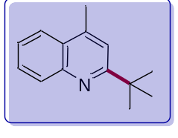
TLC: Rf = 0.6 (9:1 hexane/EtOAc, UV).
GC (Ti= 80 ºC): Rt: 6.1 min
MS: m/z (%) 184 (M⁺, 100), 199 (49) 157 (30) 143 (28) 185 (25) 198 (24), 157 (24) 198 (22).
¹H NMR The spectroscopy data matched what was previously reported in the literature.⁴
¹³C NMR The spectroscopy data matched what was previously reported in the literature.⁴

Alkylation of Lepidine with Adamantane
Following the GMP with lepidine (36 µL, 0.30 mmol) and adamantane (165 mg, 1.25 mmol, 5 equiv). After purification by FC, the product was obtained as a colorless oil (41.5 mg, 0.15 mmol, 60% (C1:C2 95:5)) using from 0% to 5% EtOAc in n-hexane as the eluent.
2-(Adamantan-1-yl)-4-methylquinoline (23):
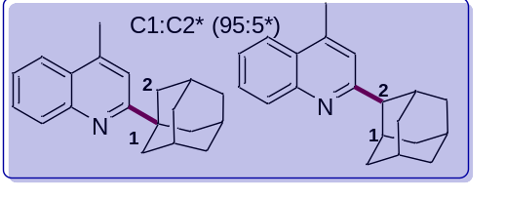TLC: Rf = 0.74 (97:3 hexane/EtOAc, UV).
GC(C1) (Ti= 80 ºC): Rt 9.785 min.
MS(C1): m/z (%) 277 (M⁺, 100), 220 (39), 278 (30), 276 (23), 222 (18), 234 (18).
GC(C2) (Ti= 80 ºC): Rt 9.789 min.
MS(C2): m/z (%) 277 (M⁺, 100), 157 (35), 276 (35), 234 (23), 278 (22), 262 (20).
¹H NMR The spectroscopy data matched what was previously reported in the literature.⁴
¹³C NMR The spectroscopy data matched what was previously reported in the literature.⁴

Alkylation of Lepidine with 1,3-dimethyladamantane
Following the GMP with lepidine (36 µL, 0.25 mmol) and 1,3-dimethyladamantane (205 µL, 1.25 mmol, 5 equiv). After purification by FC, the product was obtained as a yellow oil (36.5 mg, 0.12 mmol, 48%) using 1% to 5% EtOAc in n-hexane as the eluent.
2-(3,5-dimethyladamantan-1-yl)-4-methylquinoline (24):
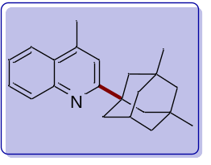
TLC: Rf = 0.73 (9:1 hexane/EtOAc, UV).
GC (Ti= 80 ºC): Rt: 9.57 min
MS: m/z (%) 305 (M⁺, 100), 290 (17) 248 (17) 234 (21) 196 (9) 170 (12), 157(18).
¹H NMR (400 MHz, Chloroform-d) δ 8.07 (ddd, J = 8.4, 1.3, 0.6 Hz, 1H), 7.94 (dd, J = 8.3, 1.0 Hz, 1H)., 7.65 (ddd, J = 8.4, 6.8, 1.4 Hz, 1H), 7.49 (ddd, J = 8.2, 6.8, 1.3 Hz, 1H), 7.32 (d, J = 1.1 Hz, 1H), 2.69 (d, J = 1.0 Hz, 3H), 2.24 (p, J = 3.2 Hz, 1H), 1.95 (dt, J = 3.3, 1.0 Hz, 2H), 1.85 – 1.70 (m, 5H), 1.54 – 1.37 (m, 4H), 1.26 (s, 2H), 0.93 (s, 6H).
¹³C NMR (101 MHz, Chloroform-d) δ 168.40, 147.7, 143.7, 130.1, 128.8, 126.8, 125.5, 123.6, 118.8, 51.1, 48.2, 43.2, 41.6, 40.6, 31.6, 30.9, 30.1, 19.1.
HRMS (EI-TOF): m/z calcd for C₂₂H₂₇ 305.2143, found 305.2135.

Alkylation of Lepidine with isopentyl-adamantane-1-carboxylate
Following the GMP with lepidine (36 µL, 0.25 mmol) and isopentyl-adamantane-1-carboxylate (312 mg, 1.25 mmol, 5 equiv). After purification by FC, the product was obtained as a white solid (47.8 mg, 0.12 mmol, 49%) using 5% to 15% EtOAc in n-hexane as the eluent.
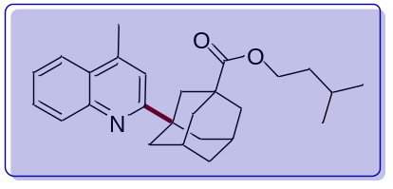
isopentyl-3-(4-methylquinolin-2-yl)adamantane-1-carboxylate (25):
TLC: Rf = 0.64 (9:1 hexane/EtOAc, UV).
GC (Ti= 140 ºC): Rt: 9.302 min
MS: m/z (%) 391 (M⁺, 100), 281 (40) 276 (30) 191(11) 157 (14).
¹H NMR (400 MHz, Chloroform-d) δ 7.98 (dd, J = 8.3, 1.0 Hz, 1H), 7.90 – 7.83 (m, 1H), 7.59 (ddd, J = 8.4, 6.8, 1.4 Hz, 1H), 7.42 (ddd, J = 8.2, 6.8, 1.3 Hz, 1H), 7.24 (d, J = 1.1 Hz, 1H), 4.04 (t, J = 6.8 Hz, 2H), 2.62 (d, J = 0.9 Hz, 3H), 2.21 (p, J = 3.2 Hz, 2H), 2.16 (s, 2H), 2.02 (s, 3H), 1.90 (s, 3H), 1.71 (d, J = 3.4 Hz, 2H), 1.66 – 1.53 (m, 3H), 1.46 (q, J = 6.8 Hz, 2H), 0.85 (d, J = 6.6 Hz, 6H).
¹³C NMR (101 MHz, Chloroform-d) δ 176.6, 166.4, 146.5, 142.8, 128.9, 127.7, 125.7, 124.5, 122.4, 117.3, 61.9, 41.8, 40.7, 39.8, 38.8, 37.2, 36.3, 34.7, 27.6, 24.1, 21.5, 17.9.
HRMS (EI-TOF): m/z calcd 391.2511, found 391.2495.

Amidation of Adamantane
Following the GRP with Adamantane (41 mg, 0.30 mmol). The product was obtained as a white solid (48 mg, 0.25 mmol, 84 %) after FC using a gradient from 60% to 75% of EtOAc in n-hexane as the eluent.
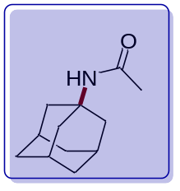
N-(adamantan-1-yl)acetamide (26):
TLC Rf = 0.22 (3:7 hexane/EtOAc, KMnO₄ Stain).
GC (Ti= 50 ºC): Rt 6.451 min.
MS m/z (%) 193 (M⁺, 61), 192 (4), 150 (8), 136 (100), 135 (9), 134 (7).
¹H NMR (400 MHz, Chloroform-d) δ 5.25 (s, 1H), 2.04 (dd, J = 6.3, 3.2 Hz, 3H), 1.96 (d, J = 3.0 Hz, 6H), 1.88 (s, 3H), 1.65 (t, J = 3.0 Hz, 6H).
¹³C NMR (101 MHz, Chloroform-d) δ 169.4, 51.9, 41.7, 36.4, 29.5, 24.8.

Amidation of 1,3-Dimethyladamantane
Following the GRP with 1,3-dimethyladamantane (49.2 mg, 0.30 mmol). The product was obtained as a yellow oil (44.4 mg, 0.20 mmol, 67 %) after FC using a gradient from 60% to 70% of EtOAc in n-hexane as the eluent.
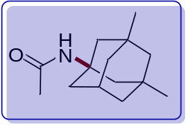
N-(3,5-dimethyladamantan-1-yl)acetamide (27):
TLC Rf = 0.43 (3:7 hexane/EtOAc, KMnO₄ Stain).
GC (Ti= 50 ºC): Rt 8.086 min
MS m/z (%) 221 (M⁺,79), 206 (11), 165 (14), 164 (100), 150 (94), 107 (31), 106 (27).
¹H NMR (400 MHz, Chloroform-d) δ 5.36 (s, 1H), 2.10 (t, J = 3.0 Hz, 1H), 1.87 (s, 3H), 1.80 (s, 2H), 1.67 – 1.55 (m, 4H), 1.34 (d, J = 12.1 Hz, 2H), 1.25 (d, J = 12.1 Hz, 2H), 1.17 – 1.06 (m, 2H), 0.81 (s, 6H).
¹³C NMR (101 MHz, Chloroform-d) δ 169.6, 53.6, 50.7, 47.6, 42.7, 40.2, 32.4, 30.1, 24.7.

Amidation of Isopentyl-adamantane-1-carboxylate
Following the GRP with isopentyl-adamantane-1-carboxylate (75 mg, 0.30 mmol). The product was obtained as a white solid (69.9 mg, 0.23 mmol, 76%) after FC using a gradient from 60% to 70% of EtOAc in n-hexane as the eluent.
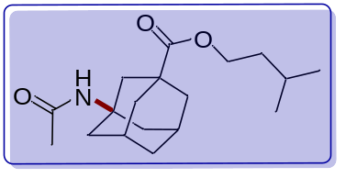
Isopentyl -3-acetamidoadamantane-1-carboxylate (28):
TLC Rf = 0.40 (3:7 hexane/EtOAc, KMnO₄ Stain).
GC (Ti= 50 ºC): Rt 9.076 min
MS m/z (%) 307 (M⁺,50), 264 (16), 238 (64), 192 (100), 191 (47), 150 (51).
HRMS (EI-TOF): m/z calcd for C₁₈H₂₉NO₃ 307.2147, found 307.2143.
¹H NMR (400 MHz, Chloroform-d) δ 6.26 (s, 1H), 4.50 – 3.83 (m, 2H), 2.21 – 2.09 (m, 4H), 2.06 – 1.91 (m, 4H), 1.91– 1.71 (m, 6H), 1.70 – 1.54 (m, 3H), 1.54 – 1.43 (m, 2H), 1.24 (t, J = 7.1 Hz, 1H), 0.88 (d, J = 6.5 Hz, 6H).
¹³C NMR (101 MHz, Chloroform-d) δ 178.7, 172.4, 64.1, 60.8, 52.8, 42.8, 41.3, 40.1, 37.6, 37.1, 35.2, 28.9, 25.1, 22.5.

Amidation of Adamantane with isobutyronitrile
Following the GRP with Adamantane (40.8 mg, 0.30 mmol) and isobutyronitrile as nitrile source. The product was obtained as a yellow oil (19.9 mg, 0.09 mmol, 30%) after FC using a gradient from 20% to 40% of EtOAc in n-hexane as the eluent.
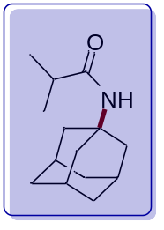
N-(adamantan-1-yl)isobutyramide (29):
TLC Rf = 0.66 (4:6 hexane/EtOAc, KMnO₄ Stain).
GC (Ti= 50 ºC): Rt 6.863 min.
MS m/z (%) 221 (M⁺,25), 164 (22), 136 (13), 135 (100).
HRMS (EI-TOF): m/z calcd for C₁₄H₂₃NO 221.1781, found 221.1778.
¹H NMR (400 MHz, Chloroform-d) δ 5.07 (s, 1H), 2.21 (p, J = 6.9 Hz, 1H), 2.05 (d, J = 11.4 Hz, 3H), 1.99 (d, J = 3.0 Hz, 5H), 1.68 (d, J = 3.0 Hz, 7H), 1.11 (d, J = 6.9 Hz, 6H).
¹³C NMR (101 MHz, Chloroform-d) δ 176.3, 51.5, 4.7, 36.4, 36.4, 29.5, 19.8.

Amidation of Cycloheptane
Following the GRP with Cycloheptane (29.1 mg, 0.30 mmol) and acetonitrile as nitrile source. The product was obtained as a white solid (26.51 mg, 0.17 mmol, 57%) after FC using a gradient from 30% to 40% of EtOAc in n-hexane as the eluent.
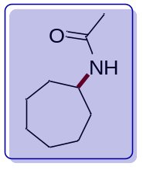
N-cycloheptylacetamide (30):
TLC Rf = 0.32 (4:6 hexane/EtOAc, KMnO₄ Stain).
GC (Ti= 50 ºC): Rt 5.193 min
MS m/z (%) 155 (M⁺,100), 156 (11), 140 (12), 113 (14), 112 (37).
¹H NMR (400 MHz, Chloroform-d) δ 5.48 (s, 1H), 3.94 (dt, J = 8.6, 4.3 Hz, 1H), 1.96 (s, 3H), 1.91 (dd, J = 10.2, 5.3 Hz, 2H), 1.66 – 1.57 (m, 4H), 1.49 (dt, J = 8.9, 5.1 Hz, 6H).
¹³C NMR (101 MHz, Chloroform-d) δ 169.41, 50.74, 35.25, 28.20, 24.15, 23.72.

Amidation of Cyclooctane
Following the GRP with Cyclooctane (34 mg, 0.30 mmol). The product was obtained as a white solid (30.4 mg, 0.18 mmol, 60%) after FC using a gradient from 60% to 70% of EtOAc in n-hexane as the eluent.
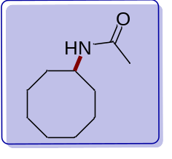
N-cyclooctylacetamide (31):
TLC Rf = 0.55 (3:7 hexane/EtOAc, KMnO₄ Stain).
GC (Ti= 50 ºC): Rt 9.458 min
MS m/z (%) 169 (M⁺,19), 110 (18), 98 (38), 67 (17), 60 (86), 56 (100).
¹H NMR (400 MHz, Chloroform-d) δ 5.89 (d, J = 7.9 Hz, 1H), 3.96 (s, 1H), 1.98 (s, 3H), 1.80 (d, J = 15.3 Hz, 2H), 1.69 – 1.43 (m, 12H).
¹³C NMR (101 MHz, Chloroform-d) δ 170.5, 50.0, 31.8, 27.4, 25.4, 23.6, 23.5.

Amidation of Indane
Following the GRP with Indane (35.4 mg, 0.30 mmol). The product was obtained as a yellow oil (23.1 mg, 0.13 mmol, 44%) after FC using a gradient from 20% to 40% of EtOAc in n-hexane as the eluent.
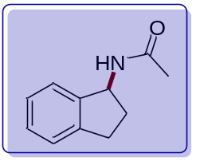
N-(2,3-dihydro-1H-inden-1-yl)acetamide (32):
TLC Rf = 0.45 (3:7 hexane/EtOAc, KMnO₄ Stain).
GC (Ti= 50 ºC): Rt 6.298 min
MS m/z (%) 175 (M⁺,8), 132 (42), 130 (10), 117 (27), 116 (100), 115 (32).
¹H NMR (400 MHz, Chloroform-d) δ 7.36 – 7.26 (m, 3H), 7.22 (dd, J = 7.4, 4.0 Hz, 1H), 6.07 (d, J = 8.4 Hz, 1H), 5.54 (q, J = 7.7 Hz, 1H), 2.99 (ddd, J = 16.0, 8.7, 3.9 Hz, 1H), 2.84 (dt, J = 16.0, 8.1 Hz, 1H), 2.60 (dtd, J = 12.1, 7.8, 4.0 Hz, 1H), 2.14 (s, 3H), 1.84 (dq, J = 12.9, 8.0 Hz, 1H).
¹³C NMR (101 MHz, Chloroform-d) δ 171.7, 143.6, 142.6, 128.3, 126.9, 124.9, 124.2, 55.3, 33.8, 30.3, 23.5.

Copies of NMRs for new compounds
¹H NMR (400 MHz, CDCl₃) 7a + 7b
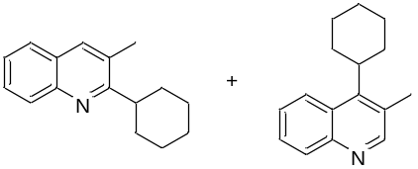
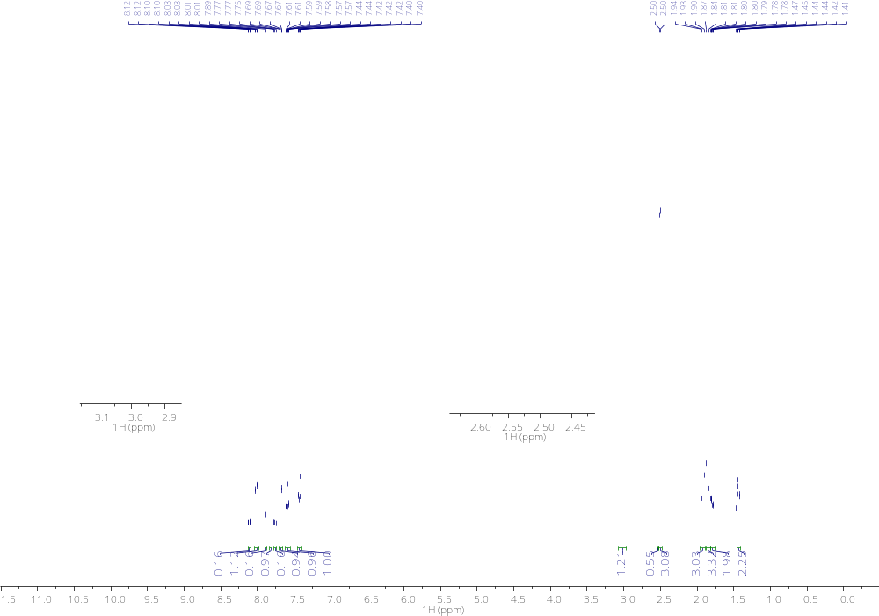
¹³C NMR(101MHz,CDCl₃) 7a + 7b
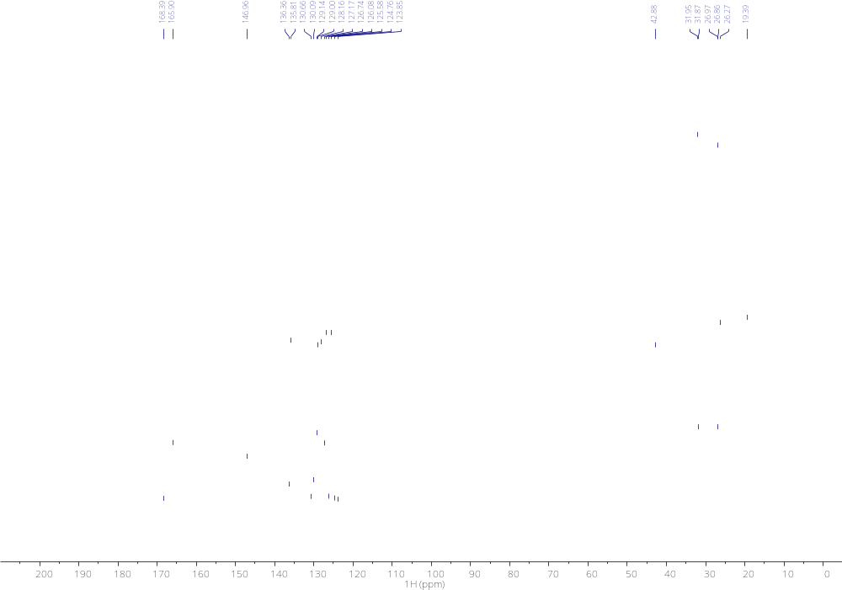

¹H NMR (400 MHz, CDCl₃) 8
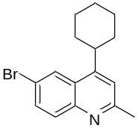
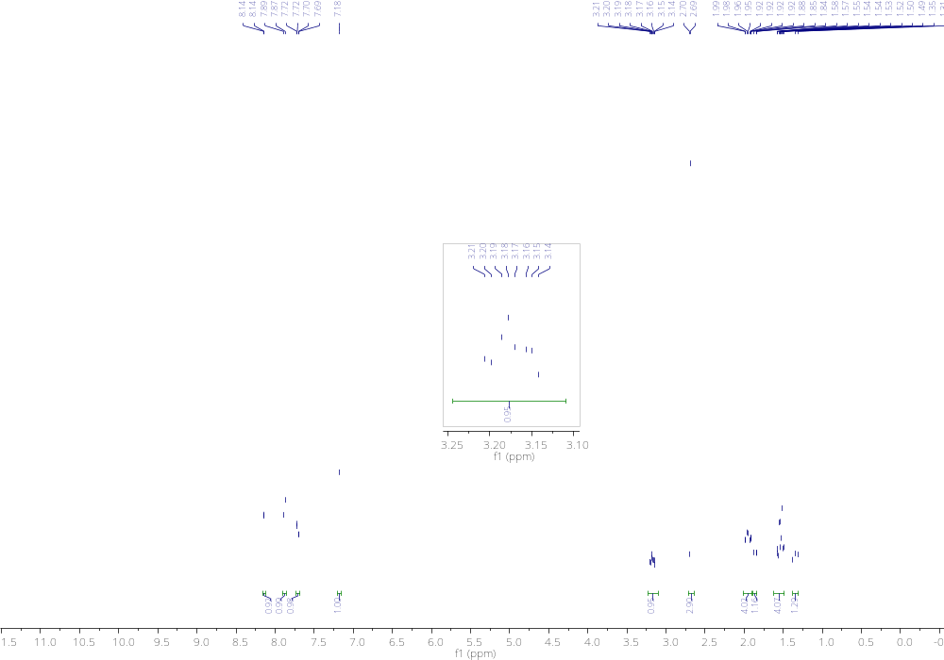
¹³C NMR(101MHz,CDCl₃) 8

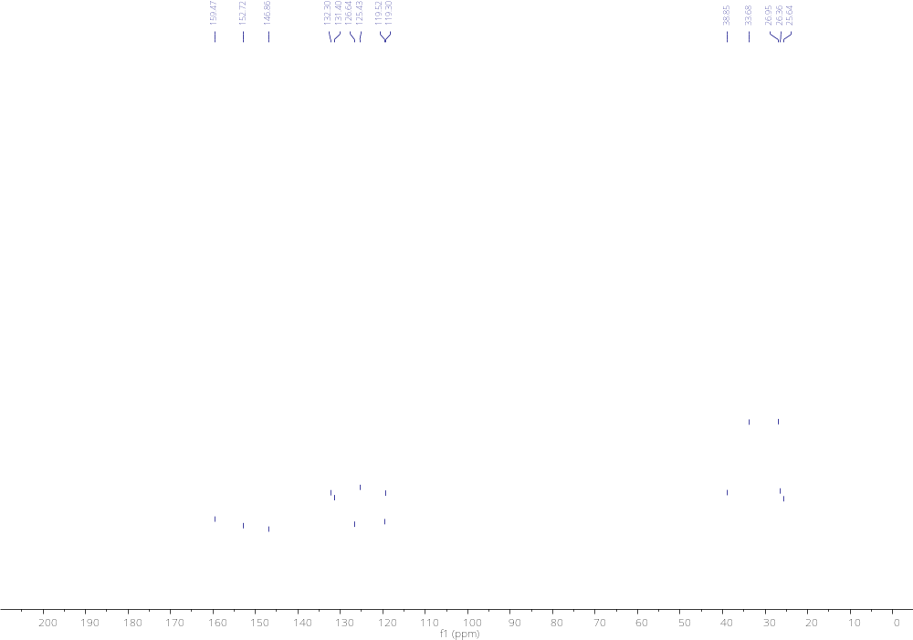
¹HNMR (400 MHz, CDCl₃) 9
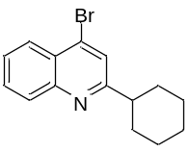
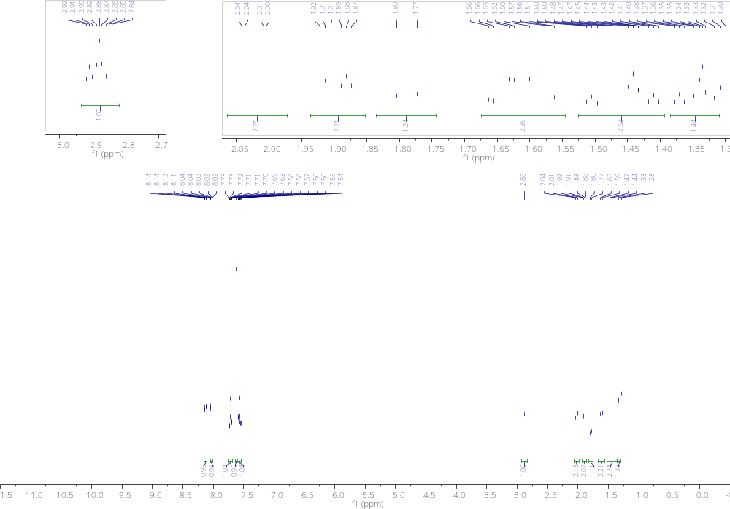
¹³C NMR(101MHz,CDCl₃) 9
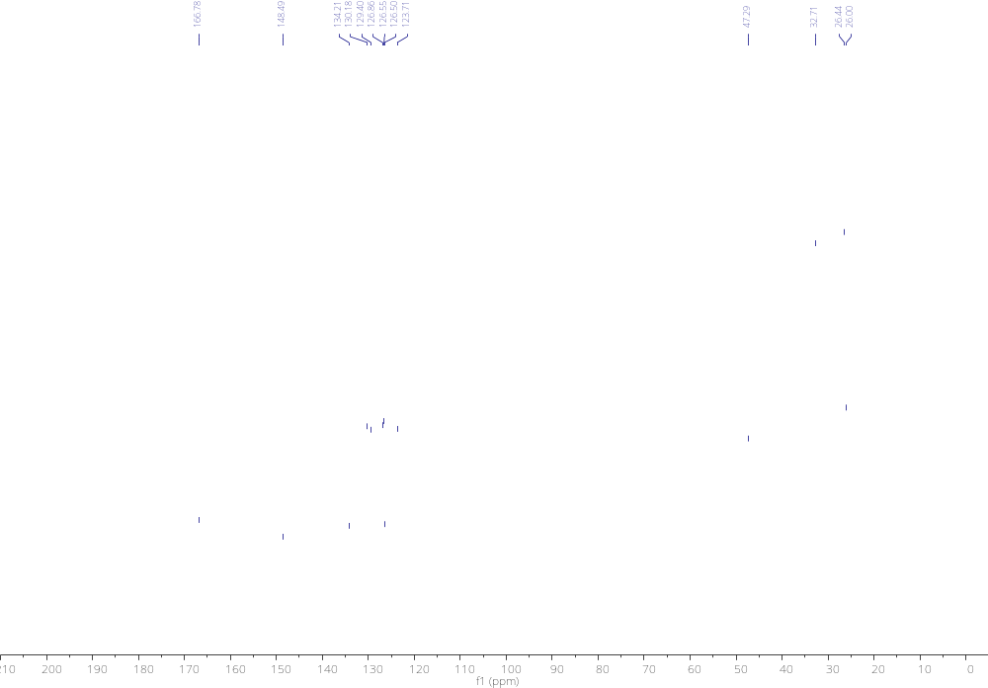
¹H NMR (400 MHz, CDCl₃) 10
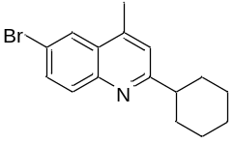
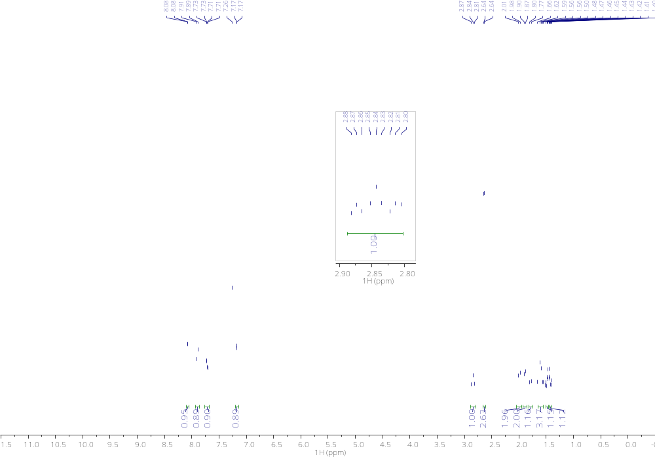
¹³C NMR(101MHz,CDCl₃) 10
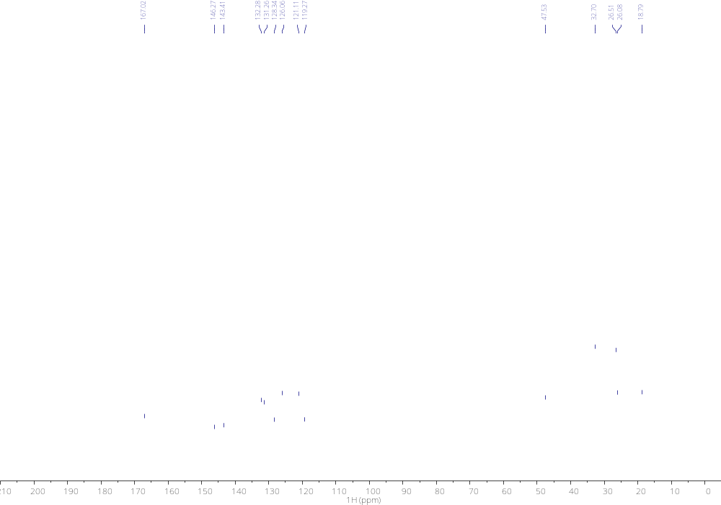

¹H NMR (400 MHz, CDCl₃) 11 (a cleaner spectra could not be obtained)
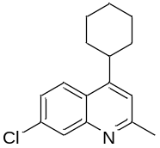
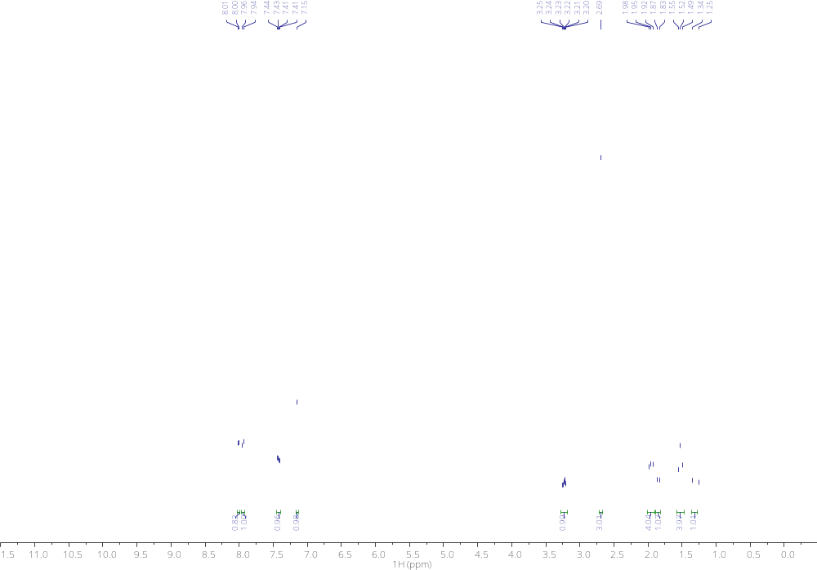
¹³C NMR(101MHz,CDCl₃) 11
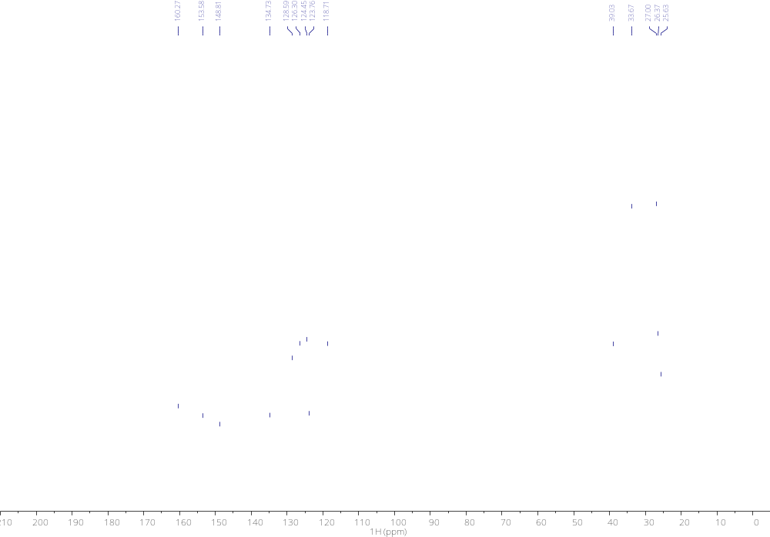

¹H NMR (400 MHz, CDCl₃) 12 (obtained with an inseparable 10% of 2-methyl-8-nitroquinoline)
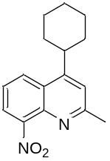
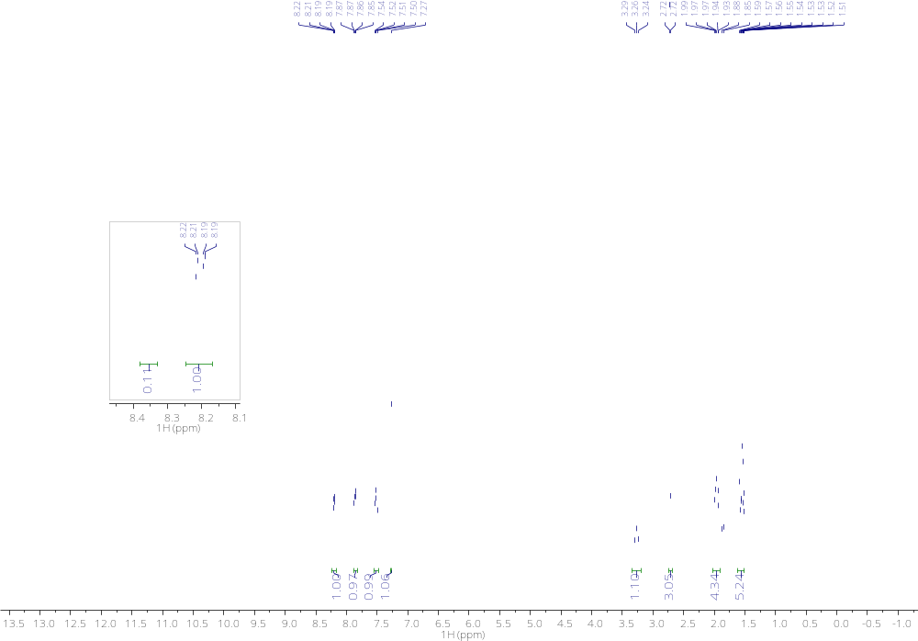
¹³C NMR(101MHz,CDCl₃) 12
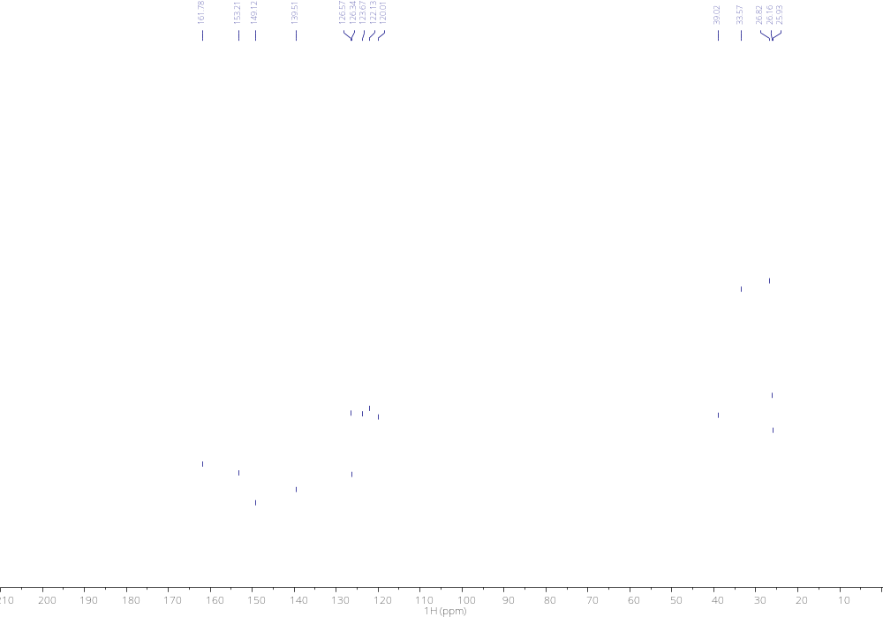
¹H NMR (400 MHz, CDCl₃) 13
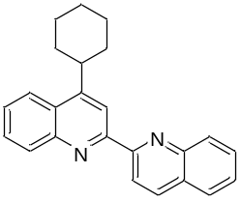
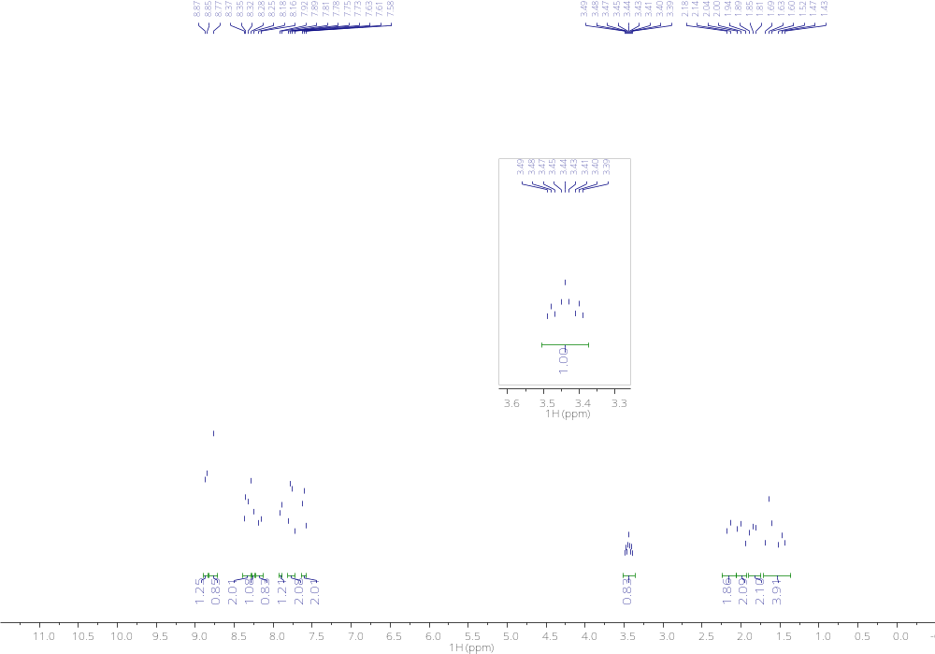
¹³C NMR(101MHz,CDCl₃) 13
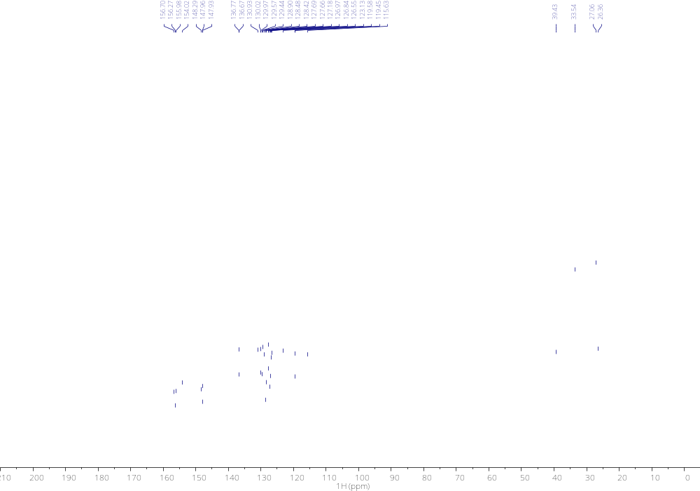
¹H NMR (400 MHz, CDCl₃) 17
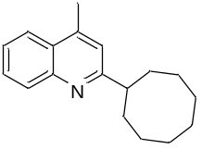
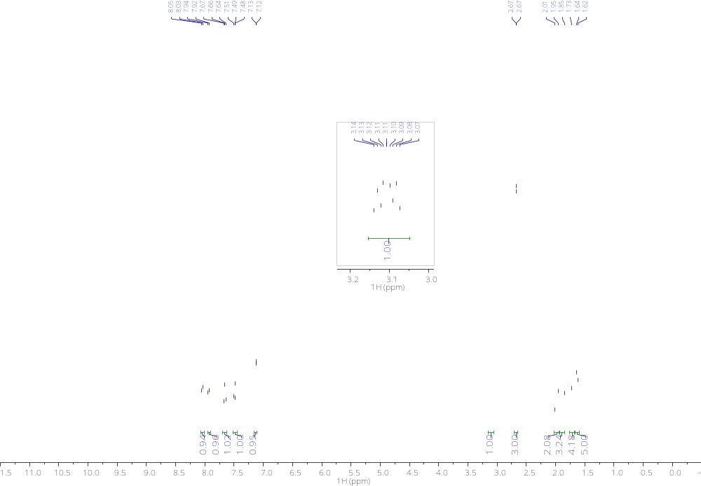

¹³C NMR(101MHz,CDCl₃) 17
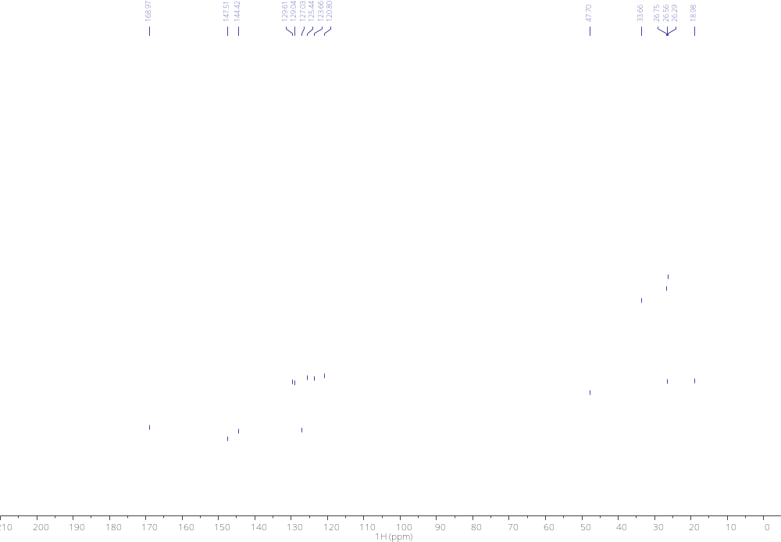
¹H NMR (400 MHz, CDCl₃) 24
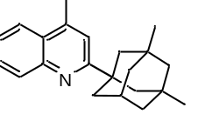
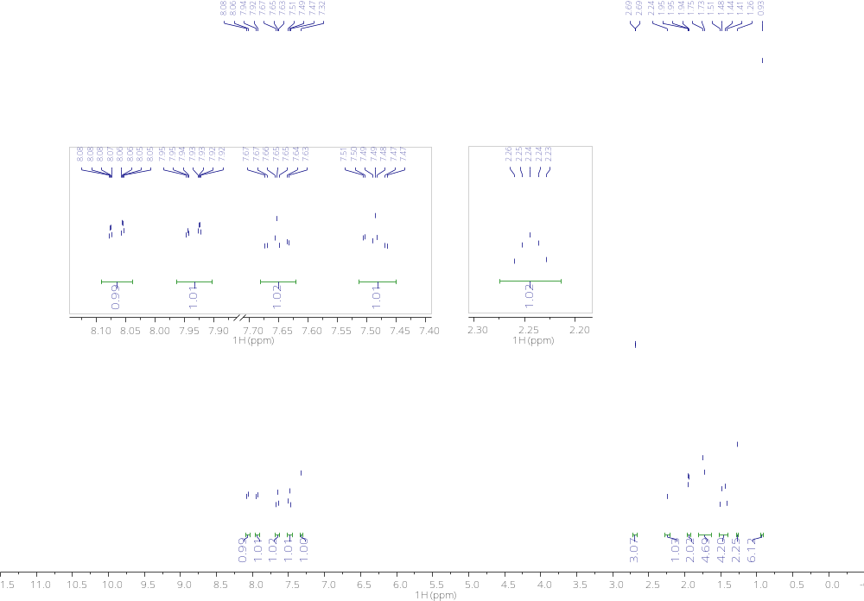

¹³C NMR(101MHz,CDCl₃) 24
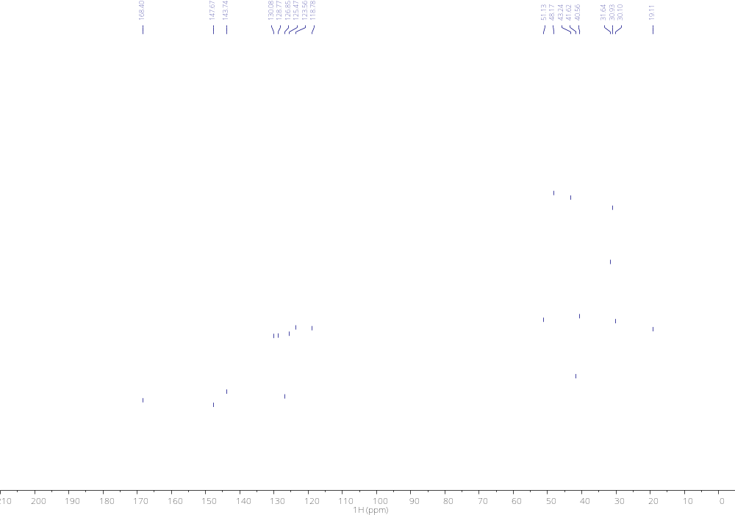
¹H NMR (400 MHz, CDCl₃) 25
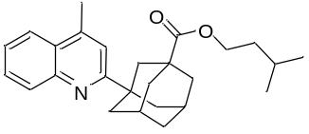
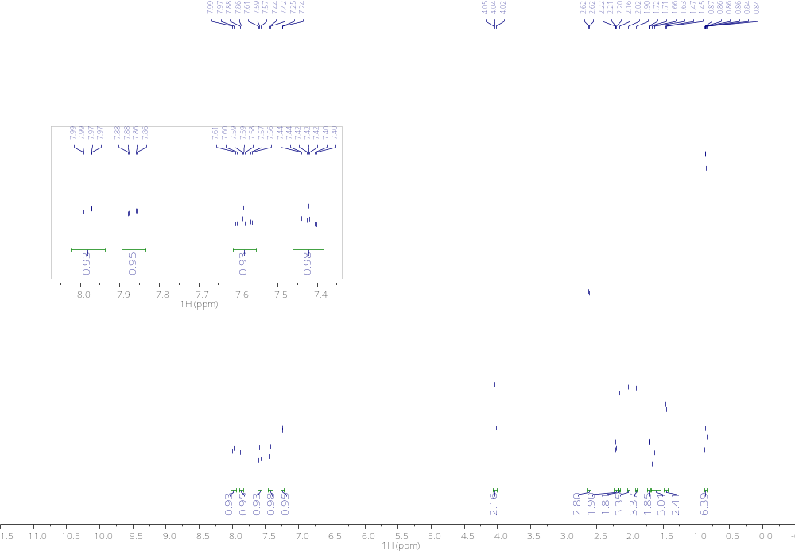

¹³C NMR(101MHz,CDCl₃) 25
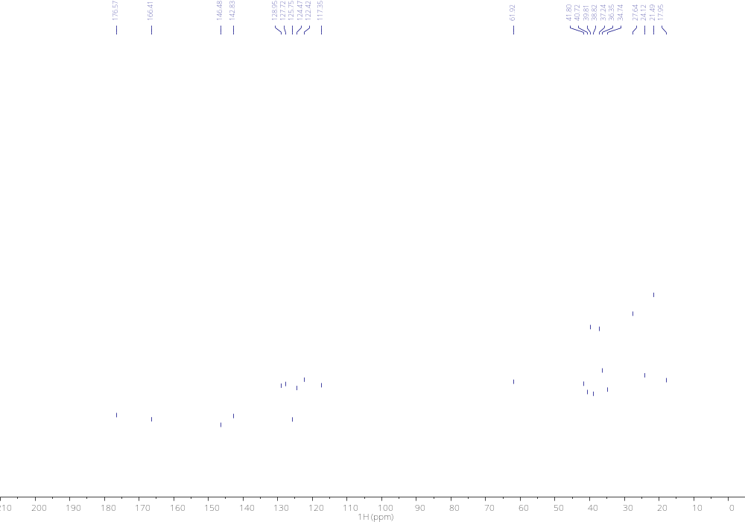
¹H NMR (400 MHz, CDCl₃) 26
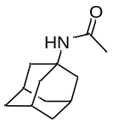
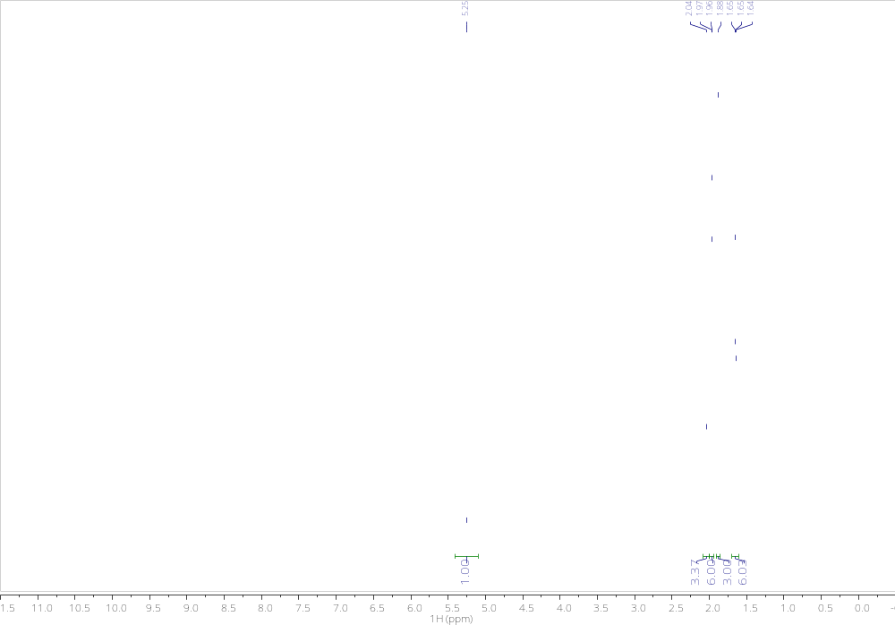

¹³C NMR(101MHz,CDCl₃) 26
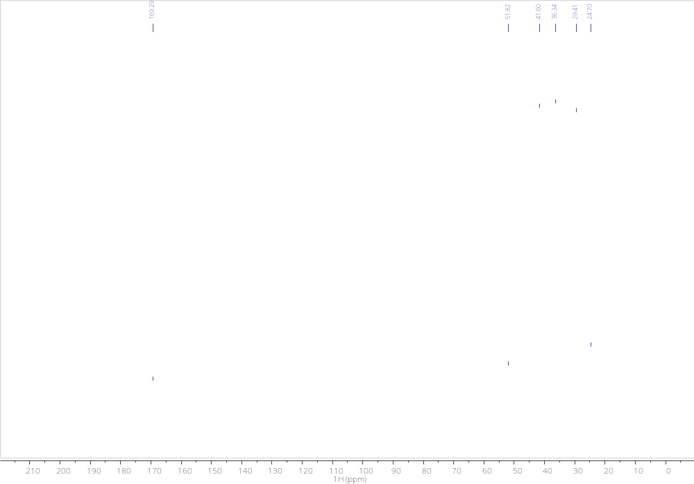
¹H NMR (400 MHz, CDCl₃) 27
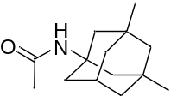
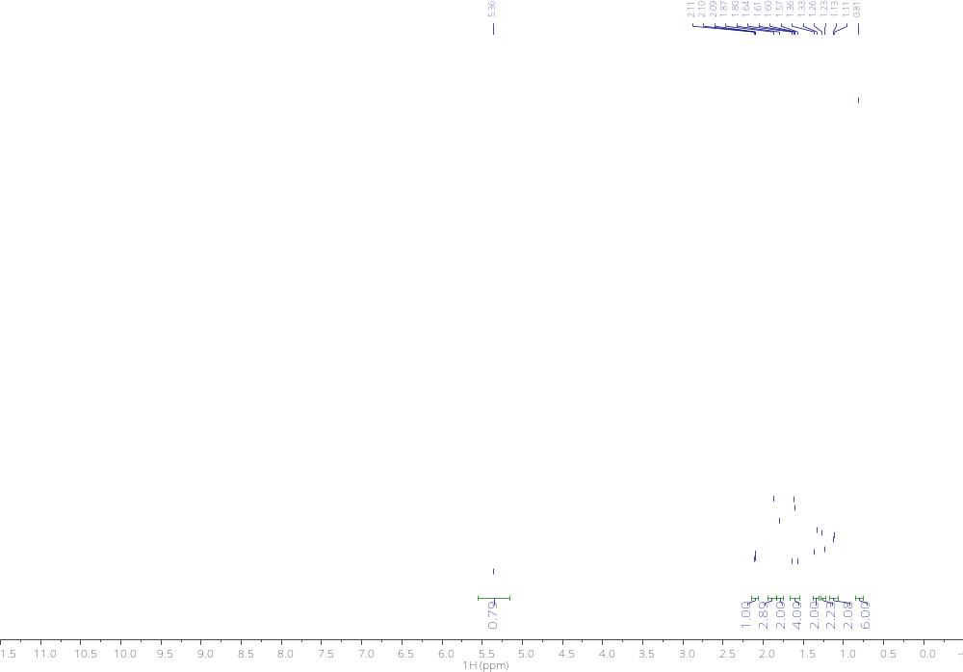
¹³C NMR(101MHz,CDCl₃) 27
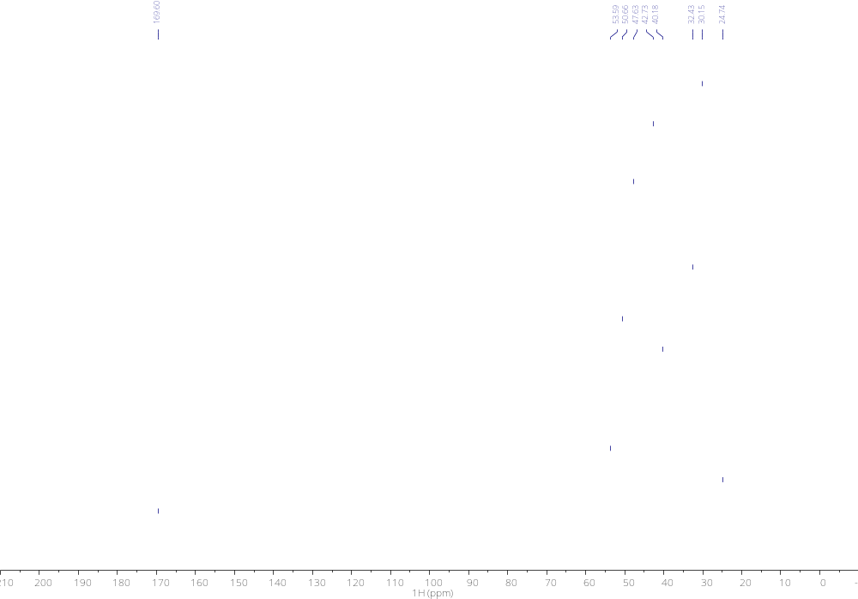
¹H NMR (400 MHz, CDCl₃) 28

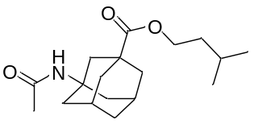
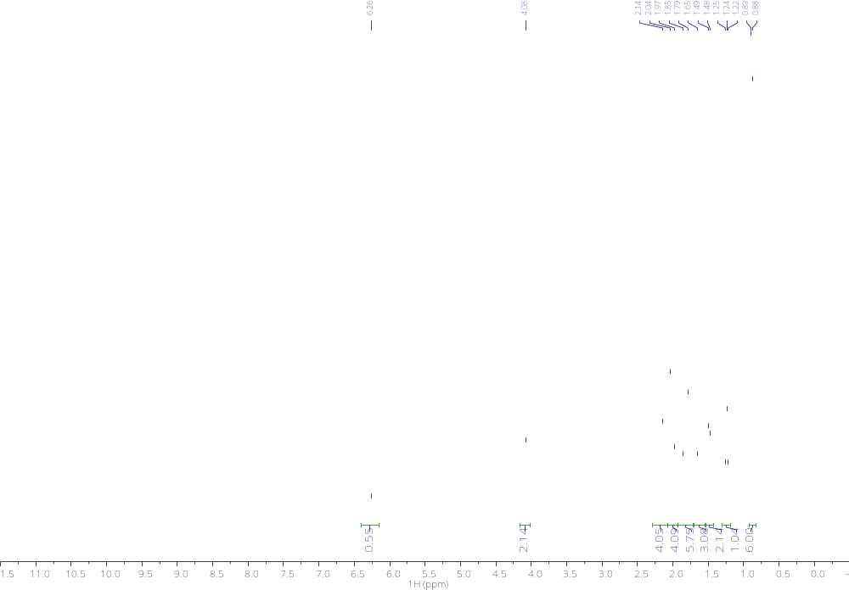
¹³C NMR(101MHz,CDCl₃) 28
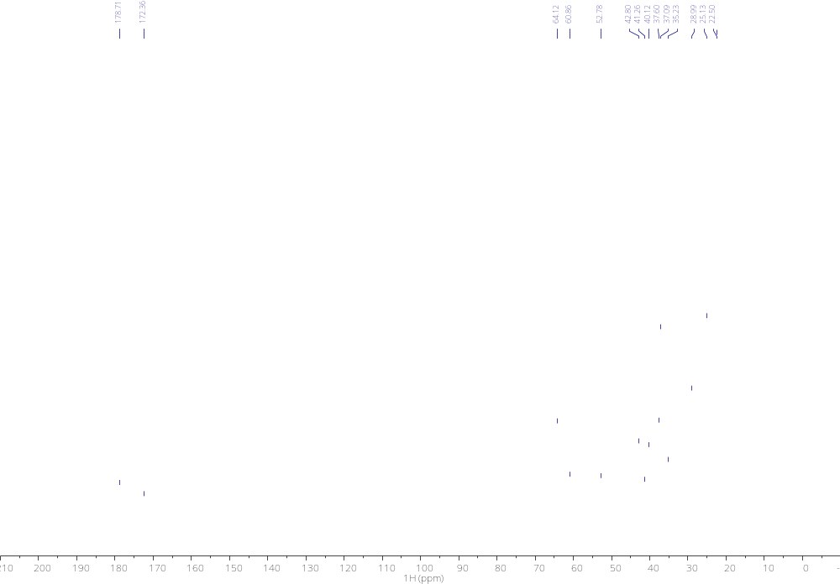
¹H NMR (400 MHz, CDCl₃) 29 (a cleaner spectra could not be obtained)
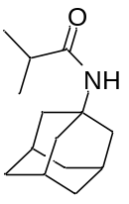
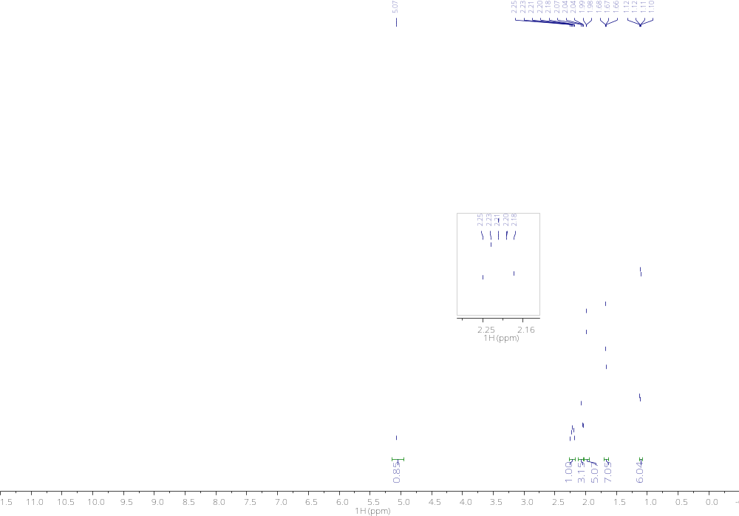
¹³C NMR(101MHz,CDCl₃) 29
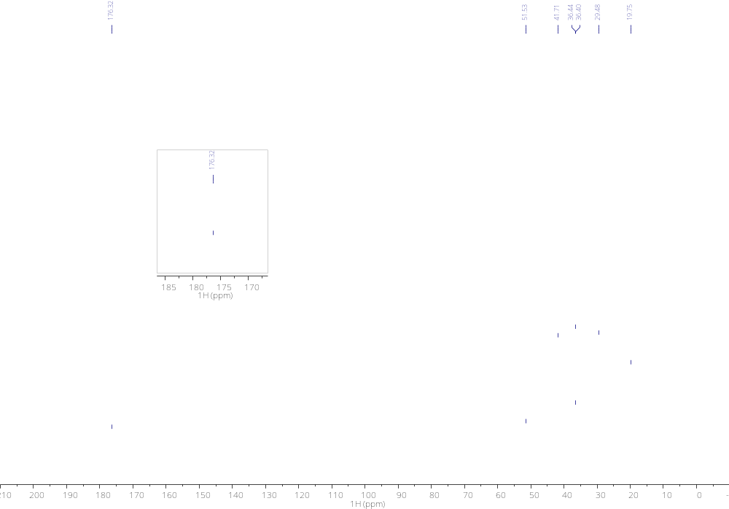
¹H NMR (400 MHz, CDCl₃) 30

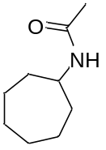
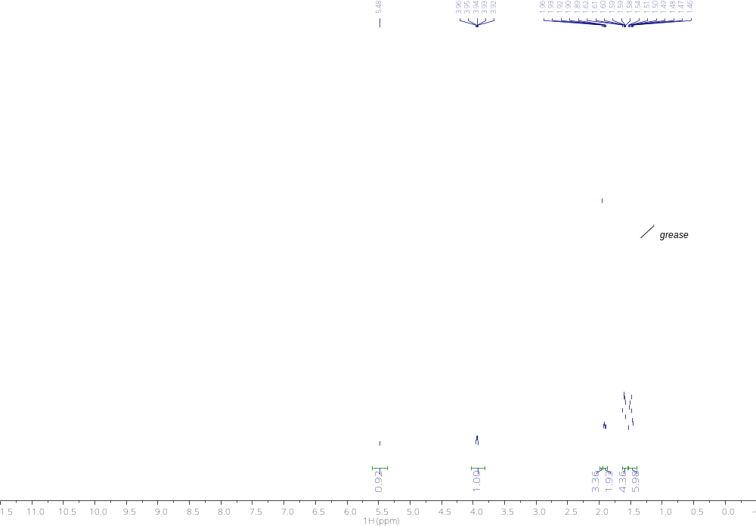
¹³C NMR(101MHz,CDCl₃) 30
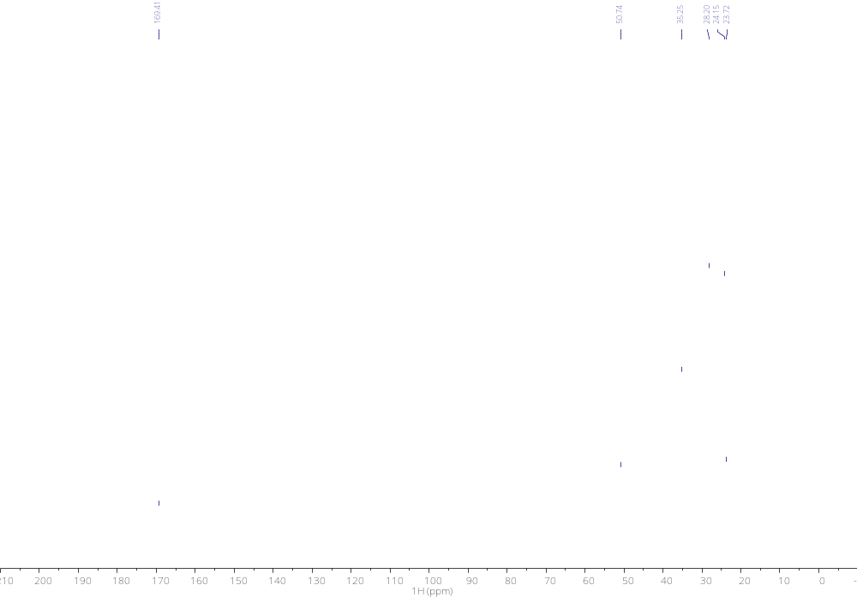
¹H NMR (400 MHz, CDCl₃) 31
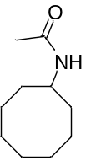
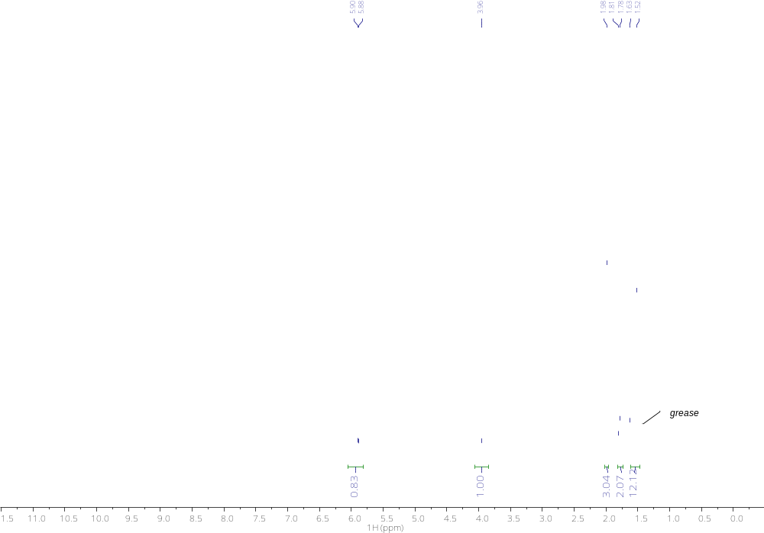
¹³C NMR(101MHz,CDCl₃) 31
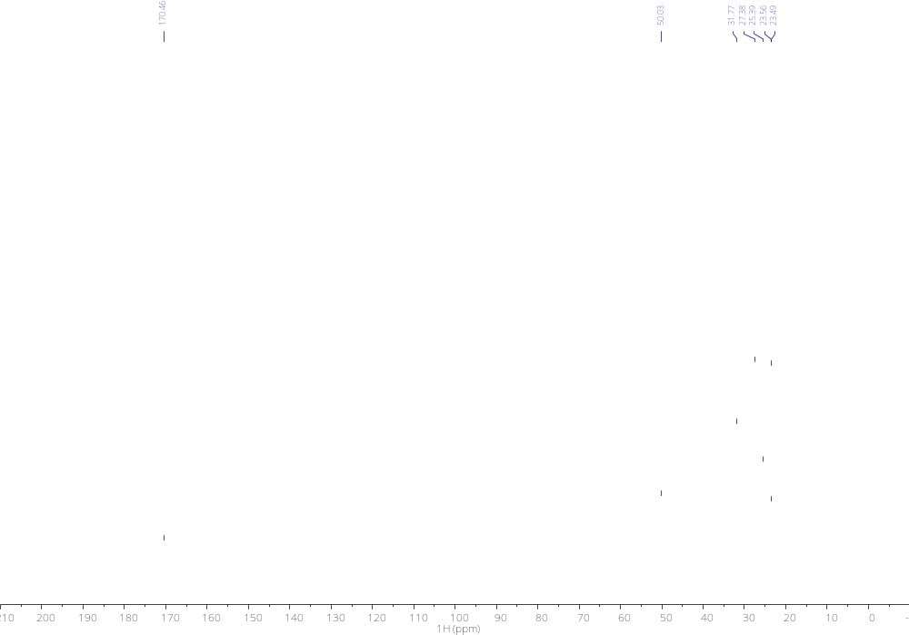
¹H NMR (400 MHz, CDCl₃) 32
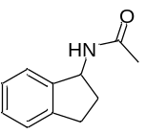
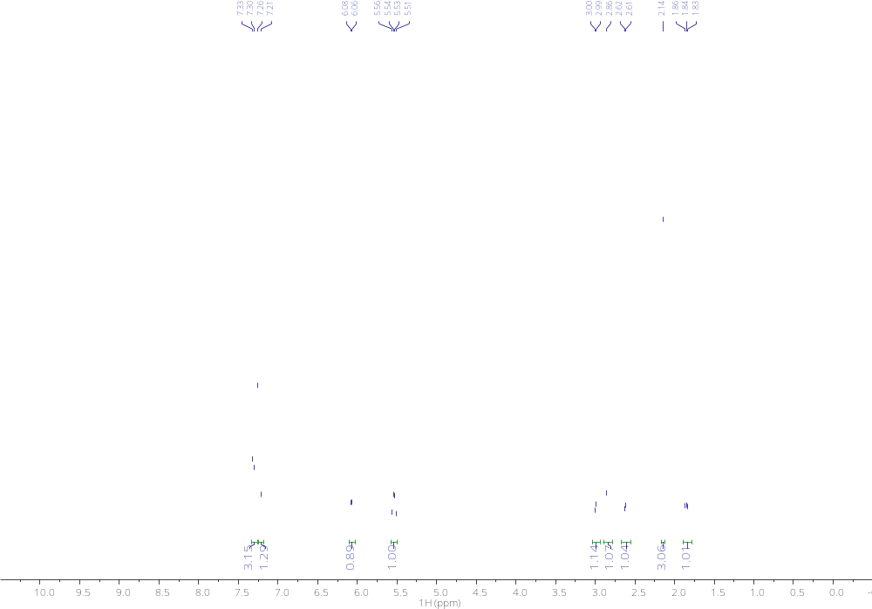

¹³C NMR(101MHz,CDCl₃) 32
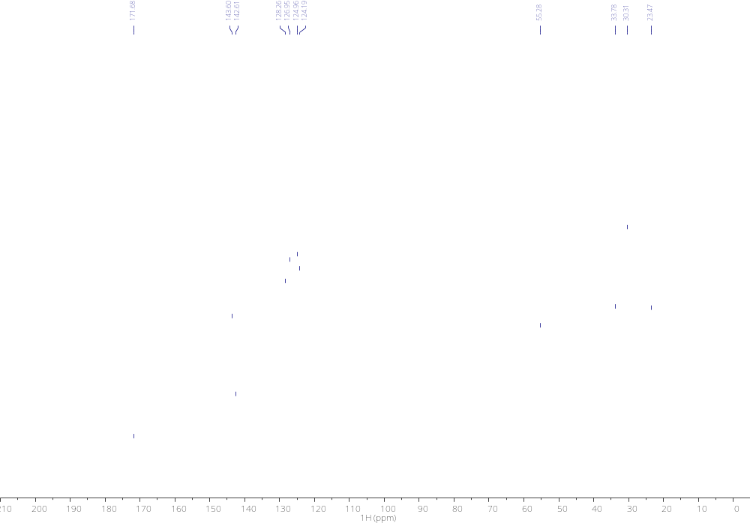

References

Schlengel, M.; Qian, S.; Nicewicz, D. A. ACS Catal. 2022, 12, 10499.
Chatterjee, A.; König, B. Angew. Chem. Int. Ed. 2019, 58, 14289.
Ali, M. A.; Hamdy, H. H.; Ibrahim, H. A. B. ACS Omega 2022 7, 34127.
Laze, L.; Quevedo-Flores, B.; Bosque, I.; Gonzalez-Gomez, J.-C. Org. Lett. 2023 25, 8541.

