Supplementary Information for:

Changes in daily precipitation extremes over the Fiji Islands (1905-2021)
Fernández-Duque, B.^{1,*}, Kumar, R.², El Kenawy, A.^{1,3}, Vicente-Serrano, S.M.¹

¹Instituto Pirenaico de Ecología, Consejo Superior de Investigaciones Científicas (IPE–CSIC), Zaragoza, Spain.

²Fiji Meteorological Service, Suva (Fiji).
³ Department of Geography, Mansoura University, Mansoura, 35516, Egypt.

*Corresponding author
Instituto Pirenaico de Ecología (Consejo Superior de Investigaciones Científicas). Avda. Montañana, Nº1005, 50059 Zaragoza, Spain
Phone: +34 976 369 393 ext. 880037
e-mail: bfernandez@ipe.csic.es

Table S1. Mean daily precipitation values for the period 1905-2021
1905-2021 | bio13 (mm) | bio14 (mm) | bio15 | bio16 (mm) | bio17 (mm) | cdd (days) | cwd (days) | d50mm (days) | d95p (days) | dd (days) | dr1mm (days) | dr3mm (days) | gsr (mm) | ngsr (mm) | pci | prcptot (mm) | r10mm (days) | r20mm (days) | r95tot (%) | r99tot (%) | rti (mm) | rx1day (mm) | rx5d (mm)
Lautoka | 498 | 12 | 96 | 1006 | 118 | 35 | 8 | 9 | 18 | 267 | 99 | 77 | 614 | 1539 | 16 | 1887 | 47 | 29 | 30 | 9 | 1895 | 154 | 295
Rarawai | 586 | 12 | 98 | 1206 | 118 | 35 | 9 | 11 | 18 | 261 | 104 | 85 | 655 | 1831 | 16 | 2188 | 53 | 34 | 28 | 9 | 2194 | 164 | 333

Table S2. Mean daily precipitation values for the period 1960-2021
1960-2021 | bio13 (mm) | bio14 (mm) | bio15 | bio16 (mm) | bio17 (mm) | cdd (days) | cwd (days) | d50mm (days) | d95p (days) | dd (days) | dr1mm (days) | dr3mm (days) | gsr (mm) | ngsr (mm) | pci | prcptot (mm) | r10mm (days) | r20mm (days) | r95tot (%) | r99tot (%) | rti (mm) | rx1day (mm) | rx5d (mm)
Rotuma | 561 | 109 | 48 | 1223 | 534 | 10 | 14 | 15 | 18 | 153 | 212 | 164 | 1844 | 2274 | 10 | 3474 | 94 | 54 | 30 | 10 | 3493 | 155 | 292
Yasawa | 409 | 18 | 89 | 843 | 132 | 32 | 10 | 8 | 18 | 260 | 105 | 78 | 669 | 1357 | 15 | 1711 | 45 | 27 | 31 | 10 | 1722 | 127 | 235
Nadi | 518 | 11 | 98 | 1040 | 120 | 36 | 9 | 9 | 18 | 261 | 104 | 81 | 599 | 1574 | 16 | 1907 | 49 | 30 | 31 | 10 | 1919 | 149 | 298
Lautoka | 545 | 14 | 100 | 1068 | 119 | 36 | 10 | 9 | 18 | 263 | 102 | 79 | 618 | 1607 | 16 | 1951 | 48 | 30 | 31 | 10 | 1961 | 163 | 335
Rarawai | 627 | 12 | 104 | 1248 | 109 | 35 | 9 | 11 | 18 | 261 | 104 | 84 | 658 | 1890 | 17 | 2237 | 54 | 35 | 29 | 9 | 2244 | 170 | 360
Penang | 647 | 18 | 97 | 1253 | 137 | 26 | 10 | 12 | 18 | 239 | 127 | 94 | 807 | 1980 | 16 | 2400 | 55 | 34 | 35 | 12 | 2414 | 204 | 388
Dobuilevu | 611 | 28 | 82 | 1244 | 197 | 21 | 12 | 13 | 18 | 219 | 146 | 112 | 991 | 2107 | 14 | 2635 | 65 | 40 | 31 | 10 | 2641 | 182 | 356
Koronivia | 580 | 63 | 62 | 1251 | 360 | 13 | 13 | 14 | 18 | 174 | 191 | 140 | 1465 | 2205 | 12 | 3056 | 75 | 44 | 35 | 12 | 3077 | 180 | 327
Nausori | 558 | 61 | 62 | 1201 | 344 | 13 | 13 | 14 | 18 | 178 | 188 | 135 | 1415 | 2143 | 11 | 2955 | 73 | 42 | 36 | 12 | 2977 | 176 | 309
Laucala | 573 | 68 | 63 | 1210 | 350 | 13 | 13 | 14 | 18 | 179 | 186 | 136 | 1485 | 2139 | 12 | 2998 | 75 | 43 | 36 | 12 | 3023 | 182 | 313
Nacocolevu | 418 | 19 | 81 | 856 | 162 | 27 | 10 | 7 | 18 | 251 | 115 | 88 | 674 | 1395 | 14 | 1808 | 51 | 29 | 27 | 8 | 1816 | 113 | 226
Vunisea | 431 | 43 | 66 | 918 | 266 | 16 | 11 | 9 | 18 | 213 | 153 | 109 | 1087 | 1561 | 12 | 2208 | 57 | 32 | 34 | 12 | 2227 | 143 | 249
Nabouwalu | 518 | 40 | 74 | 1054 | 234 | 17 | 12 | 10 | 18 | 204 | 161 | 116 | 1024 | 1845 | 13 | 2411 | 64 | 37 | 33 | 11 | 2431 | 145 | 266
Seaqaqa | 632 | 19 | 95 | 1292 | 121 | 30 | 13 | 11 | 18 | 232 | 133 | 107 | 753 | 2080 | 15 | 2446 | 64 | 39 | 28 | 9 | 2454 | 153 | 323
Labasa | 585 | 15 | 95 | 1200 | 122 | 29 | 12 | 10 | 18 | 237 | 128 | 99 | 703 | 1905 | 16 | 2258 | 61 | 37 | 28 | 9 | 2266 | 146 | 308
Udu-Point | 537 | 42 | 73 | 1058 | 241 | 17 | 12 | 11 | 18 | 209 | 156 | 114 | 1071 | 1941 | 13 | 2535 | 63 | 38 | 34 | 12 | 2554 | 168 | 312
Savusavu | 477 | 37 | 70 | 927 | 241 | 18 | 11 | 9 | 18 | 215 | 150 | 114 | 1027 | 1619 | 12 | 2235 | 62 | 34 | 29 | 9 | 2243 | 137 | 263
Matei | 538 | 45 | 69 | 1086 | 273 | 15 | 12 | 11 | 18 | 195 | 170 | 124 | 1188 | 1983 | 12 | 2665 | 67 | 39 | 35 | 12 | 2683 | 169 | 304
Matuku | 403 | 28 | 74 | 820 | 203 | 19 | 9 | 8 | 18 | 232 | 133 | 92 | 916 | 1331 | 13 | 1884 | 47 | 27 | 36 | 13 | 1901 | 158 | 252
Lakeba | 422 | 26 | 76 | 863 | 186 | 20 | 9 | 8 | 18 | 235 | 131 | 92 | 832 | 1446 | 13 | 1929 | 49 | 28 | 36 | 12 | 1947 | 145 | 238
Ono-I-Lau | 375 | 24 | 78 | 744 | 179 | 20 | 8 | 7 | 18 | 251 | 114 | 77 | 808 | 1163 | 13 | 1674 | 41 | 24 | 37 | 13 | 1689 | 152 | 246

Table S3. Trends for the daily precipitation indices over the Fiji Islands for the period 1905-2021 (units expressed per decade).
Station | bio13 (mm) | bio14 (mm) | bio15 | bio16 (mm) | bio17 (mm) | cdd (days) | cwd (days) | d50mm (days) | d95p (days) | dd (days) | dr1mm (days) | dr3mm (days) | gsr (mm) | ngsr (mm) | pci | prcptot (mm) | r10mm (days) | r20mm (days) | r95tot (%) | r99tot (%) | rti (mm) | rx1day (mm) | rx5d (mm)
Lautoka | 13.72** | 0.00 | 1.50* | 19.00* | -1.30 | 0.00 | 0.26** | 0.00 | 0.00 | -0.98 | 1.00 | 0.71 | 0.04 | 23.03 | 0.21 | 15.56** | 0.24 | 0.00 | 0.40 | 0.00 | 15.88 | 2.68* | 9.04**
Rarawai | 13.14** | 0.00 | 1.61** | 15.84** | -4.02** | 0.12 | 0.10 | 0.00 | 0.00 | -0.25 | 0.20 | 0.00 | 0.54 | 24.94** | 0.22 | 14.97** | 0.16 | 0.13 | 0.51 | 0.00 | 15.61 | 2.32 | 9.82**
*statistically significant values at 95% confidence (p-values < 0.05 ), ** statistically significant values at 99% confidence (p-values < 0.01)
Table S4. Trends for the daily precipitation indices over the Fiji Islands for the period 1960-2021 (units expressed per decade)
Station | bio13 (mm) | bio14 (mm) | bio15 | bio16 (mm) | bio17 (mm) | cdd (days) | cwd (days) | d50mm (days) | d95p (days) | dd (days) | dr1mm (days) | dr3mm (days) | gsr (mm) | ngsr (mm) | pci | prcptot (mm) | r10mm (days) | r20mm (days) | r95tot (%) | r99tot (%) | rti (mm) | rx1day (mm) | rx5d (mm)
Rotuma | 1.47 | 0.60 | 0.61 | 9.13 | -10.02 | 0.00 | 0.42** | 0.00 | 0.00 | 1.67 | -1.67 | -0.61 | 3.13 | 15.98 | 0.04 | 4.06 | -0.18 | -0.21 | 0.79 | 0.71 | 4.02 | 3.38 | 5.72
Yasawa | 4.18 | -0.56 | 1.24 | -7.09 | -4.96 | 0.56 | 0.37 | 0.00 | 0.17 | -0.26 | 0.00 | 0.00 | -11.43 | 1.18 | 0.17 | -5.65 | -0.42 | 0.00 | -0.75 | 0.00 | -6.94 | -3.38 | -2.00
Nadi | 8.65 | -0.81 | 1.66 | 16.41 | -0.73 | 0.31 | 0.28 | 0.00 | 0.71 | 0.77 | -0.77 | -0.20 | 5.32 | 44.22 | 0.23 | 29.36 | 0.00 | 0.67 | 0.73 | 0.00 | 28.74 | 0.73 | 1.92
Lautoka | 4.85 | -0.84 | 0.94 | 9.15 | -2.35 | 0.48 | -0.25 | 0.00 | 0.50 | 1.18 | -1.21 | -0.48 | 10.32 | 6.32 | 0.14 | 8.00 | 0.00 | 0.27 | 0.10 | 0.00 | 8.80 | 0.98 | -0.82
Rarawai | 2.47 | 0.00 | -0.25 | 1.87 | -3.35 | 0.18 | 0.29 | 0.00 | 0.00 | -1.90 | 1.89 | 1.25 | 8.21 | 10.29 | -0.04 | -6.62 | 0.34 | 0.00 | -0.55 | 0.00 | -6.58 | -2.00 | 2.78
Penang | -7.39 | -0.57 | 1.29 | -11.07 | -6.38 | 0.25 | 0.53 | -0.23 | -0.26 | -1.74 | 1.67 | 0.37 | 2.71 | -12.40 | 0.18 | -31.66 | 0.00 | 0.00 | -0.82 | 0.00 | -30.42 | 0.49 | -9.63
Dobuilevu | 8.27 | -0.71 | 0.85 | 12.10 | 8.88 | 0.71 | 0.00 | 0.00 | 0.27 | -2.42 | 2.46 | 2.05 | 26.57 | -0.41 | 0.10 | 26.41 | 1.11 | 0.63 | -0.56 | 0.30 | 25.08 | 2.85 | 1.11
Koronivia | -7.68 | 2.61 | 0.04 | 2.43 | -3.14 | 0.00 | -0.43 | 0.00 | 0.00 | -1.54 | 1.47 | -0.21 | 0.74 | 11.48 | 0.00 | -6.71 | 0.47 | 0.56 | -0.55 | 0.23 | -4.44 | -4.38 | -1.25
Nausori | 3.24 | 1.78 | 0.08 | 10.36 | -0.80 | 0.42 | -0.42* | 0.00 | 0.23 | 0.50 | -0.40 | 0.00 | 11.62 | 29.72 | 0.01 | 25.72 | 0.71 | 0.26 | 0.17 | 0.78 | 27.10 | 4.80 | 5.45
Laucala | -0.67 | 2.07 | 0.03 | -3.62 | -4.50 | 0.00 | 0.00 | 0.00 | 0.00 | -0.83 | 0.81 | 1.14 | 1.52 | 32.45 | 0.00 | 18.99 | 0.32 | 0.34 | -0.19 | -0.34 | 19.17 | -3.36 | -5.38
Nacocolevu | -4.11 | -1.56* | -0.04 | -18.97 | -2.27 | 0.36 | 0.00 | 0.00 | -0.38 | -1.08 | 0.95 | 1.15 | -4.09 | -27.36 | -0.01 | -28.87 | 0.00 | 0.00 | -0.86 | 0.00 | -28.21 | -1.86 | -1.92
Vunisea | 3.74 | 0.83 | 0.84 | 7.96 | -4.31 | 0.00 | 0.00 | 0.00 | 0.00 | -1.33 | 1.32 | 0.30 | 10.33 | 29.53 | 0.07 | 13.26 | 0.48 | 0.00 | -0.18 | -0.16 | 13.84 | -0.98 | 0.92
Nabouwalu | 9.52 | 1.50 | 1.68 | 5.14 | -7.95 | 0.00 | 0.32 | 0.00 | 0.00 | -0.34 | 0.20 | 1.52 | -5.09 | 15.05 | 0.17 | 1.08 | 0.00 | 0.00 | 0.04 | -0.29 | 0.92 | -1.13 | 1.89
Seaqaqa | -8.19 | 0.00 | -0.18 | -23.83 | -3.08 | -0.71 | 0.00 | -0.36 | -0.56 | -0.98 | 0.73 | 0.80 | -17.37 | -15.77 | -0.02 | -36.37 | 0.91 | 0.00 | -1.17 | -0.59 | -36.45 | -3.29 | -9.44
Labasa | 3.79 | -0.89 | 1.60* | -0.36 | -5.11 | 0.56 | 0.00 | 0.00 | -0.21 | 2.63 | -2.69 | -1.76 | -11.83 | -23.99 | 0.22* | -31.04 | -0.83 | -0.67 | 0.59 | 0.00 | -33.52 | -0.18 | -3.09
Udu-Point | 17.36 | 0.79 | 0.54 | 19.21 | 1.08 | 0.00 | 0.00 | 0.00 | 0.00 | -1.54 | 1.54 | 1.09 | 31.89 | 26.21 | 0.05 | 52.15 | 1.43 | 0.77 | 0.20 | 0.15 | 50.12 | 4.56 | 3.91
Savusavu | -15.28* | -1.79 | 0.42 | -34.28 | -18.88** | 0.00 | 0.00 | -0.75* | -1.11* | 0.30 | -0.43 | 0.00 | -33.60 | -57.83 | 0.05 | -84.10** | -1.06** | -1.32** | -2.00* | -1.02* | -84.76** | -9.72** | -16.57**
Matei | -2.32 | -1.77 | 0.26 | -19.03 | -4.55 | 0.00 | 0.42* | -0.52 | -0.91* | 0.59 | -0.53 | -0.45 | 0.82 | -49.02 | 0.02 | -61.30 | -1.11 | -1.16 | -0.54 | -0.14 | -60.04 | -3.06 | -4.55

Table S4. (Cont.)

Station | bio13 (mm) | bio14 (mm) | bio15 | bio16 (mm) | bio17 (mm) | cdd (days) | cwd (days) | d50mm (days) | d95p (days) | dd (days) | dr1mm (days) | dr3mm (days) | gsr (mm) | ngsr (mm) | pci | prcptot (mm) | r10mm (days) | r20mm (days) | r95tot (%) | r99tot (%) | rti (mm) | rx1day (mm) | rx5d (mm)
Matuku | 9.41 | 0.93 | 0.40 | 31.41 | -1.43 | 0.00 | 0.00 | 0.30 | 0.40 | -0.61 | 0.59 | 1.38 | 20.92 | 39.74 | 0.04 | 44.08 | 1.36 | 0.78 | 0.45 | 0.00 | 41.52 | 1.42 | 7.10
Lakeba | 8.50 | 0.25 | 1.03 | 6.67 | 1.15 | 0.29 | 0.00 | 0.00 | 0.00 | -0.43 | 0.40 | 0.29 | 5.05 | -0.99 | 0.12 | 14.18 | 0.50 | 0.00 | 0.18 | 0.04 | 14.42 | 0.36 | 6.70
Ono-I-Lau | 5.03 | 1.29 | -0.06 | 14.73 | 0.93 | -1.15** | 0.00 | 0.29 | 0.37 | -0.77 | 0.75 | 0.38 | 10.86 | 1.29 | -0.01 | 24.12 | 0.53 | 0.30 | 0.57 | 0.00 | 23.72 | -1.78 | 3.93
*statistically significant values at 95% confidence (p-values < 0.05), ** statistically significant values at 99% confidence (p-values < 0.01)

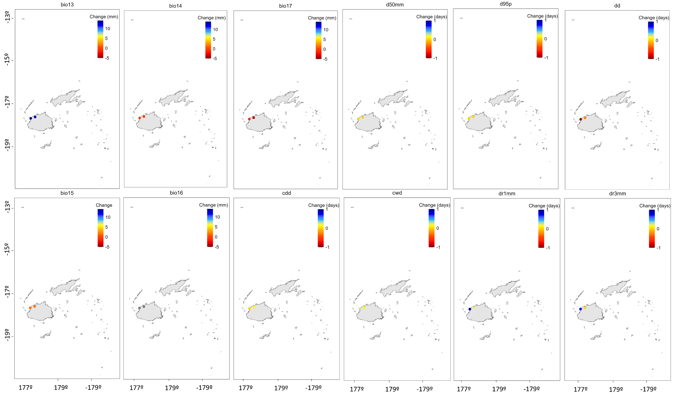
Figure S1. Trend daily precipitation changes for the period 1905-2021
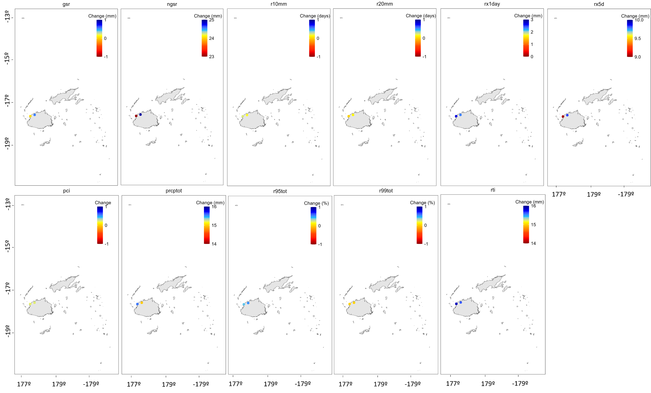
Figure S1. (Cont.)

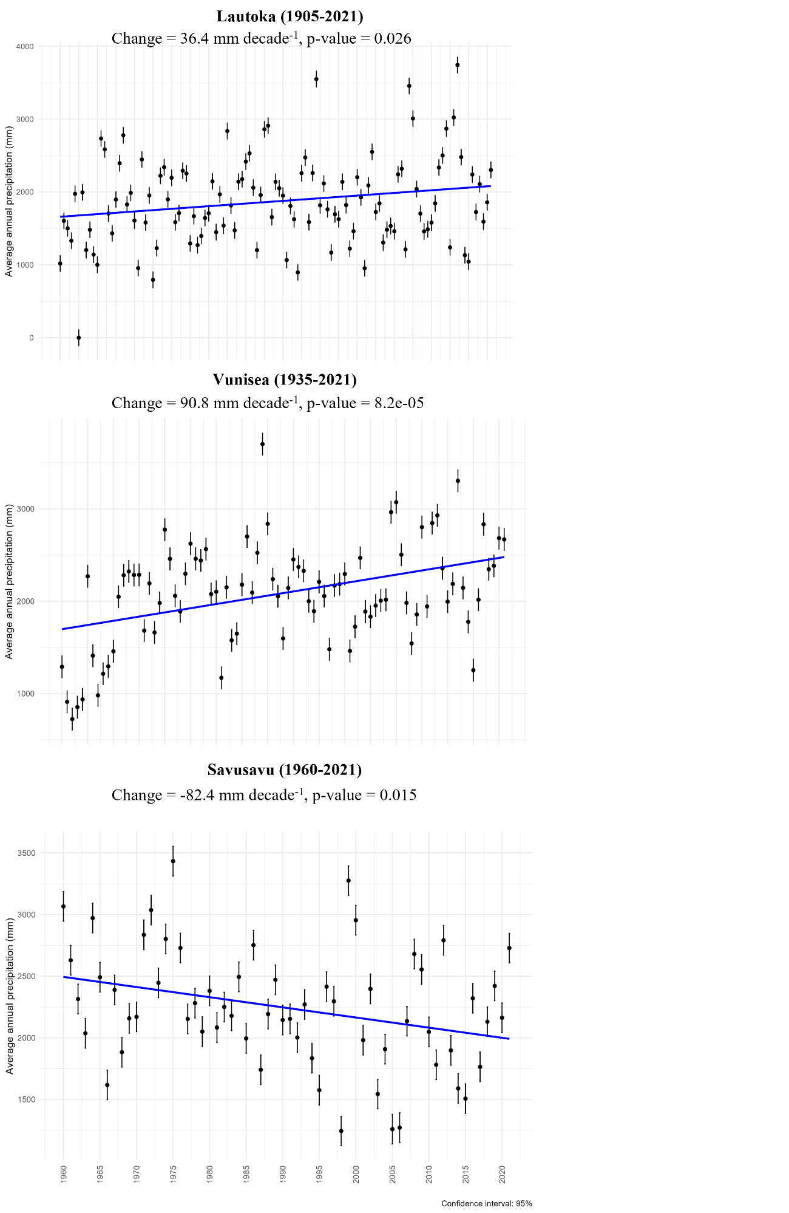
Figure S2. Evolution of the mean annual precipitation data (black dots) and trend evolution (blue line) for those station in which the trend was statistically significant. The upper and lower lines from the black dots represent the confidence interval at a 95% level.

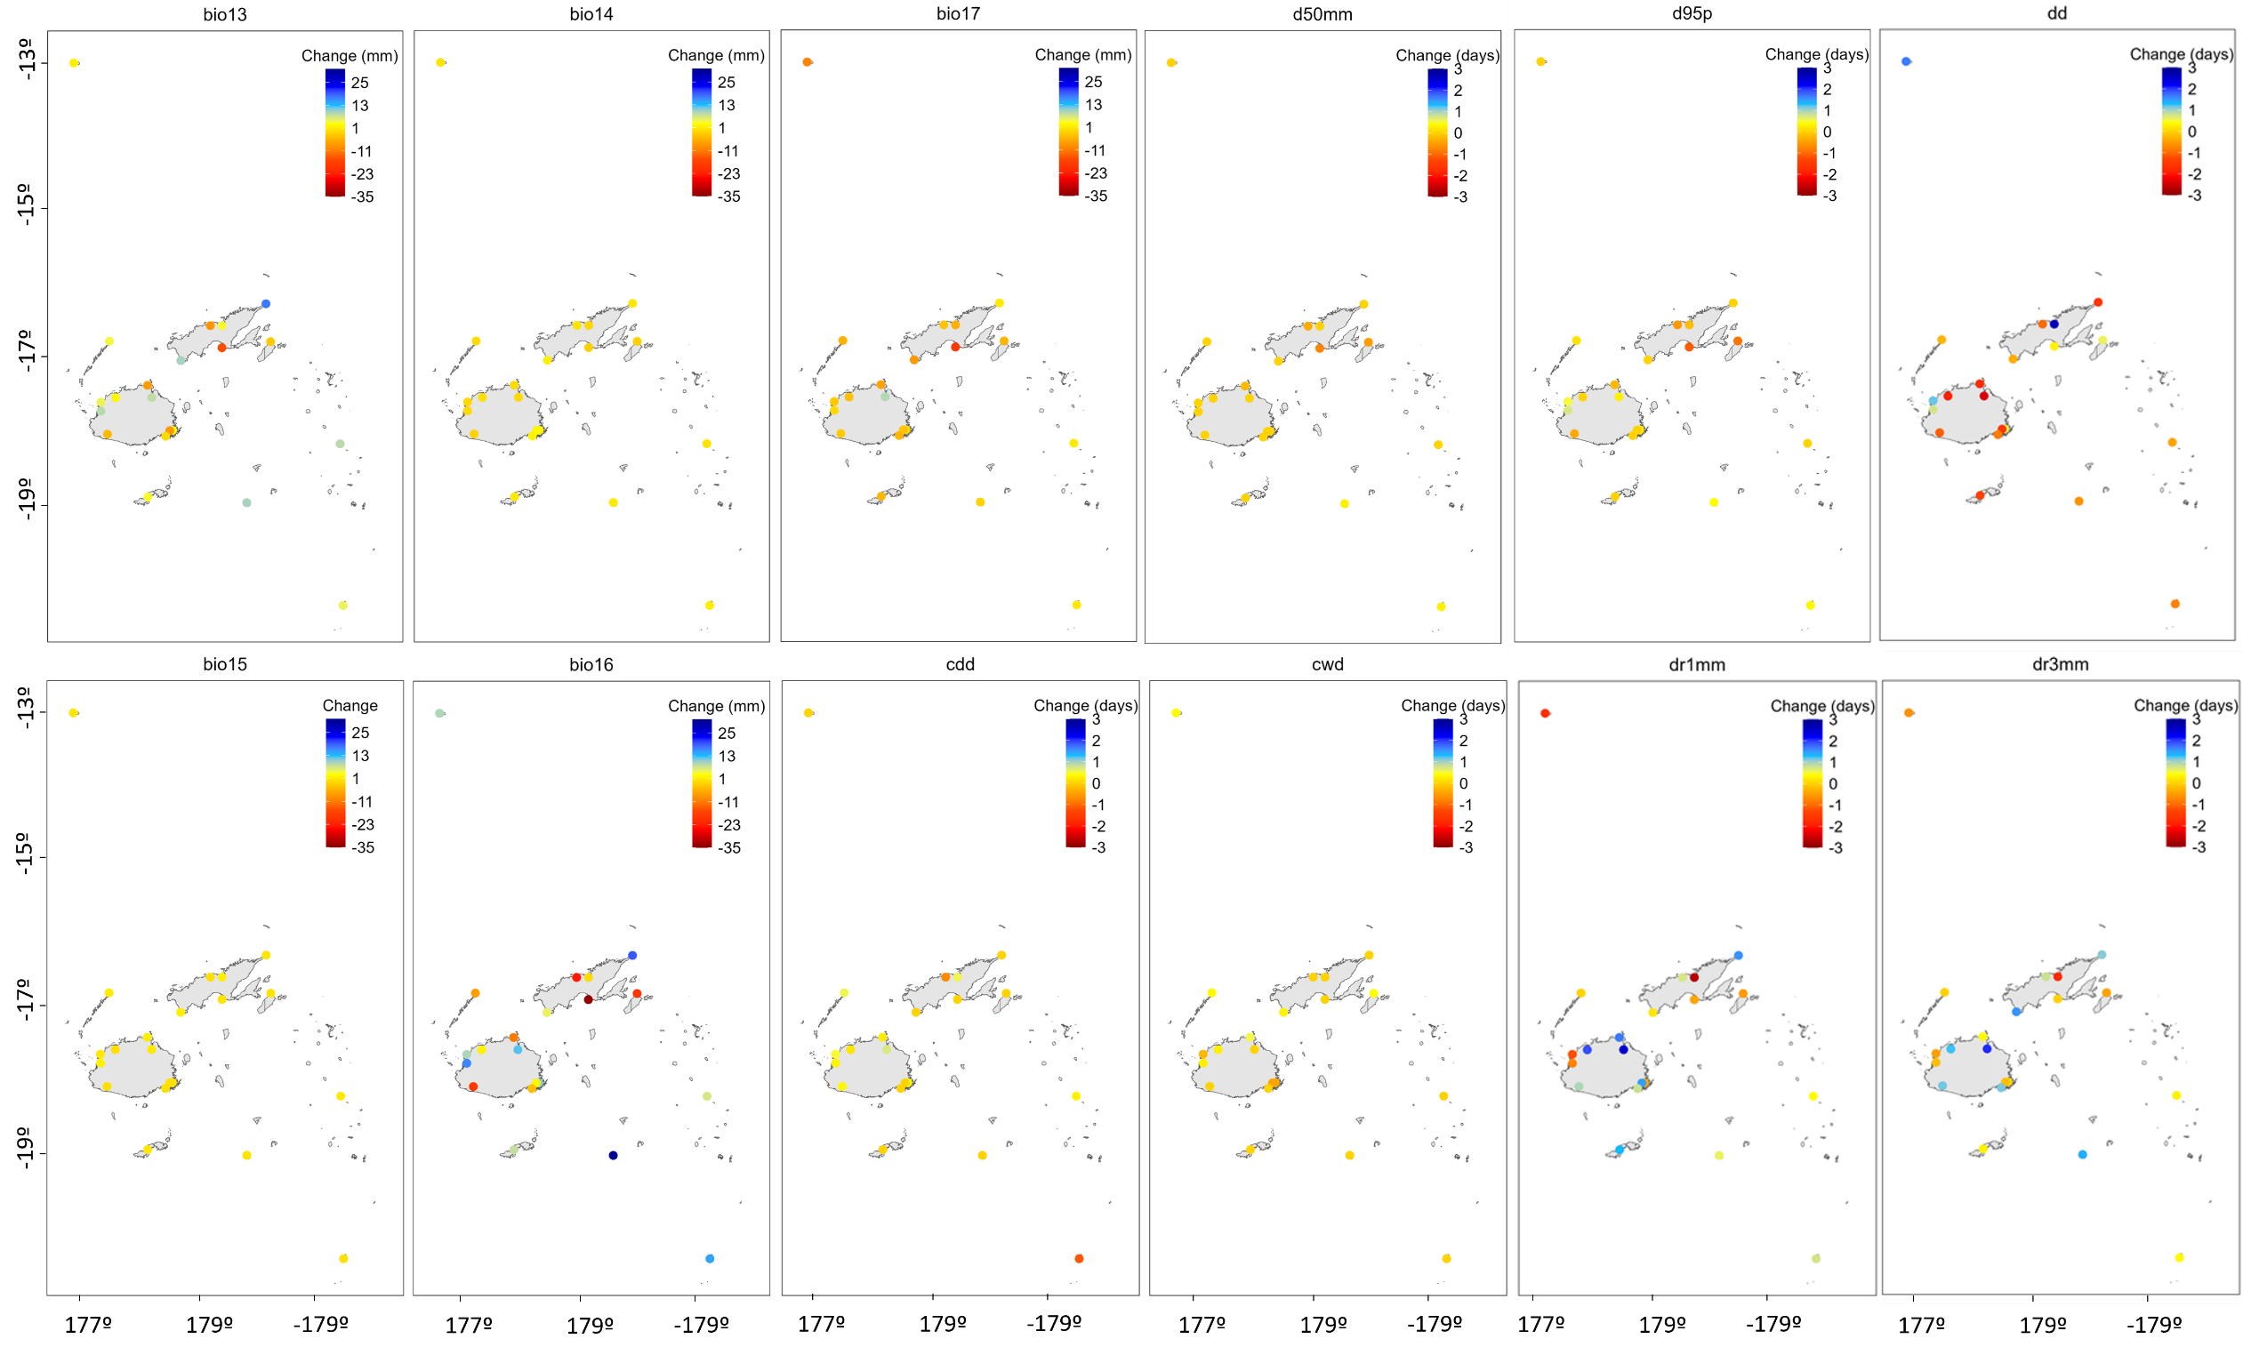
Figure S3. Trend daily precipitation changes for the period 1960-2021
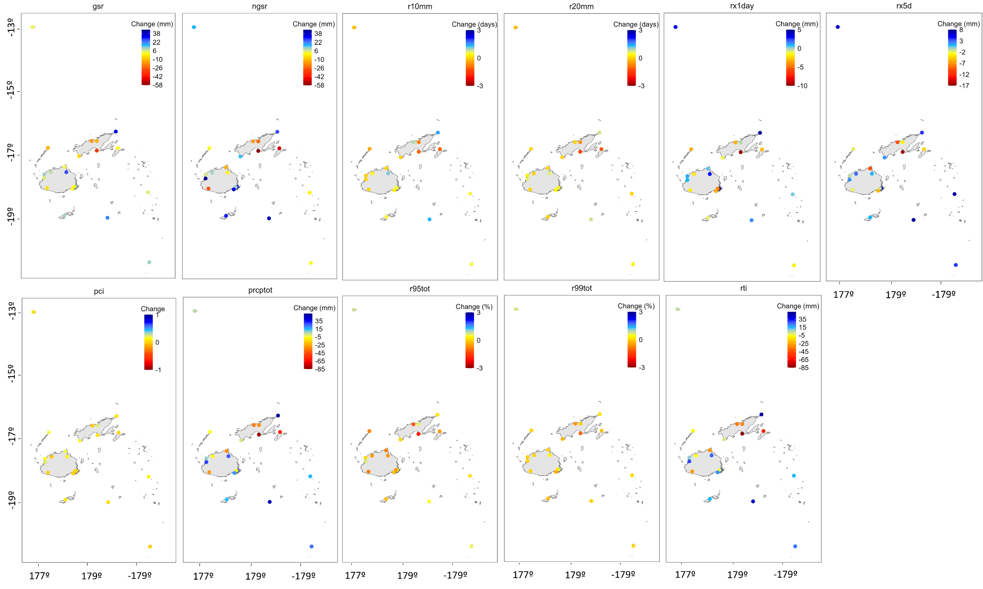
Figure S3. (Cont.)
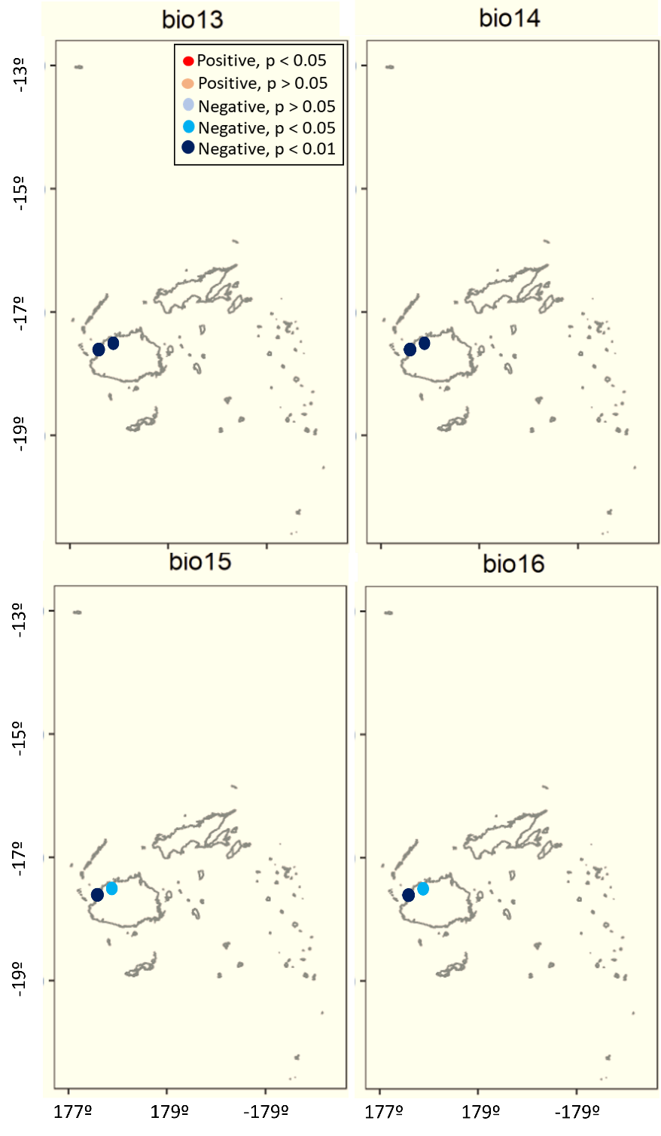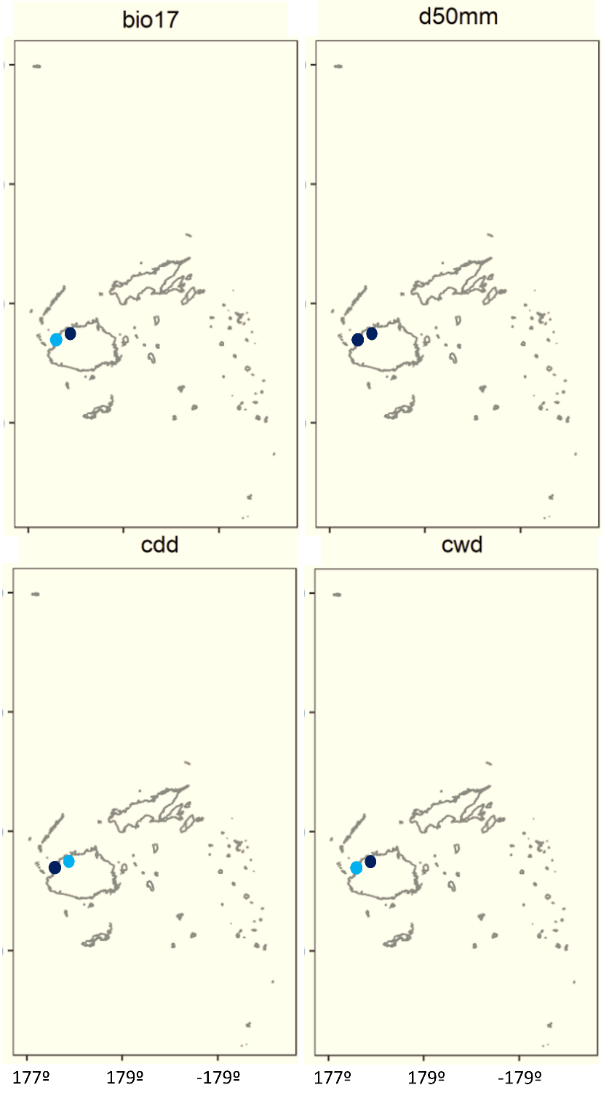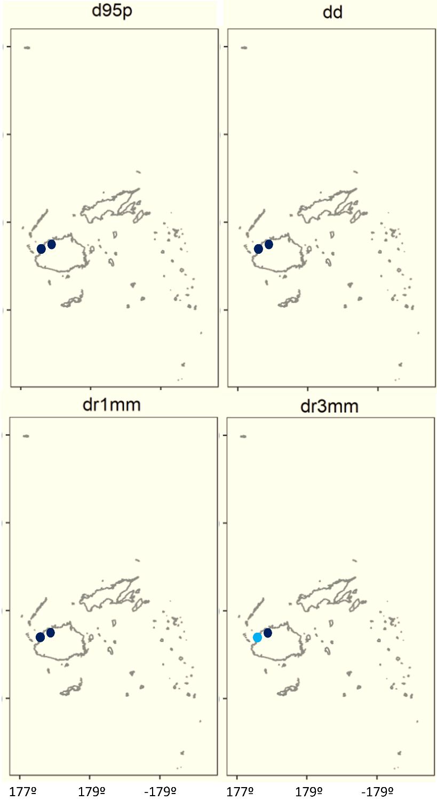
Figure S4. Significance of the daily precipitation trends for the period 1905-2021
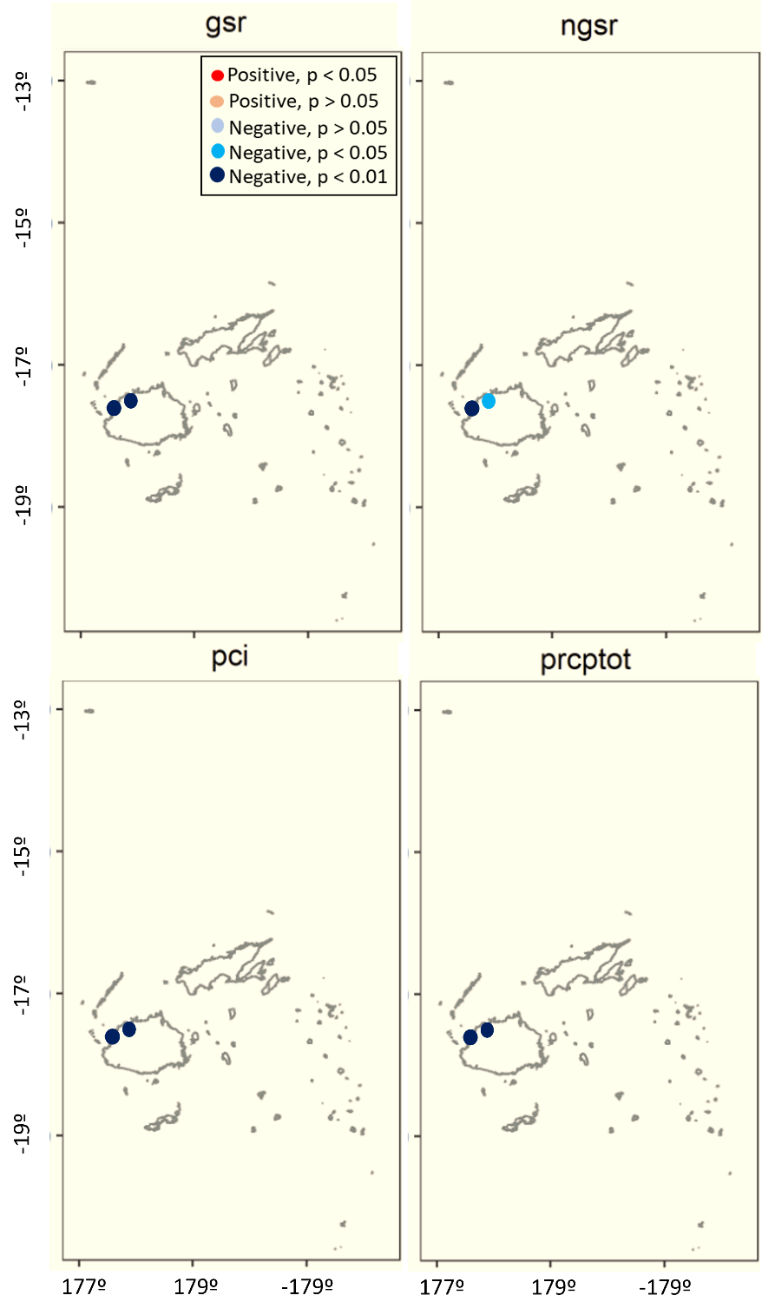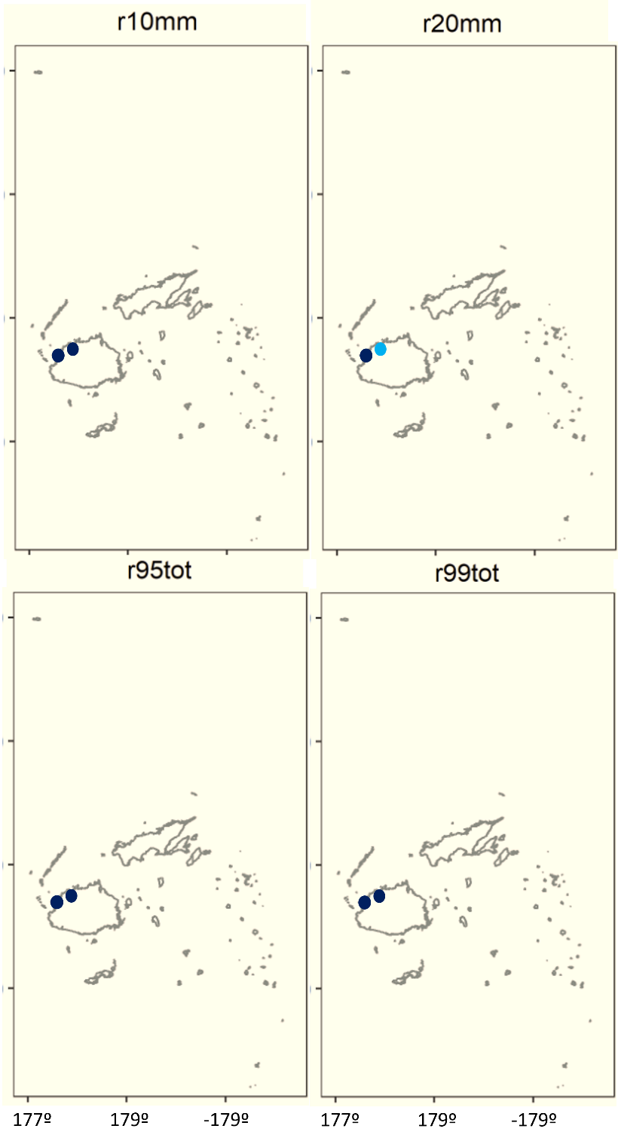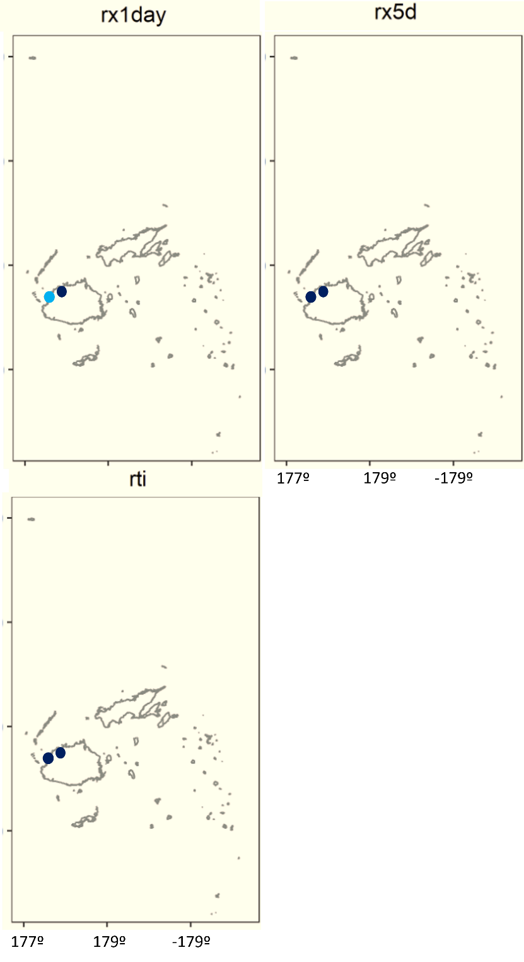
Figure S4. (Cont.)
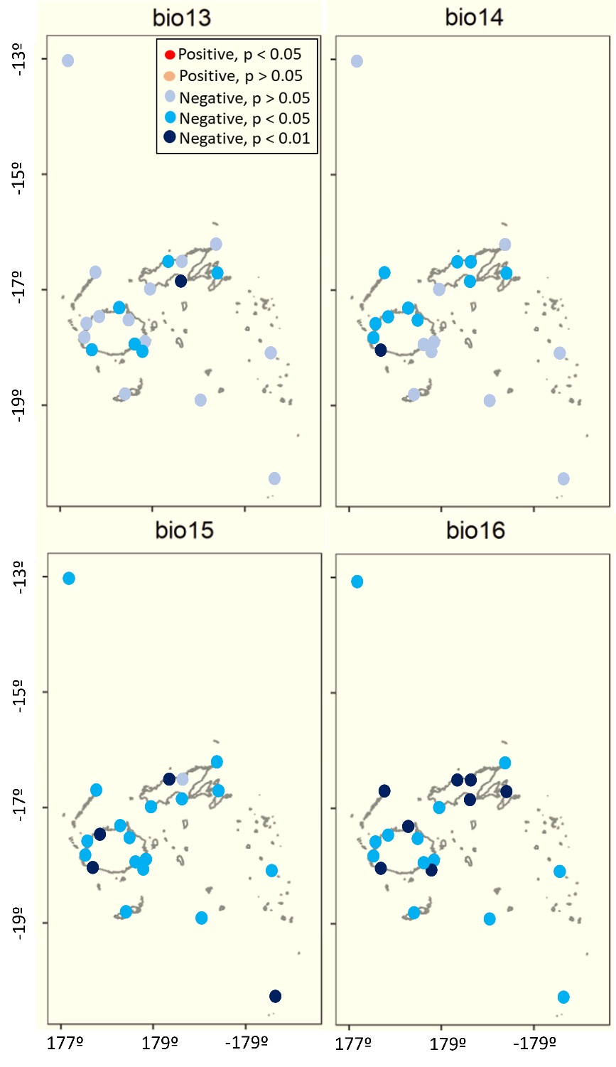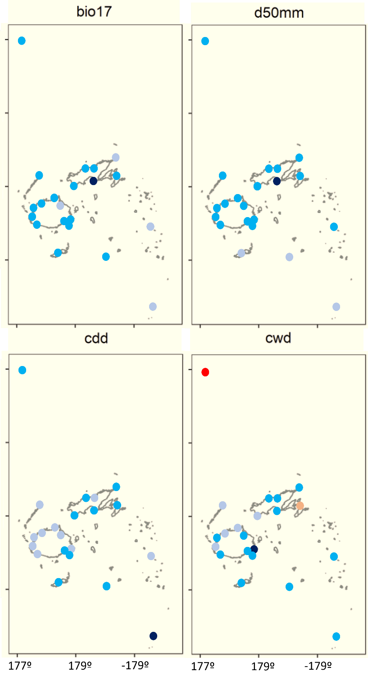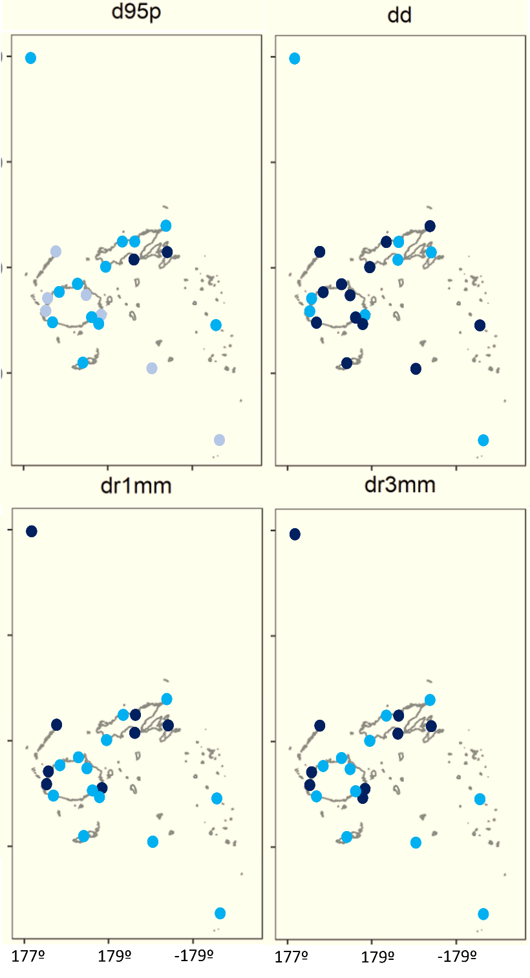
Figure S5. Significance of the daily precipitation trends for the period 1960-2021
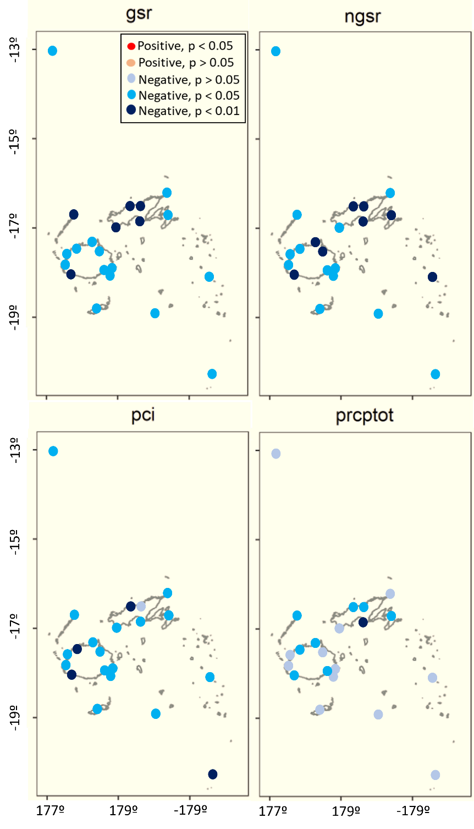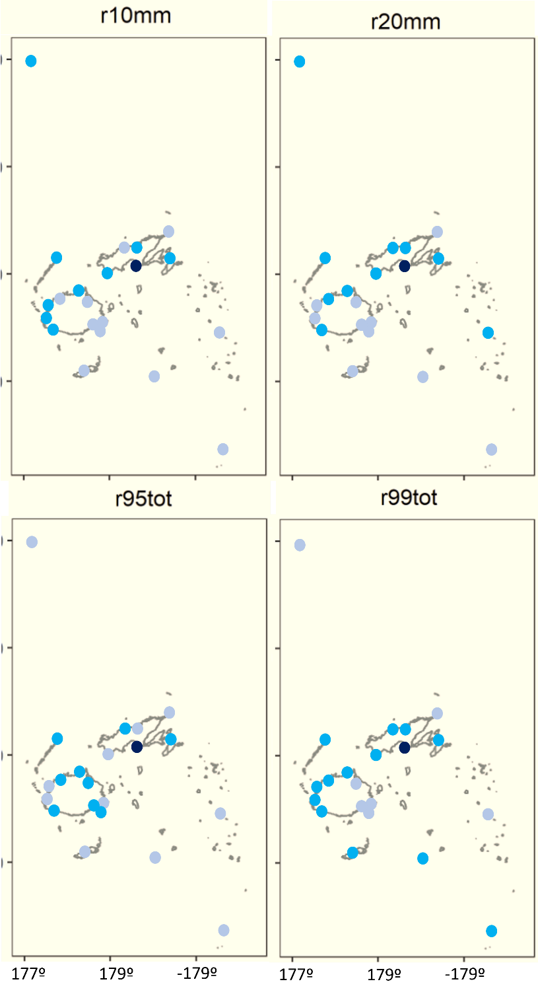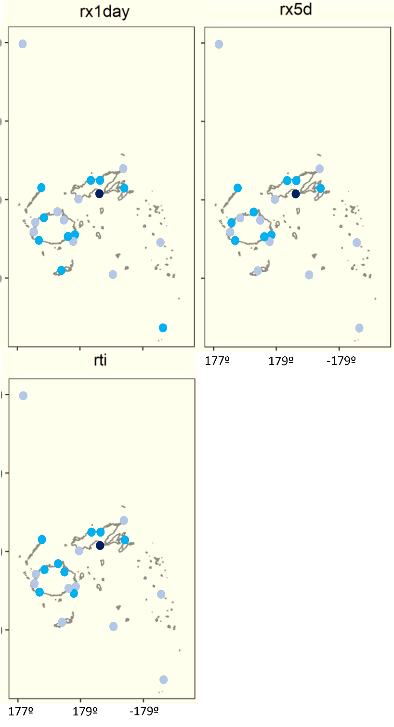
Figure S5. (Cont

