Table 1. General description of African marigold genotypes with different flower forms used in the study
Genotype | Description of flowers
IIHRMO 12 | Flower type: Fertile  Flower form:  Single-with one whorl of ray florets | 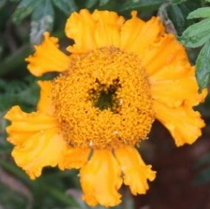
IIHRMO 53 | Flower type: Fertile  Flower form:  Single -with one whorl of ray florets | 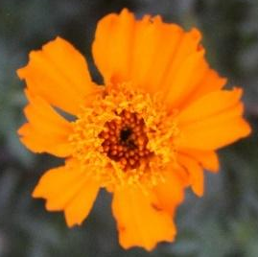
IIHRMO 2330 | Flower type: Fertile  Flower form:  Semi-Double- with more than one whorl of ray florets | 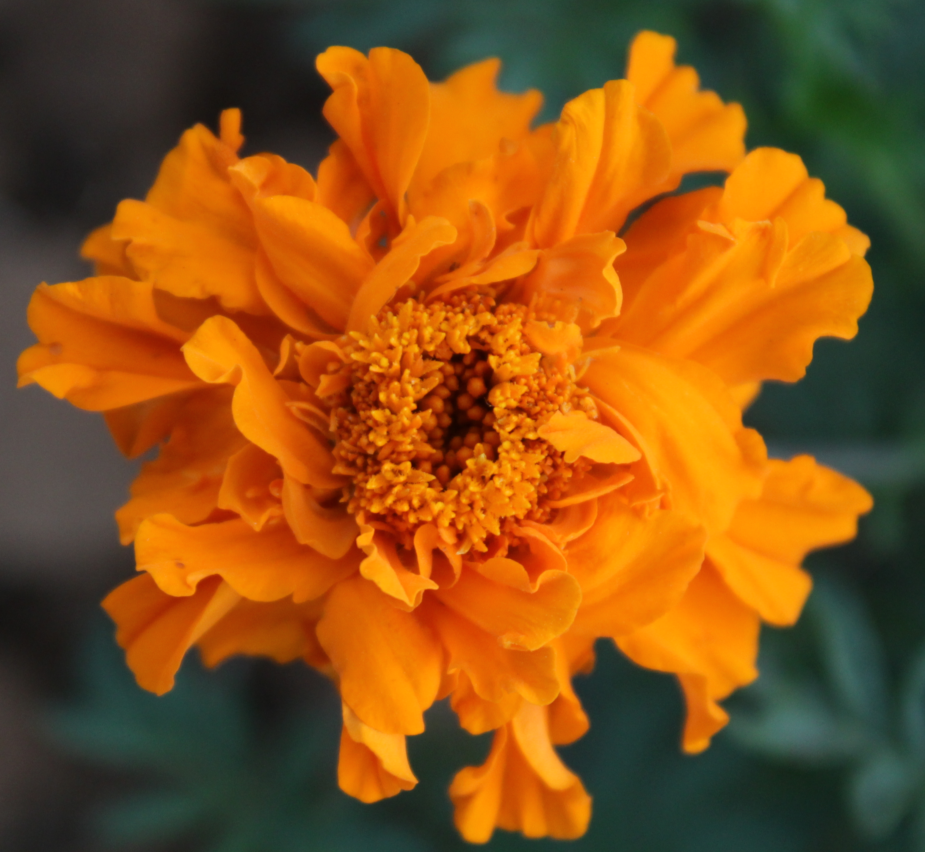
IIHRMY 1-4 | Flower type: Fertile  Flower form:  Double- with more than three whorl of ray florets | 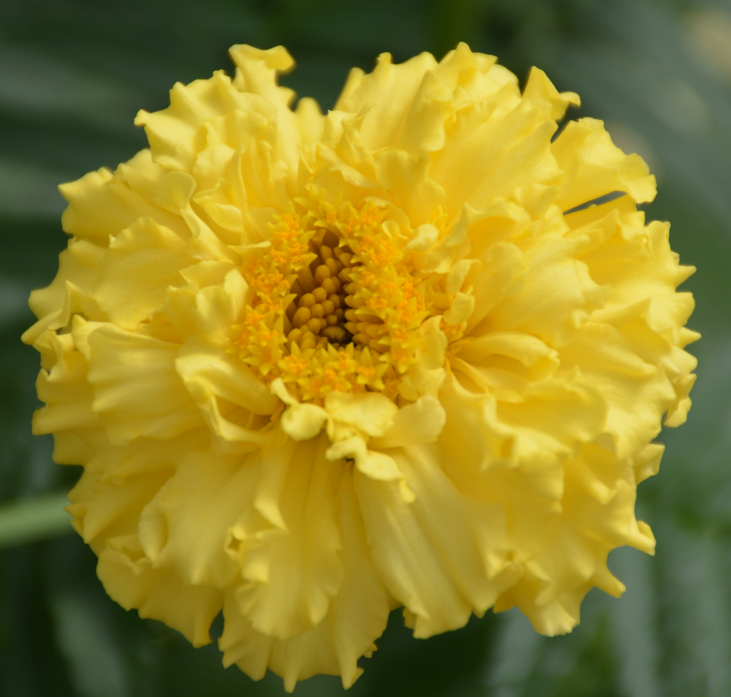
IIHRMO 2335 | Flower type: Fertile  Flower form:  Double- with more than three whorl of ray florets | 
IIHRMY 2-1 | Flower type: Fertile  Flower form:  Double- with more than three whorl of ray florets | 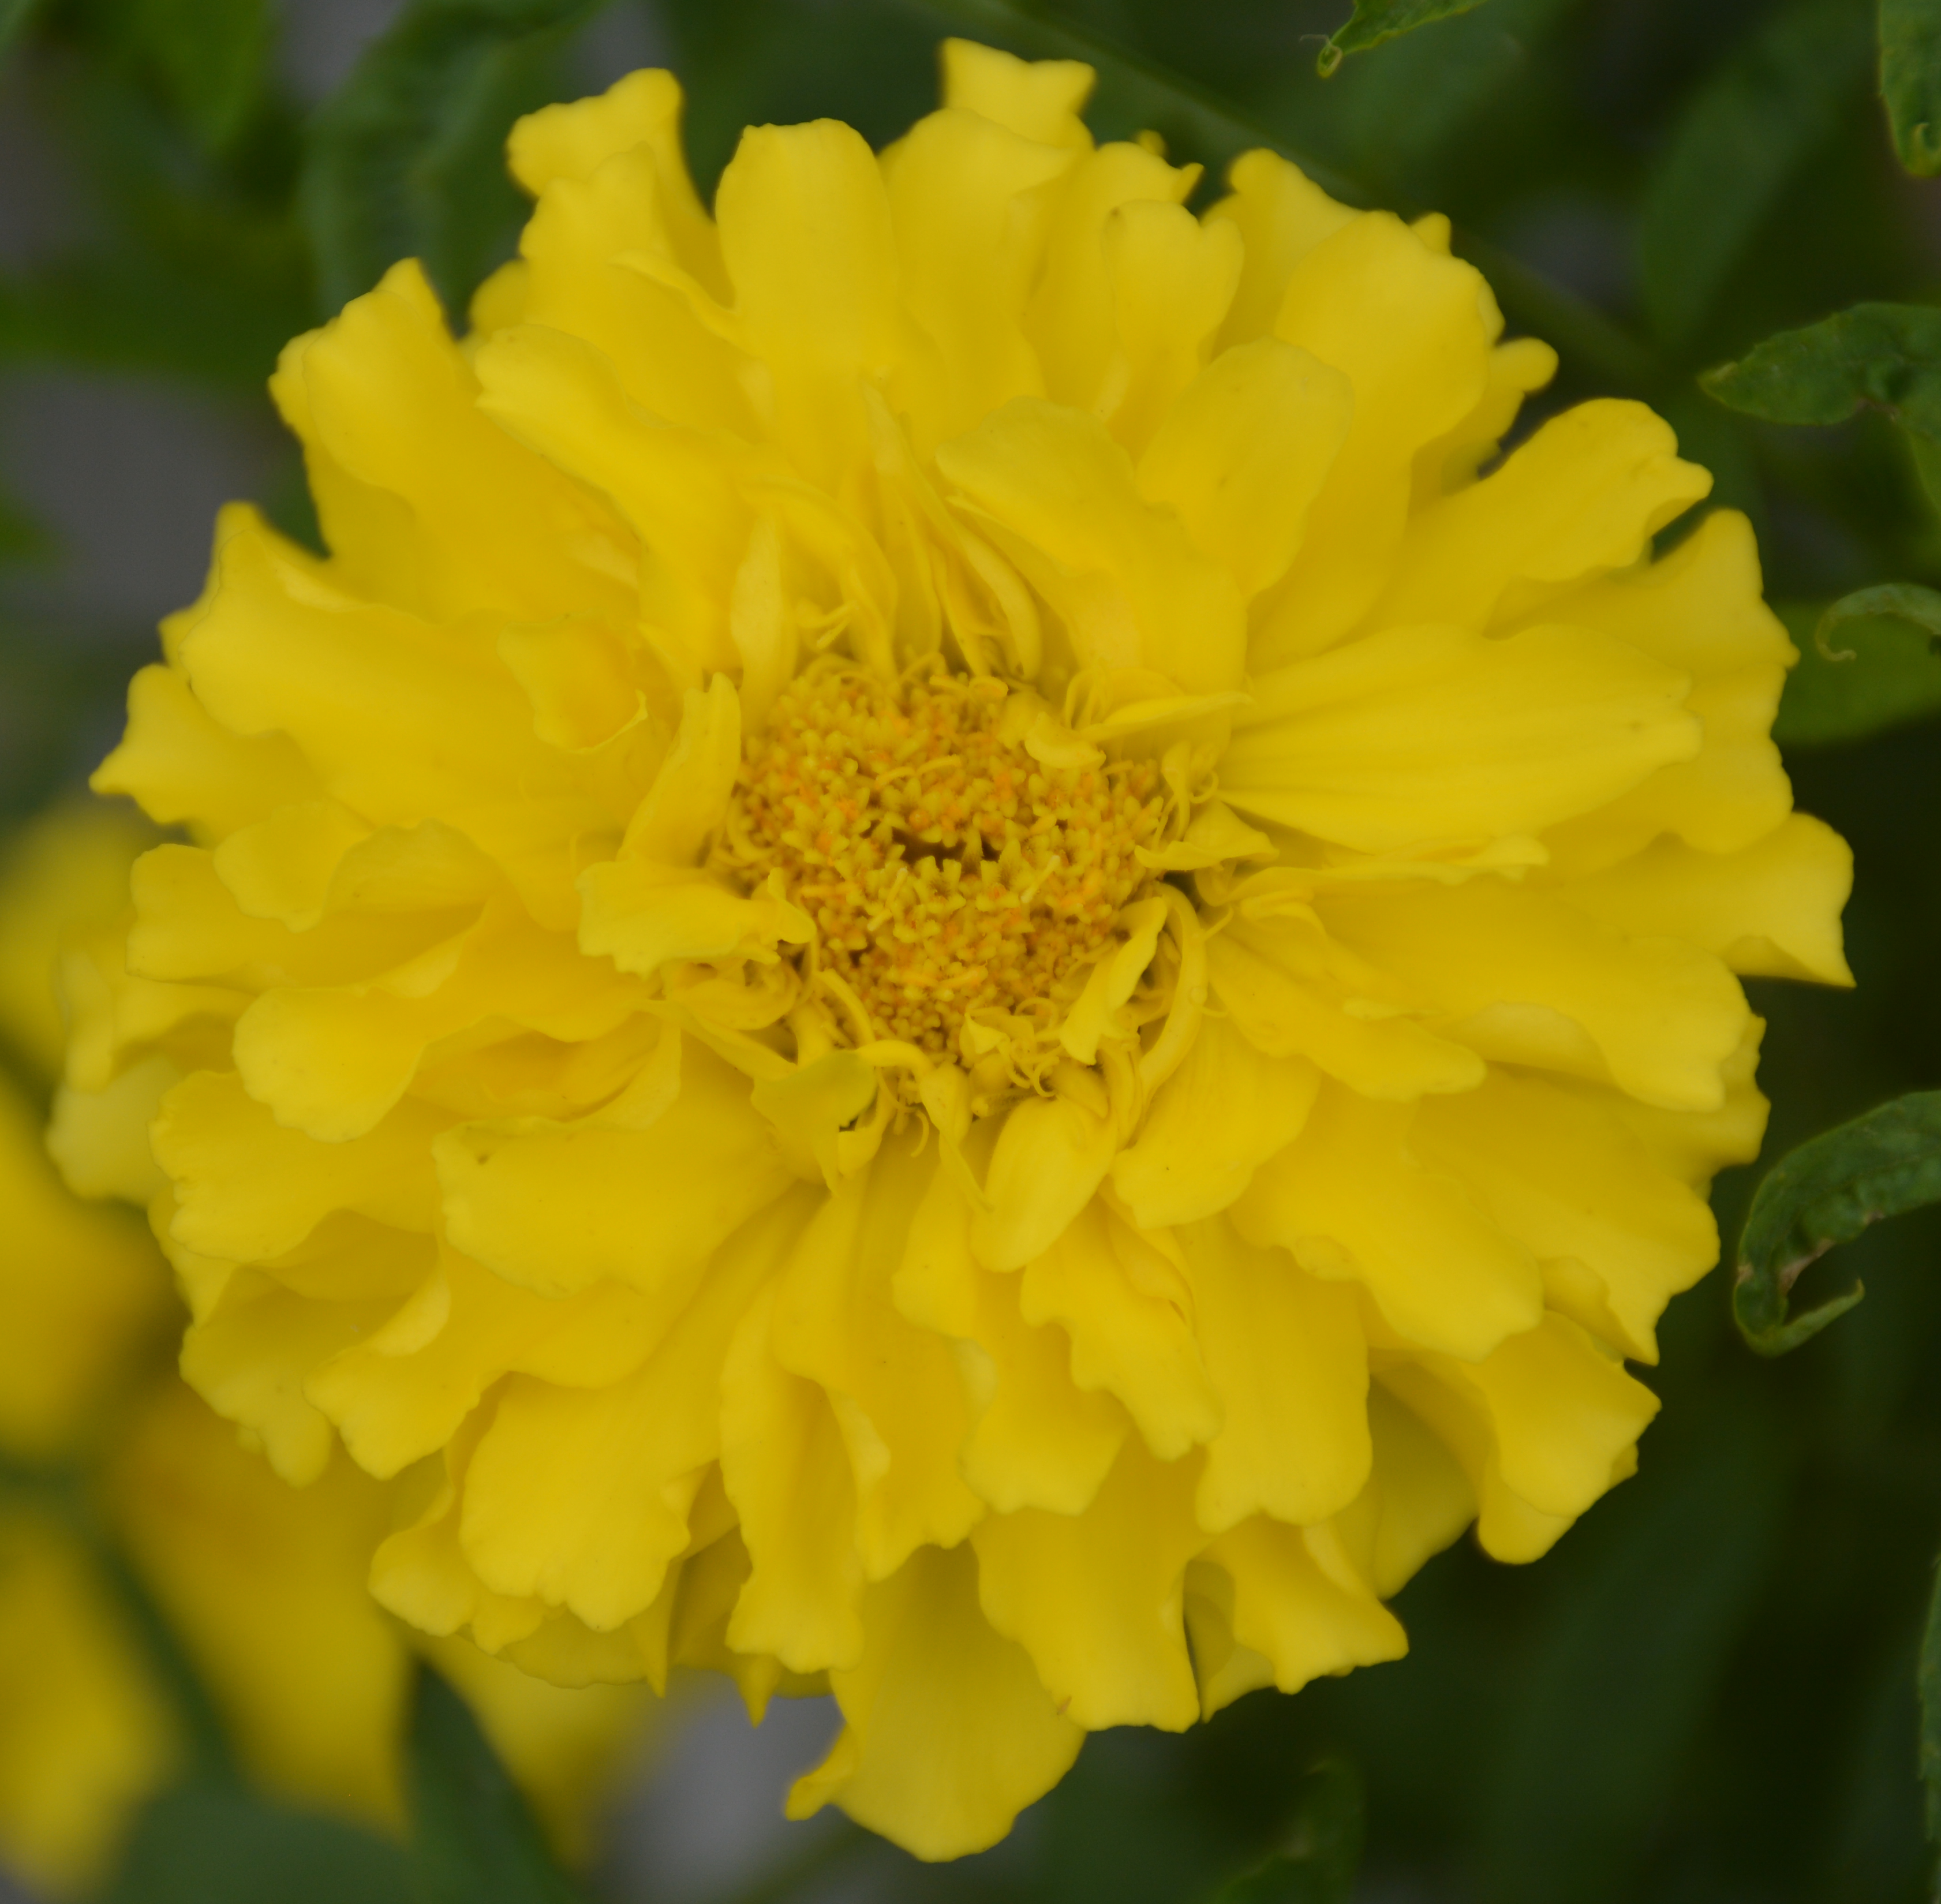
IIHRMO 2356 SF | Flower type: Apetaloid sterile  Flower form:  Sterile - with no petals;  Fertile-Double with more than three whorl of ray florets | 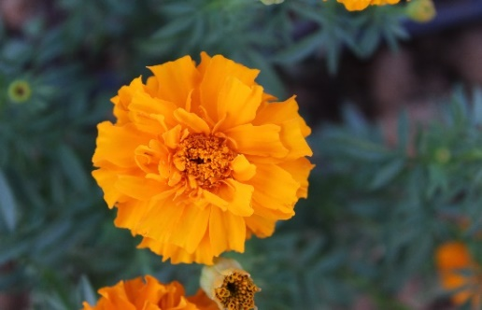  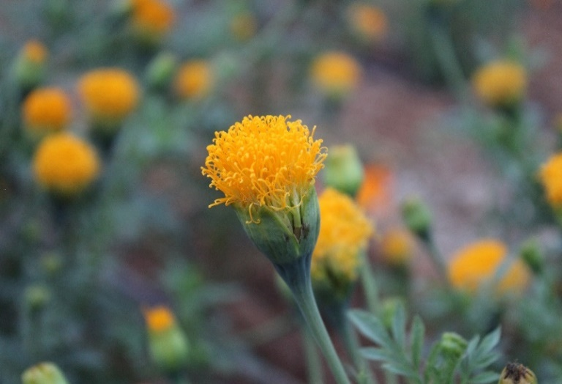  Sterile  Fertile
IIHRMO 2337 SF | Flower type: Apetaloid sterile  Flower form:  Sterile -with no petals;  Fertile -Single with one whorl of ray florets |   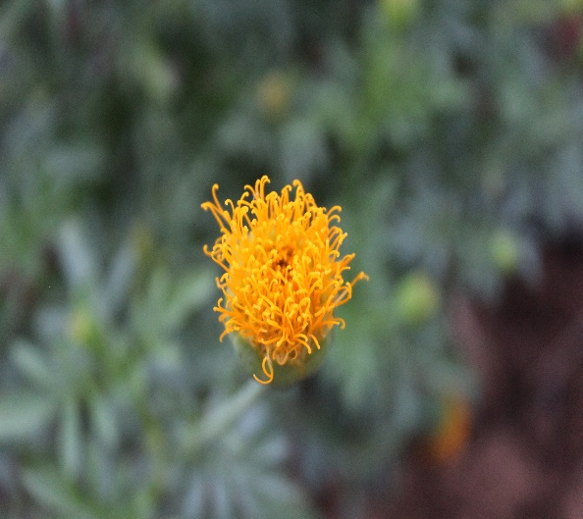  Sterile  Fertile
IIHRM 2-3 SF | Flower type: Petaloid sterile  Flower form:  Sterile- petals;  Fertile- Single with one whorl of ray florets | 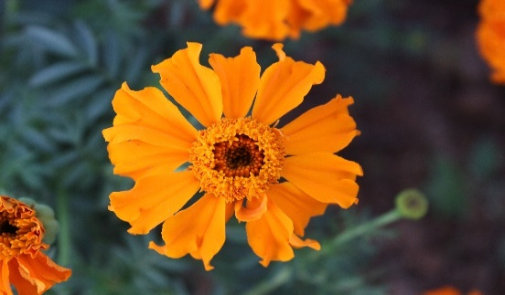    Sterile  Fertile

