Supplementary Information 1 (SI1) for
Multi-environment Microbial Risk Assessment Based on Metagenomic Absolute Quantification with Cellular Internal Standard

S1 Absolute quantification calculation methodology

$$\frac{bacteria genome copy number}{spike-in genome copy number}×spike-in cell number= bacteria cell number$$

The breakthroughs in absolute quantification presented in this article include:
(1) Designing experiments to verify the representativeness of the selected two types of spike-ins for Gram-positive and Gram-negative bacteria.

(2) Beyond their quantification role, it also demonstrates that spike-ins can correct biases in community composition that arise due to differences in cell structure throughout the DNA extraction to sequencing process, thus providing a new role for absolute quantification.

(3) Simplifying the use of marker genes as spike-ins by directly using the whole genomes of rare environmental bacteria as internal standards. Since these two types of spike-ins are rare in the environment and easily distinguished from other species, their species can be directly removed for subsequent analysis without needing to remove all bacteria of the same genus with the marker gene spike-ins, reducing the impact on sample AQ results and avoiding neglect of pathogens and ARGs related to the major genera Pseudomonas and Bacillus.

(4) In the ZymoBIOMICS® Gut Microbiome Standard mock, the addition of both marker gene spike-ins and whole genome spike-ins shows that using whole genome as spike-ins is significantly more accurate than the marker gene internal standard method.

(5) In calculating the sequenced genome copy number of a taxonomic lineage, an updated structured average genome size database built upon the newer GTDB version[1] (R207) is utilized.

S2 The contribution of ARG subtypes carried by various ESKAPE+EV related genera to the total absolute abundance of those ARG subtypes in different environmental types

Criteria of ESKAPE+EV-related high-risk ARGs:
- Being carried by three or more genera in ESKAPE+EV group.
- Being presence in three or more sample types.
- Being relevance to ESKAPE+EV-related genera while not being classified as multidrug resistance genes.

SI1 Table1. Genus of ESKAPE+EV pathogens related high risk ARG subtypes
Genus of ESKAPE+EV pathogens related high risk ARG subtypes list
aminoglycoside__AAC(6')−Ib7
aminoglycoside__AAC(6')−Ib9
aminoglycoside__aadA
aminoglycoside__ANT(2'')−Ia
aminoglycoside__APH(3'')−Ib
aminoglycoside__APH(6)−Id
bacitracin__bacA
beta_lactam__Klebsiella pneumoniae OmpK37
beta_lactam__OtherclassAbeta−lactamase
beta_lactam__OXA−10
chloramphenicol__cmlA5
MLS__macA
MLS__macB
other_peptide_antibiotics__microcin efflux pumu gene yojI
polymyxin__arnA
polymyxin__pmrF
polymyxin__rosB
polymyxin__ugd
rifamycin__arr−2
sulfonamide__sul1
sulfonamide__sul2
tetracycline__tet(A)
tetracycline__tet(C)

S3 Host tracking of important resistance genes

SI1 Fig. 1. (a) Total absolute abundance of 17 ARG types carried by pathogens in all 34 environment samples. (b) Absolute abundance of ARGs carried by chromosome reads and plasmids/unclassified reads of pathogens belonging to resistance genes with absolute abundance larger than 10¹⁰ copy/L carried by pathogens.

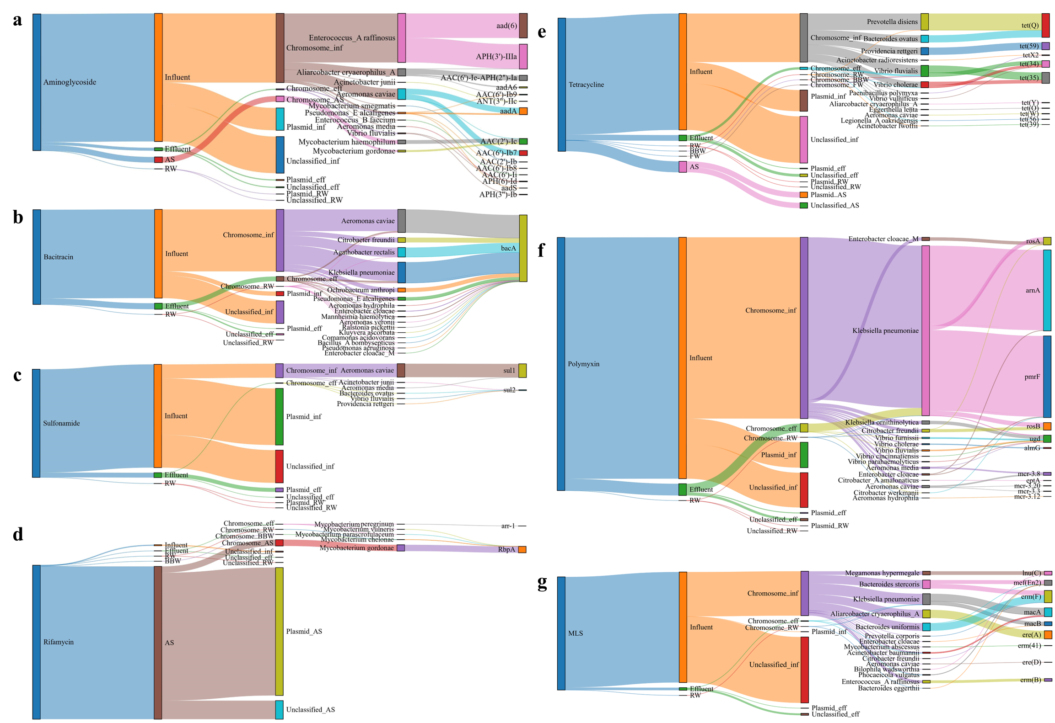
SI1 Fig. 2. Host tracking of aminoglycoside, bacitracin, sulfonamide, rifamycin, tetracycline, polymyxin and MLS resistance genes.

