Figure S1
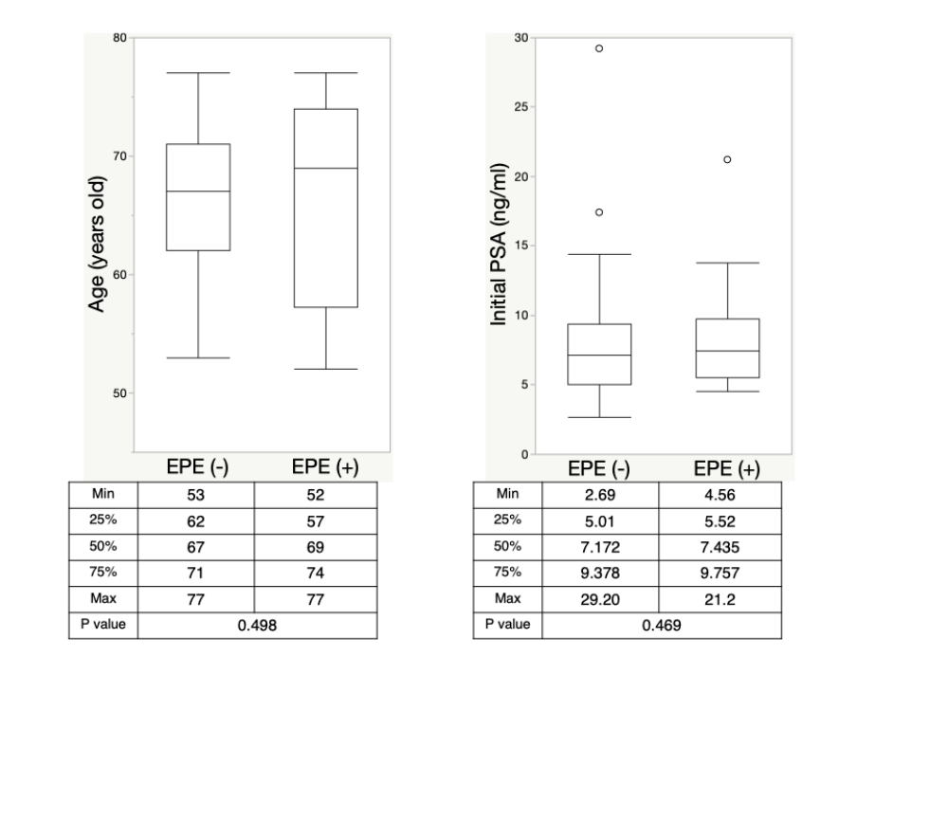
Comparison between EPE- and EPE+ patients in age and initial PSA using Mann-Whitney U test.

Figure S2
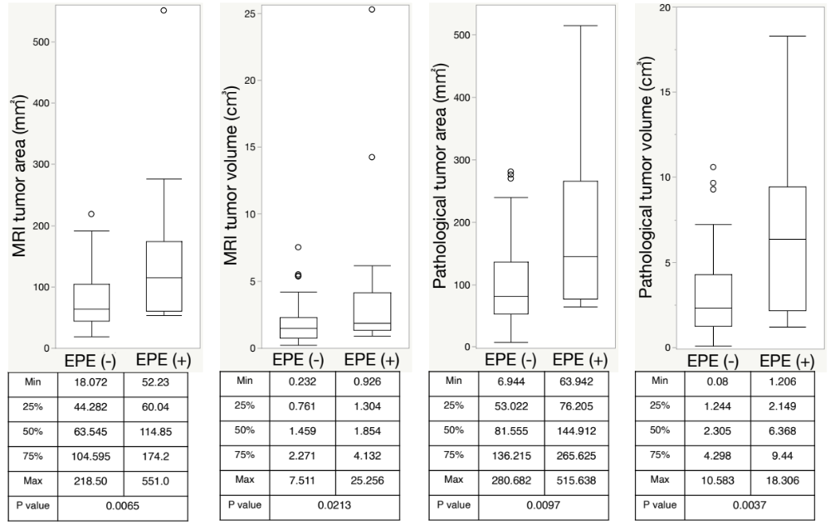
Comparison between EPE- and EPE+ patients in MRI tumor area, MRI tumor volume, pathological tumor area and pathological tumor volume using Mann-Whitney U test.

Figure S3
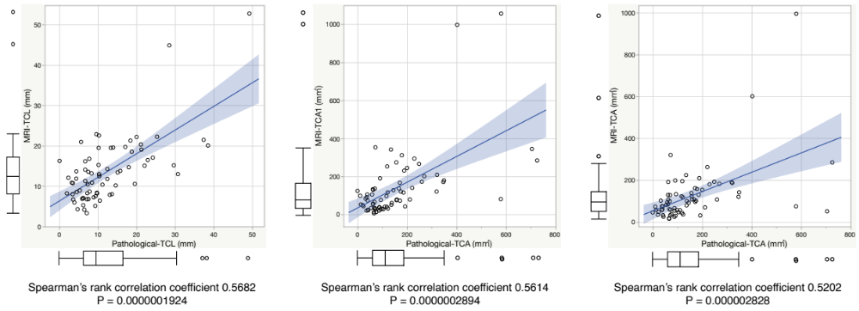
Spearman’s rank correlation coefficient between MRI-TCL and pathological-TCL, MRI-TCA1 and pathological-TCA, and MRI-TCA2 and pathological-TCA.

