Supplement

Matching procedure

Baseline analyses of the complete high-dose therapy sample and low-dose interdisciplinary multimodal pain therapy (IMPT) sample

Table S1-1. Demographic, treatment related and pain related patient data for both groups. Continuous data is displayed in median, first and third quartile (Q₁, Q₃). Dichotomous data is displayed in number (n) and percent (%). P values of the group comparisons are displayed in the last column (p). Bold p values indicate significant group differences.
 |  |  | low-dose IMPT  (n=32) |  |  |  | high-dose IMPT: all  (n=118)
 |  |  | Median | Q₁ | Q₃ |  | Median | Q₁ | Q₃ | p¹
age | (years) |  | 55.0 | 47.8 | 69.8 |  | 52.0 | 45.0 | 58.3 | .066
pain-related disability scale | (NRS) |  | 5.3 | 3.9 | 6.9 |  | 5.3 | 4.0 | 6.7 | .978
average pain rating | (NRS) |  | 6.0 | 5.0 | 7.0 |  | 6.0 | 4.8 | 7.0 | .671
maximum pain rating | (NRS) |  | 7.5 | 7.0 | 9.0 |  | 8.0 | 7.0 | 8.0 | .324
follow-up | (days) |  | 79.5 | 71.0 | 95.3 |  | 94.0 | 71.8 | 99.0 | .216
 |  |  | n | % |  |  | n | % |  | p²
sex | (female) |  | 15 | 46.9 |  |  | 89 | 75.4 |  | .002
anxiety | (yes³) |  | 14 | 43.8 |  |  | 44 | 37.3 |  | .506
depression | (yes⁴) |  | 12 | 37.5 |  |  | 34 | 28.8 |  | .345
chronic pain duration | (≥5years) |  | 19 | 59.4 |  |  | 60 | 50.8 |  | .391
chronic back pain | (yes) |  | 23 | 71.9 |  |  | 51 | 43.2 |  | .004
¹ p values result from Mann-Whitney-U tests
² p values result from chi-squared tests
³ sum scores of the Hospital Anxiety Depression Scale (HADS): Anxiety >10 or sum score
of the Depression, Anxiety and Stress Scale (DASS): Anxiety >6
⁴ sum scores of the Hospital Anxiety Depression Scale (HADS): Depression >10 or sum score
of the Depression, Anxiety and Stress Scale (DASS): Depression >10

Results of the matching procedure

Table S1-2. Results of the sequential matching procedure. First, patients were matched exactly regarding sex and the presence of chronic back pain. Second, patients were matched regarding age and the pain-related disability scale within the subclasses (females and back pain: no | females and back pain: yes | males and back pain: no | males and back pain: yes) using “nearest neighbour” matching.
“exact” matching
 |  | low-dose  (n=32) |  |  | high-dose: all  (n=118) |  |  |  | high-dose: matched  (n=32)
 |  | n | % |  | n | % | Δ% |  | n | % | Δ% |  | % improvement
sex (female) |  | 15 | 46.9 |  | 89 | 75.4 | 28.5 |  | 15 | 46.9 | 0.0 |  | 100.0
back pain (yes) |  | 23 | 71.9 |  | 51 | 43.2 | 28.7 |  | 23 | 71.9 | 0.0 |  | 100.0
“nearest neighbour” matching in subgroups
 |  | low-dose |  |  | high-dose: all |  |  |  | high-dose: matched
females & back pain: yes |  | mean |  |  | mean | SD | Δmean |  | mean | SD | Δmean |  | % improvement
age (years) |  | 59.8 |  |  | 54.0 | 10.2 | 5.9 |  | 59.3 | 11.1 | 0.5
pain-related disability (0-10) |  | 5.2 |  |  | 5.2 | 1.7 | 0.0 |  | 5.0 | 1.4 | 0.3
distance: |  | 0.3 |  |  | 0.2 | 0.1 | 0.1 |  | 0.3 | 0.1 | 0.0 |  | 82.9
females & back pain: no |  | mean |  |  | mean | SD | Δmean |  | mean | SD | Δmean |  | % improvement
age (years) |  | 62.0 |  |  | 51.4 | 10.8 | 10.6 |  | 60.7 | 12.6 | 1.3
Pain-related disability (0-10) |  | 6.2 |  |  | 5.1 | 2.0 | 1.1 |  | 5.6 | 4.0 | 0.7
distance: |  | 0.2 |  |  | 0.0 | 0.0 | 0.2 |  | 0.1 | 0.1 | 0.1 |  | 56.5
males & back pain: yes |  | mean |  |  | mean | SD | Δmean |  | mean | SD | Δmean |  | % improvement
age (years) |  | 56.8 |  |  | 50.3 | 9.9 | 6.6 |  | 54.9 | 8.1 | 1.9
pain-related disability (0-10) |  | 5.5 |  |  | 5.0 | 2.2 | 0.4 |  | 4.5 | 2.4 | 1.0
distance: |  | 0.5 |  |  | 0.4 | 0.1 | 0.1 |  | 0.4 | 0.1 | 0.1 |  | 40.5
males & back pain: no |  | mean |  |  | mean | SD | Δmean |  | mean | SD | Δmean |  | % improvement
age (years) |  | 49.7 |  |  | 46.2 | 12.3 | 3.4 |  | 50.7 | 7.9 | -1.0
pain-related disability (0-10) |  | 4.6 |  |  | 6.0 | 2.2 | -1.4 |  | 5.0 | 2.0 | -0.4
distance: |  | 0.4 |  |  | 0.3 | 0.1 | 0.1 |  | 0.4 | 0.1 | 0.0 |  | 73.3

Drop out analysis

Table S2-1. Raw means and first/third quartile (Q₁/Q₃) of patients with or without follow-up visit (T3) of both therapy groups. P values of the group comparisons using Mann-Whitney-U tests are displayed in the last column (p).
 |  |  | drop out T2 to T3  (n=62) |  |  |  | data for T2 and T3  (n=150)
T1: start of therapy |  |  | median | Q₁ | Q₃ |  | median | Q₁ | Q₃ | p
pain-related disability scale | (0-10) |  | 4.67 | 2.92 | 7.00 |  | 5.33 | 4.00 | 6.67 | .118
average pain rating | (0-10) |  | 5.50 | 4.00 | 7.00 |  | 6.00 | 5.00 | 7.00 | .412
maximum pain rating | (0-10) |  | 7.00 | 6.00 | 8.00 |  | 8.00 | 7.00 | 8.05 | .357
T2: end of therapy |  |  | median | Q₁ | Q₃ |  | median | Q₁ | Q₃ | p
pain-related disability scale | (0-10) |  | 3.17 | 2.00 | 5.75 |  | 4.33 | 2.67 | 6.00 | .218
average pain rating | (0-10) |  | 5.00 | 3.88 | 6.13 |  | 5.00 | 4.00 | 6.00 | .649
maximum pain rating | (0-10) |  | 7.00 | 6.00 | 8.00 |  | 7.00 | 6.00 | 8.00 | .763
T1 vs. T2 |  |  | median | Q₁ | Q₃ |  | median | Q₁ | Q₃ | p
pain-related disability scale | (0-10) |  | -0.67 | -1.67 | 0.33 |  | -0.92 | -2.00 | 0.00 | .476
average pain rating | (0-10) |  | -1.00 | -2.00 | 0.50 |  | -0.50 | -2.00 | 0.00 | .812
maximum pain rating | (0-10) |  | 0.00 | -1.13 | 0.05 |  | 0.00 | -1.05 | 0.08 | .593

Table S2-2. Number (n) and percent (%) of patients with significant symptoms of anxiety or depression. Significant p values for between group comparisons (p, Chi-squared tests) are printed bold.
 |  |  | drop out T2 to T3  (n=62) |  |  |  | data for T2 and T3  (n=150)
 |  |  | n | % |  |  | n | % |  | p
anxiety | (yes¹) | T1 | 25 | 40.30 |  |  | 58 | 38.70 |  | .822
 |  | T2 | 12 | 19.40 |  |  | 38 | 25.50 |  | .339
depression | (yes²) | T1 | 21 | 33.90 |  |  | 46 | 30.70 |  | .648
 |  | T2 | 11 | 17.70 |  |  | 22 | 14.80 |  | .588
¹ sum scores of the Hospital Anxiety Depression Scale (HADS): Anxiety >10 or sum score
of the Depression, Anxiety and Stress Scale (DASS): Anxiety >6
² sum scores of the Hospital Anxiety Depression Scale (HADS): Depression >10 or sum score
of the Depression, Anxiety and Stress Scale (DASS): Depression >10

Comparisons of the matched and unmatched high-dose therapy group

Table S3-1. Raw means and first/third quartile (Q₁/Q₃) of both groups. P values of the group comparisons using Mann-Whitney-U tests are displayed in the last column (p).
 |  |  | high-dose: matched  (n=32) |  |  |  | high-dose: unmatched  (n=86)
T1: start of therapy |  |  | median | Q₁ | Q₃ |  | median | Q₁ | Q₃ | p
pain-related disability scale | (0-10) |  | 5.00 | 4.00 | 6.25 |  | 5.33 | 4.25 | 7.00 | .177
average pain rating | (0-10) |  | 6.00 | 4.00 | 7.00 |  | 6.00 | 5.00 | 7.00 | .700
maximum pain rating | (0-10) |  | 7.50 | 7.00 | 8.00 |  | 8.00 | 7.00 | 8.00 | .823
anxiety | (0-21) |  | 3.50 | 2.00 | 8.75 |  | 4.00 | 1.00 | 7.00 | .588
depression | (0-21) |  | 6.50 | 3.25 | 12.75 |  | 7.00 | 4.00 | 10.00 | .879
T2: end of therapy |  |  | median | Q₁ | Q₃ |  | median | Q₁ | Q₃ | p
pain-related disability scale | (0-10) |  | 4.00 | 2.67 | 5.59 |  | 4.50 | 2.67 | 6.08 | .509
average pain rating | (0-10) |  | 5.00 | 4.00 | 6.00 |  | 5.00 | 4.00 | 6.00 | .614
maximum pain rating | (0-10) |  | 7.00 | 6.25 | 8.00 |  | 7.00 | 6.00 | 8.00 | .389
anxiety | (0-21) |  | 3.00 | 1.00 | 6.75 |  | 2.50 | 1.00 | 5.00 | .266
depression | (0-21) |  | 4.00 | 0.00 | 8.00 |  | 3.00 | 1.00 | 6.00 | .857
T3: follow-up |  |  | median | Q₁ | Q₃ |  | median | Q₁ | Q₃ | p
pain-related disability scale | (0-10) |  | 3.84 | 2.00 | 5.50 |  | 4.50 | 2.67 | 6.08 | .526
average pain rating | (0-10) |  | 5.00 | 3.00 | 6.00 |  | 5.00 | 4.00 | 6.00 | .556
maximum pain rating | (0-10) |  | 7.00 | 5.00 | 8.00 |  | 7.00 | 6.00 | 8.00 | .593
anxiety | (0-21) |  | 3.00 | 1.00 | 7.75 |  | 3.00 | 1.00 | 6.00 | .208
depression | (0-21) |  | 5.00 | 1.25 | 8.75 |  | 6.00 | 1.75 | 8.00 | .939

Table S3-2. Number (n) and percent (%) of patients with significant symptoms of anxiety or depression. Significant p values for between group comparisons (p, Chi-squared tests) are printed bold.
 |  |  | high-dose: matched  (n=32) |  |  |  | high-dose: unmatched  (n=86)
 |  |  | n | % |  |  | n | % |  | p
anxiety | (yes¹) | T1 | 14 | 43.8 |  |  | 30 | 34.9 |  | .376
 |  | T2 | 12 | 37.5 |  |  | 18 | 20.9 |  | .066
 |  | T3 | 13 | 40.6 |  |  | 23 | 26.7 |  | .145
depression | (yes²) | T1 | 11 | 34.4 |  |  | 23 | 26.7 |  | .416
 |  | T2 | 6 | 18.8 |  |  | 8 | 9.3 |  | .158
 |  | T3 | 7 | 21.9 |  |  | 15 | 17.4 |  | .583
¹ sum score of the Depression, Anxiety and Stress Scale (DASS): Anxiety >6
² sum score of the Depression, Anxiety and Stress Scale (DASS): Depression >10

Long-term effects of the high-dose therapy program

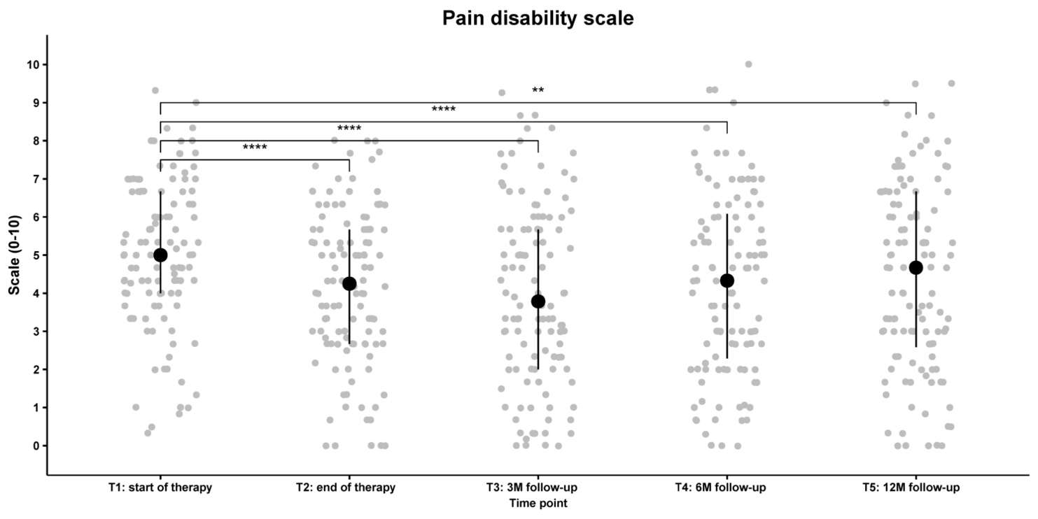

Figure S4-1. Median, first and third quartile (Q₁/Q₃) of the pain-related disability scale for the 114 patients in the 4-week therapy program with complete datasets for T1 (start of therapy), T2 (end of therapy), 3-months (T3, median=3, Q_{1|3}: 2|3), 6-months (T4, median=6, Q_{1|3}: 6|7) and 12-months follow-up (T5, median=12, Q_{1|3}: 12|12). Significant differences to T1 data in the Wilcoxon signed-rank tests are marked with stars (Bonferroni-Holm corrected p values: ** p<0.01, *** p<0.001, **** p<0.0001, effect sizes T₁T₂: r=0.36, T₁T₃: r=0.34, T₁T₄: r=0.26, T₁T₅: r=0.20).

