Soil dryness matters to ecosystem photosynthesis when and where it does

Jiangong Liu¹, Qiren Wang², Weiwei Zhan¹, Xu Lian¹, Pierre Gentine¹

¹ Department of Earth and Environmental Engineering, Columbia University, New York, NY 10027, USA
² Division of Geological and Planetary Sciences, California Institute of Technology, Pasadena, CA 91125, USA

The SI contains 2 Supplementary Tables and 6 Supplementary Figures.

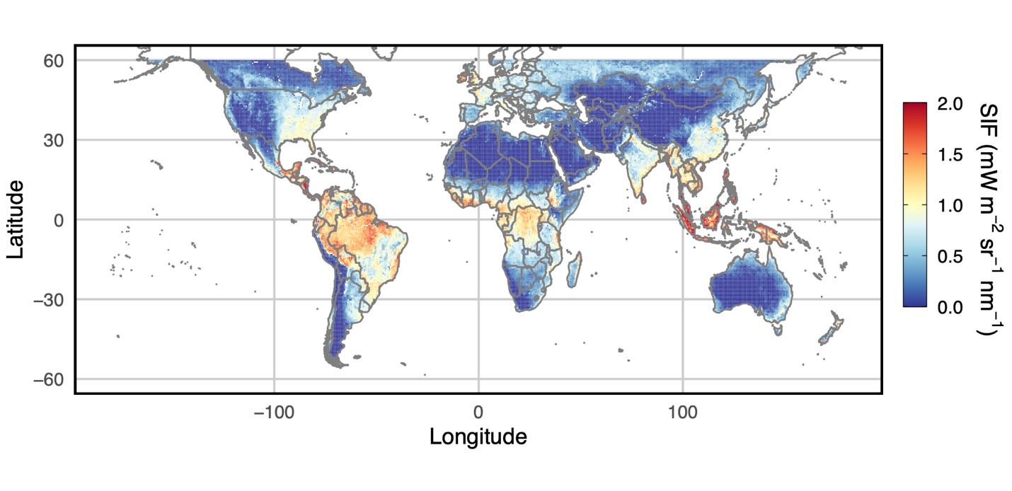
Supplementary Fig. 1: Spatial variability of the yearly-averaged TROPMI SIF for 2020.

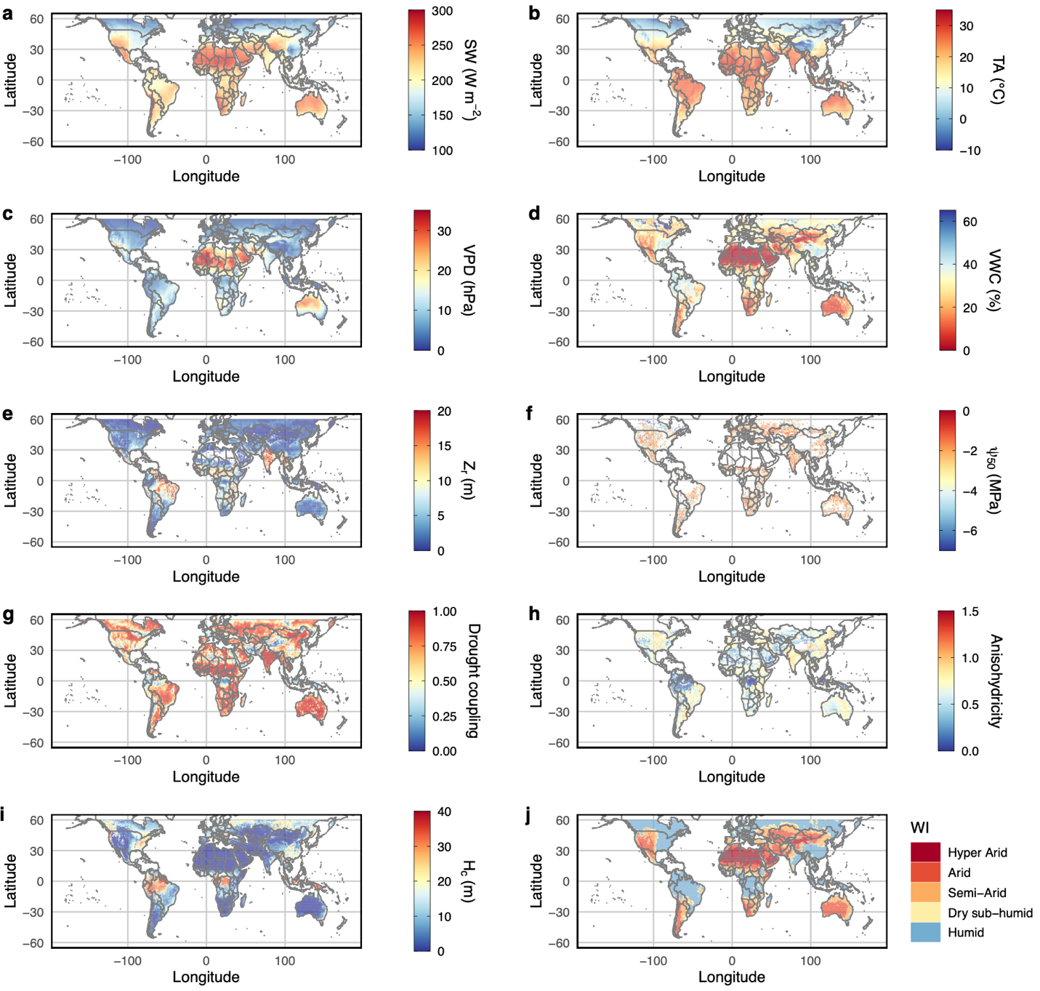
Supplementary Fig. 2: Global patterns of the spatial data used in this study. The annual averages of SW (a), TA (b), VPD (c), soil VWC (d), as well as Z_{r} (e), Ψ₅₀ (f), drought coupling index (g), degree of anisohydricity (h), canopy height (H_{c}) (i), and wetness index (WI) (j). The drought coupling index, derived from ref¹, demonstrates ecosystem resilience to variations in water availability, with stronger coupling indicating lower resilience to droughts. SW: incoming shortwave radiation; TA: air temperature; VPD: vapour pressure deficit; VWC: volumetric water content; Z_{r}: apparent rooting depth; Ψ₅₀: xylem water potential measured at 50% xylem conductivity loss; H_{c}: canopy height; WI: wetness index.

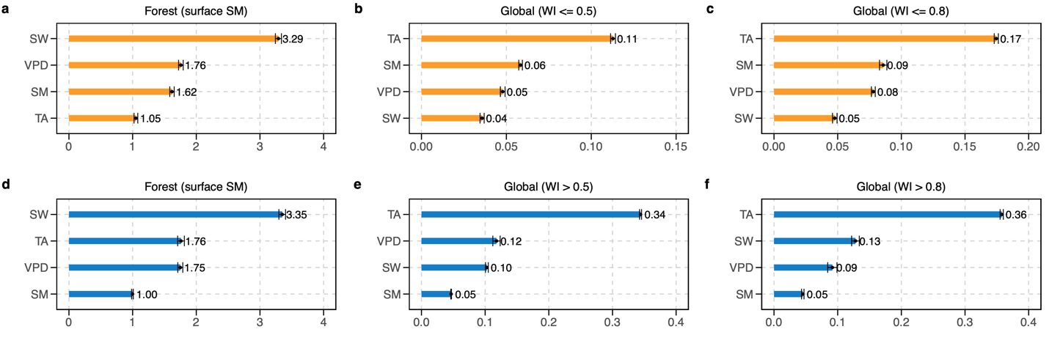
Supplementary Fig. 3: Sensitivity analysis for the choices of soil VWC depths and WI thresholds. Influence of using surface soil VWC (a,d) on GPP over forest sites and influence of WI thresholds of 0.5 (b,e) and 0.8 (c,f) on global biome SIF. Orange and blue bars illustrate conditions of water and energy limitation, respectively. Error bars indicate one standard deviation of the causal Shapley values calculated from three XGBoost models. Causal Shapley values are presented in consistent units with the eddy covariance half-hourly GPP data (µmol m⁻² s⁻¹, a,d) and TROPOMI SIF (mW m⁻² sr⁻¹ nm⁻¹, b,c,e,f). SW: incoming shortwave radiation; TA: air temperature; VPD: vapour pressure deficit; SM: soil moisture.

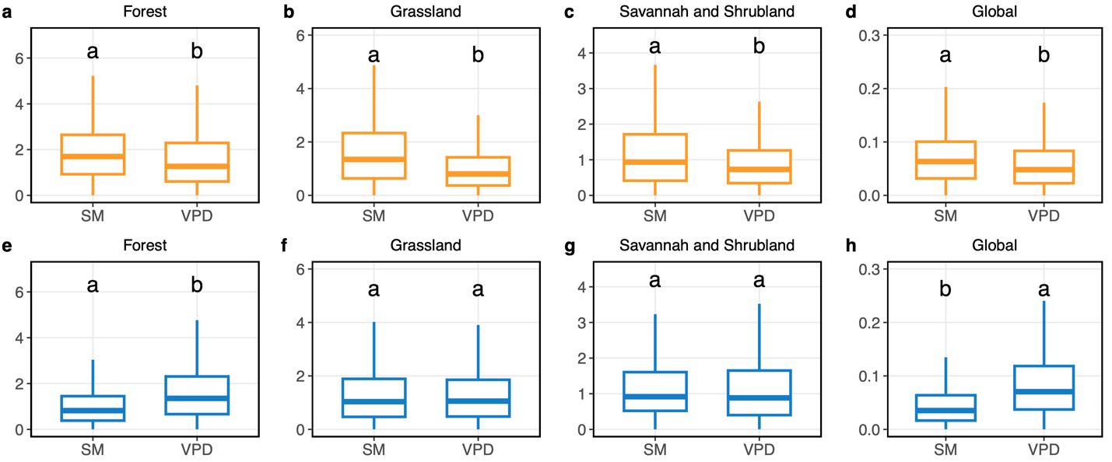
Supplementary Fig. 4: Comparison between the causal Shapely values for VWC and VPD. Different letters represent statistically significant differences in means (Welch’s t-tests, P < 0.05), and letter a indicates the variable with higher values. Orange and blue box plots represent conditions of water and energy limitation, respectively. The central lines indicate the median values, the upper and lower box limits represent the 75% and 25% percentiles, and the upper and lower whiskers extend to 1.5 times the interquartile range, respectively.

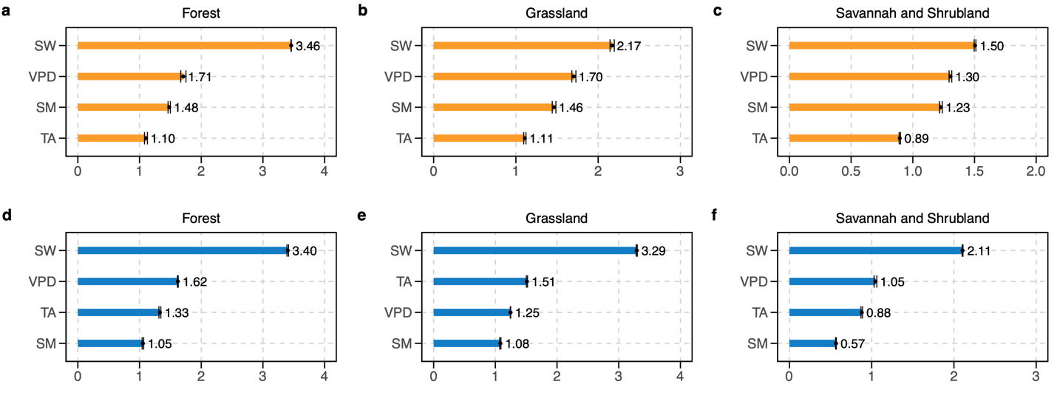
Supplementary Fig. 5: SHAP-based relative importance of predominant hydrometeorological drivers of GPP. a-f, The average absolute Shapley values calculated from triplicate XGBoost models based on SHAP for the biome-level eddy covariance GPP for forests (a,d), grasslands (b,e), and drylands (c,f). Orange and blue bars illustrate conditions of water and energy limitation, respectively. Error bars indicate one standard deviation of the Shapley values calculated from three XGBoost models. The Shapley values are presented in consistent units with the eddy covariance half-hourly GPP data (µmol m⁻² s⁻¹). SW: incoming shortwave radiation; TA: air temperature; VPD: vapour pressure deficit; SM: soil moisture.

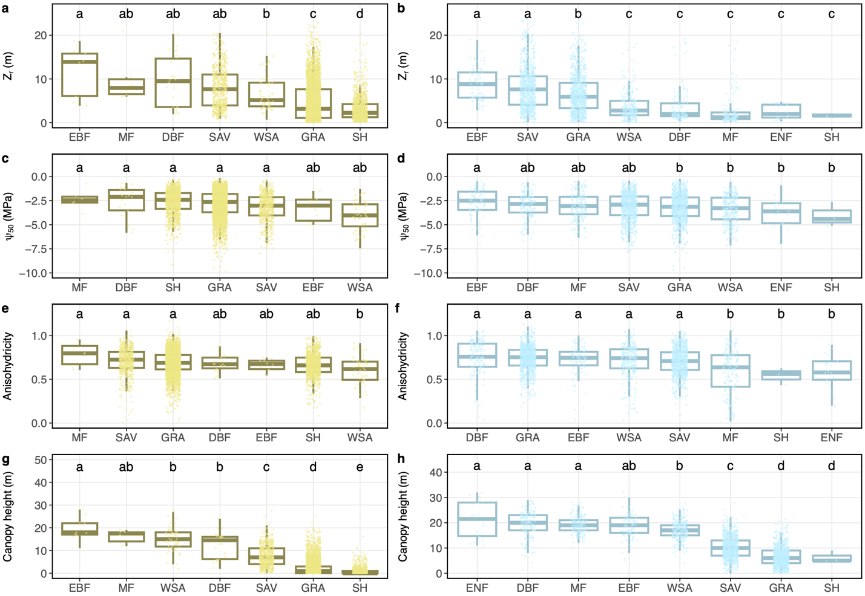
Supplementary Fig. 6: Comparison of Z_{r}, Ψ₅₀, degree of anisohydricity, and canopy height among different PFTs. Beige and blue colours represent water- and energy-limited regions. Letters represent statistically significant differences in the mean values (Tukey’s HSD test, P < 0.05). PFTs are arranged in descending order based on the averages. For box plots, the central lines indicate the median values, the upper and lower box limits represent the 75% and 25% percentiles, and the upper and lower whiskers extend to 1.5 times the interquartile range, respectively. Z_{r}: apparent rooting depth; Ψ₅₀: xylem water potential measured at 50% xylem conductivity loss.

Supplementary Table 1: Information on the selected FLUXNET2015 sites
Site | IGBPª | Threshold^{b} | Period | Latitude | Longitude | DOI
AT-Neu | GRA | Biome | 2002-2012 | 47.11667 | 11.3175 | 10.18140/FLX/1440121
AU-ASM | SAV | Site | 2010-2014 | -22.283 | 133.249 | 10.18140/FLX/1440194
AU-Cpr | SAV | Site | 2010-2014 | -34.0021 | 140.5891 | 10.18140/FLX/1440195
AU-DaP | GRA | Site | 2007-2013 | -14.0633 | 131.3181 | 10.18140/FLX/1440123
AU-DaS | SAV | Biome | 2008-2014 | -14.1593 | 131.3881 | 10.18140/FLX/1440122
AU-Dry | SAV | Site | 2008-2014 | -15.2588 | 132.3706 | 10.18140/FLX/1440197
AU-How | WSA | Site | 2001-2014 | -12.4943 | 131.1523 | 10.18140/FLX/1440125
AU-Stp | GRA | Site | 2008-2014 | -17.1507 | 133.3502 | 10.18140/FLX/1440204
BE-Vie | MF | Biome | 1996-2014 | 50.30493 | 5.99812 | 10.18140/FLX/1440130
CA-NS6 | OSH | Site | 2001-2005 | 55.91667 | -98.96444 | 10.18140/FLX/1440041
CA-SF3 | OSH | Biome | 2001-2006 | 54.09156 | -106.00526 | 10.18140/FLX/1440048
CH-Cha | GRA | Site | 2005-2014 | 47.21022 | 8.41044 | 10.18140/FLX/1440131
CH-Dav | ENF | Biome | 1997-2014 | 46.81533 | 9.85591 | 10.18140/FLX/1440132
CH-Fru | GRA | Biome | 2005-2014 | 47.11583 | 8.53778 | 10.18140/FLX/1440133
CH-Oe1 | GRA | Site | 2002-2008 | 47.28583 | 7.73194 | 10.18140/FLX/1440135
CZ-BK2 | GRA | Site | 2004-2012 | 49.49443 | 18.54285 | 10.18140/FLX/1440144
DE-Gri | GRA | Biome | 2004-2014 | 50.95004 | 13.51259 | 10.18140/FLX/1440147
DE-Hai | DBF | Site | 2000-2012 | 51.07921 | 10.45217 | 10.18140/FLX/1440148
DE-Lnf | DBF | Site | 2002-2012 | 51.32822 | 10.3678 | 10.18140/FLX/1440150
DE-Obe | ENF | Biome | 2008-2014 | 50.78666 | 13.72129 | 10.18140/FLX/1440151
DK-Sor | DBF | Site | 1996-2014 | 55.48587 | 11.64464 | 10.18140/FLX/1440155
ES-Amo | OSH | Biome | 2007-2012 | 36.83361 | -2.25232 | 10.18140/FLX/1440156
ES-LJu | OSH | Site | 2004-2013 | 36.92659 | -2.75212 | 10.18140/FLX/1440157
FI-Hyy | ENF | Biome | 1996-2014 | 61.84741 | 24.29477 | 10.18140/FLX/1440158
FR-LBr | ENF | Site | 1996-2008 | 44.71711 | -0.7693 | 10.18140/FLX/1440163
GF-Guy | EBF | Site | 2004-2014 | 5.27877 | -52.92486 | 10.18140/FLX/1440165
GL-ZaH | GRA | Biome | 2000-2014 | 74.47328 | -20.5503 | 10.18140/FLX/1440224
IT-Col | DBF | Site | 1996-2014 | 41.84936 | 13.58814 | 10.18140/FLX/1440167
IT-Lav | ENF | Site | 2003-2014 | 45.9562 | 11.28132 | 10.18140/FLX/1440169
IT-MBo | GRA | Site | 2003-2013 | 46.01468 | 11.04583 | 10.18140/FLX/1440170
IT-Noe | CSH | Site | 2004-2014 | 40.60618 | 8.15169 | 10.18140/FLX/1440171
IT-SRo | ENF | Site | 1999-2012 | 43.72786 | 10.28444 | 10.18140/FLX/1440176
IT-Tor | GRA | Site | 2008-2014 | 45.84444 | 7.57806 | 10.18140/FLX/1440237
NL-Loo | ENF | Biome | 1996-2014 | 52.16658 | 5.74356 | 10.18140/FLX/1440178
RU-Fyo | ENF | Site | 1998-2014 | 56.46153 | 32.92208 | 10.18140/FLX/1440183
SD-Dem | SAV | Site | 2005-2009 | 13.2829 | 30.4783 | 10.18140/FLX/1440186
US-IB2 | GRA | Site | 2004-2011 | 41.84062 | -88.24103 | 10.18140/FLX/1440072
US-SRG | GRA | Site | 2008-2014 | 31.789379 | -110.82768 | 10.18140/FLX/1440114
US-SRM | WSA | Site | 2004-2014 | 31.8214 | -110.8661 | 10.18140/FLX/1440090
US-Ton | WSA | Site | 2001-2014 | 38.4316 | -120.96598 | 10.18140/FLX/1440092
US-Var | GRA | Site | 2000-2014 | 38.4133 | -120.9507 | 10.18140/FLX/1440094
US-Whs | OSH | Site | 2007-2014 | 31.7438 | -110.0522 | 10.18140/FLX/1440097
US-Whs | OSH | Site | 2007-2014 | 31.7438 | -110.0522 | 10.18140/FLX/1440097
US-Wkg | GRA | Site | 2004-2014 | 31.7365 | -109.9419 | 10.18140/FLX/1440096
ZM-Mon | DBF | Biome | 2000-2009 | -15.4391 | 23.2525 | 10.18140/FLX/1440189

ªThe land cover classification defined by the International Geosphere Biosphere Programme (IGBP) (definitions are as in Fig. 3)
^{b}Whether the VWC threshold is derived from the site or biome level.

Supplementary Table 2: Performance of the XGBoost models
Biome | Condition | R² | RMSE | rBias | Triplicate No.
Forest | water-limited | 0.653 | 4.477 | -0.010 | 1
Forest | water-limited | 0.661 | 4.468 | 0.668 | 2
Forest | water-limited | 0.657 | 4.468 | -0.326 | 3
Forest | energy-limited | 0.661 | 4.595 | 0.023 | 1
Forest | energy-limited | 0.664 | 4.559 | 0.042 | 2
Forest | energy-limited | 0.663 | 4.562 | 0.020 | 3
Savannah/Shrubland | water-limited | 0.682 | 2.905 | 0.939 | 1
Savannah/Shrubland | water-limited | 0.679 | 2.929 | 0.288 | 2
Savannah/Shrubland | water-limited | 0.675 | 2.932 | 0.250 | 3
Savannah/Shrubland | energy-limited | 0.725 | 4.020 | -0.145 | 1
Savannah/Shrubland | energy-limited | 0.717 | 4.066 | -1.047 | 2
Savannah/Shrubland | energy-limited | 0.724 | 4.050 | -0.106 | 3
Grassland | water-limited | 0.808 | 3.365 | 0.076 | 1
Grassland | water-limited | 0.809 | 3.380 | -0.139 | 2
Grassland | water-limited | 0.807 | 3.436 | 0.292 | 3
Grassland | energy-limited | 0.630 | 5.500 | 0.153 | 1
Grassland | energy-limited | 0.635 | 5.462 | -0.040 | 2
Grassland | energy-limited | 0.637 | 5.459 | -0.533 | 3
Global | water-limited | 0.777 | 0.141 | 2.498 | 1
Global | water-limited | 0.763 | 0.142 | -0.251 | 2
Global | water-limited | 0.766 | 0.141 | -0.236 | 3
Global | energy-limited | 0.854 | 0.189 | -0.228 | 1
Global | energy-limited | 0.856 | 0.187 | 0.246 | 2
Global | energy-limited | 0.855 | 0.188 | 1.095 | 3

Reference
1. Anderegg, W. R. L. et al. Hydraulic diversity of forests regulates ecosystem resilience during drought. Nature 561, 538–541 (2018).

