Synthesis and characterization of Substituted Schiff Base from Benzene-1,4-Diamine: Study of Biological Activity and Corrosion Inhibitor Effect
Sura Hamid Kathim^{1*}, Hayder Dawood Arkawazi 2†
and Mohamed Loukil3†
^{*1}WasitUniversity, Al-Kut, Wasit, Iraq.
² Wasit University, Al-Kut, Wasit, Iraq.
³ SfaxUniversity, Al-Ain, Sfax, Tunis.

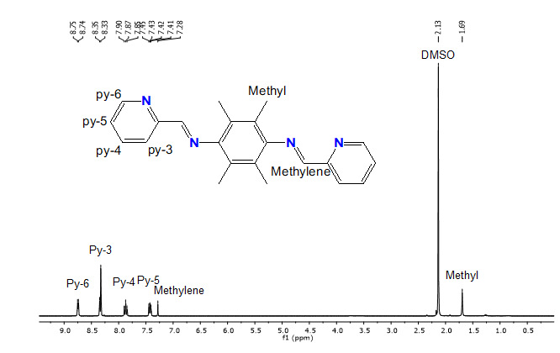
Fig.S1. ¹H NMR spectrum of " of ligands L2a.
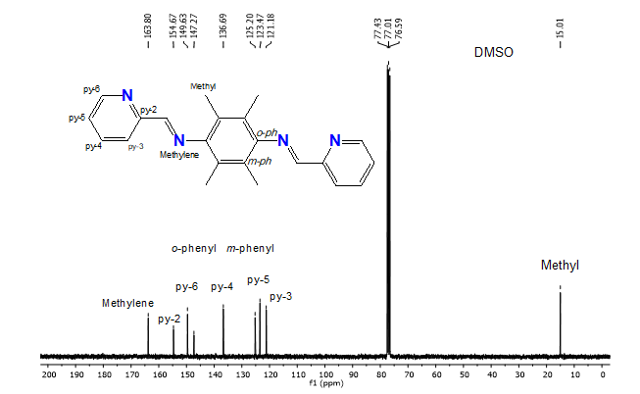

Fig.S2.¹³CNMR spectrum of " of ligands L2a.

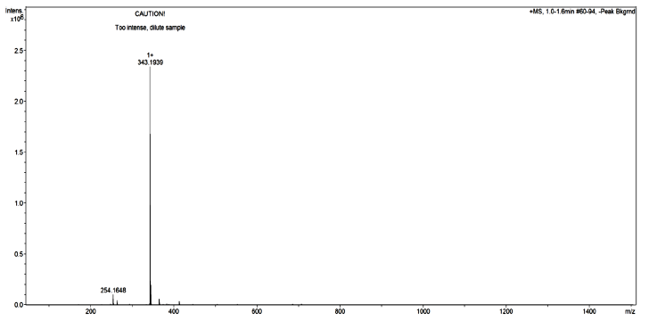
Fig.S3. Mass spectrum of " of ligands L2a.
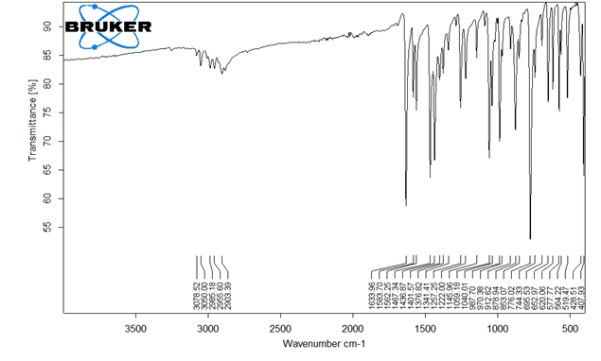

Figure 4. FT. IR spectrum of " of ligands L2a

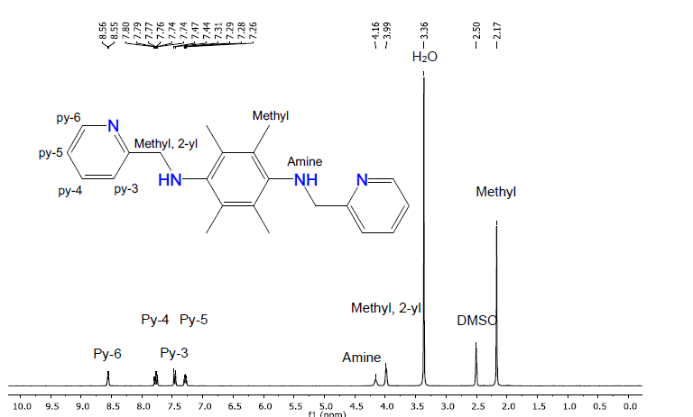
Fig.S5.¹H NMR spectrum of " of ligands L2b.

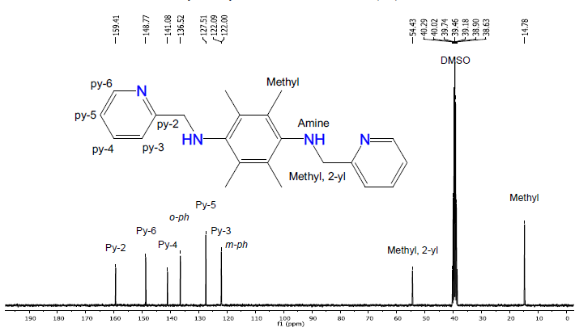

Fig.S6.¹³C NMR spectrum of of ligands L2b.

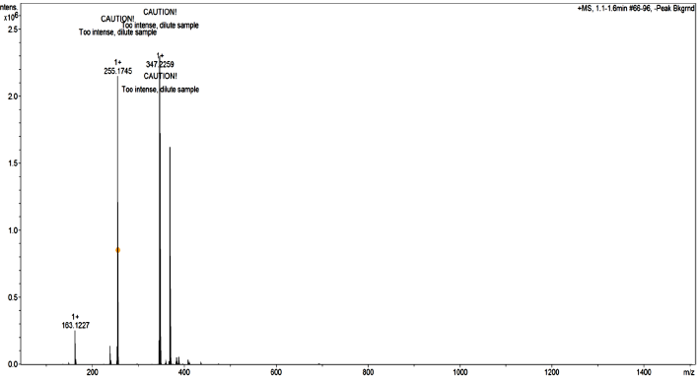
Fig.S7.Mass spectrum of of ligands L2b.
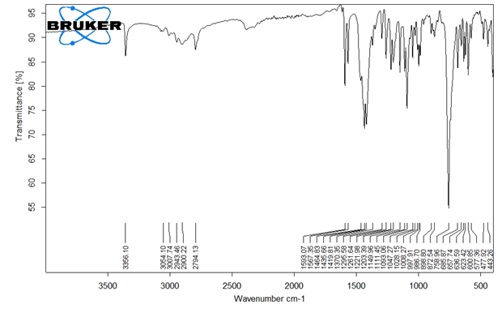

Figure 8. FT. IR spectrum " of ligands L2b

