- Extended Data Figures
- Supplement

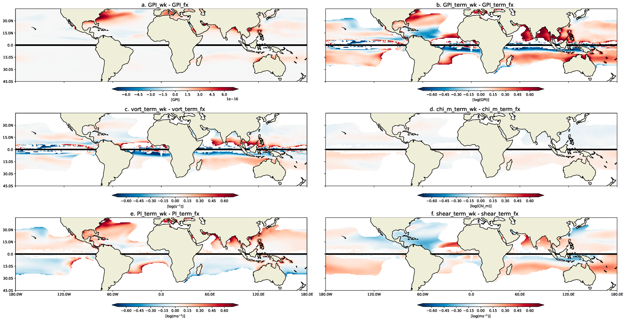
Extended Data Figure 1. Logarithmic GPI decomposition. The absolute change in GPI between the 2075-2100 averaged wk and fx simulations in Fig. 3 are shown in (a), and the logarithm of the difference depicted in (a) is shown in (b). GPI is not normalized to yield 90 annual storms per season in this figure. The logarithmic decomposition of the variables comprising GPI are shown: (c) absolute vorticity, (d) moist entropy deficit in the mid-troposphere, (e) TC potential intensity (PI), and (f) vertical wind shear between 850hPa and 250 hPa. White values represent undefined or zero values. Panels (c), (d), (e), and (f) sum to panel (b). In all panels, ASO (DJF) conditions are depicted in the Northern (Southern) Hemisphere, respectively. High magnitude increases in Northern Hemisphere potential intensity (e), particularly near the Southeastern U.S. coastline, due to a weakened AMOC, are critical for the projected increase of basin TC activity. The higher magnitude of (e) and (f) in comparison to (c) and (d) highlights the important contribution of potential intensity and vertical wind shear to changes in global TC activity. Note that (b)-(f) are plotted using the same scale and can be directly compared. Positive values imply a variable’s increase when AMOC declines, and vice versa. Given that the chi_m and shear_terms are negated, positive values in panels (d) and (f) suggest a decrease in moist entropy deficit and vertical wind shear with a decline in the AMOC strength. Units are given in square brackets.
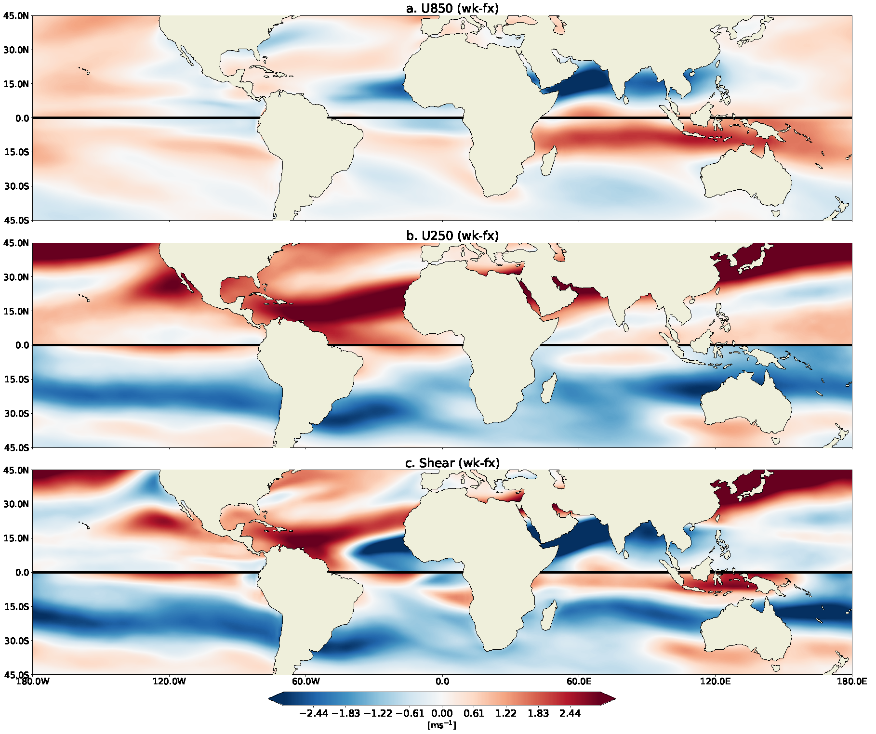
Extended Data Figure 2. The AMOC’s effect on global winds. The difference in zonally-averaged winds between the 2075-2100 ensemble mean of the wk simulation and the fx simulation at (a) 850 hPa and (b) 250 hPa, and the difference in vertical windshear between these two levels of the atmosphere (c). We observe a greater magnitude of change in the upper atmosphere, as well as a strengthening of the East Asian Jetstream with a weakened AMOC (observed red values). In all panels, ASO (DJF) conditions are depicted in the Northern (Southern) Hemisphere.

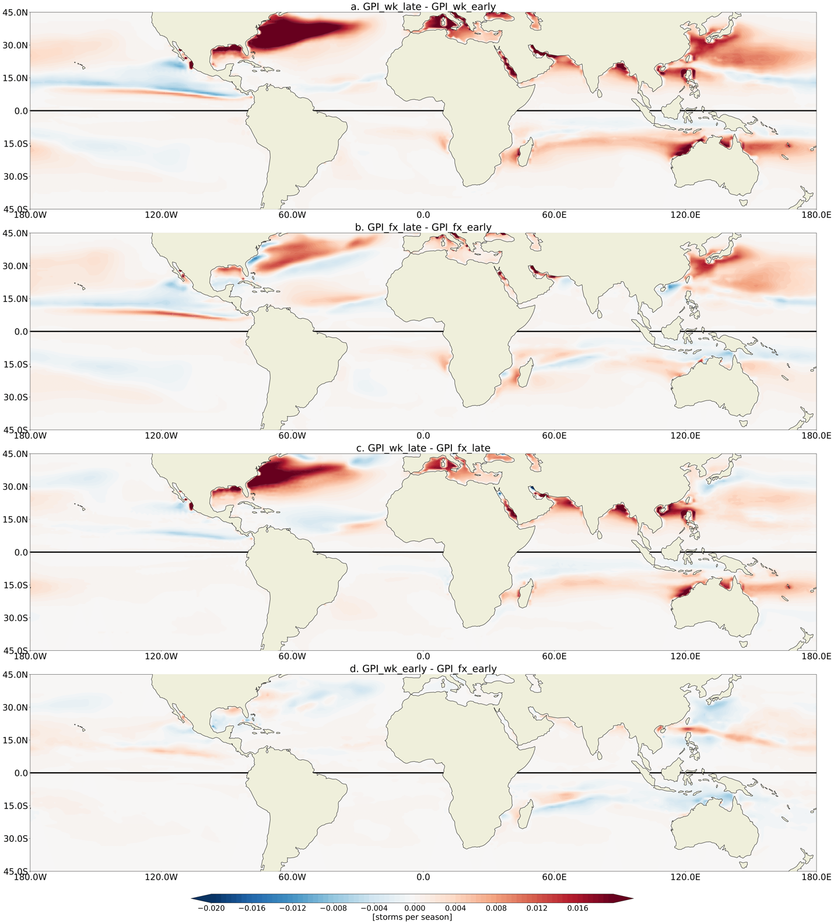

Extended Data Figure 3. Spatial change in TC genesis potential due to anthropogenic warming and/or AMOC weakening. The difference in mean TC season GPI between (a) the 2075-2100 late wk RCP8.5 simulation and the 1980-2005 early wk historical simulation, (b) the 2075-2100 late fx RCP8.5 simulation and the 1980-2005 early fx historical simulation, (c) the 2075-2100 late wk RCP8.5 simulation and the 2075-2100 late fx RCP8.5 simulation, and (d) the 1980-2005 early wk historical simulation and the 1980-2005 early fx historical simulation. GPI has been normalized to yield a global annual average of 90 events between 1980-2005 of the wk simulation. ASO (DJF) conditions are considered in the Northern (Southern) Hemisphere. Panel (a) represents the combined signal of anthropogenic forcing and AMOC weakening, panel (b) represents the signal due to anthropogenic warming, panel (c) represents the signal due to a weakened AMOC in a warmer climate, and panel (d) represents the signal due to a weakened AMOC in a historical 1980-2005 climate. Note the projected increase in North Atlantic TC activity in a warmer climate and the dominant contribution of the declining AMOC to this increase in the North Atlantic.

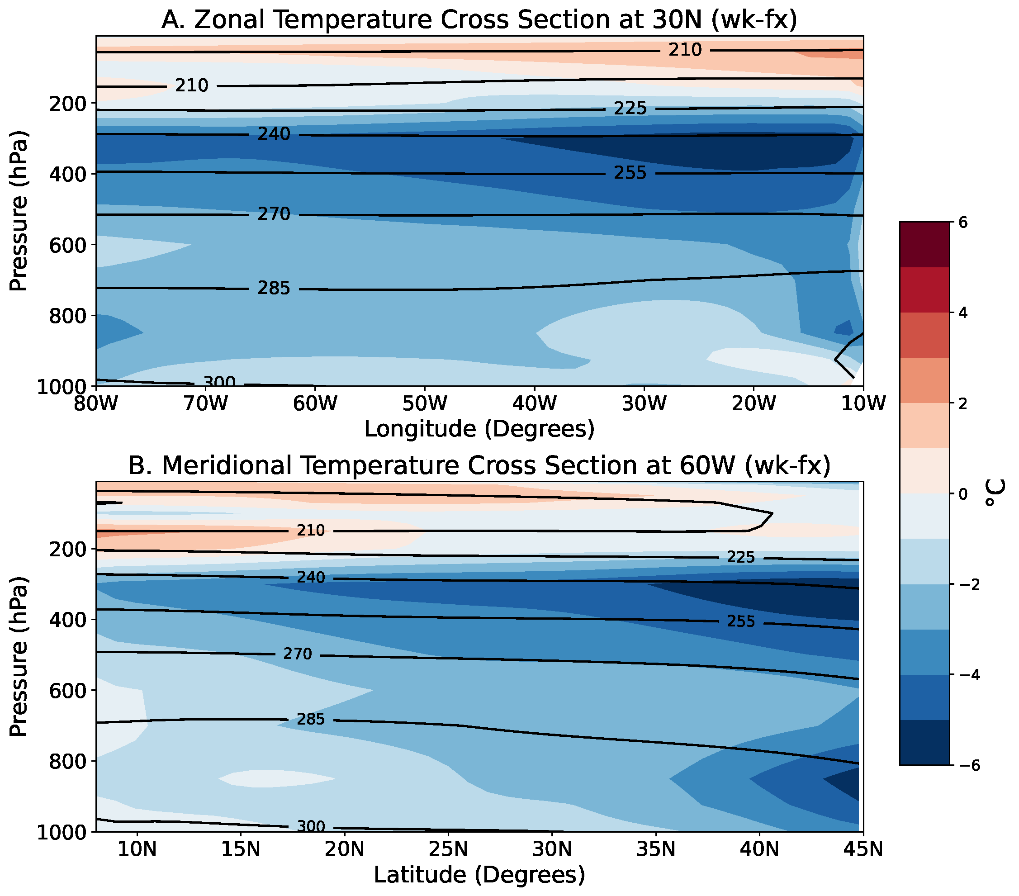
Extended Data Figure 4. Reduced atmospheric temperature stratification with a weakened AMOC. Differences in atmospheric temperature between the wk and fx simulations (a) along 30°N and (b) along 60°W in the North Atlantic. These cross sections depict the relative temperature change in the atmosphere due to a weakening of the AMOC, given a warm late-21st century climate. Black contour lines depict mean temperature (in K) for the wk simulation. We observe a stronger relative cooling in the upper troposphere than in the lower troposphere and, therefore, a reduction of temperature stratification and atmospheric static stability in the global warming scenario with a weaker AMOC. We stress that the “cooling” refers only to the difference between the wk and fx simulations, but in both simulations the atmosphere actually warms.
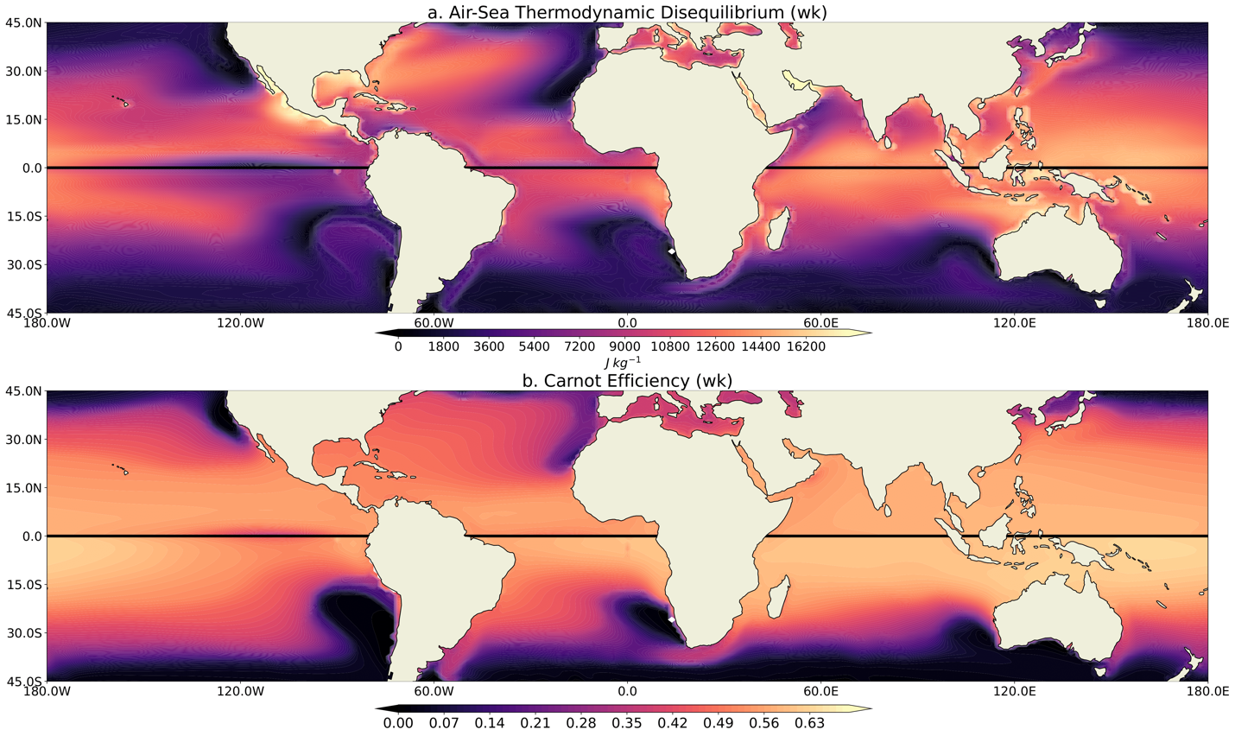
Extended Data Figure 5. Air-Sea thermodynamic disequilibrium and Carnot Efficiency in a warming 21st-century climate with a weakened AMOC. (a) Air-sea thermodynamic disequilibrium (eq. 5) during the wk simulation for TC seasons. (b) Similar but for the modified Carnot efficiency (eq. 5), which is unitless. ASO (DJF) conditions are depicted in the Northern (Southern) Hemisphere for all panels.

b) Supplement
Decomposition of the GPI Equation
To complete a linear factor separation of GPI, we follow the methods of ref. 7 and took the logarithm of both sides of equation 1:
$$\log\left(GPI\right)= \left[3\log\left(\left|vort\right|\right)\right]- \left[ \frac{4}{3}log\left(χ\right)\right]+$$
$\left[2log\left\{MAX\left[\left(PI-35 ms^{-1}\right),1\right]\right\}\right]- \left[4log\left(25 ms^{-1}+ shear\right)\right]$ (2),
where we define $\log\left(GPI\right)$ as the GPI_term, $3\log\left(\left|vort\right|\right)$ as the vort_term, $\frac{4}{3}log\left(χ\right)$ as the chi_m_term, $2log\left\{MAX\left[\left(PI-35 ms^{-1}\right),1\right]\right\}$ as the PI_term, and $4log\left(25 ms^{-1}+ shear\right)$ as the shear_term.
To investigate the influence of each environmental variable in the GPI equation (Eqn. 1) on the overall change in projected TC activity between the two model simulations, we follow the practices of Emanuel 2020 (7) and complete a linear factor separation of equation 1, by taking the logarithm of both sides of this equation (see Eqn. 2). We can draw conclusions about which environmental factors largely contribute to the difference in GPI projections between the two simulations by subtracting the terms on the righthand side of Eqn. 2 for each simulation. In this way we decompose Eqn1 into an additive equation and examine each factor comprising the GPI definition on the same scale. Therefore, Figs. S1c-f sum to the results in Fig. S1b.
First, in the North Atlantic, we observe a similar magnitude of increase in PI and GPI near the U.S. coastline on a log scale between the two simulations (Fig. S1e). This suggests that a weakened AMOC contributes to a notable increase in PI near the coastal southeastern United States. Figs. 4b and 4f illustrate that this spatial shift in shear is a contributing factor to the increase in GPI in this region. Additionally, using the logarithmic decomposition of the GPI equation, we find that a weakened AMOC contributes to an increase in Caribbean vertical wind shear and a decrease in TC Main Development Region vertical wind shear (Fig. 21f), which aligns with the results presented by Yan et al. 2017 (31; see Fig. 3). These patterns, along with the slight decrease in shear near the U.S. coastline, appears to contribute to changes in GPI in these regions. Figs. S1b, S1e, and S1f illustrate the importance of PI and vertical wind shear in governing the North Atlantic GPI between the two simulations. PI and vertical windshear also play an important role in governing the changes in GPI in other basins, including the Indian and Pacific Oceans. On the other hand, absolute vorticity and the moist entropy term appear to play a small role in governing the changes in GPI between the two simulations. One exception is an increase in vorticity in the northern Indian Ocean, which impacts the change in the decomposed GPI.
Strengthening of the East Asian jet stream associated with a weakened AMOC
Given the influence of vertical wind shear between 250hPa and 850hPa on shifts in GPI in a warm climate simulation with a weakened AMOC strength in comparison to a warm climate simulation with a fixed AMOC strength, we examine the difference in upper and lower-level zonal winds between the two simulations (Fig. S2). A decrease in strength of the AMOC yields weaker changes in lower-level atmospheric zonal winds (Fig. S2a), but the magnitude of change in upper-level zonal winds at 250hPa is much larger (Fig. S2b). Specifically, upper-level winds in the Caribbean and along the East Asian jet stream (EAJS) intensity given a weakening of the AMOC (+2.60 m s⁻¹). Therefore, this strengthening of upper-atmospheric winds drives variations in vertical wind shear noted in Figures 3c and S2c. Previous studies suggest that the strength of the EAJS is correlated to frequency of landfalling atmospheric rivers over the continental United States (S1) as well as vertical wind shear in the NA TC main development region and NA TC frequencies (S2) due to emanating Rossby wave trains from East Asia. We note that in a warmer climate with a weak AMOC strength relative to a warmer climate with a steady AMOC strength, 250hPa northern hemisphere zonal winds are strengthened, which has implications for large-scale atmospheric circulation and TC development.

References
S1. Zhang, W., & Villarini, G. (2018). Uncovering the role of the East Asian jet stream and heterogeneities in atmospheric rivers affecting the Western United States. Proceedings of the National Academy of Sciences, 115(5), 891 896. https://doi.org/10.1073/pnas.1717883115
S2. Zhang, W., Villarini, G., & Vecchi, G. A. (2020). The East Asian subtropical jet stream and Atlantic tropical cyclones. Geophysical Research Letters, 47(15). https://doi.org/10.1029/2020gl088851

