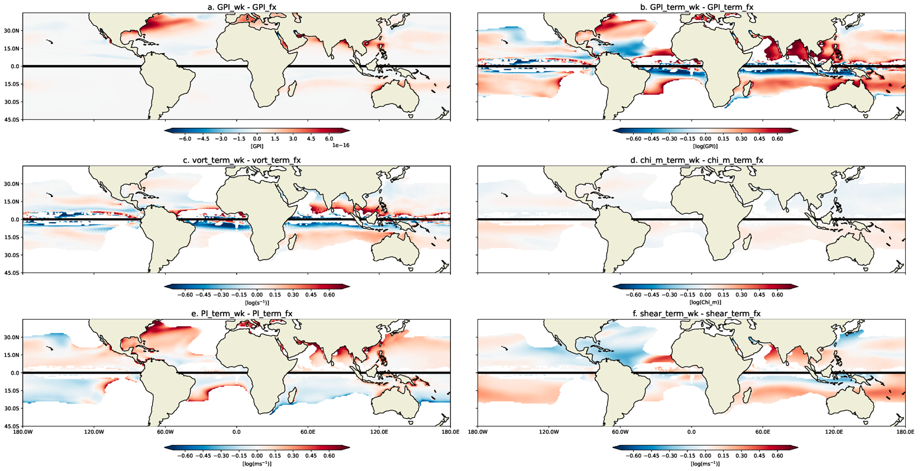
Extended Data Figure 1. Logarithmic GPI decomposition. The absolute change in GPI between the 2075-2100 averaged wk and fx simulations in Fig. 3 are shown in (a), and the logarithm of the difference depicted in (a) is shown in (b). GPI is not normalized to yield 90 annual storms per season in this figure. The logarithmic decomposition of the variables comprising GPI are shown: (c) absolute vorticity, (d) moist entropy deficit in the mid-troposphere, (e) TC potential intensity (PI), and (f) vertical wind shear between 850hPa and 250 hPa. White values represent undefined or zero values. Panels (c), (d), (e), and (f) sum to panel (b). In all panels, ASO (DJF) conditions are depicted in the Northern (Southern) Hemisphere, respectively. High magnitude increases in Northern Hemisphere potential intensity (e), particularly near the Southeastern U.S. coastline, due to a weakened AMOC, are critical for the projected increase of basin TC activity. The higher magnitude of (e) and (f) in comparison to (c) and (d) highlights the important contribution of potential intensity and vertical wind shear to changes in global TC activity. Note that (b)-(f) are plotted using the same scale and can be directly compared. Positive values imply a variable’s increase when AMOC declines, and vice versa. Given that the chi_m and shear_terms are negated, positive values in panels (d) and (f) suggest a decrease in moist entropy deficit and vertical wind shear with a decline in the AMOC strength. Units are given in square brackets.
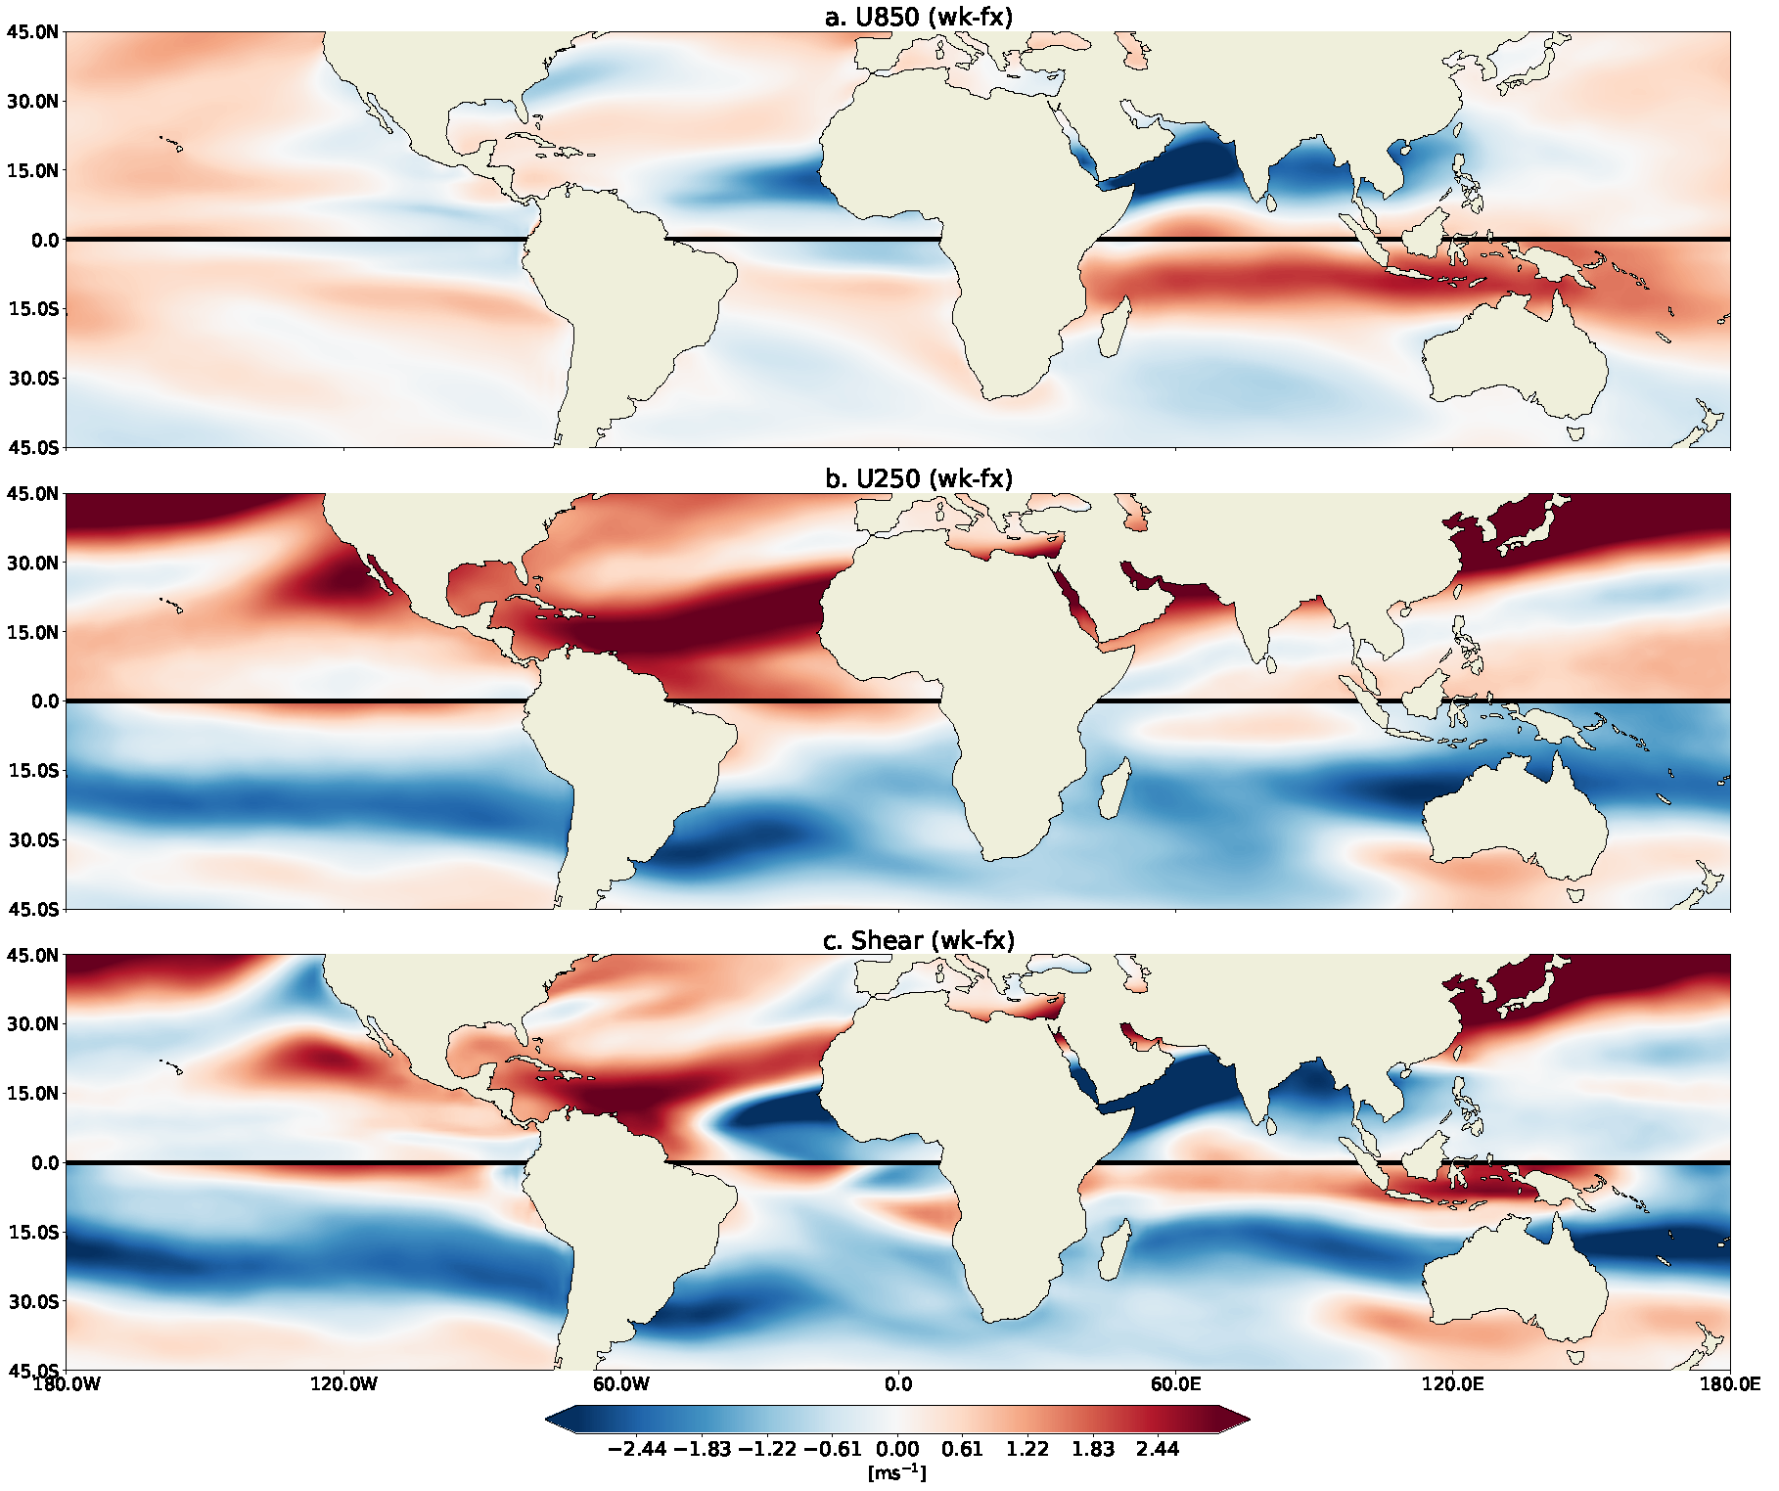
Extended Data Figure 2. The AMOC’s effect on global winds. The difference in zonally-averaged winds between the 2075-2100 ensemble mean of the wk simulation and the fx simulation at (a) 850 hPa and (b) 250 hPa, and the difference in vertical windshear between these two levels of the atmosphere (c). We observe a greater magnitude of change in the upper atmosphere, as well as a strengthening of the East Asian Jetstream with a weakened AMOC (observed red values). In all panels, ASO (DJF) conditions are depicted in the Northern (Southern) Hemisphere.
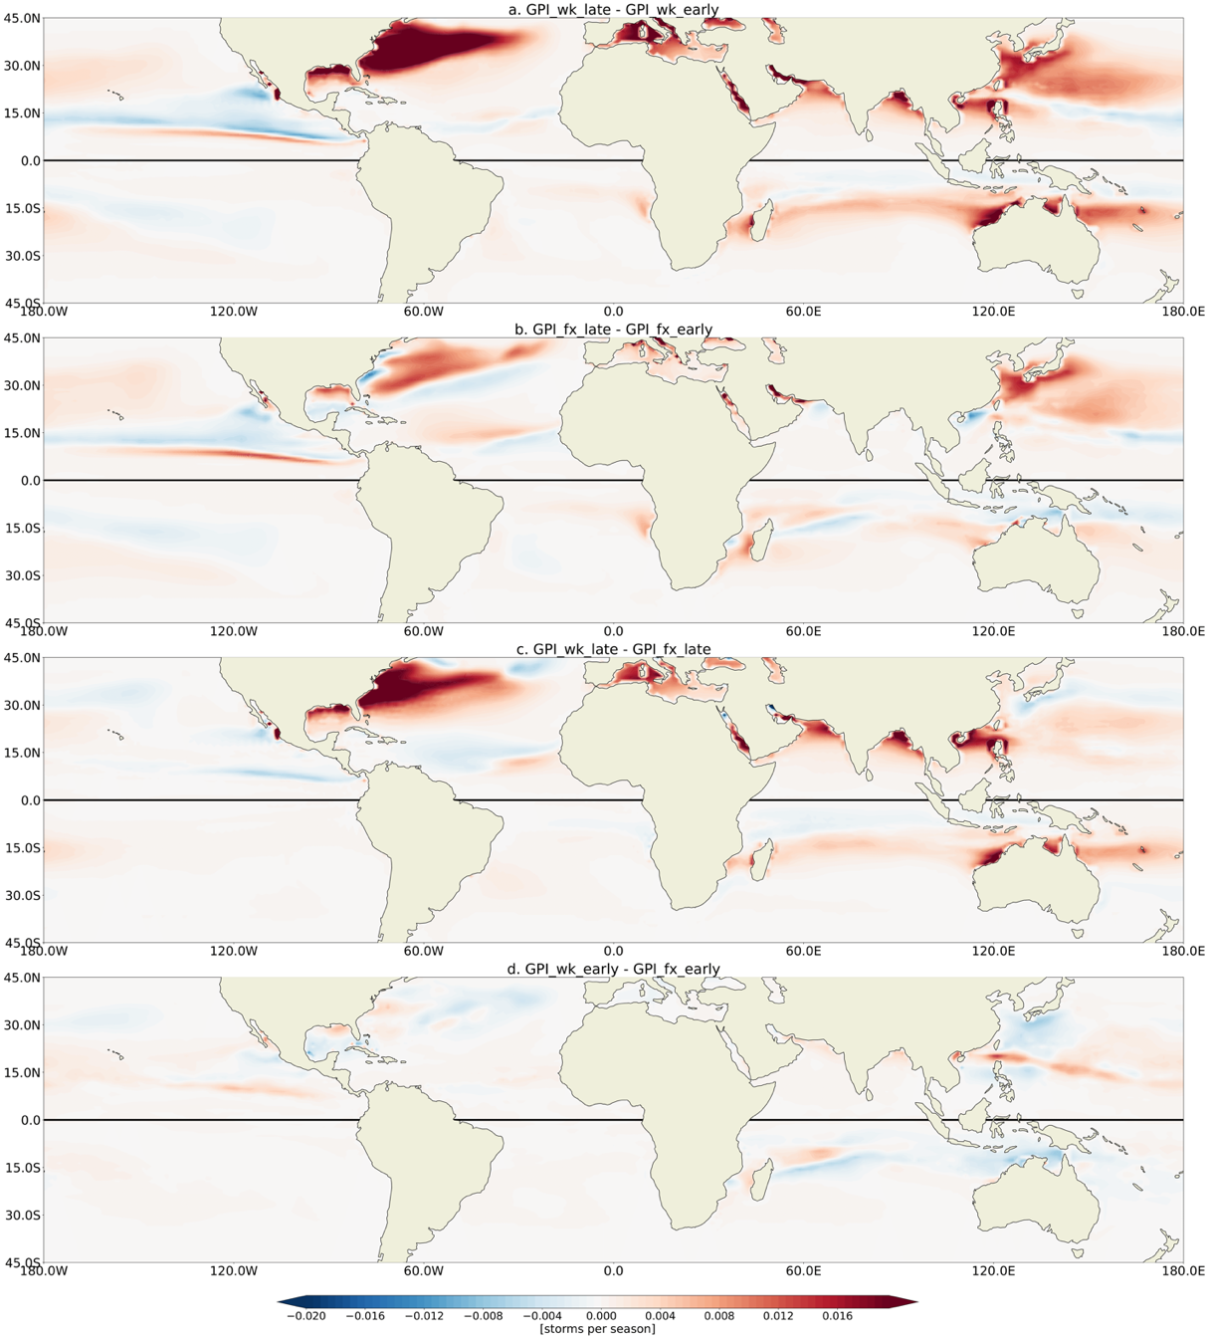
Extended Data Figure 3. Spatial change in TC genesis potential due to anthropogenic warming and/or AMOC weakening. The difference in mean TC season GPI between (a) the 2075-2100 late wk RCP8.5 simulation and the 1980-2005 early wk historical simulation, (b) the 2075-2100 late fx RCP8.5 simulation and the 1980-2005 early fx historical simulation, (c) the 2075-2100 late wk RCP8.5 simulation and the 2075-2100 late fx RCP8.5 simulation, and (d) the 1980-2005 early wk historical simulation and the 1980-2005 early fx historical simulation. GPI has been normalized to yield a global annual average of 90 events between 1980-2005 of the wk simulation. ASO (DJF) conditions are considered in the Northern (Southern) Hemisphere. Panel (a) represents the combined signal of anthropogenic forcing and AMOC weakening, panel (b) represents the signal due to anthropogenic warming, panel (c) represents the signal due to a weakened AMOC in a warmer climate, and panel (d) represents the signal due to a weakened AMOC in a historical 1980-2005 climate. Note the projected increase in North Atlantic TC activity in a warmer climate and the dominant contribution of the declining AMOC to this increase in the North Atlantic.
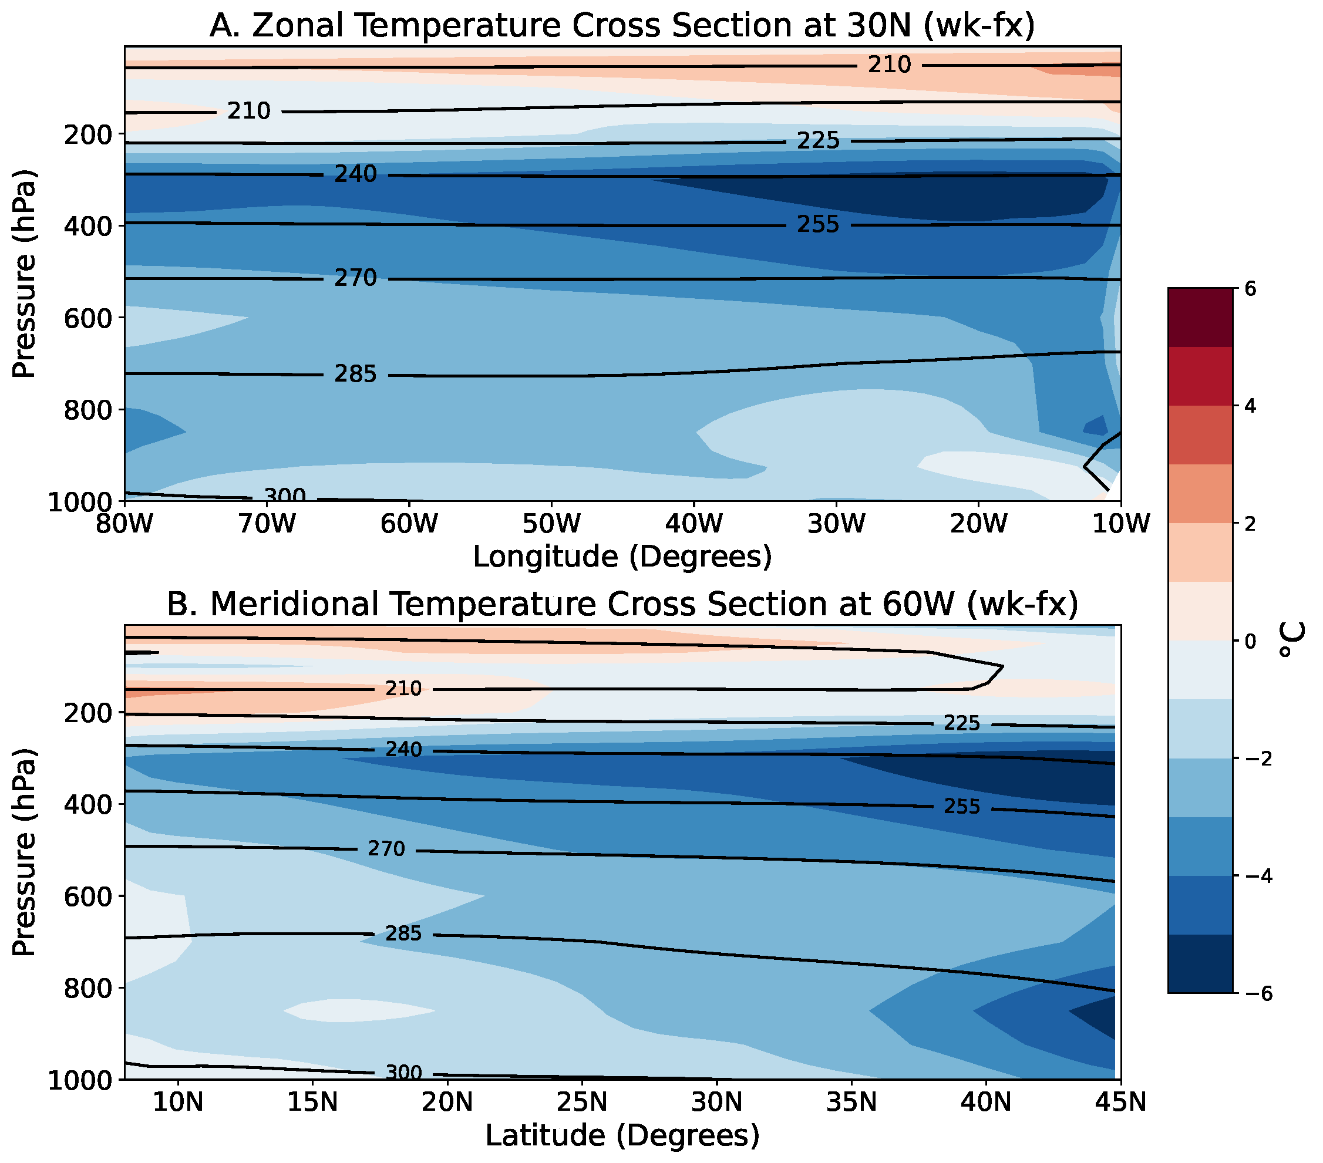
Extended Data Figure 4. Reduced atmospheric temperature stratification with a weakened AMOC. Differences in atmospheric temperature between the wk and fx simulations (a) along 30°N and (b) along 60°W in the North Atlantic. These cross sections depict the relative temperature change in the atmosphere due to a weakening of the AMOC, given a warm late-21st century climate. Black contour lines depict mean temperature (in K) for the wk simulation. We observe a stronger relative cooling in the upper troposphere than in the lower troposphere and, therefore, a reduction of temperature stratification and atmospheric static stability in the global warming scenario with a weaker AMOC. We stress that the “cooling” refers only to the difference between the wk and fx simulations, but in both simulations the atmosphere actually warms.
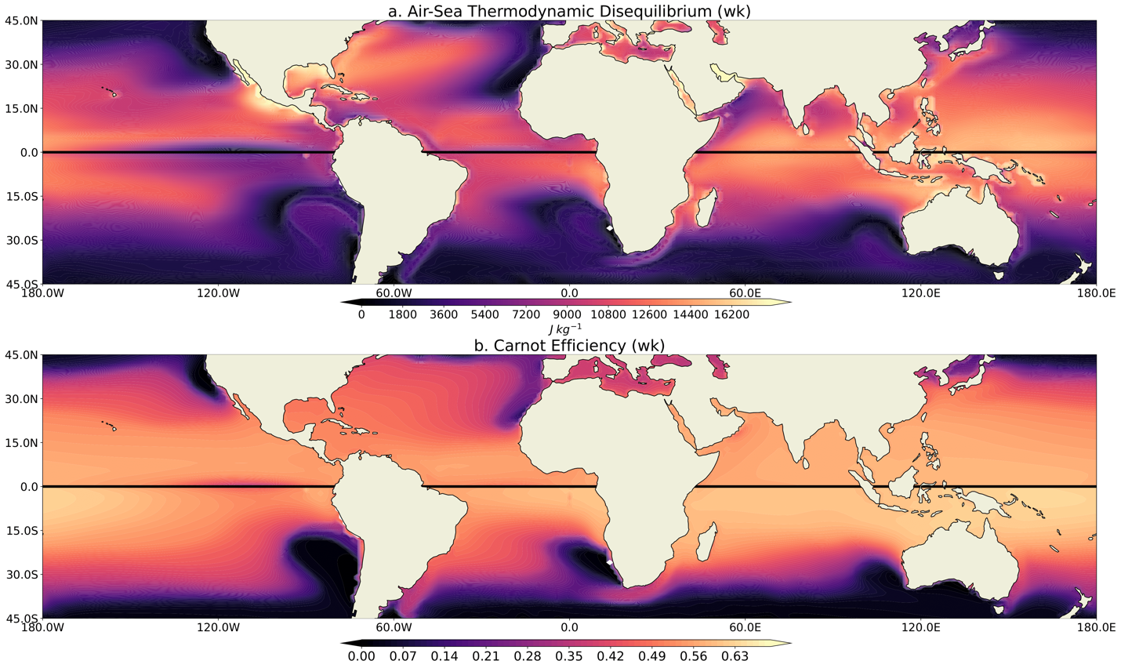

Extended Data Figure 5. Air-Sea thermodynamic disequilibrium and Carnot Efficiency in a warming 21st-century climate with a weakened AMOC. (a) Air-sea thermodynamic disequilibrium (eq. 5) during the wk simulation for TC seasons. (b) Similar but for the modified Carnot efficiency (eq. 5), which is unitless. ASO (DJF) conditions are depicted in the Northern (Southern) Hemisphere for all panels.

