Glacier Forecast: Jakobshavn Isbrae Primed for Thinning and Acceleration
Supplementary Information
CTD observations from tagged ringed seals was collected and analyzed in the fjord between 2016 and 2020. Data collection methods are described in Boehme et al. (2010) and data are available from the NSF Arctic Data Center (https://arcticdata.io/catalog/view/doi:10.18739/A2NV99B1S). Although they often do not dive deep in into the warm, salty Atlantic Water present at depths below the sill depth (245 m), the seals regularly sample the top 200 – 300 m of water in the fjord throughout most of the winter. This water later mixes slightly with the deeper water, that fills the fjord (See Figures 2 & 3 in the main text). The seal data show that the warm water observed in the late March 2020 cruise was not present through the winter of 2019/20 (Supplementary Figure 2). A much shallower layer of 3 – 4 °C water did enter the fjord in the winter at a depth of approximately 50 m (Supplementary Figure 3). Such warm water is occasionally observed inside the fjord during winter months, and has been attributed to surface water that warmed during the summer in Disko Bay (Gladish et al., 2015). However, since these shallow warm waters are trapped in the near surface layer, they are unlikely to play a strong role in direct melt at the glacier face.
Supplementary Figures
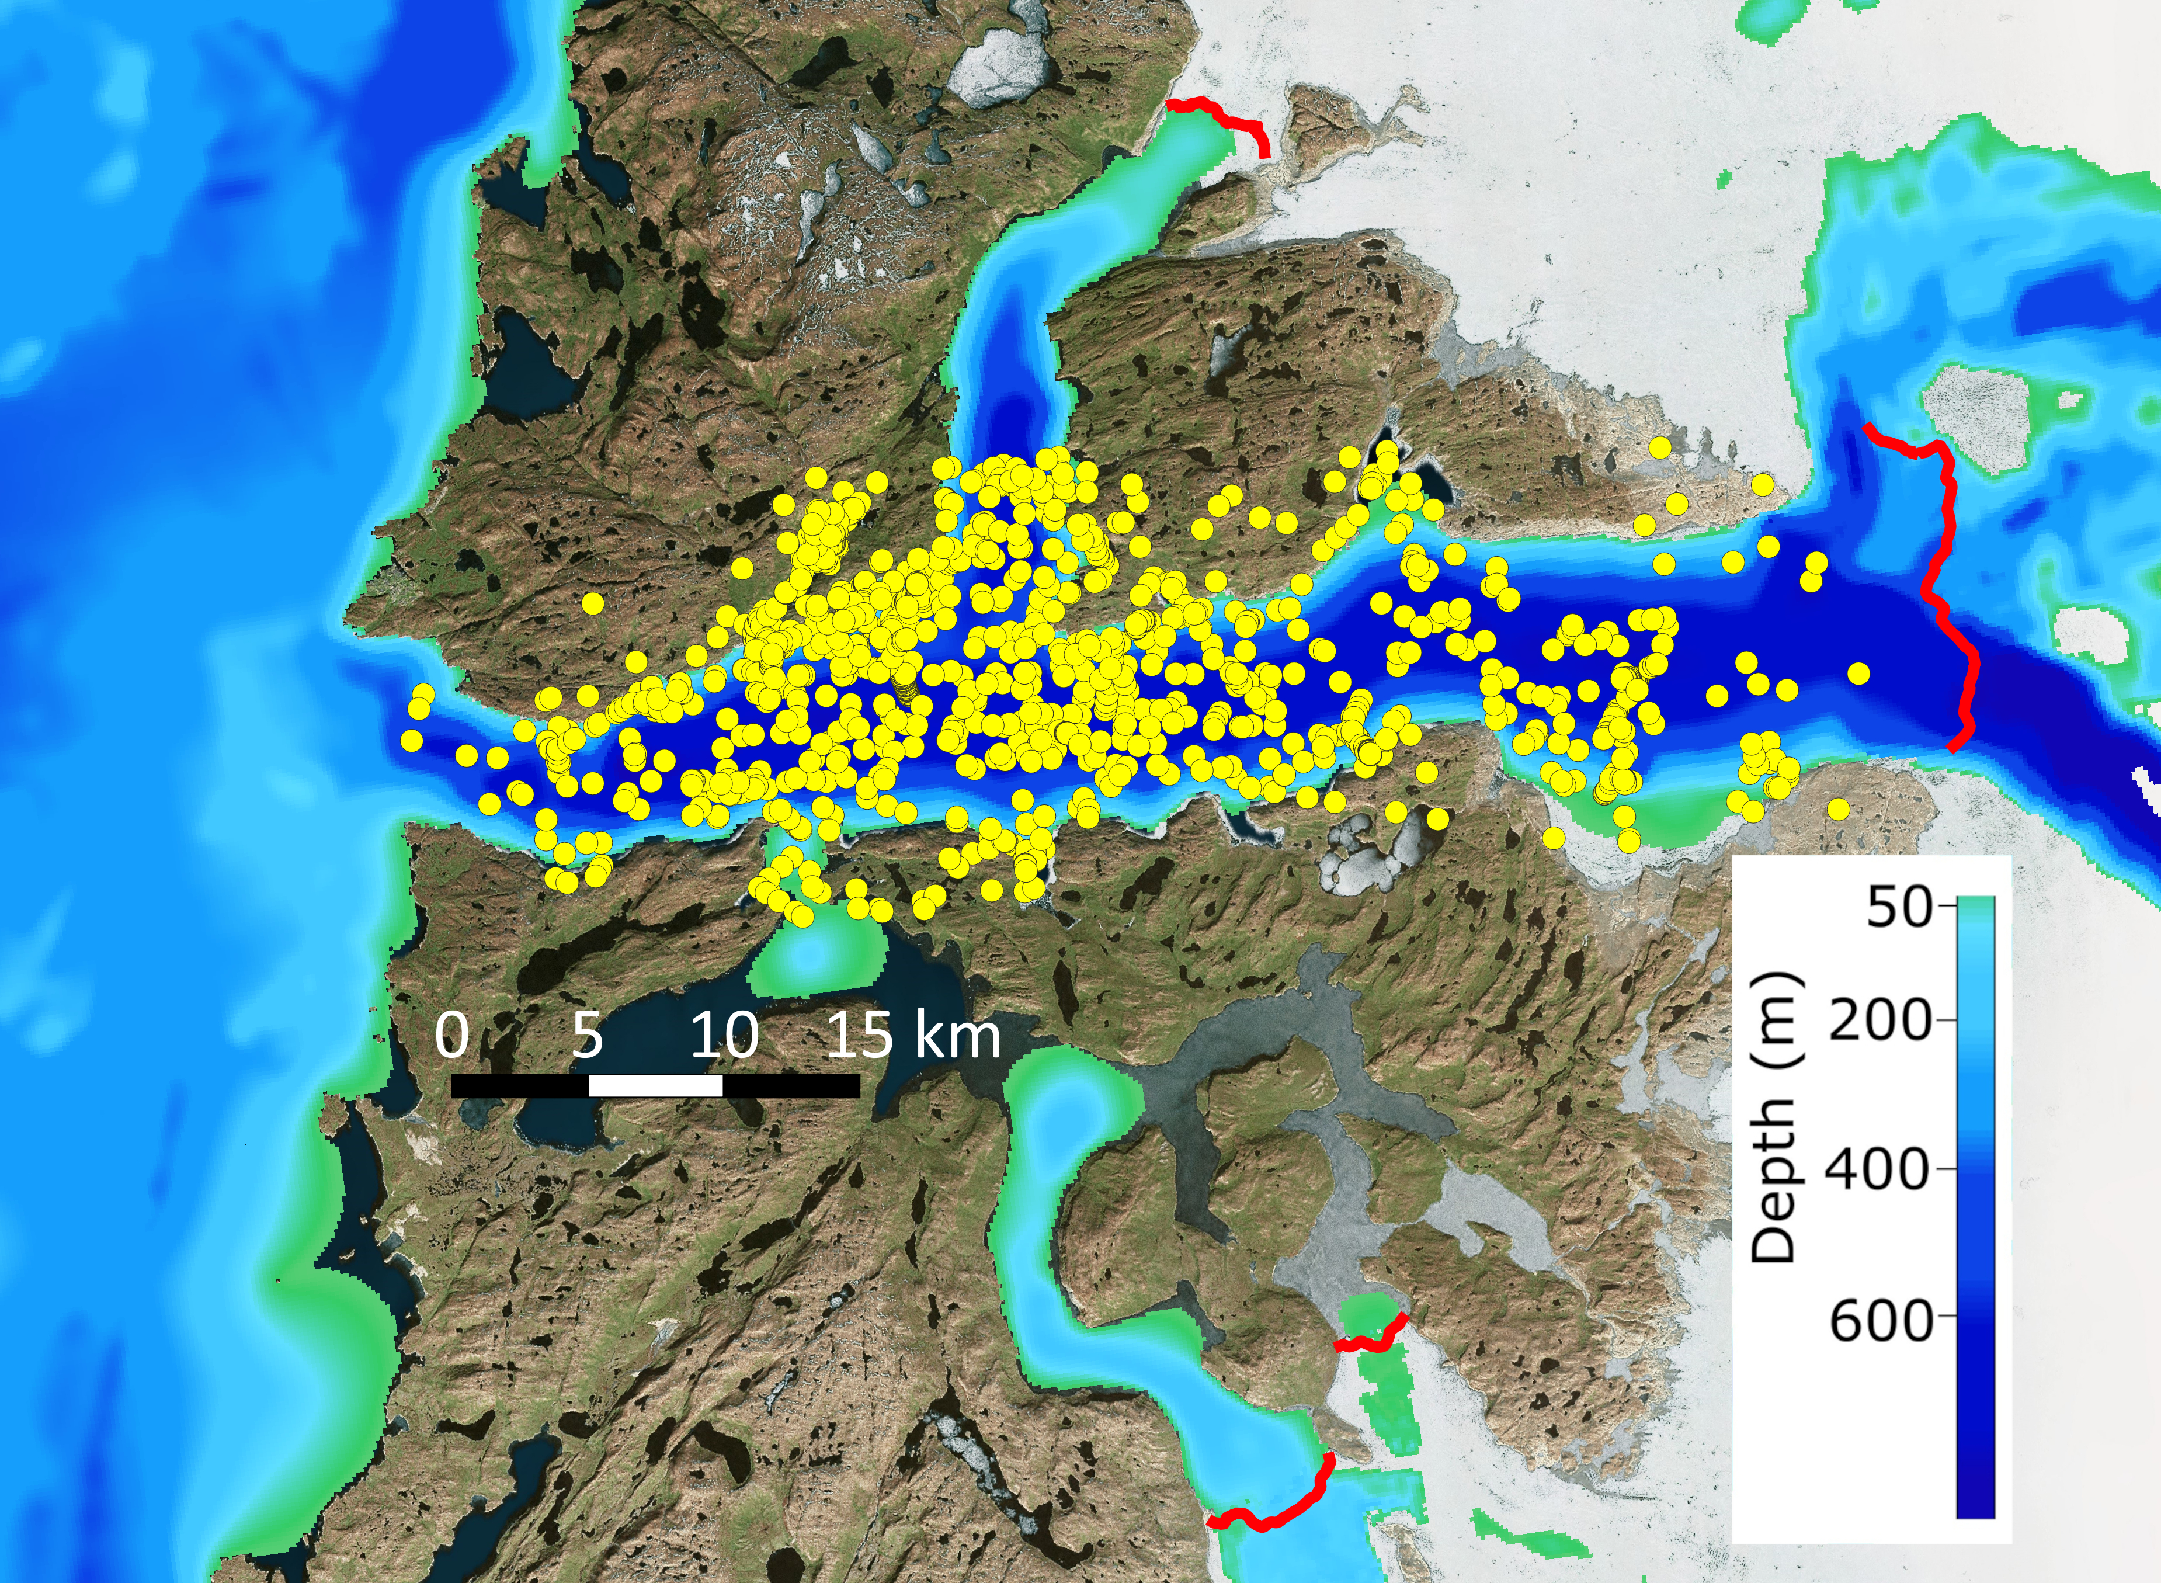

Supplementary Figure 1. Locations of the Seal Tagged CTD profiles used in this study. Some profiles appear to be collected on land. However, this position error is simply due to the time required to acquire a position, which sometimes requires many minutes. As a result, seals occasionally make it out of the water before the position can be determined. Red lines show locations of the Front in May 2017. Blue and green shading show fjord depth.

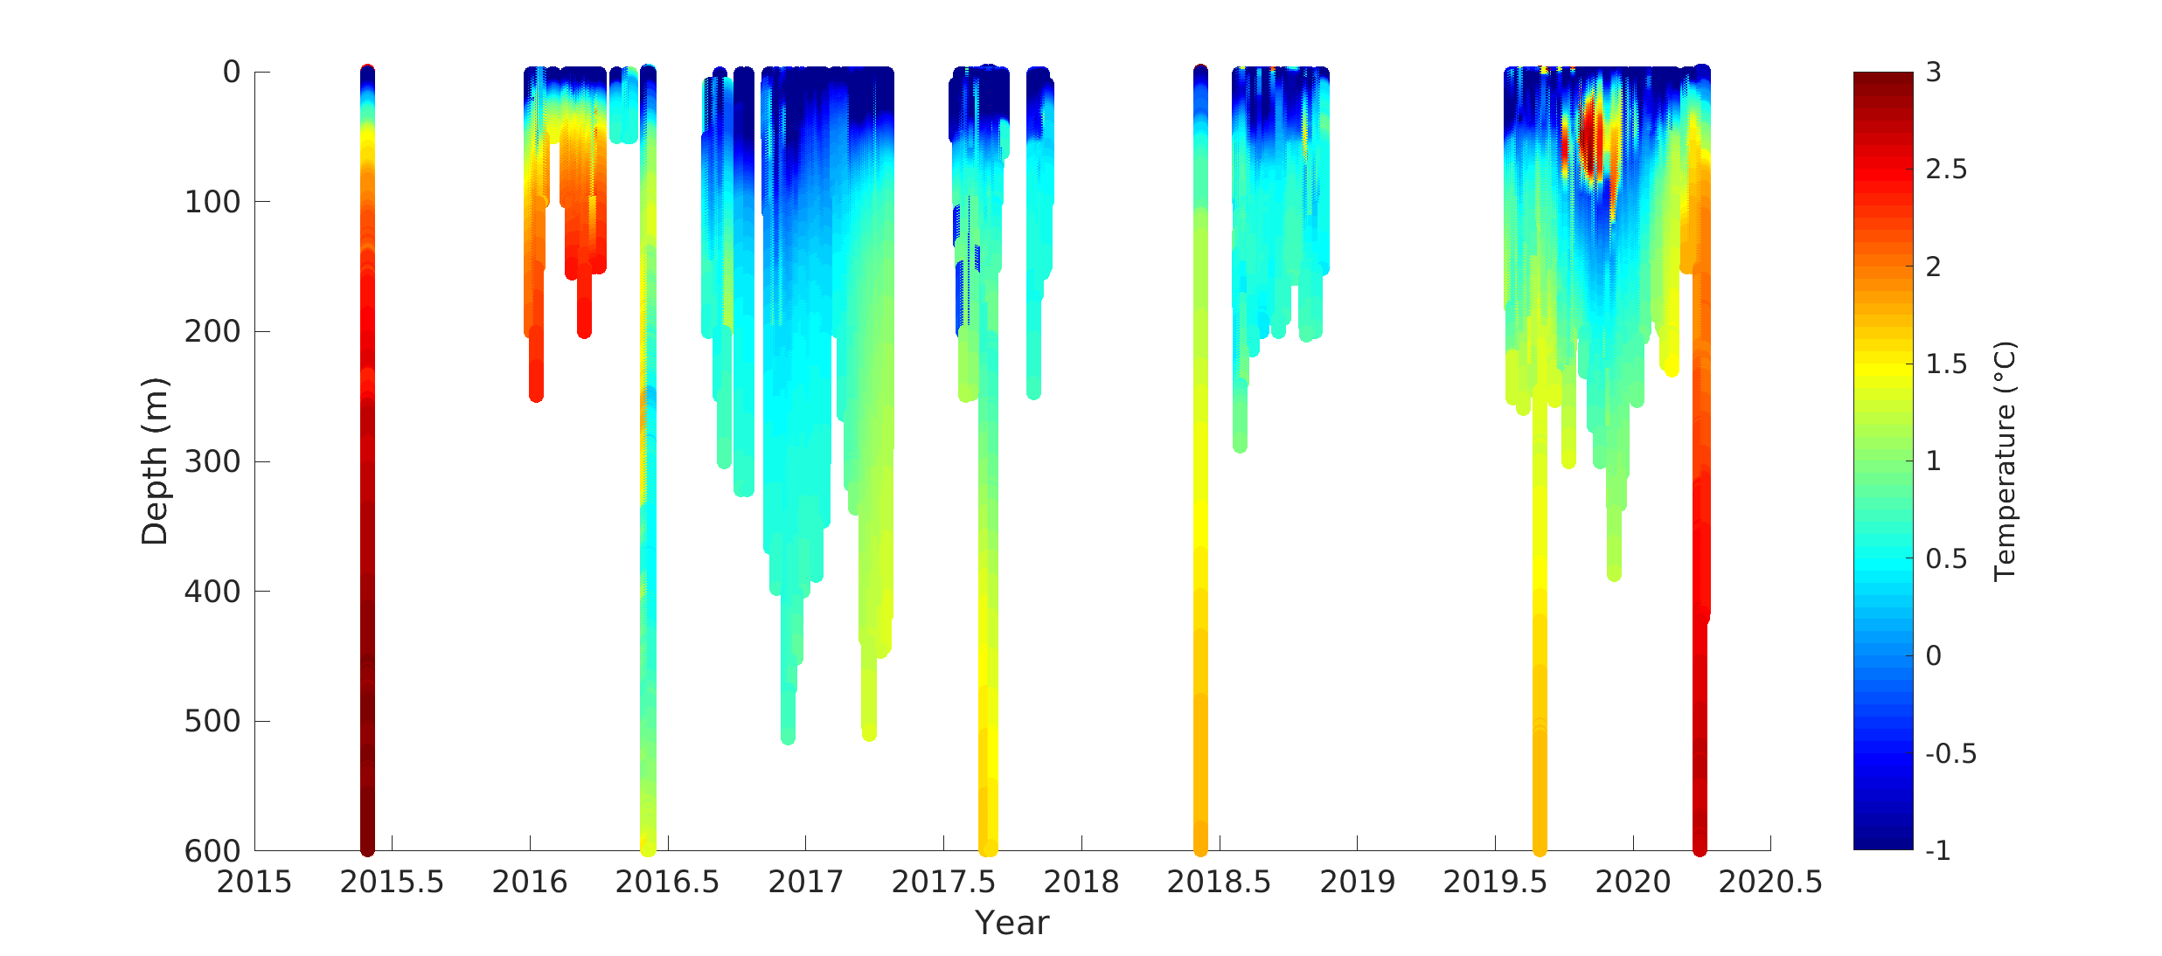

Supplementary Figure 2. Water temperature as a function of year and depth in Ilulissat Icefjord. The periodic profiles that reach below 600 m are the XCTD and CTD profiles discussed in the main article text. Since the XCTD profiles are so tightly grouped in time, the plot does not clearly show variety of fjord temperatures in 2016. However, the seal data provide much more detailed information over time, especially during the winter. Based on the seal data, the 2020 warming did not begin until March of 2020.

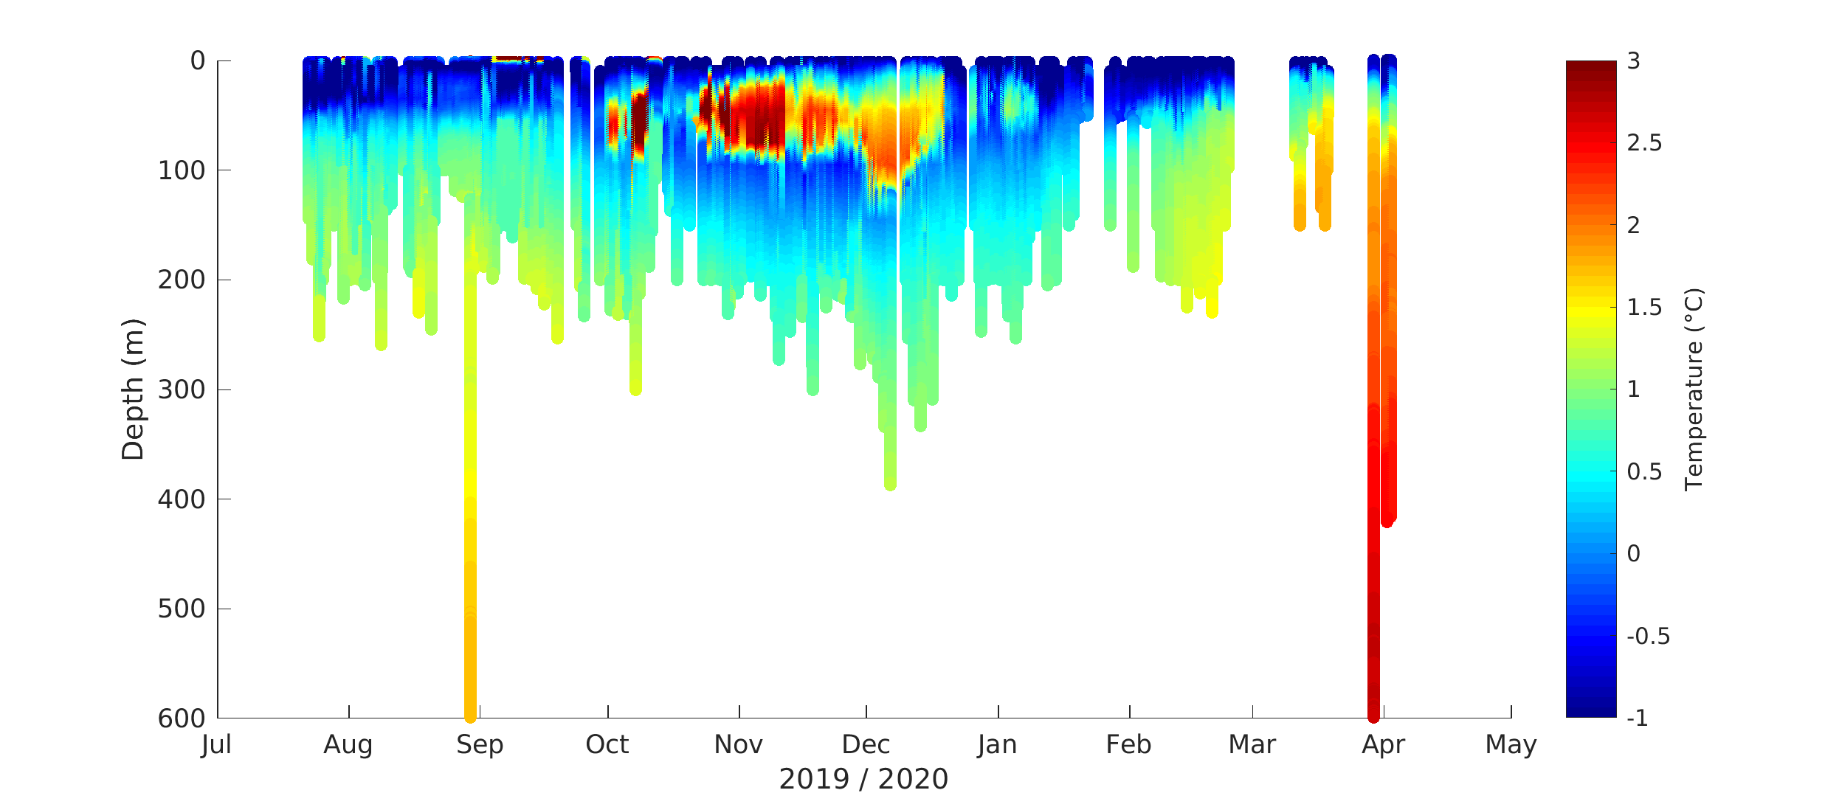

Supplementary Figure 3. An expanded view of the July 2019 to May 2020 from Supplementary Figure 2. The August 29 AXCTD profiles are visible as the deep data collected at that time. The arrival of the warm water occurred sometime in March 2020. The warm signal near the surface is likely water that was warmed at the surface in Disko Bay during summer of 2019 that advected into the fjord during winter as discussed by Gladish et al., (2015).

Supplementary References
Boehme, L., Lovell, P., Biuw, M., Roquet, F., Nicholson, J., Thorpe, S. E., Meredith, M. P., and Fedak, M. (2009), Technical Note: Animal-borne CTD-Satellite Relay Data Loggers for real-time oceanographic data collection, Ocean Sci., 5, 685–695, https://doi.org/10.5194/os-5-685-2009.
Gladish, C. V., Holland, D. M., and Lee, C. M (2015a), Oceanic Boundary Conditions for Jakobshavn Glacier. Part II: Provenance and Sources of Variability of Disko Bay and Ilulissat Icefjord Waters, 1990–2011, J. Phys. Oceanogr., 45, 33–63, https://doi.org/10.1175/JPO-D-14-0045.1.

