Supplementary figures and tables

Figures

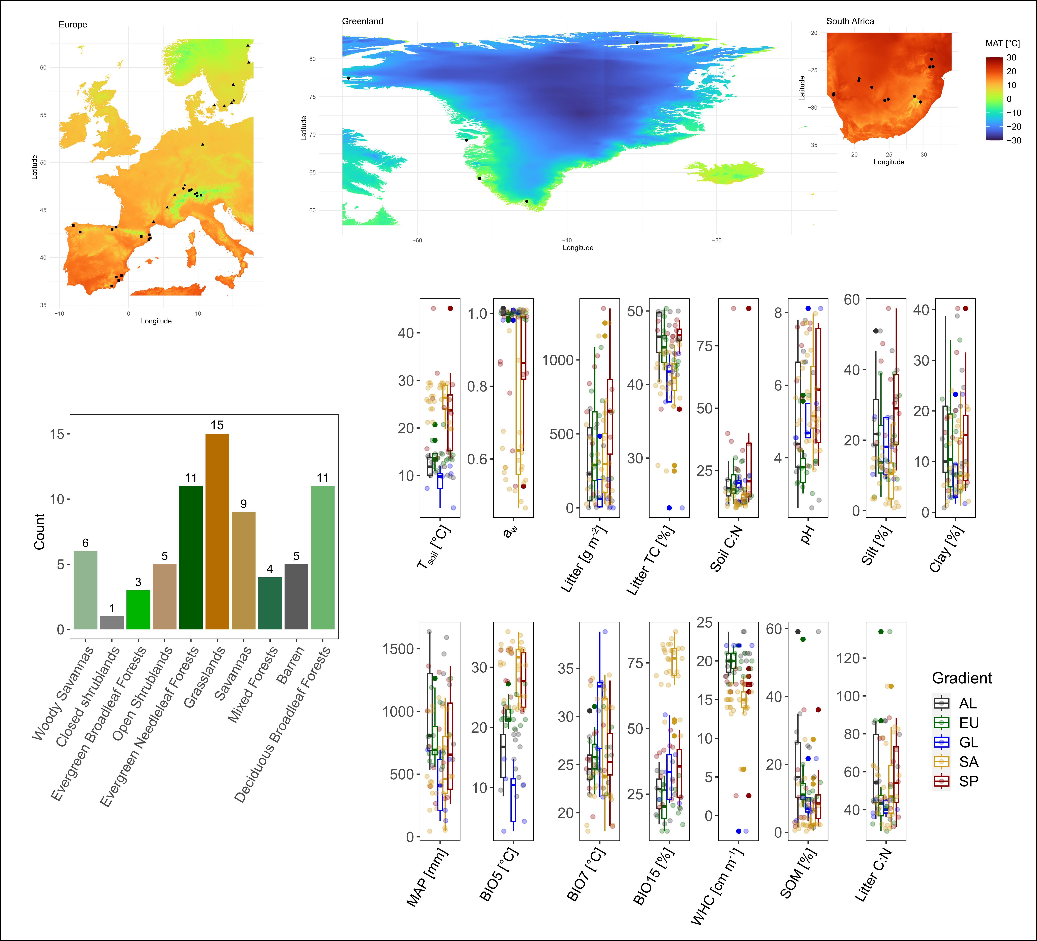
Figure S1 Climatic, vegetation and soil properties of the sites. Numbers on top of bars indicate sites per land cover class. The central mark of the boxplots indicates the median, upper and lower limits of boxes indicate the 25th and the 75th percentile. AL = alpine, EU = Europe, GL = Greenland, SA = South Africa, SP = Spain, a_{w} = water activity, BIO5 = maximum temperature warmest month, BIO15 = precipitation seasonality, LC = land cover, MAP = mean annual precipitation, MAT = mean annual temperature, SOM = soil organic matter, TC = total carbon, TOC = total organic carbon, T_{soil} = in situ soil temperature at the time of sampling, WHC = water holding capacity.

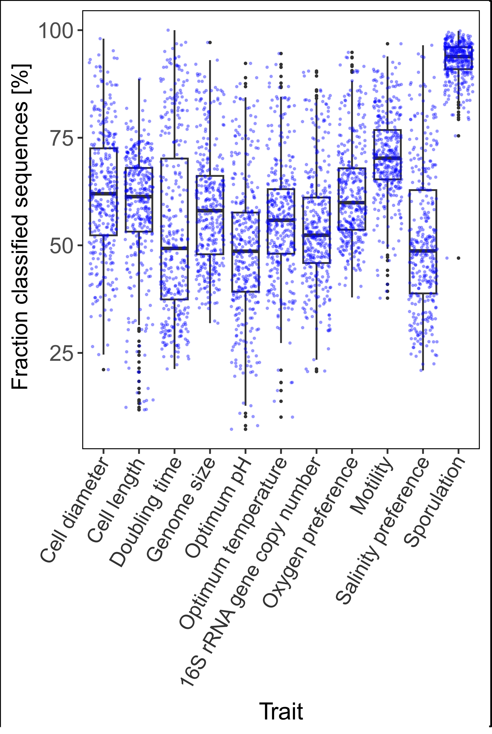
Figure S2 Fraction of classified sequences for each trait. The central mark indicates the median, upper and lower limits of boxes indicate the 25th and the 75th percentile. Blue points represent samples, 70 sites with 5 replicates (n = 349).

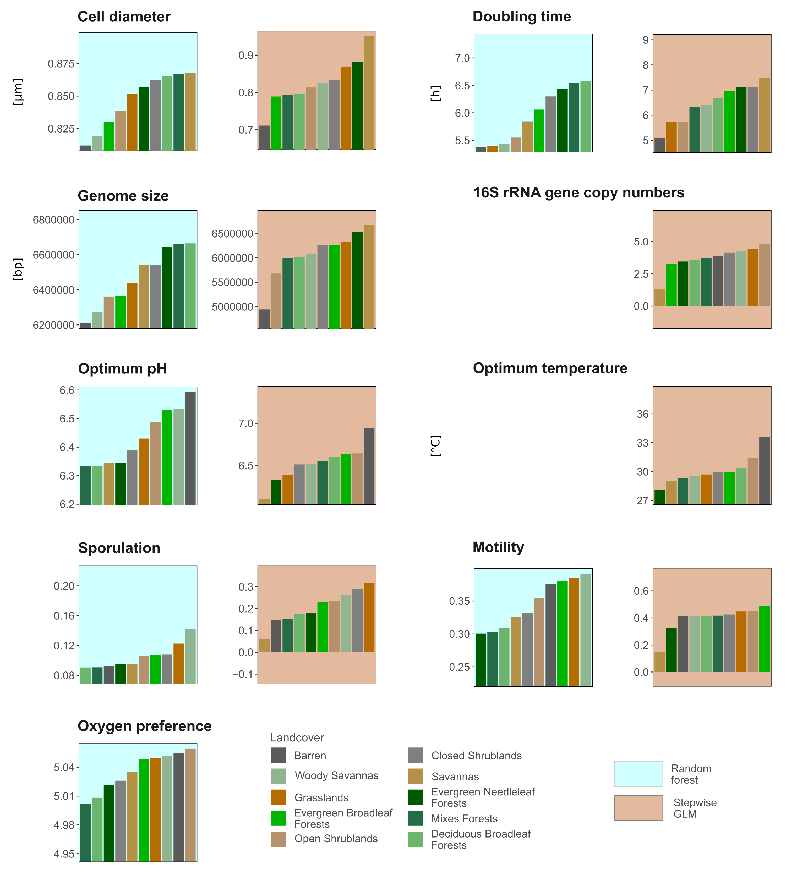
Figure S3 Response plots for CWMs as a function of land cover class based on RFs and stepwise GLM. Only traits and models where land cover was among the five most important predictors are shown (see also Fig. 2).

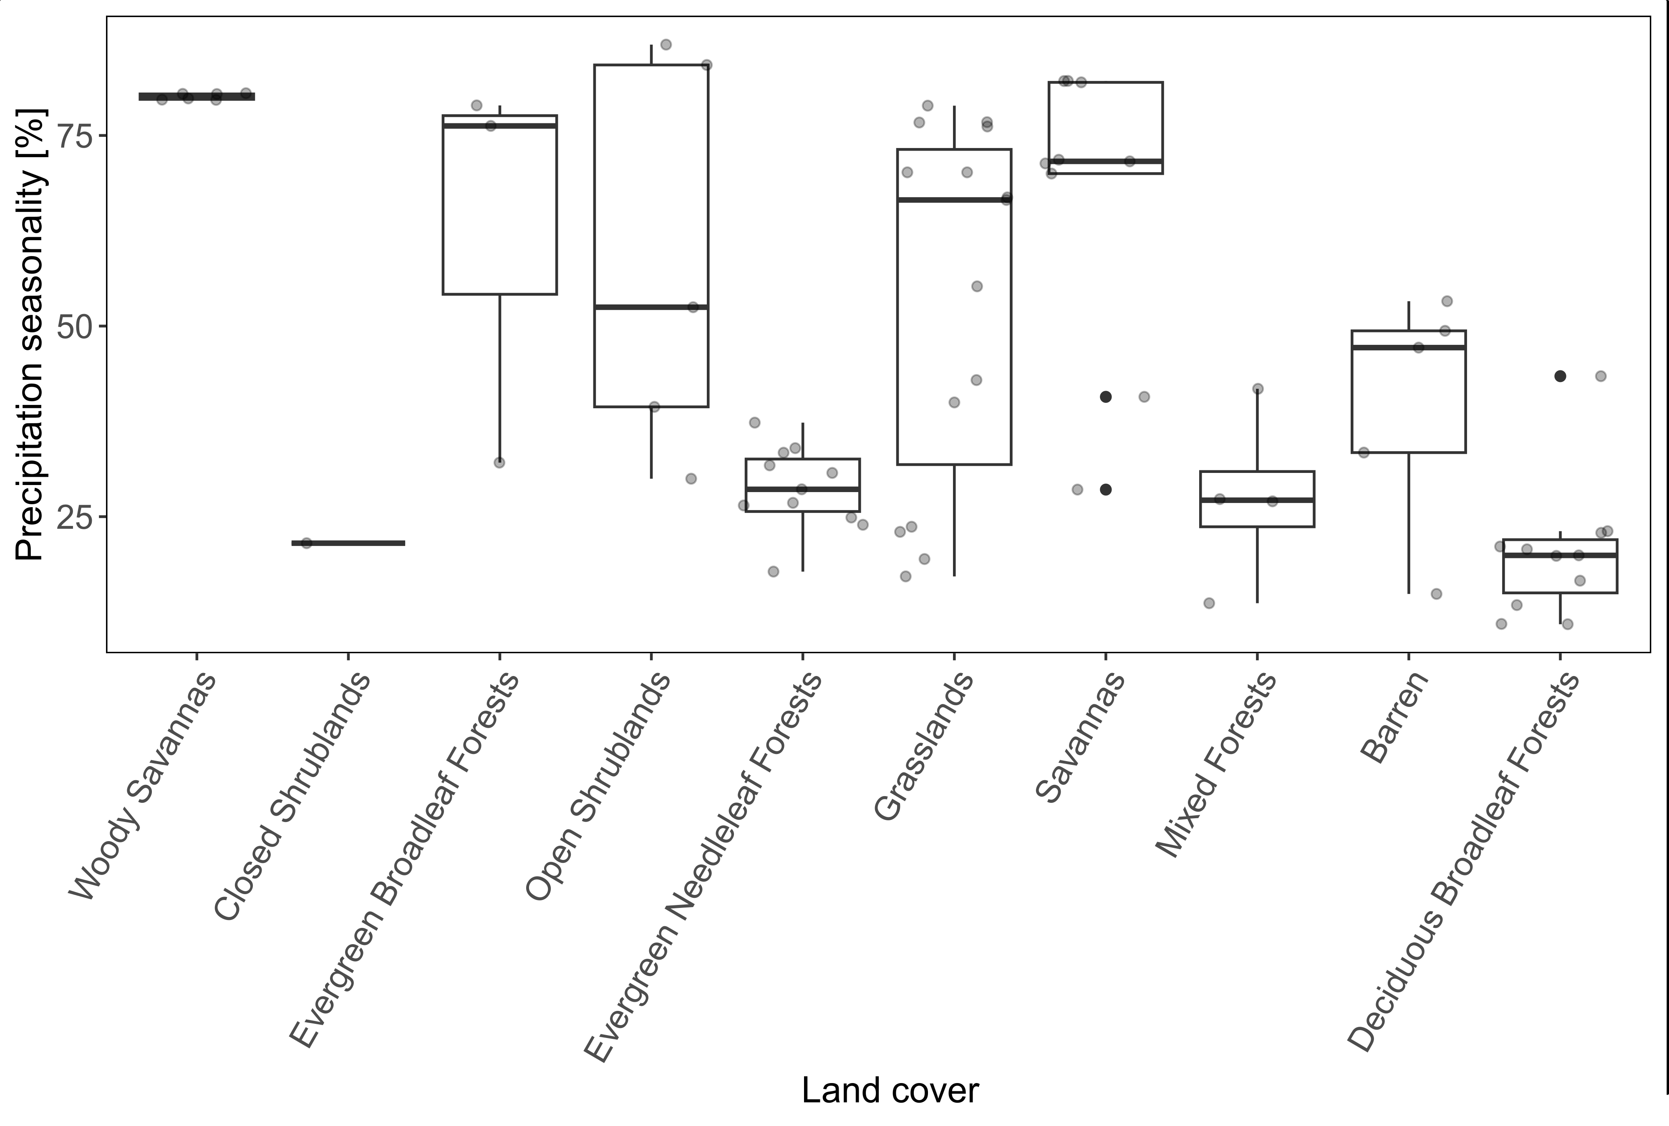
Figure S4 Precipitation seasonality across land cover classes. The central mark indicates the median, upper and lower limits of boxes indicate the 25th and the 75th percentile. Grey points represent individual sites.

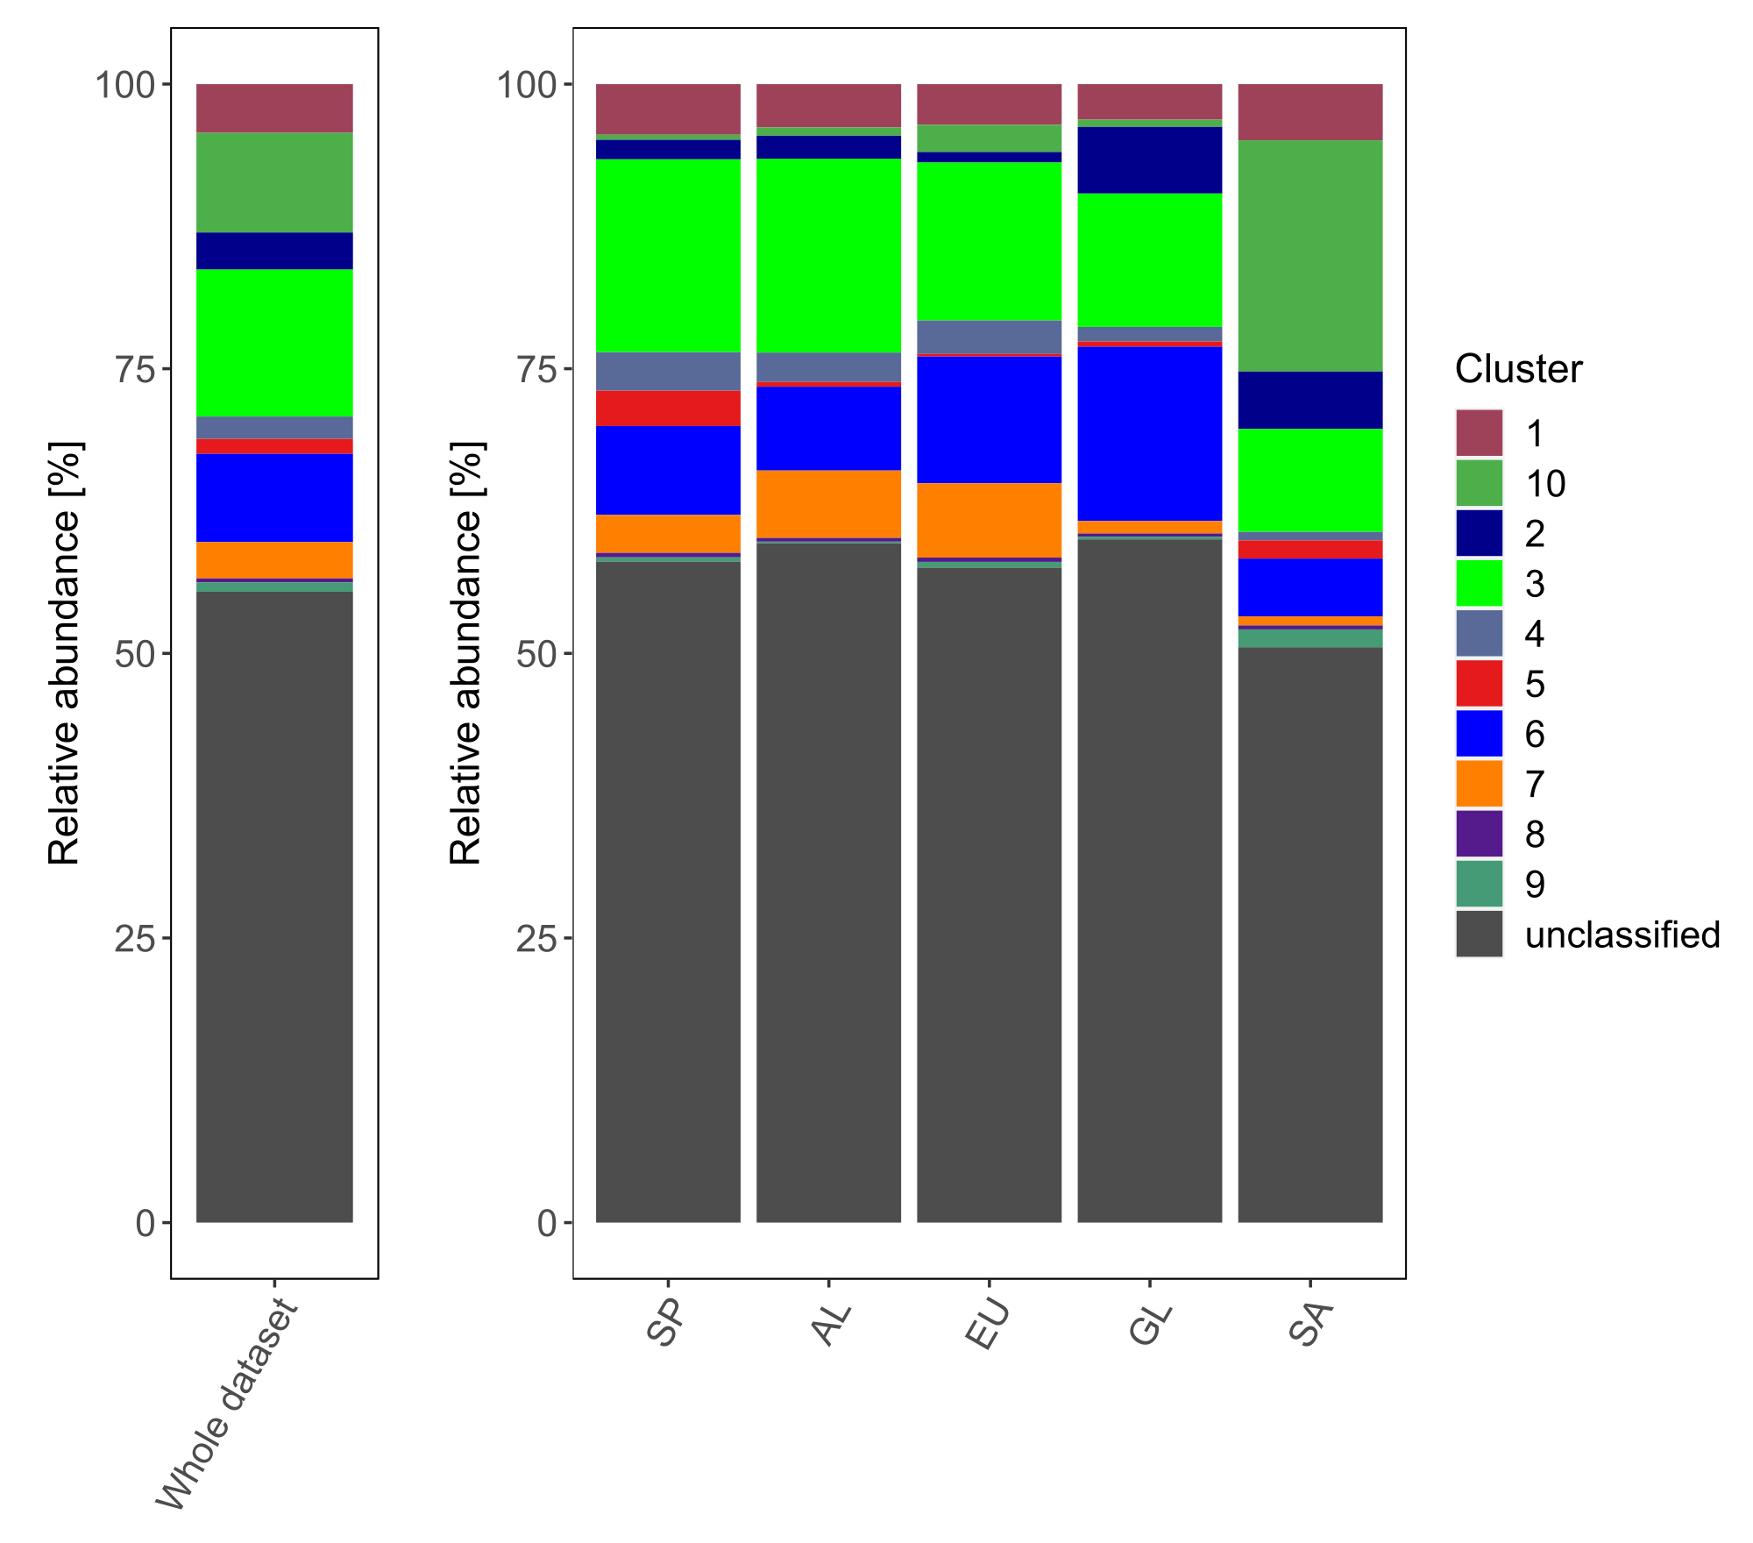 Figure S5 Relative abundances of trait-based clusters across the whole dataset and individual gradients

Tables
Table S1 Temperature and aridity gradients. Site information, climatic properties and land cover classes. MAP = mean annual precipitation, MAT = mean annual temperature, AI = aridity index
Site Name | Gradient | Country | Latitude  [d.d.] | Longitude  [d.d.] | Altitude [m a.s.l] | MAP [mm] | MAT [°C] | BIO15 (Precipitation seasonality) [%] | AI | Predominant land cover
Artikutza | Spain | Spain | 43.1983 | -1.8054 | 344 | 1313 | 12.1 | 20 | 1.2 | Deciduous Broadleaf Forests
Las Herrerias | Spain | Spain | 42.66882 | -6.98307 | 610 | 1253 | 11.0 | 43 | 1.1 | Deciduous Broadleaf Forests
Gavarres | Spain | Spain | 41.89968 | 2.91217 | 259 | 720 | 13.8 | 24 | 0.6 | Evergreen Needleleaf Forests
Coy | Spain | Spain | 37.94358 | -1.77985 | 925 | 402 | 13.5 | 39 | 0.2 | Open Shrublands
Tabernas | Spain | Spain | 37.00954 | -2.44254 | 283 | 265 | 17.0 | 49 | 0.2 | Barren
Vallcebre | Spain | Spain | 42.20294 | 1.82094 | 1096 | 859 | 9.2 | 21 | 0.7 | Deciduous Broadleaf Forests
Arantzazu | Spain | Spain | 42.96013 | -2.3783 | 803 | 1004 | 9.4 | 23 | 1.0 | Deciduous Broadleaf Forests
Fragas do Eume | Spain | Spain | 43.36926 | -7.98579 | 450 | 1362 | 12.2 | 42 | 1.3 | Mixed Forests
Santomera | Spain | Spain | 38.0986 | -1.03135 | 195 | 314 | 17.1 | 41 | 0.2 | Savannas
Malcamino | Spain | Spain | 37.58771 | -1.44243 | 278 | 304 | 16.9 | 43 | 0.2 | Grasslands
Montgrí | Spain | Spain | 42.06125 | 3.12231 | 103 | 550 | 14.7 | 32 | 0.4 | Evergreen Needleleaf Forests
Albera | Spain | Spain | 42.396 | 2.9823 | 154 | 591 | 14.4 | 30 | 0.4 | Open Shrublands
Umbrail Summit | Alpine | Switzerland | 46.55162 | 10.418467 | 2959 | 807 | -3.2 | 15 | 1.3 | Barren
Umbrail Meadow | Alpine | Switzerland | 46.55365 | 10.434283 | 2336 | 617 | -1.1 | 24 | 0.9 | Grasslands
Celerina | Alpine | Switzerland | 46.49205 | 9.8904 | 1844 | 799 | 1.3 | 37 | 1.0 | Evergreen Needleleaf Forests
Alpthal | Alpine | Switzerland | 47.0479 | 8.712617 | 1159 | 1636 | 6.1 | 25 | 1.9 | Evergreen Needleleaf Forests
Vordemwald | Alpine | Switzerland | 47.27337 | 7.886733 | 530 | 1213 | 9.0 | 14 | 1.4 | Mixed Forests
Umbrail Room | Alpine | Switzerland | 46.54887 | 10.424167 | 2715 | 740 | -2.5 | 17 | 1.2 | Grasslands
Umbrail Water | Alpine | Switzerland | 46.543 | 10.431183 | 2543 | 686 | -2.0 | 19 | 1.0 | Grasslands
Umbrail Treeline | Alpine | Switzerland | 46.56612 | 10.435117 | 2114 | 570 | 0.0 | 29 | 0.8 | Savannas
Umbrail Forest | Alpine | Switzerland | 46.5835 | 10.4404 | 2001 | 535 | 1.3 | 33 | 0.7 | Evergreen Needleleaf Forests
Davos | Alpine | Switzerland | 46.81552 | 9.856467 | 1613 | 1062 | 3.5 | 34 | 1.3 | Evergreen Needleleaf Forests
Lantsch | Alpine | Switzerland | 46.6978 | 9.564417 | 1443 | 1300 | 4.7 | 31 | 1.5 | Evergreen Needleleaf Forests
Sihltalhütte | Alpine | Switzerland | 47.07022 | 8.860217 | 971 | 1589 | 6.6 | 27 | 1.8 | Mixed Forests
Schänis | Alpine | Switzerland | 47.1648 | 9.066367 | 713 | 1458 | 8.1 | 27 | 1.6 | Mixed Forests
Sundsvall | Europe | Sweden | 62.301207 | 17.197130 | 94 | 718 | 3.8 | 26 | 1.1 | Evergreen Needleleaf Forests
Dångamålaö | Europe | Sweden | 56.52225 | 15.145862 | 163 | 668 | 6.5 | 18 | 0.9 | Evergreen Needleleaf Forests
Gribskov | Europe | Denmark | 56.01215 | 12.35839 | 41 | 604 | 7.7 | 23 | 0.8 | Deciduous Broadleaf Forests
Lausanne | Europe | Switzerland | 46.58377 | 6.659367 | 803 | 1263 | 8.2 | 11 | 1.4 | Deciduous Broadleaf Forests
Gävle | Europe | Sweden | 60.51314 | 17.302571 | 38 | 628 | 5.4 | 27 | 0.9 | Evergreen Needleleaf Forests
Boxholm | Europe | Sweden | 58.17229 | 15.079989 | 151 | 559 | 6.0 | 29 | 0.8 | Evergreen Needleleaf Forests
Långasjönäs | Europe | Sweden | 56.2525 | 14.849509 | 76 | 662 | 7.0 | 20 | 0.9 | Deciduous Broadleaf Forests
Linderöd | Europe | Sweden | 55.92609 | 13.782463 | 174 | 814 | 6.7 | 21 | 1.2 | Deciduous Broadleaf Forests
Kohlerholz | Europe | Germany | 51.87936 | 10.663356 | 297 | 805 | 7.8 | 13 | 1.0 | Deciduous Broadleaf Forests
Muhlbach | Europe | Germany | 47.59507 | 8.092183 | 418 | 1191 | 8.9 | 11 | 1.4 | Deciduous Broadleaf Forests
Grenoble | Europe | France | 45.26808 | 5.553806 | 598 | 1073 | 10.2 | 17 | 1.0 | Deciduous Broadleaf Forests
Montpellier | Europe | France | 43.731 | 3.60235 | 211 | 671 | 13.6 | 32 | 0.5 | Evergreen Broadleaf Forests
Brønlundhus | Greenland | Greenland | 82.17289 | -30.640871 | 45 | 212 | -18.1 | 33 | 1.0 | Barren
Qaanaaq | Greenland | Greenland | 77.46581 | -69.196991 | 57 | 129 | -12.3 | 55 | 0.5 | Grasslands
Disko | Greenland | Greenland | 69.26574 | -53.470587 | 118 | 410 | -5.9 | 40 | 1.1 | Grasslands
Nuuk | Greenland | Greenland | 64.19056 | -51.695473 | 52 | 618 | -1.0 | 23 | 1.3 | Grasslands
Narsarsuaq | Greenland | Greenland | 61.18367 | -45.370575 | 56 | 693 | 0.8 | 22 | 1.0 | Closed shrublands
Giants Castle, Maloti Drakensberg Park | South Africa | South Africa | -29.25911 | 29.526806 | 1870 | 1007 | 13.9 | 77 | 0.6 | Grasslands
Giants Castle, Maloti Drakensberg Park | South Africa | South Africa | -29.27036 | 29.520444 | 1870 | 1019 | 13.8 | 76 | 0.7 | Grasslands
Giants Castle, Maloti Drakensberg Park | South Africa | South Africa | -29.24872 | 29.531333 | 1870 | 1001 | 14.2 | 77 | 0.6 | Grasslands
Mariepskop | South Africa | South Africa | -24.58461 | 30.862306 | 1306 | 1043 | 17.2 | 79 | 0.6 | Grasslands
Mariepskop | South Africa | South Africa | -24.56119 | 30.893694 | 1402 | 1110 | 16.7 | 76 | 0.7 | Evergreen Broadleaf Forests
Mariepskop | South Africa | South Africa | -24.58472 | 30.861639 | 1212 | 1043 | 17.2 | 79 | 0.6 | Evergreen Broadleaf Forests
SAWLC | South Africa | South Africa | -24.53967 | 31.332306 | 502 | 707 | 21.4 | 80 | 0.4 | Woody Savannas
SAWLC | South Africa | South Africa | -24.54208 | 31.328667 | 489 | 706 | 21.4 | 80 | 0.4 | Woody Savannas
SAWLC | South Africa | South Africa | -24.55306 | 31.326861 | 514 | 713 | 21.3 | 80 | 0.4 | Woody Savannas
Mthimkhulu | South Africa | South Africa | -23.53314 | 31.101583 | 345 | 483 | 22.4 | 82 | 0.3 | Savannas
Mthimkhulu | South Africa | South Africa | -23.52492 | 31.116444 | 349 | 482 | 22.4 | 82 | 0.3 | Savannas
Mthimkhulu | South Africa | South Africa | -23.53231 | 31.101722 | 344 | 482 | 22.4 | 82 | 0.3 | Savannas
Benfontein | South Africa | South Africa | -28.89161 | 24.860444 | 1156 | 437 | 18.0 | 70 | 0.2 | Savannas
Benfontein | South Africa | South Africa | -28.85594 | 24.841 | 1180 | 440 | 18.1 | 70 | 0.2 | Grasslands
Benfontein | South Africa | South Africa | -28.85586 | 24.841139 | 1170 | 440 | 18.1 | 70 | 0.2 | Grasslands
Golden Gate National Park | South Africa | South Africa | -28.50433 | 28.646472 | 2006 | 797 | 12.6 | 67 | 0.5 | Grasslands
Golden Gate National Park | South Africa | South Africa | -28.51483 | 28.656278 | 2092 | 810 | 12.4 | 67 | 0.5 | Grasslands
Mokala National Park | South Africa | South Africa | -29.01372 | 24.375972 | 1064 | 410 | 18.6 | 72 | 0.2 | Savannas
Mokala National Park | South Africa | South Africa | -29.05086 | 24.353694 | 1121 | 406 | 18.5 | 72 | 0.2 | Savannas
Mokala National Park | South Africa | South Africa | -29.07953 | 24.3725 | 1148 | 407 | 18.3 | 71 | 0.2 | Savannas
Tswalu Kalahari Reserve | South Africa | South Africa | -27.28314 | 22.484778 | 1162 | 346 | 19.3 | 80 | 0.1 | Woody Savannas
Tswalu Kalahari Reserve | South Africa | South Africa | -27.28697 | 22.485722 | 1200 | 347 | 19.3 | 80 | 0.1 | Woody Savannas
Tswalu Kalahari Reserve | South Africa | South Africa | -27.29197 | 22.486917 | 1216 | 348 | 19.2 | 81 | 0.1 | Woody Savannas
Kgalagadi Transfrontier Park | South Africa | South Africa | -26.42622 | 20.619278 | 875 | 213 | 20.5 | 84 | 0.1 | Open Shrublands
Kgalagadi Transfrontier Park | South Africa | South Africa | -26.12164 | 20.664722 | 928 | 224 | 20.2 | 87 | 0.1 | Open Shrublands
Richtersveld Transfrontier Park | South Africa | South Africa | -28.12186 | 17.009028 | 287 | 45 | 20.3 | 47 | 0.0 | Barren
Richtersveld Transfrontier Park | South Africa | South Africa | -28.16331 | 17.020222 | 418 | 53 | 19.7 | 53 | 0.0 | Barren
Richtersveld Transfrontier Park | South Africa | South Africa | -28.33547 | 16.987167 | 662 | 71 | 18.8 | 52 | 0.0 | Open Shrublands

