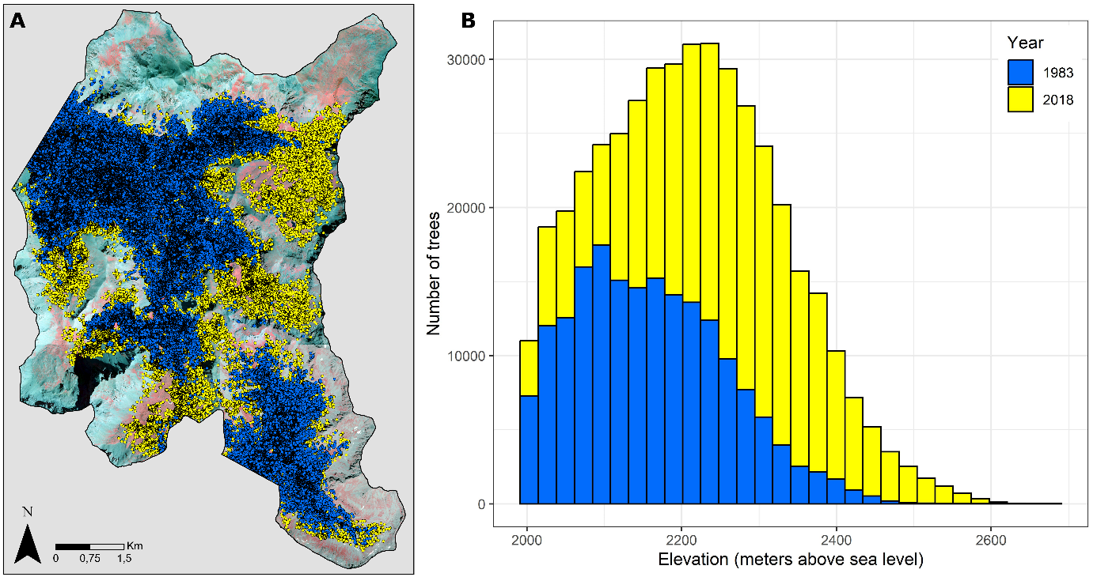
Supplementary Material 1. Expansion of larch trees in the study area over the last four decades. Panel A shows a photo-interpretation map depicting the distribution of larch trees in 1983 (blue) and 2018 (yellow). Panel B presents a histogram of the number of trees in 1983 and 2018 categorized by elevation. In this histogram, only trees above 2000m asl are displayed, to highlight the increase in the upper limit of the forest.

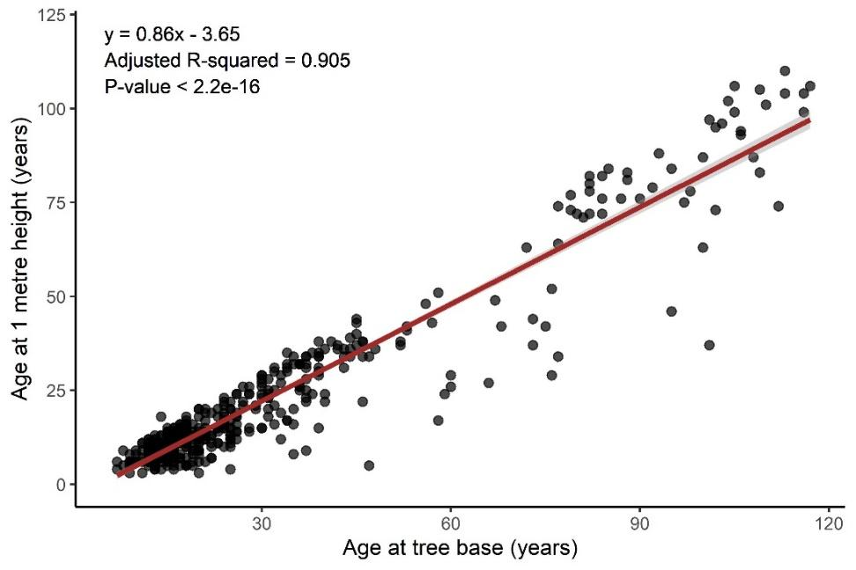
Supplementary Material 2. Linear regression analysis between the age at the base of the stem and the age at 1 meter height to estimate the age of trees lacking base core samples. Black dots represent trees with increment cores taken at both 0- and 1-meter heights. The red line represents the linear regression fitted to these data points.

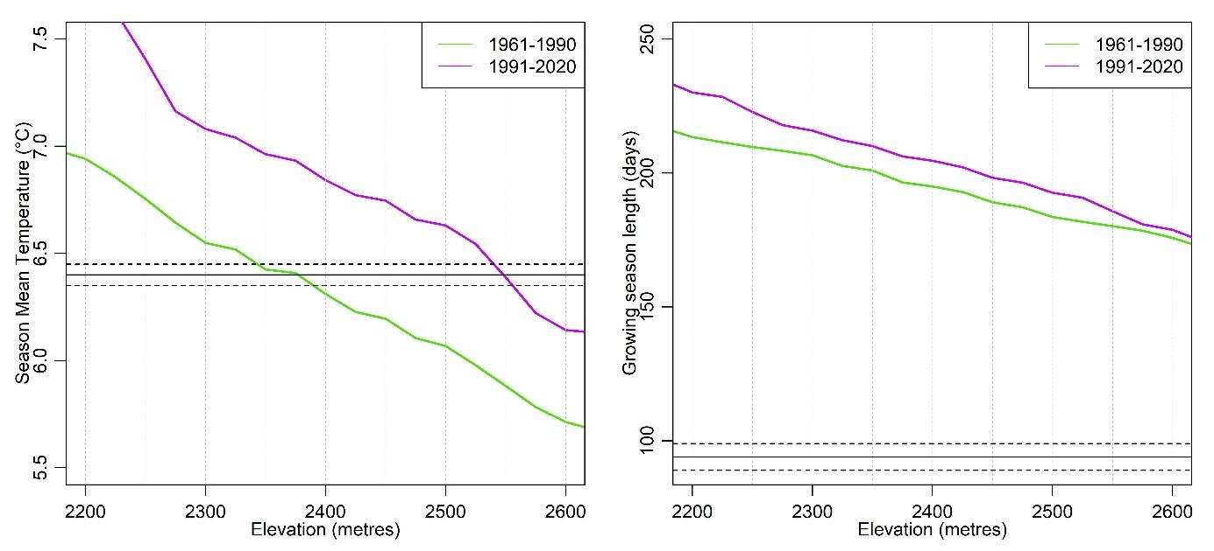
Supplementary Material 3. Parameters used to determine the elevational position of the climatic treeline over time in the study area. Panel A shows the mean temperature during the growing season plotted against elevation, with the solid black bar indicating the 6.4°C threshold and dotted lines representing ± 0.05°C uncertainty. Panel B illustrates the length of the growing season as a function of elevation with the solid black bar denoting the 94-day threshold and dotted lines indicating the ± 5 days uncertainty. See methods for more details.

