Supplemetary Materials
A. Assumption of ANOVA (Analysis of Variance)
The main assumption of ANOVA are normality test, homogeneity of variance, and no presence of outliers. Each of these assumptions were tested using SPSS. From the result of the box-plot displayed in the analysis below (Supplementary Figure 1), it could be displayed that there is presence of outliers in the data set. Supplementary Figure 2 also show that the values of the observation also deviation from normal which indicates a problem of outliers. Also, result from the Figure 2 showed that the data is not normally distributed since the standard deviation deviated from the mean value as indicate in the Histogram plot (Supplementary Figure 3).
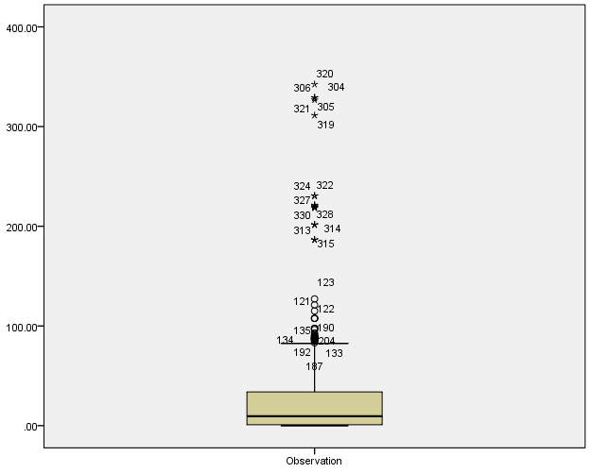
Supplementary Figure 1 Analysis Box Plot
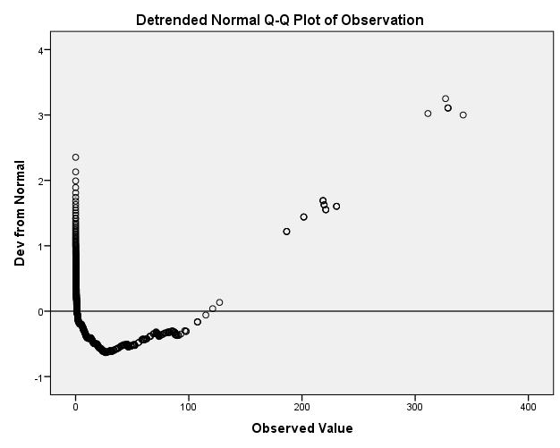
Supplementary Figure 2 Outlier’s test

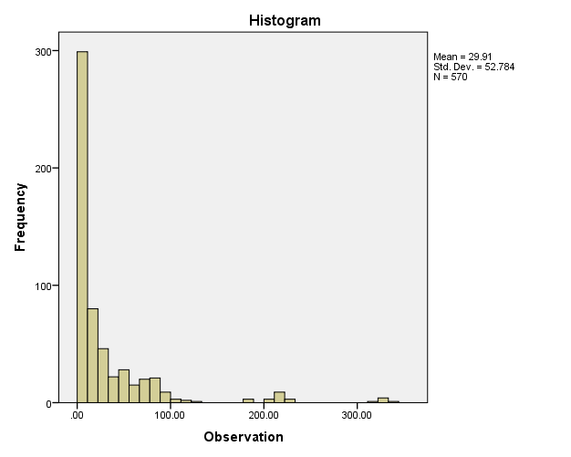
Supplementary Figure 3 Histogram of for the experimental analysis

B. Test of Hypothesis
Since the assumption was not satisfied, we resulted to Kruskal–Walli’s non-parametric aspect of ANOVA using the median range. The statistical outputs showed significant different between the biochemical evaluation done on the rats’ brain homogenates. This is as a result of the p-value < 0.05, where P-value = 0.000. The null hypothesis is rejected at the decision of 95% confidence interval (Supplementary Table 1). Meanwhile, the difference between brain regions (hippocampus and cortex) was also observed in the analysis, and it was shown that there is a significant difference between the variables as displayed in Supplementary Table 2a-b of the test of statistics. It is important to note that, the data presented in the section is the test statistics outputs across all groups and the two brain regions tested for all the nineteen (19) in vivo experiments and not individual case processed summary. The statistics in section B of the supplementary material focused more on the differences between the outcome variables (i.e the various assays and the brain regions tested) rather than individual assays. However, the normality assessed for each outcome variables across all groups are further addressed in the next section of this supplementary material.
Supplementary Table 1 Test Statisticsª
 | Observation
N | 570
Median | 9.4438
Chi-Square | 474.133^{b}
Df | 18
Asymp. Sig. | .000
ªGrouping Variable (In vivo assays)
^{b}No cell (0.0%) have expected frequencies less than 5. The minimum expected cell frequency is 15.0.

Supplementary Table 2a Frequencies
 |  | Brain Regions
 |  | Cortex | Hippocampus
Observation | > Median | 140 | 145
Observation | <= Median | 145 | 140

Supplementary Table 2b Test Statisticsª
 |  | Observation
N |  | 570
Median |  | 9.4438
Chi-Square |  | .175
Df |  | 1
Asymp. Sig. |  | .675
Yates' Continuity Correction | Chi-Square | .112
Yates' Continuity Correction | Df | 1
Yates' Continuity Correction | Asymp. Sig. | .738
ªGrouping Variable (Brain regions)

C. Test of Normality for Assays
The assays from the in vivo experiments are tested using Kolmogrov-Smirnov tests. The normality of each of the assay as tested is sumarized in Supplementary Table 3. The result shows that assays for activities/levels of complex I, TH, MAO, Dopamine, GDH, GS, GDH, GSH, FRAP, PC, LPO, NO, and MPO are normally distributed. This proves that their P-value is less than 0.05 (5% significance level). It means that the data comes from the same distributed. When considering some of the variables which are normally distributed at P-value < 0.05, they might not be normally distributed when the p-value is considered at 10% level of significance. The assays include Complex I, MAO, Dopamine, GDH and LPO activities/levels. These variables might not come from the same distribution when considered at 10% level of significance (90% confidence interval). On the other hand, the result of Na⁺/K⁺ ATPase, LDH, AChE, GPx, SOD, CAT and XO activities are not normally distributed at P-value < 0.05. This means that these assays do not come from the same distribution since their p-value < 0.05.
Supplementary Table 3 Statistical outputs for Tests of Normality of the in vivo biochemical assays
 | Kolmogorov-Smirnov^{b}
In vivo Assays | Statistic | N | P value
Complex I Activity | 0.152 | 30 | 0.077
Na⁺/K⁺ ATPase Activity | 0.218 | 30 | 0.001
Lactate Dehydrogenase Activity | 0.180 | 30 | 0.015
Tyrosine Hydroxylase Activity | 0.102 | 30 | 0.200*
Monoamine Oxidase Activity | 0.149 | 30 | 0.087
Dopamine Level | 0.093 | 30 | 0.200*
Acetylcholinesterase Activity | 0.205 | 30 | 0.002
Glutamate Dehydrogenase Activity | 0.093 | 30 | 0.200*
Glutamine Synthetase Activity | 0.128 | 30 | 0.200*
Reduced Glutathione Level | 0.121 | 30 | 0.200*
Glutathione Peroxidase Activity | 0.168 | 30 | 0.030
Superoxide dismutase Activity | 0.184 | 30 | 0.011
Catalase Activity | 0.187 | 30 | 0.009
Ferric Reducing Antioxidant Power | 0.108 | 30 | 0.200*
Protein Carbonyl Level | 0.077 | 30 | 0.200*
Extent of Lipid Peroxidation | 0.150 | 30 | 0.083
Nitric Oxide Level | 0.126 | 30 | 0.200*
Xanthine Oxidase Activity | 0.202 | 30 | 0.003
Myeloperoxidase Activity | 0.110 | 30 | 0.200*
*This is a lower bound of the true significance.
^{b}Lilliefors Significance Correction

D. Test of homogeneity
Levene’s test was used to assess the homogeneity of variance. The combined statistical output for test of homogeneity is displayed in Supplementary Table 4. The explanation was based on the mean of the result due to small number of groups. Since the P values < 0.05, we rejected the Null hypothesis and concluded on the alternative. This implies that, the variance among the variables is significantly different which means that there is no equal variance among the various in vivo experiments. The unequal variance implicates the unsatisfactory ANOVA assumption which further supported the statistical outputs for the Kruskal–Walli non-parametric analysis of variance early presented in this supplementary note.
Supplementary Table 4 Test of Homogeneity of Variance
 |  | Levene Statistic | Df1 | Df2 | Sig.
Observation | Based on Mean | 27.375 | 18 | 551 | 0.000
Observation | Based on Median | 22.283 | 18 | 551 | 0.000
Observation | Based on Median and adjusted with df | 22.283 | 18 | 47.367 | 0.000
Observation | Based on trimmed mean | 26.765 | 18 | 551 | 0.000

