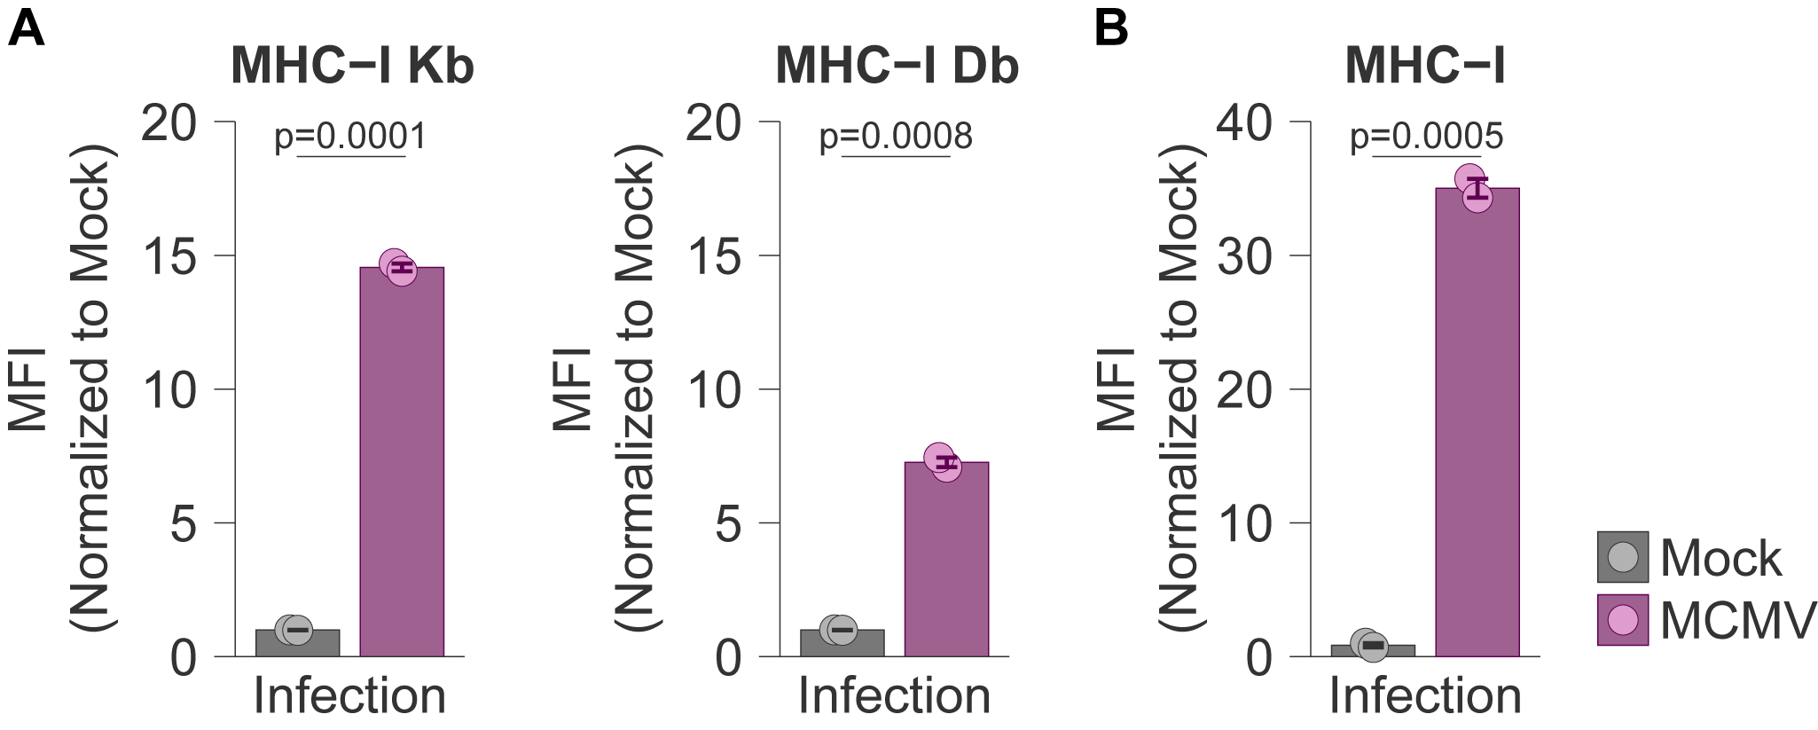
Suppl. Fig. 1. MHC expression is a hallmark of microglial activation during acute MCMV infection. Newborn (A) C57BL/6 and (B) BALB/c mice were intraperitoneally (i.p.) infected with MCMV or left mock-infected. Expression of MHC-I on microglia was analyzed by flow cytometry 13 days post-infection (dpi) on C57BL/6 (A) and BALB/c (B) mice. Mean values ± SEM are shown. n=2 Mock, n=2 MCMV, for both mice strains. Unpaired two-tailed Student’s test was used. Statistically significant differences are indicated (p values).

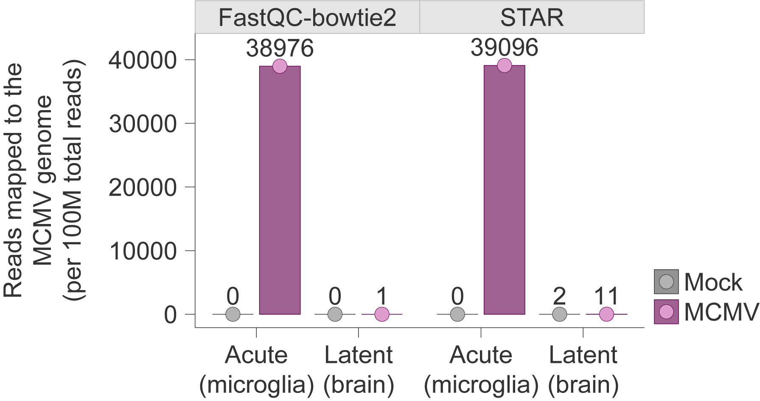

Suppl. Fig. 2. Latent infection is established in the brain. (A) Number of reads mapping to the MCMV genome in microglia from acutely infected mice (Acute microglia), and whole brains from latently infected mice (Latent brain). For the Acute microglia dataset, newborn BALB/c mice were infected, i.p., with MCMV or left mock-infected. 8 days p.i. (dpi), mice were sacrificed, microglia cells were sorted as CD45.2^{int}CD11b⁺ population, and total RNA was isolated and sequenced by RNASeq. Independent, condition-specific FASTQ files were then concatenated into a single FASTQ file for each condition (Mock vs MCMV) and reads aligned to the MCMV genome using either bowtie2 (as implemented in FastQC) or STAR. For the Latent brain dataset, newborn C57BL/6 mice were intraperitoneally (i.p.) infected with MCMV or left mock-infected. At 7 months post-infection (mpi), mice were sacrificed, and the brain cells from three mice in each experimental group were pooled together into a single. The total RNA was isolated from pooled brain homogenates and sequenced by RNASeq. Similarly to the Acute microglia dataset, reads in the obtained FASTQ files were then aligned to the MCMV genome using bowtie or STAR.

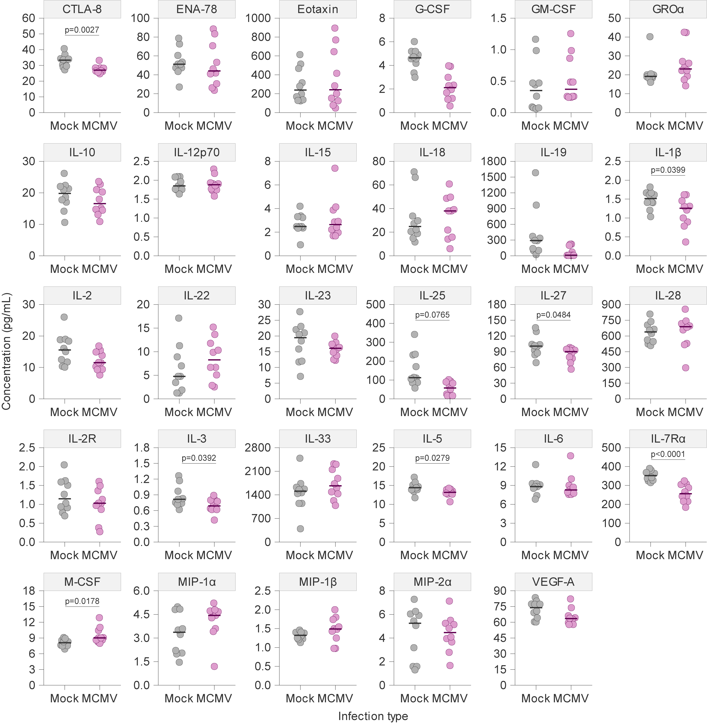

Suppl. Fig.3. Analysis of cytokine and chemokine levels in MCMV latently infected brains. Newborn BALB/c mice were intraperitoneally (i.p.) infected with 400 PFU of MCMV, or left mock-infected. Mice were sacrificed 6 months post-infection (mpi). Levels of cytokines, chemokines, and growth factors were determined in brain homogenates, 16 months p.i. Concentrations of TNF-α, IL-1 α, IL-7, IL-13, RANKL, LIF, and Leptin were below detection level. Median values are shown. Unpaired two-tailed Student’s test was used. n = 10 mice per group. Statistically significant differences are indicated (p values).

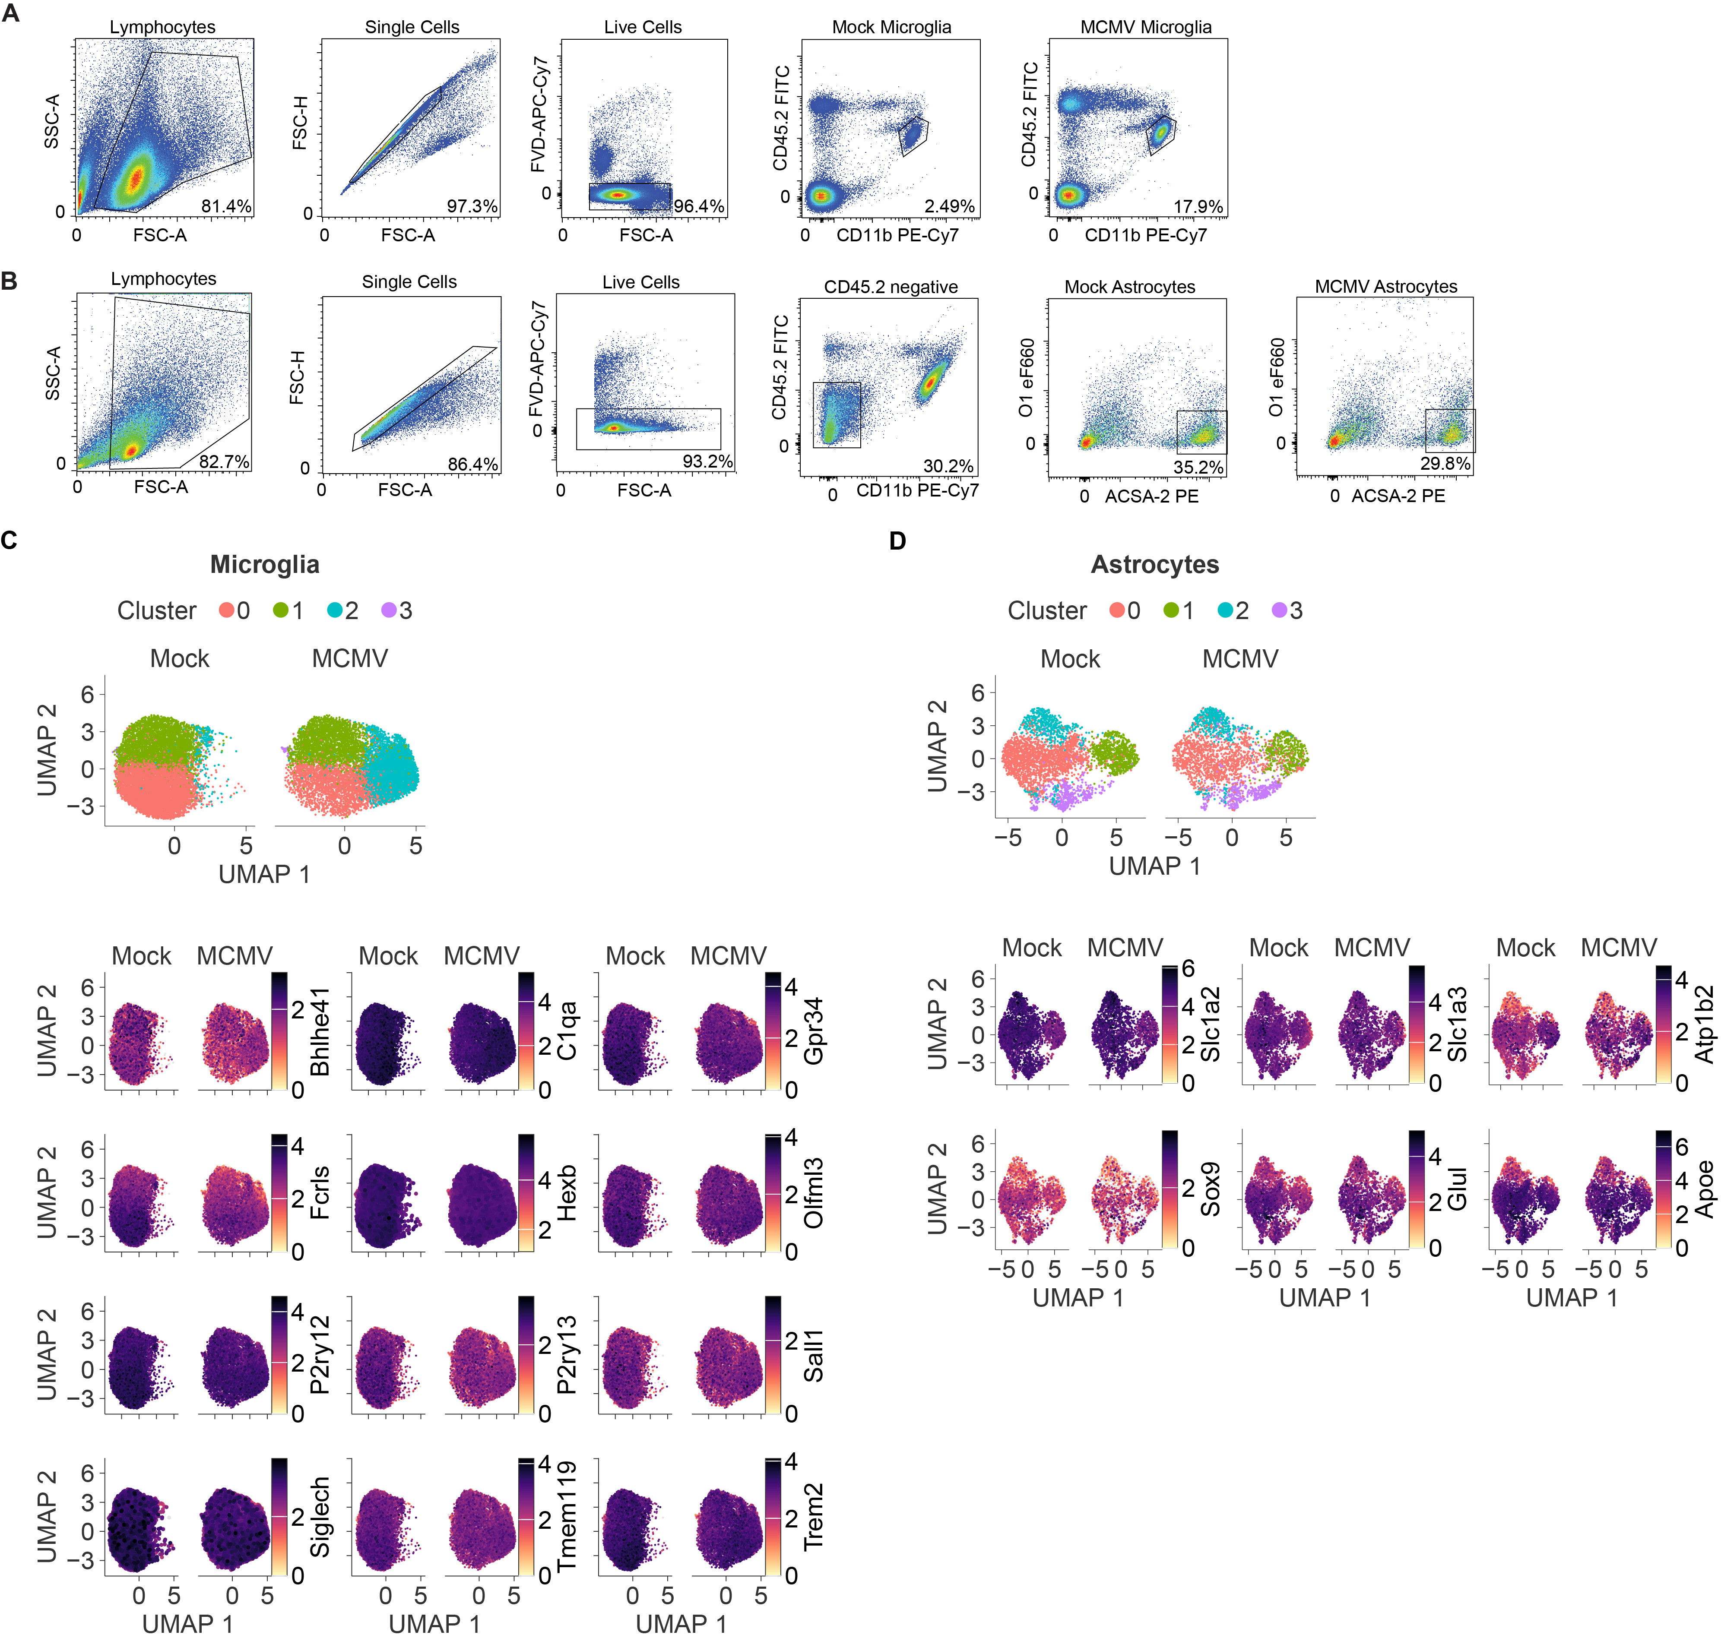

Suppl. Fig. 4. Gating strategy and identification of microglia and astrocytes population on transcriptomic level. Representative flow cytometry plots show the gating strategy used for sorting (A) microglia and (B) astrocytes population, 2.5 months post-infection (mpi). (A) For microglia cell isolation, brains were harvested at the indicated time-point post-infection, and lymphocytes were obtained using Percoll gradient centrifugation. Prior to staining, Fc receptors were blocked using the Fc block antibody. Cells were labeled with fixable viability dye (APC-eFluor780) to exclude dead cells, and microglia cells were detected using anti-CD45.2 and anti-CD11b. The population of microglia is defined as CD45.2^{int}CD11b⁺ cells. (B) Adult brain dissociation kit (Miltenyi Biotec) was used for astrocyte isolation. Astrocytes population is defined using anti-CD45.2, anti-CD11b, anti-O1, and anti-ACSA-2 as CD45.2⁻CD11b⁻O1⁻ACSA-2⁺ cells. (C-D) After cell sorting, the cDNA library was generated based on the Drop-seq method, using cell- and transcript-specific barcodes (UMI - unique molecular identifiers on beads) that capture mRNA from the lysed cells. Barcoded-labeled libraries were pooled, and RNA was sequenced on Illumina NovaSeq 6000 using NovaSeq 6000 S1 Reagent Kit. (C) UMAP plots showing the expression of the canonical microglia markers C1qa, Fcrls, Hexb, P2ry12, P2ry13, Trem119, Trem2 Siglech, Sall1, Bhlhe41, Gpr34 and Olfml3 in microglia cells/clusters. (D) UMAP plots show the canonical astrocyte markers Slc1a2, Slc1a3, Atp1b2, Sox9, Glul, and Apoe expression in astrocyte cells/clusters. Each cell in the UMAP expression plots is labeled with a color corresponding to the normalized expression value of the selected gene.

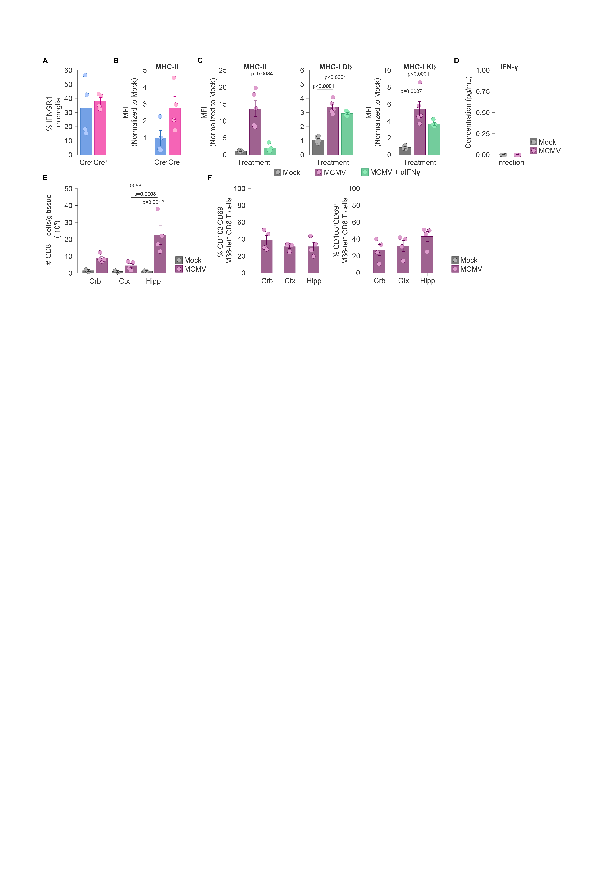
Suppl. Fig. 5. Local IFN-γ in the brain during MCMV latency maintains microglial MHC-II expression. (A) Newborn Sall1Cre^{ERT2}Ifngr1^{fl/fl} (Cre⁺) and Ifngr1^{fl/fl} (Cre⁻) mice were infected with 200 PFU intraperitoneally (i.p.) or left mock-infected. Expression of (A) IFNGR1 and (B) MHC-II on microglia are shown without tamoxifen treatment. Mean values ± SEM are shown. Unpaired two-tailed Student’s test was used. n=4 for both mice groups. (C) 5-months old C57BL/6 mice were infected with 2x10⁵ PFU of MCMV i.p.. MCMV mice were neutralized IFN-γ prior (-8, -5 and -1 day) and post (+2, +5, +7 day) MCMV infection. MHC-I and MHC-II expression by peritoneal macrophages is shown. Mean + SEM values are shown. Unpaired two-tailed Student’s test was used. n=5 Mock, n=5 MCMV, n=6 MCMV+aIFN-γ; N=2. (D) BALB/c mice were sacrificed 6 months p.i. (mpi), and the brains were collected. Brain homogenates were immediately frozen, and levels of IFN-γ were determined. Unpaired two-tailed Student’s test was used. n=10 mice per group. Statistically significant differences are indicated (p values). (E) Numbers of CD8 T cells and (F) percentage of CD8 T_{RM} cells are shown, 4 mpi. Mean values ± SEM are shown. Values are shown per gram of tissue, for each brain region. n=2 Mock, n=4 MCMV. Crb-cerebellum, Ctx-cortex, Hipp-hippocampus. Statistically significant differences are indicated (p values).

