Appendix - Methodology

A.1 Image enhancement and textualization
In this study, the data enhancement method (Bloice et al., 2017) is used to automatically generate many related oracle bone characters. Given the many forms of oracle bone inscriptions and the coexistence of positivity and negation, the mirror image writing of one part or the entire character of the oracle bone inscriptions has the same meaning. Some oracle bone inscriptions have the characteristics of left-right or upper and lower symmetry. Therefore, we can use various image enhancement methods and generate many images in line with the characteristics of oracle bone painting. The image enhancement operations in this study include rotation (rotating the image clockwise with three different angles), flipping, image size change, and vertical deformation.

In the process of image textualization, image information must be extracted. Usually, the text image is black on a white background, while our dataset is photocopied from the original rubbings of oracle bone inscriptions, which is white on a black background. Therefore, the original image of oracle bone inscriptions obtained by scanning the entire image and segmenting the words should be color reversed to make the text part black and the background part white. Then, graying processing is carried out for the image to contain only brightness information and no redundant color information. Thus, the image pixel content can be mapped to a simple representation of a numerical matrix. Finally, to extract the horizontal and vertical features of the image simultaneously, the image numerical and transpose matrices are spliced and stored in the document as the feature representation of the image content.

Algorithm 1 Feature extraction method of oracle bone inscriptions
Input: Image set, {Img}= {img1,img2, ..., imgn}
Output: Feature representation of oracle bone inscriptions
1: for each imgi∈{Img}do
2: Let {result} = 0
3: Image graying
4: Image enhancement
5: Extract the image pixel matrix
6: Obtain the transpose matrix of the pixel matrix
7: Combined picture features
9: end for
10: return result

A.2 Word embedding model
Bengio (2000) developed the word embedding model. Le and Mikolov (2014) proposed Word2Vec model based on word embedding model.

Word2Vec can better express the similarity and analogy between different words. The Word2vec tool mainly contains two models (Fig. 9): the skip-gram model (skip-gram) and the continuous bag of words model (CBOW). These two models are the realization of vector representation of text. The Skip-gram model uses the known current word to predict the context, and constantly adjusts the word vector of the head word by using the prediction results of the words in the context. CBOW model is to predict the current word through the known context, and constantly adjust the vector of surrounding words by using the prediction result of the head word.

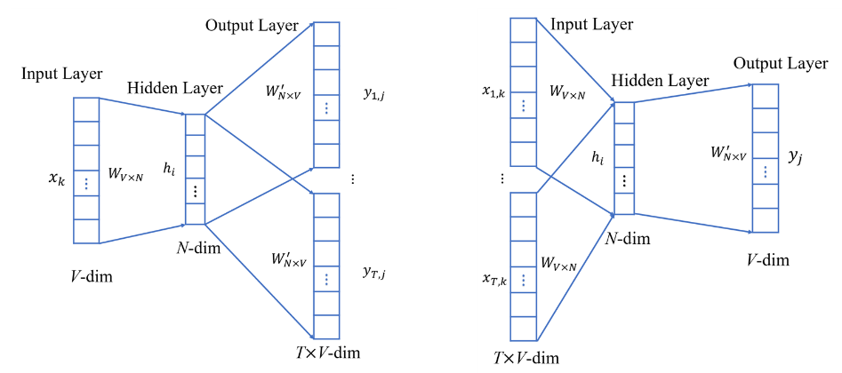
Fig. 9 Main models of Word2Vec. a Skip-gram model. b CBOW model.

Doc2Vec has two kinds: Distributed Memory Model of Paragraph Vectors (PV-DM) and Distributed Bag of Words version of Paragraph Vector (PV-DBOW). We used the PV-DM algorithm presented in the document embedding model, which is based on the idea of CBOW model.

In this framework, every word is mapped to a unique vector, represented by a column in matrix W. The column is indexed by position of the word in the vocabulary. The concatenation or sum of the vectors is then used as features for prediction of the next word in a sentence.

More formally, given a sequence of training words W1, W2, W3, ..., WT, the objective of the word vector model is to maximize the average log probability:
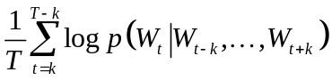. (1)
The prediction task is typically done via a multiclass classifier, such as softmax. There, we have 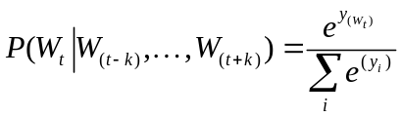 Each of yi is un-normalized log-probability for each output word i, computed as 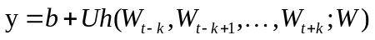 where U, bare the softmax parameters. h is constructed by a concatenation or average of word vectors extracted from W.
A.3 Image embedding
We use the Doc2Vec document embedding model to achieve document vectorization. Doc2Vec model has been widely used in the field of word processing, but this work uses it for image vectorization. The processing of images and documents has a certain similarity. Each pixel of an image can be regarded as a word in the document, and the image matrix can be regarded as a document. The Doc2Vec model can quantify the word usage and context information in the document. Thus, this model can also identify the appearance, proximity and arrangement of pixels in the image document. Meanwhile, considering that the model only recognizes the x-axis context, we add the transpose matrix of the image numerical matrix to provide the y-axis context information when extracting the image text representation. There is no standardized note for oracle data, and the complexity of oracle writing makes the manual construction of the structure pattern of oracle impossible. It is necessary to use an unsupervised method. Therefore, it is a meaningful exploration and innovation to introduce Doc2Vec model into the unsupervised image field.

First, a feedforward neural network model f(tm-k+1,…,tm-1) is constructed to fit the conditional probability P(tm|t1,t2,…,tm-1) of a word sequence composed of gray values. For text sequence S= t1,t2,…,tn, the probability is expressed as:
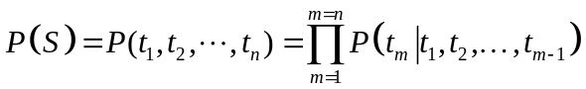. (2)

In this study, the PV-DM model in Doc2Vec is used to train the space representation of the vector. In addition to all the pixel values in the oracle text, the Document ID is added in the neural network input. The Document ID is unique and it can represent the subject word of the document. In the output, the multi-dimensional vector of each text can be obtained, and each dimension represents a hidden feature of the image represented by the text. These features summarize the horizontal and vertical features of the image represented by the text.

Due to the unitary invariance of the document embedding vector (Hamilton et al., 2016, Yin and Shen, 2018), the relative position between the document embedding vectors does not change and the geometric properties between the vectors do not change when the document embedding vector is rotated or transformed symmetrically in the geometric space. From the perspective of semantics, the transformed document embedding vector can be equivalent to the vector before the change. Given the symmetry of oracle images, Doc2Vec can process the horizontal and vertical image features after reading the image features into the text, and read the neighborhood information of image pixels. The similarity, analogy, and clustering of document embedding vectors are all part of the unitary invariance of embedding vectors. By using the clustering of the document embedding vector, the image text with similar features can be gathered to distinguish the oracle bone inscriptions.

Therefore, according to the unitary invariance of the document embedding vector and the positive and negative coexistence, and left-right symmetry of oracle bone inscriptions, the document embedding matrix can be defined as A=MMT. The document embedding matrix A and the original document embedding vector M have the same properties in the geometric space. It is a $N×N$ matrix, and the vector in the ith row of the matrix is Vi(vi1, vi2,..., viN). At the same time, the image features of oracle bone inscriptions represented by the embedded matrix are consistent with the original documents.

In different dimensions and windows, the image embedding matrix is different. We proposed a loss calculation formula for image embedding, which is very simple, but provides an efficient supervision signal for learning to express feature representation, thus optimizing the parameters of image embedding. These features can be well used in downstream prediction tasks. The loss function is defined as Oracle_DVL, where $M_{p}$and $M_{q}$ represent two different document embedding matrices, and Oracle_DVL takes Euclidean_distance:
(3)

The image embedding function calculates the document embedding vectors $M_{p}$and $M_{q}$ for the same document relative coordinate drift, and then offsets the dependence on a specific coordinate system.

To obtain the best effect of document embedding, the loss function of document embedding is used to determine the optimal window and dimension.

Algorithm 2 Optimal vector_size and window selection
Input: Document set{doc}
Output: Optimal vector_size and optimal sliding window for document embedding
1: set window fixed
2: for dimension in (lower bound, upper bound):
3: M = Doc2Vec({doc}, window, vector_size)
4: A= MMT
5: {A}.append(A)
6: for A 1 in { A }:
7: SUMDVL=SUM(DVL(A1, Aother))
8: {Oracle_DVL }.append(Oracle_DVL)
9: optimal vector_size = min{Oracle_DVL }.dimension
10: set dimension fixed
11: Perform steps 2-8
12: optimalwindow = min{ Oracle_DVL }.window

According to Algorithm 2, the control variable method is used to determine the two parameters: sliding window and model vector_size of Doc2Vec model in turn. The running results on dataset 1 are shown in Fig. 10. Therefore, we confirm the optimal dimension vector_size = 680 and optimal window = 8.

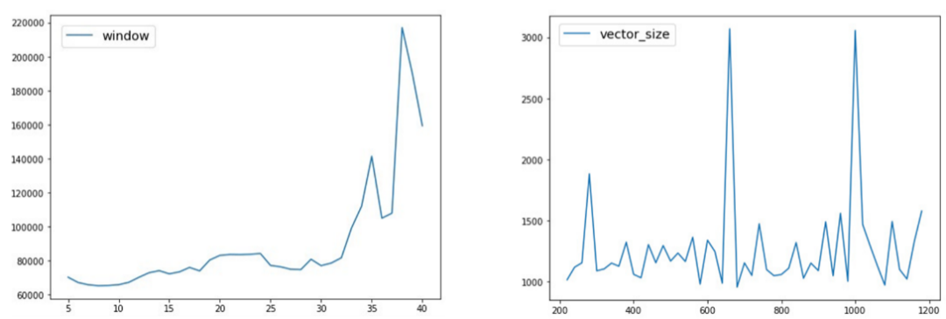
Fig.10 Determination of optimal window (a) and optimal vector_size (b)

A.4 Manifold learning dimension reduction
Manifold learning dimensionality reduction is a process of finding low dimensional data in high dimensional spatial data, that is, mapping f for dataset {ai} in high dimensional space and constructing low dimensional dataset {yi= f(ai)} where yi satisfies the given condition in the dimension. We use the nonlinear dimensionality reduction method in manifold learning. For the document embedding matrix of high-dimensional data, we use the nonlinear dimensionality reduction method, which can retain the original features of the oracle image, and visualize the low dimensional data. The dimension reduction of oracle image vector can help find the structural and writing features hidden in the oracle image.

We use the T-SNE (Maaten, 2008) dimension reduction method. It uses gradient descent method for learning in the dimension reduction to enlarge the distance between different oracle image clusters. Compared with the linear dimension reduction method, it can gather the same kind of vectors into the same cluster, and realize the two-dimensional visual clustering of oracle bone images.

For the two-dimensional manifold after dimension reduction {yi}={(ai,bi)}, for any two clusters Y1 and Y2, Y1 has N1 points, Y2 has N2 points, and the distance between two clusters can be calculated as:
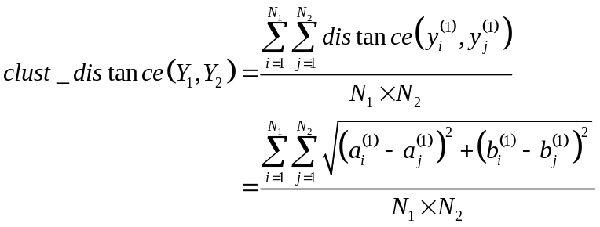
(4)
The cluster distance equation can quantitatively represent the similarity between two types of documents, and then represent the similarity between the images represented by documents. The closer the distance is, the more similar the two types of documents are. Due to the embedding vectors of image documents are clustering and the distance between similar image documents is small, they tend to cluster. T-SNE dimension reduction enlarges the distance between different classes in the process of learning by gradient descent method, which makes the visualization effect of clustering more obvious. In order to show the similarity between images more intuitively, after T-SNE dimension reduction, we used the original image to replace the point to visualize the image.

