CONTENTS
Supplementary Note 1: Algorithm design and optimization.
Supplementary Figure 1: The flowchart and experimental results of the GS algorithm.
Supplementary Figure 2: Comparison of the experimentally generated light field without and with the proposed correction Method.
Supplementary Note 2: Comparison of etching results under different light intensities.
Supplementary Figure 3: The cross-section contours at the same location on the surface of four samples under the illumination of 2 µW, 10 µW, 100 µW, and 200 µW irradiance.
Supplementary Figure 4: The picture of our in-house developed a-PEC etching and in-situ monitoring system.
Supplementary Figure 5: The etching experiments without light illumination.
Supplementary Figure 6: The etching results for GaAs wafers with different conductivities.
Supplementary Figure 7: Four sets of conductivity measurements of undoped GaAs, using the probe method (the distance between the probes is the same).
Supplementary Figure 8: The SEM image of an a-PEC etched pattern based on a physical photomask.
Supplementary Figure 9: The spectral measurement results of the material for the protuberant structure using an energy dispersive spectrometer (EDS).
Supplementary Figure 10: The holographic imaging system based on the reflective phase mask, which is fabricated using a PEC etching technique.

Supplementary Note 1: Algorithm design and optimization
GS algorithm is the most widely used iterative algorithm in computer-generated holograms (CGH)¹. As shown in Fig. S1a, the specific steps of iteration can be described as follows: First of all, we take out the intensity I₀ of the original Gaussian beam measured by the camera, and Φ₀ can be randomly chosen. As a result, the input can be described as
(1)
A fast Fourier transform (FFT) is implemented to obtain a spectral function on the image plane
(2)
where F denotes the FFT, I₁, and Φ₁ are the intensity and phase in the Fourier domain, respectively. We then replace the intensity I₁ with the targeted intensity I₂ (i.e., the target pattern) while reserving the phase Φ₁. The new spectral function can be obtained as
(3)
The inverse FFT (IFFT) is then implemented to obtain the intensity and phase function
(4)
where F ⁻¹ represents IFFT, I₃, and Φ₂ are the intensity and phase on the SLM plane. We then replace intensity I₃ with the intensity I₀ of the originally input Gaussian beam, but reserve the phase Φ₂. Hence the optical field on the SLM plane is
(5)
We then go back to Step 2 and repeat the above processes until the difference between I₁ and I₂ is smaller than a preset threshold or until the number of iterations is reached. As a result, the final phase map Φ₂ can be loaded into the SLM.
Figure S2a shows the experiment result of the light field produced by our optical system directly, in which we can observe that the light intensity distribution is not uniform. We propose a method based on camera feedback to correct the intensity of the simulated target pattern according to the experimental pattern captured by the camera, and the correction algorithm flowchart is shown in Fig. S2c. First of all, we input the initial light intensity I_{t,0} as the target pattern and calculate the phase map according to the GS algorithm. We then load the calculated phase map on LCSLM. We compare the initial light intensity I_{t,0} with the experimentally captured light intensity I_{e,}k (k ≥ 0 and k is an integer) to confirm if the experimental light intensity uniformity is satisfied. If the answer is yes, we then output the phase map, otherwise the target intensity pattern should be updated using the equation I_{t,k}=I_{t,k}-1+Δ(I_{t,0}-I_{e,k-1}). In this way, the region in which the intensity is higher or lower than the initial light intensity will be reduced or increased respectively. The weight coefficient Δ determines how much the light intensity is reduced or increased.
Figure S1 The flowchart and experimental results of the GS algorithm. a, the flowchart of the GS algorithm. b and c, the simulated and experimental results of an array consisting of 36 circles. The three sub-figures from left to right in b or c are the results presented in 3D, 2D, and 1D forms, respectively.
Figure S2 The experimentally generated light field a. without and b. with the proposed correction method. The three sub-figures from left to right in a and b are the results presented in 3D, 2D, and 1D forms, respectively. c, the framework of the correction algorithm.

Supplementary Note 2: Comparison of ETCHING results under different light intensities.
We carried out four etching experiments on the same undoped GaAs using identical patterns for illumination, in which the intensity of the light field gradually increased from 2 µW to 200 µW. The cross-section contours at the same location on the surface of these samples are presented in Fig. S3, in which we can find that the shapes of the generated structures are exactly similar while the height of the high-intensity regions relative to the dark regions is gradually increased indicating a more pronounced etching suppression when the light intensity is progressively increased. It can be inferred that as the light intensity progressively increases, the ratio of electron concentrations to hole concentrations on the sample's surface also increases. This has been demonstrated by our simulation results in Fig.3a.
Figure S3 The cross-section contours at the same location on the surface of four samples under the illumination of a. 2 µW, b. 10 µW, c. 100 µW, and d. 200 µW irradiance, respectively.
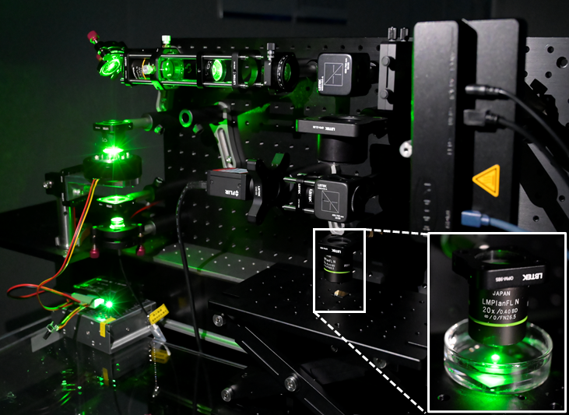
Figure S4 The picture of our in-house developed a-PEC etching and in-situ monitoring system.

Figure S5 The etching experiments without light illumination. a, the measured surface height for the regions in the air (left) and in the etching solution (right), respectively. b, the cross-section contour corresponding to the dashed line in a.

As shown in Fig. S5, the surface of the sample exposed to air is higher than the surface immersed in the etchant, which means the etching rate in the dark region is about 50-100 nm/min. The etching depth in the dark region is larger than the height of the regions illuminated by high light intensity (see the results in Fig. S3), indicating that the structures in regions illuminated by the high-intensity light do not exceed the height of the original wafer surface, which excludes the possibility that the result is produced by redeposition in a-PEC etching.

Figure S6 The etching results for GaAs wafers with different conductivities. a and d, the simulated light field alongside the cross-section contours corresponding to the white dashed lines. b and e, the etching results for the GaAs wafers with a high conductivity. c and f, the etching results for the GaAs wafers with a low conductivity.

The etching results were significantly different when we conducted etching on undoped GaAs with different conductivity (i.e., the higher the doping rate, the higher the conductivity is). As shown in Fig. S6c and f, the GaAs wafer with a lower conductivity shows a more significant etching suppression because the structures in regions of high-intensity light are significantly elevated compared to non-illumination areas. In contrast, the GaAs wafer with a higher conductivity does not exhibit noticeable etching suppression, as depicted in Fig. S6b and e. These results are consistent with our proposed theory, that is, a stronger built-in electric field in a high-conductivity GaAs wafer can drive more holes to the surface, resulting in the accelerated etching effect.

Figure S7 Four sets of conductivity measurements of undoped GaAs, using the probe method (the distance between the probes is the same). In each graph, two curves represent the measurement results for two types of GaAs (i.e., suppressed etching and accelerated etching).

Figure S8 The SEM image of an a-PEC etched pattern based on a physical photomask (i.e., the “USAF 1951” resolution test target pattern). The processing time was 10 minutes, resulting in a 600 nm height.

Figure S9 The spectral measurement results of the material for the protuberant structure using an energy dispersive spectrometer (EDS). a and b are the energy spectra of the first measurement measured by area scan and point scan, respectively. c, the percentage of atoms and weight of the two measurement results.

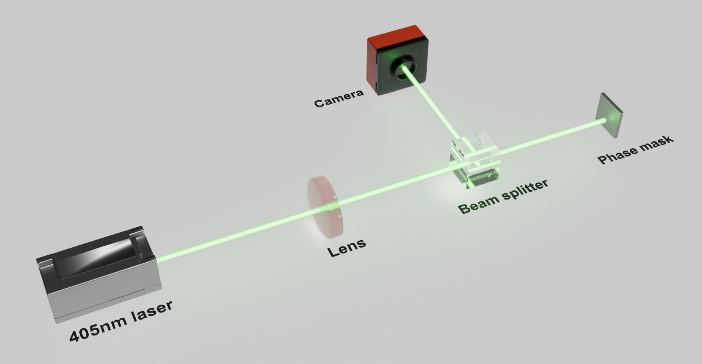
Figure S10 The holographic imaging system is based on the reflective phase mask, which is fabricated using a-PEC etching technique. A 405nm collimated laser is focused by a 300mm lens, after which the focused beam is modulated by the reflective phase mask. The modulated light field is then captured by the camera positioned at the focal plane of the lens to validate the holographic imaging.

