Additional file 1 Determine of the PEDV S1 antigen in recombinant L. reuteri S1/J31 (a) Results of western blot. (b) Results of IFA.

Additional file 2 Acidic mucins stained with Alcian blue and imaged. Alcian blue staining indicated that acidic mucins are spread throughout the HT29-MTX-E12 cell monolayer Monoculture of Caco-2 cells do not produce mucus and showed only background levels of staining when compared to staining of Caco-2/HT29-MTX-E12.
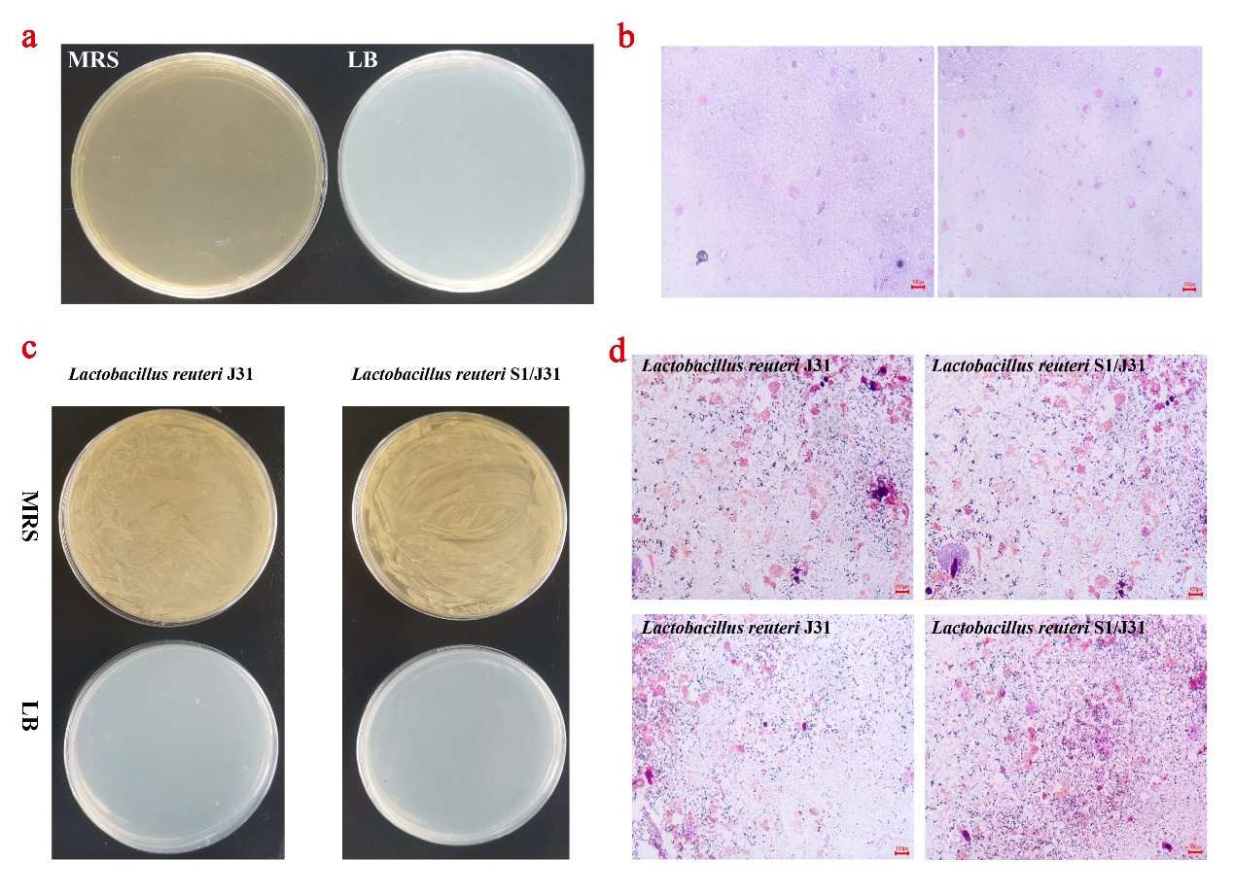
Additional file 3 The small intestine of newborn piglets is sterile, as demonstrated by culturing its contents on (a) MRS/LB medium and (b) Gram staining. Bacterial culture (c) and Gram staining (d) of intestinal contents after ligation and injected with L. reuteri.
Additional file 4 Determine of the PEDV S1 antigen and the DCs targeting peptide 6aa in recombinant L. reuteri S1-6aa/J31 (a) Results of western blot. (b) Results of IFA.
Additional file 5 Culture and identification of porcine monocyte-derived DCs (a) Morphology of DCs（400×）. (b) Fluorescence microscopy of surface makers on DCs.

