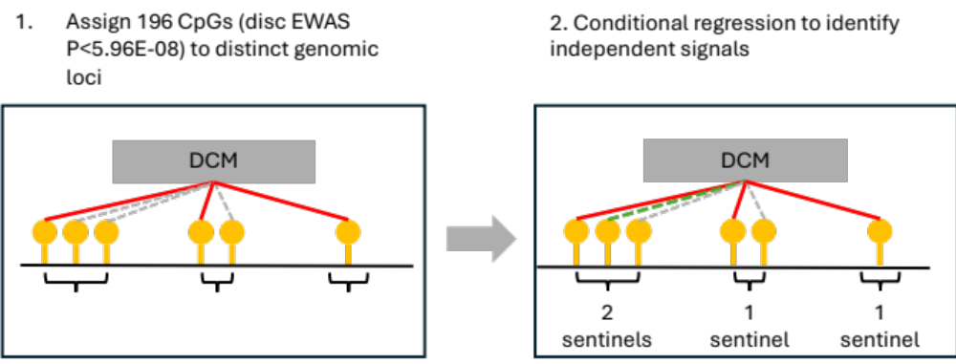
Figure S1 Identification of sentinel CpGs from epigenome-wide significant CpGs in discovery-stage EWAS. The 196 CpGs were grouped into distinct genomic loci, whereby CpGs less than 1Mb apart are considered as belonging to a single genetic locus (curly brackets; Panel 1). At each genomic locus, the lead signal, defined as the CpG with the lowest EWAS P value, is identified as a sentinel CpG. For genomic loci with >1 CpG, additional independent signals were identified by conditioning on the lead signal for the locus. Similar to EWAS, separate analyses were conducted for Whites and African Americans, followed by an inverse variance-weighted meta-analysis to identify non-lead CpGs with independent associations to DCM (Bonferroni P<0.05). The 194 DCM sentinel CpGs analysed in the manuscript consists of lead CpGs and independent signals identified through conditional analysis.

Figure S2 Ancestry-specific clustering using methylation levels of 194 DCM sentinel CpGs. Unsupervised hierarchical clustering was performed separately for Whites and African Americans. Within both ancestry groups, two distinct clusters were formed, clearly segregating cases from controls. The clustering was highly significant in both ancestries (Whites: binomial P<2.2E-16; African Americans: binomial P=1.98E-10).

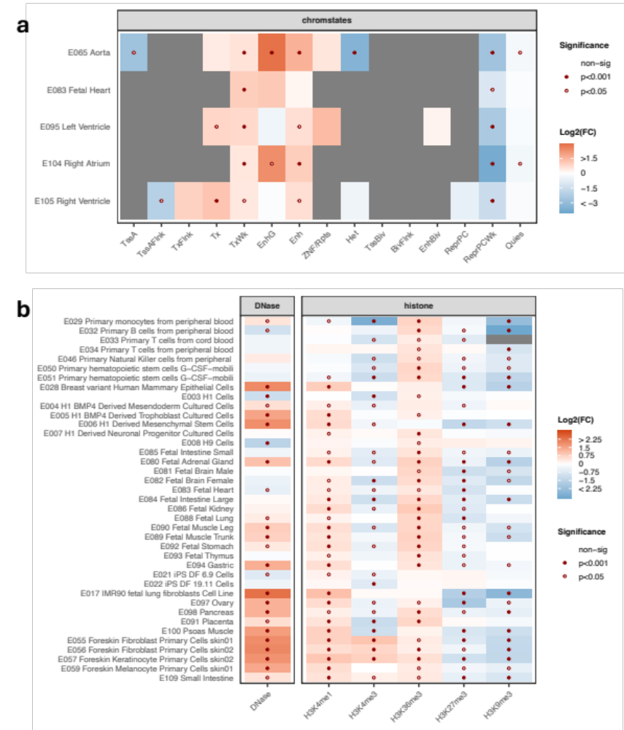
Figure S3 Enrichment analysis for genomic regulatory regions. The 194 DCM sentinel CpGs were assessed for enrichment (and depletion) in genomic regulatory regions against 1,000 sets of background CpGs from the EPIC array, matched to the sentinel CpGs based on methylation levels and variability. The results are presented as fold change, calculated by comparing the overlap counts amongst sentinel CpGs to the mean overlap count of the 1,000 background sets. A. Cardiac-specific chromatin states. The proportion of DCM sentinel CpGs overlapping 15 chromatin states in five types of cardiac tissue was calculated. B. Accessible chromatin and regions with core histone marks. The proportion of DCM sentinel CpGs overlapping DNAse hypersensitivity sites (DHS) and regions marked by the five core histone modifications was calculated across 39 cell types. Gene regulatory features were sourced from the Roadmap Epigenomics database.

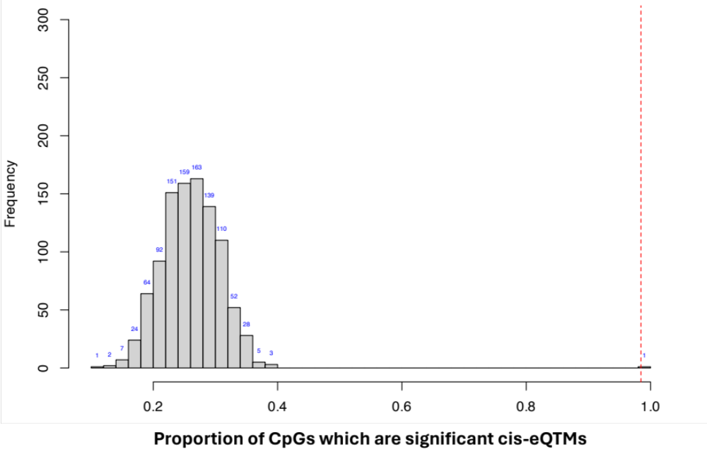
Figure S4 Enrichment analysis for eQTMs. The 194 DCM sentinel CpGs were assessed for enrichment in significant eQTM relationships (discovery-stage, FDR P<0.05) with proximal genes (sentinel CpG within ±1Mb of gene TSS). Enrichment was assessed against 1,000 sets of background CpGs from the EPIC array, matched to the sentinel CpGs based on methylation levels and variability. DCM sentinel CpGs showed enrichment in significant eQTM relationships (3.80-fold compared to mean of 1,000 background sets; P < 0.001)

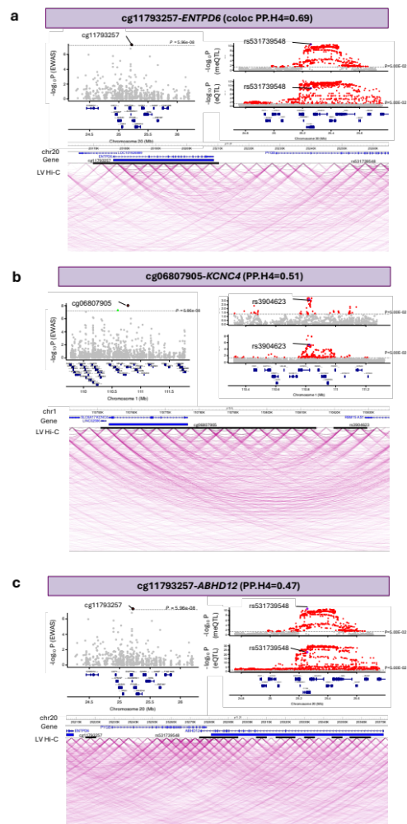

Figure S5 Regional plots for colocalized sentinel-CpG gene pairs (PP.H4>0.4). Three types of regional plots are shown for each pair, including two regional association plots (top) and bulk left ventricular Hi-C chromatin interactions (bottom). Regional association plots include: (i) Associations of CpGs surrounding DCM sentinel CpGs with DCM from discovery-stage EWAS (left); and (ii) Genetic associations with the sentinel CpG (meQTL; MAGNet) and target gene (eQTL; GTex) in a +/-500kb region centered on the SMR instrumental variable (right). Bottom plots are left ventricular Hi-C chromatin interactions based on the sentinel CpG site (5-kb resolution). A. cg11793257-ENTPD6: EWAS and genetic associations. The displayed region in the EWAS plot is centered on cg11793257. Posterior probability of colocalization (PP.H4) between cg11793257 meQTLs and ENTPD6 eQTLs was 0.69. B. cg06807905-KCNC4: EWAS and genetic associations. The displayed region in the EWAS plot is centered on cg06807905. PP.H4 between cg06807905 meQTLs and KCNC4 eQTLs was 0.51. C. cg11793257-ABHD12: EWAS and genetic associations. PP.H4 between cg11793257 meQTLs and ABHD12 eQTLs was 0.47. Gene tracks for all regional plots consist of protein-coding genes were obtained from Ensembl Release 75 (last release to be based on the hg19 assembly).

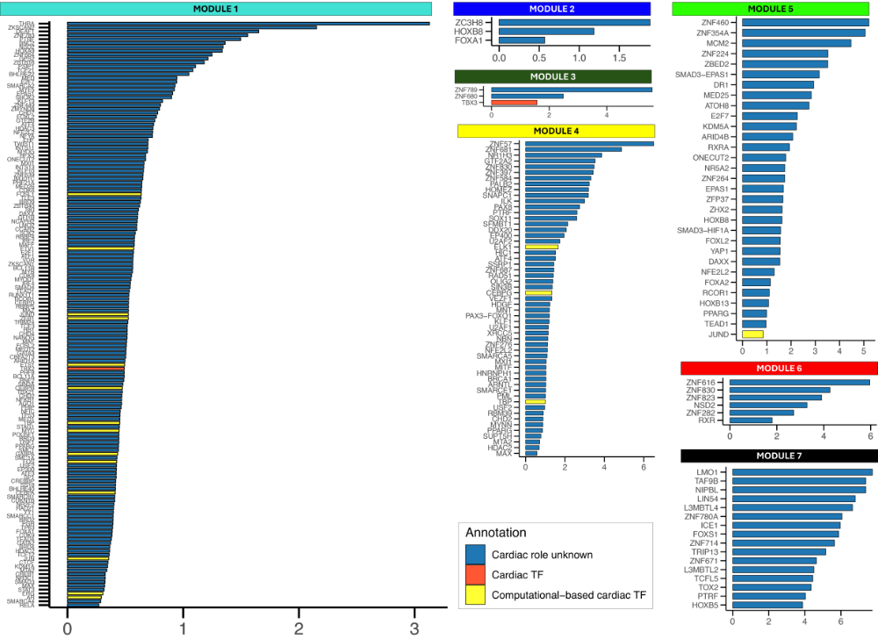
Figure S6 Bar plots of transcription factors (TFs) with enriched binding sites (permutation test P<0.001) in co-methylation modules. Co-methylated CpGs were assessed for enrichment (and depletion) in TFBS against 1,000 sets of background CpGs from the EPIC array, matched to the module-specific CpGs based on methylation levels and variability. The results are presented in decreasing order of fold change (log2FC), calculated by comparing the overlap counts amongst module-specific CpGs to the mean overlap count from the 1,000 background sets. Cardiac TF=expressed in humans with in vivo validation of cardiac function; Computational-based=putative cardiac TFs based on computational studies using human samples; cardiac role unknown transcription factors of uncertain cardiac relevance to humans. Known binding sites of transcription regulators were sourced from the Remap 2022 database.

