Appendix A – Supplemental Figures
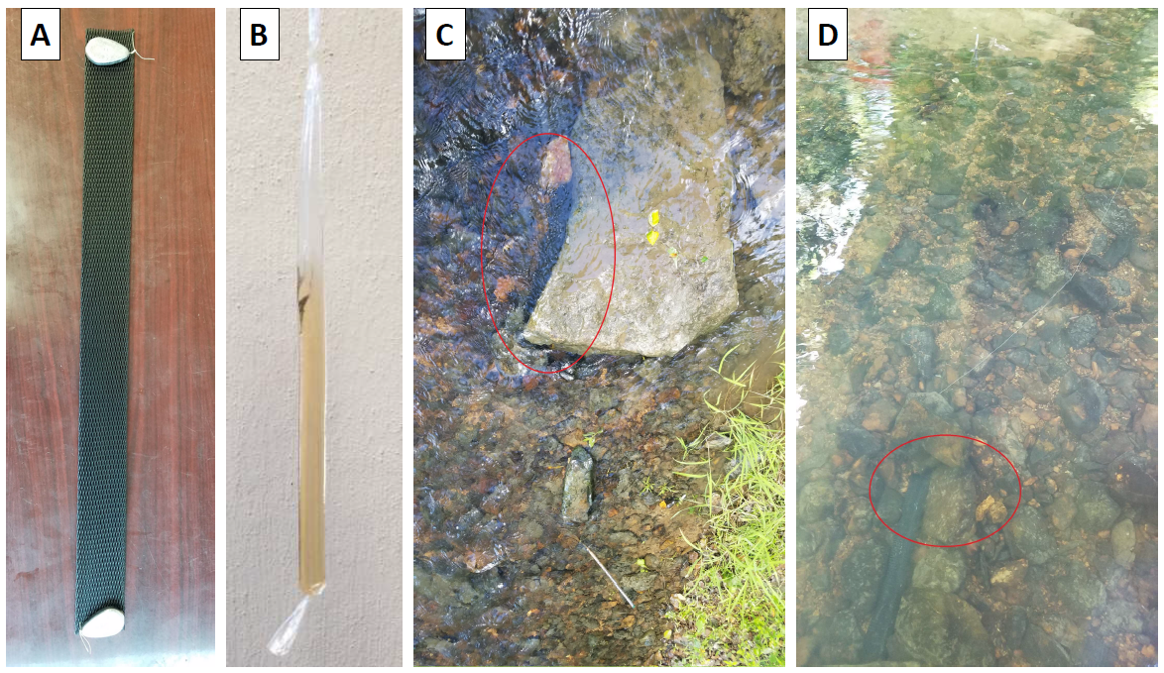
Fig 6 Frames A and B show the protective mesh sleeve and the passive sampler filled with deionized water (DIW), respectively. For the illustrative purposes, we added a dye to the deionized water. Frames C and D show in-situ deployment and placement of the passive samplers inside the protective mesh sleeve.

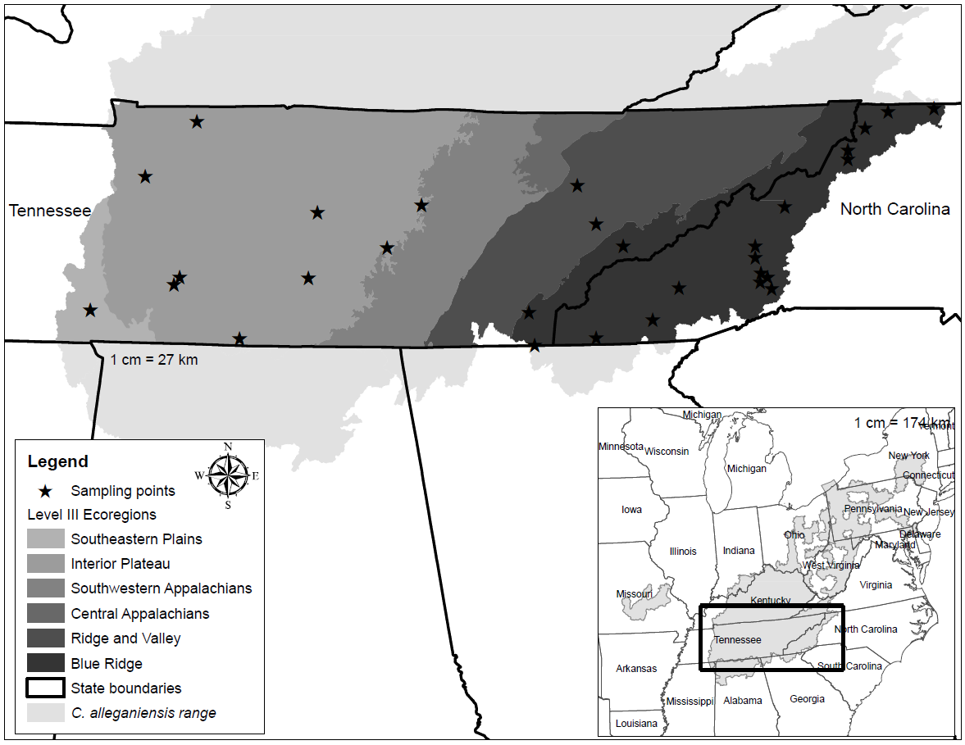
Fig 7 Map representing Level III ecoregions within the Cryptobranchus alleganiensis range in Tennessee and North Carolina. From left to right: Southeastern Plains, Interior Plateau, Southwest Appalachians, Central Appalachians, Ridge and Valley, and Blue Ridge.

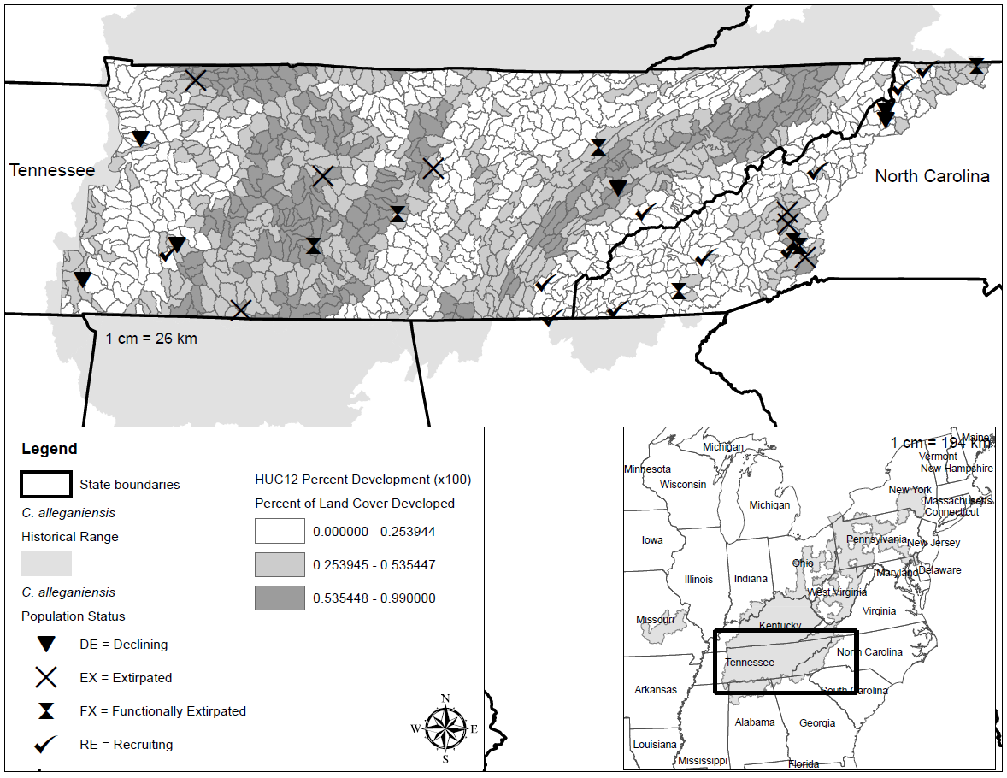
Fig 8 Map representing Cryptobranchus alleganiensis population status at each site sampled in North Carolina and Tennessee along with the percent development for each HUC12 watershed.
RE = Since 2000: 1) evidence of recruitment as demonstrated by a range of post-metamorphic juveniles and adults and no documentation of declines
DE = Documented decline in abundance or recruitment (e.g., shift in size classes or biased sex ratio) as demonstrated by survey data
FE = Despite significant survey effort, few individuals in adult age classes found and no evidence of reproduction
EX = 1) Despite sufficient effort (multiple survey methods or survey events), only negative observations since 2000 or 2) no suitable habitat available (includes water quality)
Reference: USFWS (2018) Eastern Hellbender (Cryptobranchus alleganiensis alleganiensis) Species Status Assessment Report

