Breastfeeding interventions for low-birth-weight infants in South Asia: A systematic review and meta-analysis
Supplementary file
Contents
1 Search strategy 1
2 Publication bias 7
3 Meta-regression analysis 8
4 Inclusion, exclusion criteria and interventions description of selected articles. 9
5 Quality assessment/ assessment of risk of bias 17
6 PRISMA checklist 20

1 Search strategy

Table S1: Search strategy
Database
PubMed (National Library of Medicine)
Date of search: 20230911
#1
"Asia, Southern"[Mesh]
=174847
#2
bangladesh OR bangladeshi OR india OR indian OR indians OR pakistan OR pakistani OR "sri lanka" OR "sri lankan" OR "sri lankans" OR ceylon OR nepal OR nepalese OR bhutan OR bhutanese OR maldives OR maldivian OR maldivians OR afghanistan OR afghani OR afghan OR afghans OR "south asia" OR "south asian" OR "south asians" OR "southern asia" OR "southern asian" OR "southern asians"
=1098749
#3
#1 OR #2
=1098749
#4
(((("Breast Feeding"[Mesh]) OR "Colostrum"[Mesh]) OR "Breast Milk Expression"[Mesh]) OR "Lactation"[Mesh]) OR "Bottle Feeding"[Mesh]
=93923
#5
breastfeed* OR "breast feed*" OR "breast milk expression*" OR colostrum* OR "breast milk expression*" OR "feeding breast*" OR lactat* OR breastfed OR "breast fed" OR "prelacteal feed*" OR "bottle feed*" OR "formula feed*" OR "breastmilk substitute*" OR "breast milk substitute*"
=314801
#6
#4 OR #5
=314902
#7
"Randomized Controlled Trial" [Publication Type]
=600968
#8
intervent* OR experiment* OR randomised OR randomized OR "quasi-experimental" OR "quasi experimental" OR quasiexperimental OR RCT
=5784785
#9
#7 OR #8
=5785186
#10
#3 AND #6 AND #9
=2758

#11
#10 Filters: Other Animals
=823
#12
#10 NOT #11
=1937 records

Embase (Elsevier)
Date of search: 20230911
#1
'south asia'/exp OR 'south asian'/exp OR bangladesh:ti,ab,kw OR bangladeshi:ti,ab,kw OR india:ti,ab,kw OR indian:ti,ab,kw OR indians:ti,ab,kw OR pakistan:ti,ab,kw OR pakistani:ti,ab,kw OR 'sri lanka':ti,ab,kw OR 'sri lankan':ti,ab,kw OR 'sri lankans':ti,ab,kw OR ceylon:ti,ab,kw OR nepal:ti,ab,kw OR nepalese:ti,ab,kw OR bhutan:ti,ab,kw OR bhutanese:ti,ab,kw OR maldives:ti,ab,kw OR maldivian:ti,ab,kw OR maldivians:ti,ab,kw OR afghanistan:ti,ab,kw OR afghani:ti,ab,kw OR afghan:ti,ab,kw OR afghans:ti,ab,kw OR 'south asia':ti,ab,kw OR 'south asian':ti,ab,kw OR 'south asians':ti,ab,kw OR 'southern asia':ti,ab,kw OR 'southern asian':ti,ab,kw OR 'southern asians':ti,ab,kw
=458233
#2
'breast feeding'/exp OR 'breast milk expression'/exp OR 'colostrum'/exp OR 'lactation'/exp OR 'bottle feeding'/exp OR breastfeed*:ti,ab,kw OR 'breast feed*':ti,ab,kw OR colostrum*:ti,ab,kw OR 'breast milk expression*':ti,ab,kw OR 'feeding breast*':ti,ab,kw OR lactat*:ti,ab,kw OR breastfed:ti,ab,kw OR 'breast fed':ti,ab,kw OR 'prelacteal feed*':ti,ab,kw OR 'bottle feed*':ti,ab,kw OR 'formula feed*':ti,ab,kw OR 'breastmilk substitute*':ti,ab,kw OR 'breast milk substitute*':ti,ab,kw
=340581
#3
'randomized controlled trial'/exp OR intervent*:ti,ab,kw OR experiment*:ti,ab,kw OR randomised:ti,ab,kw OR randomized:ti,ab,kw OR 'quasi-experimental':ti,ab,kw OR 'quasi experimental':ti,ab,kw OR quasiexperimental:ti,ab,kw OR rct:ti,ab,kw
=5611075
#4
#1 AND #2 AND #3
=1461
#5
#4 AND ('animal experiment'/de OR 'animal model'/de OR 'animal tissue'/de OR 'nonhuman'/de)
=149
#6
#4 NOT #5
=1312
#7
#6 AND [embase]/lim NOT ([embase]/lim AND [medline]/lim)
=451 references

Web of Science core collection (Clarivate)
Date of search: 20230912
#1
TS=(bangladesh OR bangladeshi OR india OR indian OR indians OR pakistan OR pakistani OR "sri lanka" OR "sri lankan" OR "sri lankans" OR ceylon OR nepal OR nepalese OR bhutan OR bhutanese OR maldives OR maldivian OR maldivians OR afghanistan OR afghani OR afghan OR afghans OR "south asia" OR "south asian" OR "south asians" OR "southern asia" OR "southern asian" OR "southern asians")
=714702
#2
TS=(breastfeed* OR "breast feed*" OR "breast milk expression*" OR colostrum* OR "breast milk expression*" OR "feeding breast*" OR lactat* OR breastfed OR "breast fed" OR "prelacteal feed*" OR "bottle feed*" OR "formula feed*" OR "breastmilk substitute*" OR "breast milk substitute*")
=280036
#3
TS=(intervent* OR experiment* OR randomised OR randomized OR "quasi-experimental" OR "quasi experimental" OR quasiexperimental OR RCT)
=9254807
#4
#1 AND #2 AND #3
=1188 records
CINAHL Complete (Ebsco)
Date of search: 20230912
#1
(MH "Asia, Southern+") OR ( bangladesh OR bangladeshi OR india OR indian OR indians OR pakistan OR pakistani OR "sri lanka" OR "sri lankan" OR "sri lankans" OR ceylon OR nepal OR nepalese OR bhutan OR bhutanese OR maldives OR maldivian OR maldivians OR afghanistan OR afghani OR afghan OR afghans OR "south asia" OR "south asian" OR "south asians" OR "southern asia" OR "southern asian" OR "southern asians") )
=97424
#2
( (MH "Breast Feeding+") OR (MM "Colostrum") OR (MM "Lactation") OR (MM "Bottle Feeding") ) OR ( breastfeed* OR "breast feed*" OR "breast milk expression*" OR colostrum* OR "breast milk expression*" OR "feeding breast*" OR lactat* OR breastfed OR "breast fed" OR "prelacteal feed*" OR "bottle feed*" OR "formula feed*" OR "breastmilk substitute*" OR "breast milk substitute*" )
=62030
#3
(MH "Randomized Controlled Trials+") OR TI ( intervent* OR experiment* OR randomised OR randomized OR "quasi-experimental" OR "quasi experimental" OR quasiexperimental OR RCT ) OR AB ( intervent* OR experiment* OR randomised OR randomized OR "quasi-experimental" OR "quasi experimental" OR quasiexperimental OR RCT )
=939838
#4
#1 AND #2 AND #3
=490 records

Cochrane library (Cochrane central)
Date of search: 20230912
#1
MeSH descriptor: [Asia, Southern] explode all trees
=5980
#2
(bangladesh OR bangladeshi OR india OR indian OR indians OR pakistan OR pakistani OR "sri lanka" OR "sri lankan" OR "sri lankans" OR ceylon OR nepal OR nepalese OR bhutan OR bhutanese OR maldives OR maldivian OR maldivians OR afghanistan OR afghani OR afghan OR afghans OR "south asia" OR "south asian" OR "south asians" OR "southern asia" OR "southern asian" OR "southern asians"):ti,ab,kw
=21612
#3
#1 OR #2
=21612
#4
MeSH descriptor: [Breast Feeding] explode all trees
=2674
#5
MeSH descriptor: [Colostrum] explode all trees
=216
#6
MeSH descriptor: [Lactates] in all MeSH products
=3565
#7
MeSH descriptor: [Bottle Feeding] explode all trees
=252
#8
(breastfeeding OR "breast feeding" OR breastfeed OR "breast feed""breast milk expression" OR "breast milk expressions" OR colostrum OR "feeding breast" OR lactating OR lactation OR lactates OR breastfed OR "breast fed" OR "prelacteal feeding" OR "bottle feeding" OR "formula feeding" OR "breastmilk substitute" OR "breastmilk substitutes" OR "breast milk substitute" OR "breast milk substitutes"):ti,ab,kw
=28975
#9
#4 OR #5 OR #6 ORR #7 OR #8
=29657
#10
(intervent* OR experiment* OR randomised OR randomized OR "quasi-experimental" OR "quasi experimental" OR quasiexperimental):ti,ab,kw
=1501061
#11
#3 AND #9 AND #10
=749 records trials 731

2 Publication bias

2.1. Meta Funnel plot
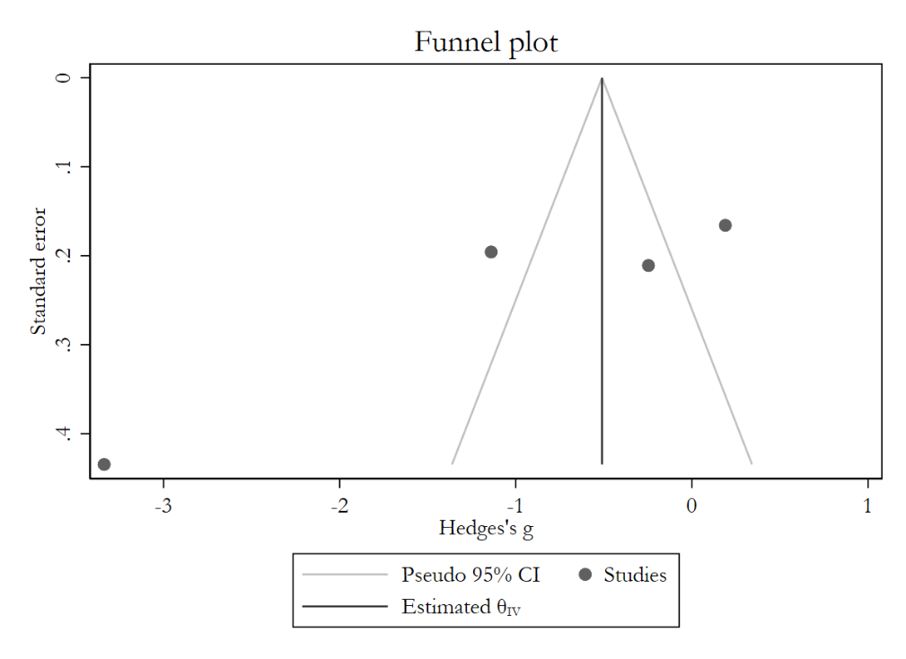

3 Meta-regression analysis
3.1 Studies considered for meta-analysis
Study | Country | Study type | Study arms | Birth weight maximum | Intervention sample | Time to IBF_intervention | Control sample | Time to IBF_control
Akter, 2021 | Bangladesh | Quasi-experimental | 2 | <1800 gram | 25 | 9.6, 2.16 days | 25 | 20.12, 3.82 days
Gonuguntla, 2018 | India | Non-RCT | 3 | <2000 gram | 60 | 2.68, 1.55 days | 60 | 5.17, 2.65 days
Kadam, 2005 | India | RCT | 2 | <1800 gram | 44 | 4.7, 3.3 days | 45 | 5.6, 3.9 days
Sumon Rao, 2008 | India | RCT | 2 | <2000 gram | 91 | 3.76, 4.49 days | 60 | 2.95, 3.85 days

3.2 Meta regression analysis

Variable | Univariate |  |  |  | Multivariate
Variable | Beta (β) | 95% CI | P-value | R² (%) | Beta (β) | 95% CI | P-value | R² (%)
Country | 2.94 | 1.22 - 4.66 | 0.001 | 81.16 | 2.12 | 1.05 - 3.35 | 0.000 | 97.39
Study type | -2.14 | -4.27 - -0.02 | 0.048 | 51.22 | -1.13 | -1.88 - -0.39 | 0.003 | 97.39

4 Inclusion, exclusion criteria and interventions description of selected articles.
Author, year | Inclusion criteria | Exclusion Criteria | Intervention
Author, year | Inclusion criteria | Exclusion Criteria | Intervention group | Control group
Akter, 2021 | -preterm LBW babies who were haemodynamically stable with no severe respiratory problem | -neonates with severe perinatal asphyxia, requiring ventilator support or inotropic therapy, life-threatening congenital malformation, having critically ill mothers  -parents unable to comply with the follow-up or refusing KMC intervention | Kangaroo Mother Care:  -skin-to-skin contact was given for a minimum of one hour at a time and at least for 12 hours/day, gradually increasing its duration if the mother and baby felt comfortable.  - mothers provided skin-to-skin contact with their babies dressed in cap, socks, and diapers and supported at the bottom  with a sling/binder.  -adequate privacy was ensured and proper chairs and beds were provided  - Whenever KMC was discontinued, babies were placed in the cot adequately clothed and covered.  - milk, vitamin, and minerals supplementation according to protocol.  - mothers were allowed to handle their babies at any time of the day | Standard Care (SC):  - care according to the instruction received from doctors.  -thermal control for neonates managed with radiant warmers  -milk, vitamin, and minerals supplementation according to protocol.  - mothers were allowed to handle their babies at any time of the day
Gathwala, 2010 | -neonates with a birth weight of ≤1800 gram  -stable cardiopulmonary status, Apgar score ≥7 at 1 and 5 minutes,  -tolerating enteral feeding and maintaining temperature were  enrolled for the study | -babies who were sick, unstable or  who had major congenital malformations.  -mothers who were unwell and unable to attend and those  who refused consent. | Kangaroo Mother Care:  -mother wore an open front gown and sat in an inclined posture in a  chair.  -the baby was positioned between her breasts inside  her dress giving skin-to-skin contact.  -the baby was naked  except for a cap and nappy. -the gown covered the baby’s trunk and extremities but not the head.  -KMC performed for at least six hour/day for a maximum of four sittings.  - KMC was given for a minimum of one hour at a stretch and continued for as long as it was comfortable for baby and mother | Standard care:  -care under a warmer or incubator.  -mothers visited their babies, touch and handle them.
Gavhane, 2016 | -inborn singleton,  VLBW (birth weight <1500 gram) infants,  -tolerating spoon feeds of 150mL/kg/day,  -haemodynamically stable (not on oxygen or respiratory support, no apnea for 72 hours, not on any intra-venous fluids) | -pairs of twins,  -sets of triplets,  -major malformations,  -hemodynamic  Instability  -refused consent  -expired before randomization | Kangaroo Mother Care:  -skin-to-skin contact between the mother breasts in an upright position dressed in a cap, socks, diaper and supported from bottom.  -front open gowns, comfortable chairs, and beds for mothers.  -mothers were encouraged to practice KMC for as many hours per day as possible ensuring a minimum of eight hours per day. | Conventional care:  -incubator/warmer  -mothers were encouraged for promoting baby care such as diaper change, oil message and spoon feeding.  -infant’s temperature was  maintained in the servo mode of the incubator.  -expressed milk/preterm formula/supplements (as per protocol) in two hourly intervals
Ghavane, 2012 | -inborn singleton, VLBW (birth weight <1500 gram) infants,  -tolerating spoon feeds of 150 mL/kg/day and hemodynamically stable (not on oxygen or respiratory support, no apnea for 72 hours, not on any intravenous fluids). | -infants with major malformation | -skin-to-skin contact between the mothers’ breasts in an upright position dressed in a cap, socks, and diaper and  supported at the bottom with a cloth sling ⁄ binder.  -front open gowns were for mothers and privacy.  -comfortable chairs and beds for mothers.  -mothers encouraged to do KMC for as many hours per day as possible, ensuring a minimum of eight hours per day.  -when not in KMC position, infants were placed in open cribs well covered with clothes, socks, and mitten  -expressed milk/preterm formula/supplements (as per protocol) in two hourly intervals | -conventional care with incubator / warmer  -mother was encouraged for baby care activities such as diaper change, oil massage and spoon feeding.  -infant’s temperature was  maintained in the servo mode of the incubator.  -expressed milk/preterm formula/supplements (as per protocol) in two hourly intervals
Gonuguntla, 2018 | -neonates (twins and singletons) with the birth weight of <2000 grams | -critically ill neonates requiring ventilation, oxygen, orogastric aspiration, and ionotropic support;  -critically ill mothers who were not able to nurse the neonates;  -neonates with congenital anomalies (e.g., cleft palate)  -mothers with multiple pregnancies (more than two neonates) | Kangaroo Mother Care to Intervention Group 1 (twin neonates) & 2 (singleton neonates):  -the mothers were encouraged to provide skin-to-skin care for a minimum of 13-14 hours.  -neonates were placed in kangaroo bag in an upright position.  - counselling on basic hygiene principles, importance of temperature  maintenance, and skills and benefits related to  breastfeeding and expressing breast milk. | Conventional maternal care:  - counselling on basic hygiene principles, importance of temperature  maintenance, and skills and benefits related to  breastfeeding and expressing breast milk.  -the neonates were wrapped appropriately and placed next to the mother.
Jayaraman, 2017 | -neonates weighing  between 1000 and 1800 grams and hemodynamically stable  -infants who were  transferred to level 2 or 3 areas of hospitals within the first 4 days of life | - hemodynamic instability  - ventilation  - major cognitive malfunction  - mother sick  - contraindications for breastfeeding  - moved to level 2 or 3 areas beyond day 4 of life  - gestation ≤28 weeks  - refused consent  - missed cases | -Early Kangaroo Mother Care (Early KMC) initiated within the first four days of life.  -a minimum of 4 hours of KMC per day. Any temporary discontinuation due to phototherapy or apnea or hypothermia was recorded.  -special KMC chair and reclining bed for mothers  - front-opening regular clothing was used for mothers and caps and socks were used for babies | Late KMC after complete stabilization, which is off respiratory support and off intravenous fluids.
John, 2019 | -infants of gestational age of 32 weeks  - birth weight ≤ 1250 gram and  -mothers who had a working knowledge of English or Tamil | -infants with major genetic abnormalities or congenital abnormalities of the oral and pharyngeal region  -mothers diagnosed with postpartum psychosis or depression | Standard care and the infant were facilitated to suckle on the mother’s emptied breast (emptied by manual expression) for 5 to 10 minutes 3 times a day till nutritive breastfeeding. | Nonnutritive sucking on the finger during gavage feeds
Kadam, 2005 | -neonates with birth weight of less than 1800 grams,  -stable cardiopulmonary status in air  -Apgar's scope of greater ≥ 7 at 5 minutes and on feeds (direct breastfeed or expressed breast milk) | -sick and unstable neonates  -major congenital malformations and,  -refusal of parental consent | Kangaroo Mother Care (KMC): Baby placed on mother's chest in between the breasts in vertical position supported by a cloth with mothers sitting in a semi-reclining position. KMC was given for a minimum of one hour at stretch and continued for as long as comfortable. | Conventional Method Care (CMC): Radiant warmers.
Mondkar, 2022 | -mothers with healthy term neonates in the postnatal care (PNC) wards and mothers with very low birth weight (VLBW) neonates admitted to the NICU | -neonates born to women below 18 years  -major congenital malformation or  - medical contraindication to human milk feeding | Mother Baby Friendly Initiative Plus (MBFI+):  -interventions for improving survival like breastfeeding  -kangaroo mother care (KMC) and  -provision of pasteurized donor human milk (PDHM) to vulnerable and sick babies (without not having access to mother's own milk)
Narayanan, 1991 | -birth weight less than 1800g  -could not accept direct breastfeeding | Not reported | -mothers expressed the breastmilk as completely as possible from both breasts,  -the infant was put to the breast in a warm room and allowed to suckle  -initially the full calculated volume of milk was given by intermittent bolus by the orogastric route | -infants were fed through intermittent tube feeds  -mothers hold and cuddled the infants and  -breastfeed in convention manner only after infants could suck adequate volumes from trail feeds.
Ramanathan, 2001 | Babies birth weight <1500 gram, cardiopulmonary stable status, tolerating enteral feeds and maintaining temperature in the thermoneutral environment | Babies whose mothers unable to visit the facility because of illness or disability | Kangaroo Mother Care (KMC): four hours per day not more than three settings. Mother covered in gown, sat in an inclined chair. The baby was positioned inside her dress and between breasts. The gown covered the infant's trunk and extremities, but not the head, which was covered with a cap. The rest of the time, the baby was nursed in warmer  /incubator (standard care). In addition, the baby received KMC at home after exiting from hospital. | Standard care: Nursing in warmer/incubator. Mothers were allowed to visit the baby, touch, and handle them. They also fed babies with spoon and changed babies' napkins.
Sasmal, 2023 | -Hemodynamically stable,  -inborn babies born between 26 0/7 and 32 0/7 weeks of gestation,  -birth weight <1500 g,  4. APGAR score of ≥6 at 5 min after birth, with or without respiratory support, via high-frequency nasal cannula ≤2 L/kg/min or nasal prong (0.1-0.2 L/min) | -prenatal illicit drug exposure history  -medical conditions such as bronchopulmonary dysplasia and severe asphyxia  -severely undersized for gestational age  -experiencing necrotizing enterocolitis, neo-natal jaundice necessitating exchange transfusion, and presence of seizures 3rd or 4th degree intracranial hemorrhage and  periventricular leukomalacia  -positive blood culture and at the time of enrolment or during the intervention kept NPO during the study period  -Transferred to another center before discharge or died during hospitalization, their parents dropped out of the trial, and their mothers were not the primary caregiver due to their sickness | Premature Infant Oromotor Intervention (PIOMI) developed by Dr. Brenda Knoll; consisting of 3 minutes of oral stimulation and 2 minutes of non-nutritive sucking for seven consecutive days, 15-30 minutes before any two consecutive feedings and monitoring of vital signs. In addition, developmentally supportive standard care per the unit protocol. Babies were put on the breast once the oral feeding was initiated before non-nutritive sucking. | Developmentally supportive standard care per the unit protocol
Shinde,2019 | Baby ≤ 2.499 kg of birth weight | No exclusion criteria reported | Kangaroo Mother Care: Started from second day of delivery for eight hours per day by half to one hour interval and each episode for 30-45 min for seven days | Breastfeeding, rooming in and swaddling
Sinha, 2022 | Newborns weighing 1500-2250 grams and mothers enrolled within 72 hours of birth | - KMC already initiated in a birth facility  - not weighed within 72 hours of birth, or they  were unable to feed.  - breathing problems  -gross congenital  malformations  - reported less than normal movements or mothers were not living with their babies or intending to  move away over the next 6 months.  - twins, triplets, and not breastfeeding infants. | Community-initiated kangaroo mother care (CiKMC) for skin-to-skin contact (SSC) and exclusive breastfeeding by counselling | Home based postnatal are visits by accredited social health activists (ASHAs) implemented through the health system
Suman Rao, 2008 | Singleton intramural  neonates with birth weight <2000 gram | -Critically ill babies requiring ventilatory or inotropic support,  -babies with chromosomal and life-threatening congenital anomalies  -babies requiring transfer, or whose mothers were critically ill, or unable to comply with the follow up schedule | Kangaroo mother care (KMC). Mothers were explained about kangaroo mother care. "Kangaroo bag” made of soft flannel cloth was provided. The mothers were encouraged to keep the baby in KMC as long as possible during the day and night with a minimum period of one to two hours at a time. The mean duration of KMC provided was 13.5 hours per day | Conventional method of care (CMC).  CMC group was managed under either servo controlled radiant warmers or in a cradle under hot lamps in neonatal intensive care unit. The babies in postnatal wards were adequately clothed and bedded in with their mothers.
Thakur, 2012 | Low birth weight babies | a. cesarian section, b. retained placenta, c. multiple births, d. babies born at night after 2100hr, e. mentally and physically disturbed and handicapped (family members stated) | Nutrition education on exclusive breastfeeding twice a month for two months after delivery.  Nutrition education was emphasized to avoid the pre lacteal feeds, starting early initiation (within 1 hour after birth) of breastfeeding, attachment of baby to the breast, position of baby during breastfeeding, exclusive breastfeeding for six months, increasing the frequency and quality of food intake of the mother during lactation, food  hygiene, personal hygiene, and necessary assistance from the family for breastfeeding. | Not reported

5 Quality assessment/ assessment of risk of bias

5.1 Assessment of risk of bias for Randomized Control Trails using Risk of Bias 2 (RoB2)
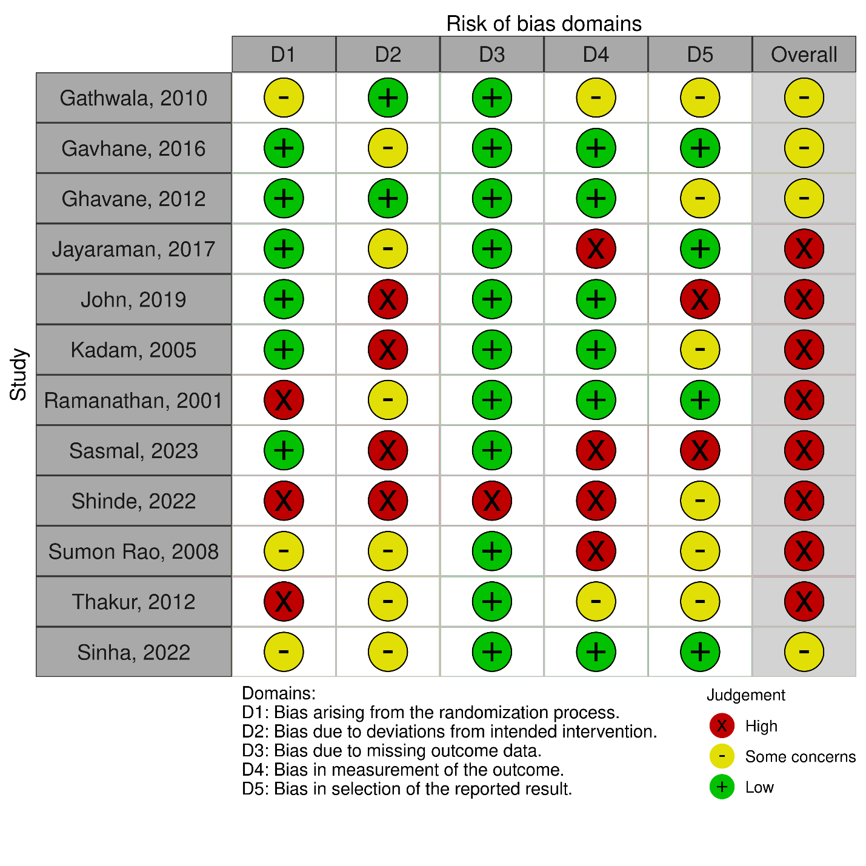

5. 2 Assessment of risk of bias in non-randomized studies-of interventions using ROBINS-1

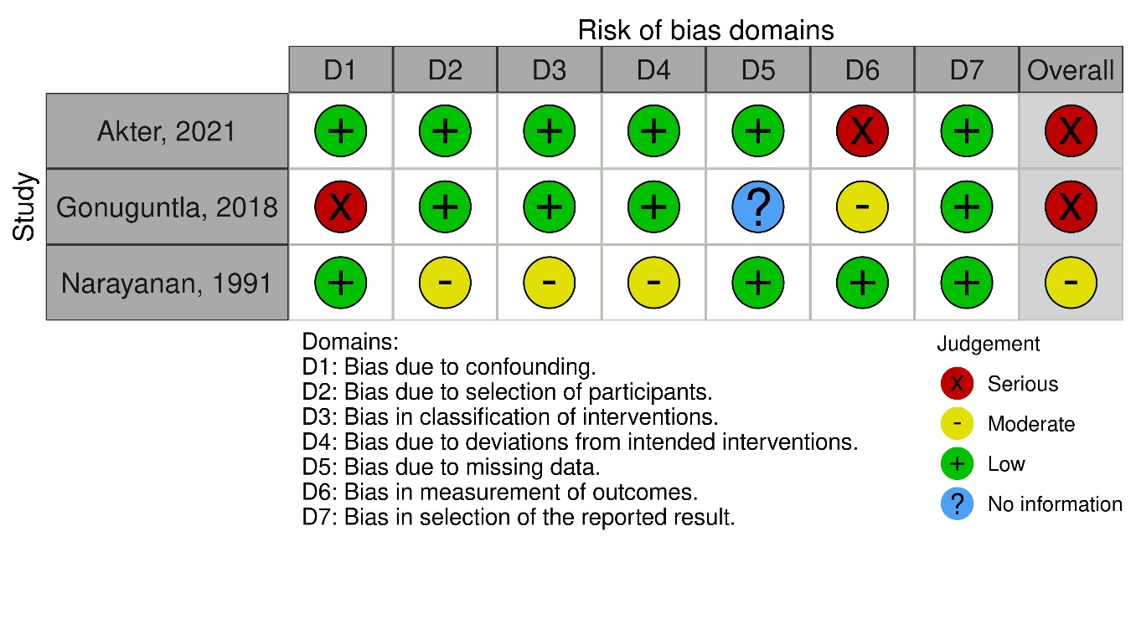

5.3 Assessment of before and after studies with no control group using NIH Quality assessment tool
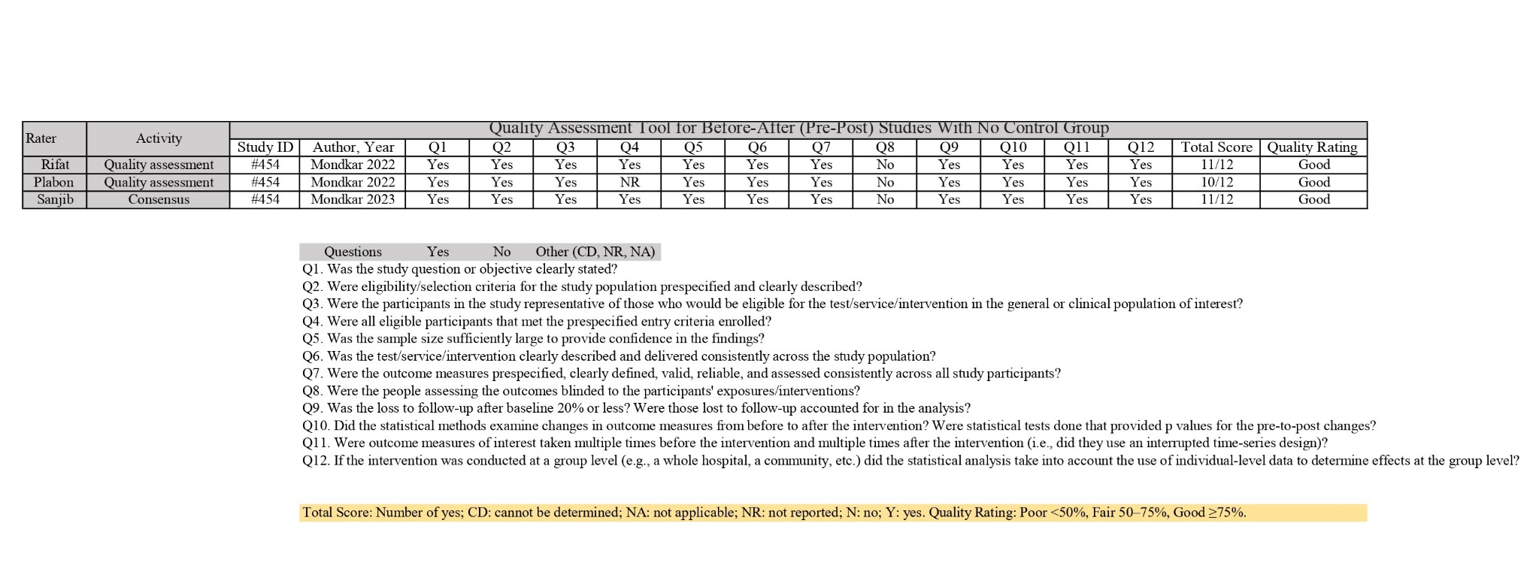

6 PRISMA checklist

Section and Topic | Item # | Checklist item | Location where item is reported
TITLE
Title | 1 | Identify the report as a systematic review. | Title
ABSTRACT
Abstract | 2 | See the PRISMA 2020 for Abstracts checklist. | Abstract
INTRODUCTION
Rationale | 3 | Describe the rationale for the review in the context of existing knowledge. | Paragraph 6 and 7
Objectives | 4 | Provide an explicit statement of the objective(s) or question(s) the review addresses. | Paragraph 8
METHODS
Eligibility criteria | 5 | Specify the inclusion and exclusion criteria for the review and how studies were grouped for the syntheses. | Inclusion and exclusion criteria
Information sources | 6 | Specify all databases, registers, websites, organisations, reference lists and other sources searched or consulted to identify studies. Specify the date when each source was last searched or consulted. | Data source and strategy
Search strategy | 7 | Present the full search strategies for all databases, registers and websites, including any filters and limits used. | Supplementary file (Item 2) and Inclusion and exclusion criteria
Selection process | 8 | Specify the methods used to decide whether a study met the inclusion criteria of the review, including how many reviewers screened each record and each report retrieved, whether they worked independently, and if applicable, details of automation tools used in the process. | Study selection process
Data collection process | 9 | Specify the methods used to collect data from reports, including how many reviewers collected data from each report, whether they worked independently, any processes for obtaining or confirming data from study investigators, and if applicable, details of automation tools used in the process. | Data extraction and management
Data items | 10a | List and define all outcomes for which data were sought. Specify whether all results that were compatible with each outcome domain in each study were sought (e.g. for all measures, time points, analyses), and if not, the methods used to decide which results to collect. | Data extraction and management
Data items | 10b | List and define all other variables for which data were sought (e.g. participant and intervention characteristics, funding sources). Describe any assumptions made about any missing or unclear information. | Not applicable
Study risk of bias assessment | 11 | Specify the methods used to assess risk of bias in the included studies, including details of the tool(s) used, how many reviewers assessed each study and whether they worked independently, and if applicable, details of automation tools used in the process. | Quality assessment and risk of bias
Effect measures | 12 | Specify for each outcome the effect measure(s) (e.g. risk ratio, mean difference) used in the synthesis or presentation of results. | Table 3, 4 and 5
Synthesis methods | 13a | Describe the processes used to decide which studies were eligible for each synthesis (e.g. tabulating the study intervention characteristics and comparing against the planned groups for each synthesis (item #5)). | Data extraction and management, Table 3, 4 and 5
Synthesis methods | 13b | Describe any methods required to prepare the data for presentation or synthesis, such as handling of missing summary statistics, or data conversions. | Not applicable
Synthesis methods | 13c | Describe any methods used to tabulate or visually display results of individual studies and syntheses. | Not applicable
Synthesis methods | 13d | Describe any methods used to synthesize results and provide a rationale for the choice(s). If meta-analysis was performed, describe the model(s), method(s) to identify the presence and extent of statistical heterogeneity, and software package(s) used. | Data extraction and management, Data synthesis and meta-analysis
Synthesis methods | 13e | Describe any methods used to explore possible causes of heterogeneity among study results (e.g. subgroup analysis, meta-regression). | Discussion, Paragraph 2
Synthesis methods | 13f | Describe any sensitivity analyses conducted to assess robustness of the synthesized results. | Meta -analysis
Reporting bias assessment | 14 | Describe any methods used to assess risk of bias due to missing results in a synthesis (arising from reporting biases). | Not applicable
Certainty assessment | 15 | Describe any methods used to assess certainty (or confidence) in the body of evidence for an outcome. | Meta-analysis
RESULTS
Study selection | 16a | Describe the results of the search and selection process, from the number of records identified in the search to the number of studies included in the review, ideally using a flow diagram. | Selection and study characteristics
Study selection | 16b | Cite studies that might appear to meet the inclusion criteria, but which were excluded, and explain why they were excluded. | Not applicable
Study characteristics | 17 | Cite each included study and present its characteristics. | Table 2
Risk of bias in studies | 18 | Present assessments of risk of bias for each included study. | Supplementary file, item 5
Results of individual studies | 19 | For all outcomes, present, for each study: (a) summary statistics for each group (where appropriate) and (b) an effect estimate and its precision (e.g. confidence/credible interval), ideally using structured tables or plots. | Table 3, 4 and 5
Results of syntheses | 20a | For each synthesis, briefly summarise the characteristics and risk of bias among contributing studies. | Selection and study characteristics and Risk of bias, quality assessment and strength of assessment
Results of syntheses | 20b | Present results of all statistical syntheses conducted. If meta-analysis was done, present for each the summary estimate and its precision (e.g. confidence/credible interval) and measures of statistical heterogeneity. If comparing groups, describe the direction of the effect. | Table 3, 4 and 5  Meta-analysis
Results of syntheses | 20c | Present results of all investigations of possible causes of heterogeneity among study results. | Meta-analysis
Results of syntheses | 20d | Present results of all sensitivity analyses conducted to assess the robustness of the synthesized results. | Meta-analysis
Reporting biases | 21 | Present assessments of risk of bias due to missing results (arising from reporting biases) for each synthesis assessed. | Risk of bias, quality assessment and strength of assessment
Certainty of evidence | 22 | Present assessments of certainty (or confidence) in the body of evidence for each outcome assessed. | Not applicable
DISCUSSION
Discussion | 23a | Provide a general interpretation of the results in the context of other evidence. | Discussion, paragraph 1
Discussion | 23b | Discuss any limitations of the evidence included in the review. | Strengths and limitations
Discussion | 23c | Discuss any limitations of the review processes used. | Strengths and limitations
Discussion | 23d | Discuss implications of the results for practice, policy, and future research. | Discussion, paragraph 6
OTHER INFORMATION
Registration and protocol | 24a | Provide registration information for the review, including register name and registration number, or state that the review was not registered. | Methods
Registration and protocol | 24b | Indicate where the review protocol can be accessed, or state that a protocol was not prepared. | Methods
Registration and protocol | 24c | Describe and explain any amendments to information provided at registration or in the protocol. | Selection and study characteristics
Support | 25 | Describe sources of financial or non-financial support for the review, and the role of the funders or sponsors in the review. | Funding
Competing interests | 26 | Declare any competing interests of review authors. | Competing interest
Availability of data, code and other materials | 27 | Report which of the following are publicly available and where they can be found: template data collection forms; data extracted from included studies; data used for all analyses; analytic code; any other materials used in the review. | Supplementary file

