Supplementary Information

Ventilatory variables and computed tomography features in COVID-19 ARDS and non–COVID-19-related ARDS: A prospective cohort study
Authors: Li-Chung Chiu, Hsin-Hsien Li, Yu-Hsiang Juan, et al.

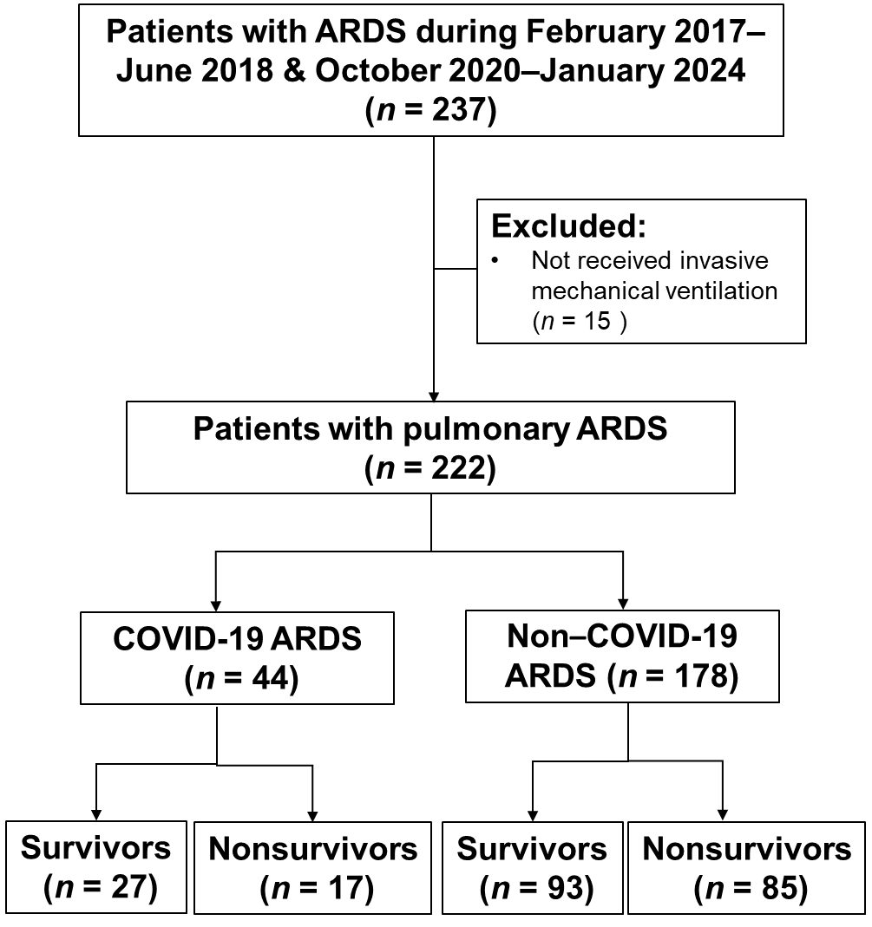
Fig. 1 Flowchart of participants with COVID-19 ARDS and non–COVID-19 ARDS. ARDS, acute respiratory distress syndrome; COVID-19, coronavirus disease 2019

Table 1 Ventilatory variables at day 3 after ARDS onset: Survivors and non-survivors
Variables | COVID-19 |  |  | Non–COVID-19
 | Survivors  (n = 27) | Non-survivors  (n = 17) | p value | Survivors  (n = 93) | Non-survivors (n = 85) | p value
Ventilator settings
MP (J/min) | 16.5 ± 4.6 | 17.4 ± 6.6 | 0.624 | 16.5 ± 5.7 | 19.3 ± 6.6 | 0.004
MP/PBW (× 10⁻³J/min/kg) | 275 ± 74 | 307 ± 119 | 0.287 | 279 ± 93 | 345 ± 129 | <0.001
MP/compliance (J/min/ml/cm H₂O) | 0.55 ± 0.27 | 0.78 ± 0.54 | 0.124 | 0.61 ± 0.38 | 0.90 ± 0.57 | <0.001
Ventilatory ratio | 1.7 ± 0.5 | 1.9 ± 0.8 | 0.384 | 1.9 ± 0.6 | 2.2 ± 0.7 | 0.004
Tidal volume (ml/kg PBW) | 8.5 ± 1.9 | 8.5 ± 2.9 | 0.958 | 7.9 ± 1.9 | 7.9 ± 2.4 | 0.996
PEEP (cm H₂O) | 10.0 ± 2.5 | 9.9 ± 2.0 | 0.868 | 10.1 ± 2.4 | 10.6 ± 2.3 | 0.152
Peak inspiratory pressure (cm H₂O) | 25.8 ± 4.1 | 28.3 ± 5.6 | 0.119 | 25.6 ± 5.7 | 29.2 ± 6.7 | <0.001
Mean airway pressure (cm H₂O) | 14.9 ± 3.0 | 15.4 ± 3.1 | 0.572 | 15.7 ± 3.3 | 16.8 ± 3.2 | 0.038
Dynamic driving pressure (cm H₂O) | 15.8 ± 3.2 | 18.4 ± 4.1 | 0.030 | 15.5 ± 4.5 | 18.5 ± 6.2 | <0.001
Dynamic compliance (ml/cm H₂O) | 33.5 ± 10.4 | 28.4 ± 15.2 | 0.201 | 33.4 ± 14.9 | 27.5 ± 14.5 | 0.01
Respiratory rate (breaths/min) | 18.7 ± 3.7 | 20.4 ± 6.1 | 0.311 | 20.7 ± 4.5 | 22.7 ± 4.8 | 0.008
Minute ventilation (L/min) | 9.3 ± 1.8 | 9.2 ± 2.9 | 0.906 | 9.4 ± 2.5 | 9.9 ± 2.6 | 0.286
FiO₂ (%) | 0.46 ± 0.10 | 0.49 ± 0.16 | 0.508 | 0.47 ± 0.14 | 0.59 ± 0.21 | <0.001
Arterial blood gas
pH | 7.43 ± 0.05 | 7.37 ± 0.08 | 0.002 | 7.43 ± 0.08 | 7.39 ± 0.09 | 0.002
PaCO₂ (mm Hg) | 40.3 ± 8.3 | 42.5 ± 10.7 | 0.474 | 44.0 ± 9.4 | 46.4 ± 9.0 | 0.096
PaO₂ (mm Hg) | 95.3 ± 28.1 | 96.5 ± 22.4 | 0.881 | 91 ± 48.7 | 85.6 ± 22.9 | 0.368
HCO₃ (mEq/L) | 26.1 ± 4.6 | 23.4 ± 4.1 | 0.060 | 28.4 ± 5.2 | 27.7 ± 5.6 | 0.345
PaO₂/FiO₂ (mm Hg) | 203 (158–262) | 190 (142–266) | 0.908 | 189 (143–249) | 147 (110–210) | 0.007
Data are presented as mean ± standard deviation or median (interquartile range)
ARDS, acute respiratory distress syndrome; COVID-19, coronavirus disease 2019; FiO₂, fraction of inspired oxygen; MP, mechanical power; PaCO₂, partial pressure of carbon dioxide in arterial blood; PaO₂, partial pressure of oxygen in arterial blood; PBW, predicted body weight; PEEP, positive end-expiratory pressure

Table 2 Ventilatory variables at day 7 after ARDS onset: Survivors and non-survivors
Variables | COVID-19 |  |  | Non–COVID-19
 | Survivors  (n = 27) | Non-survivors  (n = 17) | p value | Survivors  (n = 93) | Non-survivors (n = 85) | p value
Ventilator settings
MP (J/min) | 14.2 ± 7.2 | 14.8 ± 6.0 | 0.785 | 15.4 ± 6.4 | 19.1 ± 7.7 | 0.001
MP/PBW (× 10⁻³J/min/kg) | 250 ± 135 | 257 ± 128 | 0.882 | 259 ± 105 | 344 ± 140 | <0.001
MP/compliance (J/min/ml/cm H₂O) | 0.51 ± 0.49 | 0.61 ± 0.51 | 0.559 | 0.60 ± 0.43 | 0.96 ± 0.68 | <0.001
Ventilatory ratio | 1.6 ± 0.6 | 1.7 ± 0.7 | 0.571 | 1.9 ± 0.7 | 2.3 ± 0.9 | 0.002
Tidal volume (ml/kg PBW) | 8.3 ± 2.3 | 8.8 ± 3.1 | 0.563 | 7.8 ± 2.1 | 7.9 ± 2.8 | 0.806
PEEP (cm H₂O) | 9.4 ± 2.5 | 8.8 ± 1.5 | 0.418 | 9.8 ± 2.5 | 10.7 ± 2.5 | 0.045
Peak inspiratory pressure (cm H₂O) | 23.0 ± 7.4 | 26.1 ± 5.9 | 0.193 | 25.7 ± 6.2 | 29.8 ± 7.5 | <0.001
Mean airway pressure (cm H₂O) | 15.6 ± 4.7 | 14.8 ± 2.6 | 0.574 | 15.3 ± 3.3 | 17.2 ± 3.6 | 0.004
Dynamic driving pressure (cm H₂O) | 13.7 ± 5.6 | 17.3 ± 5.0 | 0.046 | 15.9 ± 5.2 | 19.2 ± 6.6 | 0.001
Dynamic compliance (ml/cm H₂O) | 42.8 ± 20.2 | 31.9 ± 18.7 | 0.102 | 33.0 ± 16.9 | 25.9 ± 12.9 | 0.005
Respiratory rate (breaths/min) | 19.2 ± 6.6 | 17.8 ± 6.3 | 0.527 | 19.7 ± 5.1 | 22.6 ± 5.5 | 0.001
Minute ventilation (L/min) | 9.1 ± 3.5 | 8.1 ± 2.4 | 0.329 | 8.8 ± 2.7 | 9.8 ± 3.4 | 0.059
FiO₂ (%) | 0.44 ± 0.13 | 0.46 ± 0.14 | 0.718 | 0.46 ± 0.13 | 0.56 ± 0.21 | 0.001
Arterial blood gas
pH | 7.45 ± 0.05 | 7.40 ± 0.07 | 0.035 | 7.43 ± 0.07 | 7.40 ± 0.11 | 0.030
PaCO₂ (mm Hg) | 42.4 ± 6.9 | 41.5 ± 8.7. | 0.732 | 45.9 ± 10.3 | 49.4 ± 13.7 | 0.079
PaO₂ (mm Hg) | 98.5 ± 38.1 | 98.6 ± 21.6 | 0.991 | 87.4 ± 24.1 | 86.7 ± 52.7 | 0.914
HCO₃ (mEq/L) | 28.7 ± 3.7 | 25.6 ± 5.3 | 0.034 | 29.6 ± 5.8 | 29.5 ± 7.4 | 0.886
PaO₂/FiO₂ (mm Hg) | 237 (166–268) | 220 (181–290) | 0.985 | 192 (144–246) | 154 (107–209) | 0.006
Data are presented as mean ± standard deviation or median (interquartile range)
ARDS, acute respiratory distress syndrome; COVID-19, coronavirus disease 2019; FiO₂, fraction of inspired oxygen; MP, mechanical power; PaCO₂, partial pressure of carbon dioxide in arterial blood; PaO₂, partial pressure of oxygen in arterial blood; PBW, predicted body weight; PEEP, positive end-expiratory pressure

