SUPPLEMENTARY MATERIAL
Appendix S1: Auxiliary information to the methods section.

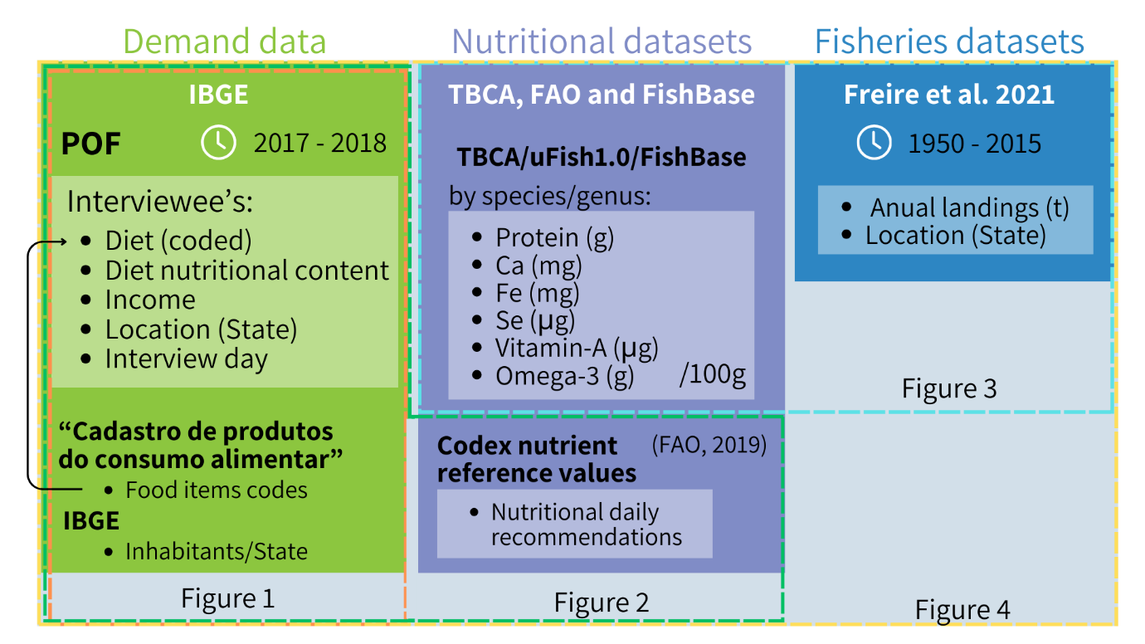
Figure S1.1. Representation of the datasets used in the analysis.

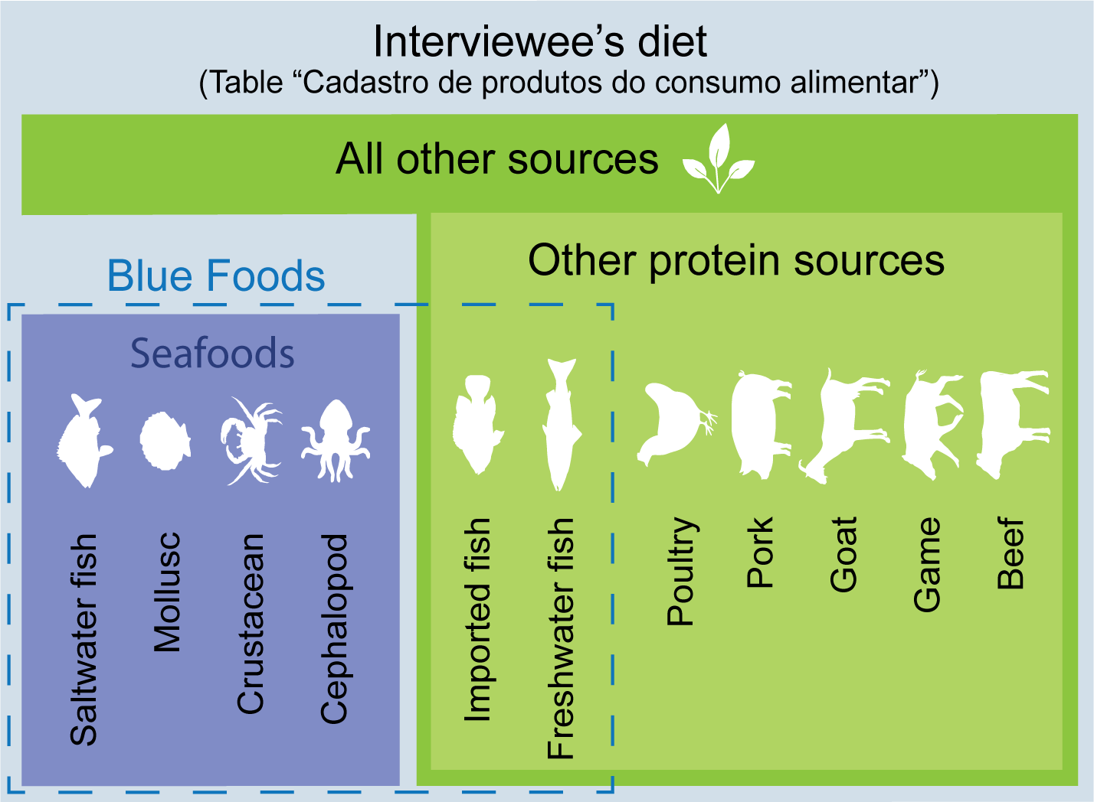
Figure S1.2. Representation of the groupings of different food items, from the total interviewee’s diet, used in the analysis here. The specific food items can be found in the table “Cadastro de produtos do consumo alimentar” (Food Consumption Product Registry) in www.ibge.gov.br.

Appendix S2: Complementary maps.

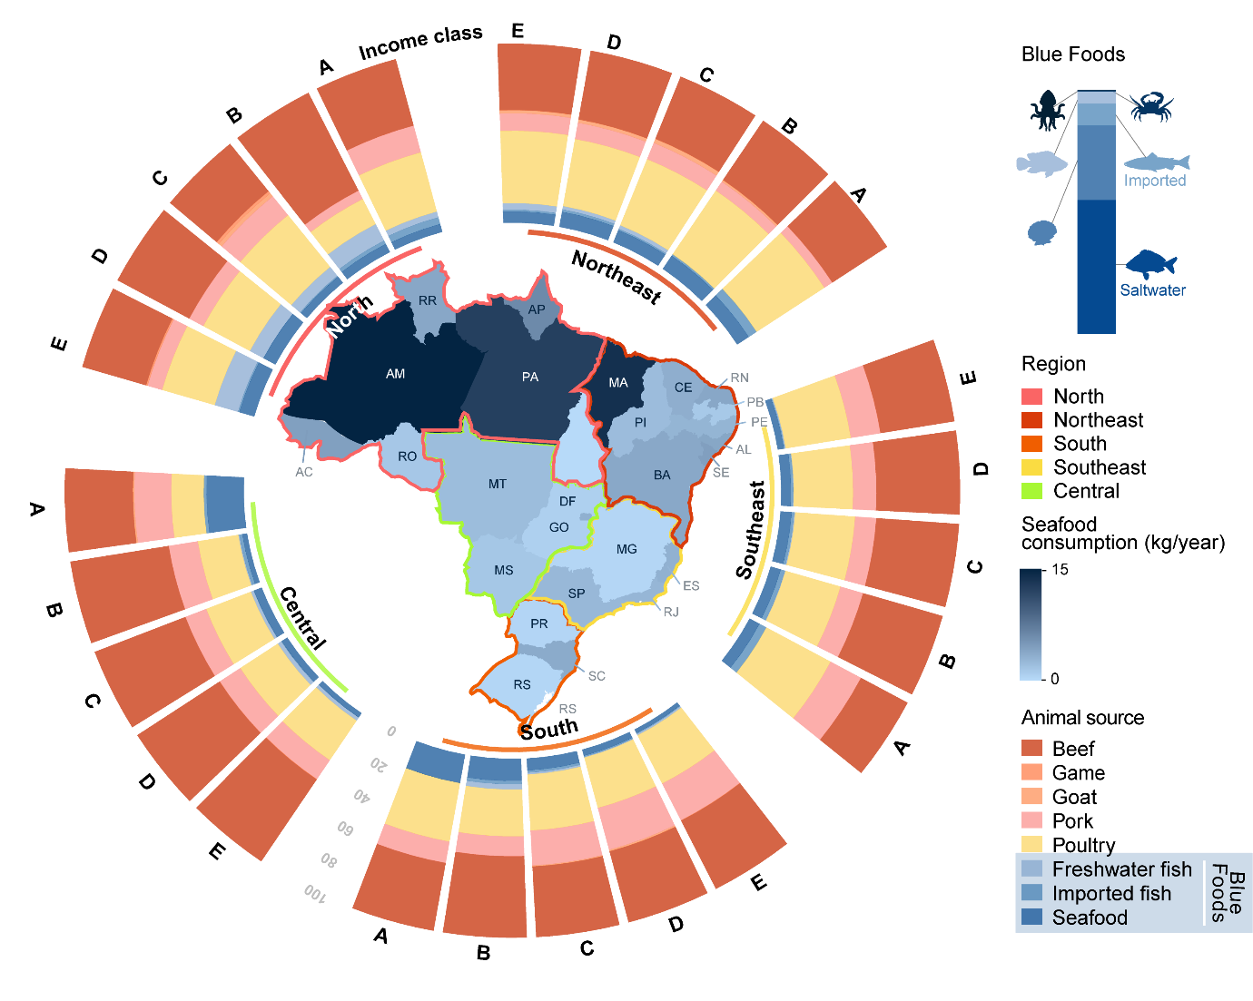
Figure S2.1. Contribution of different animal protein sources to the daily diet of Brazilians per category of income class (E: <U$371.28; D: U$ 371.28 - 742.56; C: U$ 742.57 - 1856.40; B: U$ 1856,41 - 3,712.80; and A: >3,712.80) and region. The blue bar in the upper right represents the different contributions of food groups to blue foods: cephalopod, crustacean, freshwater fish, imported fish, mollusc, and saltwater fish. The blue color gradient of Brazilian states (AC, Acre; AL, Alagoas; AP, Amapá; AM, Amazonas; BA, Bahia; CE, Ceará; DF, Distrito Federal; ES, Espírito Santo; GO, Goiás; MA, Maranhão; MT, Mato Grosso; MS, Mato Grosso do Sul; MG, Minas Gerais; PA, Pará; PB, Paraíba; PR, Paraná; PE, Pernambuco; PI, Piauí; RJ, Rio de Janeiro; RN, Rio Grande do Norte; RS, Rio Grande do Sul; RO, Rondônia; RR, Roraima; SC, Santa Catarina; SP, São Paulo; SE, Sergipe; TO, Tocantins) within regions depicts the per capita annual mean consumption of seafood.

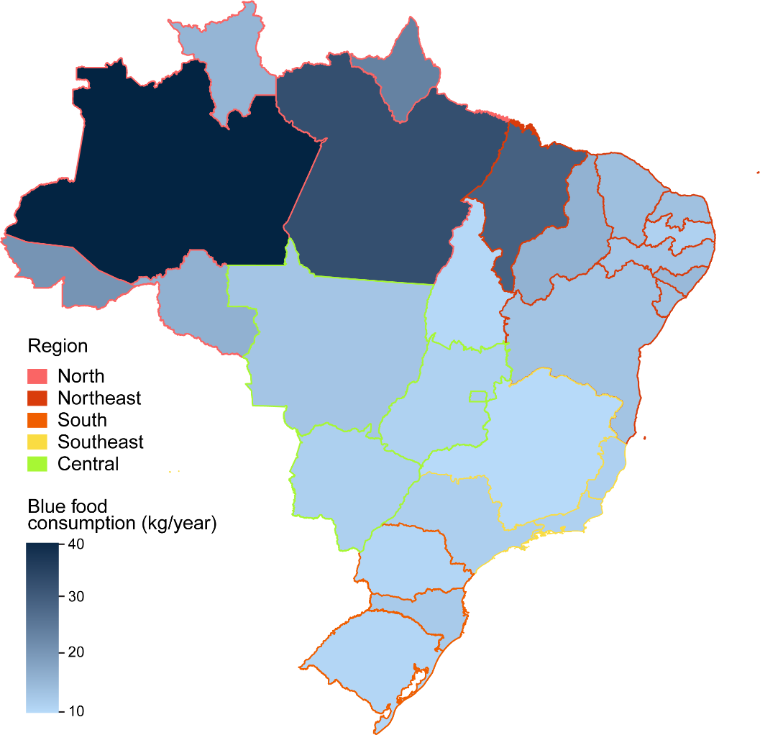
Figure S2.2. Per capita blue food consumption in all Brazilian states. Data source: POF 2017-2018. Data source: Household budget surveys, Brazilian Institute of Geography and Statistics (64).

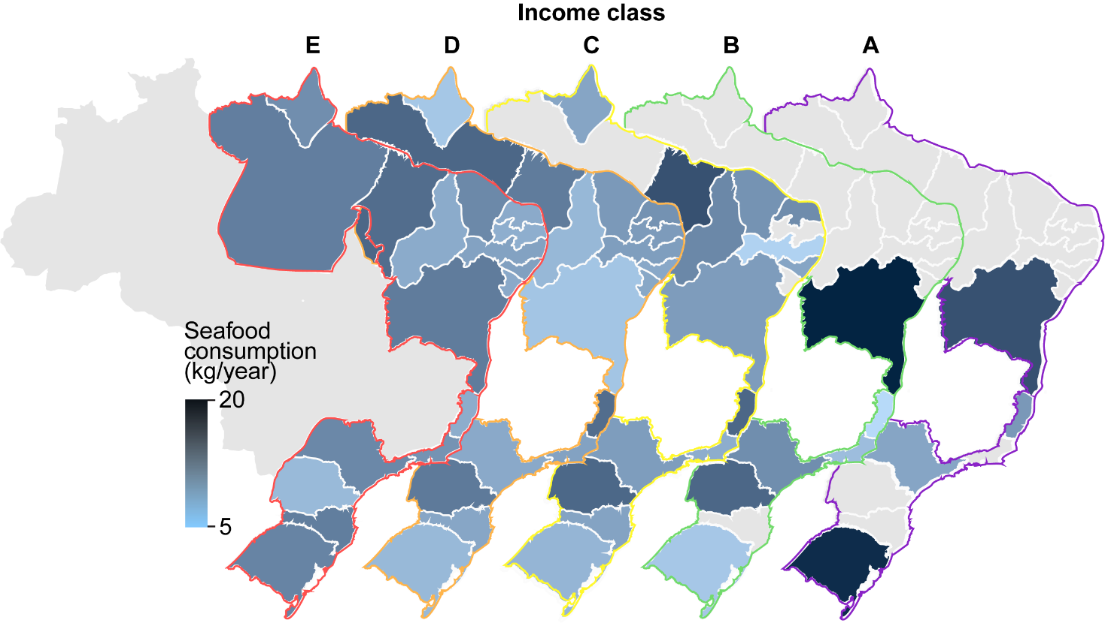
Figure S2.3. Per capita amount of seafood (mapped gradient) and nutrient consumption (pie charts) per income class in coastal states of Brazil. Gray colors show states with missing data in POF (IBGE) for a given income class (E: <U$371.28; D: U$ 371.28 - 742.56; C: U$ 742.57 - 1856.40; B: U$ 1856,41 - 3,712.80; and A: >3,712.80).

Appendix S3:
Table S3.1. Number of interviewees per state. The table is ordered by the decreasing number of interviewees.
State | Number of interviewees | Proportion of the total
Minas Gerais | 3505 | 0.080
São Paulo | 2923 | 0.067
Rio de Janeiro | 2402 | 0.055
Bahia | 2353 | 0.054
Pernambuco | 2278 | 0.052
Ceará | 2063 | 0.047
Rio Grande do Sul | 2035 | 0.046
Espírito Santo | 1997 | 0.045
Santa Catarina | 1808 | 0.041
Paraná | 1795 | 0.041
Maranhão | 1757 | 0.040
Piauí | 1754 | 0.040
Goiás | 1691 | 0.038
Mato Grosso | 1537 | 0.035
Pará | 1535 | 0.035
Amazonas | 1500 | 0.034
Alagoas | 1434 | 0.033
Paraíba | 1425 | 0.032
Mato Grosso do Sul | 1287 | 0.029
Rio Grande do Norte | 1218 | 0.028
Sergipe | 1215 | 0.028
Distrito Federal | 980 | 0.022
Rondônia | 737 | 0.017
Acre | 731 | 0.017
Amapá | 709 | 0.016
Tocantins | 662 | 0.015
Roraima | 617 | 0.014
Total | 43948 | 1.000
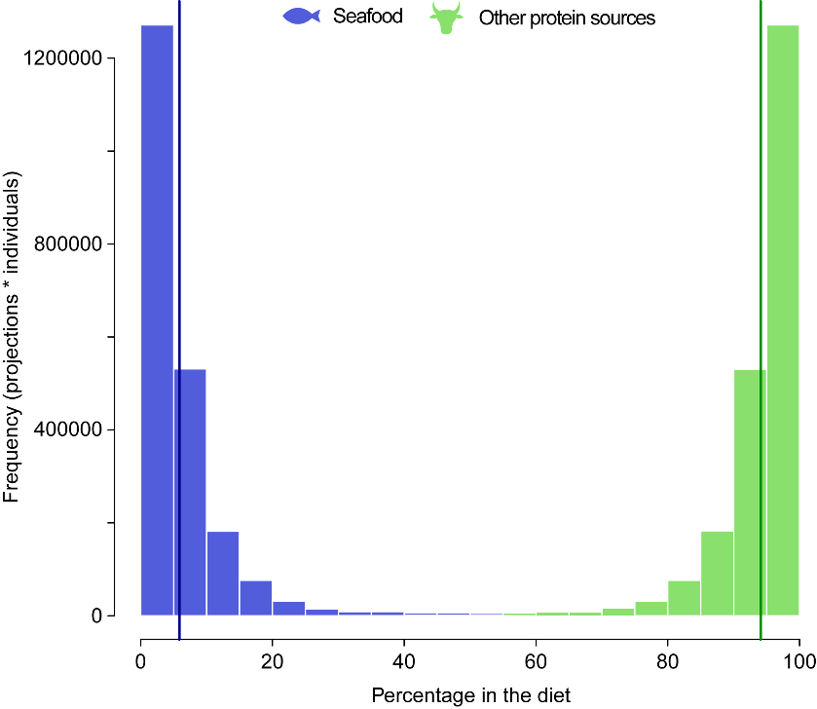

Figure S3.1. Observed percentage of different food types in the diet (blue = seafood, green = other sources) of Brazilians consuming both seafood and other sources (n=3,037). The vertical lines depict the average percentage per food type. Data: POF, 2017-2018.

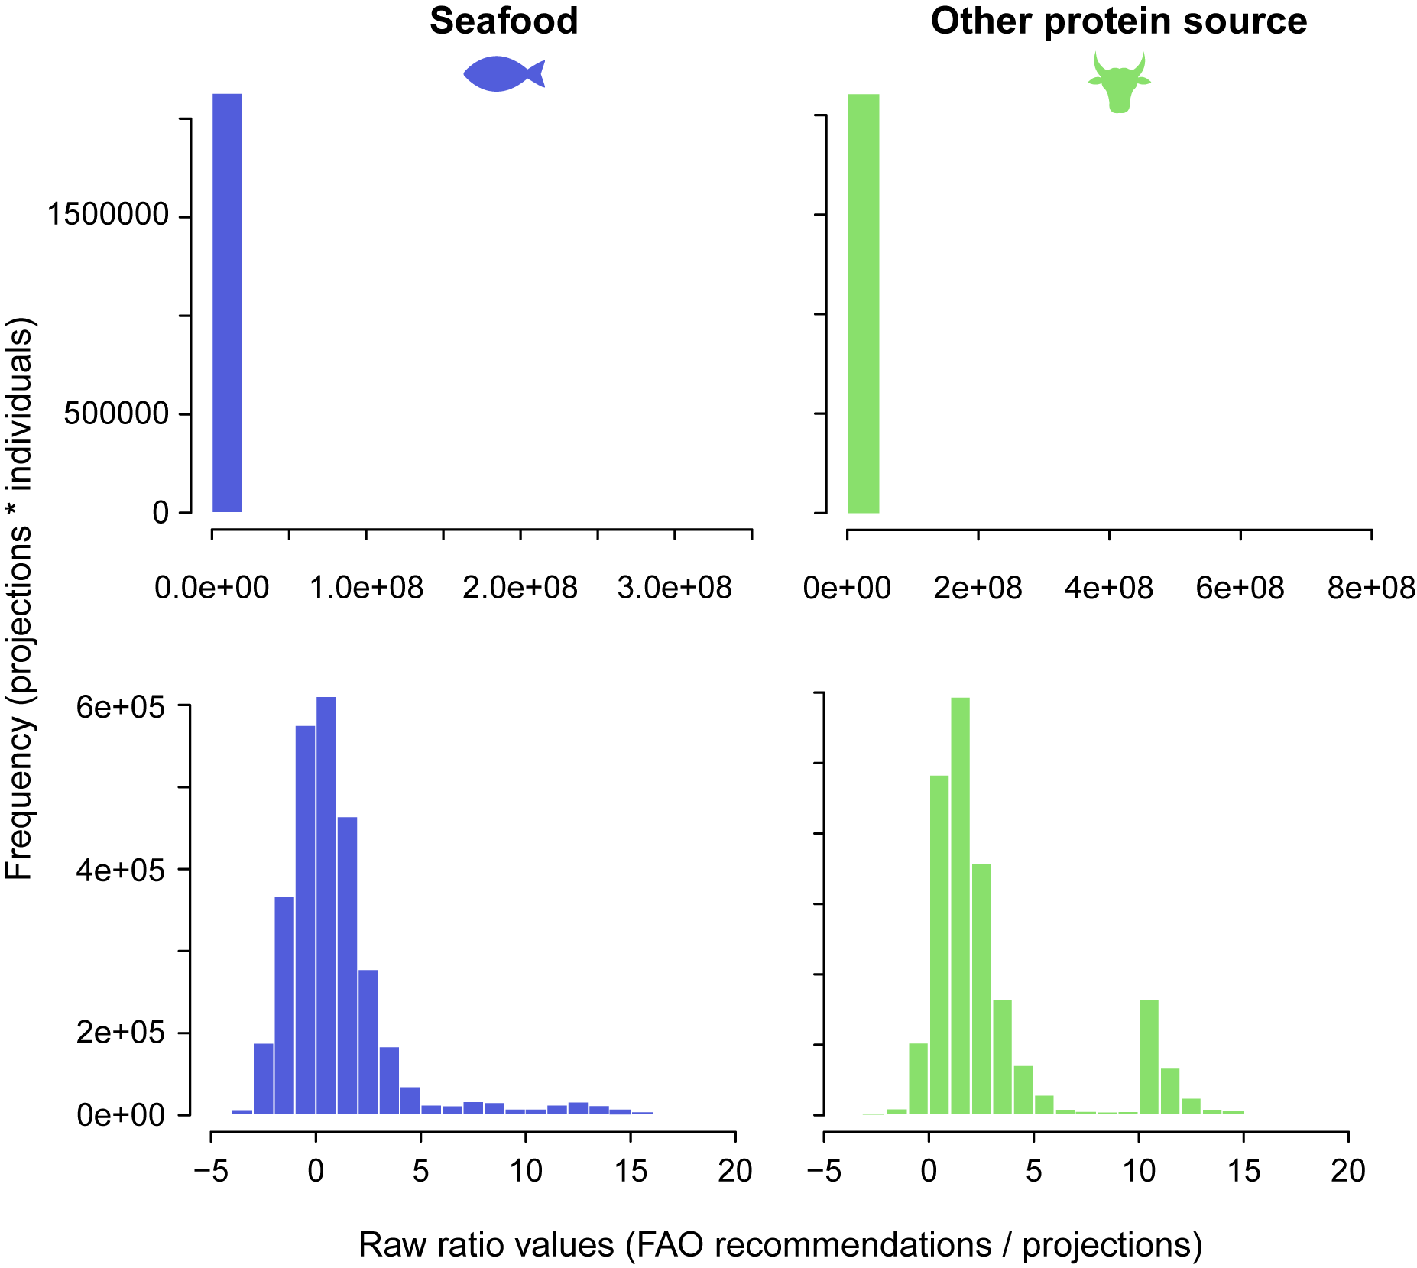

Figure S3.2. Histograms showing the distribution of ratio values for seafood and other sources in two scales: raw (top) and natural-log scales (bottom).

Table S3.2. Table of the 20 most caught taxa per region. The landings represent the sum of all states of each region.

Region | Species/taxon | Abbreviation | Class | Family | Landings (t)
Northeast
 | Ucides cordatus | Uci cor | Malacostraca | Ocypodidae | 343162.43
 | Mugil spp. | Mug spp | Osteichthyes | Mugilidae | 329766.77
 | Scomberomorus brasiliensis | Sco bra | Osteichthyes | Scombridae | 195146.59
 | Lutjanus purpureus | Lut pur | Osteichthyes | Lutjanidae | 161252.76
 | Ocyurus chrysurus | Ocy chr | Osteichthyes | Lutjanidae | 148457.43
 | Opisthonema oglinum | Opi ogl | Osteichthyes | Clupeidae | 142999.83
 | Micropogonias furnieri | Mic fur | Osteichthyes | Sciaenidae | 139071.76
 | Scomberomorus cavalla | Sco cav | Osteichthyes | Scombridae | 124958.27
 | Sciades herzbergii | Sci her | Osteichthyes | Ariidae | 117094.88
 | Genyatremus luteus | Gen lut | Osteichthyes | Haemulidae | 116397.21
 | Cynoscion acoupa | Cyn aco | Osteichthyes | Sciaenidae | 110304.14
 | Aspistor quadriscutis | Asp qua | Osteichthyes | Ariidae | 106915.69
 | Megalops atlanticus | Meg atl | Osteichthyes | Megalopidae | 99628.62
 | Caranx hippos | Car hip | Osteichthyes | Carangidae | 99397.92
 | Centropomus spp. | Cen spp | Osteichthyes | Centropomidae | 94378.76
 | Cynoscion leiarchus | Cyn lei | Osteichthyes | Sciaenidae | 89809.74
 | Conodon nobilis | Con nob | Osteichthyes | Haemulidae | 87328.91
 | Sciades proops | Sci pro | Osteichthyes | Ariidae | 84864.35
 | Sardinella brasiliensis | Sar bra | Osteichthyes | Clupeidae | 84834.09
 | Bagre bagre | Bag bag | Osteichthyes | Ariidae | 84191.79
North
 | Cynoscion acoupa | Cyn aco | Osteichthyes | Sciaenidae | 317120.12
 | Ucides cordatus | Uci cor | Malacostraca | Ocypodidae | 256274.49
 | Sciades parkeri | Sci par | Osteichthyes | Ariidae | 238074.18
 | Scomberomorus brasiliensis | Sco bra | Osteichthyes | Scombridae | 168911.69
 | Carcharhinus spp. | Car spp | Chondrichthyes | Carcharhinidae | 109245.15
 | Mugil spp. | Mug spp | Osteichthyes | Mugilidae | 100064.94
 | Lutjanus purpureus | Lut pur | Osteichthyes | Lutjanidae | 95687.05
 | Sciades proops | Sci pro | Osteichthyes | Ariidae | 94478.84
 | Coryphaena hippurus | Cor hip | Osteichthyes | Coryphaenidae | 88998.63
 | Macrodon ancylodon | Mac anc | Osteichthyes | Sciaenidae | 87349.18
 | Sciades herzbergii | Sci her | Osteichthyes | Ariidae | 73334.14
 | Bagre bagre | Bag bag | Osteichthyes | Ariidae | 68471.58
 | Mugil curema | Mug cur | Osteichthyes | Mugilidae | 44589.61
 | Caranx spp. | Car spp | Osteichthyes | Carangidae | 40929.43
 | Aspistor quadriscutis | Asp qua | Osteichthyes | Ariidae | 36694.73
 | Cynoscion virescens | Cyn vir | Osteichthyes | Sciaenidae | 36286.97
 | Sciades couma | Sci cou | Osteichthyes | Ariidae | 35626.53
 | Megalops atlanticus | Meg atl | Osteichthyes | Megalopidae | 33969.64
 | Centropomus spp. | Cen spp | Osteichthyes | Centropomidae | 31567.39
 | Notarius grandicassis | Not gra | Osteichthyes | Ariidae | 26126.75
Southeast
 | Sardinella brasiliensis | Sar bra | Osteichthyes | Clupeidae | 3807235.04
 | Scomber colias | Sco col | Osteichthyes | Scombridae | 384299.67
 | Micropogonias furnieri | Mic fur | Osteichthyes | Sciaenidae | 363911.42
 | Macrodon atricauda | Mac atr | Osteichthyes | Sciaenidae | 199374.92
 | Cetengraulis edentulus | Cet ede | Osteichthyes | Engraulidae | 165468.79
 | Opisthonema oglinum | Opi ogl | Osteichthyes | Clupeidae | 152447.91
 | Katsuwonus pelamis | Kat pel | Osteichthyes | Scombridae | 144653.59
 | Mugil spp. | Mug spp | Osteichthyes | Mugilidae | 127649.78
 | Balistes capriscus | Bal cap | Osteichthyes | Balistidae | 121099.07
 | Cynoscion spp. | Cyn spp | Osteichthyes | Sciaenidae | 115561.8
 | Coryphaena hippurus | Cor hip | Osteichthyes | Coryphaenidae | 105216.55
 | Thunnus albacares | Thu alb | Osteichthyes | Scombridae | 104871.38
 | Brevoortia spp. | Bre spp | Osteichthyes | Clupeidae | 100449.54
 | Cynoscion jamaicensis | Cyn jam | Osteichthyes | Sciaenidae | 99681.25
 | Selene spp. | Sel spp | Osteichthyes | Carangidae | 87996.73
 | Pomatomus saltatrix | Pom sal | Osteichthyes | Pomatomidae | 84074.98
 | Caranx spp. | Car spp | Osteichthyes | Carangidae | 75883.22
 | Balistes spp. | Bal spp | Osteichthyes | Balistidae | 64268.67
 | Pagrus pagrus | Pag pag | Osteichthyes | Sparidae | 62882.55
 | Trichiurus lepturus | Tri lep | Osteichthyes | Trichiuridae | 44822.07
South
 | Sardinella brasiliensis | Sar bra | Osteichthyes | Clupeidae | 2340055.08
 | Micropogonias furnieri | Mic fur | Osteichthyes | Sciaenidae | 1600609.04
 | Umbrina canosai | Umb can | Osteichthyes | Sciaenidae | 786945.72
 | Merluccius hubbsi | Mer hub | Osteichthyes | Merlucciidae | 757135.28
 | Katsuwonus pelamis | Kat pel | Osteichthyes | Scombridae | 553003.37
 | Cynoscion guatucupa | Cyn gua | Osteichthyes | Sciaenidae | 374764.46
 | Pomatomus saltatrix | Pom sal | Osteichthyes | Pomatomidae | 321628.91
 | Macrodon atricauda | Mac atr | Osteichthyes | Sciaenidae | 299813.17
 | Mugil liza | Mug liz | Osteichthyes | Mugilidae | 280782.82
 | Genidens barbus | Gen bar | Osteichthyes | Ariidae | 243991.54
 | Opisthonema oglinum | Opi ogl | Osteichthyes | Clupeidae | 225467.82
 | Scomber colias | Sco col | Osteichthyes | Scombridae | 142012.11
 | Selene spp. | Sel spp | Osteichthyes | Carangidae | 123292.44
 | Mugil spp. | Mug spp | Osteichthyes | Mugilidae | 114481.82
 | Prionotus punctatus | Pri pun | Osteichthyes | Triglidae | 99565.2
 | Chloroscombrus chrysurus | Chl chr | Osteichthyes | Carangidae | 98030.79
 | Brevoortia pectinata | Bre pec | Osteichthyes | Clupeidae | 96579.06
 | Paralichthys spp. | Par spp | Osteichthyes | Paralichthyidae | 88020.62
 | Urophycis brasiliensis | Uro bra | Osteichthyes | Phycidae | 83869.95
 | Trachurus lathami | Tra lat | Osteichthyes | Carangidae | 62251.87

Appendix S4: Analysis of Variance (ANOVA) to testfor regional differences in protein and nutrient intake.

Table S4.1. Results of the Analysis of Variance (ANOVA) with offset (FAO’s nutritional recommendations) and blocking factor (interviewees family). One independent ANOVA testing for regional differences in nutrient consumption was conducted for other sources and seafood. Data: POF
(IBGE, 2018).

 | Consumption of seafood |  |  |  |  |  | Consumption of other sources
Nutrient | Source of variation | Degrees of Freedom | Sum of squares | Mean squares | F-statistics | p- value | Degrees of Freedom | Sum of squares | Mean squares | F-statistics | p-value
Protein
 | Region | 3 | 411 | 136.95 | 0.1739 | 0.9141 | 3 | 212,969 | 70,990 | 30.284 | 2.20E-16
 | Blocks | 1,800 | 1,417,782 | 787.66 |  |  | 13,654 | 32,006,743 | 2,344
 | Error  (Within) | 1,233 | 261,560 | 212.13 |  |  | 17,043 | 15,706,637 | 922
 | Total | 3,036 | 1,679,753 | 1,136.74 |  |  | 30,700 | 47,926,349 | 74,255
Calcium
 | Region | 3 | 1,786,769 | 595,590 | 8.1589 | 2.14E-05 | 3 | 26,402,797 | 8,800,932 | 55.72 | 2.20E-16
 | Blocks | 1,800 | 131,397,538 | 72,999 |  |  | 13,654 | 2.16E+09 | 157,949
 | Error  (Within) | 1,233 | 26,486,426 | 21,481 |  |  | 17,043 | 7.54E+08 | 44,229
 | Total | 3,036 | 159,670,733 | 690,070 |  |  | 30,700 | 2.94E+09 | 9,003,111
Iron
 | Region | 3 | 78 | 25.964 | 0.5829 | 0.6262 | 3 | 724 | 241.185 | 6.1906 | 0.000337
 | Blocks | 1,800 | 80,170 | 44.539 |  |  | 13,654 | 531,956 | 38.96
 | Error(Within) | 1,233 | 20,984 | 17.018 |  |  | 17,043 | 284,588 | 16.698
 | Total | 3,036 | 101,232 | 87.521 |  |  | 30,700 | 817,267 | 296.843
Zinc
 | Region | 3 | 3.7 | 1.2497 | 0.4186 | 0.7397 | 3 | 11,041 | 3,680.5 | 62.909 | 2.20E-16
 | Blocks | 1,800 | 5,374 | 2.9855 |  |  | 13,654 | 798,822 | 58.5
 | Error(Within) | 1,233 | 6,706.4 | 5.4391 |  |  | 17043 | 344568 | 20.2
 | Total | 3,036 | 12,084.1 | 9.6743 |  |  | 30,700 | 1,154,432 | 3,759.2
Vitamin-A
 | Region | 3 | 116,323 | 38,774 | 1.8808 | 0.1308 | 3 | 2.64E+08 | 88,119,573 | 19.536 | 1.24E-12
 | Blocks | 1,800 | 37,109,095 | 20,616 |  |  | 13,654 | 6.16E+10 | 4,510,650
 | Error(Within) | 1,233 | 4,734,976 | 3,840 |  |  | 17,043 | 2.19E+10 | 1,284,775
 | Total | 3,036 | 41,960,394 | 63,231 |  |  | 30,700 | 8.37E+10 | 93,914,998
Omega-3
 | Region | 3 | 5.41 | 1.8038 | 10.49 | 7.69E-07 | 3 | 19.66 | 6.5547 | 80.622 | 2.20E-16
 | Blocks | 1,800 | 309.66 | 0.17203 |  |  | 13,654 | 1,110.09 | 0.0813
 | Error(Within) | 1,233 | 32.01 | 0.02596 |  |  | 17,043 | 344 | 0.0202
 | Total | 3,036 | 347.08 | 2.00266 |  |  | 30,700 | 1,473.75 | 6.6562
Magnesium
 | Region | 3 | 5,621 | 1,873.5 | 1.1718 | 0.3191 | 3 | 7,755,764 | 2,585,255 | 98.928 | 2.20E-16
 | Blocks | 1,800 | 2,877,977 | 1,598.9 |  |  | 13,654 | 3.57E+08 | 26,133
 | Error(Within) | 1,233 | 557,698 | 452.3 |  |  | 17,043 | 1.41E+08 | 8,284
 | Total | 3,036 | 3,441,296 | 3,924.7 |  |  | 30,700 | 5.06E+08 | 2,619,672

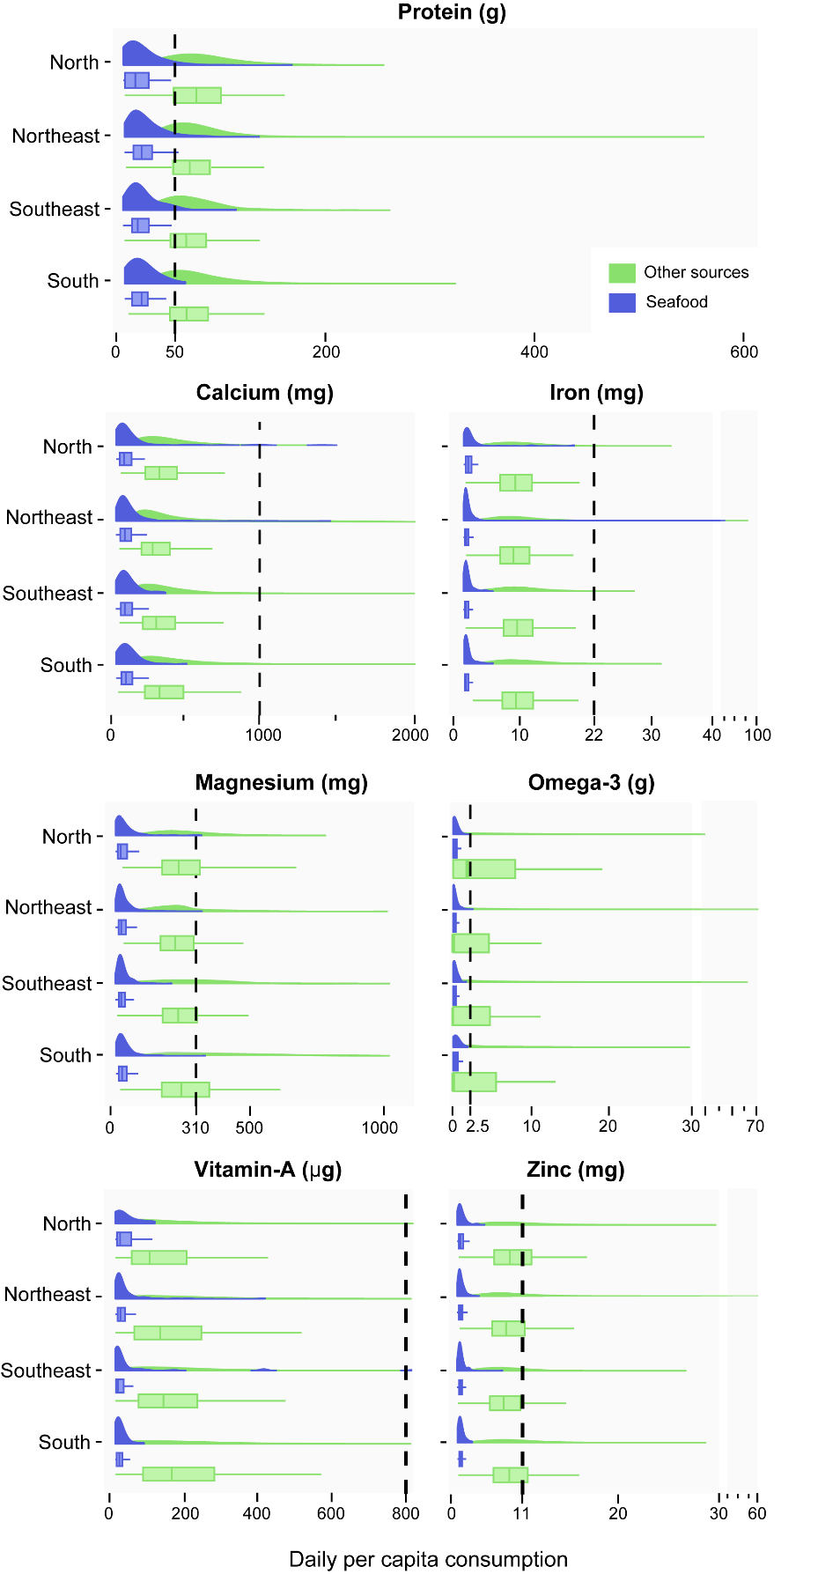

Figure S4.1. Densities and box plots summarizing data from all interviewees in the POF dataset (X-axis) to illustrate variation in daily per capita nutrient consumption for both other sources (n=182) and seafood (n=27) among regions (Y-axis). The vertical dashed lines indicate FAO’s daily nutrient intake recommendations. Outliers (data above the 90% quantile) were removed, and the X-axis was broken for improved visualization. Units on the X-axis match those in each nutrient facet title. Daily per capita nutrient consumption distribution is represented through a density curve, with boxplots indicating the median, first, and third quantiles.

